CONSTRAINTS
Constraints in a project refers to any limitations or restrictions that impact its planning, execution, or completion. These constraints can arise from various sources and can affect different aspects of a project. They also differ based on the project’s size, location, budget etc.

Location Constraint
The site is located near a church in that will remain open during construction which means vehicle and foot traffic will have to remain open to facilitate access. Figure 1 shows the street, this will need to be properly signed to promote safety especially to those on foot.
Figure 1
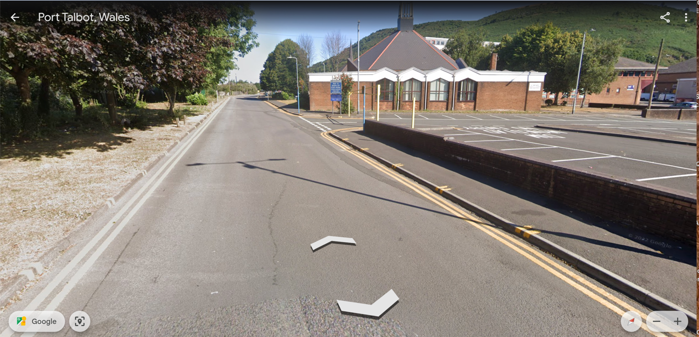
New Footpath
Church
SITE

Establish open lines of communication with the church leadership and congregation from the outset of the project. Keep them informed about the construction plans, schedule, and potential impacts on their activities. Solicit their input and address any concerns or objections they may have.

Take measures to minimize disturbances to church activities, services, and events. Schedule noisy or disrupting construction activities during offpeak hours or times when the church is not in use. Coordinate with church staff to ensure that access to the church and parking facilities is maintained as much as possible.

Implement noise and vibration control measures to minimize disturbances to the church and its surroundings. Use sound barriers, mufflers, and vibration dampening methods on construction equipment to lessen noise levels.

Implementation of dust and debris control measures to prevent construction related contaminants from affecting the church, its premises, and occupants. Use of dust suppression techniques such as water spraying, covering materials, and installing barriers to contain dust and debris within the construction site.

Use temporary fencing to visually screen the construction site from the church and its surroundings. This can help minimize the visual impact of the construction activities and maintain the aesthetic appeal of the church environment.

Remain flexible and adaptable in responding to unforeseen challenges that may arise during the construction process. As well as being prepared to adjust construction plans and schedules as needed to accommodate the needs and concerns of the church and the surrounding community.

Demolition
Demolition work will also be carried out on site and careful consideration will need to be made to undergo this process. The demolition process must be carefully planned to avoid compromising the structural integrity of the operational building (the church).

Safety of occupants in the operational building is paramount. Measures such as temporary barriers, signage, and evacuation plans should be implemented to protect occupants from hazards such as dust, debris, noise, and vibration generated during demolition.

Demolition activities can disrupt utility services such as water, electricity, gas, and telecommunications to the operational building. Coordination with utility providers is essential to safely disconnect or reroute utilities as needed to prevent service interruptions.

Demolition can generate dust, airborne pollutants, and hazardous materials which pose environmental risks if not properly managed. Dust control measures, waste disposal protocols, and environmental monitoring should be implemented to minimize impacts.

Demolition activities can generate significant noise and vibration, which may disturb occupants of the operational building and nearby residents.

Noise barriers, sound insulation, and scheduling work during off-peak hours can help mitigate these effects.

Safe access routes for occupants of the operational building must be maintained throughout the demolition process. Temporary closures or rerouting of access points may be necessary to ensure safe passage and emergency evacuation.

Demolition work carries the risk of accidental damage to the operational building or adjacent structures. Precautions such as protective barriers, structural bracing, and monitoring of nearby buildings should be implemented to prevent accidental damage.

Close communication and coordination with stakeholders, including building owners, regulatory authorities, and emergency responders, are critical throughout the demolition process. Stakeholder input, feedback, and concerns should be addressed to ensure a smooth and safe demolition operation.

Tower Crane
To complete construction there will be the use of a tower crane however, with the proximity of the Port Talbot Railway and A48 dual carriage way is within site and will cause an issue with the crane lifts.

Train track authorities will have to be notified, construction activities near train tracks must be coordinated with rail authorities to avoid conflict with train schedules. Vibrations and noise generated by crane operations can potentially impact nearby train tracks and railway infrastructure Work may need to be scheduled during off-peak hours or suspended temporarily during train operations to minimize disruptions and ensure safety. It has been decided that the crane will have a set position and the use of the crane will be heavily monitored. Figure 2 shows arial image of the trin track proximity to the site.
Figure 2
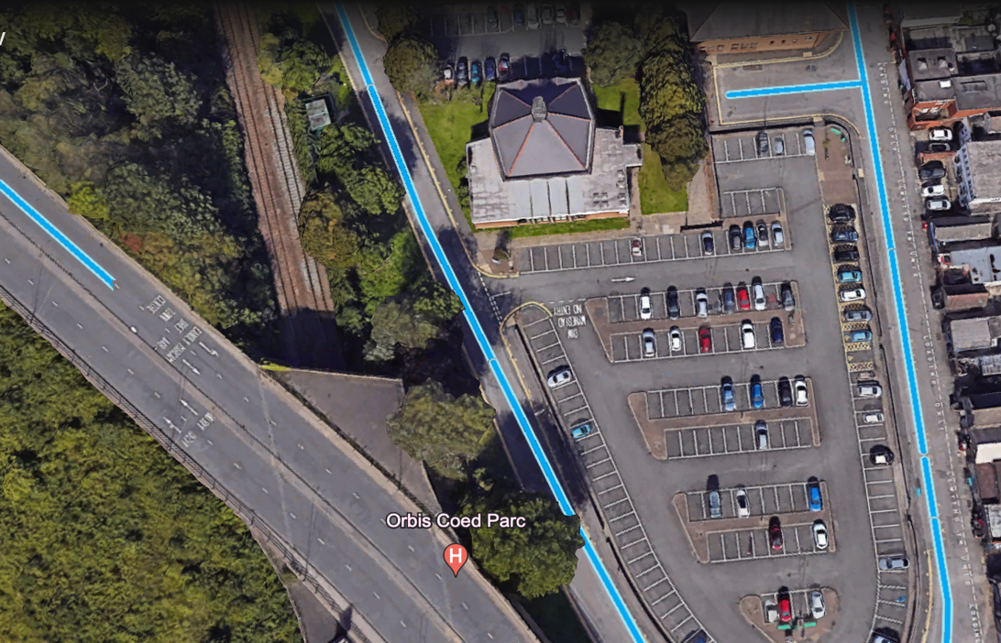
Train tracks
Site

Safety Constraints
Because of the location and the elements mentions above the safety of the public is extremely important.

Providing comprehensive safety training for all personnel working on the construction site, including workers, contractors, and supervisors.

Training should cover hazard recognition, safe work practices, proper use of personal protective equipment (PPE), emergency procedures, and regulatory compliance.

Develop and enforce clear safety protocols and procedures tailored to the specific risks and constraints of the construction site. This includes protocols for working at heights, handling hazardous materials, operating machinery (tower crane) etc.

Develop site-specific safety plans that address unique hazards and constraints present on the construction site. Involve all stakeholders in the development of these plans and ensure they are communicated effectively to everyone on-site.

Design the construction site layout to minimize safety constraints and optimize workflow. This includes providing clear signage, designated walkways, barricades, and traffic control measures to prevent accidents and ensure safe movement of personnel and equipment.

Implement regular safety inspections, audits, and job site walkthroughs to identify potential hazards and ensure compliance with safety protocols.

Assign qualified supervisors to oversee safety performance and promptly to address any safety concerns.

Develop and implement emergency response plans for various scenarios, including medical emergencies, fires, chemical spills, and natural disasters.

Conduct regular drills and training exercises to ensure that all personnel are familiar with emergency procedures and can respond effectively in case of an emergency. In the case of an emergency there will always be trained health and safety personnel on site and in the even the emergency is escalated the Neath Port Talbot hospital is a seven (7) minute drive away.

Foster an environment of safety through open communication, collaboration, and teamwork among all stakeholders concerned with the construction project. Encourage workers to report safety concerns straightaway and encourage them to address potential hazards.

The safety for church staff, congregation members, and visitors by implementing stringent safety measures on the construction site is very important. Erect barriers, signage, and warning lights to highlight hazardous areas and ensure that pedestrians can safely navigate around the construction site.

