The Circular economy of LEGO
Benedict Michael Gibson 2114133
Carmarthen Business School UWTSD
BMSP6001 Globally Responsible Business
Jessica Shore
08 April 2024

Abstract
This report considers the relationship between business and the circular economy, presents the model, its purpose, and following evidentiary research, identifies areas in which LEGO currently reflect the model’s principles, the challenges they face, and provides solutions to these challenges as short-, medium- and long-term goals. These solutions highlight the importance of adopting the circular economy and the benefits it, and biomimicry approaches, can have on business and its sustainability.

Contents
Abstract 2
List of Figures 4
Introduction 5
LEGO’s circular economy 8
Challenges 10
Short-term 10
Medium-Term 11
Long-term 11
Conclusion 12
References 13

List of Figures
Figures | Name and Reference | Page number
Figure 1: | the circular economy model (European Parliment Research Service, 2023) | 5
Figure 2: | The linear economy-The 'take, make and waste' approach of production (ResearchGate, n.d.) | 6
Figure 3: | the circular economy systems diagram (ellenmacarthurfoundation, 2019) | 7

Introduction
The Circular economy, an adaptation of the Cradle to Cradle concept introduced by Stahel, popularised by such theorists as Broungart and McDonough, who described a “law of return” of materials (2008), which is, in the Ellen Macarthur foundations’ definition, based on three design driven principles, to eliminate waste and pollution, circulate products and materials, and regenerate nature (Ellen Macarthur foundation, n.d.). The ’Framework’ concept is based on the premise of sale of service as opposed to product, and that materials are not consumed but shared, highlighting Repair, Re-use and recycle in order maintain the viability of materials for long term use in order to protect the environment, reduce our dependence on raw materials, save consumers money and create jobs (European Parliment, 2023). Adoption of this circular economy as a model for business, according to Atasu et al. is dependent on recovering value from a product, to do so further depends on adoption of the framework at all levels of business (2021), therefore its conceptual success depends on migration away from the Linear economy.
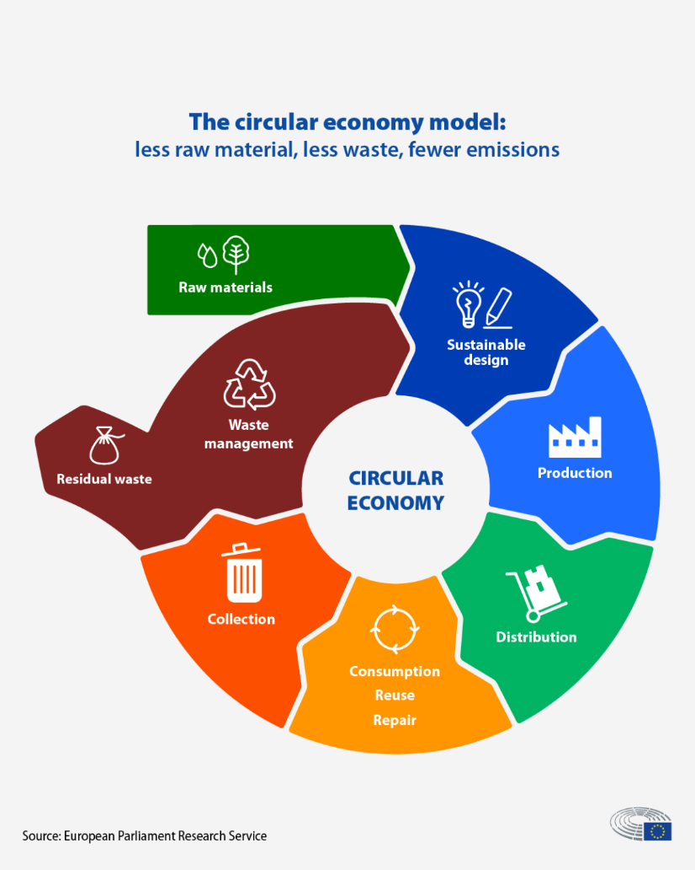
Figure 1: The circular economy model (European Parliment Research Service, 2023)

The ‘linear economy’ term refers to a linear sequence of a products life, where it is of beginning middle and end, and its materials are consumed (Knight, 2023). Knight also describes how this economic model is of a “take-make-use-dispose” format, which, the Ellen Macarthur foundation explains, found its origins in the industrial revolution era, and whilst it enabled global development, it came at a cost to society and our planet, through pollution and natural material loss (n.d.). This economic model, according to Sariatli, is not sustainable as is environmentally negative, will prevent the supply of resources to our future and growing populations and leads to failures in economies (Sariatli, 2017). The effects of a Linear economy have great affect on our planet and society, Ehfaaz highlights this model as the driving force behind climate change and environment degradation, as is the “dominant economic paradigm” in recent times (Ehfaaz, 2023), highlighting the need for a new approach, in line with the UN’ SDG’s.
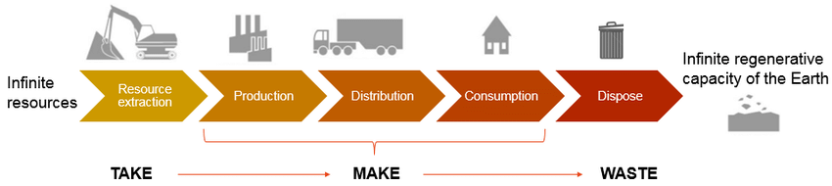
Figure 2: The linear economy-The 'take, make and waste' approach of production (ResearchGate, n.d.)

In 2012, according to the SDG Accelerator, the UN conference introduced the Sustainable Development Goals (SDG’s) in order address the “urgent environmental, political and economic challenges facing our world” (n.d.). These goals highlight 17 areas to which, in 2015, 193 countries agreed to commit to achieving by 2030 (SDG Zone, n.d.), one of which is worthy of note, to ensure “sustainable consumption and production patterns” (The Global Goals, n.d.). This can be addressed directly with the circular economy for its very purpose, which is the sustainable management and use of natural resources by closing the loop.
In order to close the loop on linear economies, to turn the line into a circle, theorists Braungart and McDonough devised the Cradle to Cradle concept, which considers all material inputs in business processes fit into one of two “nutrient” categories, Biological or Technical, those which the biological atmosphere needs and considers food, and those that are for technical purposes and can not be consumed by the planet, and are of finite resource (2008), introducing the theoretical framework that was the basis for the Ellen MacArthur foundation’ diagram in Figure 3 (ellenmacarthurfoundation, 2019). This Framework considers the economic use of technical resources as most efficient when used or designed in a biomimicry of the natural, so that their resource’ value can be retained through the principle of sharing.
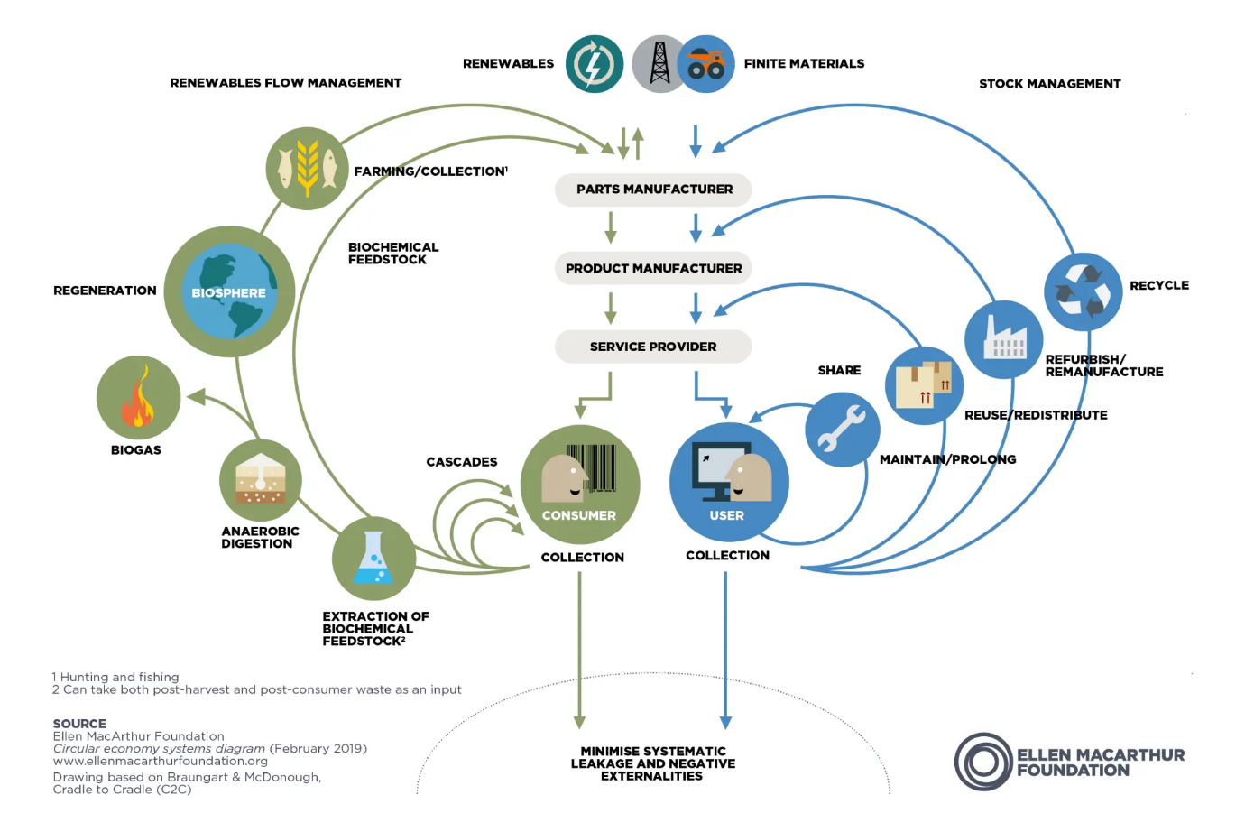Figure 3: Circular economy systems diagram (ellenmacarthurfoundation, 2019)

The Sharing economy, according to Lessig, is an economy based on this act, where the customer, user, does not gain ownership of the resource, and that financial value lies with enabling their access to it (Lessig, 2008). This applied to the circular economy refers to the resources on which the product relies, as, once the product has reached the end of its life, it should be able to be broken down in a way that its resources retain their value and useability. For example, single use plastics cannot be re-used, retain no value, and pollute, whereas plastics of certain design can be recycled for re-use, and as such, to incorporate this into a circular economy business model would be to not only use recyclable plastics by product design, but also necessitate their recycling, returning the technical resource into the circular model. Thus, the consumer is no longer consuming the plastic, but sharing the plastic resource with the manufacturer, and reducing the dependency on the technical resource supply, and its negative effect, externality, through consumption.
Biomimicry is the notion that nature has resolved most issues which face humanity (Benyus, 1997) an in terms of resources, this planet already has in place an ecosystem for their reuse through decay, and as such are considered biological, an approach adopted by Braungart and McDonough to consider technical resources, by considering natures solution to its problem of resource management, the solution can be considered for the use of unnatural or finite resources through considerate design, thus allowing its similar re-use in their respective environment.

LEGO’s circular economy
The LEGO group, the Danish toy company founded in 1932, famed for its bricks and figurines, who in 2023 were the largest valued toy company globally at over 7 billion U.S. dollars, a giant compared to its nearest rival, valued at 1.6 billion (Tighe, 2024). LEGO are active promoters of, and ambassadors for, development through play. Centred around their twice “toy of the century”, the LEGO brick, their success owes to the continuation of their founding ideal, of which LEGO is an abbreviation, the Danish “leg god” which literally translates to “play well” (LEGO Group, n.d.).
In a commitment to becoming a more circular business, LEGO Group joined forces with the Ellen MacArthur foundation in 2020, not only accelerating their product approach, but incorporating their existing ethos of development by educating teenagers to promote the circular economy, to sustain future generations, and quoted their Environmental Responsibility VP “Everything we do at the LEGO Group is centred on the child, and our sustainability ambitions are no different” (LEGO Group, 2020). LEGO’s mission is to “Inspire and develop the builders of tomorrow” (Lego Team, 2018), and their vision is conceivably doing so by inventing the future of play. Legos approach to sustainability and the circular economy, it seems, is by re-inventing its future of play.
Despite LEGO’s excellent approach to child development, there is unfortunately no escaping the proverbial elephant in the room, that LEGO products are made from plastics. There can be no full adoption of the circular economy model if their primary manufacturing resource is unsustainable, not effectively recyclable, not biodegradable, and the materials value is not fully retained at the end of the products life; this is where LEGO has recognised its flaw, and are actively re-inventing products, approaches to product design, and manufacture, to incorporate the circular economic model. Spending $1.4 billion U.S. dollars on sustainability initiatives in the four years up to 2025, real progress has been made in alternative material sourcing and product development (LEGO Group, 2023). This investment and their partnerships speak to an heir of urgency and reflects the business and revenue implications of stopping plastic production, a loss of revenue that could be measured as the current non-recyclable 60 billion bricks per year (BRICKS McGEE, 2022).
LEGO openly tell us that they are researching, experimenting and developing alternative materials, where all the flexible parts are made of Bio-PE since 2018 and that parts such as axles are made from a CO2 and bio waste mix (LEGO Group, n.d.), however, it is the building bricks that are of most significance, as they are dominantly of fossil fuel origin plastics and not recyclable. In an example of their commitment to a design approach to the circular economy, Lego promoted a re-invented prototype brick made from recycled bottles in 2021, however, as Milne highlights, the change of infrastructure to produce new brick would result in higher carbon emissions overall, and although this would lead to less plastic pollution through internalisation and reflowing the waste to retain the source material value, the increased negative externality prompted a dismissal of the materials by LEGO (Milne, 2023), highlighting further the challenges of adopting this circular model.
Whilst the plastics used in the manufacture of LEGO bricks cannot currently be recycled into new bricks due to the costly recouperation of material value, they can be reformed into larger plastic containers. In an effort to repurpose some of the vast amounts of bricks manufactured, and presumably stockpile potential source material should future technology permit, LEGO offer a replay scheme. The scheme allows anyone to return their unwanted bricks by freepost which will then be re-formed into LEGO containers for schools or charities (Replay: Give your old LEGO® bricks a new life, n.d.). The scheme however is not clear, where CNN reporters Capron and Leon write that the donated LEGO bricks will end up with schools and charities (Capron & Lear, 2019), a premise also reported by the Circular Innovation Council (Circular Innovation Council, n.d.), but in a contrast to LEGO’s own site. Both approaches are true, where replay for the U.S re-homes the bricks, the UK approach is primarily to utilise the materials for recycling research (iDisplayit, 2024).
In terms of achievement in becoming a circular economy, LEGO have made gains but are, in the words of Baruniuk, “haunted by (their) own plastic” (Baraniuk, 2023). Whilst strong efforts are being made in developing and educating our future generations, they are facing an uphill battle in resolving their plastic legacy without creating further pollution or taking away from their revenue and profitability. There is demonstrated an understanding of a circular economy leadership approach in their investments, partnerships, and child development, suggesting that it is those in control of the business that have a responsibility to ensure its sustainability, as, if the circular economy is described by Braungart and McDonough as cradle to cradle, who then is the hand that rocks it? (2008), certainly, LEGO have the opportunity to be.

Challenges
In order to understand the challenges faced by LEGO, a SWOT analysis is provided, where the source information is based on that conducted by Hauqe (2023), with the inclusion of sustainability factors.
Strengths  Global brand recognition  R&D potential  Product progression/ relevancy  Strategic Partnerships | Weaknesses  Single Use Plastics dependence  High Price  Low R&D funding  High Competition
Opportunities  Increase R&D funding  Reduce negativity of LEGO plastics use  Utilise circular economy  Reduce price whilst securing resources | Threats  Screen based play  Consumer behaviour/ opinion on plastics  Competition / Pricing  Decreased availability of source materials

Despite LEGO dropping the recycled bottle plastic bricks due to the carbon cost of manufacture, it is reported that they have continued commitments, to achieve fully sustainable bricks by 2032 (Agrawal, 2023), highlighting the need to review its efforts towards adopting a circular economy business model and the challenges they face. Although it could be considered that the computer game rise has been the one of the biggest challenges to LEGO’s traditional play business model in the near past, LEGO continue to address this with great success, where they have incorporated this phenomenon by creating strategic partnerships and developing products to build, maintaining that there is no substitute for creative development and satisfaction from dexterity based physical interaction with their products (Judge, 2018). On this basis, the remaining challenges, or threats, can be determined as follows, as short-term, medium-term, and long-term challenges.

Short-term
Consumer behaviour can be summed up as mutual trust, where both sides trust each other to deliver on the communicated terms (Morgan & Hunt, 1994), where expectations are formed over these communicated terms such as an organisations approach to sustainability or commitment to societal improvement (Indeed Editorial Teem, 2023). Lego heavily commit to societal gain through their product ethos, and heavily expose their approaches to sustainable business and the circular economy. Demonstrated by self-advertised racially equal Doves now removed Facebook advertising showing a black woman turning white when using the soap, which caused a consumer backlash (Simms, 2017) and presumably a drop in sales. Lego’s single use plastics pollution could be a potential PR disaster and could be realised at any time. This, although LEGO are communicating strong research and committing to rectify manufacture, the circular economy could be utilised here with greater effect, in reintroducing the resource, by re-moulding, of existing plastic blocks to renew them as opposed to breaking them down completely or changing their purpose, for, according to Essentra components, ABS plastics (those used by LEGO) can be easily reformed (Essentra components, 2023). This would allow LEGO to regain the resource value once though to be lost, and create a positive consumer opinion, where LEGO are actively seeking to clean up their unintended negative externality of consumption.

Medium-Term
Competition/ Pricing is the medium-term challenge facing LEGO. Whilst LEGO are the leading toy company globally, it is common knowledge that their products are expensive, which, as the patents expired in 1988 (Belanger, 2023), leaves them open to better priced market competition in the medium term. This is where the short-term solution can be utilised, for the savings made by re-claiming of resource value from the discarded bricks can be passed on to the consumer, whilst initially the donated stocks of bricks could be utilised, together with the existing revenue, to cover the cost of infrastructure change, there could be utilised a buy back scheme such as that utilised by IKEA (IKEA, n.d.), which frees up the value of old goods allowing the goods or material resources to be re circulated in the economic model. This would lead to a cheaper product for the consumer, which together with the superior brand recognition, would lead to a strong market position.

Long-term
Highlighted by the common unpopularity of plastic pollution, and the difficulty LEGO has had in creating a sustainable alternative to their building bricks, the search for an alternative solution is imperative to solve the long-term issue of the primary oil-based resource future availability and cost. Whilst the solution posed above, to renew existing bricks, would resolve the issue of waste and pricing to the consumer, there is a need for increased research to a full alternative long-term, for this plastic would still exist, and is unknown for how many remoulds it would maintain its function. LEGO have stated that recycling plastic bottles would cause additional carbon pollution, however, focus on a full plastic alternative, such as that highlighted in Guan et al.’s article, using bio-mimicry methodology to create natural resource based plastic alternatives (2020), would be the optimal long term goal, and, together with remoulding, could be implemented long term to spread the cost of infrastructure change.

Conclusion
The circular economy in its nature promotes an organisations responsibility to society in the economic use of resources, to protect our planet, its occupants, and its natural resources, so that future generations might have the same opportunities as todays. LEGO are haunted by their plastic legacy and must act to reduce its future impact in a way that benefits society and themselves to be sustainable. There are three main opportunities highlighted in order to address this which address three terms of challenges, to renew existing waste bricks for re-sale, to buy back old or unwanted bricks, and increase R&D to enable full adoption of a natural product alternative. By undertaking these opportunities, LEGO can deliver on their sustainable ethos, and adopt a fully circular economy model to unsure their sustainability by retaining value from source materials, allow natural resources to return to the planet so they can be re-used by future generation, reduce, or eliminate waste, and, as the market leader, be a positive example to other models of business.

References
Agrawal, A. (2023, 09 27). Lego's Sustainability Challenge: Navigating the Roadblocks in Plastic-Free Bricks. Retrieved from Linked in: https://www.linkedin.com/pulse/legos-sustainability-challenge-navigating-roadblocks-bricks-agrawal
Atasu, A., Dumas, C., & Van Wassenhove, L. (2021). The Circular Business Model. Harvard Business Review(July-August). Retrieved from https://hbr.org/2021/07/the-circular-business-model
Baraniuk, C. (2023, 09 30). Lego Is a Company Haunted by Its Own Plastic. Retrieved from Wired: https://www.wired.com/story/lego-haunted-by-its-own-plastic/
Belanger, E. (2023, 09 21). LEGO: How the legendary toy brand has overcome globalisation challenges over its 90-year history. Retrieved from sand berg: https://stptrans.com/lego-how-the-legendary-toy-brand-has-overcome-globalisation-challenges-over-its-90-year-history/
Benyus, J. (1997). Biomimicry: Innovation. Boston: Mariner Books.
Braungart, M., & McDonough, W. (2008). Cradle to Cradle: remaking the way we make things (2 ed.). London: Vintage Digital.
Braungart, M., & McDonough, W. (2008). Cradle to Cradle: Remaking the way we make things. London: Vintage Digital.
BRICKS McGEE. (2022, 01 06). FUN FACTS ABOUT LEGOS. Retrieved from Bricksmcgee: https://www.bricksmcgee.com/blog/international-lego-day-lego-facts/
Capron, M., & Lear, J. (2019, 10 08). You can feel good about ditching your LEGO bricks thanks to this new program. Retrieved from CNN: https://edition.cnn.com/2019/10/08/us/lego-replay-trnd/index.html
Circular Innovation Council. (n.d.). About. Retrieved 04 04, 2024, from Circular Innovation Council: https://playcircular.ca/about/
Ehfaaz. (2023, 03 03). ROAD TO COP28: Let's talk Linear Economy's Impact on the Planet and Solutions. Retrieved from Linked In: https://www.linkedin.com/pulse/road-cop28-lets-talk-linear-economys-impact-planet-solutions-ehfaaz
Ellen Macarthur foundation. (n.d.). Circular economy introduction. Retrieved 04 02, 2024, from ellenmacarthurfoundation.org: https://www.ellenmacarthurfoundation.org/topics/circular-economy-introduction/overview
ellenmacarthurfoundation. (2019). Circular economy systems diagram. Retrieved from https://images.ctfassets.net/isq5xwjfoz2m/3v3SXaPbb5iKAFF4sSMClk/920fc7076d12cf6c2b4478c2d91dfbdc/Butterfly_Diagram.webp
Essentra components. (2023, 01 31). PVC vs ABS: which plastic should you choose? Retrieved from Essentracomponents: https://www.essentracomponents.com/en-gb/news/manufacturing/injection-moulding/pvc-vs-abs.
European Parliment. (2023, 05 24). Circular economy: definition, importance and benefits. Retrieved from European Parliment: Topics: https://www.europarl.europa.eu/topics/en/article/20151201STO05603/circular-economy-definition-importance-and-benefits
European Parliment Research Service. (2023, 05 24). The circular economy model. Retrieved from https://www.europarl.europa.eu/resources/library/images/20230927PHT05951/20230927PHT05951_original.png
Guan, Q.-F., Yang, H.-B., Han, Z.-M., Ling, Z.-C., & Yu, S.-H. (2020). An all-natural bioinspired structural material for plastic replacement. Nature Communication, 11. doi:https://doi.org/10.1038/s41467-020-19174-1
Hauqe, A. (2023, 02 13). Lego SWOT Analysis 2024 : An Ultimate Report With Advice. Retrieved from SWOT wizard: https://swotwizard.com/lego-swot-analysis/?utm_content=cmp-true
iDisplayit. (2024, 01 25). LEGO Trial New ‘LEGO Replay’ UK Brick Recycling Scheme. Retrieved from iDisplayit: https://www.idisplayit.co.uk/news/lego-releases/lego-trial-new-lego-replay-uk-brick-recycling-scheme/
IKEA. (n.d.). Buyback & Resell. Retrieved 04 08, 2024, from IKEA: https://www.ikea.com/gb/en/customer-service/services/buy-back/
Indeed Editorial Teem. (2023, 03 11). Customer Expectations: What They Are and How To Improve Them. Retrieved from indeed: https://www.indeed.com/career-advice/career-development/customer-expectations
Judge, A. (2018, 07 12). Brick by brick: how Lego embraced video games. Retrieved from theguardian: https://www.theguardian.com/games/2018/jul/12/lego-video-games
Knight, C. (2023, 08 02). What is the Linear Economy? Retrieved from European Investment Bank: https://www.eib.org/en/stories/linear-economy-recycling
LEGO Group. (2020, 08 31). Ellen MacArthur Foundation and LEGO Group join forces to accelerate the move towards a circular economy. Retrieved from LEGO: https://www.lego.com/en-gb/aboutus/news/2020/august/ellen-macarthur-foundation
LEGO Group. (2023, 09 27). The LEGO Group remains committed to make LEGO® bricks from sustainable materials. Retrieved from LEGO: https://www.lego.com/en-gb/aboutus/news/2023/september/the-lego-group-remains-committed-to-make-lego-bricks-from-sustainable-materials
LEGO Group. (n.d.). Sustainable Materials. Retrieved 04 04, 2024, from LEGO: https://www.lego.com/en-gb/sustainability/environment/sustainable-materials
LEGO Group. (n.d.). The LEGO Group History. Retrieved 04 04, 2024, from Lego.com: https://www.lego.com/en-gb/aboutus/lego-group/the-lego-group-history
Lego Team. (2018, 02 10). History of LEGO Group:. Retrieved from medium: https://medium.com/@bus407legos/history-of-lego-group-f80280f7c5cd
Lessig, L. (2008). Two Economies: Commercial and Sharing. In Remix: Making Art and Commerce Thrive in the Hybrid Economy. London: Bloomsbury Acedemic. doi:http://dx.doi.org/10.5040/9781849662505.ch-006
Milne, R. (2023, 09 25). Lego ditches oil-free brick in sustainability setback. Retrieved from Financial Times: https://www.ft.com/content/6cad1883-f87a-471d-9688-c1a3c5a0b7dc
Morgan, R. M., & Hunt, S. D. (1994). The Commitment-Trust Theory of Relationship Marketing. Journal of Marketing, 58(3), 20-38. doi:https://doi.org/10.1177/002224299405800302
Replay: Give your old LEGO® bricks a new life. (n.d.). Retrieved 04 04, 2024, from LEGO: https://www.lego.com/en-gb/sustainability/environment/replay
ResearchGate, n.d. (n.d.). The linear economy-The 'take, make and waste' approach of production . Retrieved 04 08, 2024, from https://www.researchgate.net/figure/The-linear-economy-The-take-make-and-waste-approach-of-production_fig2_323809440
Sariatli, F. (2017). Linear Economy Versus Circular Economy: A Comparative and Analyzer Study for Optimization of Economy for Sustainability. Visegrad Journal on Bioeconomy and Sustainable Development, 6(1), 31-34.
SDG Accelerator. (n.d.). Sustainable Development Goals: Background on the Goals. Retrieved 04 02, 2024, from SDG Accelerator: https://www.undp.org/sdg-accelerator/background-goals
SDG Zone. (n.d.). What are Sustainable Development Goals (SDGs)? Retrieved 04 02, 2024, from SDG Zone: https://sdgzone.com/learn/what-are-the-sdgs
Simms, M. (2017, 10 11). What the *#&$*” were they thinking?!: A Look at Dove’s Viral PR Disaster. Retrieved from huffpost: https://www.huffpost.com/entry/what-the-were-they-thinking-a-look-at-doves_b_59dd5b49e4b0df59e2613cf5
The Ellen Macarthur Foundation. (n.d.). What is the Linear Economy? Retrieved 04 02, 2024, from The Ellen Macarthur Foundation: https://www.ellenmacarthurfoundation.org/what-is-the-linear-economy
The Global Goals. (n.d.). 12 Responsible Consumption and Production. Retrieved 04 02, 2024, from The Gobal Goals: https://www.globalgoals.org/goals/12-responsible-consumption-and-production/
Tighe, D. (2024, 03 22). LEGO - statistics & facts. Retrieved from Statista: https://www.statista.com/topics/10867/lego/#topicOverview

