Introduction
Properly formalised as an archaeological practice by Rathje in Tucson, Arizona, garbology is the practice of using rubbish to establish conclusions about social and cultural patterns (Rathje & Murphy, 2001). It is used by a multitude of academic disciplines, including anthropology, sociology and archaeology. Archaeology is useful for interpreting social patterns from garbage because methods such as artefact analysis are easily utilised to process garbage and gain relevant data from it. (Lehmann, 2015). Garbology can be useful for informing institutions such as local or national authorities on which parts of recycling and sustainability guidance are being effectively done, and which to focus recycling and waste education on, and diets in local areas for funding health initiatives. It also can help inform private companies of the consumption of their products, and the demographics to target when marketing produce. However, it is important to note that there are ethical concerns around the level of invasion of privacy that digging through someone’s rubbish amounts to. Some form the argument that once an individual has thrown away an item, it no longer belongs to them and therefore they have no right to view it as an invasion of privacy. However, this is often disputed, most notably by the US Constitution, which protects certain instances of searching an individual’s rubbish under the 4th amendment, or the right to privacy, however, this privacy has to be ‘objectively reasonable’, and often as soon the rubbish is placed outside of the boundaries of a private property, it is legal to search (Spelman, 2016). The main way in which archaeologists can avoid this ethical consideration is through consent from the owners or anonymisation of the individuals whose rubbish the archaeologists are collecting data from.
The social patterns which can be drawn from the garbology practical on individual, communal and greater societal levels can be separated into different categories of rubbish. This includes how the rubbish was destroyed and thrown away, the shops in which the rubbish was purchased, the materials and origins of the rubbish, and the use and sell-by dates of the products.

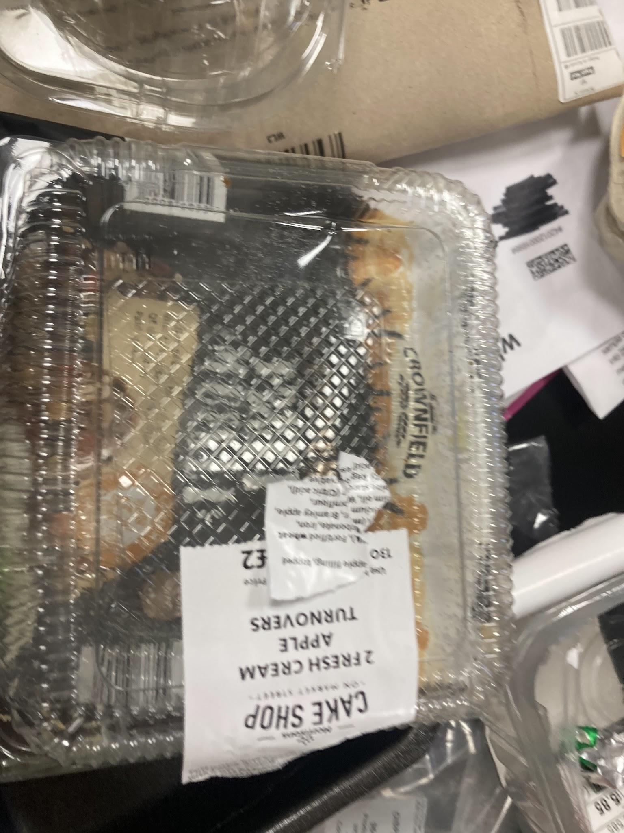
Item types, recycling and destruction patterns
The manner in which the packaging which has been disposed of has been destroyed can also create ways of inferring about the everyday lives of the individuals in the household. How a lot of the rubbish was destroyed in this household was ripped, and rarely washed, showing a lack of care or time. The individuals also don't squash their plastic waste to retain space, something which is common according to Lehmann’s (2015) research in Australia, showing that this style of disposal is most likely representative of how many dispose of their items. This lack of time, however, directly contrasts with the products they are purchasing, such as oxtail, which is often used in slow-cooked meals that take a lot of time and energy. However, another reason why it may be inferred that these individuals do not have a lot of time is a lack of items which are washed out before being recycled. The time-poorness of these people is a wider indication of long work hours and a work-centred society.
From the items which are disposed of, assumptions can be made about the demographics of a household by looking at the items which are purchased and the amount of produce which is thrown away in a period of time. In this household, there is not a large amount of waste in this timeframe, especially when it comes to levels of food packaging. This likely means that this is a two-person household. Furthermore, there are no child-centred items (such as brightly coloured packaging, or toys), or child-friendly foods, meaning this is likely two adults with no children living in their house.

Economic status and shops
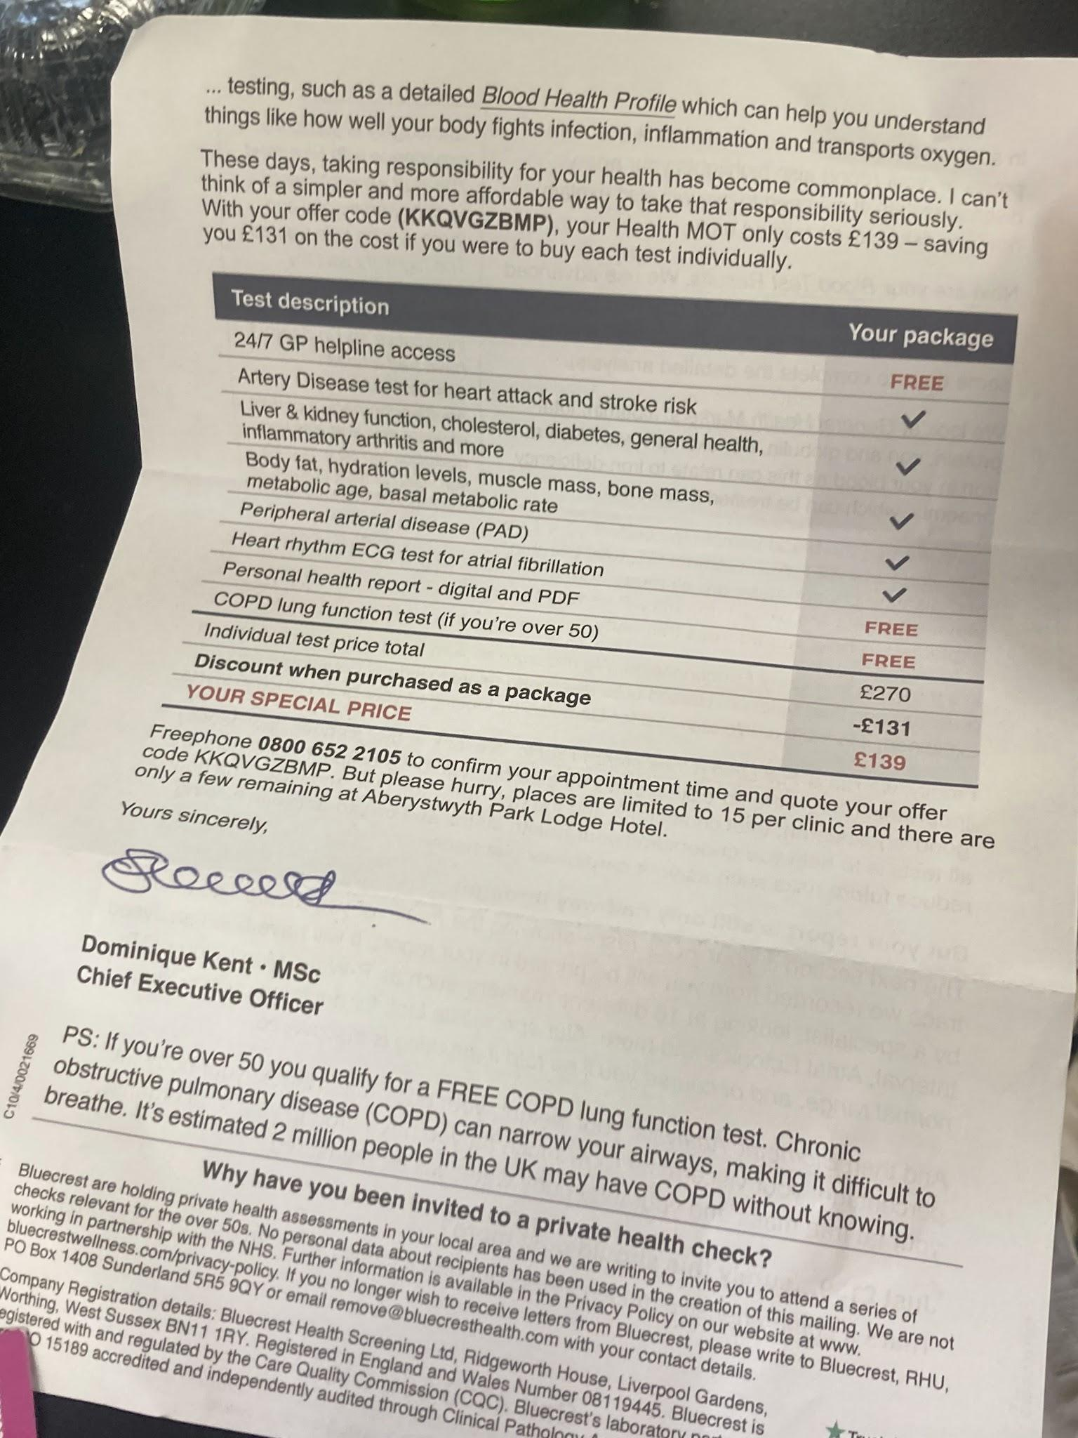

The rubbish left in bins can be useful to draw conclusions about the earnings of the individuals in a household. Income from this household can be drawn from data such as where they shop, the items they buy, and personal assets. In this household, there is likely a higher income level. The food they purchase, including venison sausages from local vendors, and expensive Earl Grey tea bags. This shows a disposable income which can afford higher quality and more artisanal items. There can also be an insight into the economic stability of this household through some of the post they were receiving. These individuals were receiving post from private healthcare practices (likely indicating some form of using this private healthcare practice), and a subscription to the New York Review of Books, which is around $100 to subscribe to. This shows a disposable income and a high economic status.

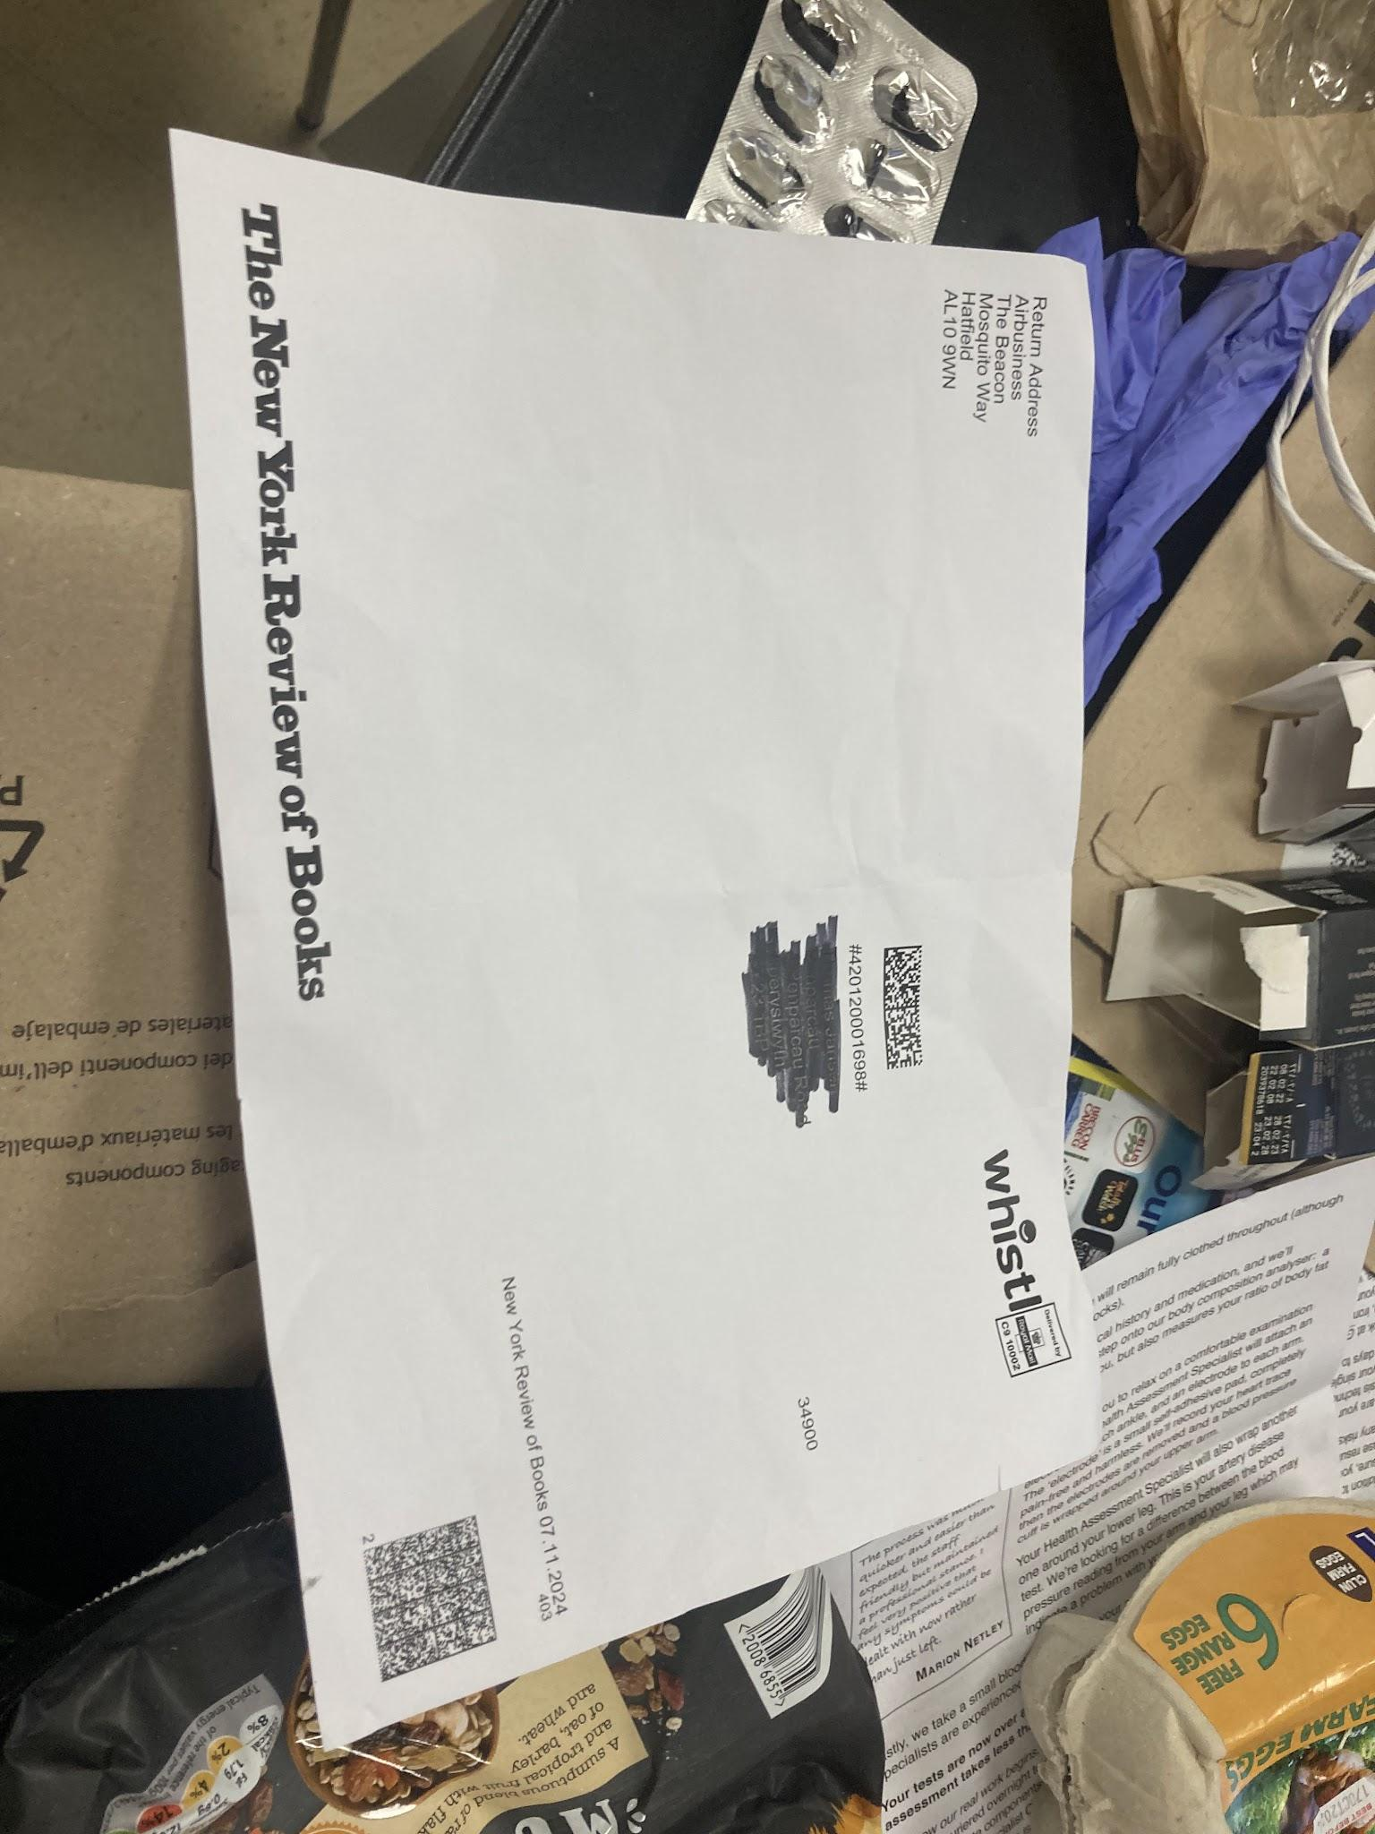

The food products found in the bin bags from the practical can be identified as mainly coming from three supermarkets: Lidl, Morrisons, and M&S. Some items were from smaller businesses, but very few. The majority of the items were from Lidl. This shows that this household is likely in an urban area due to the concentration of shops which must be close by for the household to have such a diversity of shops.

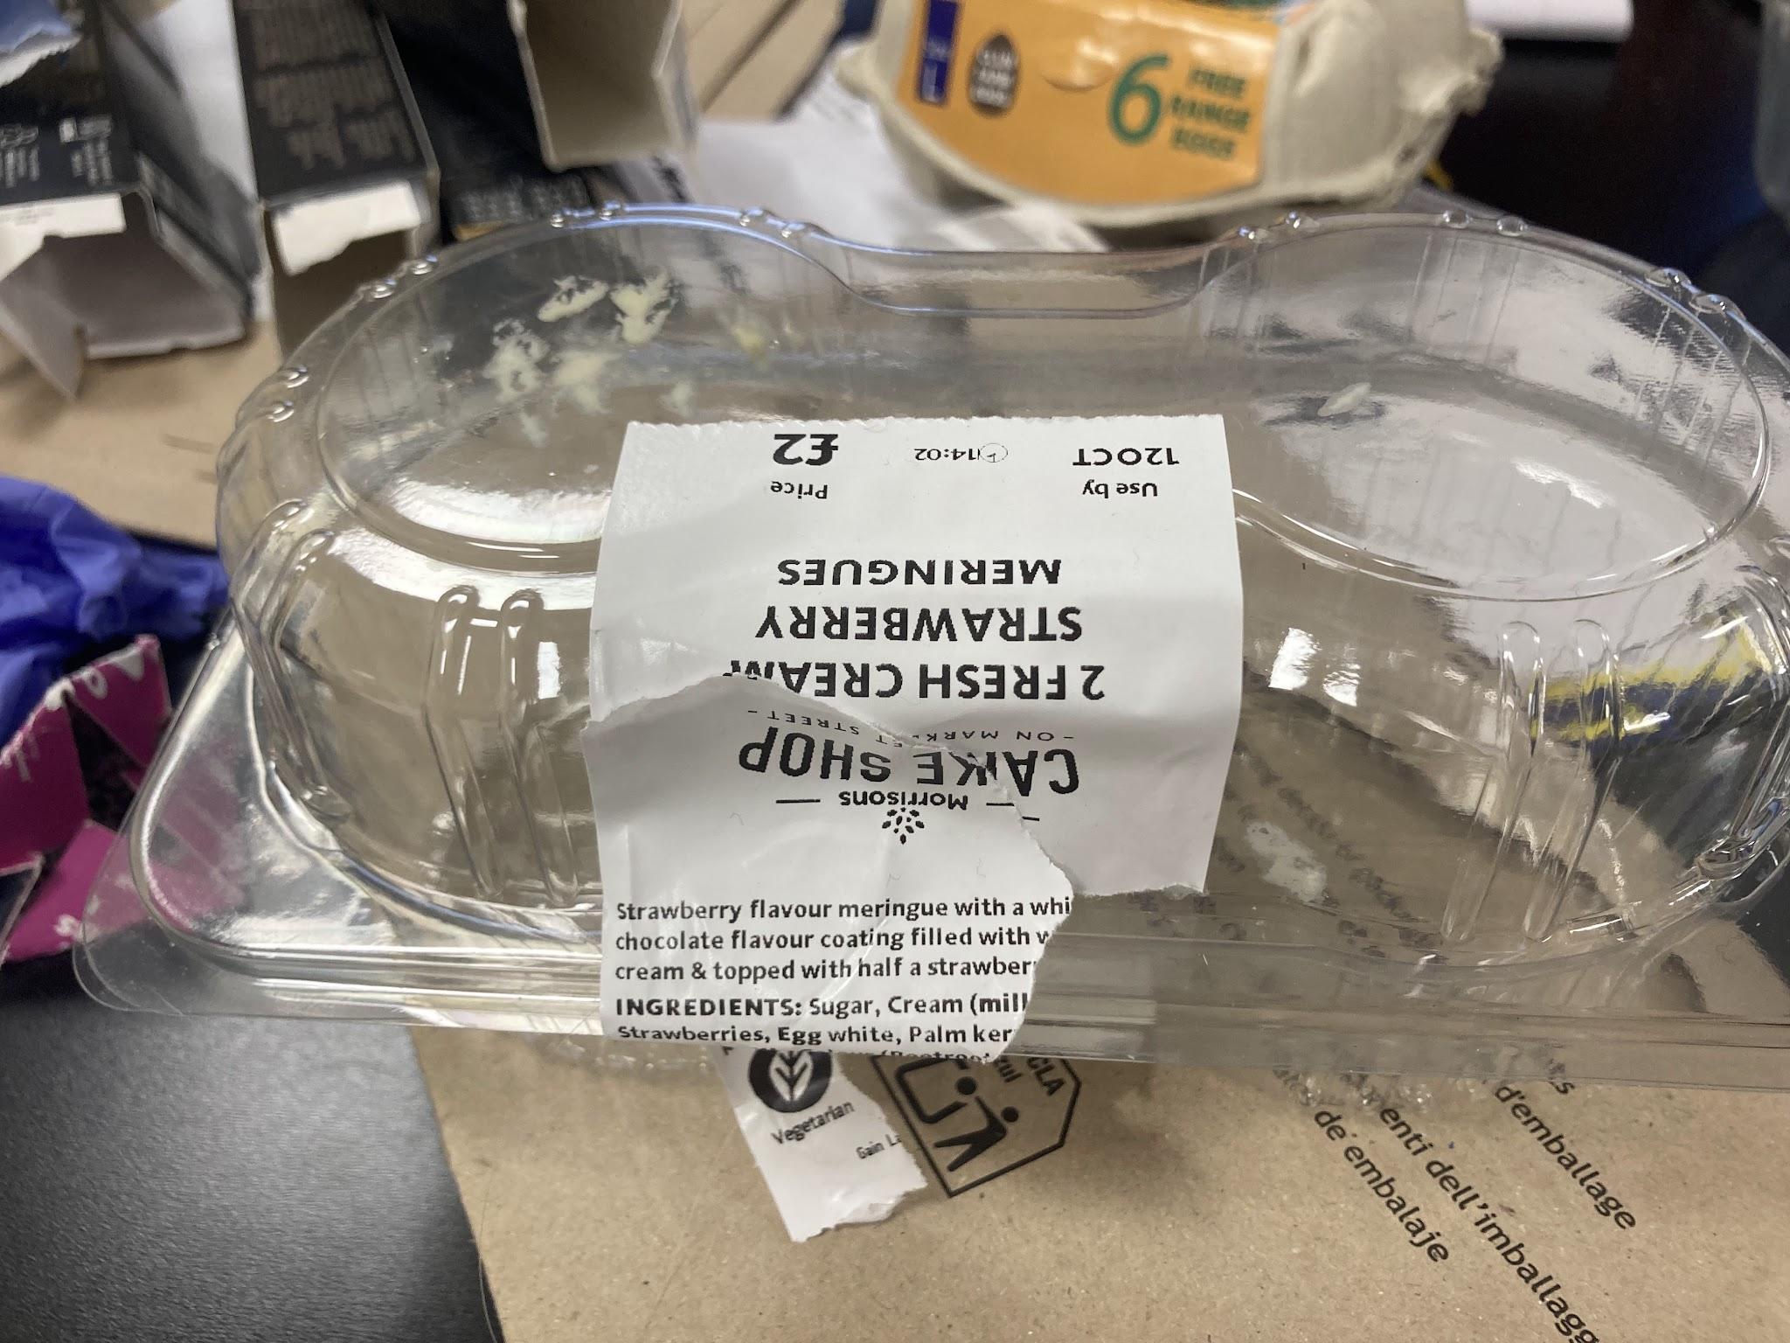
Typically, the use of Lidl as a main shop to purchase produce from would indicate economic instability for the household, as it is a budget shop which consistently ranks as one of the cheapest supermarkets in the UK (Simmonds, 2024). however, the utilisation of other shops such as Morrisons and M&S shows that this is not entirely a money-saving strategy and instead may have something to do with the products which are found in little stores which may not be found in others. This is because Morrisons and M&S are not budget supermarkets, with M&S being notorious for its high prices. Furthermore, other items they were purchasing were more expensive, such as Earl Grey tea bags which were around £10. This could connect with the increased amount of German-prone rubbish found in the bins as little is a German supermarket with predominantly German products which may be difficult to find in other shops. culturally German tastes in this household can also be found in the food which is consumed. Items such as venison sausages and oxtail are uncommon to be found in solely British households but would be more likely to be found in German households. From this, we can infer that there is at least one individual in the house who has some form of cultural tie with Germany. This also shows a pattern of immigration into the UK, once again solidifying the trade and travel links. However, this cultural connection with Germany is likely unrepresentative of wider social patterns in all UK households, or even the cultural patterns of this area. This can be seen by analysing other rubbish in the same area, as seen with this spread:

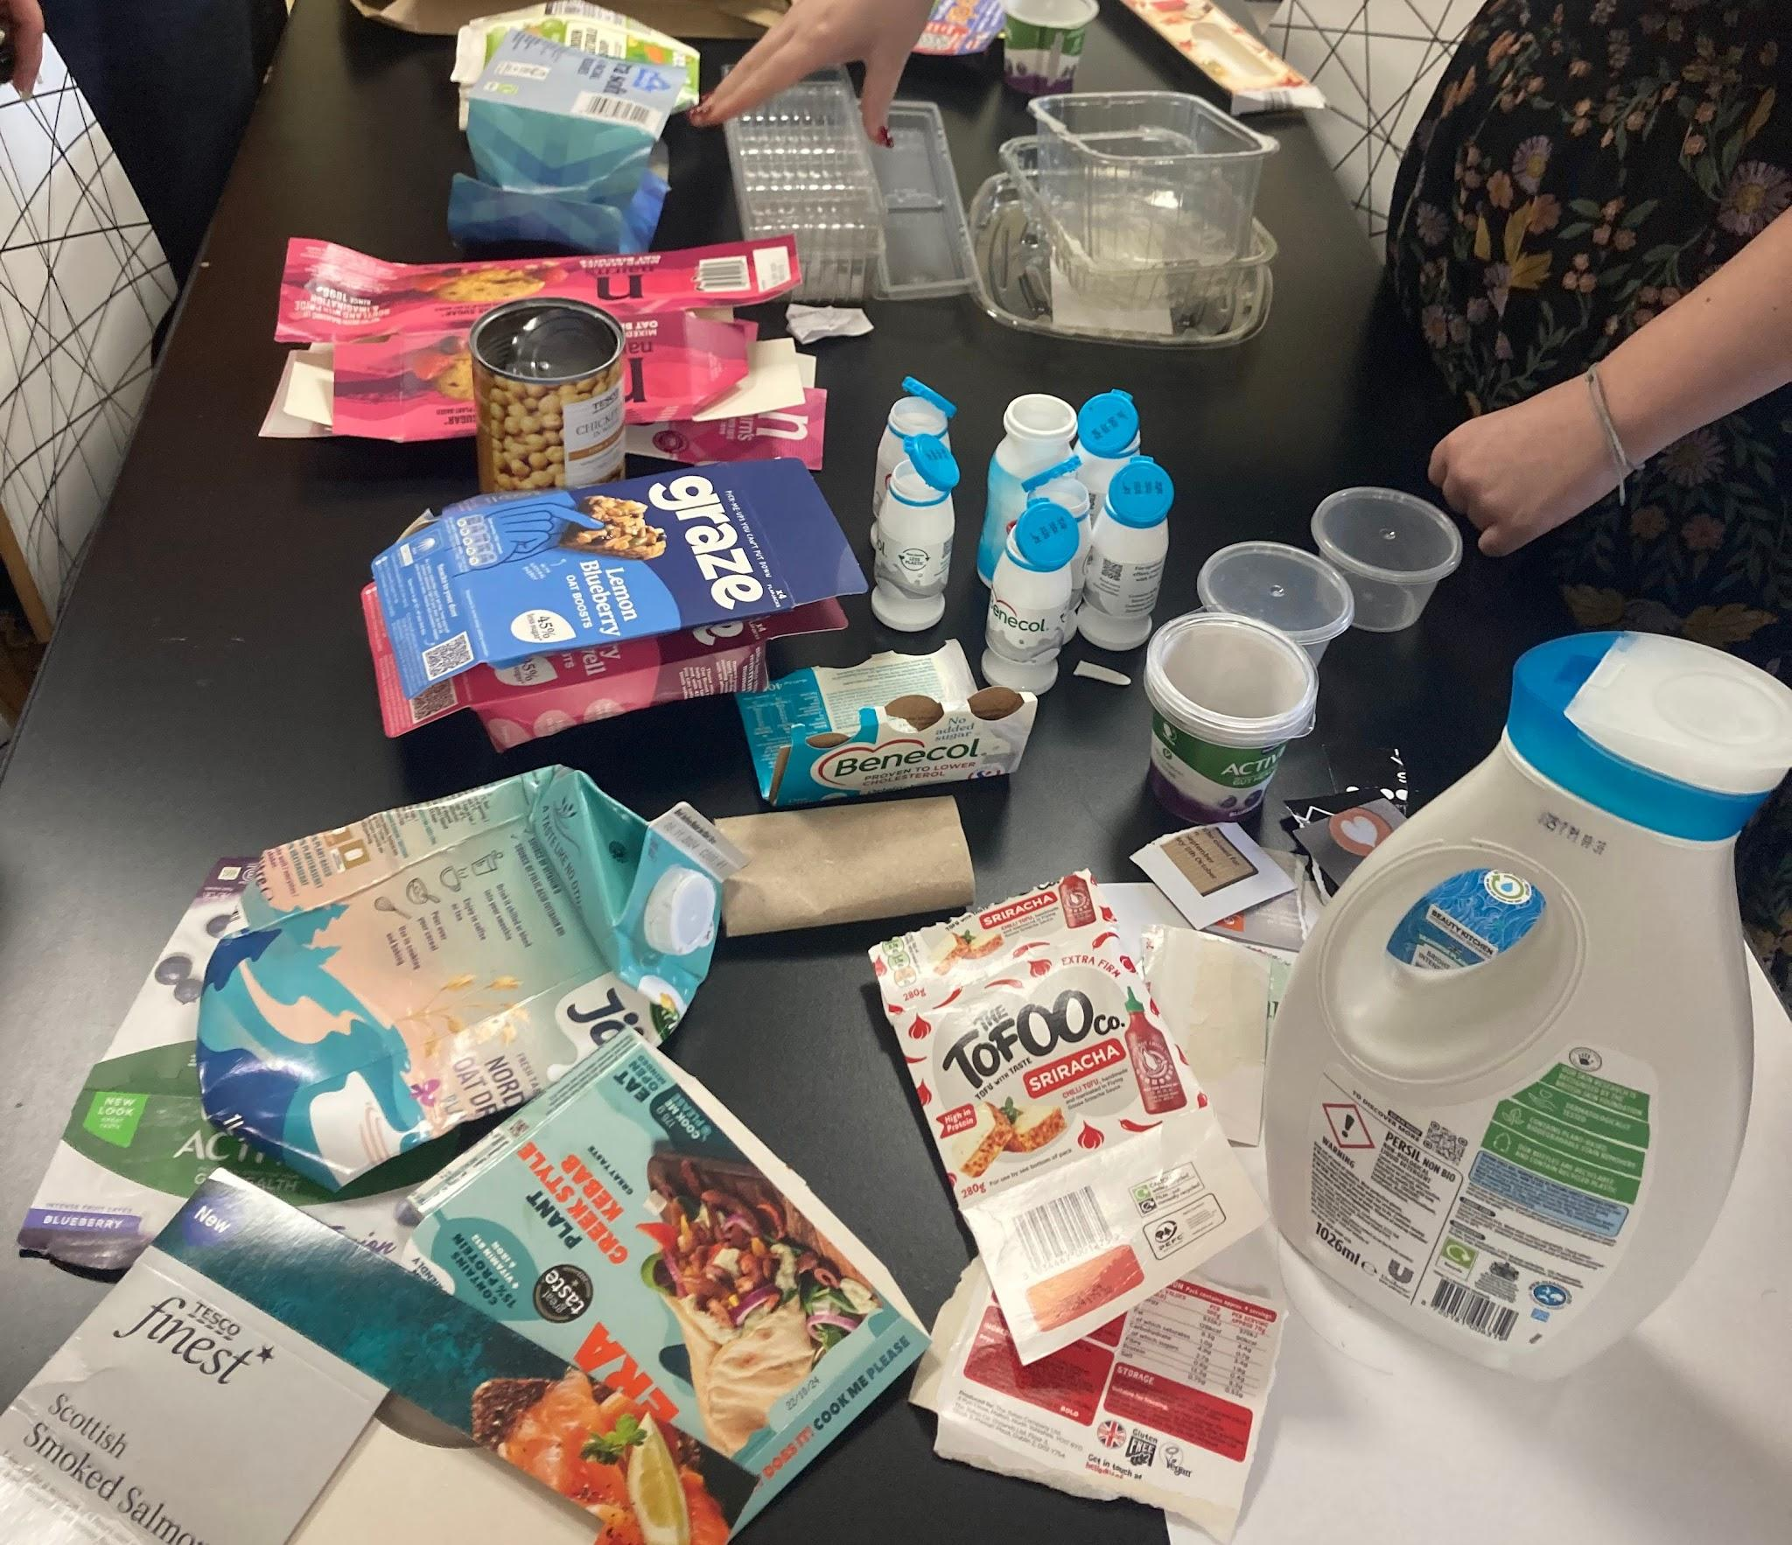
This collection of rubbish, along with other spreads of rubbish in the same area, show a minimal amount of real German or Chinese influence on them. This shows that whilst this spread of rubbish is useful for understanding trade and travel links, along with the cultural migration from Germany to the UK, it is not a fully representative picture of the consumption or purchasing habits of the demographic, so could be an outlier to stereotypical UK consumption habits.

This information could be useful for Manufacturers and supermarkets to know and understand their target audiences and the items which are preferred to be purchased from them. For example, this household shows a distinct preference for buying baked goods from Morrisons, showing the shop what they should invest more in. It could also be useful to understand portion sizes,
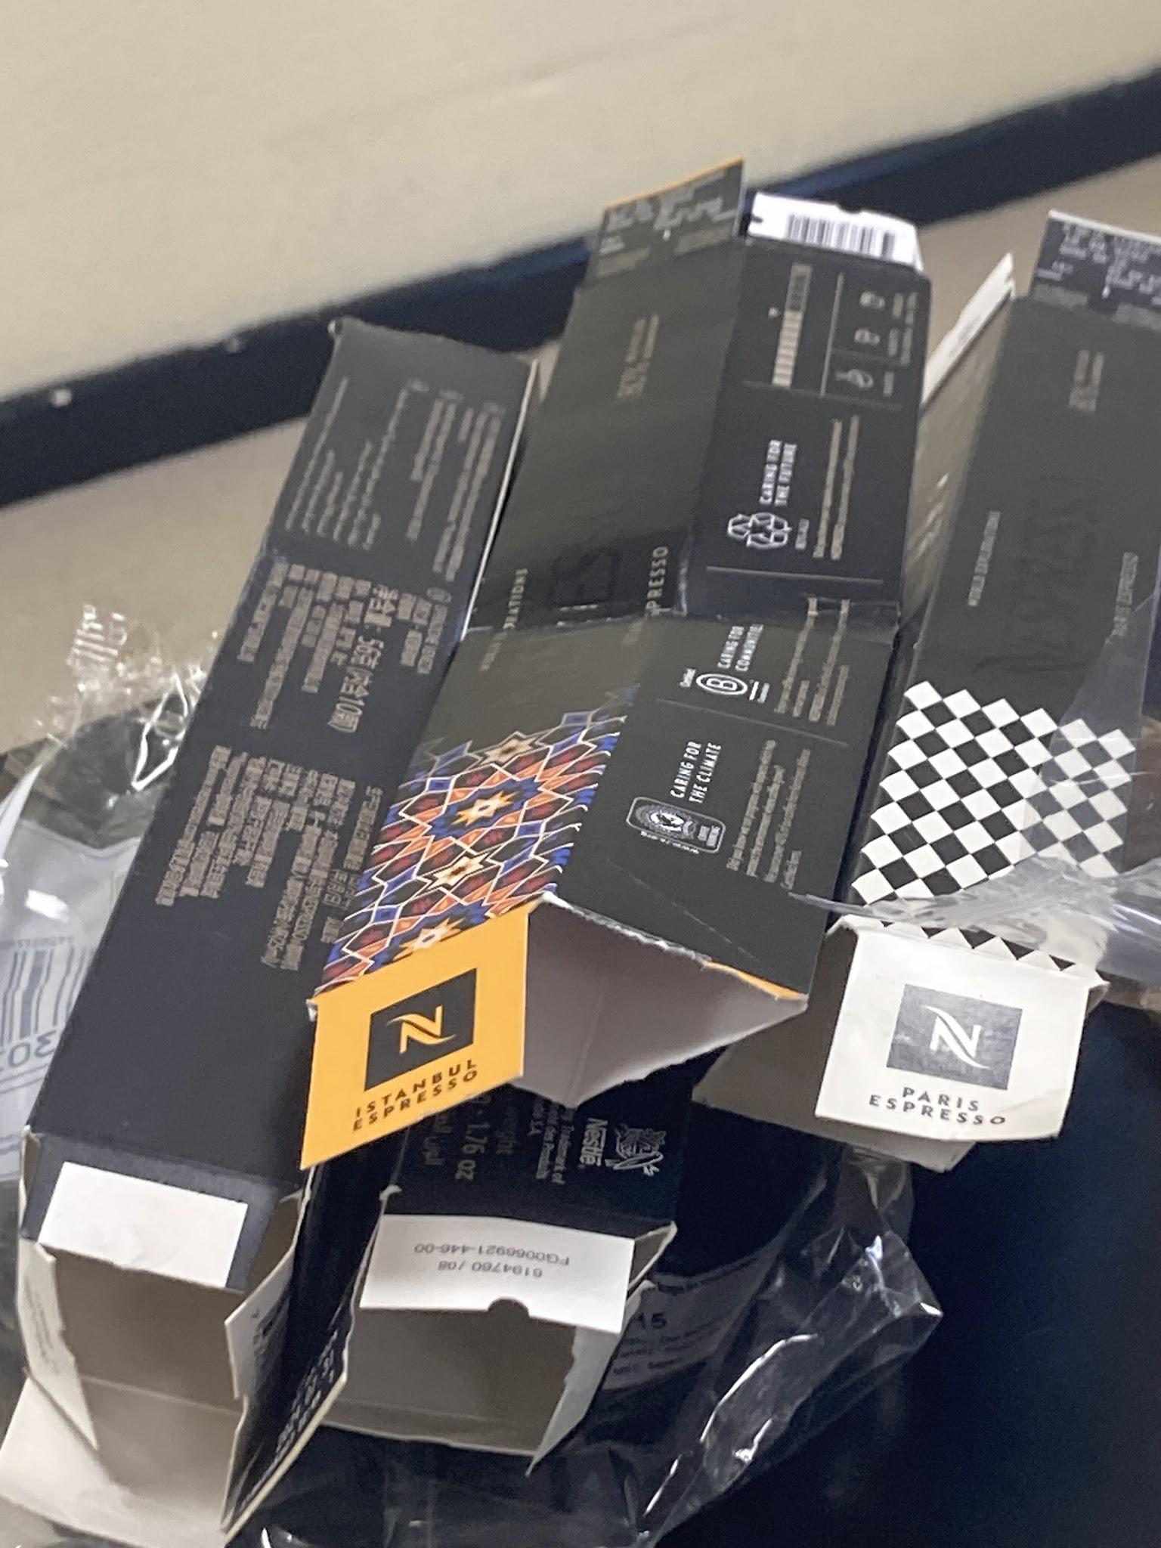

Material and origins
The rubbish found in this household’s bin bags shows a distinct pattern of globalised trade and travel links. This can be seen due to a number of German products, especially letters and postage, and some Chinese products, specifically Nespresso boxes with Chinese writing on them being found in the binbag. These products show some form of connection to both China and Germany by the individuals living in this household. The coffee boxes with Chinese writing on them were likely bought in China instead of purchased in a shop that imports Chinese produce or shipped in because they are a relatively popular product that can be purchased in the UK, and is not a specifically Chinese brand. This shows that it is likely these individuals travelled to China and then brought back the coffee pots. Items from Germany are also products that are used in everyday life, and are accessible in the UK and not specific things that can only be purchased in Germany, so it is also likely that these are not personal effects and are instead the after-effects of travel to both Germany and China. On a wider societal level that tells us that there are trade and travel links to both Germany and China from where this household is, and therefore infers a wider sense of global trade and cultural links.

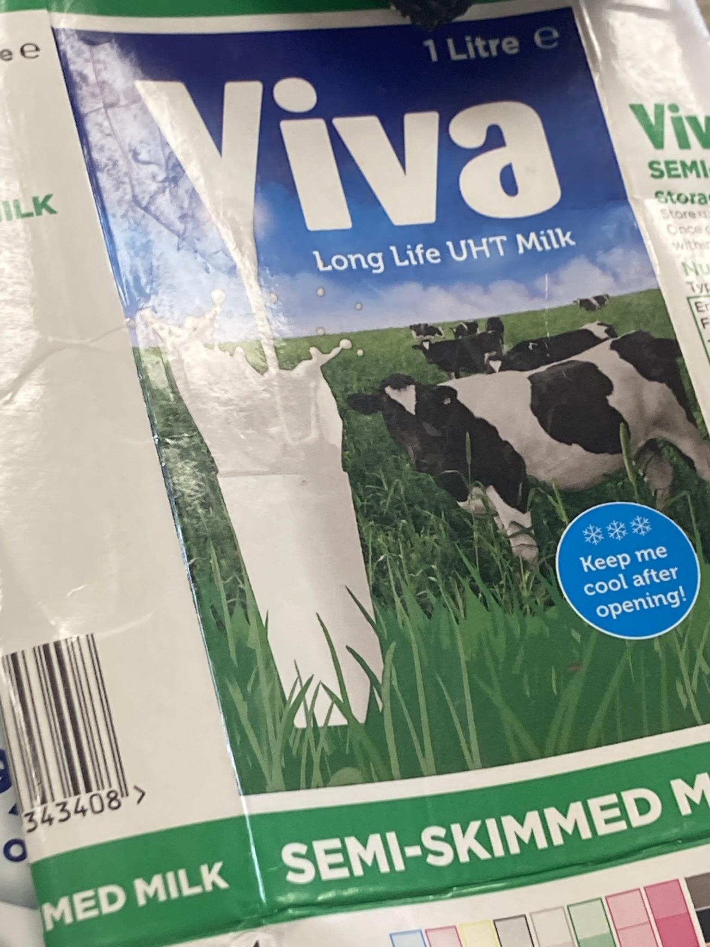
Dates
The dates on which the food products were expiring were around October, with some exceptions going into December and a bottle of long-life milk which expired in August. From this, the assumption can be made that this rubbish was thrown away around October time. The exception of the long-life milk, however, could show that there was either a lack of product or a timeframe in which they were not throwing away or producing rubbish. Both of these indicate time away from the household, tying into the amount of foreign produce. The limited timeframe which this rubbish comes from makes this research limited in the conclusions which can be formed about this household's consistent patterns in consumption, and it is entirely possible that this could be an inaccurate representation of the usual consumption habits of this household.

Conclusion

Overall, whilst the garbology of this rubbish is not useful for representing the socio-economic patterns of the larger demographic of households in the UK, or even high-income, no-children households in the UK; it is useful for understanding more about the connections of our society, and how increased globalisation may have affected social patterns. The study of garbology is useful for understanding consumption and how it reflects the day-to-day lives of individuals and the wider social context. To come to more representative, and therefore generalisable, conclusions about consumer habits in a wider community, this practical would benefit from a larger sample size, of both individuals whose rubbish is being analysed, but also a larger timeframe from these households, which would also add an understanding of how consumption fluctuates over time. Larger sample sizes are what make Rathje's (2001) and Lehmann’s (2015) research in the US and Australia respectively representative. The quantifiable data which was drawn from these large numbers of participants means that it is entirely likely that the findings can easily be generalised to a wider community, and represent cultural patterns in an area.

Bibliography
Lehmann, L.V. (2015) The Garbage Project Revisited: From a 20th Century Archaeology of Food Waste to a Contemporary Study of Food Packaging Waste, Sustainability. Edited by Kirrilly Thompson, Drew Dawson, and Anne Sharp. Article, pp. 6994–7010. https://doi.org/10.3390/su7066994.
Simmonds, E. (2024) Supermarket prices: which is the cheapest supermarket in 2024? https://www.which.co.uk/reviews/supermarkets/article/supermarket-price-comparison-aPpYp9j1MFin.
Spelman, E.V. (2016) Combing through the Trash. https://doi.org/10.1093/acprof:oso/9780190239350.003.0002.

