Lv.5 DATA CAPTURE – ACDA6021, REFLECTION
BEN LLOYD - 2219811

DATA CAPTURE: TRIAL CRITIQUE
- Abstract

A visit to the Cranfield Ordnance Test and Evaluation Centre (COTEC) was organised to make use of their facilities to gain an understand of how an OME Trial would be conducted under “real world” conditions. Whilst there, an unknown device was detonated and based on the data obtained, the operator was able to determine that the detonated munition was a pipe bomb, filled with PE8 Energetic Material (EM). This report analyses the OME Trial for opportunities for improvements and makes recommendations to refine future trials.

Table Of Contents
- Abstract (Page 1)
- Introduction (Page 1 – Page 3)
  - Figure 1 (Page 2)
  - Figure 2 (Page 2)
  - Figure 3 (Page 3)
- Experiment Critique (Page 3 – Page 7)
  - Figure 4 (Page 3)
  - Figure 5 (Page 4)
  - Figure 6 (Page 4)
  - Figure 7 (Page 5)
  - Figure 8 (Page 6)
- Critique of Results (Page 7 – Page 10)
  - Figure 9 (Page 7)
  - Figure 10 (Page 8)
  - Figure 11 (Page 9)
  - Figure 12 (Page 9)
  - Figure 13 (Page 10)
- Conclusion (Page 10 – Page 11)
- References & Appendices (Page 11)

- Introduction

The OME Trial carried out at COTEC was a small-scale Arena Trial consisting of a 50cm raised platform that the Device was placed on with a cardboard piece underneath the platform to help absorb ground shock. Also utilised were double-layered Fragmentation Packs, known as strawboard, which were placed two layers thick and one layer high and banded to steel support struts. Each pack in the strawboard array was labelled to note it’s relative position to the device and the raised platform was placed 1 metre away from the strawboard array.
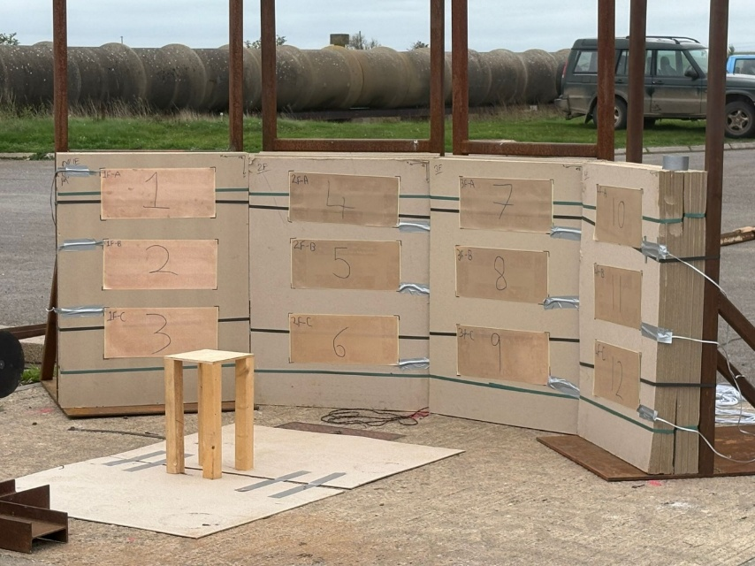

Figure 1 – Velocity Foils fitted to Fragmentation Packs

Attached to the strawboard array are Velocity Foils, which were subjected to constant electrical current and broken by fragmentation. Upon impact, the circuit is interrupted and flow of electricity will cease, indicating the velocity of the ejected material. Similar to the packs, these were also labelled so the reading from each Foil can be attributed to their location relative to the blast’s epicentre.
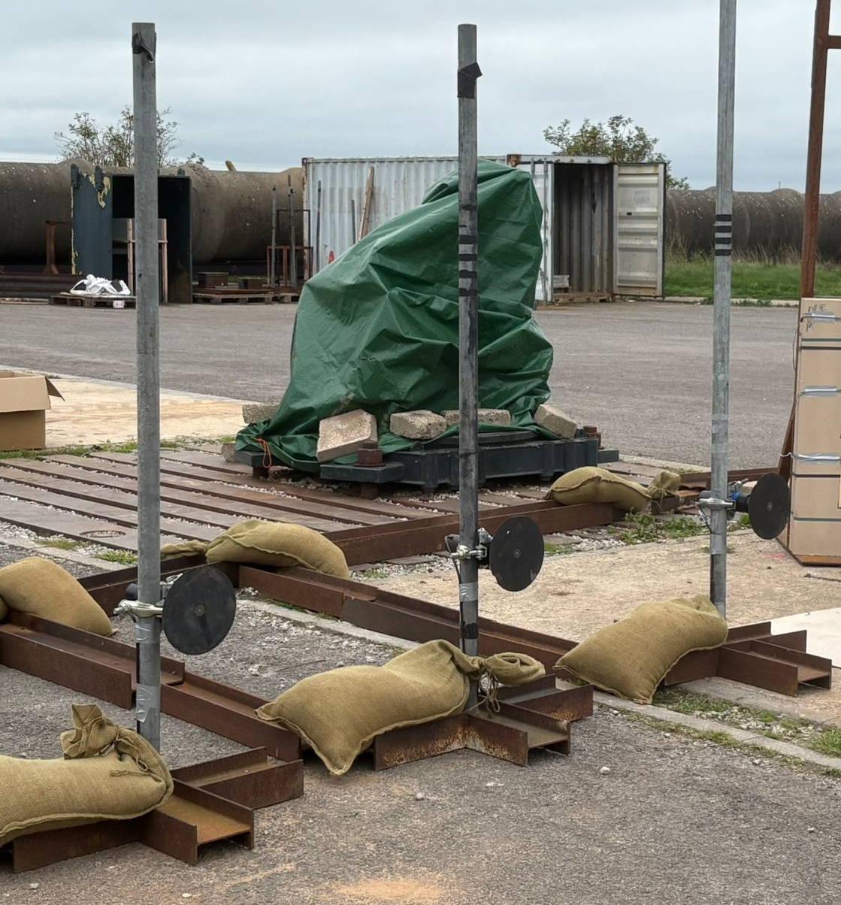

Figure 2 – Blast Gauges

The final component needed for the trial are the three Pressure Gauges placed 1, 2 and 3 metres from the epicentre, these are to measure how the blast’s waves behaviour and how the wave’s energy dissipates over a distance. When all these components are combined and presented diagrammatically from a bird’s eye perspective, it resembles Figure 3.

Pressure Gauges with 1, 2 and 3 metre separation

Blast epicentre

1 metre separation

Fragmentation Packs & Velocity Foils

Figure 3 – Trial Diagram
- Experiment Critique

Whilst the trial was successful in discerning the nature of the device, there were several opportunities for improvement in regard to the physical aspects of the trial itself. The Pressure Gauges were set to the correct height to capture the leading edge of the blast wave. However, it is reasonable to assume that if they were set higher or lower, obtained data would likely be unusable as gauges would be recording pressure after the wave front has passed the gauge itself, resulting in conflicting readings.
Leading edge of blast wave and Pressure Gauge

Blast epicentre

50cm raised platform

Figure 4 – Pressure Gauges, horizontal plane

However, the largest issue is that data was obtained from only three gauges and the sample size of obtained pressure data was too small to form a verifiable average blast pressure curve. In future, it would be better if more gauges were used and in multiple directions, this allows operators to create a more complete set of data and give a more accurate representation of the blast wave [1].

Figure 5 – Revised Pressure Gauge layout [1]

A major component of gathering “clean” data is elimination of noise and this could be achieved through several alterations; the cardboard piece underneath the raised platform intended to absorb ground shock was unfit for the task and could be exchanged for an alternative material more suited to absorb the shockwave. Polymers such as Sorbothane or Hydrogel show excellent insulating properties during trials [2] and would be ideal for such a task.
Reflected blast wave

Figure 6 – Pathway of reflected blast wave

Pressure data obtained from the trial showed a large secondary shockwave as shown in Figure 7, it is theorised that the second spike in pressure is caused by the blast wave reflecting off of the concrete standing and into the second pressure gauge. Replacing the cardboard with the previously mentioned materials may help eliminate this behaviour and allow the obtained data to more closely resemble “ideal” blast wave behaviour.

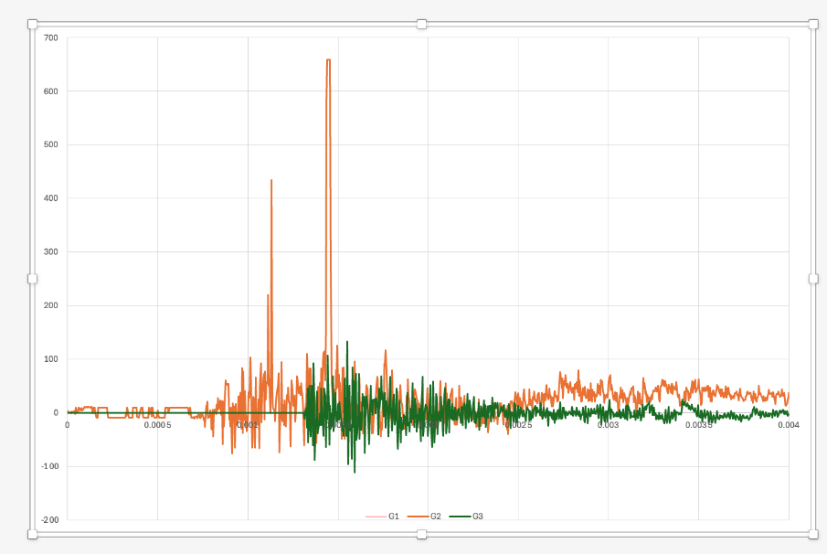

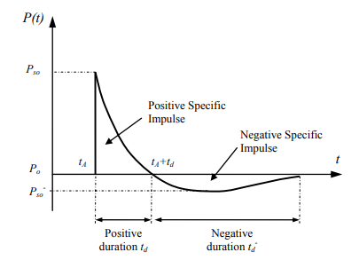

Figure 7 – Actual data versus ideal data

To further assist with elimination of noise, changes could be made to the steel supports the pressure gauges were mounted to. Both steel and concrete are excellent conductors of shockwaves and that while a Sorbothane pad underneath the munition could help, it is unlikely that it would absorb all ground shock. This shock would subsequently travel through the supports and into the pressure gauges, which would manifest as noise. To solve this, an alternative material to steel could be selected. Wood has long been used for its shock absorbing properties [3] and can very easily be worked to full the same function as the steel versions, they may not be as resilient as the metallic versions but this is a fair compromise to help eliminate noise and “clean up” the obtained pressure data.

This trial also did not make use of any high-speed cameras either and being able to watch the detonation happen would have been useful however usage of cameras would also be accompanied by several caveats, chief among these would be that it would defeat the point of interpreting the data to ascertain the nature of the device. In a more realistic scenario where the device is known, visual data would be invaluable.

Lastly, the strawboard fitted to the steel frames could also be improved. As already stated, they were banded to the frames two layers deep and one layer high. Post-detonation observation indicated that no fragmentation was able to fully penetrate the first layer and this implies that the second was unnecessary. Whilst it is useful the undamaged second layer could be reused; these strawboards could instead be stacked one layer deep and two layers high.

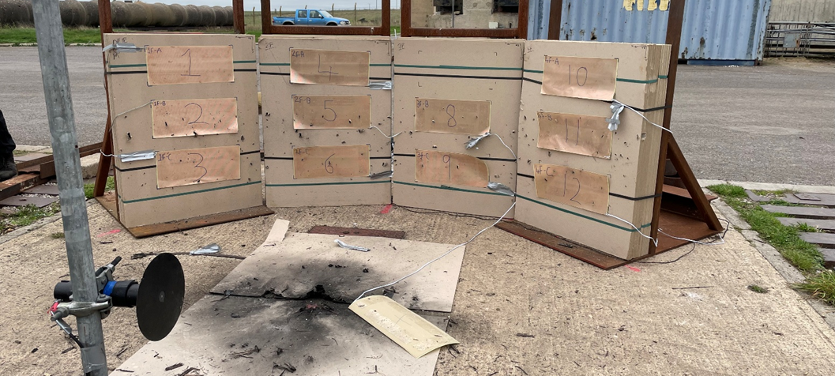
The purpose of this is to capture a wider segment of the device’s detonative arc, the trial proved that the fragmentation pattern was mostly flat and thus implied a cylindrical casing, this can only be said with the benefit of hindsight. Were the device not a pipe bomb and the blast more omnidirectional, this revised setup would provide greater information about the device’s fragmentation pattern and captured a greater number of fragmentation pieces for analysis.
Figure 8 – Fragmentation pattern

Also worthy of note that the weather conditions on the day were a low cloud cover, it is entirely possible that the generated blast wave could be reflected from the cloud back into the pressure gauges which would also be a contributing noise factor. However given the overall low NEQ and time taken for the blast wave to return, this can be discounted from this particular trial but should be considered for larger munitions. Ideally, a different day should be selected to carry out the trial but this may not always be possible due to time constraints, a relevant issue concerning real weapons development programmes.

As a final method for controlling noise, the lengths of cable used could be shortened; excessively long cables are subject to Radiation Hazard (RADHAZ) which can also influence the final readings of sensors used in the trial, especially as the operators had electronic devices on their person. While all personnel were isolated from outside conditions during the detonation, the cables were still subjected to background electromagnetic radiation and this should be controlled where possible. The cables themselves were protected by steel beams which helped them survive a potential fragmentation strike but may have helped isolate them from RADHAZ, like a Faraday cage.

- Critique of Results

The Device was successfully detonated and data from the Blast was gathered. Starting with Fragmentation pieces, these were washed in acetone to remove any remnants of velocity foil that may have bonded with them, leaving behind a dull grey appearance. The fragments were also weighed, with the average mass being listed as 0.862g, and as the volume of the fragments was also known, density can be calculated which will provide an indication of what the fragments were made of. Whilst it was clear that this was a low-carbon steel based on the overall appearance and prior experience with metalwork, this approach is not scientific and not reproducible between operators.

Instead, more reliable methods should be used. Checking to see if the metal is ferrous with a magnet would instantly rule out brass or aluminium as potential materials, further tests such as X-Ray Diffraction (XRD) would show a more comprehensive review of the material’s exact crystalline structure and would highlight what kind of steel is used [4], for instance the presence of chromium or molybdenum would indicate if the steel is a stainless or a tool steel, which may also indicate the origin of the fragmentation as different countries may favour different metallic blends.

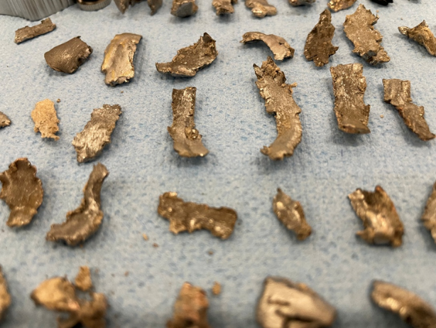

Figure 9 – Fragmentation obtained from the blast

During the trial, the pressure gauge closest to the blast’s epicentre suffered a fragmentation strike and for obvious reasons, data from this gauge was discounted. However, the gauges themselves were left exposed to the blast and while a degree of damage will always be unavoidable, it would be sensible to up-armour the gauges in future to protect against damage.

Blast pressure gauges such as the Kistler 607c3 used at COTEC are not cheap and efforts to preserve and reuse sensors where possible not only saves money over a long period, it also boosts overall efficiency as time and resources are not spent constantly replacing parts.

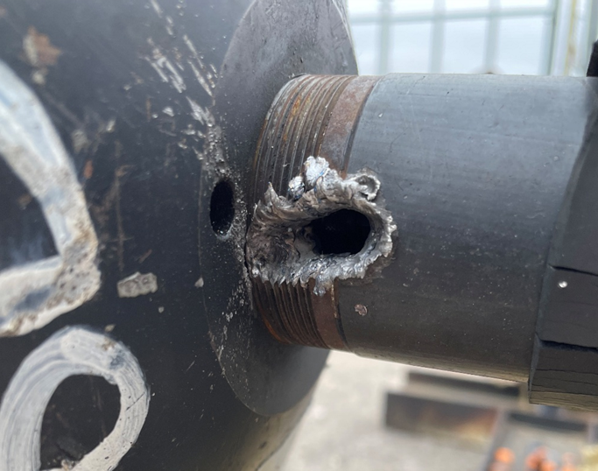

Figure 10 – Destroyed gauge

It also should be noted that the only option for this trial involved detonating the device rather than making use of Non-Destructive Testing (NDT) methods such as Neutron Radiography (NR) [6] which can reveal if there are any internal voids in the device that could hold explosives or changes in material density that confirm presence of EM in an object. The flaw with this methodology is that it relies on being able to physically handle the device, which in this case was not permitted but certainly could be applied to a more realistic version of a similar trial.

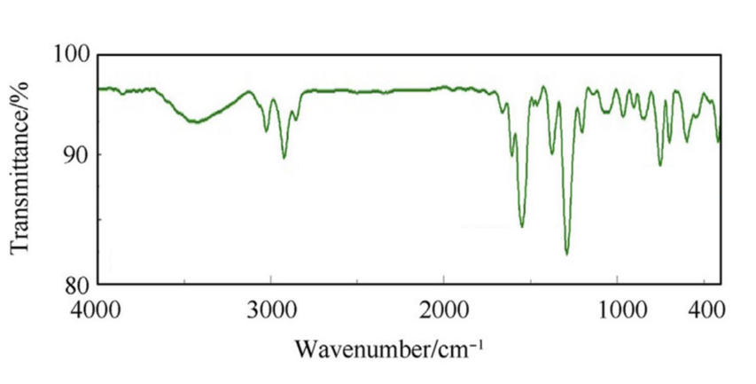
Fournier-Transform Infrared Spectroscopy (FTIR) analysis was also used on the EM residue to determine which explosive was used, which indicated Peaks at 3070 cm⁻¹, 1600 cm⁻¹, 1040 cm⁻¹ and 1270 cm⁻¹.
Figure 11 – FTIR graph

While the chart was not particularly detailed, the generated sheet of test results clearly listed the transmissivity of each chemical bond inside the EM and these figures were cross-referenced with a chart that indicated the presence of C-H, C-O and N-O bonds and also noted that there was plasticiser in the mix.

It was down to the operator to discern what EM was used based on the chemical bonds present. Prior to receiving this data, operators were given a list of potential options and the conclusion reached was PE8. Had this information not been present, it is highly unlikely that a definitive conclusion could have been reached due to the sheer amount of different explosives that currently exist.
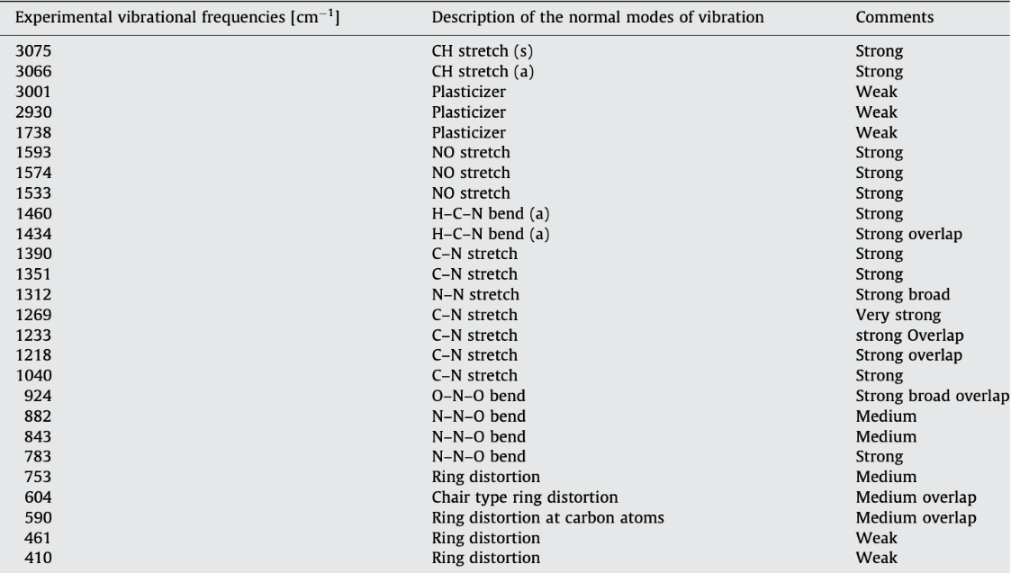

Figure 12 – FTIR Results

Pressure Data was also generated as part of the analysis, and as previously stated, data from gauge 1 is completely unusable due to the fragmentation strike and this was subsequently removed.
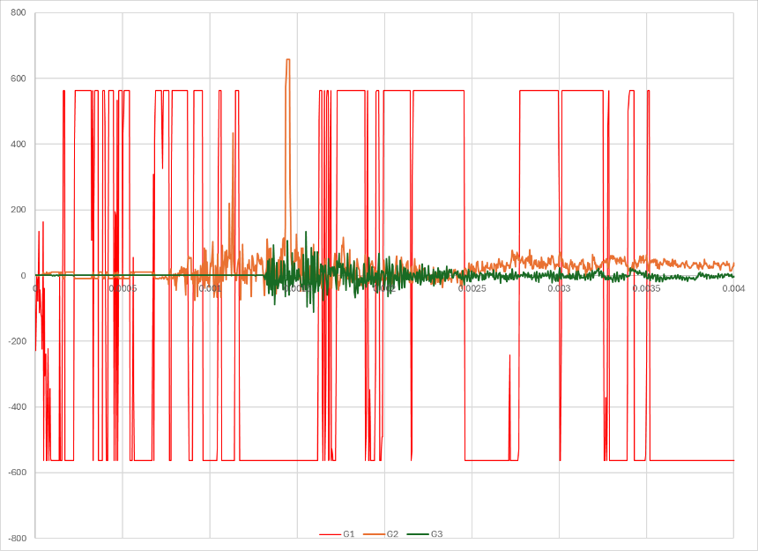

Figure 13 – Raw pressure data

Also as previous noted in Figure 7, the pressure gauges were able to record an initial Pressure of ~450KPA with a secondary Pressure of ~660KPA, this was likely due to the pipe bomb likely being unsealed causing a large, reflected ground shock and the mitigation factors for preventing this have been previously discussed in Para iii. It is also entirely possible if the non-fuzed end were sealed then the secondary shock would either not occur or not be as large as the blast wave would be vented from the top of the device.

Velocity data was also gathered but this seems to be very thorough, the foils were placed with good coverage over the strawboard, twelve foils were used which delivered a large sample size of data and using a provided velocity calculator gave a final figure of 2057m/s. If some critique is to be made, the foils should have been subject to better security as foil 7 fell from the strawboard during detonation but this likely would have happened post-detonation and would not affect obtained data.

- Conclusions

Whilst this trial was effective in demonstrating how an OME trial would function and provided awareness where there previously was none, it was also flawed and showed many areas for improvement on the equipment side. Due to inexperience with trials activities, it would be impossible for the author to say that if this trial would be acceptable in a “real world” testing regime but the recommendations set out may help to refine obtained data and form as accurate a picture as possible of the pipe bomb’s detonation.

It is the author’s opinion that the real purpose of this assignment is to be able to look at one’s own work and analyse it for weaknesses so they are not repeated in future. It is reasonable to assume that this idea may be scaled up and that testing facilities such as COTEC do much the same on their own work to provide the Ministry of Defence and industry with as accurate information as possible so that either party may make informed decisions concerning policy or the direction of development programmes.

- References & Appendices

[1] – S.Darcy-Page, October 2025, Cranfield University, Capturing an Event and COTEC Range Day
[2] – B.Langhorst, October 2010, Idaho National Laboratory, Material Systems for Blast-Energy Dissipation, https://digital.library.unt.edu/ark:/67531/metadc831886/m2/1/high_res_d/1009167.pdf
[3] – K.Takahama, August 2019, International Symposium on the Packaging and Transportation of Radioactive Materials, Study for Dynamic Behaviour of Shock Absorbing Material: Effect of Numerical Models, https://resources.inmm.org/system/files/patram_proceedings/2019/a1295_1.pdf
[4] – J.Bergstrom, 2015, Massachusetts Institute of Technology, Mechanics of Solid Polymers, https://www.sciencedirect.com/topics/materials-science/x-ray-diffraction
- Appendix A: J.Read, 23 February 2024, Forensic Science, Medicine and Pathology Cranfield, Sustainable and economical alternatives to fragment capture materials in explosive and ballistic trials, https://dspace.lib.cranfield.ac.uk/server/api/core/bitstreams/181438a6-3a30-4112-b99d-aef24a8e3a95/content

- Appendix B: M.Abir, March 2016, Massachusetts Institute of Technology, Nondestructive Detection of Explosives, https://www.researchgate.net/publication/328488397_Nondestructive_Detection_of_Explosives

- Appendix C: T.Ngo, 2007, University of Melbourne, Blast Loading and Blast Effects on Structures – An Overview, https://moodle.uwtsd.ac.uk/pluginfile.php/948281/mod_resource/content/0/Blast%20Loading%20and%20Blast%20Effects%20on%20Structures.pdf

