Children, Young People and Families
(BMHP5004)
Lecturer: Dr. Gulnar Ali
Student number: 1808072
Szilard Szanto
1808072
Table of Contents
- Introduction 2
- Special Educational Needs (SEN) 2
- Special Educational Need Pupils 3
- SEN and Disability law 3
- Case Study 5
- Conclusion 6
- References 7

1. Introduction
Incapacity isn’t failure is a typical expression numerous individuals see today. Many have acknowledged that the individuals with inabilities can embrace a few obligations only like the others, which can be found in the expanding number of individuals with a disability in establishments of higher learning just as many working spots. There are various types of handicaps, some obvious and others imperceptible.
This paper investigates a continuous discussion in the instructive field; should all understudies with Special Educational Needs (SENs) be remembered for standard instructive arrangements? Understand the issues in question; this paper will start with an introduction to SEN and authentic advancements that have moulded SEN.
The research will be presented evaluating current issues, and analysis of SEN children will explain strategic plans that guide teachers and organisations to implement development. The conclusion will close the paper evaluating fundamental discoveries.

2. Special Educational Needs (SEN)
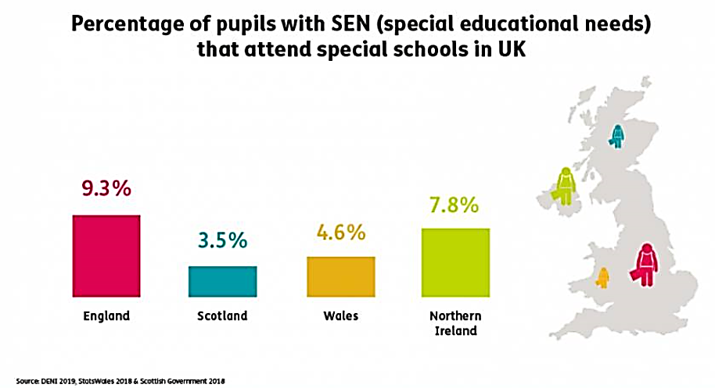
“Special educational needs (SEN) can affect a child or young person’s behaviour, reading and writing, concentration levels, ability to understand things, or their physical ability “(Gov.uk 2020). To evaluate whether understudies with SENs ought to be remembered for standard instructive arrangements, one should initially comprehend what SEN implies. Under the 1944 Education Act, young people with unique instructive needs were classified by their handicap characterised in clinical terms. Meaning that some kids were thought of to be ‘uneducable’. Pupils were labelled into classes like ‘maladjusted’ or ‘educationally sub-normal’ and given ‘special instructional treatment’ in separate schools. Without appropriate records and knowledge, it would be not possible to identify a child with SEN. Therefore, SEN (2013) characterised youngsters with exclusive academic wants as those who show off gaining knowledge of problems, emotional and behavioural problems, particular learning problem, sensory or physicals needs, communicative difficulties and scientific or fitness conditions. These features can assist parents and teachers in particular, to early discover the problem and pick out a terrific way to tackle it. This is because neglecting teens with special instructional needs will jeopardise their future.

3. Special Educational Need Pupils
On the most fundamental level of all are the children whit special needs. Considering the high level of government implication with well-structured rules and advisory group reports, one unavoidably brings up the issue of their viability. Are standard schools performing? Are understudies encountering comprehensive instruction? Are these rules and recommendations viable? Shockingly the general answer might be inadmissible. The Review Commission found that most by far of constant rejections in the 22 nearby specialists overviewed identified with students with SEN: 87% of prohibitions in elementary schools and 60% of avoidances in optional. Moreover, understudies with attention deficit hyperactivity disorder (ADHD), chemical imbalance and psychological well-being issues made up vast extents of these students.
At this stage, one needs to feature that it isn’t the deliberate expectation just to Conduct Troubles however information demonstrates that concerning the incorporation of physical or potentially physical requirements understudies, some achievement in standard training arrangements is starting to create.
Information showing that most of the of avoidance in primary and secondary are children experiencing ADHD and autism, explicit exertion has been given to address the consideration of these in standard instructive arrangements. Furthermore, the Gibraltar Instructive Tutoring Structure restricts the contact of standard instructors with students with severe and different requirements, just as multi-tangible debilitations. These understudies take a crack at excellent school condition. Being presented to students with ADHD and mental imbalance will likewise help in supporting a few answers to examine proof. Expanding information in these gatherings will likewise is valuable for CPD purposes.

4. SEN and Disability law
Sometimes the needs to invoke the law relating to children and young persons is essential. Developing the law it has been divided into two categories.
Statute, guidance and regulations are recorded and accredited by Parliament. Duties are layout to schools, local authorities (LAs) and public authority. The ability to refer to a specific duty its need to be funded in a law.” The Children and Families Act (“CAFA”) 2014 is statute law. It is legally binding, which means that the LA and schools must comply with it or else they are acting unlawfully. Part 3 of the CAFA 2014 contains all the relevant sections about children and young people with SEN and disabilities.”( IPSEA, 2020)
Case regulations are formulated through the courts and tribunals courts. It is necessary for clarifying points of the regulation which are blurred. When a case has listened through one of the higher tribunals or courts, a judgement will be prepared which explains how they think about the regulation enforces and will frequently provide extra detail about what precisely a local authority has to do to meet their legal obligations. The judgements are implemented with the LAs as correctly as decrease tribunals. Case regulation can be beneficial for discovering examples of what LAs must not and must do.

5. Case Study
This study is made based on a family with 3 children, the youngest 2 (Aaron and David) are under 5, and both have a disability suffering from learning difficulties and one of them also have bowel problems. During the pregnancy, no infection was recorded, and the delivery it was at full term and healthy. The family doesn’t have any knowledge of the same difficulties recorded in the past. The family “G” lives in Glasgow in they on property. Dad works full time in pretty low paid employment. Mother at the age of 38 years and home full time caring for the children. Mum finds it very tough to go out with the youth as she is unable to use public transport and taxis are too expensive. Due to the children’s mobility difficulties, Mum and the kids spend most of their time at home, which requests the heating of the house for most of the day and night. Due to the children’s disabilities, mum has to do plenty of laundries. These elements are having a massive effect on families.
The learning disabilities was noticed in the nursery, and SEN was informed, which was followed by a Health Visitor. After this stage, the health report confirmed that Aaron and David have a learning disability and affect them whole life. All the support provided by the GOV as promised by the “SEN support for children under 5 includes:
- written progress check when a child is 2 years old
- a child health visitor carrying out a health check for a child if they’re aged 2 to 3
- a written assessment in the summer term of your child’s first year of primary school
- making reasonable adjustments for disabled children, like providing aids like tactile signs
Nurseries, playgroups and childminders registered with Ofsted follow the Early Years Foundation Stage (EYFS) framework. The framework makes sure that there’s support in place for children with SEND.” (Gov. UK, 2020)
The youngest of the family get an extra supported from the Mencap (The voice of learning disability) organisation where at the beginning a speech and language therapy was started with the children. With a lot of love and patience teaching, it was tarted, and slowly they started to show results. It did tuck a year to manage to teach them how to use pencils and to learn some drawing. Also learned animal names, classmate names, the months of the year and also the days of the week. By this time, they started to learn also how to write. Aaron requested more help than David. He wasn’t able to writhe without some hint, but both of the children were able to writhe about the Mother and associate it with some drawing. Real big surprise it was when they started mathematics, after a short time they were able to do 3-digit addition sums.
Being quat good with numbers the team from Mencap created some new teaching methods trying to associate everything with numbers. This way, the little brains started to memorise names much more comfortable, and this was an excellent way to teach them new things. At this point, Aaron and David started to have more activities at Mencap five days a week, but this was forcing the family in a bad financial situation. The organisation helped the family to obtain a Disability Living Allowance (DLA), and they have been entitled to a Council Tax Benefit. The family was assuming that they are not entitled to any benefit because they own the house. How the economic situation allowed the mum to be able to travel even with a taxi to the daily appointment at the Mencap.
It was vealy goo to see the family getting a normal life, so the parents were able to make plans for the future. One of the most significant decision it was that they would try to explain to the boys they condition and remind them of their strengths and build their self-esteem and let them know that they’re just as good as anyone else - there’s just another way to learn. The very positive fact is was that the parents always kept the right communication level with the association, having an active interest in the boys learning progress and helping to monitor the progress.
After four years of specialised education, Aaron and David are progressing, and a special connection between the is created. Mencap is aware of the situation, and they are trying to involve more people to meet the boys, and they will be entitled to social events.
The most important is that the parents did and will do everything that they can to see these boys as a grown-up. The family support is one of the most significant support what a child needs which needs to be based on love and confidence.

6. Conclusion
In conclusion, children and young people do suffer from a learning disability, or we can call it as executive functional where a child forgets as soon as he learns.
This condition is very restrictive since the child is not in a position to be equal with other children, even though the IQ level is not weak. Such a child should be taught again and again to repeat the content. They do not keep a longer period what they have learned. In such a situation, teachers and parents should be patient with the boys. The boys should be given time to review the memorisation over and over again. Here, too, scolding and rebuke do not help, as the child is only demoralised as he is already trying to reach his highest level and is no better able to do so.

The above examples are real cases, but the details and names have changed to protect the children’s identities. The case studies of customers licensed the use of such information.

References
Anon., n.d. Department of Education. [Online]
Available at: https://www.education-ni.gov.uk/
[Accessed 17 April, 2020].
Anon., n.d. GOV.UK. [Online]
Available at: https://www.gov.uk/children-with-special-educational-needs/special-educational-needs-support
[Accessed 20 April, 2020].
Anon., n.d. GOV.UK. [Online]
Available at: https://www.gov.uk/children-with-special-educational-needs/special-educational-needs-support
[Accessed 21 April, 2020].
IPSEA, n.d. IPSEA. [Online]
Available at: SEN and disability statute law, regulations and guidance .... https://www.ipsea.org.uk/sen-and-disability-statute-law-regulations-and-guidance
[Accessed 22 April, 2020].

