Skills for the Workplace
Module Assignment Submission

Student Name:
Victoria hole
Student Number:
2022884
Module No:
BMSK4008
Module Title:
Academic and Research Skills

Table of Contents
Managing Remotely: Is it the way Forward? 3
Part 1 3
1.1 Introduction 3
1.2 Research 3
1.3 Findings 3
1.4 Conclusion 4
Part 2 4
Personal Reflection on Managing Remotely 4
2.1 Description 5
2.2 Feelings 5
2.3 Evaluation 5
2.4 Analysis 5
2.5 Conclusion 6
References 7
Appendix 1 8
Appendix 2 9

Managing Remotely: Is it the way Forward?

Part 1

Introduction.
Over the last year, the way people manage their employees has changed dramatically. Online and remote Managing has become the new normal, with face-to-face meetings and discussions having their difficulties. It is hard to see both sides of the remote-leaning argument; Varitika Kashyap, Marketing officer at Proofhub 2018, has stated many pros and cons of working remotely. Today we are going to look into that.

Research
There are many challenges to remote working. To start with, managers need to understand factors that can make remote work incredibly demanding. Otherwise, high-performing employees may experience decline and lower performances while working remotely. Both managers and staff might find it hard not to do face-to-face work. Missing the social interaction element means people can feel lonely or demotivated. This can affect some people's mental health. At the same time, other introverted characters may find it more empowering not to be in the same room while communicating. Brent Gleeson working remotely in August 2020, states some common challenges and how managers could better lead.
1. Schedule daily check-ins.
2 Over-communicate.
3 Take advantage of technology
4 Establish rules of engagement
5 Manage expectations
6 Focus on outcomes, not activities.
Management and supervisors may have concerns that employees will not work effectively when working from home; Their motivation can be affected by their working conditions. Employers don't have as much influence over employees while working from home; they could provide working equipment like desks and computer equipment may be the employee's home is not something they are likely to see. For example, people may not have curtains and windows open, may not be keeping their work environment clean, all of which can impact the employee's motivation.
I.T issues can be a concern, are workers doing enough to fix the errors, is it their internet provider's error, or is it an error with the equipment that the employee has provided. Open communication is needed from the employee to keep the manager up to date in this area.
Other concerns may be the other way around and that they worry that the employer will work too hard and make them deficient through worry and stress.
Communication is also another problematic factor through remote learning, especially with touch through email. It has a time delay unless people continuously have access to computers or phones. Employees may think that managers are out of reach and may not understand the work as much as they face asking questions. They might feel that the managers are not supportive or helpful.
Newly remote learners are often surprised with how hard and how much time is consumed from working at home. Trying to locate information from a co-worker who would seem easy face to face is quite tricky for some remote learners. Also, one of the most common factors about remote learning and working is loneliness. The most common
complaints about remote working worrying for many managers are the staff leaving due to loneliness and depression.
We often see a photo of a parent holding a child sitting down with a laptop on their lap.
It portrays remote Managing and working as easy.
It is seen as a false and unrealistic representation of sufficient work. Not everyone can work to that level.
Managing remotely and working remotely should be treated like a regular job, with routine structure, a comfortable workspace, not a room full of distractions. The managers should encourage workers to have breaks at set times and set working hours with designated start and finish times. Routine and communication are essential to prevent depression. Kluch,s.o.f.i.a.., 2020 leading Remotely, says that Managing remotely can be complicated. Of course, not all managers view remote working differently as driven by circumstances rather than choice. Some managers will embrace slight separation from their teams. They may see an opportunity to get some uninterrupted work in. Mary Lawrence mid-market human resource 2020 says to work remotely in your own home; you need to
1. understand everyday teleworking challenges.
2. set clear remote work productivity standards.
3 Identify and provide the correct tools.
4 set aside specific days, times, and methods for team interaction
5 Follow up with remote employees regularly.
6 Create a video or tip sheet with other remote workers.

Findings.
State of Remote Work (2020) reports, working remotely is here to stay. Unfortunately for some, that means working from home with some uncomfortable working conditions. Some survey respondents said they would not want to return to a job that did not allow them the option to work remotely, with 70% of workers saying they would wish to one day per week with no video meetings at all.
Remote workers are likely to stay working remotely after the pandemic, which is happening now in 2021, predominantly the better educated and well-paid minority of the workforce; now COVID-19 has occurred. Craig Lyjak Ey Global Why remote working is the way forwards states Many companies were struggling before. But now, tens of millions worldwide tend to work from home, accelerating a workplace that was struggling before. The limitations and benefits of remote Managing are much more apparent; most will return to work, but most people working remotely will stay home. More than 20 percent of a workforce will work from home three to five days a week as effectively as working five days a week from in an office in work. If remote working takes to that level, it would be five to six times as many people working from home as before. This virus has broken through cultural and technological barriers, then before would have prevented remote work. While some companies and people will thrive in remote Managing and working, many people with fewer technology skills will not survive. For example, someone who needs to handle stuff physically, maybe a factory worker or hairdresser, will not benefit. Still, someone who does office work will benefit from it greatly. Many physical or manual activities and those who require fixed equipment cannot be done remotely. Those who deliver care and support cannot work remotely. But the manager's role would mainly consist of remote management. Elizabeth Howlett April 2020 states that managing remotely can affect learning; being in an office or work environment, the newer staff members learn from the more experienced team members. Just by watching and being around them, they know how they would handle a situation.
Learning in a real-world situation can be difficult or impossible to teach from a more formal environment. A manager would do well to find alternatives. Such as listening into calls, shadowing the more experienced colleagues by joining the conference calls. Managers should figure out how to support those workers; maybe they could put together a task force and find solutions to keep them connected and ensure that they still feel valued. And include them in the planning. Managers also need to monitor their employees to check they are not struggling. A sign may be fewer emails or not talking and getting involved in the group conversation. The manager needs to get them what they need, be more flexible with them, involve them more, trust them, give them tasks, and check in on them as u would do in a workplace. Managers should also check their employees have the correct equipment and software to work comfortably from home,

Conclusion

Remote work is the best work arrangement if you want to manage your personal life better while staying productive at work. Jo brown(2020). There is some remote work that you need to consider and have to push yourself to overcome.
The world is changing so fast, in fact, faster than ever, especially in these unprecedented times, so getting the most out of your employee's necessity's success condition, from ensuring every member of staff is well set up and involving everyone in projects and events. Managing remotely is the way forwards for all companies and can be beyond that. Most successful management teams will understand how this unprecedented change is implicating their employees Havord buisness review 18,18. While the schools are primarily remote learning, I don't think remote Managing will replace the teachers, but I think it will be a massive part of school life. I think care homes admin staff and managers may take a step back from the floor and do more remote work. In my job at hillside care home, we use handheld devices to log all personal care and hand it over. I think the old way is the Right Way, face to face, with expressions. Still, I believe remote Managing and working is most defiantly the new way of life and forward.

Part 2

Personal Reflection on Managing Remotely 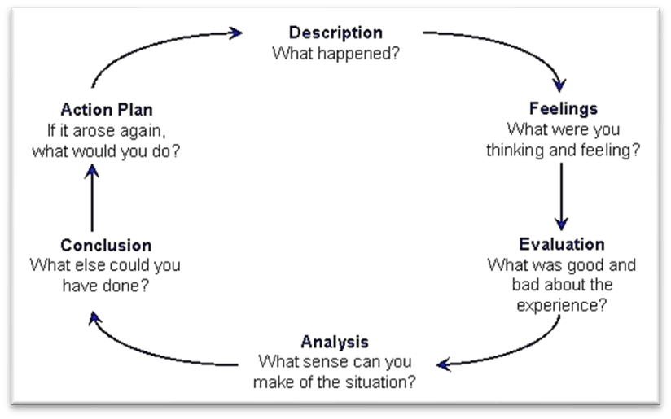

2.1 I have learned that managing remotely is not all it seems to be. Photos of parents holding their children while sat at the table with their laptops are not valid. It is false. It is misleading to people. Managers need to be much more purposeful and deliberate about managing the practice. Staff needs to be more alert and give their self's rules structure routine and a suitable workspace.
I feel when I started managing remotely that clear expectations and guidelines are needed to begin with. Remote working is still new for most people. With everyone understanding what is expected and the consequences of not doing so, managers and employees will be more confident to fulfill their roles. Discussing expectations and results gives workers on all levels the chance to express any concerns and have their voice heard before swapping to a remote working part.

2.2 The world is changing so fast that not everyone is confident with technology and that managing remotely and working remotely will Be the Way forward. I feel schools will not go back to normal now that managing and working remotely has happened, and I think Managing remotely is the new way of life and that the economy will benefit from it greatly.

2.3 Evaluation
I have read that Managing remotely is the way forward with all the information and articles I have read. Remote work increases employees' satisfaction when implanted correctly, ultimately managing remotely. Still, it has to be put into practice correctly.

2.4 Analysis If managing remotely and working remotely is here to stay. I will need to prepare myself, Maybe take some online computer classes and get a dedicated room in the house to use for work and have my workspace.

2.5 Conclusion
My conclusion is that managing remotely is the new way of life. For managers who will be doing it need to go on many training courses, for how to deal with their colleges, mental health training would be helpful to, and companion training and they also need to adapt to their employee's evaluation and performance. I feel the colleges need to consider their social environment, and the workspace needs to be fair.

Appendix1
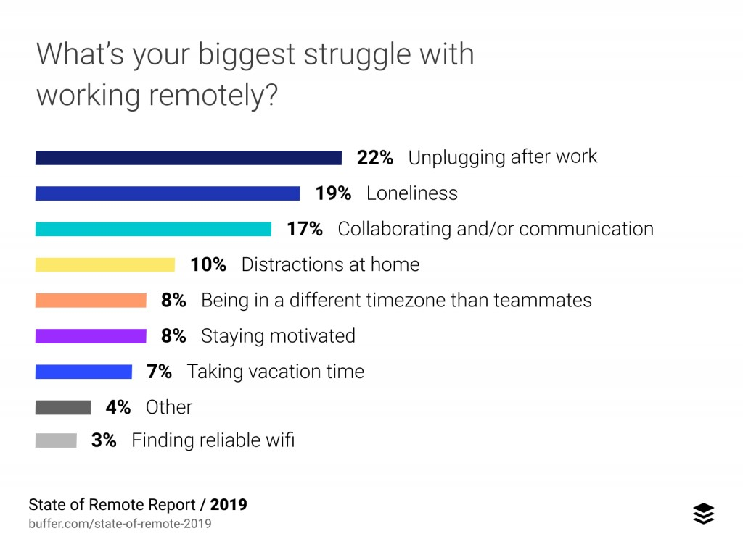

Reference
Reference source from the Internet. A guide to managing remotely workbook. Author babia z. Larson Susan vrome and Erin E. Makarios March 2020

Reference found on the Internet source. The leadership handbook jo brown. 2020

Source found on the Internet The human resource management review volume 15 issue 1 published online 1st December 1999 Arthur D sadly stable, John Hulland and Christopher A Higgins.

Source found in the university library.
Author Christian graham 1972,-editor
Hershey: Business Science Reference 2016
Strategic management and leadership.

Larson BZ,Vroman sr, Makarius EE
2020 A guide to managing your (newly) remote workers
Havord buisness review 18,18
Future Of Work: Key Findings From The State Of Remote Work .... https://allwork.space/2020/11/future-of-work-key-findings-from-the-state-of-remote-work-report/

