

Database Systems (ACCA7002)

Contents
Abstract 1
Task 1: Database Creation 1
1.1. Entity relationship diagram 1
1.2. Table creation 1
1.3. Functions 7
1.4. Triggers with Auditing feature 9
1.5. Stored Procedures 12
1.6. Transactions 16
1.7. Index 17
1.8. Insertion statements 22
Task 2: Performance Tuning Enhancement 31
2.1. Performance Tuning 31
2.2. Transaction 33
2.3. Importance of Concepts 36
2.4. Evaluation of Design and Implementation 37
References 39

Abstract
Swansea Art Emporium is an art gallery which is located in Swansea that sells a wide range of art pieces. The organization wants to increase its customer base and also want to modernize its operations. This report will provide an entity relationship diagram and will show the database creation for the organization. The code for creating table statements, the primary key for each tables, foreign key for each tables, functions, triggers, stored procedures, transactions, and indexes will be shown in this report.

Task 1: Database Creation

Entity relationship diagram
The diagram below shows entity relationship diagram for the case study.
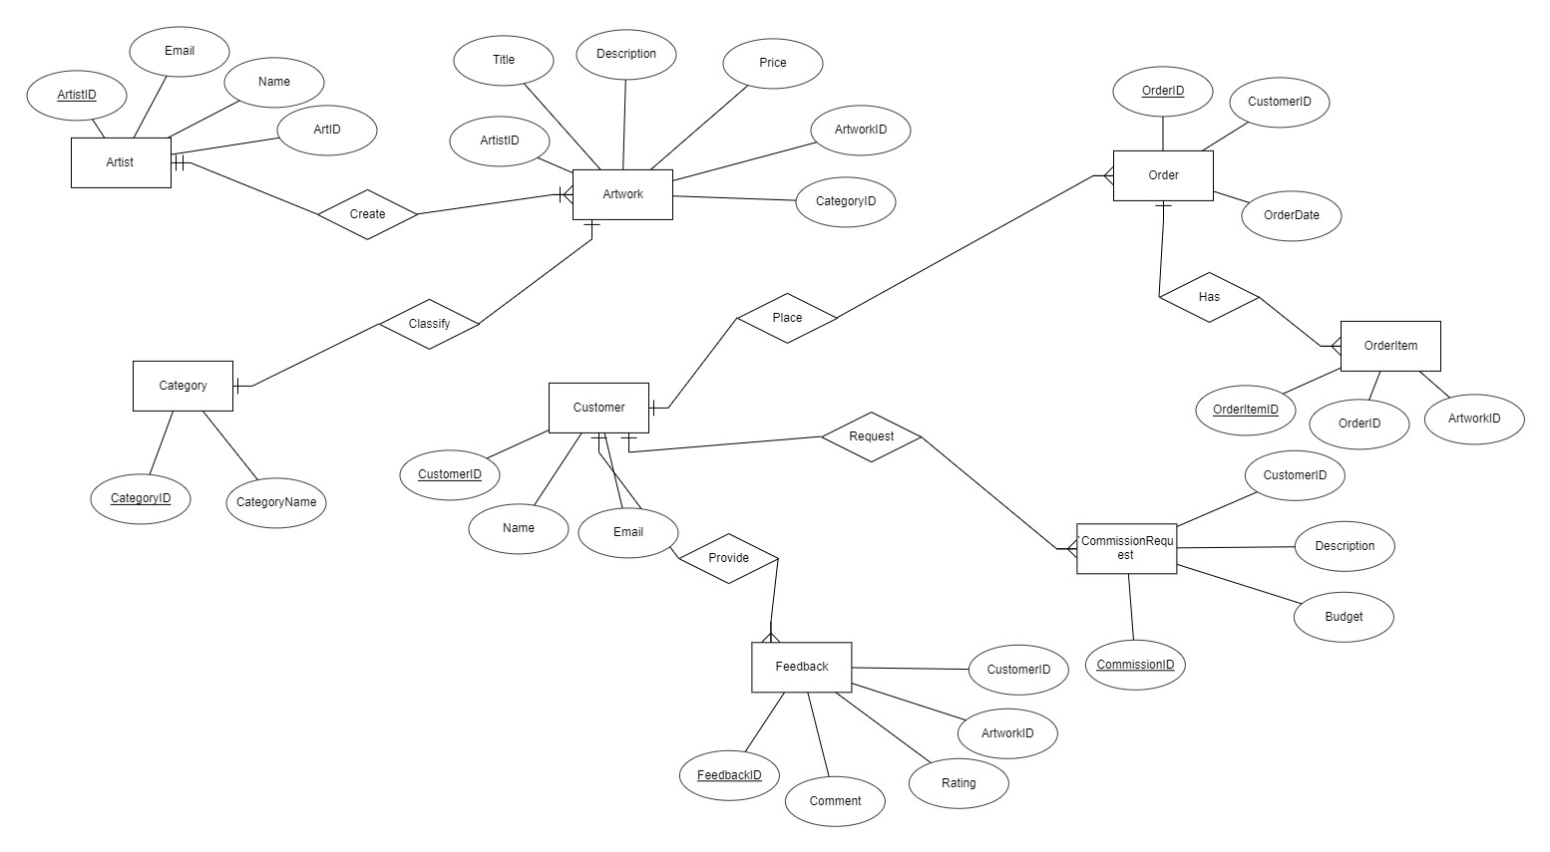

Figure 1: Entity relationship diagram

Table creation
1.2.1 Table Artist
CREATE TABLE Artist (
ArtistID SERIAL PRIMARY KEY,
Name VARCHAR(255),
Email VARCHAR(255) UNIQUE,
SampleArtID INT
);
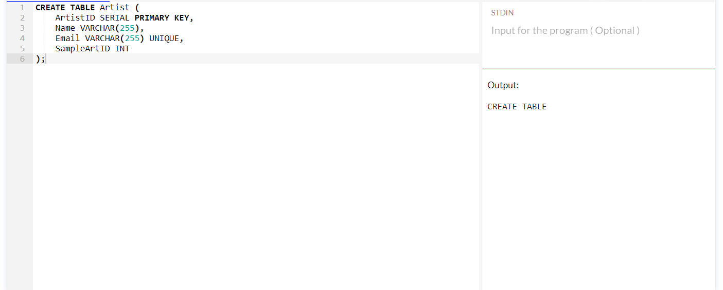
1.2.2 Table Category
CREATE TABLE Category (
CategoryID SERIAL PRIMARY KEY,
CategoryName VARCHAR(255)
);
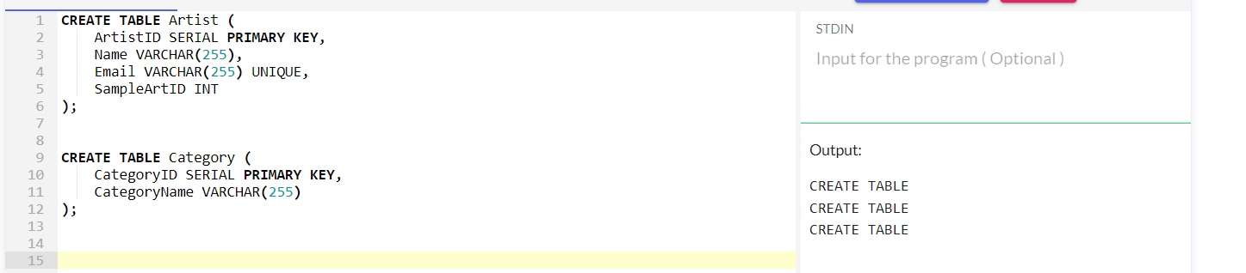
1.2.3. Table Artwork
CREATE TABLE Artwork (
ArtworkID SERIAL PRIMARY KEY,
Title VARCHAR(255),
Description TEXT,
Price DECIMAL(10, 2) CHECK (Price > 0),
ArtistID INT REFERENCES Artist(ArtistID),
CategoryID INT REFERENCES Category(CategoryID)
);
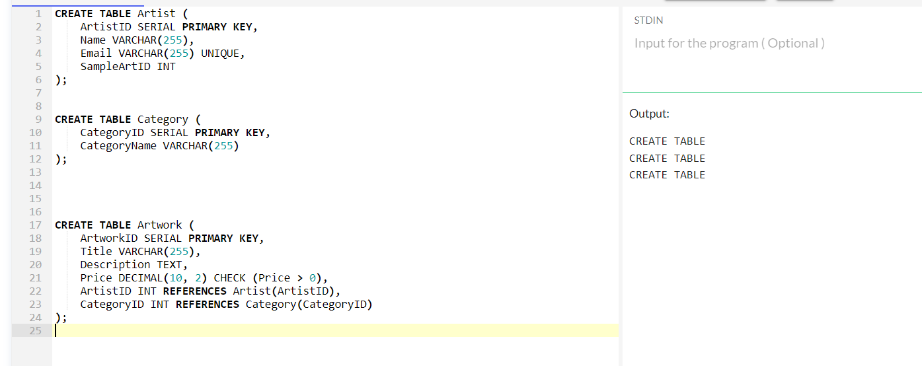
    - Table customer
CREATE TABLE Customer (
CustomerID SERIAL PRIMARY KEY,
Name VARCHAR(255),
Email VARCHAR(255) UNIQUE
);
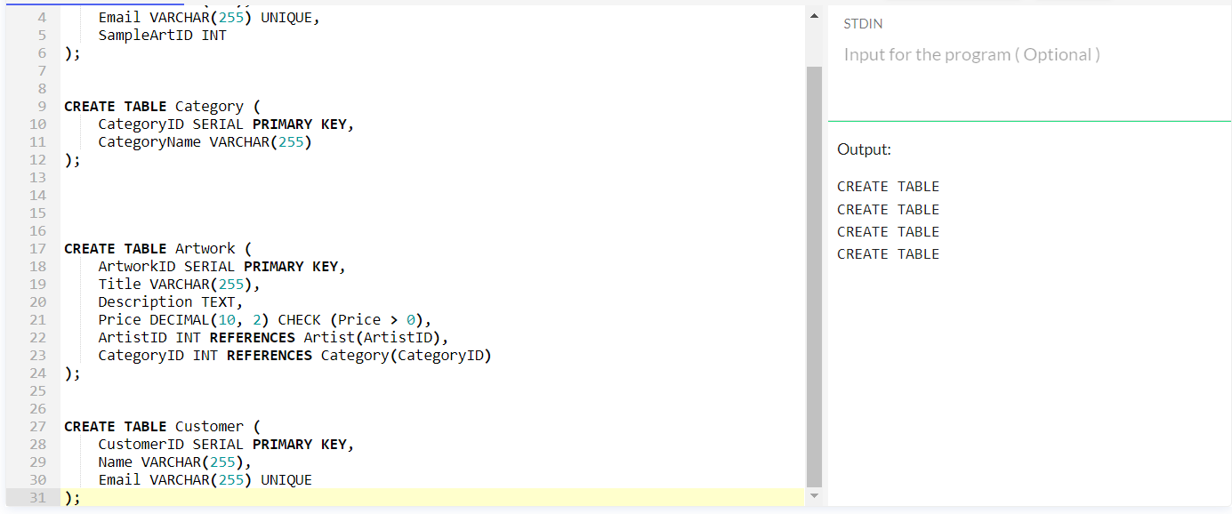
    - Table Order
CREATE TABLE Orderi (
OrderID SERIAL PRIMARY KEY,
CustomerID INT REFERENCES Customer(CustomerID),
OrderDate TIMESTAMP DEFAULT CURRENT_TIMESTAMP
);
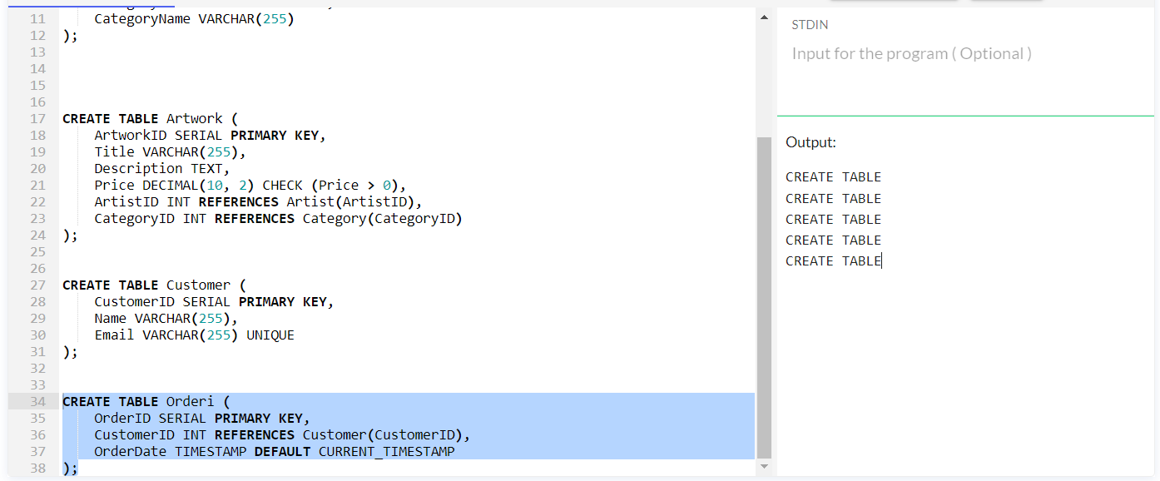
    - Table Order Item
CREATE TABLE OrderItem (
OrderItemID SERIAL PRIMARY KEY,
OrderID INT REFERENCES Orderi(OrderID),
ArtworkID INT REFERENCES Artwork(ArtworkID)
);

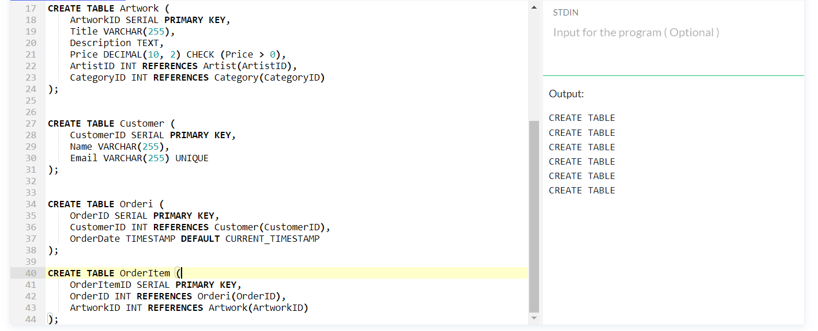

    - Table Feedback
CREATE TABLE Feedback (
FeedbackID SERIAL PRIMARY KEY,
CustomerID INT REFERENCES Customer(CustomerID),
ArtworkID INT REFERENCES Artwork(ArtworkID),
Rating INT CHECK (Rating BETWEEN 1 AND 5),
Comment TEXT
);
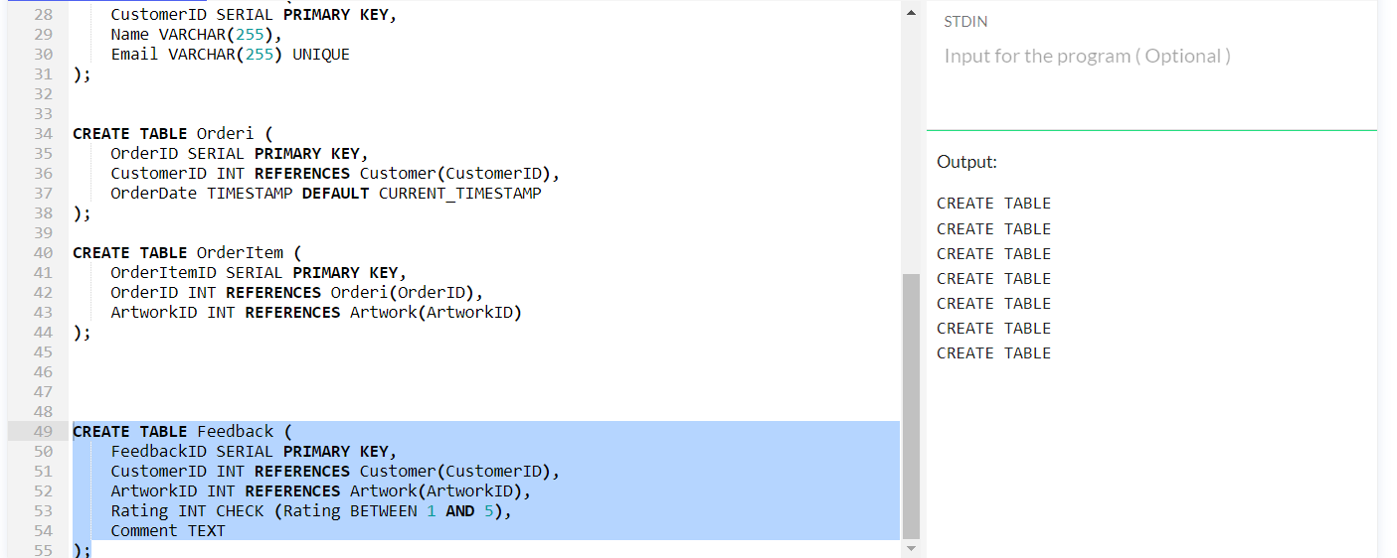
    - Table Commission Request
CREATE TABLE CommissionRequest (
CommissionID SERIAL PRIMARY KEY,
CustomerID INT REFERENCES Customer(CustomerID),
Description TEXT,
Budget DECIMAL(10, 2) CHECK (Budget > 0)
);

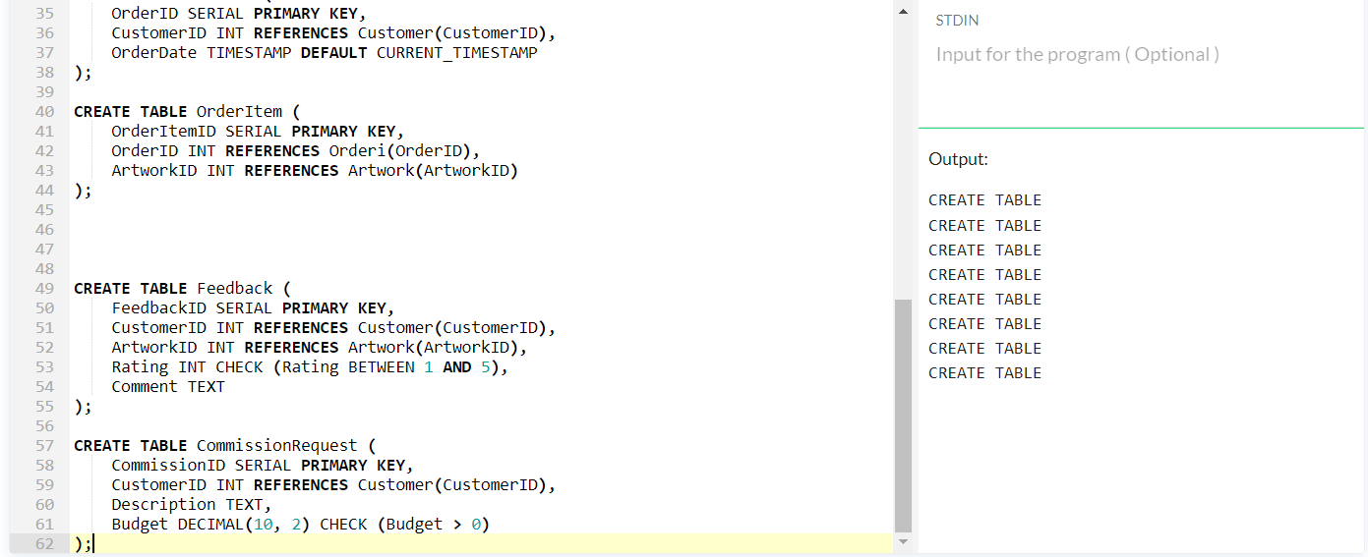
    - Adding Constraints
ALTER TABLE Artwork ADD CHECK (Price > 0);
ALTER TABLE Feedback ADD CHECK (Rating BETWEEN 1 AND 5);
ALTER TABLE CommissionRequest ADD CHECK (Budget > 0);
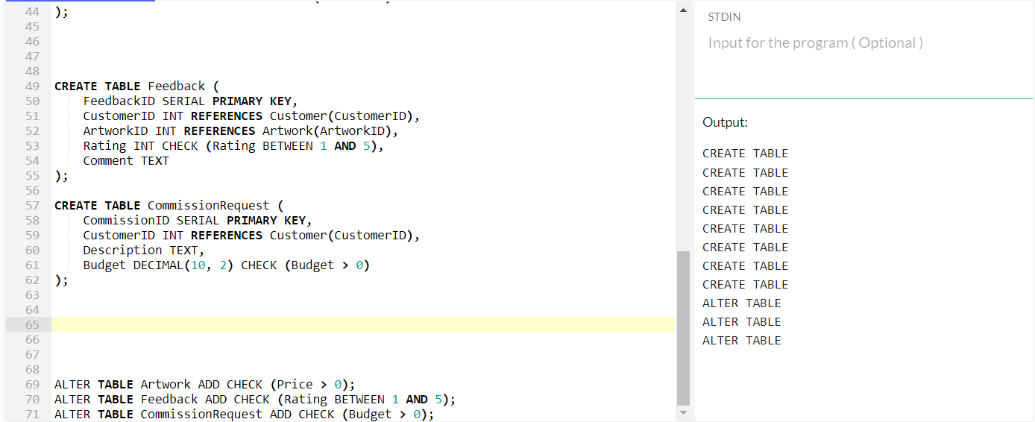

Functions
1.3.1. Function 1: Calculate total price of order
CREATE OR REPLACE FUNCTION CalculateOrderTotal(order_id INT)
RETURNS DECIMAL(10, 2) AS $$
DECLARE
total DECIMAL(10, 2);
BEGIN
SELECT SUM(Price)
INTO total
FROM OrderItem
JOIN Artwork ON OrderItem.ArtworkID = Artwork.ArtworkID
WHERE OrderItem.OrderID = order_id;

RETURN COALESCE(total, 0.00);
END;
$$ LANGUAGE plpgsql;
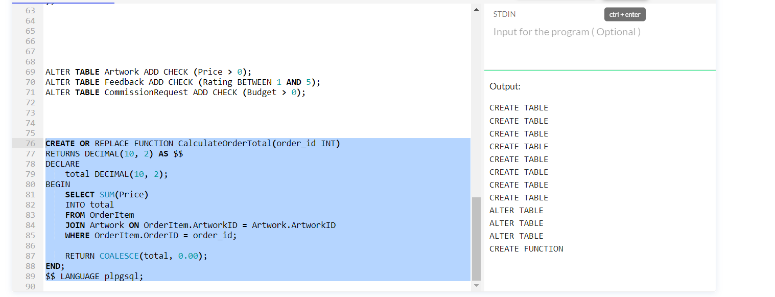

This function creates total price of the order by performing the sum of all the artworks in the order.
1.3.2. Function 2: Get average rating of an Artwork
CREATE OR REPLACE FUNCTION GetAverageRating(artwork_id INT)
RETURNS DECIMAL(2, 1) AS $$
DECLARE
avg_rating DECIMAL(2, 1);
BEGIN
SELECT COALESCE(AVG(Rating), 0.0)
INTO avg_rating
FROM Feedback
WHERE ArtworkID = artwork_id;

RETURN avg_rating;
END;
$$ LANGUAGE plpgsql;
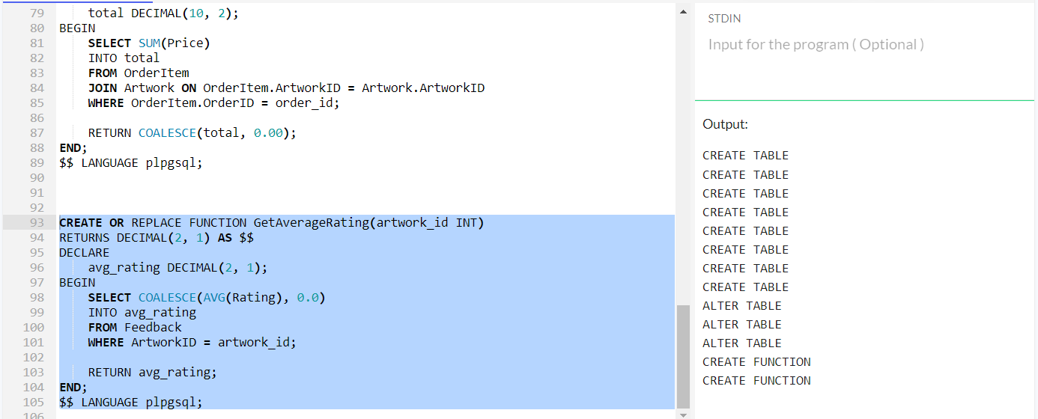
The average rating of artwork is calculated by this function on the basis of received feedback.

1.3.3. Function 3: Check budget for commission request
CREATE OR REPLACE FUNCTION CheckBudgetValidity(budget DECIMAL(10, 2))
RETURNS BOOLEAN AS $$
BEGIN
RETURN budget > 0;
END;
$$ LANGUAGE plpgsql;

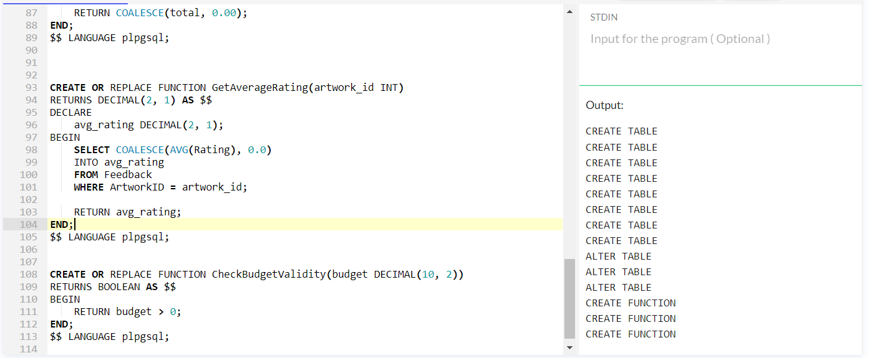

Triggers with Auditing feature
1.4.1. Trigger 1: Auditing insert activities
CREATE TRIGGER audit_insert_artist
AFTER INSERT ON Artist
FOR EACH ROW EXECUTE FUNCTION AuditInsertArtist();
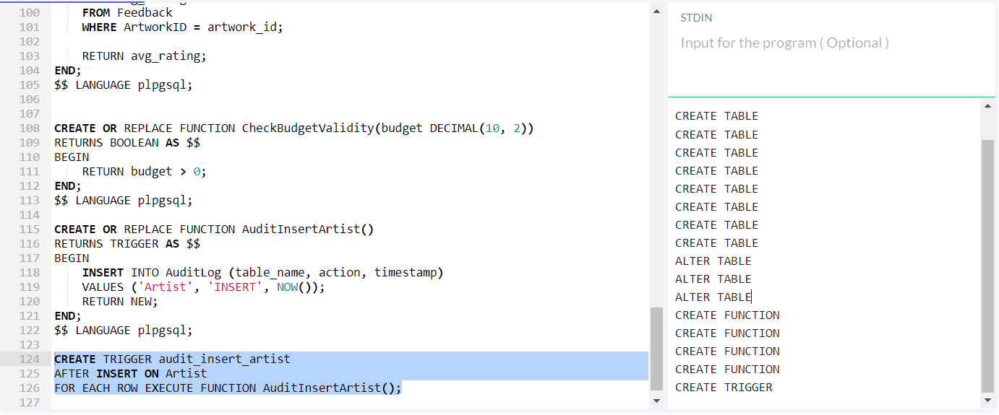

1.4.2. Trigger 2: Audit update activities
CREATE OR REPLACE FUNCTION AuditUpdateArtwork()
RETURNS TRIGGER AS $$
BEGIN
INSERT INTO AuditLog (table_name, action, timestamp)
VALUES ('Artwork', 'UPDATE', NOW());
RETURN NEW;
END;
$$ LANGUAGE plpgsql;

CREATE TRIGGER audit_update_artwork
AFTER UPDATE ON Artwork
FOR EACH ROW EXECUTE FUNCTION AuditUpdateArtwork();
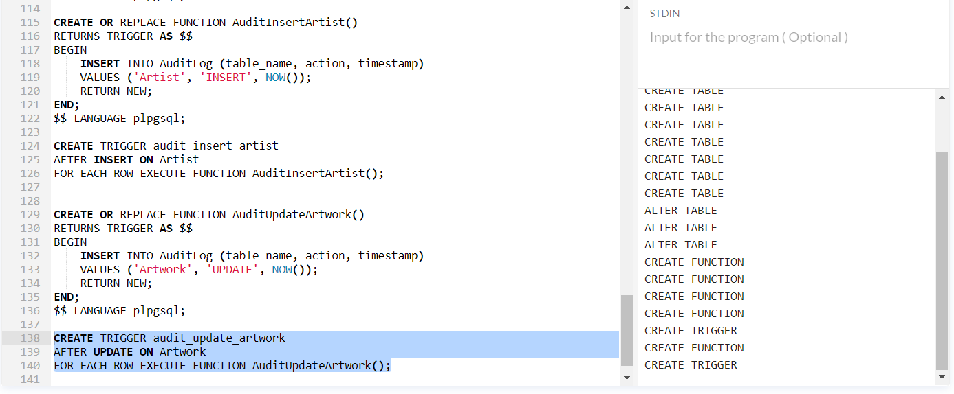

1.4.3. Trigger 3: Audit delete activities
CREATE OR REPLACE FUNCTION AuditDeleteOrder()
RETURNS TRIGGER AS $$
BEGIN
INSERT INTO AuditLog (table_name, action, timestamp)
VALUES ('Order', 'DELETE', NOW());
RETURN OLD;
END;
$$ LANGUAGE plpgsql;

CREATE TRIGGER audit_delete_order
AFTER DELETE ON Order
FOR EACH ROW EXECUTE FUNCTION AuditDeleteOrder();

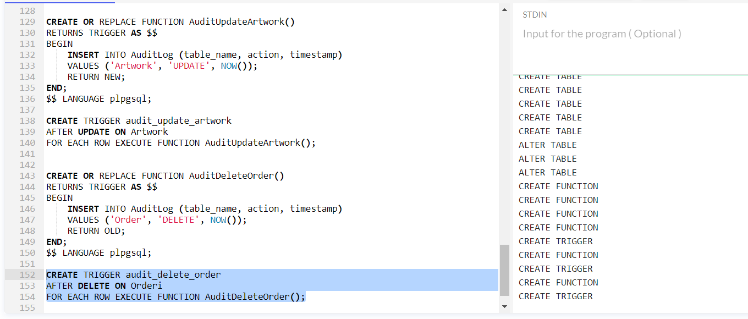

Stored Procedures
1.5.1.Stored Procedure 1: Process order
This stored procedure processes order, calculates the total price of the order and provide notification to artist for sale.
CREATE OR REPLACE PROCEDURE ProcessOrder(IN order_id INT)
AS $$
DECLARE
total_price DECIMAL(10, 2);
artist_id INT;
BEGIN
-- Calculate total price for the order
SELECT COALESCE(SUM(artwork.Price), 0.0)
INTO total_price
FROM OrderItem
JOIN Artwork ON OrderItem.ArtworkID = Artwork.ArtworkID
WHERE OrderItem.OrderID = order_id;

-- Get the artist ID for notification
SELECT ArtistID
INTO artist_id
FROM Artwork
WHERE ArtworkID IN (SELECT ArtworkID FROM OrderItem WHERE OrderID = order_id LIMIT 1);

-- Update the order status or perform other processing logic here

-- Notify the artist
RAISE NOTICE 'Order % processed. Total amount: $%', order_id, total_price;

-- You can add more processing steps as needed
END;
$$ LANGUAGE plpgsql;

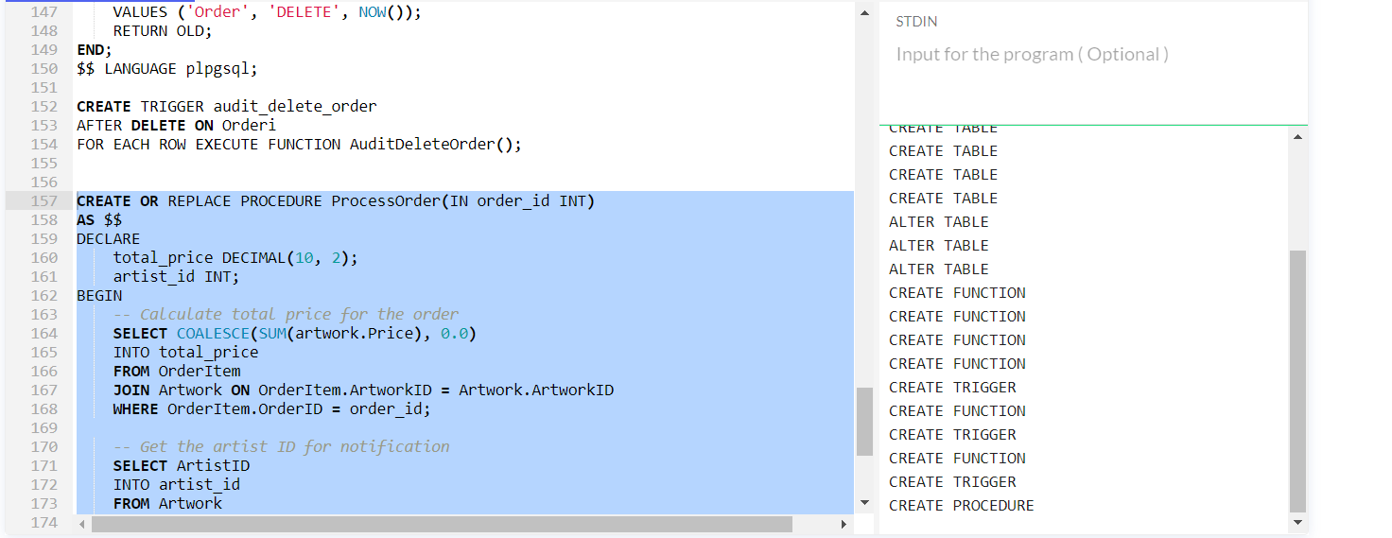
1.5.2. Stored Procedure 2: Add Artwork
The new artwork is added by this stored procedure along with associated details to artwork table.

CREATE OR REPLACE PROCEDURE AddArtwork(
IN title VARCHAR(255),
IN description TEXT,
IN price DECIMAL(10, 2),
IN artist_id INT,
IN category_id INT
)
AS $$
BEGIN
INSERT INTO Artwork (Title, Description, Price, ArtistID, CategoryID)
VALUES (title, description, price, artist_id, category_id);

RAISE NOTICE 'Artwork added successfully.';
END;
$$ LANGUAGE plpgsql;
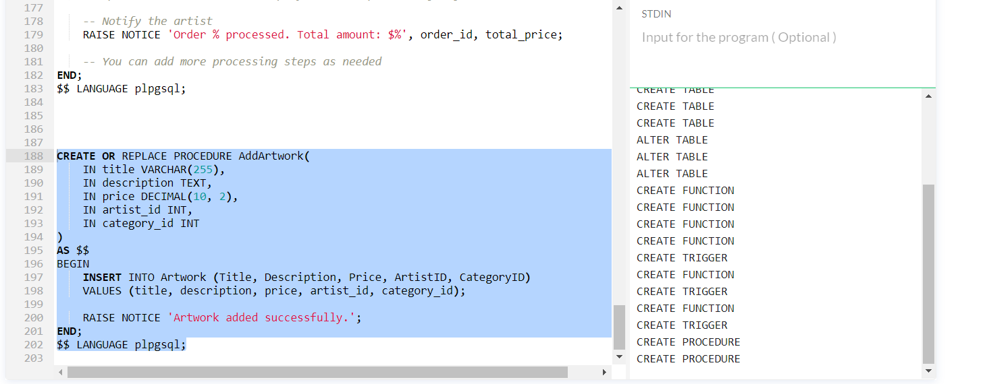

1.5.3. Stored procedure 3: Update artist email
This stored procedure update the email address of artist and audits the change.
CREATE OR REPLACE PROCEDURE UpdateArtistEmail(
IN artist_id INT,
IN new_email VARCHAR(255)
)
AS $$
BEGIN
UPDATE Artist
SET Email = new_email
WHERE ArtistID = artist_id;

-- Log the change in the audit log
INSERT INTO AuditLog (table_name, action, timestamp)
VALUES ('Artist', 'UPDATE (Email)', NOW());

RAISE NOTICE 'Artist email updated successfully.';
END;
$$ LANGUAGE plpgsql;

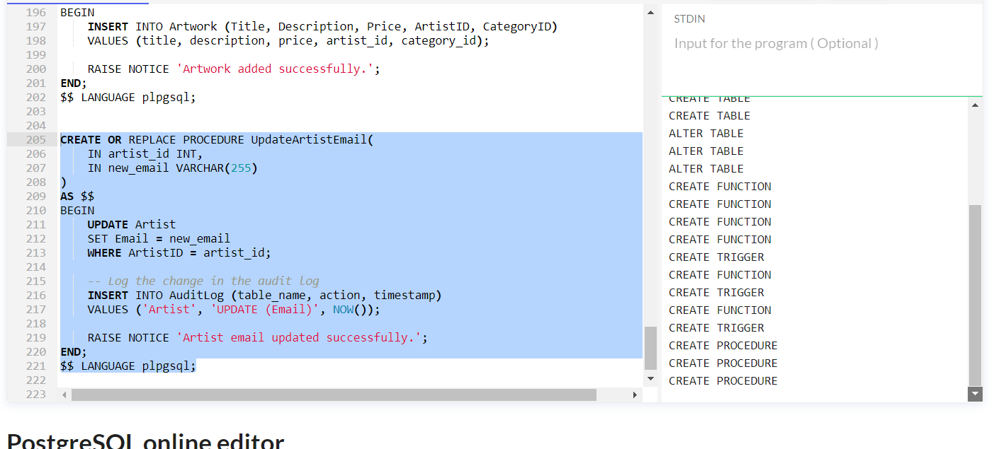

1.6. Transactions
1.6.1. Transaction 1: Update customer information
The customer information is updated by this transaction and this transaction also logs the change in the audit log.
-- Assuming the public schema, replace with your actual schema name if different
CREATE TABLE public.AuditLog (
log_id SERIAL PRIMARY KEY,
table_name VARCHAR(255),
action VARCHAR(10),
timestamp TIMESTAMP DEFAULT CURRENT_TIMESTAMP
);

-- Assuming the public schema, replace with your actual schema name if different
ALTER TABLE public.AuditLog
ALTER COLUMN action TYPE VARCHAR(255); -- Change 255 to the desired length

-- Begin the transaction
BEGIN;

-- Step 1: Update Customer Information
UPDATE Customer SET Name = 'New Name' WHERE CustomerID = 1;

-- Step 2: Log Change in Audit Log
INSERT INTO public.AuditLog (table_name, action, timestamp)
VALUES ('Customer', 'UPDATE (Name)', NOW());

-- Commit the transaction
COMMIT;

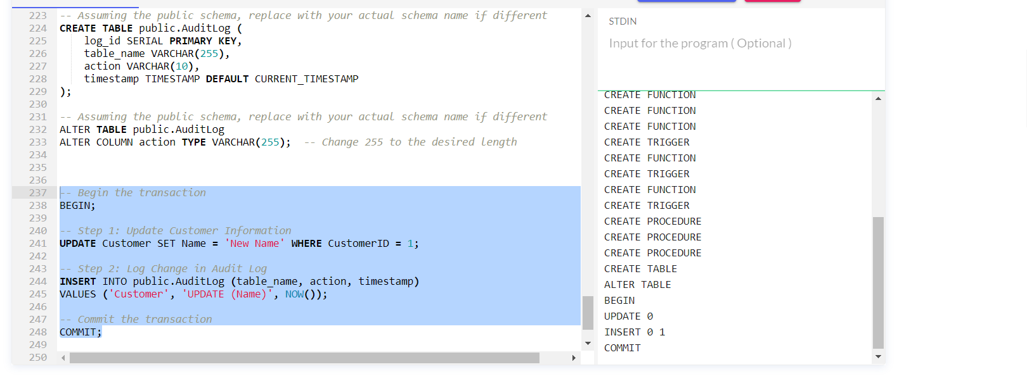

Index

1.7.1. Index 1
CREATE INDEX idx_artist_email ON Artist (Email);
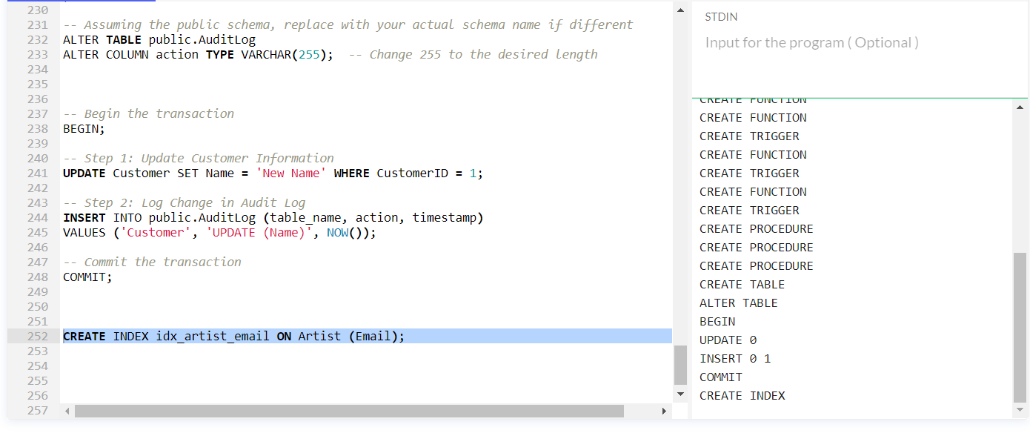
1.7.2. Index 2
CREATE INDEX idx_customer_email ON Customer (Email);
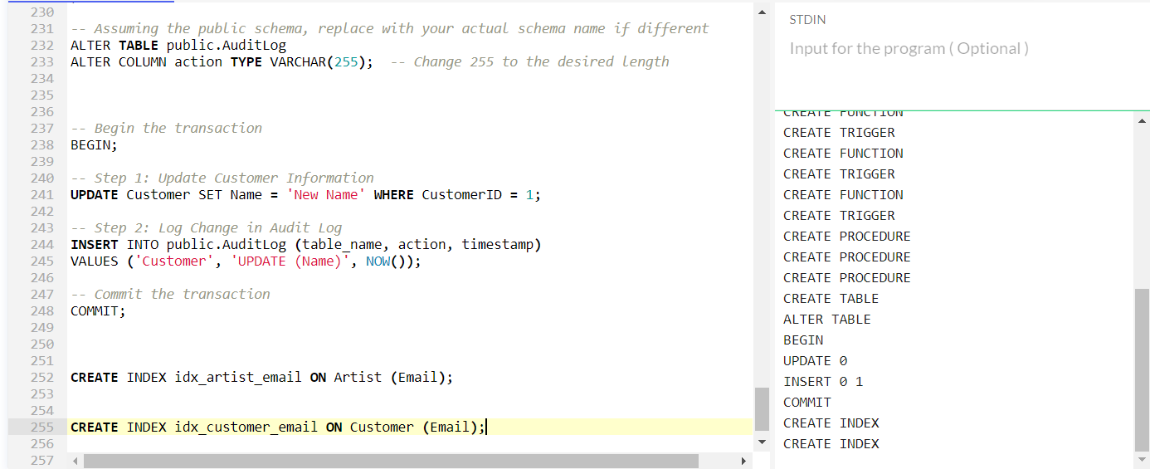
1.7.3. Index 3
CREATE INDEX idx_artwork_category ON Artwork (CategoryID);
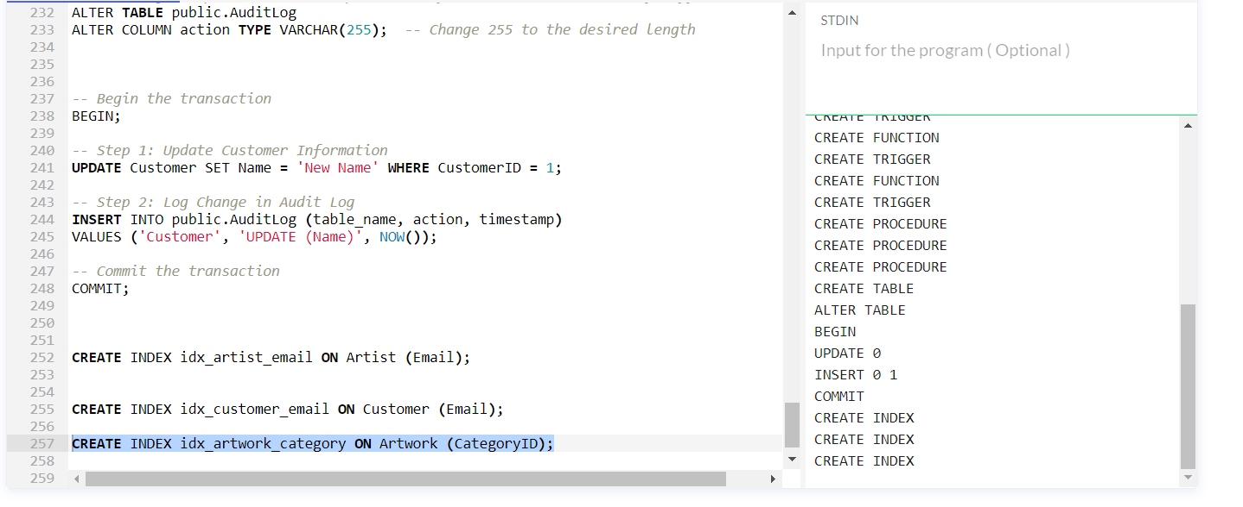
column in Artwork Table.
    - Index 4
CREATE INDEX idx_order_customer ON Orderi (CustomerID);
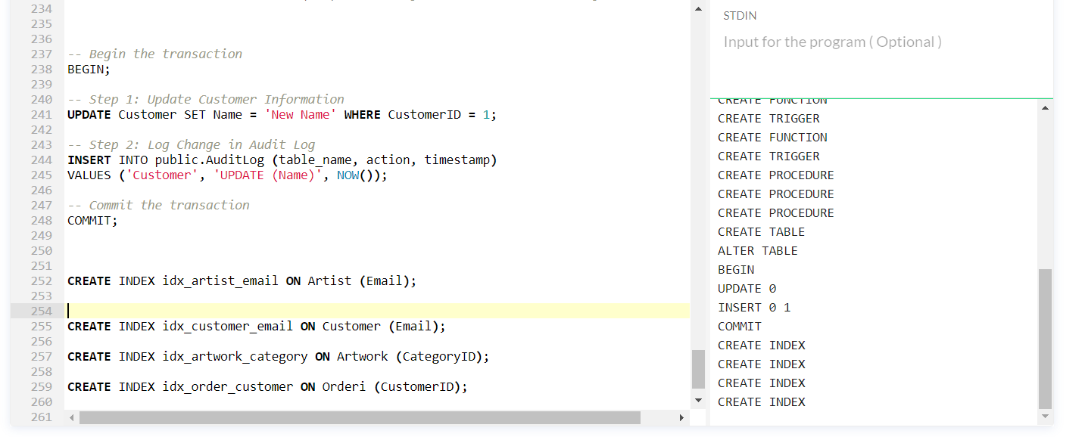
    - Index 5
CREATE INDEX idx_orderitem_artwork ON OrderItem (ArtworkID);
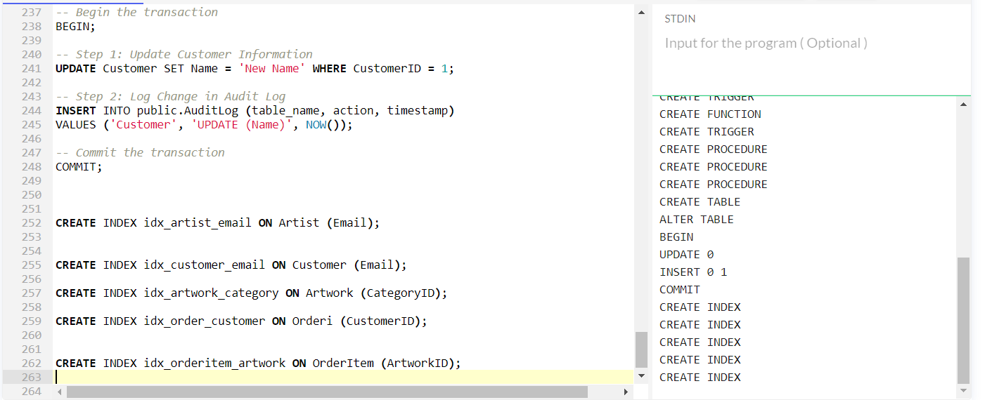
    - Index 6
CREATE INDEX idx_feedback_customer ON Feedback (CustomerID);
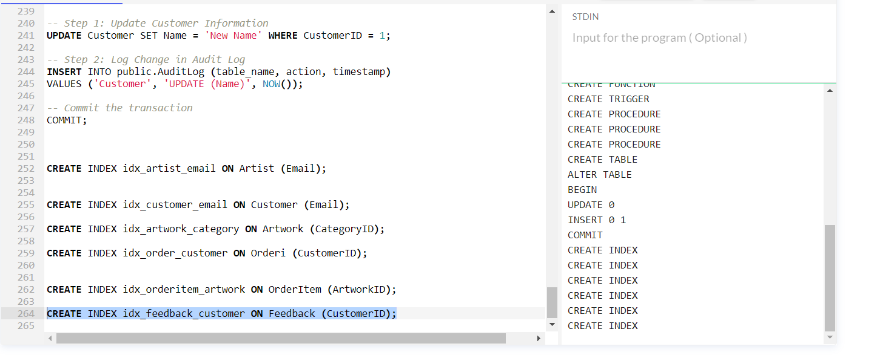
    - Index 7
CREATE INDEX idx_commission_customer ON CommissionRequest (CustomerID);

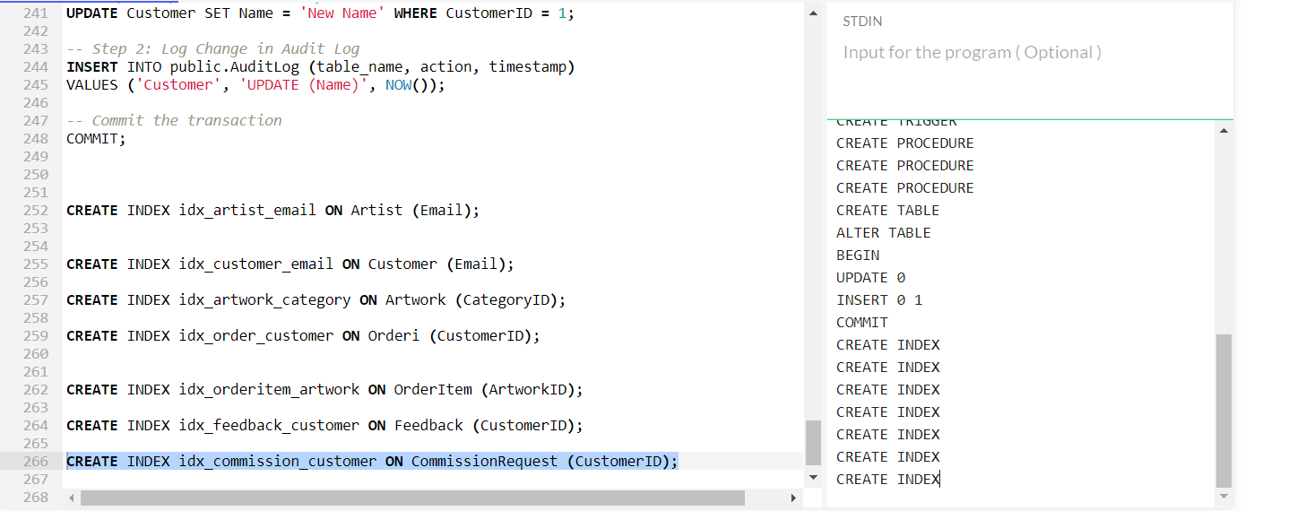
    - Index 8
CREATE INDEX idx_artwork_title ON Artwork (Title);
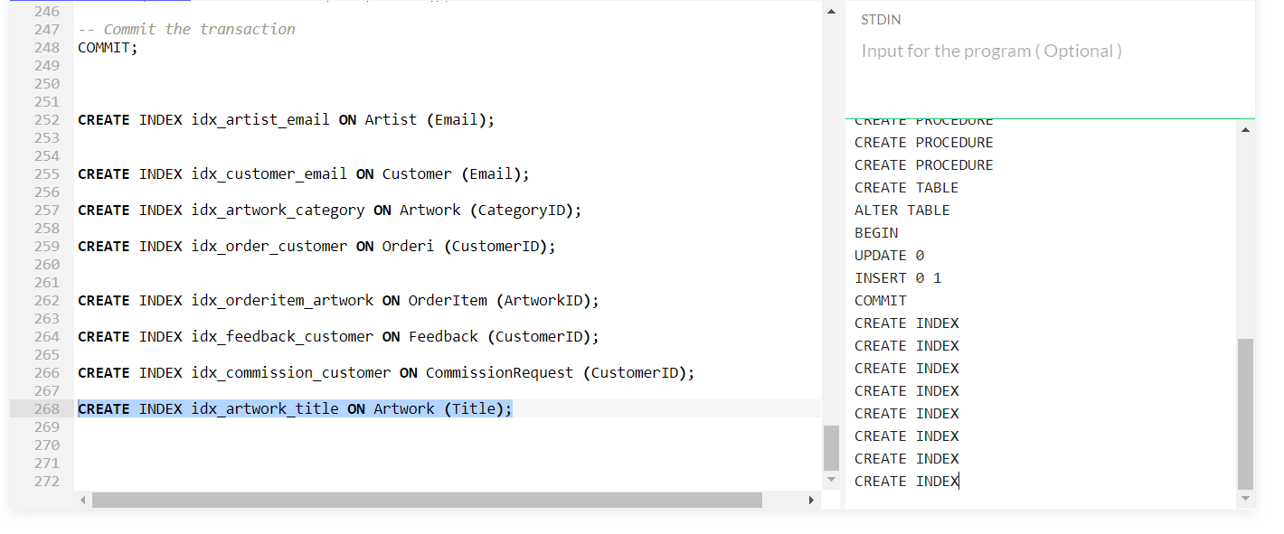
    - Index 9
CREATE INDEX idx_order_orderdate ON Orderi (OrderDate);
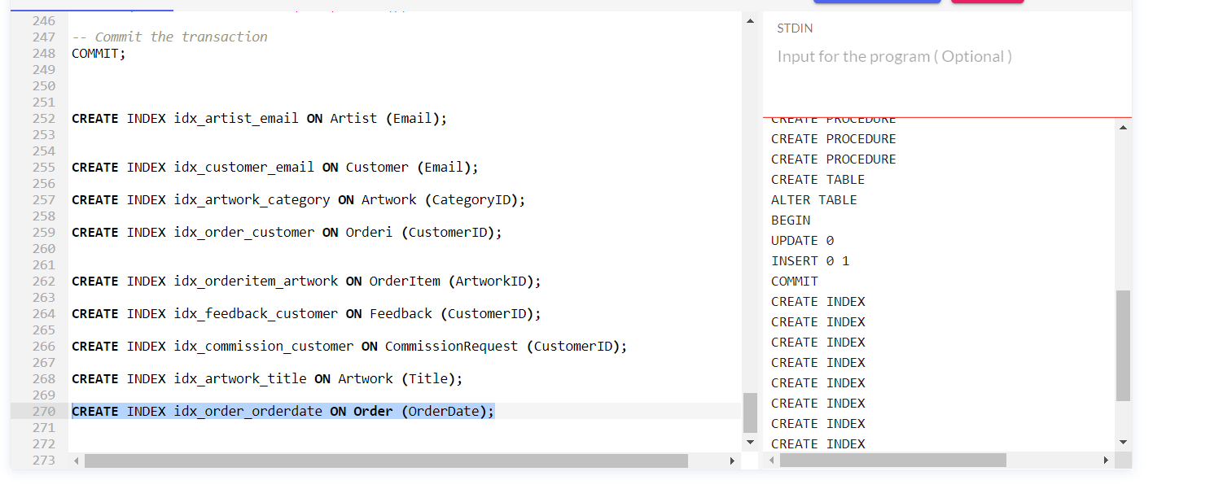

1.8. Insertion statements
1.8.1. Artist Table
INSERT INTO Artist (Name, Email, SampleArtID) VALUES
('John Doe', 'john.doe@example.com', 1),
('Jane Smith', 'jane.smith@example.com', 2),
('David Johnson', 'david.johnson@example.com', 3),
('Emily White', 'emily.white@example.com', 4),
('Michael Brown', 'michael.brown@example.com', 5),
('Sarah Davis', 'sarah.davis@example.com', 6),
('Daniel Wilson', 'daniel.wilson@example.com', 7),
('Jessica Lee', 'jessica.lee@example.com', 8),
('Kevin Miller', 'kevin.miller@example.com', 9),
('Amanda Taylor', 'amanda.taylor@example.com', 10),
('Matthew Moore', 'matthew.moore@example.com', 11),
('Olivia Wilson', 'olivia.wilson@example.com', 12),
('Christopher Hall', 'christopher.hall@example.com', 13),
('Sophia King', 'sophia.king@example.com', 14),
('Andrew Evans', 'andrew.evans@example.com', 15),
('Madison Martin', 'madison.martin@example.com', 16),
('Nicholas Hill', 'nicholas.hill@example.com', 17),
('Ava Clark', 'ava.clark@example.com', 18),
('William Turner', 'william.turner@example.com', 19),
('Ella Baker', 'ella.baker@example.com', 20);
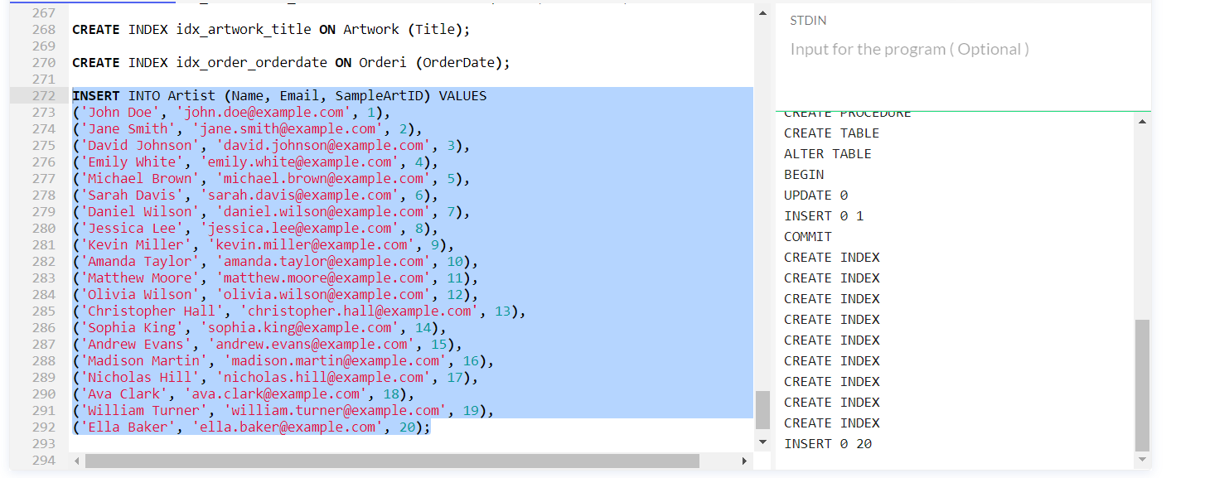
1.8.2. Category table
INSERT INTO Category (CategoryName) VALUES
('Paintings'),
('Sculptures'),
('Photography'),
('Digital Art'),
('Abstract'),
('Realism'),
('Impressionism'),
('Contemporary'),
('Ceramics'),
('Mixed Media'),
('Installation'),
('Drawing'),
('Printmaking'),
('Street Art'),
('Textile Art'),
('Glass Art'),
('Collage'),
('Landscapes'),
('Portraits'),
('Surrealism');

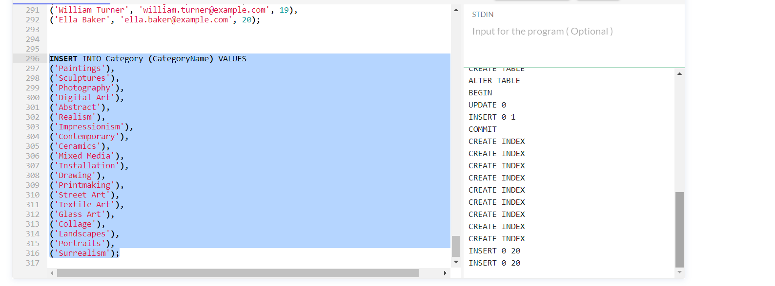
1.8.3. Artwork Table
INSERT INTO Artwork (Title, Description, Price, ArtistID, CategoryID) VALUES
('Sunset Painting', 'A beautiful painting capturing a vibrant sunset', 250.00, 1, 1),
('Abstract Sculpture', 'An abstract sculpture made from bronze', 500.00, 2, 2),
('Cityscape Photography', 'Photograph capturing the beauty of a city at night', 150.00, 3, 3),
('Digital Artwork - Dreams', 'Digital art piece exploring dreamlike landscapes', 200.00, 4, 4),
('Abstract Expressionism', 'Bold abstract artwork with vibrant colors', 300.00, 5, 5),
('Realism Portrait', 'A realistic portrait of a woman', 180.00, 6, 6),
('Impressionist Landscape', 'Landscape painting in impressionist style', 220.00, 7, 7),
('Contemporary Installation', 'Interactive contemporary art installation', 800.00, 8, 8),
('Ceramic Vase', 'Handcrafted ceramic vase with unique glaze', 120.00, 9, 9),
('Mixed Media Collage', 'Collage combining various materials and textures', 180.00, 10, 10),
('Interactive Art Installation', 'Artwork encouraging viewer participation', 600.00, 11, 11),
('Detailed Pencil Drawing', 'Highly detailed drawing of a cityscape', 250.00, 12, 12),
('Lino Print - Abstract', 'Abstract artwork created using lino print technique', 80.00, 13, 13),
('Street Art Mural', 'Large-scale mural expressing urban creativity', 350.00, 14, 14),
('Textile Art - Tapestry', 'Handwoven textile art tapestry', 280.00, 15, 15),
('Glass Art Sculpture', 'Sculpture crafted from colored glass', 450.00, 16, 16),
('Collage Art - Nature Theme', 'Collage artwork inspired by nature', 150.00, 17, 17),
('Landscape Oil Painting', 'Classic oil painting depicting a scenic landscape', 320.00, 18, 18),
('Portrait Drawing - Charcoal', 'Charcoal drawing capturing the essence of a person', 200.00, 19, 19),
('Surrealist Artwork', 'Surreal art piece challenging reality', 270.00, 20, 20);
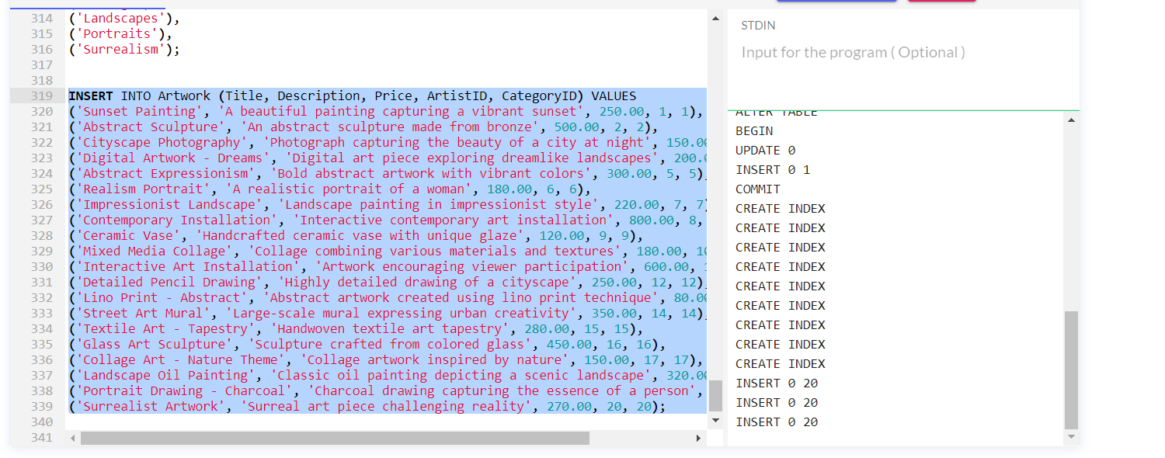
    - Customer table
INSERT INTO Customer (Name, Email) VALUES
('Alice Johnson', 'alice.johnson@example.com'),
('Bob Thompson', 'bob.thompson@example.com'),
('Charlie Davis', 'charlie.davis@example.com'),
('Diana Miller', 'diana.miller@example.com'),
('Edward Wilson', 'edward.wilson@example.com'),
('Fiona Brown', 'fiona.brown@example.com'),
('George Turner', 'george.turner@example.com'),
('Hannah White', 'hannah.white@example.com'),
('Ian Hall', 'ian.hall@example.com'),
('Jessica Clark', 'jessica.clark@example.com'),
('Kevin Evans', 'kevin.evans@example.com'),
('Linda Taylor', 'linda.taylor@example.com'),
('Mike Moore', 'mike.moore@example.com'),
('Nancy Baker', 'nancy.baker@example.com'),
('Oscar Hill', 'oscar.hill@example.com'),
('Pamela King', 'pamela.king@example.com'),
('Quentin Lee', 'quentin.lee@example.com'),
('Rachel Martin', 'rachel.martin@example.com'),
('Samuel Hill', 'samuel.hill@example.com'),
('Tina Davis', 'tina.davis@example.com');

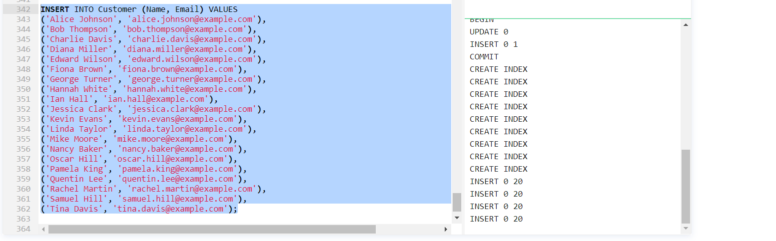

    - Orderi Table
INSERT INTO Orderi (CustomerID, OrderDate) VALUES
(1, CURRENT_TIMESTAMP),
(2, CURRENT_TIMESTAMP),
(3, CURRENT_TIMESTAMP),
(4, CURRENT_TIMESTAMP),
(5, CURRENT_TIMESTAMP),
(6, CURRENT_TIMESTAMP),
(7, CURRENT_TIMESTAMP),
(8, CURRENT_TIMESTAMP),
(9, CURRENT_TIMESTAMP),
(10, CURRENT_TIMESTAMP),
(11, CURRENT_TIMESTAMP),
(12, CURRENT_TIMESTAMP),
(13, CURRENT_TIMESTAMP),
(14, CURRENT_TIMESTAMP),
(15, CURRENT_TIMESTAMP),
(16, CURRENT_TIMESTAMP),
(17, CURRENT_TIMESTAMP),
(18, CURRENT_TIMESTAMP),
(19, CURRENT_TIMESTAMP),
(20, CURRENT_TIMESTAMP);

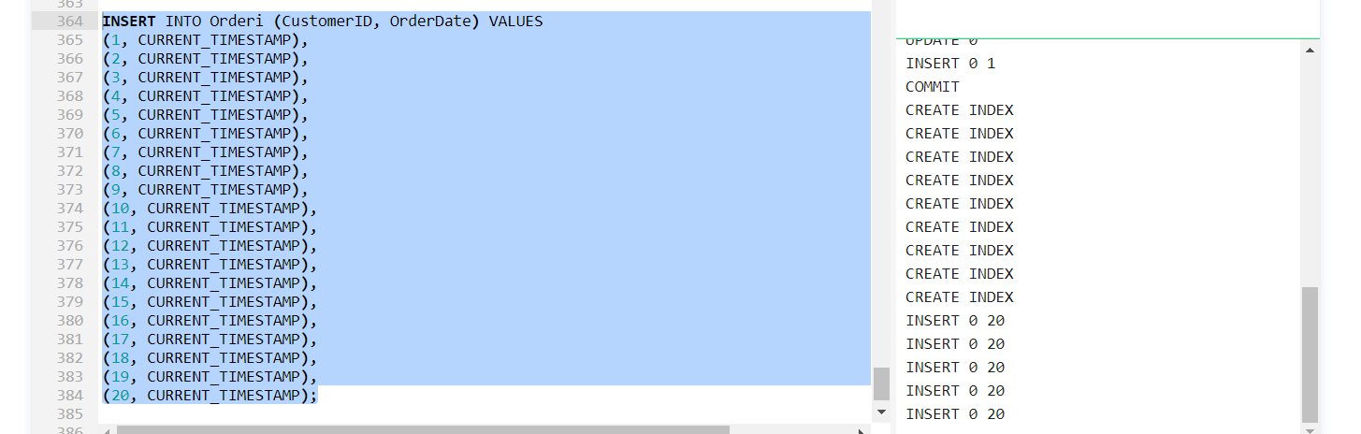
    - OrderItem Table
INSERT INTO OrderItem (OrderID, ArtworkID) VALUES
(1, 1),
(1, 2),
(2, 3),
(2, 4),
(3, 5),
(3, 6),
(4, 7),
(4, 8),
(5, 9),
(5, 10),
(6, 11),
(6, 12),
(7, 13),
(7, 14),
(8, 15),
(8, 16),
(9, 17),
(9, 18),
(10, 19),
(10, 20);

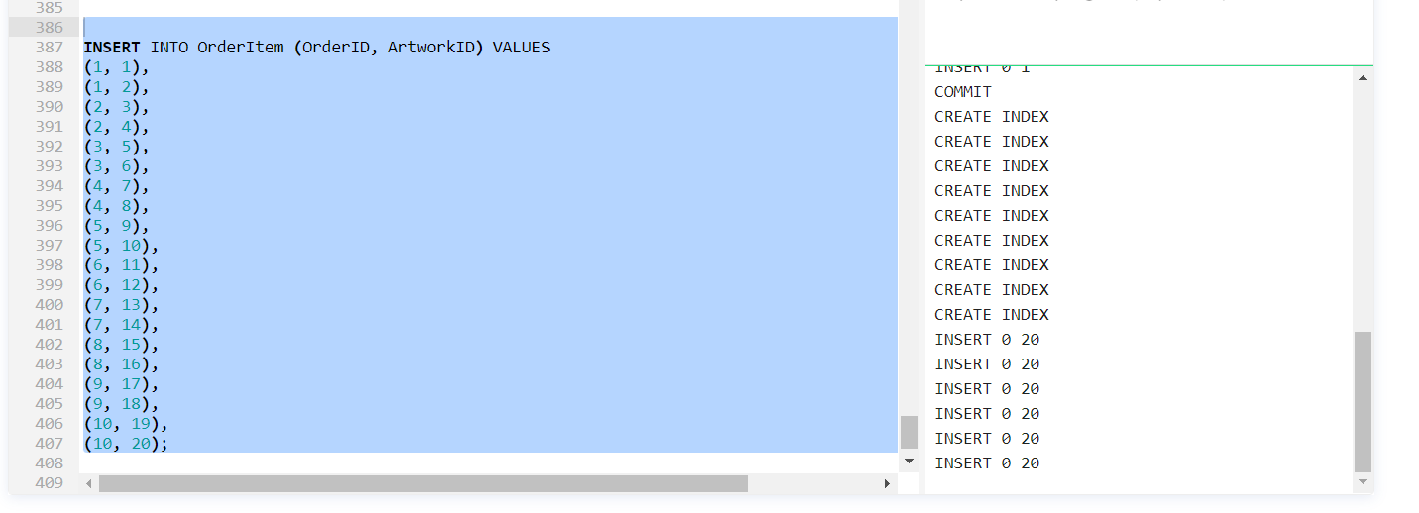
    - Feedback table
INSERT INTO Feedback (CustomerID, ArtworkID, Rating, Comment) VALUES
(1, 1, 4, 'Great piece!'),
(2, 3, 5, 'Absolutely stunning'),
(3, 5, 3, 'Good work, but could be improved'),
(4, 7, 4, 'Love the creativity'),
(5, 9, 5, 'Perfect!'),
(6, 11, 2, 'Not my style'),
(7, 13, 4, 'Unique and interesting'),
(8, 15, 5, 'Would buy again'),
(9, 17, 3, 'Decent artwork'),
(10, 19, 5, 'Exceeded my expectations'),
(11, 2, 4, 'Well done!'),
(12, 4, 3, 'Nice, but not my favorite'),
(13, 6, 5, 'Incredible talent'),
(14, 8, 4, 'Enjoying the piece'),
(15, 10, 2, 'Expected more'),
(16, 12, 5, 'Fantastic work'),
(17, 14, 4, 'Great colors'),
(18, 16, 3, 'Interesting concept'),
(19, 18, 5, 'Impressive details'),
(20, 20, 4, 'Love the style');

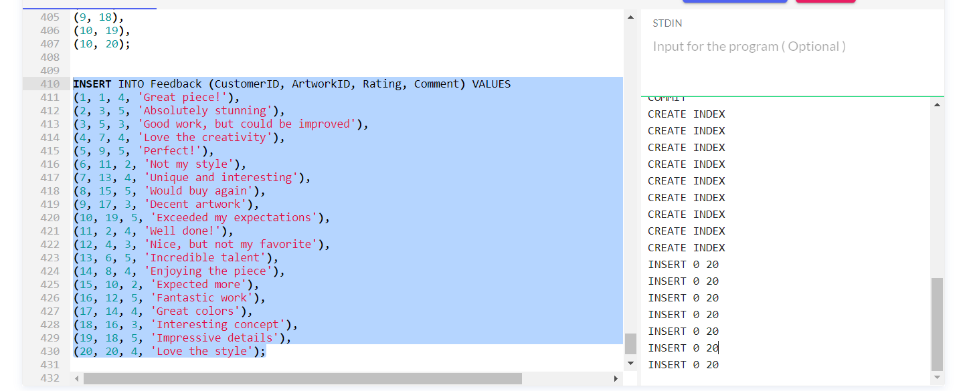
    - Commission Request table
INSERT INTO CommissionRequest (CustomerID, Description, Budget) VALUES
(1, 'Portrait painting of family', 500.00),
(2, 'Abstract sculpture for office', 800.00),
(3, 'Custom digital artwork', 300.00),
(4, 'Realistic pet portrait', 150.00),
(5, 'Large canvas landscape painting', 700.00),
(6, 'Mixed media collage for home', 200.00),
(7, 'Sculpture for garden', 1000.00),
(8, 'Portrait drawing as a gift', 120.00),
(9, 'Commission a ceramic vase', 250.00),
(10, 'Custom street art mural', 600.00),
(11, 'Abstract digital artwork', 350.00),
(12, 'Detailed pencil drawing', 180.00),
(13, 'Custom lino print', 80.00),
(14, 'Interactive art installation', 1200.00),
(15, 'Textile art tapestry', 300.00),
(16, 'Glass art sculpture', 450.00),
(17, 'Commission a collage artwork', 200.00),
(18, 'Portrait painting of a couple', 550.00),
(19, 'Abstract surreal artwork', 400.00),
(20, 'Custom ceramic bowl', 90.00);
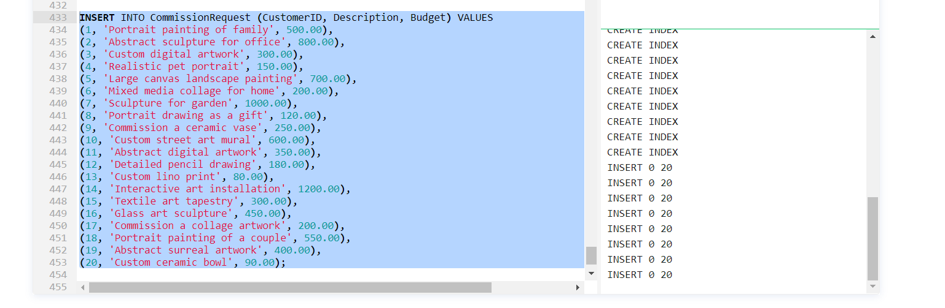

Task 2: Performance Tuning Enhancement

2.1. Performance Tuning
Create index statement helps in retrieving the data from the database quickly. In this way, data retrieval can be speed up using indexes. The information can be searched quickly from large databases. The performance of the queries can be improved by the creation of indexes. The indexes are created on the fields of the table and execution time of the insert and update statements can be decreased by using indexes. The data of the databases does not get affected by the creation and deletion of indexes.
-- Add indexes to improve query performance
CREATE INDEX idx_artist_id ON Artwork(ArtistID);
CREATE INDEX idx_category_id ON Artwork(CategoryID);
Index 1
CREATE INDEX idx_artist_email ON Artist (Email);
This index is created because this is useful for fast lookups on email column in the artist table.
Index 2
CREATE INDEX idx_customer_email ON Customer (Email);
This index is created to facilitate the quick searches on the basis of email in customer table.
Index 3
CREATE INDEX idx_artwork_category ON Artwork (CategoryID);
This index is created to speed up queries that involve sorting and filtering on the basis of CategoryID column in Artwork Table.
Index 4
CREATE INDEX idx_order_customer ON Orderi (CustomerID);
This index is created to facilitate efficient retrieval of the orders related to the particular customer.
Index 5
CREATE INDEX idx_orderitem_artwork ON OrderItem (ArtworkID);
This index is created for improvement of the performance while retrieval of the order items on the basis of the ArtworkID column.
Index 6
CREATE INDEX idx_feedback_customer ON Feedback (CustomerID);
This index is created to speed up queries related to the feedback of the customers.
Index 7
CREATE INDEX idx_commission_customer ON CommissionRequest (CustomerID);
This index is created to support quick searches about commission requests for the particular customer.
Index 8
CREATE INDEX idx_artwork_title ON Artwork (Title);
This index will support faster searches of artwork on the basis of the title.
Index 9
CREATE INDEX idx_order_orderdate ON Orderi (OrderDate);
This index is created to quickly search a particular order on a particular date.

2.2. Transaction
The multiple steps can be bundled into all or nothing operation with the help of the transaction. The intermediate steps are not visible in these. One or more operations are performed in the transaction. The ACID properties are followed by transactions. The consistency property makes sure that data written to the database must be valid and must follow the pre defined rules. The transaction integrity is visible due to the isolation property. Durability makes sure that the transaction is committed. The atomicity property guarantees that the transaction gets completed in all or nothing manner.
-- Begin the transaction
BEGIN;

-- Problem 1: Update the Price of an Artwork
UPDATE Artwork SET Price = 150.00 WHERE ArtworkID = 1;

-- Problem 2: Delete an Artwork, considering foreign key references
-- Identify the OrderItem records referencing the artwork to be deleted
-- Note: Replace 3 with the actual ArtworkID you want to delete
WITH DeletedOrderItems AS (
DELETE FROM OrderItem
WHERE ArtworkID = 3
RETURNING *
)
-- Now you can safely delete the artwork
DELETE FROM Artwork WHERE ArtworkID = 3;

-- Add a new Artwork
INSERT INTO Artwork (Title, Description, Price, ArtistID, CategoryID) VALUES
('New Artwork', 'Description of the new artwork', 300.00, 2, 1);

-- Commit the transaction if everything is successful
COMMIT;

Testing Rollback

-- Begin the transaction
BEGIN;

-- Problem 1: Update the Price of an Artwork
UPDATE Artwork SET Price = -150.00 WHERE ArtworkID = 1;

-- Intentional error to force rollback
-- This could be something like a constraint violation or division by zero
INSERT INTO NonexistentTable (Column1, Column2) VALUES ('value1', 'value2');

-- This statement won't be reached if there is an error above
COMMIT;

Testing Commit

-- Begin the transaction
BEGIN;

-- Problem 1: Update the Price of an Artwork
UPDATE Artwork SET Price = 150.00 WHERE ArtworkID = 1;

-- Problem 2: Delete an Artwork, considering foreign key references
-- Identify the OrderItem records referencing the artwork to be deleted
-- Note: Replace 3 with the actual ArtworkID you want to delete
WITH DeletedOrderItems AS (
DELETE FROM OrderItem
WHERE ArtworkID = 3
RETURNING *
)
-- Now you can safely delete the artwork
DELETE FROM Artwork WHERE ArtworkID = 3;

-- Add a new Artwork
INSERT INTO Artwork (Title, Description, Price, ArtistID, CategoryID) VALUES
('New Artwork', 'Description of the new artwork', 300.00, 2, 1);

-- Commit the transaction if everything is successful
COMMIT;

Transaction

-- Begin the transaction
BEGIN;

-- Step 1: Update Customer Information
UPDATE Customer SET Name = 'New Name' WHERE CustomerID = 1;

-- Step 2: Log Change in Audit Log
INSERT INTO public.AuditLog (table_name, action, timestamp)
VALUES ('Customer', 'UPDATE (Name)', NOW());

-- Commit the transaction
COMMIT;

This transaction will address the needs of the Swansea Art Emporium. The transaction begins with the ‘Begin’ keyword. The information of the customers is updated by this transaction. The change is logged in the audit log and important details of the table that is affected are stored. The action taken and the timestamp of the change is also recorded. This transaction makes sure that an update of the name of the customer and the corresponding log entry in the audit log is treated as an atomic operation. This will ensure that either both operations are successful or none of them get applied. This will help in maintaining the integrity of the database of the Swansea Art Emporium.

2.3. Importance of Concepts
The importance of the concepts is explained below
Concept | Importance
a. Rollback | - Ensures data consistency and integrity (Co,2022)
 | - Allows the database to return to a stable state in case of failures
 | - Supports the ACID properties (Atomicity) of database transactions
b. Commit | - Marks the successful completion of a transaction, making changes permanent (Co, 2022)
 | - Guarantees that changes are durable and survive subsequent failures
 | - Supports the ACID properties (Durability) of database transactions
c. Functions | - Encapsulate reusable logic, promoting code organization and reducing redundancy
 | - Enhance code maintainability and readability
 | - Improve performance by executing pre-compiled logic directly in the database
d. Triggers | - Automatically execute predefined actions in response to specific events (YAYA ITAI et al., 2005)
 | - Enforce business rules, ensuring data consistency
 | - Enhance data integrity by automating complex database actions
e. Procedures | - Group a set of SQL statements into a single named unit, promoting modular programming (Fujitsu Australia Ltd, 2023)
 | - Improve security by controlling access to specific procedures
 | - Enhance performance by reducing network traffic when executing multiple statements
f. Transactions | - Ensure ACID properties (Atomicity, Consistency, Isolation, Durability) of database operations
 | - Guarantee data integrity by grouping multiple operations into a single unit
- Facilitate concurrent access to the database while maintaining consistency
- Maintain integrity of valuable assets of organization (W. Jason Gilmore & Treat, 2006)
g. Indexing | - Improve query performance by quickly locating and retrieving specific rows (Sultana & Dixit, 2017)
 | - Enhance data retrieval speed for SELECT operations
 | - Enable efficient data sorting and filtering
Table 2: Importance of concepts

2.4. Evaluation of Design and Implementation
The entity relationship diagram recognizes each of the entities of the Swansea art Emporium and records information related to different attributes of the organization. The primary keys are identified for each of the entity to maintain the uniqueness and integrity of the data. The foreign key is defined to maintain the referential integrity of the data. All the relations are in normalized forms and there is no redundancy in the database. The relationship between entities is defined in a proper manner along with cardinalities in the relationships. The normalized structure of the entity relationship diagram ensures data integrity.
The diagram can be broken down into smaller and more manageable modules on the basis of the scalability requirements.
Evaluation of different aspects
Aspect | Evaluation | Consideration
Transaction Isolation Levels | - Read Committed Isolation Level: <br> - Strength: Provides a balance between data consistency and concurrency. <br> - Consideration: Higher isolation levels might be needed based on specific requirements. | - Depending on the application, consider using higher isolation levels for specific scenarios.
Lost Updates | - Strength: Proper locking mechanisms or optimistic concurrency control can minimize lost updates. | - Ensure transactions are structured to handle concurrent updates.
Uncommitted Dependencies | - Strength: Read Committed isolation level helps avoid uncommitted dependencies. | - Review and validate application logic to ensure proper transaction commitments.
Inconsistent Analysis | - Strength: Higher isolation levels (e.g., Serializable) can prevent inconsistent analysis. | - Evaluate performance impact and fine-tune isolation levels based on application needs.
Audit Log for Data Modifications | - Strength: Presence of Audit Log entity for tracking changes. | - Ensure Audit Log captures necessary information and is maintained effectively.
Testing for Multi-User Scenarios | - Strength: Thorough testing for multiple concurrent users. | - Regularly perform load testing and simulate real-world scenarios.
Optimization for Query Performance | - Strength: Proper indexing for query optimization. | - Regularly review and update indexes based on usage patterns.
Table 3: Evaluation of different aspects

References
Co, T. (2022, October). Introduction to Databases. ResearchGate; unknown. https://www.researchgate.net/publication/364644293_Introduction_to_Databases
Fujitsu Australia Ltd. (2023). PostgreSQL Insider - Using stored procedures in PostgreSQL. Fastware.com. https://www.postgresql.fastware.com/postgresql-insider-mgr-sto-prc#:~:text=A%20stored%20procedure%20is%20a,the%20database%20server%20in%20advance.
Sultana, S., & Dixit, S. (2017, February). Indexes in PostgreSQL. ResearchGate; unknown. https://www.researchgate.net/publication/318410426_Indexes_in_PostgreSQL
W. Jason Gilmore, & Treat, R. H. (2006). Transactions. ResearchGate; unknown. https://www.researchgate.net/publication/319766003_Transactions
‌ YAYA ITAI, AWODELE OLUDELE PhD, & Goga, N. (2005, April 30). Trigger and Database Security. ResearchGate; CIRWORLD. https://www.researchgate.net/publication/324989350_Trigger_and_Database_Security
‌

