Question one
The diagram below shows a negative externality of production. Below are the bulleted conditions in which a market suffers from this: -
- Occurs when the production of a product creates external costs that are harmful for third parties. Examples include environmental problems.
- Happens when marginal social cost (MSC) > marginal private cost (MPC).
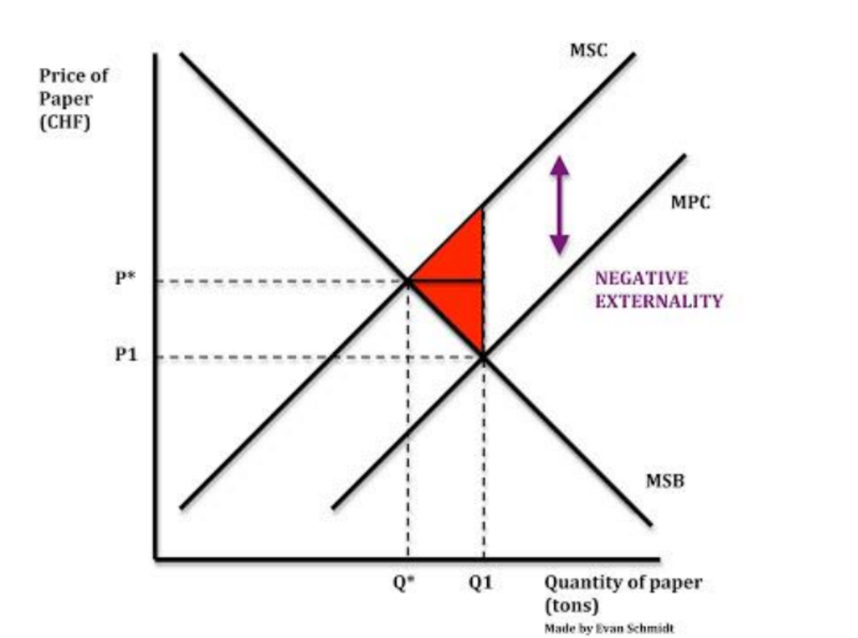
Give two or more examples of solutions to this problem of a negative production externality. Also think about what the costs there would be of implementing these solutions
Answers
- Government could tax the firm in order to increase the firm’s costs → Shifts the MPC curve upwards.
- Governments could issue tradable permits → Allows the government to control pollution.

Costs
- It is difficult to measure the pollution created and difficult to identify which firms pollute and how much they pollute the environment.
- If a firm pollutes more than they allowed, they can buy permits and it would raise their costs.

Question two
Through the use of a diagram show a negative externality of consumption. Below are the bulleted conditions in which a market suffers from this: -
● ‘Bad’ effects suffered by third parties due to consumers consuming the product.
● Examples include cigarettes, cars, loud music and noise pollution.
● Happens where marginal social benefits (MSB) < marginal private benefits (MPB)

Answer
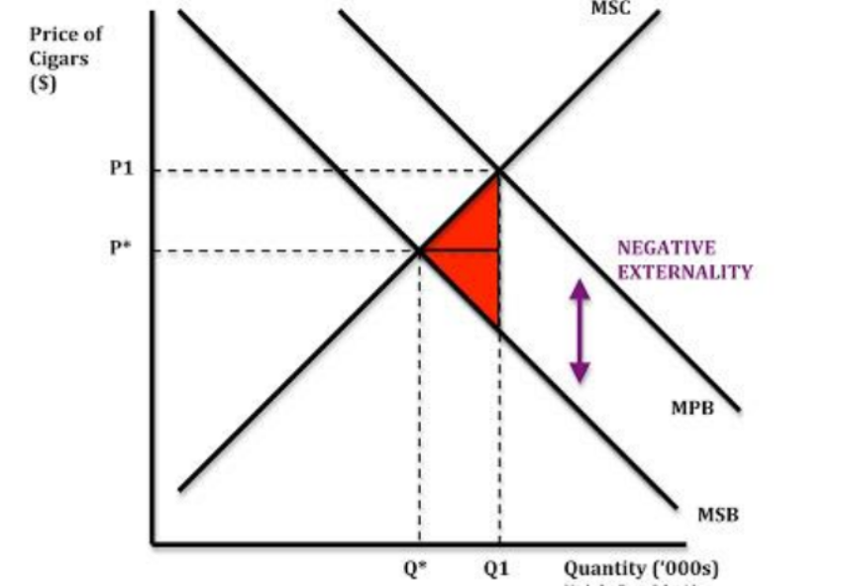
Question three
Leading on from question two - Give two or more examples of solutions to this problem of a negative consumption externality. Also think about what the costs would be of implementing these solutions.
Answers
- Impose indirect taxes on cigarettes → Reduce consumption of the cigarettes.
- Provide education about the dangers and produce anti-advertisements about smoking → Reduces demand for cigarettes → MPB shifts to the left.
Costs
- If taxes are raised too much, people will look for other sources of supply → Formation of black market.
- Educating and anti advertisements aren’t highly effective as people would still smoke after learning about dangers of smoking, so the costs involved in educating and advertising against smoking will be a waste.

Question four
Through the use of a theoretical diagram show a positive externality of consumption.
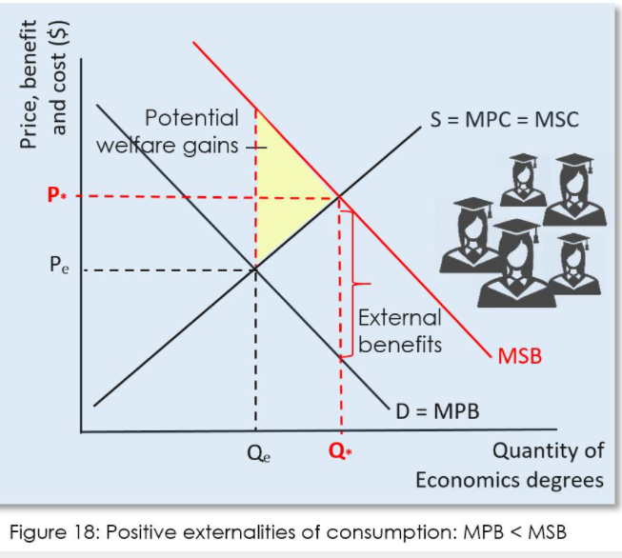

Question five
Give two or more solutions to this problem of a positive consumption externality
Answer
Subsidies and Government intervention

