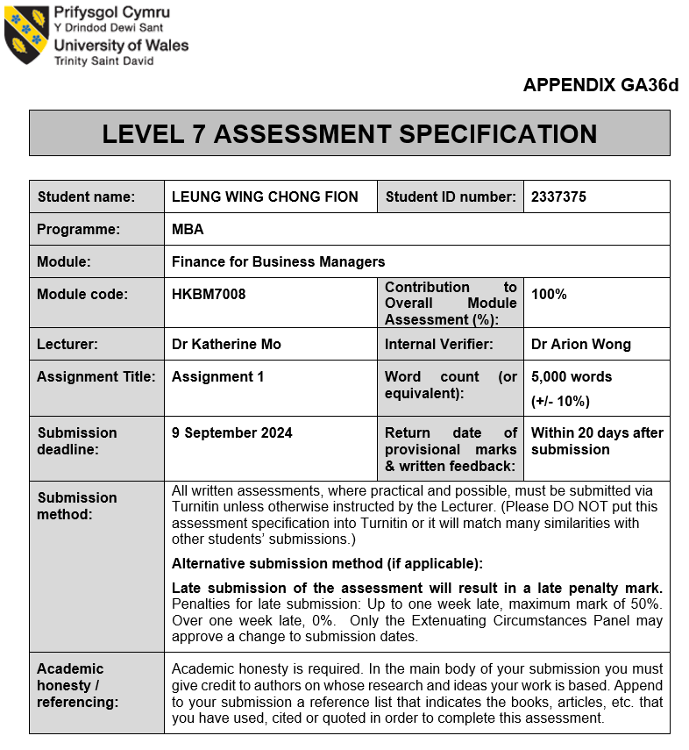
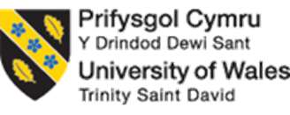

UWTSD MBA
HKBM7008 Finance for Business Managers

Nestlé S.A.

Student Name | ： | LEUNG WING CHONG FION
Student ID Number | ： | 2337375
Date of Submission | ： | 9 September 2024
Lecturer | ： | Dr Katherine Mo

I. Executive Summary

This report presents a comprehensive study of financial resource management at Nestlé, a leading player in the global food and beverage industry. The analysis is structured into six sections, with each section providing insights into the operations, financial health, and strategic growth opportunities.
The first section offers an in-depth overview of Nestlé, review on current business scope, organizational structure, and strategic positioning within the industry. This section also includes a comparative analysis with peer organizations, providing a comprehensive understanding of Nestlé's competitive landscape.
The second section conducts a detailed financial analysis of Nestlé, including a Z-score analysis to assess financial stability and bankruptcy risk. It also evaluates vital financial ratios to gauge overall financial capability and performance.
The third section reviews Nestlé's corporate governance framework, emphasizing ethical practices, transparency, and accountability. This section highlights the influence of governance on financial performance and stakeholder trust.
The fourth section explores a proposed investment project aimed at capturing new market opportunities and ensuring business sustainability. It identifies "white space" areas that could drive growth and enhance Nestlé's competitive advantage.
The fifth section discusses financing strategies and capital management practices for the proposed investment project. It emphasizes the importance of effective capital allocation in maximizing returns on investment and mitigating risks.
Finally, the report concludes with actionable recommendations to enhance Nestlé's financial resource management. These recommendations focus on strategies to improve financial health, governance practices, and investment decision-making.
In summary, this study provides valuable insights into Nestlé's financial resource management, highlighting areas for improvement and opportunities for sustainable growth. By proactively managing its financial resources, Nestlé can navigate the complexities of the global market and thrive in the competitive landscape of the food and beverage industry.

Contents
I. Executive Summary 3
1. Introduction 4
1.1 Company Background 5
1.2 Operating Business Overview (Product and Services and the sales market) 7
1.3 Current Business Environment 7
1.4 Company Structure 8
1.5 Research Comparison Company Information 9
2 Nestlé Financial Analysis 9
2.1 Listed companies of bankruptcy index Z-Score analysis 10
2.2 Financial Structure 11
2.3 Paying Debt Ability 12
2.4 Operational Ability 14
2.5 profitability 16
2.6 Growth Ability 17
2.7 Stock Market Prospect Analysis 17
3 Nestlé Corporate Governance Assessment 19
3.1 Corporate Governance of Business Organization, Impact and Importance 19
3.2 Nestlé Existing Corporate Governance 19
4 Investment Project Proposal 21
4.1 Project Information 22
4.2 The First Year Calculation of Sales 22
4.3 Computing Tax Cost 23
4.4 ARR & NPV Calculation 24
4.5 Payback Period and IRR 24
4.6 Investment Appraisal 25
4.7 Suggestion for Cashflow of New Project 25
5 Financing and Capital Management 25
5.1 Financing Alternatives 25
5.2 Financing Recommendation 26
5.3 Audit Plan Proposal 26
6 Conclusion and Recommendations 28
I. Reference 30

1. Introduction
Nestlé is a Swiss multinational food and beverage processing corporation. It is the largest publicly held food company in the world and has been since 2014. In 2017, Nestlé got as world’s most valuable food brand in Year 2023 (figure 1.1). Nestlé operates over 340 factories across 188 countries and employs 270,000 people globally (Nestle, 2023).
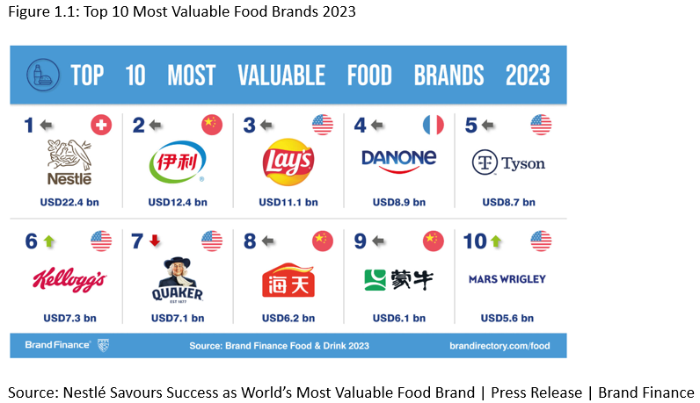
Established in 1866, the Anglo-Swiss Condensed Milk Company laid the foundation for Nestlé, a global leader in the food and beverage industry. Headquartered in Vevey, Switzerland (Nestle, 2023). Nestlé boasts a vast portfolio of over 2,000 brands and has different operating zones, illustrate in figure 1.2, business including Europe, North America, Latin America, Asia, Oceania & Africa, and Greater China (Nestle, 2023).
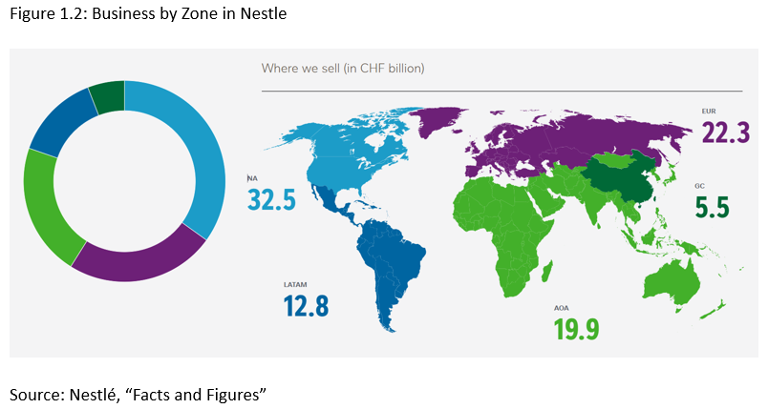

Company Background
Nestlé offers a wide range of products such as coffee under the Nescafé, Nespresso, Nescafé Dolce Gusto, Starbucks Coffee At Home, and Blue Bottle Coffee brands. In addition, it provides baby foods under the Cerelac, Gerber, Nido, and NaturNes brands; bottled water under the Nestlé Pure Life, Perrier, and S.Pellegrino brands; cereals under the Fitness, Nesquik, Cheerios, and Lion Cereals brands; and chocolate and confectionery products under various brands like KitKat, Nestlé L'atelier, Nestlé Toll House, Milkybar, Smarties, and others (Nestle, 2023).
The company's product segments also include culinary, chilled, and frozen foods under the Maggi, Hot Pockets, Stouffer's, Thomy, Jacks, TombStone, Herta, Buitoni, DiGiorno, and Lean Cuisine brands; dairy products under the Carnation, Nido, Coffee-Mate, and La Laitière brands; and drinks under the Nesquik, Nestea, Nescafé, and Milo brands. Additionally, it offers food service products under the Milo, Nescafé, Maggi, Chef, Nestea, Stouffer's, Chef-Mate, Sjora, Minor's, and Lean Cuisine brand names; healthcare nutrition products under the Boost, Peptamen, Resource, Optifast, and Nutren Junior brands; ice cream products under the Dreyer's, Mövenpick, Häagen-Dazs, Nestlé Ice Cream, and Extrême brands; and pet care products under the Purina, ONE, Alpo, Felix, Pro Plan, Cat Chow, Fancy Feast, Bakers, Friskies, Dog Chow, Beneful, and Gourmet brands (Nestle, 2023).
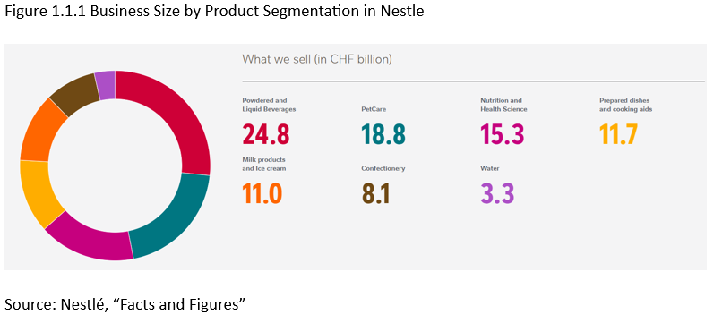

Operating Business Overview (Product and Services and the sales market)
In 2023, Nestlé delivered an impressive organic growth of 7.2%, driven by a 7.5% increase in pricing and a real internal growth (RIG) of -0.3%. This growth was distributed across different regions and product categories, reflecting a broad-based success (Nestlé 2023). Despite a slight decrease in total reported sales to CHF 93.0 billion (compared to FY-2022: CHF 94.4 billion), the company showed resilience against a challenging foreign exchange environment, which impacted sales negatively by 7.8%. Additionally, net divestitures had a modest 0.9% negative impact. The underlying trading operating profit (UTOP) margin increased to 17.3%, showing growth by 20 basis points in reported basis and 40 basis points in constant currency. The trading operating profit (TOP) margin also demonstrated strong improvement, reaching 15.6%, marking a substantial increase of 160 basis points (Nestle, 2023).

Current Business Environment
Nestlé is confronted with a dynamic and challenging business environment, compelling the company to continuously adapt its strategies, operations, and portfolio to remain competitive and relevant in the face of evolving consumer preferences and market conditions. Macroeconomic factors such as inflationary pressures on raw materials, energy, and transportation costs are exerting pressure on profit margins, necessitating a concerted focus on managing pricing and cost structures (World Bank Blogs, n.d.). One of the primary market trends and challenges for Nestlé is the growing demand for healthier, more sustainable, and ethically-sourced food and beverage products. Nestlé's purpose revolves around unlocking the power of food to enhance the quality of life for everyone, today and generations to come. To achieve this, the company pursues growth through rapid innovation, operational efficiency, and disciplined resource and capital allocation (Nestle, 2023). As multinational food companies expand their footprint, the competitive landscape is rapidly evolving, posing challenges in both developed and emerging markets.

Company Structure
Nestlé’s organizational structure (figure 1.4.1) embodies global unity, with its seamless integration of global operating regions, business divisions, and corporate functions. It harnesses worldwide scale and expertise, empowering regional teams to proactively respond to local market developments (Nestle, 2023).
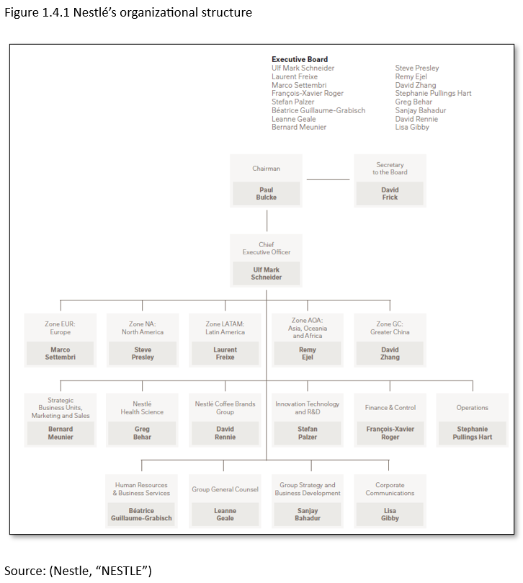

Research Comparison Company Information
When analyzing Nestlé, General Mills, and Vitasoy within the fast-moving consumer goods industry, it's important to recognize that while the companies have varying sales return sizes, it presents an opportunity to assess their performances constructively. Figure 1.5.1 showed the primary comparison on company size, market value and Price-earning ratio (PE Ratio) for Nestlé (Companiesmarketcap.com, 2024c), General Mills (Companiesmarketcap.com, 2024a) and Vitasoy (Vitasoy, n.d.).
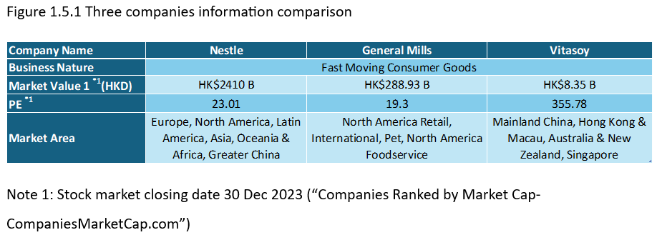

Nestlé Financial Analysis
Upon conducting an analysis of Nestlé's financial situation, it was found that the company's net current assets have experienced a consistent decline since the year 2021. From figure 2.1, notably, there was a significant 8.2% increase in sales, and the EBIT exhibited a commendable growth of 3.1% from the year 2022 to 2023. Although the overall performance demonstrated improvement compared to the previous year, it is important to highlight that there is still a discernible gap in performance when compared to the year 2021.
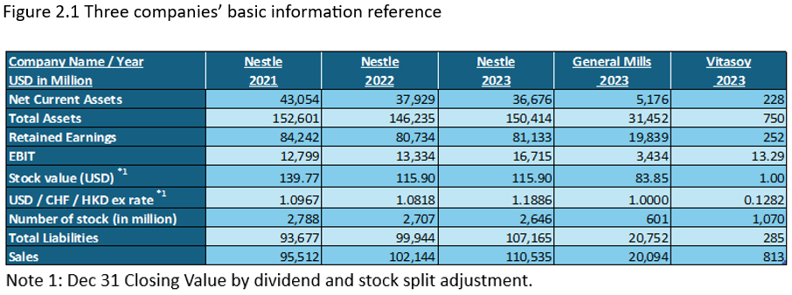

Listed companies of bankruptcy index Z-Score analysis
Altman's Z-Score model serves as a valuable tool for assessing the likelihood of a business facing bankruptcy within the next two years (Almamy, Aston and Ngwa, 2016), This model uses performance ratios to evaluate the financial health of companies from 2021 to 2023. The table presents the Z-Scores for Nestlé, General Mills, and Vitasoy, the examination for Nestlé in Year 2023 is 3.51. A score of 3 and above indicates a healthy financial position, reducing the probability of bankruptcy (CFI, 2023). Understanding and utilizing these scores can help in making informed decisions regarding investment and financial planning.

Zcore: Z=1.2A + 1.4B + 3.3C +0.6D + 0.999E:
A = Working Capital / Total Assets; B = Retained Earnings / Total Assets; C = EBIT / Total Assets;
D = [(stock value X total number of stocks)/ex rate]) / Total Liabilities; E = Sales / Total Assets
Source: Illustrate by writer

Financial Structure
Explore the liability ratios of three dynamic companies over the last three years. Uncover the financial insights that reveal their strengths and growth potential.
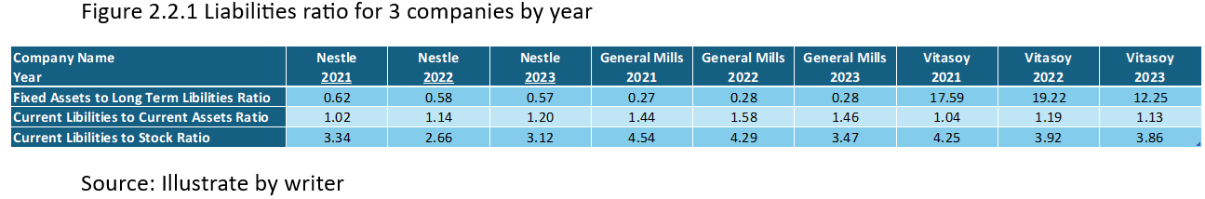
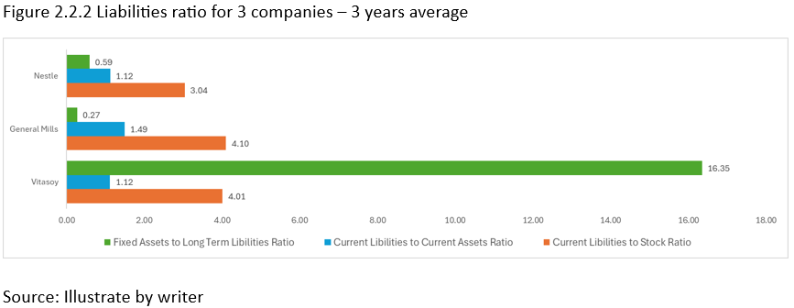
The fixed assets to long-term liabilities ratio is a key financial metric that provides insights into a company's ability to cover its long-term debts with its tangible assets. It reflects the proportion of long-term liabilities that can be offset by the company's fixed assets, such as property, plant, and equipment. A higher ratio indicates a stronger capacity to manage long-term debt and signals to potential investors and creditors that the company has the potential to take on additional long-term liabilities in the future. Conversely, a decrease in this ratio is concerning as it suggests a reduced ability to cover long-term obligations, which may impact the company's financial flexibility and access to future funding. Therefore, monitoring and analyzing this ratio is critical for assessing a company's financial strength and its ability to sustain and grow its operations over the long term (Inc, n.d.). According to Nestlé, the debt capacity of two companies has notably decreased in comparison to previous years, yet it is within the normal range. This suggests that despite the changing landscape, the companies' financial stability remains resilient.
The current liabilities to current assets ratio shown a consistent trend across the three companies, averaging between 1.12 to 1.49. This indicates that the financial stability within the industry is relatively uniform, with minimal fluctuation in the ratios. As a result, it appears that the current liabilities are being effectively managed and are not posing any major challenges.
The current liabilities to stock ratio of Nestlé also been stable in the past three years. As a fast-moving consumer goods company, it should avoid over-reliance on unsold goods to finance operations.
Upon reviewing the financial structure analysis, Nestlé's ratio above shows health and parity within the industry compared with other companies.

  - Paying Debt Ability
In today’s dynamic business landscape, a deep comprehension of financial ratios is essential for accurately forecasting long-term company performance, figure 2.3.1 showed the analyzing of paying debt ability for Nestlé from year 2021 to 2023 change.
Figure 2.3.1 Three Companies’ ratio table
Source: illustrated by writer
The current ratio is a vital gauge of a company's short-term financial stability and its ability to meet immediate financial obligations. It provides valuable insight for investors and analysts to determine if a company can effectively utilize its current assets to cover its short-term debts and other financial responsibilities (Fernando, 2024). A current ratio exceeding 1.00 signifies that the company possesses the necessary financial strength to sustain itself in the short term, indicating its capability to manage short-term debts more effectively (Fernando, 2024). Nestlé's current assets ratio has fallen from nearly 1 to 0.83, while General Mills boasts a superior ratio.
It is crucial to maintain a positive stock credit index for Nestlé, ensuring that the supply of fast-moving consumer goods is sustained at an optimal level for the best shelf life. Overstocking must be avoided, and instead, a balanced approach should be adopted to maintain a seamless supply chain.
The quick ratio, on the other hand, provides a snapshot of a company’s ability to meet short-term financial liabilities by assessing the availability of highly liquid assets. Computed by dividing cash and cash equivalents by current liabilities, the quick ratio, combined with the current ratio, offers invaluable insight into a company’s short-term financial health. For Nestlé, while the current ratio remains higher than the quick ratio due to the company's tendency to invest its capital in inventory or prepaid assets, the quick ratio falling below one implies a certain level of financial risk, contrasting with industry peers. However, assessing similar companies within the industry with comparable ratios, this situation should be considered typical.
The Equity and Debt Ratio is a critical metric that sheds light on a company's financial health. Per OECD, Nestlé's ratio ranging from 1.59 to 2.48 signals that its debt surpasses equity by 2.48 times. This substantial debt can lead to volatile earnings, inflated interest expenses, and heightened vulnerability during economic slowdowns. Notably, Nestlé's outstanding debt surpasses that of General Mills and Vitasoy, underscoring the magnitude of this financial concern.
Nestlé's Total Debt / Fixed Assets Ratio provides valuable insight into the company's financial position. When compared to General Mills and Vitasoy, a higher ratio indicates a greater level of leverage for Nestlé (Hayes, 2024a). This metric is essential for understanding Nestlé's financial stability and strategic positioning in the market.
The Time Interest Ratio is a financial metric that reflects a company's ability to pay the interest on its outstanding debt. It is calculated by dividing a company's earnings before interest and taxes (EBIT) by its interest expense during a specific period (Hayes, 2024b). Nestlé's ability to pay its outstanding debt interest decreased from 12.76 to 8.83, while General Mills averaged 8.51, and Vitasoy demonstrated a higher ability at 31.98. Furthermore, on cash coverage also decreasing since Year 2021.

Operational Ability
Nestlé's sales performance review from 2019 to 2023 highlights a dip in 2020 and 2021 due to the pandemic, followed by a strong recovery in 2022. Figure 2.4.2 provides a comprehensive overview of the past 10 years, encompassing revenue, net profit, total assets, and equity. Nestlé's performance demonstrates a consistent pattern, with a modest 0.2% compound annual growth rate (CAGR) in revenue, indicating the company's focus on sustainable growth. It's important to keep an eye on equity trends, particularly when the trend momentum is down. This could serve as a warning sign that a company is experiencing financial distress.
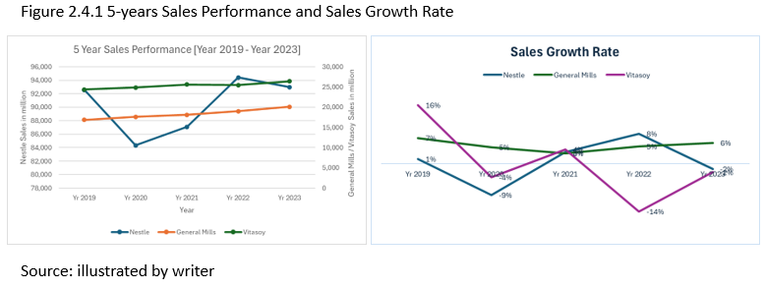
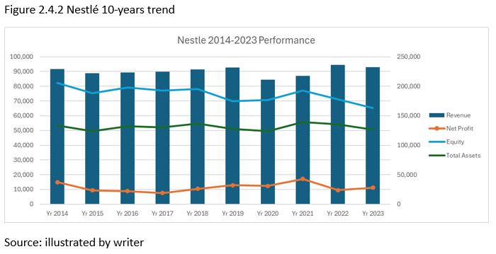

Figure 2.4.3 examines the operating expenses of Nestlé, General Mills, and Vitasoy in the fast-moving consumer goods (FMCG) sector. These expenses include essential elements such as marketing and administration costs, as well as research and development (R&D) investments. For these companies, effective above-the-line communication is vital to ensure that their brand messages connect with consumers, justifying the significant resources allocated to marketing efforts (Kenton, 2023). Through a close analysis of these operating expenses, we can gain insights into how each company prioritizes its brand promotion and innovation investments, ultimately influencing its competitive position in the FMCG market. For those operating expenses, Nestlé is relatively high compared to other companies, while the depreciation and amortization are similar.
Figure 2.4.3 Operating Expenses comparison
Source: illustrated by writer

Figure 2.4.4 Inventory and Payment period
Source: illustrated by writer

The total assets turnover of Nestlé has shown a positive trend over the past three years, increasing from 62.6% to 73.5%. This indicates an improved efficiency in utilizing owned resources to drive revenue and sales. The ratio compares the company's gross revenue to the average total number of assets, highlighting the effectiveness of every dollar of company assets in generating sales (Brand FInance, 2023). Nestlé's business operations showcase better efficiency compared to General Mills, although there is room for improvement to match the performance of Vitasoy.
Notice the remarkable improvements made by Nestlé: Day’s Sales in Inventory: Nestlé has made substantial progress by reducing its stock coverage from 105.9 days to 86.3 days, showcasing a significant enhancement over previous years.
Furthermore, Nestlé has achieved a noteworthy reduction in its average collection period from 46.8 days in 2021 to 43.2 days in 2023, highlighting its exceptional capability to efficiently manage cash flow and collect payments from customers promptly (Wall Street Prep, n.d.).
On the other hand, with the Account Payable Turnover Days currently standing at 139.3 days, which is almost five months, Nestlé's commendable creditworthiness becomes even more apparent, making it an appealing choice for potential creditors (CFI team, 2023).

profitability
The comparison of profitability across different companies (Figure 2.5.1) reveals that the gross profit margin is a critical financial metric utilized by analysts to gauge a company's financial health. It represents the profit remaining after deducting the cost of goods sold (COGS) (Bloomenthal, 2024). In 2023, Nestlé achieved an impressive 46.3% gross profit margin, signaling financial stability and robust overall health. The net profit margin, reflecting the ratio of net profits to revenues, signifies how efficiently each dollar of revenue is turned into profit (Maverick, 2021). Figure 2.5.2 illustrates the net profit margin trend for Nestlé, showcasing improvement from 2022; however, it remained at -7.3% compared to 2011.
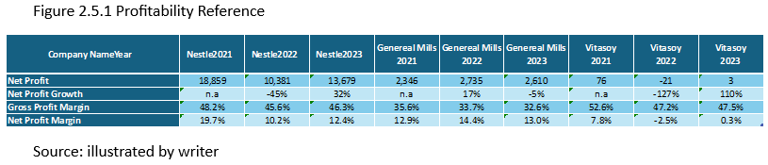
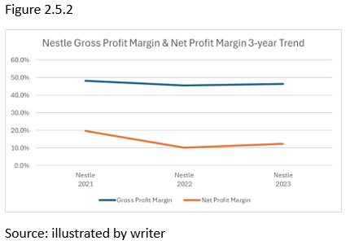

Growth Ability
Nestlé's retained earnings, when compared to those of General Mills and Vitasoy, paint a picture of relative underperformance. Although there was an increase compared to 2021, the company's retained earnings still need to reach the level of 2022 to align with industry standards and maintain competitiveness. Showed in figure 2.6.1, despite a steady retention ratio, it lags the industry due to higher ROE (after tax). Nestlé must carefully address different aspects of retained earnings and retention ratio to unleash its full growth potential. The overall outlook for Nestlé's business growth capacity falls short when compared to its peer group, calling for significant improvements in future planning.
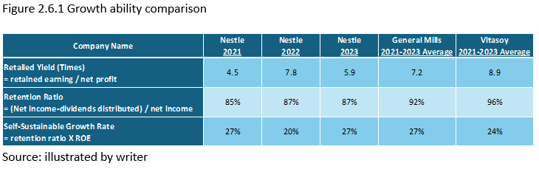

Stock Market Prospect Analysis
The per-share price of Nestlé remained around USD 115.90, despite the higher USD to CHF exchange rate at the end of 2023. This stability, along with a consistent price-earning ratio similar to industry standards, makes Nestlé a reliable and steadfast stock in the fast-moving consumer goods corporate sector.
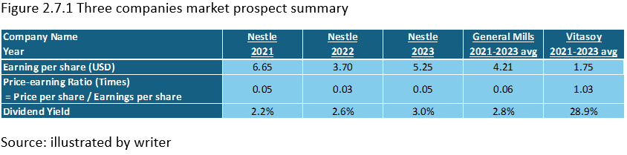

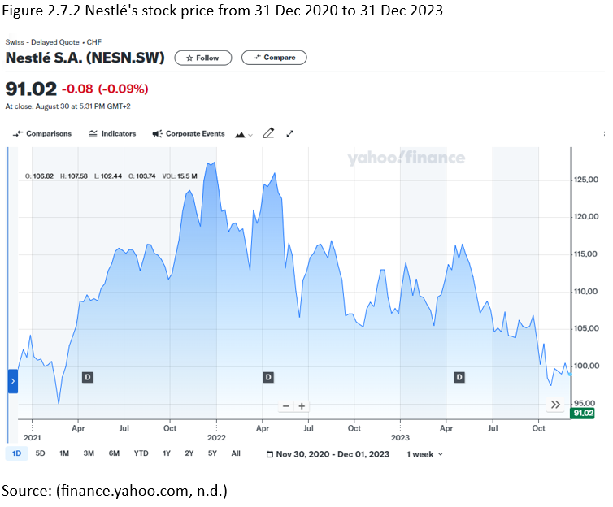

Nestlé Corporate Governance Assessment
Corporate governance stands as a pivotal and intricate framework, intricately guiding the management and control of organizations. It goes beyond being a mere set of rules, encompassing comprehensive systems, intricate principles, and detailed processes that meticulously direct and regulate corporations, ultimately aiming to safeguard the diverse and vital interests of stakeholders such as shareholders, employees, customers, and the broader community (Organisation For Economic Co-Operation And Development and Organisation For Economic Co Operation And Development, 2015). Furthermore, effective corporate governance shines as the bedrock of operating efficiently and responsibly, thereby cultivating and nurturing trust and credibility in the competitive market landscape. As businesses grapple with an array of complex challenges including regulatory changes, market volatility, and evolving consumer expectations, a robust governance structure stands out as an indispensable necessity, fortifying long-term sustainability and paving the way for enduring success.

Corporate Governance of Business Organization, Impact and Importance
This comprehensive assessment seeks to meticulously scrutinize and evaluate the corporate governance practices of select organizations, placing a keen focus on their unwavering adherence to established frameworks, their nimble and proactive risk management strategies, and their robust and inclusive engagement with a diverse array of stakeholders.

Nestlé Existing Corporate Governance
Nestlé's corporate governance framework, as outlined on its corporate governance page (Nestle, 2023a), revolves around the principles that drive sustainable value creation. The framework emphasizes striking a delicate balance between revenue growth and capital efficiency. Nestlé's core objective is to function as a positive force, leveraging its extensive scale and resources to create shared value for all its stakeholders. Impressively, the company has successfully reduced its carbon and plastic usage while maintaining growth momentum. The wholehearted support from shareholders for these initiatives was prominently evident during the 2021 Annual General Meeting. Furthermore, in 2023, shareholders approved revisions to the Articles of Association to align with the new Swiss corporate law. Notably, commencing in 2024, shareholders will be empowered to vote on an annual report focusing on Sustainability and Creating Shared Value.
The analysis of Return on Assets (ROA) entails measuring the company's ability to utilize all of its assets to generate profits, while Return on Equity (ROE) assesses its effectiveness in utilizing shareholder capital for profit generation (Supriyadi, 2021). Remarkably, as depicted in Figure 3.2.1, Nestlé demonstrates a high level of proficiency in leveraging its resources within the industry, with a ROA of 9.1% and ROE of 31.6%, both exceeding the performance of other companies.
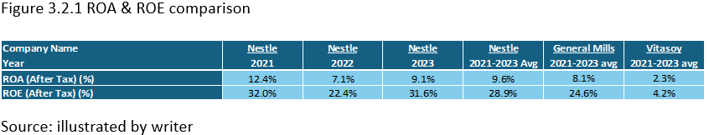

Investment Project Proposal
The world is on the brink of a transformative era, where longer and healthier lives will become the norm. By 2030, one in six people will be 60 years or older. In the Asia Pacific region, the number of older individuals is expected to surge from 630 million in 2020 to a staggering 1.3 billion by 2050. The number of people aged 60 years and older will double to a remarkable 2.1 billion. This incredibly positive trend of increased longevity is not exclusive to high-income countries but is also being
embraced by low- and middle-income countries. By 2050, two-thirds of the world’s population aged 60 years or over will call these countries home (“Population Ageing | Demographic Changes”). It is a very promising trend for Nestlé to invest in Elderly Nutrition Science Food for further development, in view of the growth trend in Adult Milk Powder with a CAGR 9.09% from 2022 to 2031 (“Business Research Insights | Global Market Research Report & Consulting”).

Figure 4.1 Global Adult Milk Powder Market Size estimation
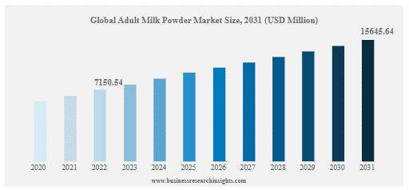
Source: (Business Research Insights, 2024)

Project Information
Nestlé is presented with an opportunity to invest in a state-of-the-art production line specifically designed for Adult Milk Powder. This investment will aid in providing essential nutritional support to the adult demographic while capitalizing on the burgeoning market demand fueled by the rapidly growing global aging population. Here is the project information that to further evaluate the possibility, investment and the payback period.

The First Year Calculation of Sales
The first year estimation from global market information that the total market value in USD is 7,794 million that in Year 2022 with CAGA 9.09% growth. Having reference in Hong Kong market that Nestle Carnation brand – adult milk powder segment market share at 38%, assume global market develop complete in the market with same situation, the estimated sales return will be USD 2,736million.

Computing Tax Cost
The anticipated first-year sales are projected to reach an impressive USD 2,735.7 million, reflecting a strong growth rate of 5.4%. These figures will serve as a key factor in computing the sales revenue for the subsequent four years. Depreciation estimation will be calculated based on the company's specific assumptions, ensuring a comprehensive and detailed financial strategy. EBITDA will be computed using the company's reference rate of 14%, while factoring in a tax cost of 18.4% to align with the current situation. These meticulous calculations will contribute to a comprehensive and detailed depiction of future profitability, as outlined in the table.

4.4 Cashflow Calculation
Note 1: assumption of expenditure to pay for depreciation
Note 2: assumption of expenditure to pay for tax cost

ARR & NPV Calculation
The meager Accounting Rate of Return (ARR) of 1.86% signals that the anticipated average annual profit from the investment equates to merely 1.86% of the initial capital outlay. This figure underscores the significant operational costs involved in the establishment of a new factory and product line. Despite the relatively low profitability, the investment reaffirms our commitment to pursuing growth in the mature market segment and underscores the potential for diversifying our product range.

Payback Period and IRR
At the end of the 25th year, the cumulative cash flow reaches -51, while at the end of the 26th year, it increases significantly to 516. Notably, the calculated payback period amounts to 25.09 years. Additionally, the internal rate of return (IRR) is an impressive 4.1%, aligning with the weighted average cost of capital (WACC) of 4.1% (www.gurufocus.com, n.d.), and a promising inflation forecast of 2% (Statista, n.d.).

Investment Appraisal
Based on the detailed data analysis, it has been established that the payback period for the new factory dedicated to adult milk powder products is 25 years and three days. With a positive net present value, it's evident that the project investment appraisal will yield a favorable return. This bodes well for ensuring sustainable growth and prosperity for Nestlé.

Suggestion for Cashflow of New Project
Focus on exploring international markets where the demand for adult milk powder is growing. Exporting products can have a significant impact on our revenue potential. Additionally, leveraging digital marketing strategies, such as social media and email campaigns, can help us reach potential customers at a lower cost than traditional advertising methods. It's important to regularly review the cash flow generated from sales to ensure operational efficiency and to adjust production plans based on sales trends. By implementing these strategies, Nestlé can create strong cash flow generation mechanisms for its new adult milk powder project, ensuring financial viability and supporting long-term growth.

Financing and Capital Management
There are diverse ways of financing, and it is crucial to further analyze equity and debt financing.

Financing Alternatives
Diverse methods of financing exist, each with its unique characteristics and implications. Two crucial avenues to consider are equity and debt financing. Traditional bank loans stand out for providing substantial capital for business investments, typically featuring competitive interest rates and flexible repayment terms. These loans are usually secured against company assets, offering access to significant funds for large-scale investments and ensuring predictable repayment schedules that are instrumental in efficient cash flow management. However, it's important to note that securing these loans often requires a meticulous business plan and financial projections, as banks rigorously assess creditworthiness and risk (Berger, 1998). Moreover, collateral requirements come into play and can profoundly impact cash flow dynamics.
Equity financing takes a different approach by raising capital through the sale of company shares to investors, including private equity firms, venture capitalists, and crowdfunding platforms. This method offers the advantage of not obliging repayment, thus easing financial pressure during the initial growth stages. Additionally, these investors bring invaluable expertise, networking opportunities, and strategic guidance to the table (Gompers and Lerner, 2004). Nonetheless, it's essential to recognize the potential dilution of ownership as investors acquire a stake in the company and the likelihood of divergent opinions on company direction and strategy.

Financing Recommendation
In considering Nestlé's current financial position, growth strategy, and the specific dynamics of the adult milk powder market, it is important to weigh the benefits of a bank loan against equity financing. A constructive approach would be to propose a mixed method, with a portion of the investment funded through a bank loan and the remainder through equity financing. This balance will help mitigate risk, maintain control, and secure the necessary funding for the project.

Audit Plan Proposal
The comprehensive audit plan has been strategically developed to achieve a multitude of critical objectives. These include ensuring strict compliance with intricate financial regulations and a meticulous internal policy review. Moreover, the plan involves a detailed assessment of the effectiveness and efficiency of operations linked to the establishment of the new factory. It also encompasses a thorough evaluation of the precision of financial reporting and projections, with the aim of identifying potential risks and formulating targeted recommendations for process and control improvements.
The audit's breadth necessitates a comprehensive approach, covering an in-depth financial audit involving a rigorous review of the financial statements, budgets, and forecasts pertaining to the new project. Additionally, an operational audit will be conducted to scrutinize the factory production process, supply chain management, and the measurement of quality control, ensuring a holistic evaluation of operations.
Of utmost importance is the stringent adherence to regulatory requirements and industry standards, making compliance audit an indispensable aspect of the plan. Furthermore, environmental audits will be carried out to assess sustainability practices and environmental impact, all in alignment with the company's mission and vision.
Through the meticulous implementation of this robust audit plan, Nestlé will be able to guarantee the efficient operation of its new adult milk powder project, ensure complete compliance with regulations, and effectively realize its financial and operational goals.

Conclusion and Recommendations
Nestlé has been presented with an exciting opportunity to invest $10 billion in a state-of-the-art factory and innovative product line for adult milk powder, targeting a rapidly expanding market segment. In 2022, the adult milk powder market was valued at $7.15 billion and is projected to reach $15.65 billion by 2031, signaling significant revenue potential. Nestlé aims to secure a 35.1% market share, which could translate to an annual sales revenue of $5.5 billion once the factory is operating at full capacity. The historical Compound Annual Growth Rate (CAGR) of 9.09% over the past decade demonstrates a steady demand trend, highlighting the potential of this investment. With a Net Present Value (NPV) of $13.68 million, this project offers the opportunity to generate surplus cash inflows and attract potential investors. Although the 25.09-year payback period is lengthy, it underscores the need for prudent financial management to ensure the project's long-term success.
There are some critical recommendations for Nestlé. Financing structure for a balanced financing approach: A mixed financing strategy, utilizing a bank loan and equity financing, will allow us to carefully manage debt levels while retaining control over the company (Berger & Udell, 1998).
It aims to secure competitive loan conditions by leveraging Nestlé's strong financial standing to optimize cash flow and ensure favorable interest rates and flexible repayment terms. From the global position, the market penetration strategy is also crucial for the project; it implements marketing campaigns to build aggressive marketing strategies leveraging Nestlé's strong brand reputation and distribution channels, which will facilitate capturing the projected 35.1% market share (Kotler and Keller, 2016). As we develop a new factory and product line, we need to focus further on product differentiation; by emphasizing unique selling propositions (USPs) such as health benefits, nutritional enhancements, and premium quality, it can attract a diverse customer base. Furthermore, Nestlé needs to optimize operational efficiency further by investing in technology and automation; state-of-the-art machinery and equipment will improve production efficiency and reduce operational costs over time (Gunasekaran, A., Subramanian and N., & Rahman, S., 2015). Implementing high technology also assists in streamlining supply chain management; for the global supply chain, it can further optimize logistics and supplier relationships, which will be vital in minimizing costs and ensuring timely delivery of raw materials. Finally, financial risk management takes the time to establish a contingency fund; given the lengthy payback period, setting aside a contingency fund will allow us to manage unexpected costs or lower-than-expected sales in the initial years. In long-term strategic planning, it needs to evaluate other expansion opportunities further to assess opportunities for expansion into adjacent product lines or markets that align with Nestlé's strategic goals (Porter, 1985). to deliver Nestlé's mission, a focus on Sustainability is essential, and integrating sustainable practices into production and marketing efforts will align with the growing consumer preference for environmentally friendly products.

Reference



