A CRITICAL EVALUATION OF THE IMPORTANCE A ‘SUSTAINABLE CUSTOMER RELATIONSHIP’ HAS ON SAINSBURY
Beniamin Luca
1914668
Table of Contents
Introduction 2
Company Background 2
Concept of Marketing Relationship 3
Importance of Marketing Relationship 5
Role of Customer Centrality within Marketing Relationship 6
Effectiveness of Data Analysis on Marketing Relationship 8
Managing Customer Expectations 9
Marketing Relationship Strategies of Sainsbury 10
Areas of Improvement 11
Conclusion 12
References 13

List of Figures
Figure 1: Official Logo of Sainsbury 4
Figure 2: Market Share of UK supermarket chain 6
Figure 3: Sales Growth of Sainsbury 9

Introduction
The modern marketing dynamics have changed to a greater extent in recent years. Businesses have shifted from “profit seeking” concepts towards “quality delivering” concepts. The changes in consumer behavior and product preferences are the main factors behind the transformation of the modern marketing dynamics. Businesses have seen to adopt different innovative concepts and strategies so as to interpret the requirements of the digitized world. The digitalisation of the entire world has provided various challenges to businesses along with its effectiveness. Consumers in recent days have a wider variety of choices and similar product lines thus, increasing the competition of the markets throughout the entire world. In order to overcome the increased amount of competition and different other challenges, businesses have to adopt a wide range of market tactics among which building a strong marketing relationship has gained huge popularity. The following report will critically analyze the significance of sustainable marketing relationship on leading Sainsbury to obtain greater potential heights in the coming days.

Company Background
Sainsbury is a popular business enterprise of the UK and is also the second largest and successful supermarket chain of the respective country. The company holds a remarkable 14.9% share of the UK’s supermarket sector. The company was first founded in the year 1869 by John James Sainsbury in the form of a small shop in Drury Lane, London. The company was remarkably the most successful market chain of the UK in the late 20th century before the establishment of Tesco. The company has overcome a variety of challenges due to the huge amount of competition delivered by Tesco and Asda (another popular supermarket chain of the UK). The company has also looked forward to merging their business with Asda in the year 2018 which was then blocked by the "Competition and Markets Authority" of the UK as it might increase the product prices for the consumers of the respective country. The market share of the company has somehow decreased a little bit in 2022 as it currently has 14.6% of the market share (Bentham, 2018). The company has experienced a double profit growth in the last business year. Sainsbury has effectively achieved a £730 Million profit with the help of identifying and mitigating the impact of the "cost-of-living" crisis all over the UK through suitable market research by its respective management body. Apart from this, the grocer sales were also increased by 7.6% while general merchandise and other non-food products have failed by 4.6% as a result of its supply chain difficulties. The mission statement of the company has been recognised to be "Helping Everyone Eat Better" that means to deliver good food at a fair rate of price. With the help of this business tactic and a fair utilization of different other business strategies, especially marketing relationships, Sainsbury will be able to achieve greater heights and recognition in the coming days.

Figure 1: Official Logo of Sainsbury
Source: (borbia.ie, 2022)

Concept of Marketing Relationship
Relationship marketing or rather "marketing relationship" is the most vital facet of CRM (customer relationship management) which has the ability to focus on delivering greater customer loyalty as well as strong consumer engagement for a longer period of time. The current market situation of Sainsbury implies that the company should focus on long term achievements through the concept of marketing relationship management rather than the short term goals for instance individual sales or consumer acquisition. The main purpose of marketing relationship strategies is to develop emotional as well as strong connections with the target customers that will effectively initiate greater profitability ratio in the future. The approach of marketing relationships is effective in leading businesses to gain access to vital information and data on the behalf of the preferences of the consumers that will eventually generate greater leads. As per the analysis stated by Palmatier and Steinhoff (2019), marketing relationships have been observed to be in contrast to the traditional transactional marketing approach that mainly focuses on the process of increasing individual sales rate. The effectiveness of the concept of marketing relationship should be utilized by the management body of Sainsbury so as to experience higher competitive advantages throughout the markets of the UK (Sousa and Alves, 2019).
It has been observed that a consumer might be convinced to select the product lines of the company in one particular period of time, but without the presence of strong consumer relationship approaches, the consumer may not prefer that product in the future also. Thus, affecting the overall sales figure to get reduced even delivering the required quality and services of the product. Relationship management involves the utilization as well as direction of a wide range of activities that are capable of developing a strong connection and bond with their target customers so that they prefer the brand for a longer period of time (Gesualdi, 2019). Consumers delivering profits for a longer run is the potential achievement of every business in the world. Through the adaptation of marketing relationship strategies, Sainsbury can comfortably emphasize more on consumer satisfaction, retention as well as delivering lifetime consumer value in the most appropriate way. The purpose of the company will be to deal with current consumers along with acquiring new ones through quality sales and advertising techniques.
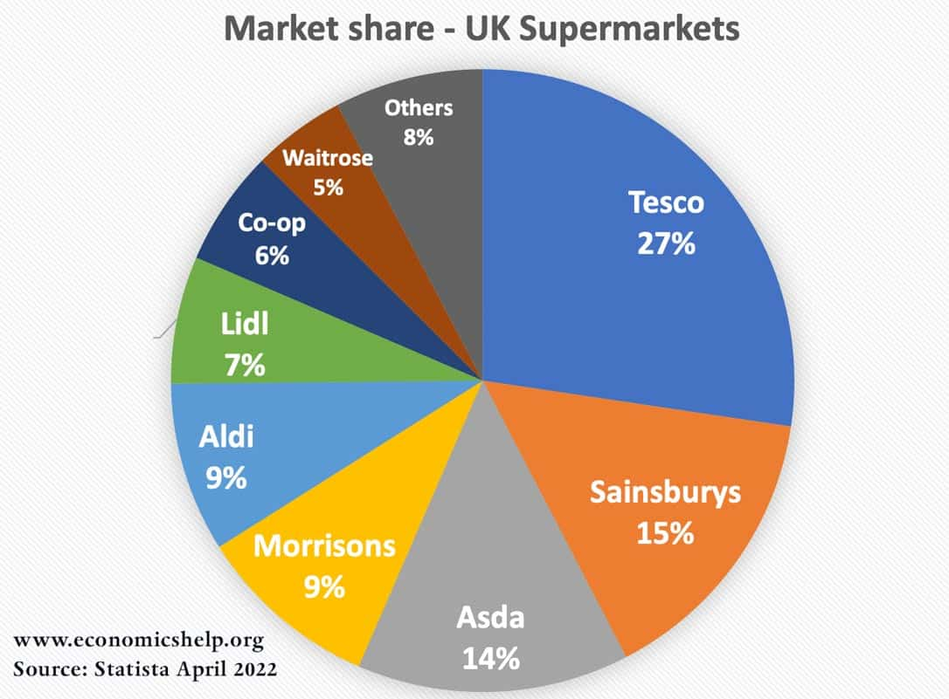
Figure 2: Market Share of UK supermarket chain
Source: (economicshelp.org, 2022)

Importance of Marketing Relationship
The importance of establishing stronger relationships with existing or target consumers directly affects the sales figure of every business organization. As per the opinions presented by Ebunoluwa (2019) relationship management is the ability to help businesses to stay in contact with their consumers in a close way that will eventually help to interpret their personal preference and interests in the most comfortable way. With the help of the respective process, Sainsbury will effectively moderate its supply chain activities and product prices that will further result in the process of generating more business leads in the future. Through relationship management, the company will understand the marketing patterns of their customers and how consumers buy their services and products. As per observation, Sainsbury analyzes the preferences of their consumers with the help of examining their unmet needs through productive relationship management and further become more capable of developing new product features as well as offerings in meeting those respective needs along with strengthening their existing consumer relationships (Lo and Campos, 2019). Other strategies of the company also involve the three basic components of marketing relationship management which are the consumer feedback, consumer service as well as consumer loyalty programs.
With the help of these identified components, Sainsbury yields the productive results from their relationship management that has effectively helped them to retain the second position in the overall supermarket chains of the UK. It has been observed that different marketing efforts in attracting new consumers and winning their attraction through advertisement approaches can be very costly. Whereas, maintaining strong relationships with existing consumers through the suitability of marketing relationship management can also act as a cost effective strategy in saving the overall cost of the business in a great way. Marketing relationships can lead to increased consumer retention that further helps to prevent any form of disruption in the profitability as well as sales figure of the company. Many businesses have been observed to face different challenges due to the ups and downs in the sales growth for which they are unable to gain potential heights and recognition in the respective markets. On the other hand, () represented marketing ROI to be the prime indicator of the success of a business organization. In this context, marketing relationships have the potential to improve this particular marketing ROI. With the help of higher numbers of consumer retention, the world cost of consumer acquisition decreases further providing businesses the higher amount of budget in implementing and building more effective relationship marketing strategies.

Role of Customer Centrality within Marketing Relationship
The effectiveness of the decision making process of an organization indicates the success as well as the competitiveness of a business. Thus, the management bodies of every modern organization should be more capable of delivering fruitful decisions and opinions according to which the entire functions and practices of the business will revolve. Various strategies are recently adopted by businesses for the sake of enhancing their decision making process in achieving greater potential heights in the future. Customer centrality is one of the many approaches that plays a unique role in the decision making process of an organization. As per the analysis stated by Kim et al., (2020), customer centrality can be referred to the perception or view in which consumer needs, predispositions as well as wants will be in the starting position of every decision making activity of an organization. The idea of placing consumer needs and preferences at the center of every business activities is considered to be the main driving force behind every planning and strategy of marketing. It has been observed that in any question of marketing, the management body of Sainsbury should always begin with the needs and demands of their customers. The concept of consumer centrality delivers every possible marketing technique that helps businesses to develop potential values for the target or existing customers. With the help of customer centrality approaches, Sainsbury will become more capable of delivering more quality services and products so as to create value for their customers that will further initiate in the increase of their respective brand image and recognition (Kurniawan et al., 2020). With the help of creating values for their customers through consumer centrality approaches, Sainsbury will effectively connect with their customers as all their business processes and activities will revolve around them. Building and nurturing loyalty with the customers is also the purpose of consumer centrality approaches that further accomplishes the goal of marketing relationship management and strategies (Chen and Yang, 2020).
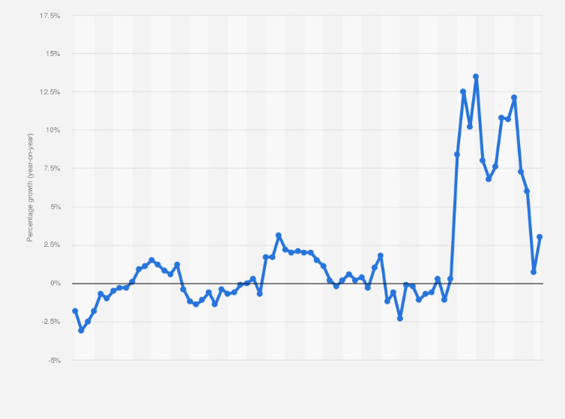
Figure 3: Sales Growth of Sainsbury
Source: (retailgazzette.com.uk, 2022)

Effectiveness of Data Analysis on Marketing Relationship
As per the analysis stated by Berraies et al., (2019), consumer data holds every single information that is effective for directing the business practices and activities of Sainsbury in delivering greater value for their target customers. The process of data analysis, evaluation as well as examination comprises every programming approach that reviews vital data about customers and further presents them to the organizations to help them streamline as well as facilitate better business decision making process. It has been observed that consumer data plays the role of visualizing the marketing relationship management about the nature and extent of interaction that their customers have with the brand. With the help of collecting and evaluating data, Sainsbury can review and experience each step of the journeys of their buyers. The longevity of Sainsbury is totally dependent upon the relationship with their consumers for which the management team should interpret their preferences and choices through the data analysis process (Astuty et al., 2021). The depth of the marketing relationship has been observed to be connected with its management approaches and its ability of relying as well as utilizing the available consumer data.
The business analytic is the process of gathering every possible data through their overall softwares, activities as well as various other services and products. It involves the systematic process of understanding and utilizing that data for the sake of developing a better decision making process for the betterment of a particular organization. Sainsbury should utilize a wide range of data mining strategies as well as predictive analytics in order to deliver the required values and quality of services to their customers in a way of strengthening the relationship with them. Analyzing and collecting data to identify the various possible ways of improving the business situation and market share of Sainsbury is one of the many purposes of the business analytic process that will eventually help the business to survive in any kind of market uncertainties in the coming days.

Managing Customer Expectations
The expectations and needs of the consumers are the factors that drive them to buy products from a particular brand. The preferences as well as the buying patterns of the consumers are being directed by their respective expectations towards a specific brand. Thus, it can be easily stated that the marketing relationship management of Sainsbury should be capable of delivering the required quality of services according to the expectations of their customers so as to earn their interest as well as loyalty in return. This interest and loyalty will help the company to establish a stronger relationship and bond with its customers and further experience higher competitive goals in the future. As per the analysis stated by Yu et al., (2018), customer expectations are the set of actions as well as behaviors that any individual anticipates during the time of interacting with a specific company or brand.
As per observation, if consumers get the quality of services and products as per their own respective expectations, they will always stay loyal to the brand for a longer period of time. Thus, helping the organization to achieve long term business goals throughout their existing markets. It has reviewed that businesses seek long term business achievements in order to carry out their business activities without any potential hindrance. It is very important to manage consumer expectations and as they will have a more realistic view of their expectations and therefore will be delighted as well as satisfied with the product quality and services that a company will offer. Creating loyal or repeat consumers as well as setting businesses apart from market competitions mainly from Tesco and Asda, are the key benefits that can be experienced by Sainsbury through the approach of managing consumer expectations (Janssens, 2021). In the process of managing consumer expectations, reviewing feedback from digital or any other platforms plays a much significant role. Sainsbury can establish a knowledgeable customer support team in order to openly discuss alternatives and solutions that will help them to build stronger consumer relationships and marketing.

Marketing Relationship Strategies of Sainsbury
As per observation, Sainsbury has a wide range of strategies that are effective for enhancing their business growth through marketing relationship. In order to establish stronger relationships and bond with their customers, the management first categorizes each of their customers through different demographic features for instance, age, income level, background, gender as well as purchase history, frequency of interaction and more (Dolnicar, 2020).Through this, the marketing relationship gets to know the level and type of interaction that should be performed with each of the customers to gain their loyalty and trust. Interpreting the expectations as well as preferences of the consumers are the best way that is considered by Sainsbury for pricing their products and items. The company also performs a thorough competitor analysis in order to analyze the business strategies of Tesco, Asda and other prominent market chains of the UK. This also acts as the most effective tool for the differentiation strategy of Sainsbury. With the help of analyzing the pricing strategies as well as quality of the services of their competitors, they deliver the lowest price possible for their food and non-food products along with ensuring the highest quality in the markets. In order to strengthen their consumer relationship, maintaining ethics is given the foremost priority by the management body of Sainsbury. Apart from this, the company also offers full refund and exchange facilities for any damaged or bad products and takes responsibility for the inconveniences faced by their consumers. Through this, the consumers feel very attached and special, further enhancing the marketing relationship approaches of the company. As per the analysis stated by Yngfalk (2019), sustainability is the key to achieve potential marketing relationship heights. Due to which, the management body always looks for various possible ways that will have the potential to enhance the brand's social media presence as well as interactions. This acts as the most productive tool in generating greater business leads from all over the country. Sainsbury always shares up to date information and contents with their social media followers in order to connect as well as attract them in a much more comfortable way. Apart from this, with the help of the data analytic process, the management body effectively identifies the most valuable consumers and further rewards them with attractive offers and discounts in order to encourage them more in the coming days. With the help of these respective approaches, the marketing relationship management body of Sainsbury became more effective in connecting as well as interacting with a potential number of consumers.

Areas of Improvement
The most effective areas that should be enhanced by the marketing relationship management body of Sainsbury are being listed below:-
- Building a culture of listening
The company should direct their customer support team in such a way that they acquire the ability of developing a culture of listening. This will help the company to review consumer feedback and preferences according to which their respective business practices and policies can be moderated (Tien et al., 2021).
- Setting clear expectations
In order to accomplish this particular approach, Sainsbury should be more capable of early clarification as well as identification of their respective goals and objectives in order to adopt the required actions and policies of achieving them in the future.
- Asking questions
Sainsbury should collect and examine every possible consumer feedback in order to analyze their choice of quality and product features. Due to which, they should ask questions for interpreting their behaviors and buying patterns.

Conclusion
As per analyzing the modern dynamics of the recent word, it has been observed that Sainsbury should become more capable of adopting different strategies and concepts so as to achieve potential heights and retain their market share in the UK. The company has effectively experienced a sales growth in the last business year but should be maintained to avoid unforeseen consequences in the future. The management body should consider the areas highlighted in the business report so as to yield the most fruitful results from their marketing relationship strategies.

References
(Dolnicar, 2020. Market segmentation for e-Tourism. Handbook of e-Tourism, pp.1-15.
Astuty, W., Zufrizal, Z., Pasaribu, F. and Rahayu, S., 2021. The effects of customer relationship management, human resource competence and internal control systems on the effectiveness of supply chain management in the Indonesian public sector. Uncertain Supply Chain Management, 9(3), pp.595-602.
Bentham, J., 2018. Business and Economics in the News–Sainsbury's and Asda-the decade's mega-merger. Teaching Business & Economics, 22(3), pp.11-12.
Berraies, S., Chtioui, R. and Chaher, M., 2019. Customer-contact employees’ empowerment and customer performance: the CRM effectiveness as a mediator. International Journal of Productivity and Performance Management.
Chen, N. and Yang, Y., 2021. The impact of customer experience on consumer purchase intention in cross-border E-commerce——Taking network structural embeddedness as mediator variable. Journal of Retailing and Consumer Services, 59, p.102344.
Ebunoluwa, E.I., 2019. Development of a framework for assessing the marketing relationship practice of quantity surveying firms in southwestern Nigeria (Doctoral dissertation, Obafemi Awolowo University).
Gesualdi, M., 2019. Revisiting the relationship between public relations and marketing: Encroachment and social media. Public Relations Review, 45(2), pp.372-382.
Janssens, J., 2021. Managing Customer Journeys in a Nimble Way for Industry 4.0. In Research Anthology on Cross-Industry Challenges of Industry 4.0 (pp. 853-876). IGI Global.
Kim, D.Y., Zhu, P., Xiao, W. and Lin, Y.T., 2020. Customer degree centrality and supplier performance: the moderating role of resource dependence. Operations Management Research, 13(1), pp.22-38.
Kurniawan, R., Manurung, A.H., Hamsal, M. and Kosasih, W., 2020. Orchestrating internal and external resources to achieve agility and performance: the centrality of market orientation. Benchmarking: An International Journal.
Lo, F.Y. and Campos, N., 2018. Blending Internet-of-Things (IoT) solutions into relationship marketing strategies. Technological Forecasting and Social Change, 137, pp.10-18.
Palmatier, R.W. and Steinhoff, L., 2019. Relationship marketing in the digital age. Routledge.
Sousa, B.M. and Alves, G.M., 2019. The role of relationship marketing in behavioural intentions of medical tourism services and guest experiences. Journal of Hospitality and Tourism Insights.
Tien, N.H., Diem, P.T., Van On, P., Anh, V.T., Van Dat, N., Hung, N.T. and Tam, B.Q., 2021. The formation and development of CRM system at Thien Hoa electronics supermarket in Vietnam. International Journal of Research and Growth Evaluation, 2(4).
Yngfalk, C., 2019. Subverting sustainability: Market maintenance work and the reproduction of corporate irresponsibility. Journal of Marketing Management, 35(17-18), pp.1563-1583.
Yu, Q., Allon, G., Bassamboo, A. and Iravani, S., 2018. Managing customer expectations and priorities in service systems. Management Science, 64(8), pp.3942-3970.

