-

Database Systems
ACCA7002
Assignment Title: Database Construction and Solution Research Based on Abertawe Arts Centre
Student Number: 2006613
Student Name: Hai Jiang

Date of Submission: 15th January 2021

Contents
Abstract 3
1 Introduction 3
2 Database Creation 4
2.1 Create Table 4
3 Performance Tuning Enhancement 5
3.1 Create Secondary Index 5
3.2 Transactions 7
4 SQL vs. NoSQL 8
4.1 SQL 8
4.2 NoSQL 8
4.3 Comparison of SQL and NoSQL 9
4.3.1 Theoretical difference 9
4.3.2 Schema 9
4.3.3 Scalability 9
4.3.4 Support 10
4.3.5 Languages Used 10
5 Distributed Database Solution 11
5.1 Overview of Distributed Database System 11
5.2 Features and advantages and disadvantages of DDBS 11
5.2.1 Basic features of DDBS 11
5.2.2 Advantages of DDBS 12
5.2.3 Disadvantages of DDBS 12
5.3 Data fragmentation 12
5.3.1 Fragmentation type 12
5.3.2 Fragmentation conditions: 12
5.4 Distributed Database Solution 13
5.4.1 Horizontal Fragmentation 13
5.4.2 vertical fragmentation 13
5.4.3 mixed fragmentation 14
References 14

Database Construction and Solution Research Based on Abertawe Arts Centre

Abstract
In this report, we first briefly introduced the database created for Abertawe Arts Centre. A small amount of data was inserted into the database and constrained operations such as checks were performed. In order to improve database performance, secondary indexes and transactions have been added. Provide some clarity on the debate between using SQL databases and using NoSQL databases at the company's request. Finally, Using the Abertawe Arts Centre case study, a distributed database solution is proposed.
Key words: Database, secondary indexes, transactions, SQL, NoSQL, Distributed Database

1 Introduction
With the maturity of traditional database technology, the rapid development of computer network technology and the expansion of its application range, the application of databases has been generally established on computer networks. In this regard, centralized database systems show their shortcomings. The application runs on the computer. Once the computer fails, the entire system will be affected and the reliability is not high; centralized processing will lead to inflexible system size and configuration, and very poor system scalability. In this case, the concept of "centralized computing" for centralized databases is developing toward the concept of "distributed computing". [1] So this article will propose a distributed database solution after introducing the database.

2 Database Creation

2.1 Create Table
Through the analysis of the case, I created eight tables, namely: ProductionCompany, EntertainmentProduction, PerformanceSchduling, Venue, Seat, Customer, Ticket, Booking, and used VISIO to draw a schematic diagram, as shown in Figure 2.1.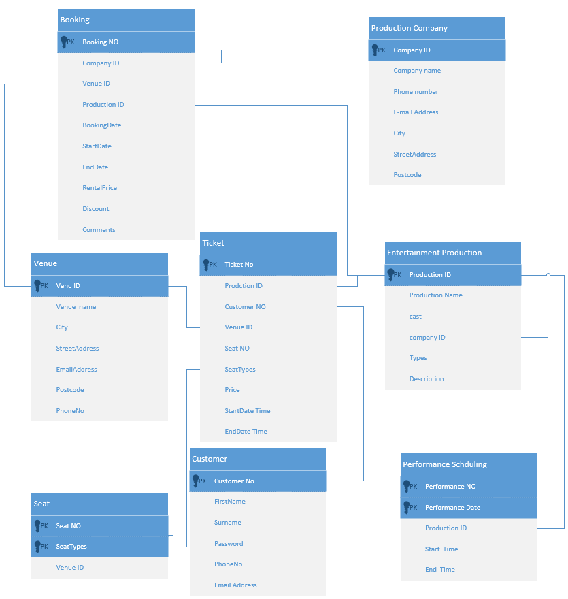
Create a table through SQL code statements in SQL SEVER, and add constraints such as primary keys and foreign keys. The code example is shown in the figure below.
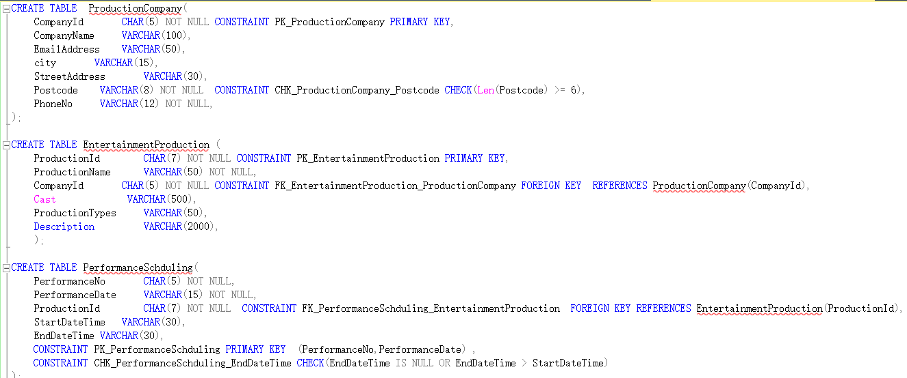 Then use the insert statement to insert part of the data into each table, part of the insert code is shown in the figure below.
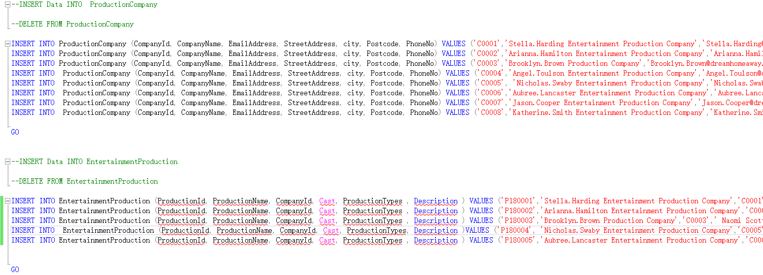
The table after creating and inserting data is shown below.
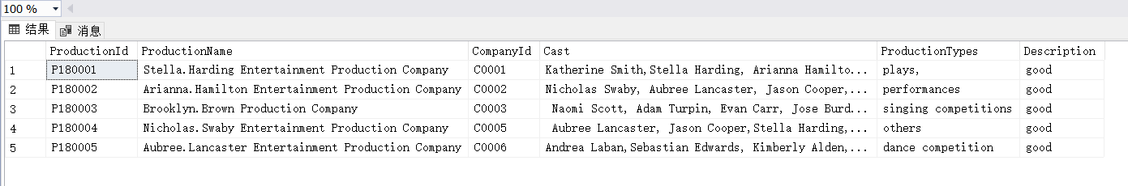 SQL code used to create the check constraint(s), as shown below.

3 Performance Tuning Enhancement

3.1 Create Secondary Index
Think of data query requirements that are going to be important and/or frequently executed in the database。Therefore, in addition to the primary key index, multiple secondary indexes should be added to improve data query performance. In this task, I added three important secondary indexes. First, I added an index about CompanyId in the Booking table. The code is as shown below.
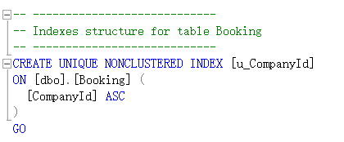
The CompanyId column is indexed in the Booking table to quickly query which companies have booked venues in the Abertawe Arts Centre. In addition, I also added an index about BookingDate in the Booking table, the code is as shown below.
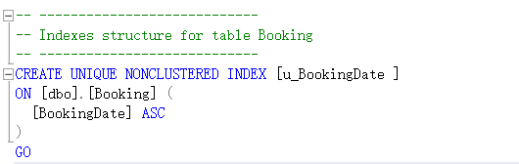
The BookingDate column is indexed in the Booking table to quickly query how many companies have booked venues in the Abertawe Arts Centre on a specific date. Finally, I added an index about ProductionId in the PerformanceSchduling table, the code is as shown below.
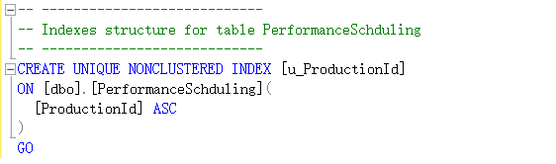
Indexing the ProductionId column in the PerformanceSchduling table is to quickly query the performance schedule of a certain work.

3.2 Transactions
A transaction is a logical unit of work in SQL Server and is processed as a whole. The transaction guarantee must successfully perform multiple operations in succession, otherwise it must immediately return to the state of not performing any operations, that is, the result of executing the transaction will complete the purpose of the data, otherwise all data will not be modified. [2] At the request of the Abertawe Arts Centre, the trading business is conducted on the established database. The code is shown in the figure below.
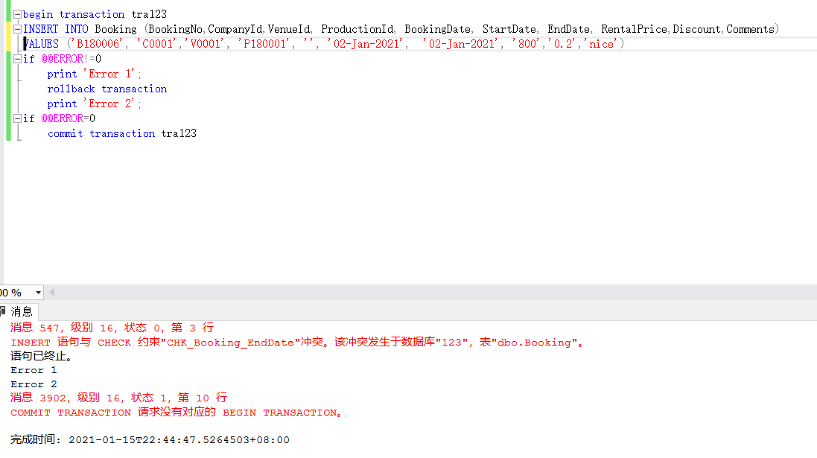
The production company will reserve a venue at the Abertawe Arts Centre, so there will be a record of the company's reservation of the venue in the Booking table of the database. When there is no detailed content for the specific date (bookingdate) required by the production company or the bookingdate is empty, "Error" will be displayed, and then rollback operation will be performed, and then commit transaction. This will complete a Transaction operation.

4 SQL vs. NoSQL

4.1 SQL
SQL stands for Structured Query Language. As the name suggests, it is a query language used to perform various data operations. Almost all relational databases support it. Relational database is usually synonymous with SQL database. It is a collection of data records. These data records may have predefined associations or relationships. [3]
SQL databases or relational databases use traditional data storage methods (each database may contain multiple tables). However, it is worth noting that in RDB, each table contains rows with the same attributes or "shape". Each column describes specific information about the record. The type of data that each column will contain is also predefined.
The correct definition of tables and columns is a prerequisite to benefit from the database. Then, the daily task will add a new row. This is where SQL comes in handy. It provides a convenient way to create tables, define columns, add records, delete records, and so on. It also allows us to "join" or associate (create relationships) multiple tables by using the concept of primary keys and foreign keys. [4]

4.2 NoSQL
In the past few years, many NoSQL database systems have become more and more popular. They are non-relational DMSs that support structured, unstructured, semi-structured and polymorphic data. At a high level, NoSQL is more than just SQL. Therefore, it is not for a single database product, but for a series of technologies. [5] Also don't assume that databases are similar in nature.
NoSQL Databases:
- typically don’t use SQL
- usually don’t store data in tables
- usually don’t care about relationships
- usually don’t provide ACID transaction
- usually don’t require formal data schemas (making them more flexible)

4.3 Comparison of SQL and NoSQL

4.3.1 Theoretical difference
In short, SQL databases are primarily Relational Database Management Systems, while NoSQL databases are non-relational distributed databases and datastores.

4.3.2 Schema
Schema refers to the organization and shape of records in the database. These two database types have very different data storage models. SQL databases usually deal with structured data organized as tables. On the other hand, NoSQL databases and support for structured data also promote the storage of unstructured, semi-structured and polymorphic data. NoSQL databases can store information in the form of document storage, key-value pairs, graph databases, and column storage. These databases do not need to follow a predefined architecture. This distinction makes them useful for specific scenarios. [6] For example, RDB is very intuitive to accounting systems because they simulate accounting books well. NoSQL is the first choice for "big data" solutions. The flexibility of data types is crucial in these solutions.

4.3.3 Scalability
Scalability refers to how database technology can adapt to growing data volumes without sacrificing performance. In this regard, a single SQL database tends to scale vertically, which means that more efficient and newer hardware (CPU, RAM, and SSD) can be used to handle the additional load. On the other hand, NoSQL databases tend to have a higher level of scalability (by distributing traffic among more servers in the database cluster, they can automatically handle more traffic). Please note that relational databases can also be expanded with more hardware, but some extra work is required to unify various database instances. [7] This is why we prefer to use NoSQL databases when our data is growing at a very high rate.

4.3.4 Support
Historically, SQL databases entered the market before NoSQL. Therefore, it is not surprising that almost all SQL database vendors provide a lot of support for their users. In addition, a community of independent consultants can help deploy SQL databases on a large scale. Of course, NoSQL databases have started to do the same thing. [8] However, many people are still in their infancy, so they rely more (or usually alone) on the support of the open source community. In addition, there are fewer independent consultants when building and deploying large NoSQL databases.

4.3.5 Languages Used
SQL database supports Structured Query Language (SQL), which enables us to perform various operations on the database. It accomplishes this by providing different types of commands. Although SQL is the most stable and widely used option for performing database operations, it may be limited because it requires users to define the structure of tables and records in advance. [9] There is also a constraint that all data stored in a structure must be consistent when viewed. On the other hand, NoSQL databases are dynamic and flexible. They allow storing unstructured data in multiple ways. According to the nature of the data, NoSQL options include document storage, key-value pairs, graph databases, and column-oriented storage. As mentioned earlier, you do not need to suggest the data structure in advance. Each document can have its own unique structure. [10] This is called Unstructured Query Language (UNQL), and its syntax varies from product to product.

5 Distributed Database Solution

5.1 Overview of Distributed Database System
Distributed Database System (DDBS) is a database management information system proposed for geographically dispersed, and management needs to require different levels of centralized management. [11] Distributed database is the product of the combination of database technology and network technology, and has formed a branch in the database field. Since the 1990s, distributed database systems have entered the stage of commercial application. Traditional relational database products have developed into distributed database products centered on computer networks and multitasking operating systems. At the same time, distributed databases have gradually become client/server Model development.

5.2 Features and advantages and disadvantages of DDBS

5.2.1 Basic features of DDBS
(1) Physical distribution: Data is not stored on one site, but on multiple sites on a computer network.
(2) Logical integrity: The data is physically distributed in each site, but logically as a whole, they are shared by all users (global users) and managed by a DDBMS.
(3) Site autonomy: The data on each site is managed by a local DBMS, with autonomous processing capabilities, to complete the application (partial application) of the site.
(4) Collaboration between venues: Although the venues have a high degree of autonomy, they cooperate with each other to form a whole. [12]

5.2.2 Advantages of DDBS
(1) Have a flexible system structure
(2) Adapt to distributed management and control institutions
(3) Superior economic performance
(4) The system has high reliability and good availability
(5) Fast response speed for partial application
(5) Good scalability and easy integration with existing systems

5.2.3 Disadvantages of DDBS
(1) The system overhead is relatively large, mainly spent on the communication part.
(2) Complex access structure (such as auxiliary index, file link technology) is an important technology for effective data access in centralized DBS, but it is not necessarily effective in distributed systems.
(3) The security and confidentiality of data are difficult to handle.

5.3 Data fragmentation

5.3.1 Fragmentation type
(1) Horizontal fragmentation; (2) Vertical fragmentation; (3) Export fragmentation; (4) Mixed fragmentation.

5.3.2 Fragmentation conditions:
(1) Completeness conditions: All data of the global relationship must be mapped to fragments, and data that belongs to the global relationship but does not belong to any fragment of it is never allowed.
(2) Reconfigurable condition: It must be ensured that the global relationship can be reconstructed by each segment of the same global relationship. For horizontal shards, it can be used to reconstruct the global relationship; for vertical shards, the join operation can be used to reconstruct the global relationship.
(3) Disjoint condition: It is required that the data fragments obtained after a global relationship is divided do not overlap with each other (except for the primary key of vertical fragmentation). [13]

5.4 Distributed Database Solution

5.4.1 Horizontal Fragmentation
In the Abertawe Arts Centre case, perform horizontal fragmentation on the form PerformanceSchduling, as shown in the figure below.
The fragmentation condition is to split startdatetime, which is split every six months. Because there are various performance arrangements every day, a long time will cause too much data in the table PerformanceSchduling, which will affect the server operation and query efficiency.

5.4.2 vertical fragmentation
In the Abertawe Arts Centre case, I will perform vertical fragmentation on the customer form, as shown in the figure below.
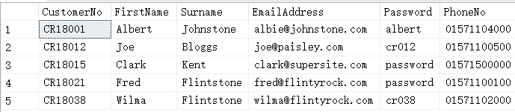
Because many customers come to watch the performance every day, the attributes in the table are divided into customer-1 (CustomerNo, FirstName, Surname, Password) and customer-2 (CustomerNo, EmailAddress, PhoneNo). Of course, each table contains the primary key CustomerNo.

5.4.3 mixed fragmentation
In the Abertawe Arts Centre case, I will perform mixed fragmentation on the ticket form, as shown in the figure below.
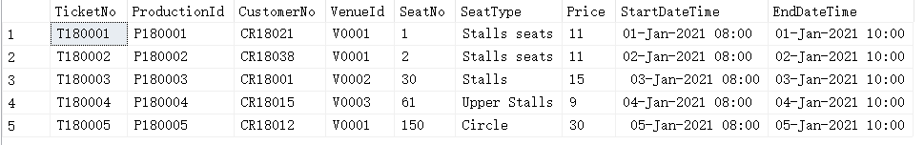
First, perform horizontal fragmentation on the form Ticket, and the fragmentation condition is to split StartDatetime, which is split every six months. Then perform vertical fragmentation and divide the table into Ticket-1(TicketNo,ProductionId,CustomerNo), Ticket-1(TicketNo,SeatNo,SeatType,Price), Ticket-1(TicketNo,StartDateTime,EndDateTime) according to the attributes.

References
[1] Tang Hao, Jiang Chunyu, Tian Jiafeng. Research on Distributed Database Technology and Its Development Trend [J]. Information and Communication Technology and Policy, 2020(11): 86-90.
[2] Zhao Pei, Zuo Qi. A high-performance distributed transaction and consistent replication implementation[J]. Information and Communication Technology and Policy, 2020(11): 72-78.
[3] Chen Juan, Li Wei. Summary of non-relational database and relational database technology[J]. Electronic Technology and Software Engineering, 2020(18):147-148.
[4] Liu Yucheng, Li Gang. Comparison of NoSQL database and relational database[J]. China New Communications, 2018, 20(07): 81.
[5] Zhang Jie. A Brief Talk on NoSQL[J]. Computer CD Software and Application, 2013, 16(23): 64-66.
[6] Lu Mingyu, Li Xiaoyong. Comparative analysis of NoSQL database and relational database[J]. Microcomputer Applications, 2011, 27(10): 55-58.
[7] Zhang Bingbing. Research on data query conversion method between SQL and NoSQL databases [J]. Electronic Science and Technology, 2017, 30(08): 109-112+116.
[8] Leavitt N. Will NoSQL databases live up to their promise [J]. Computer , 2010 , 43 ( 7 ):12一14.
[9]Baron Schwartz，Peter Zaitsev，Vadim Tkachenko. performance replication [R] MySQL: optimization，backups，and replication[R].3rd Edition-0’Reilly M edia , 2012.
[10] Rith J，Lehmayr P S，Meyer}vegener K. Speaking in tongues: SQL the access to NoSQL systems }C .England: Proceedings of29th Annual ACM Symposium on Applied Computing SAC’14)，2014.
[11] Mu Zhichun. A Brief Talk on the Architecture of Distributed Database System [J]. Electronic World, 2020(21):167-168.
[12] International Business Machines Corporation; Researchers Submit Patent Application, "Record Replication For Multi-Column Partitioning On Distributed Database Systems", for Approval (USPTO 20200327147). 2020, :6758-.
[13] Ahmet Ercan Topcu, Aimen Mukhtar Rmis. Analysis and evaluation of the riak cluster environment in distributed databases. 2020, 72.

