James Ball (1809296)
1809296@student.uwtsd.ac.uk
Visualisation of IoT data
Smart and Connected Devices 1 - Feb 2020

Contents
Contents 1
1 Login & Logout 2
1.1 Redirect to Home if logged in. 2
1.2 Login 3
1.3 Logout 5
2 Home Page 6
2.1 Check for files 7
2.2 Useful stats 9
3 Table Page 13
3.1 Table filters 14
3.2 Table sort 19
4 Graph page 22
4.1 Month graphs 23
4.2 Day graphs 24
5 Account page 27
5.1 Displaying information 28
5.2 Changing password 31
5.2.1 Show/hide passwords 34

Login & Logout
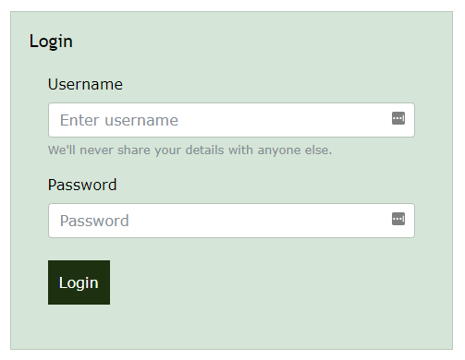
Figure 1 – Login Page
The login page is called index.php and is located in the root directory of the website, this ensures it is the page that is loaded when the user navigates to the domain of the website.

Redirect to Home if logged in.
The login page will only load if there is no current logged in browser session. It checks this by invoking the session with session_start() and checking if there is a value in “uName” session variable:
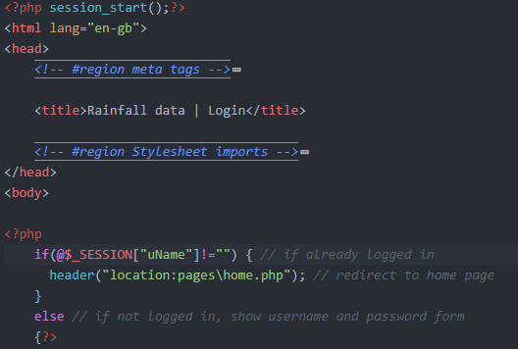
Figure 2 – login page redirect
If there is a logged in user, it redirects to the home page.
The opposite happens on all other pages in the site. If the user navigates to a page other than index.php whilst not logged in, they are automatically redirected back to the login page:
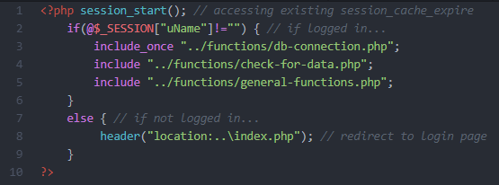
Figure 3 - home page redirect

Login
When the user tries to log in, the username is checked against the database by “checkUsername”, then if that returns true, the password is checked against the username using “checkPass”. If the user is correct, they are logged in and redirected to the home page, if not they are redirected back to the login page with an error message:
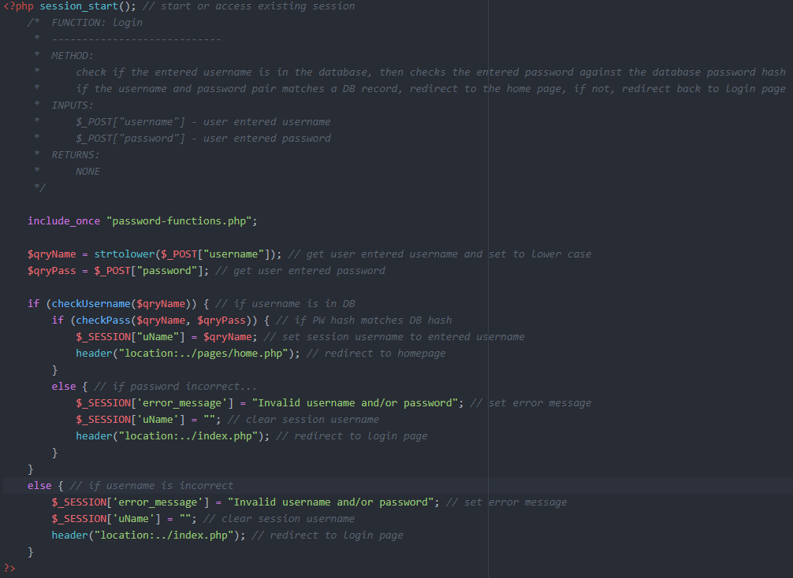
Figure 4 – login functions
“checkUsername” checks if the input username matches a user in the database:
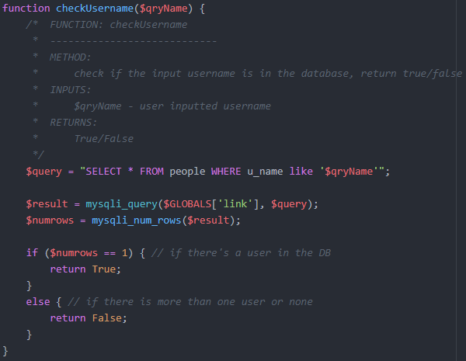
Figure 5 – checkUsername function
The “checkPass” function gets the hashed password for the user from the database, then hashes the entered password and compares them:
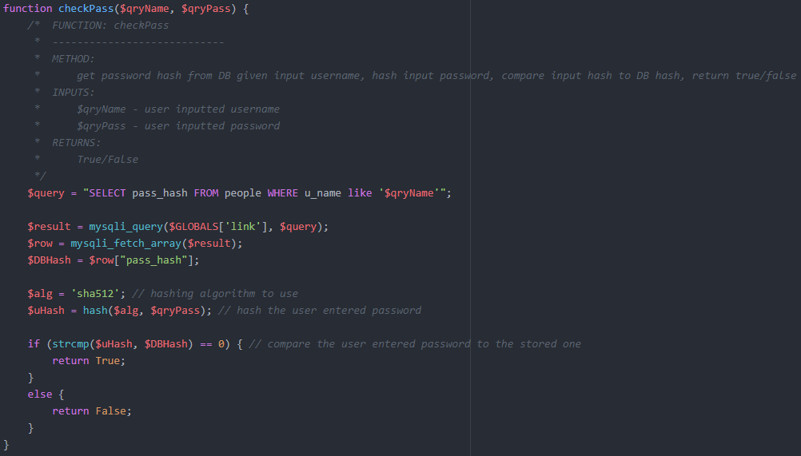
Figure 6 – checkPass function

Logout
Clicking logout on any of the site pages destroys the browser session and redirects to login page:
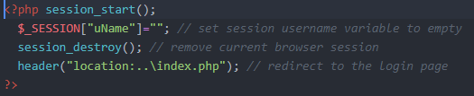
Figure 7 – logout function

Home Page
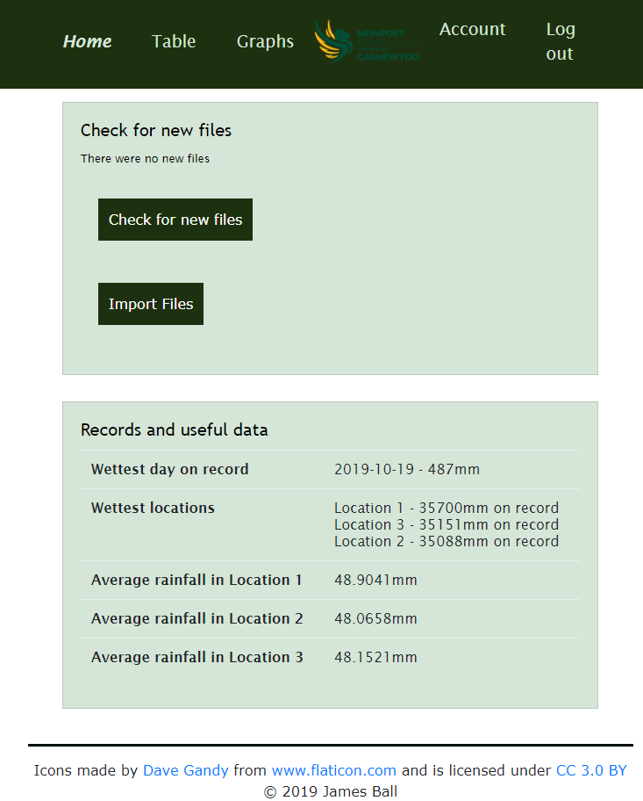
Figure 8 – Home Page

Check for files
The “data” folder is checked whenever the home page is reloaded using the “checkforFiles” function, this can be forced using the “Check for new files” button:
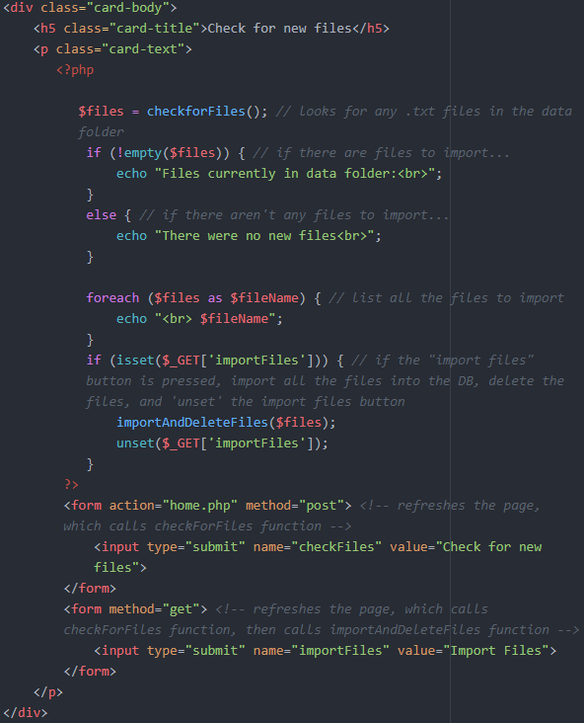
Figure 9 – hame page function calls
“checkforFiles” uses FileSystemIterator to recursively search through the directory and return the file names, which are then filtered by file type to only .txt to exclude any miscellaneous files:
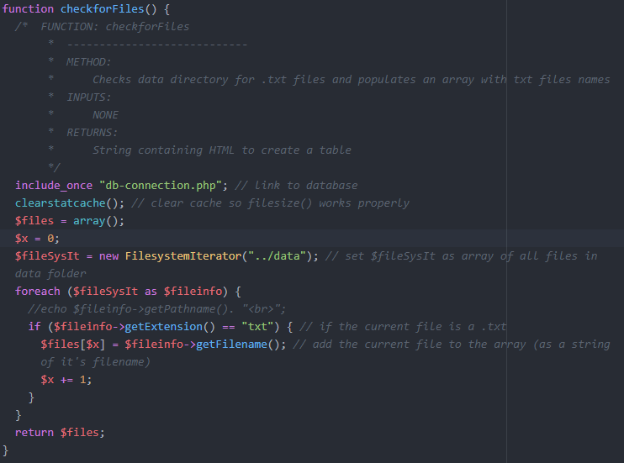
Figure 10 – checkforFiles function
When the “Import Files” button is pressed, the “importAndDeleteFiles” function is called, this takes the array of data file names and imports them to the database, then deletes the files:
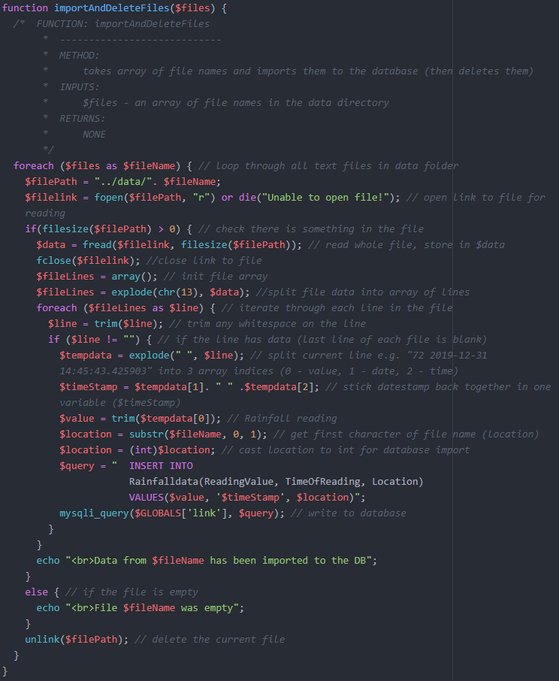
Figure 11 – importAndDeleteFiles function
The importAndDeleteFiles function iterates through the data files returned by checkforFiles and extracts the data, imports the data into the database and deletes the data file. This is under the assumption that the sensor nodes would populate the files locally and periodically send new files to the central server, rather than the nodes populating the files on the central server in real time.

Useful stats
Stats are displayed on the home page through various functions:
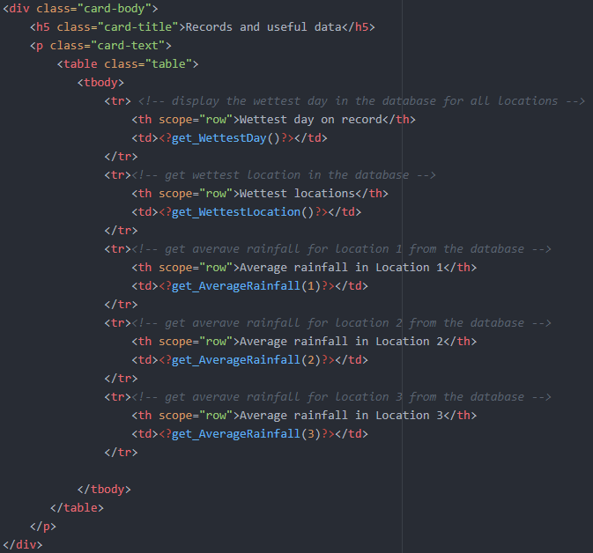
Figure 12 – stats functions
The wettest day is retrieved by formatting the timestamp of the records to only the date and grouping on this value:
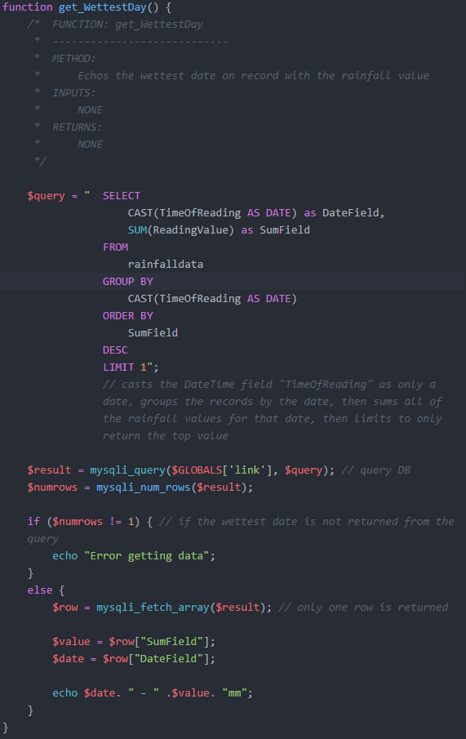
Figure 13 – wettest day function
The wettest location is gathered in a similar way, by grouping on the location:
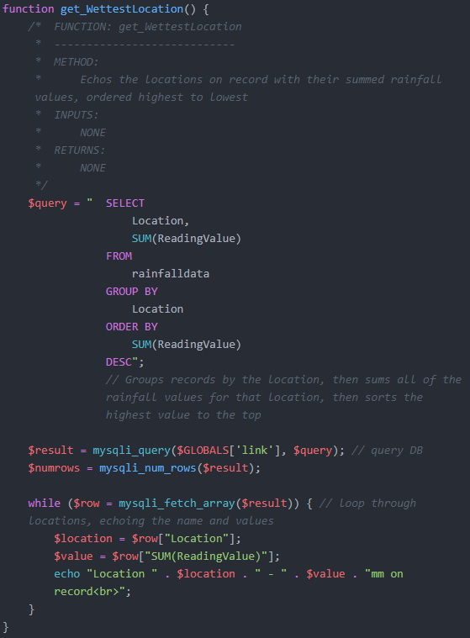
Figure 14 – wettest location
The average rainfall is calculated using the SQL AVG() function:
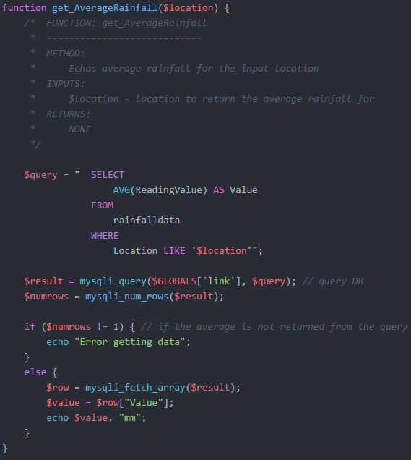
Figure 15 – average rainfall

Table Page
The table page allows the user to filter the data in various ways and display it in a table format. On load the table shows all of the data in the database.
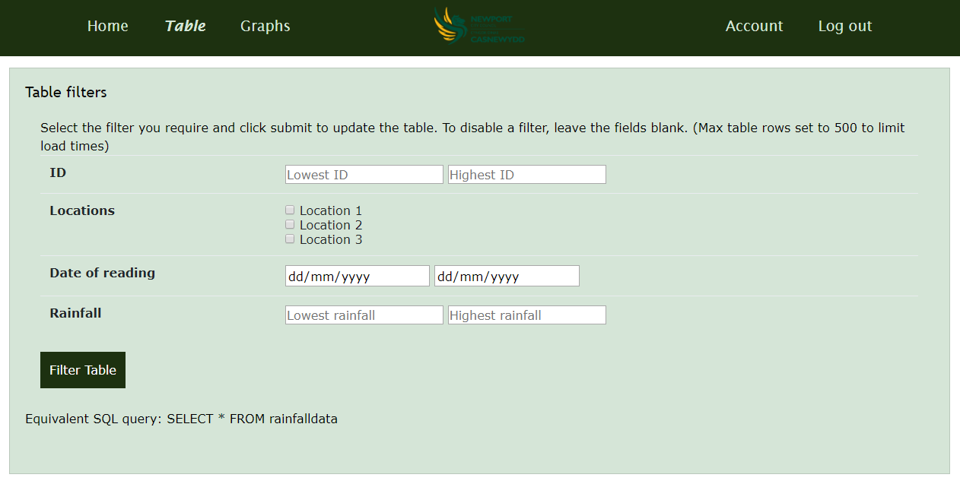
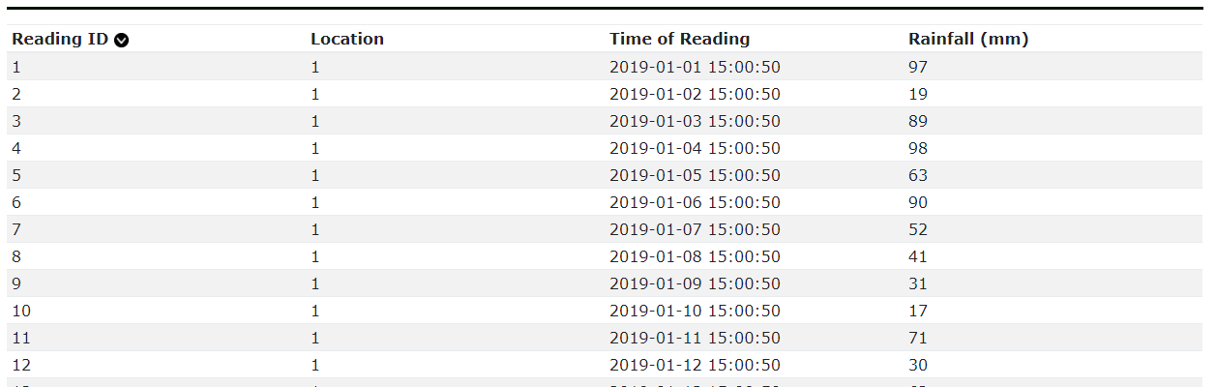
Figure 16 – Table Page

Table filters
The user can filter on any combination of the following:
- Reading ID (e.g. readings 1 to 500)
- Location (e.g. only readings from location 1, or 1 and 3)
- Date of reading (e.g. between 01/01/2019 and 01/03/2019)
- Rainfall value (e.g. only return records with a rainfall value between 50mm and 100mm)

When the filters are submitted, the SQL query is created by “setTableFilters” function, then the SQL query is run against the database in “filterTable” and finally the table is displayed by “createTable”:
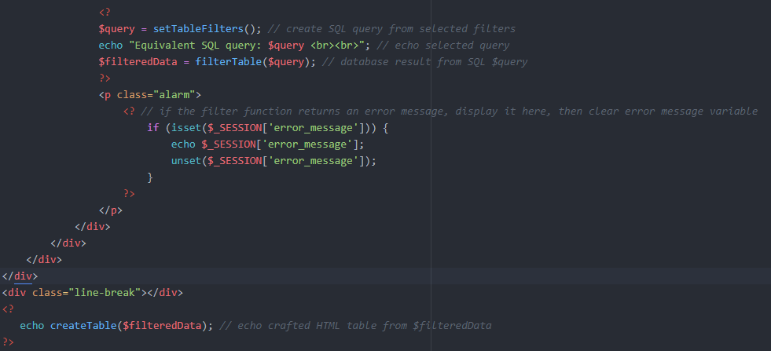
Figure 17 – table PHP functions

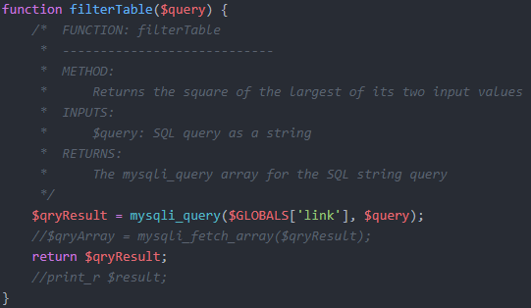
Figure 18 – filterTable function

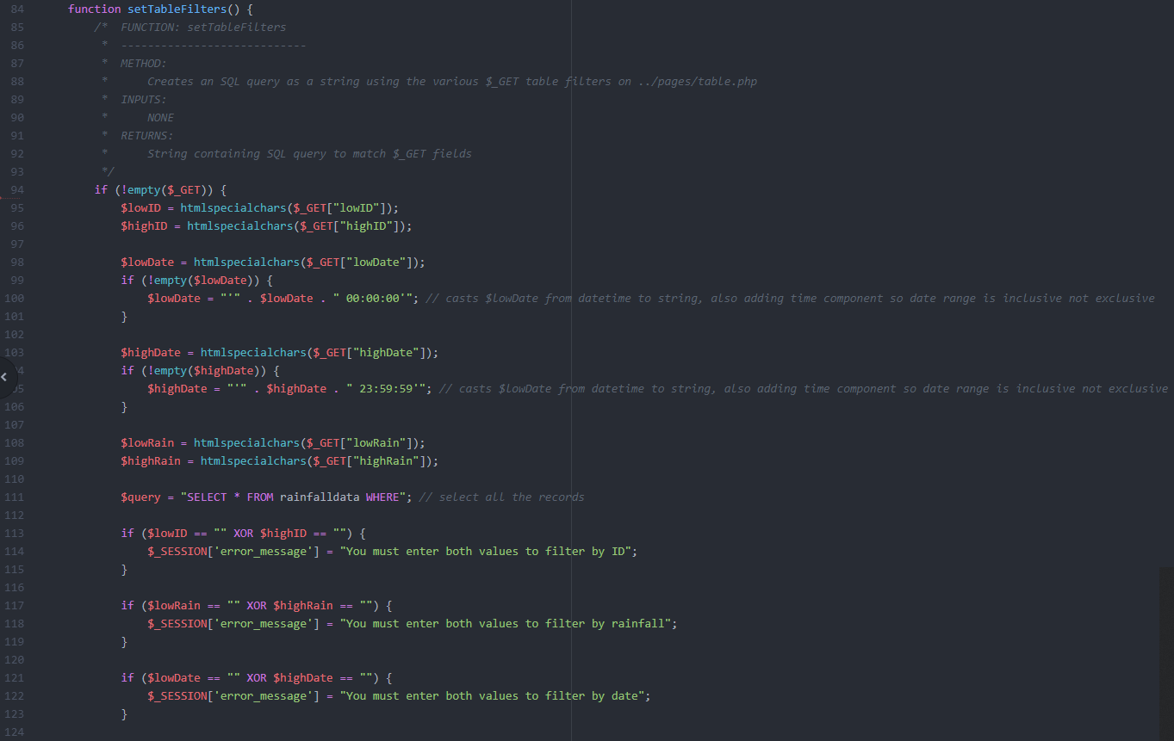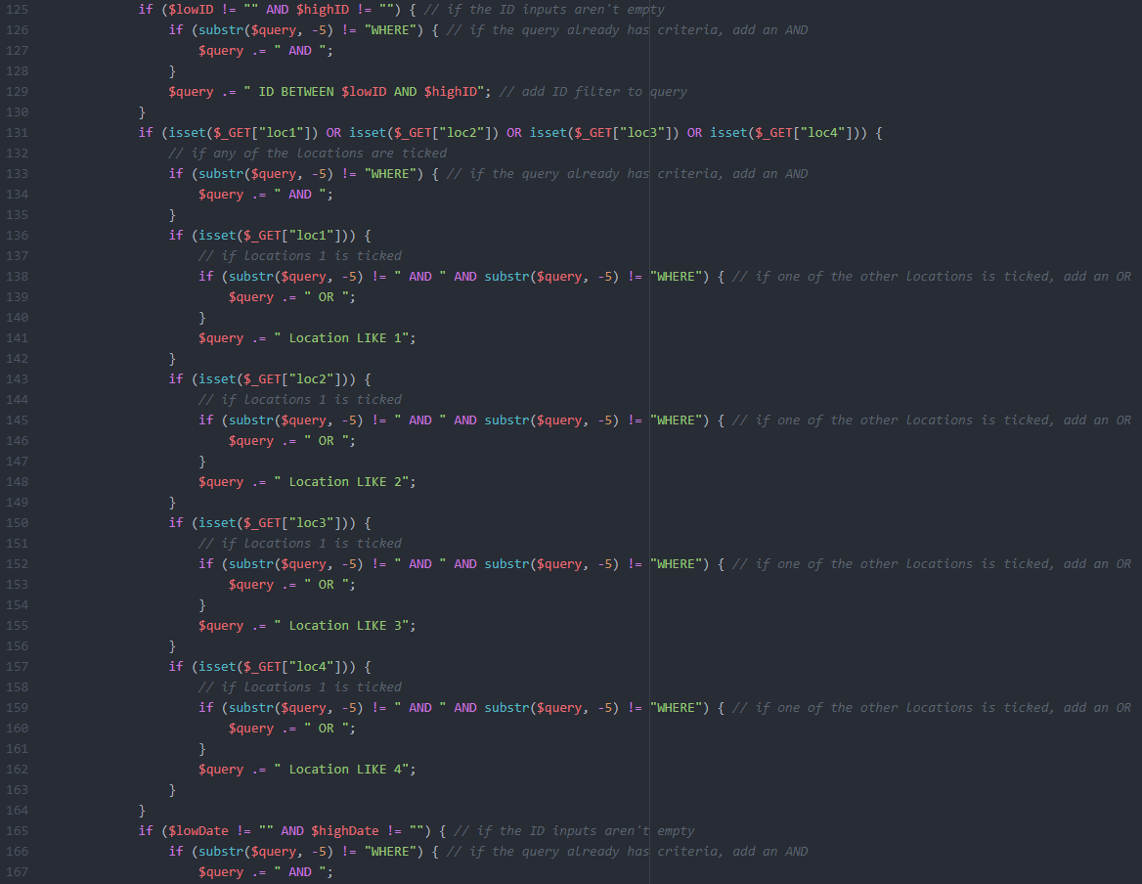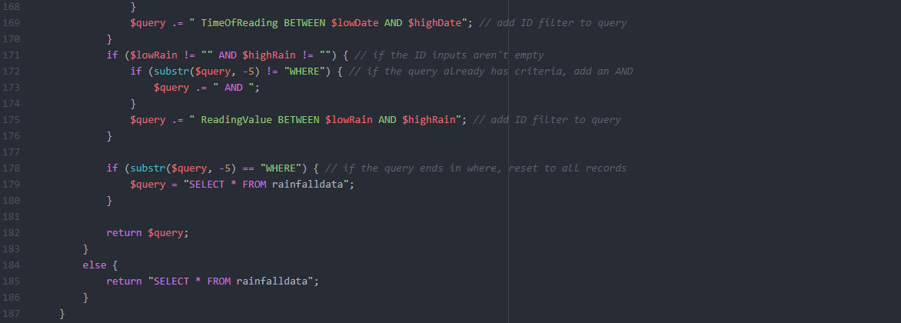
Figure 19 – setTableFilter function
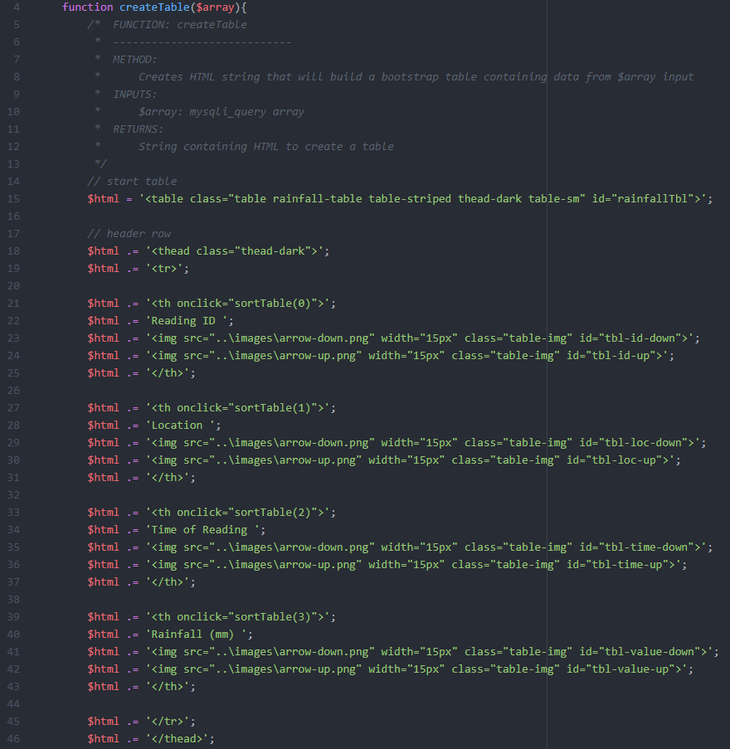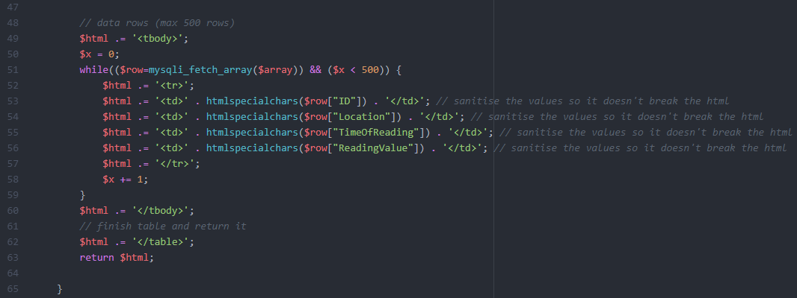
Figure 20 – createTable function

When a filter is applied the filters stay in the fields to allow the user to edit their queries rather than starting again:
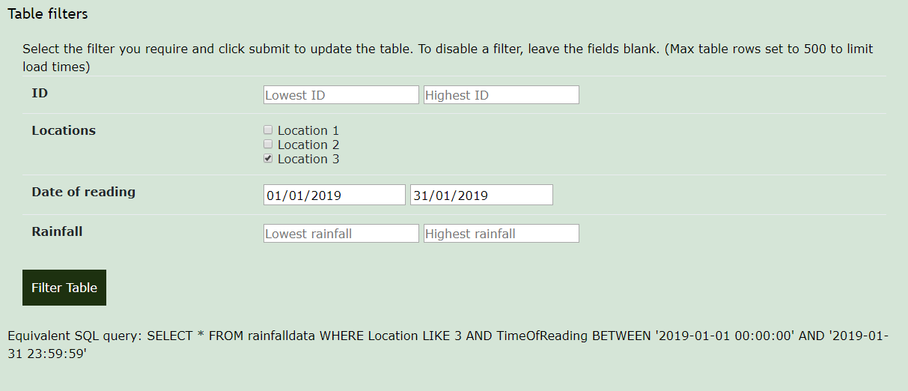
Figure 21 – table filters

This is done by using the GET variables to re-fill the fields once submitted:
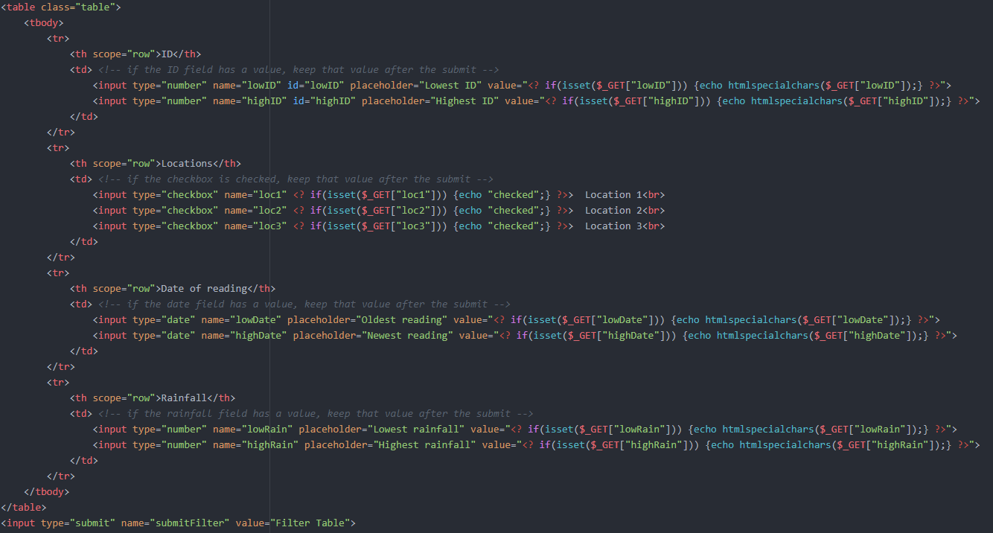
Figure 22 – table filter field code

Table sort
By clicking on the table headers, the user can sort the filtered data by any of the fields, either ascending or descending:
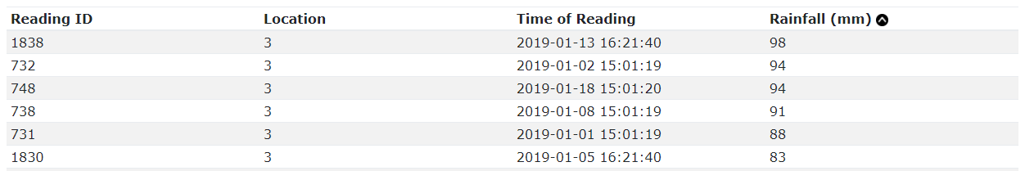
Figure 23 – sorted by rainfall
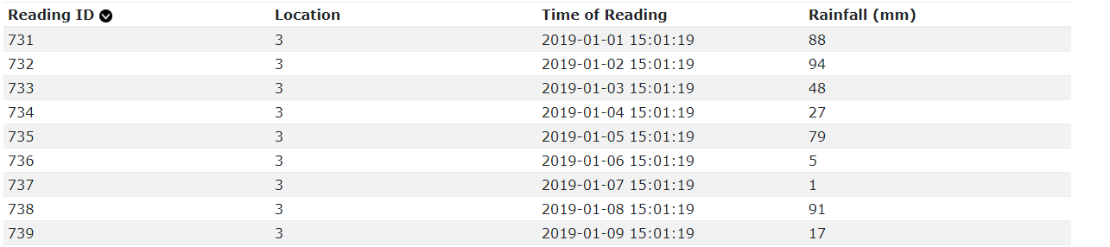
Figure 24 – sorted by reading ID

This is done using JavaScript and bubble sorting the HTML table row elements by their value:
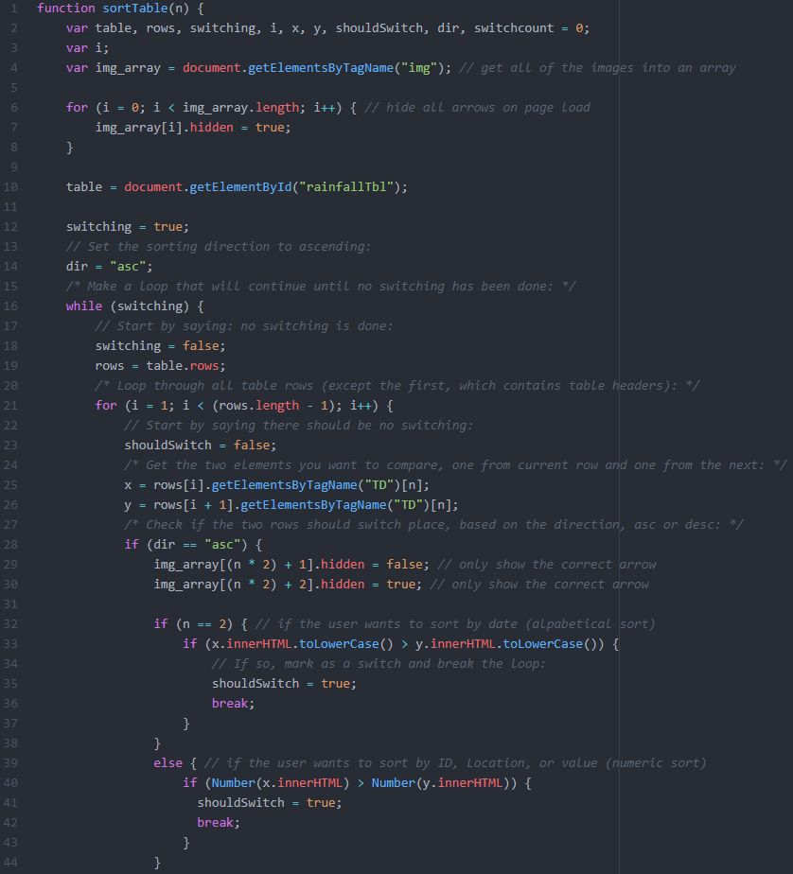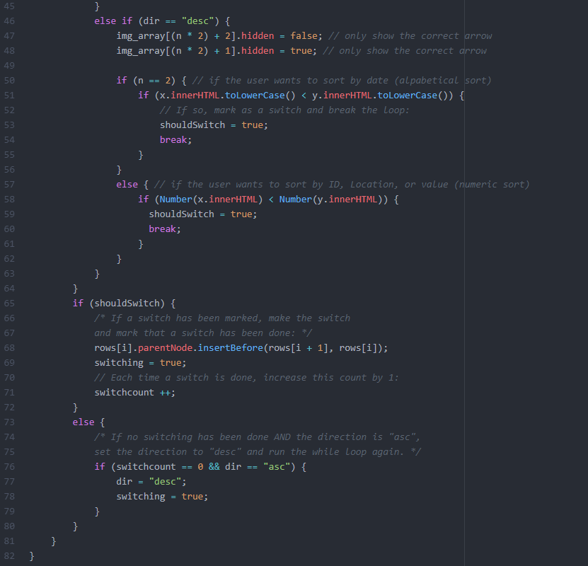
Figure 25 – JavaScript table sort function

Graph page
The graphs page shows the data by month for each location, and also shows each day of the wettest month on record for each record.

Month graphs
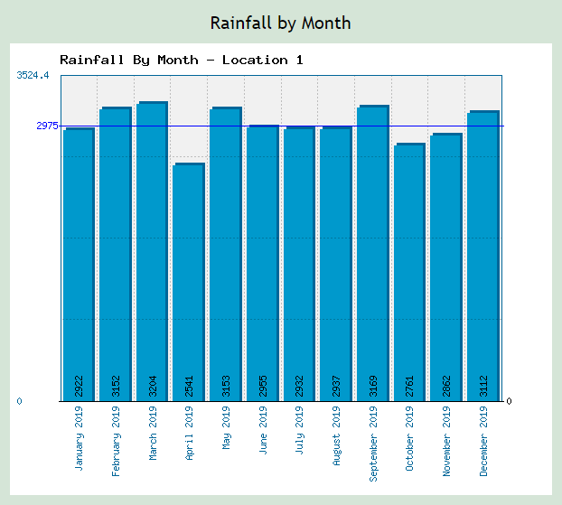
Figure 26 – monthly rainfall graph for location 1
The rainfall by months graphs are created using “makeGraphMonths.php” using hard-coded get variables for the location and graph title:
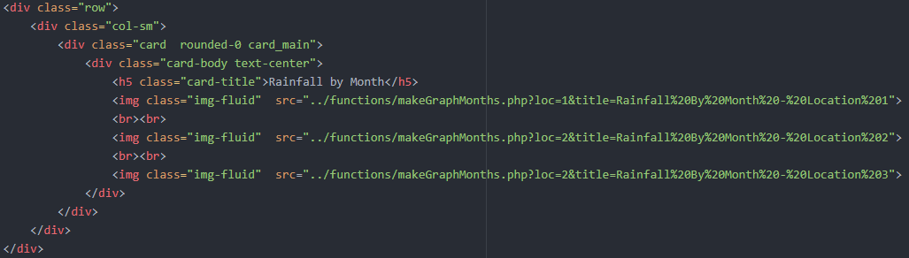
Figure 27 – graphs page graph images
The makeGraphMonths.php file includes the phpMyGraph5.0.php library for creating graphs. It formats the “TimeOfReading” field of the rainfalldata table to only the month and year, then groups on this value and sums the “ReadingValues” to get the data in the correct format for the phpMyGraph library to read and turn into a png file:
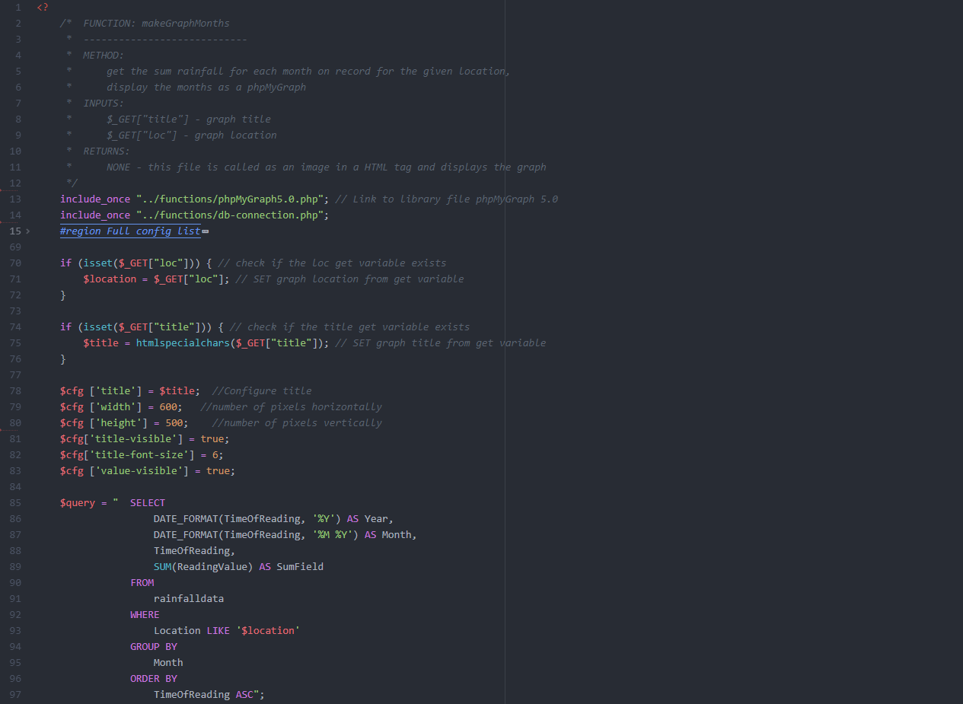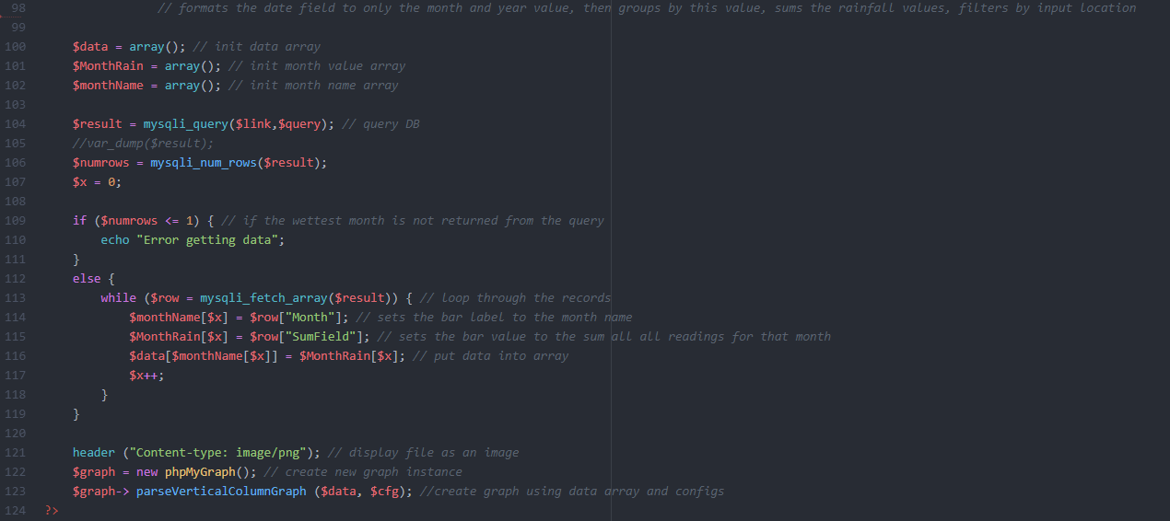
Figure 28 – makeGraphMonths.php

Day graphs
The wettest month on record was May 2019, so the graphs show the rainfall for each day in May for each location:
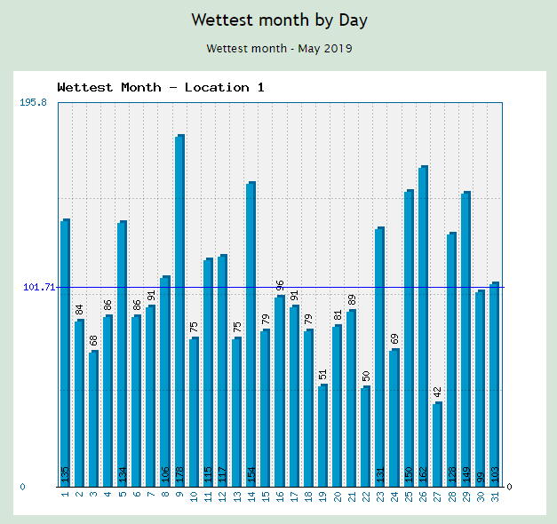
Figure 29 – wettest month graph for location 1
The makeGraphDays.php file first gets the wettest month on record by grouping the records by month and summing the “ReadingValue” values:
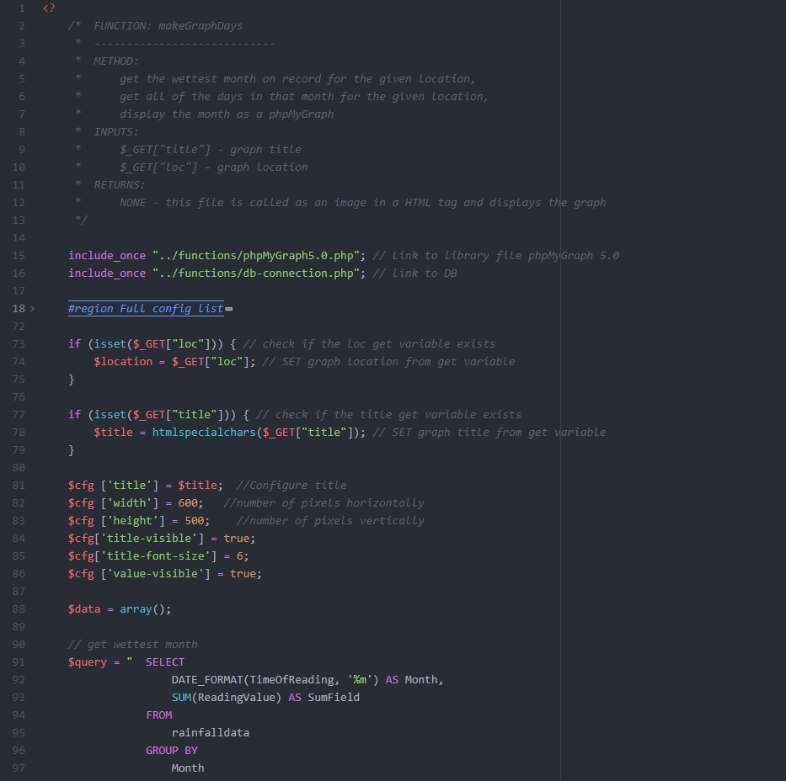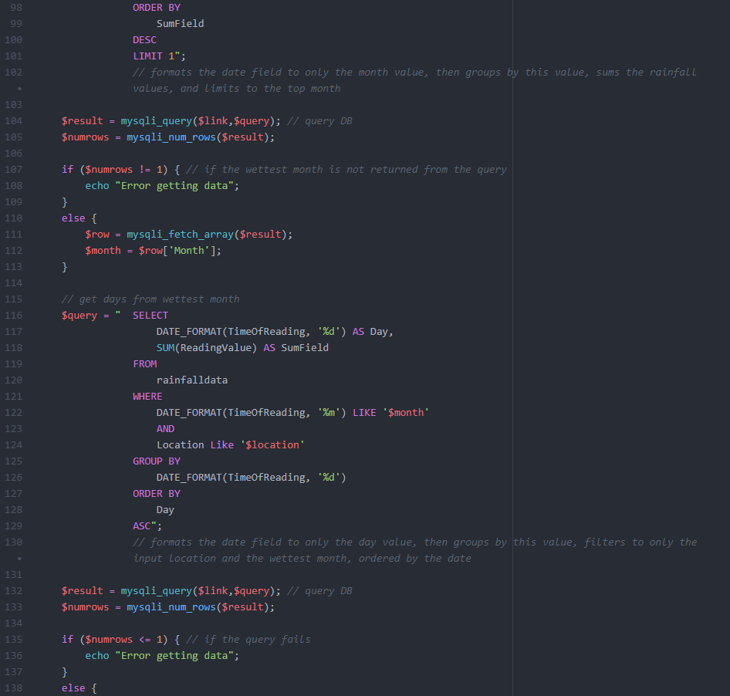
Figure 30 – makeGraphDays.php getting wettest month
Then this wettest month value is used to filter the database values which are grouped by day, summed and displayed in the graph
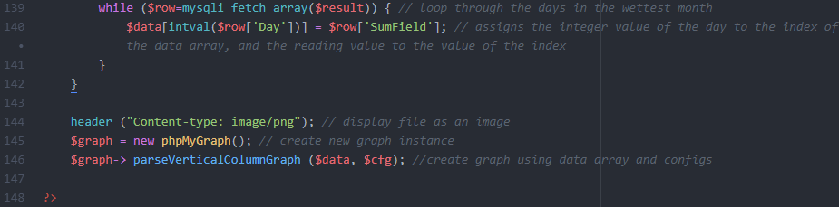
Figure 31 – makeGraphDays.php filtering by wettest month and grouping values by day

Account page
The accounts page shows some of the user data stored in the database and also allows the user to change their password:
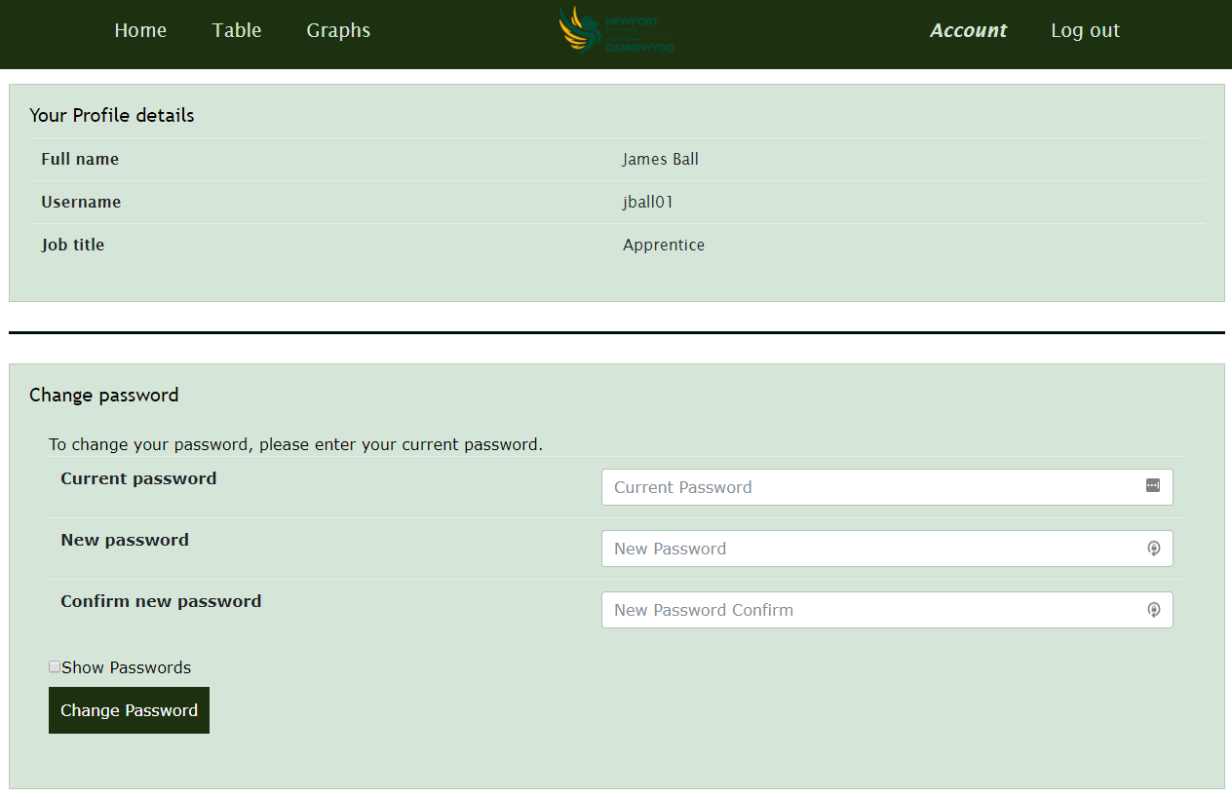
Figure 32 – Account Page

Displaying information
The account details are displayed by calling functions “get_uFullName” and “get_uJobTitle”:
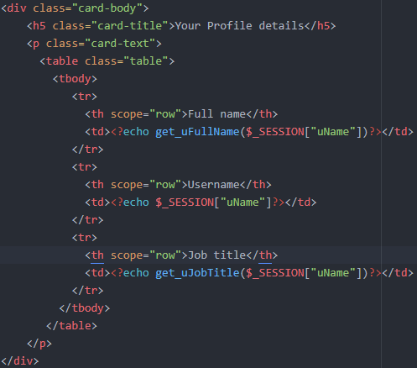
Figure 33 – echo the result of “get_” functions
These functions use the session variable “uName” for the current logged in user to query the database for the other information tied to that user:
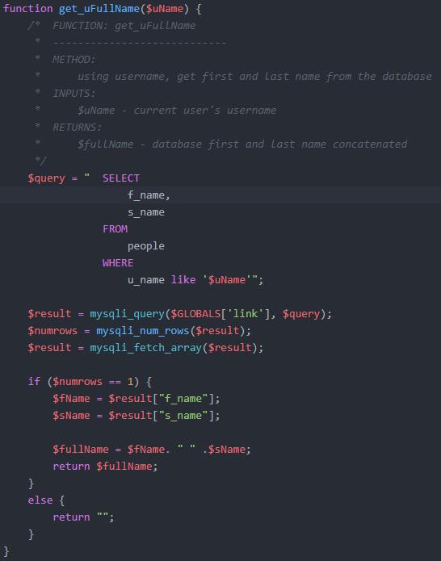
Figure 34 – getting first and last name using the username
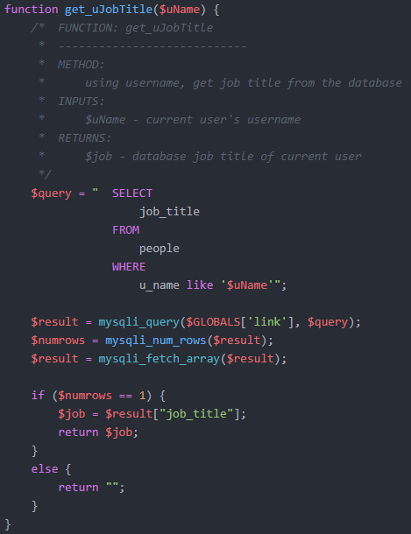
Figure 35 – getting the job title using the username

Changing password
They must put their current password in correctly and put the same new password in twice to successfully change their password, otherwise an error message is shown:
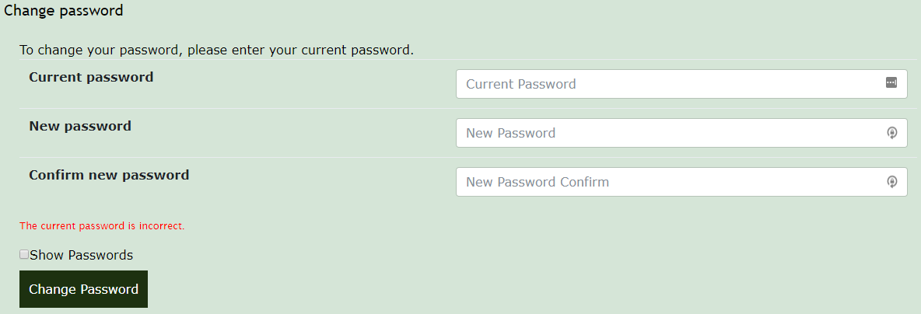
Figure 36 – current password incorrect
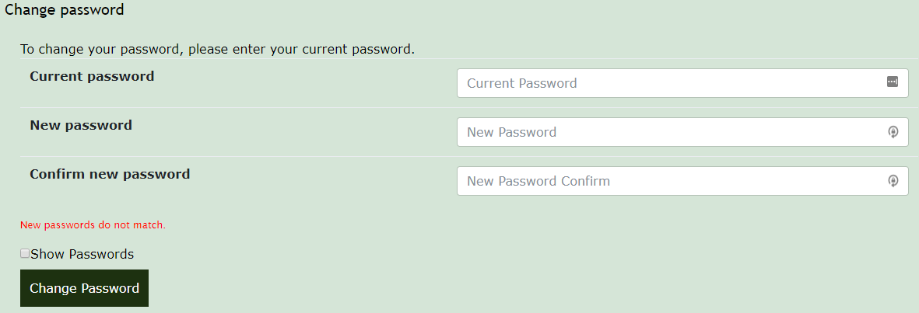
Figure 37 – new passwords don’t match
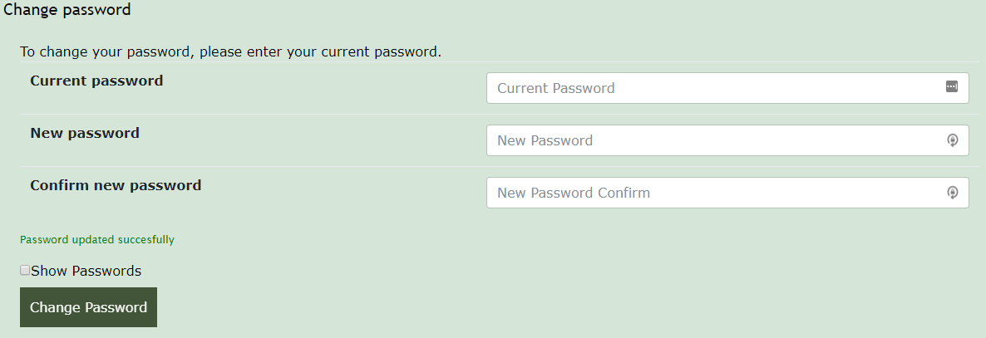
Figure 38 – successful password change
This is achieved using the “error_message” session variable:
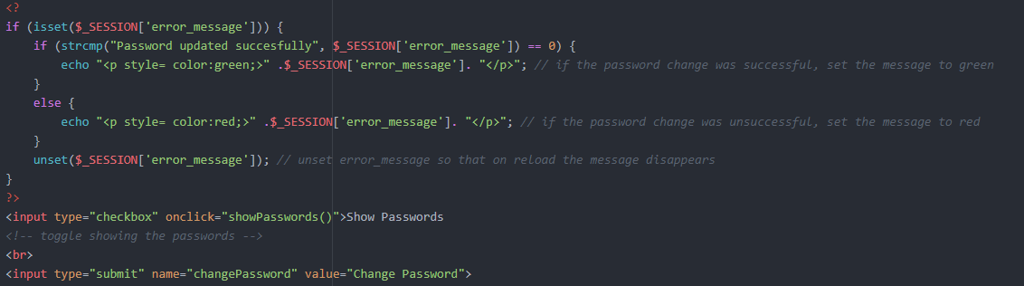
Figure 39 – echo error message on page reload
The password change function first uses “checkPass” to check the current password is correct, then compares the two new passwords to check they are the same. If they are then the password is updated using the “updatePass” function. If the current password is wrong or the new passwords don’t match an error message is displayed using “error_message” session variable:
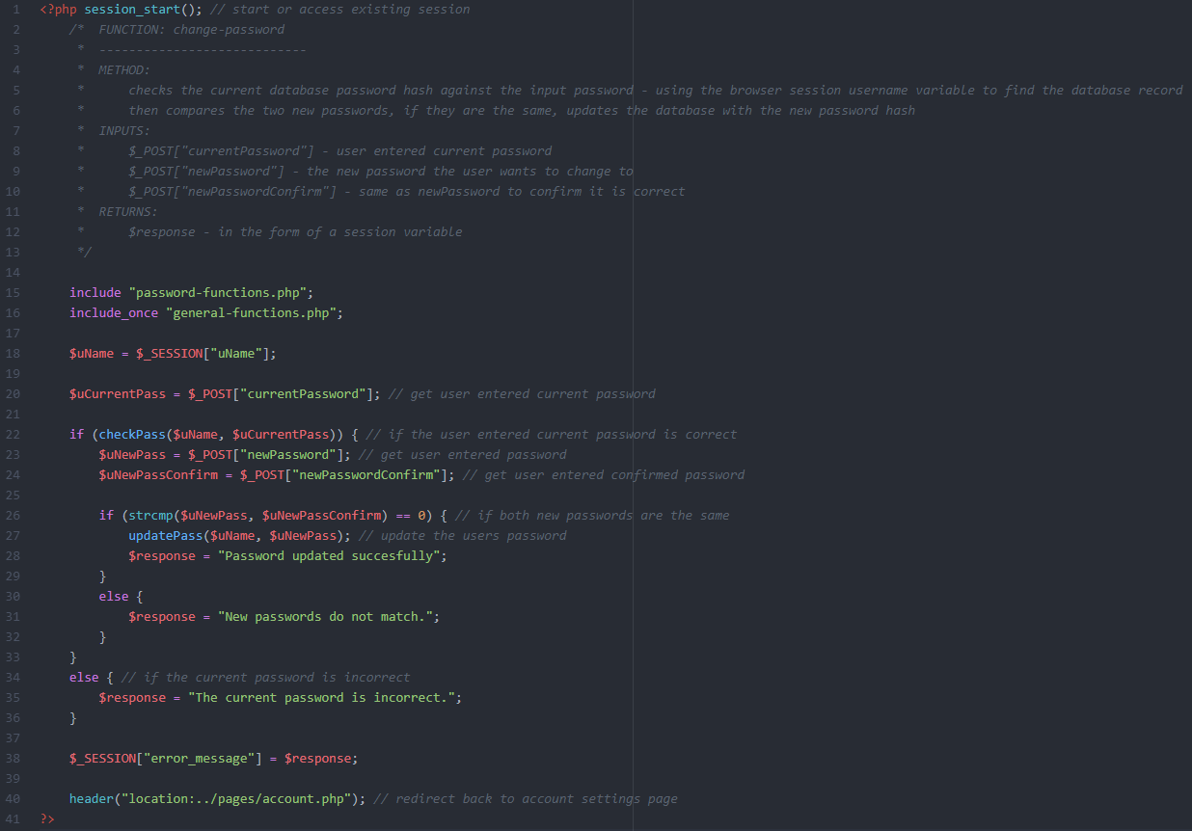
Figure 40 – change-password.php
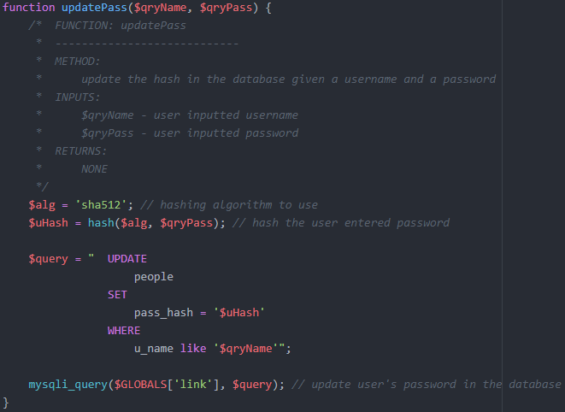
Figure 41 – updatePass function

Show/hide passwords
The passwords can be toggled to be hidden or shown:
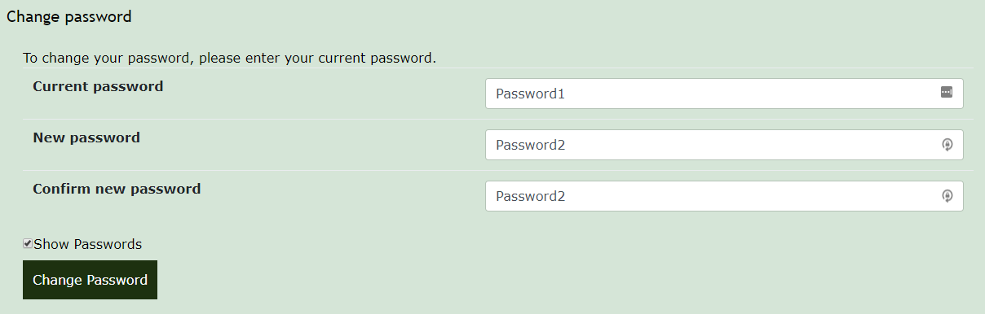
Figure 42 – Passwords showing
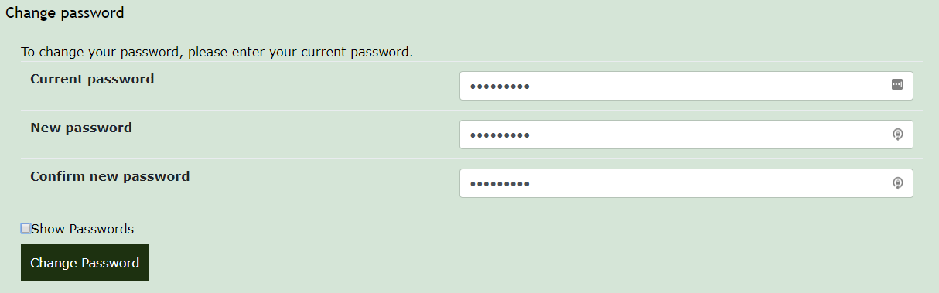
Figure 43 - passwords hidden
This is done using a JavaScript function that when the “show passwords” button is pressed toggles the input types of the three text boxes between text and password:
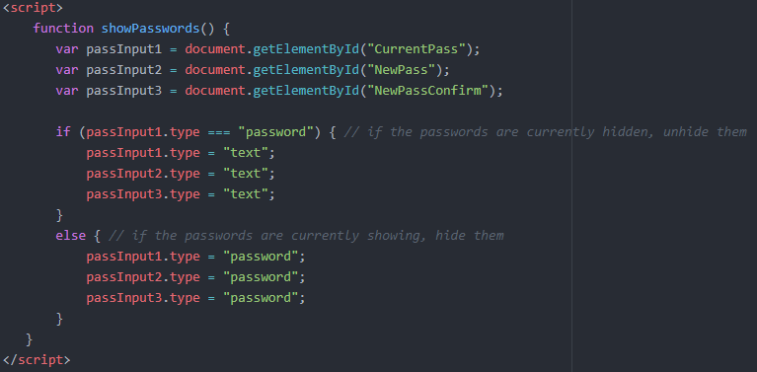
Figure 44 - showPasswords JavaSript function

