
WHS
The Effectiveness of
Performance Appraisals Report – HR Manager
BMHR7016

Word Count: 1647

Amberlea Knowles - 2116495
Executive Summary:
This report examines the effectiveness of WHSmith Travel Plc Employee Appraisals, the broader HRM context in the VUCA world, and the requirement for an adaption to align with organisational objectives and employee expectations.
Implications of Employee Performance, morale, and Development are explored in line with the current twice-yearly appraisals and models adopted successfully by other organisations. The importance of HR in influencing and implementing people practices in addition to the continuous review cycle required to ensure that processes remain conclusive of internal and external contexts.
The report concludes that changes are required to the Appraisal system in WHST for continued growth and in line with the organisational objective of Retaining and Developing Talent and are outlined below:
Est Cost £600k ROI: 1.2M
Line Manager Coaching, progressive review structure:
Quarterly objectives with monthly Check- In’s, focussing three goals one KPI metric, one Team development and one Personal development objective closely aligned with the business objective.
- Remove the overall Rating structure and separate compensation scheme to eliminate bias and unfairness. ( Chowdhury, Hieo & Shaninger, 2018)
- Simplify business objectives and remove compliance complexities. (Gifford, 2022)
- Create a simple framework for record-keeping that focuses on personal and professional growth.
Review Success Quarterly and adapt strategy required: Retention % of Management, internal Progression, employee satisfaction scores, Stress related absence.

Contents Page:
Introduction………………………………………………………………….5
WHST Overview……………………….……………………………………5
Main Findings……………………………………………………………….6
Performance Management…………………………………………….….6
Are Appraisals Effective in WHST?....................................................7
Critique of the application of Performance Appraisals………..……7
Lack of Objectivity……………………………………………...….7
Insufficient Feedback……………………………………………..8
Lack of Developmental Focus…………………….…………….8
Inadequate Goal Alignment…………………………….……….8
Application and Advancement of Appraisals in a VUCA World.
Examples……………………………………………………….……………9
Continuous Feedback and Coaching…………………………..9
Goal Setting and Cascading……………………………………10
360-Degree Feedback………………………..………………….10
Emerging Trends………………………………………………………….10
Case Study Example……………………………..………………………11
The Role of the HR Profession in Designing people practices…..12
Models of Influence, persuasion, and Negotiation HR…………….13
Recommendation…………………………………………………..……..13
Conclusion…………………………………………………………………14
References……………………………………………………….…….15-17

Introduction:
The Performance Review is Pervasive, according to Cespedes (2022), Time-consuming, biased and demotivating. A Mckinsey survey found that CEOs and senior management do not believe in the value of appraisals. ( Chowdhury, Hieo & Shaninger, 2018) Another study found that just one in five employees agree that they motivated growth. For the continued success of the Organisation and in line with the Mission statement to Retain and Develop employees (Scollen, 2023). Should WHSmith Travel (WHST) review and adapt the current Appraisal structure?

WHST Overview:
This report aims to review and critique the effectiveness of employee performance appraisals in WHST and its general application in human resource management. WHST is a Travel convenience retailer operating in 800 locations across the United Kingdom. (WHSmith, 2023). Employing over 3500 employees as of May 2023. Six hundred-three employees have others directly reporting to them. (Scollen, 2023)
WHST are a well-established brand with exceeding profit aspirations in the last financial year. However, employee engagement and retention remain at the forefront of the organisation's objectives (WHSmith, 2022).; enhancing performance and sustainability is essential in the current fast-changing and volatile employment landscape. (Jain,2021)
whether the performance appraisal still has relevance in the new world of work with continuing changes in the expectations of employees from the organisation that they work for.
In addition, models of influence, persuasion and negotiation will be linked with behavioural theories with an outline of HR and leaders' role in ensuring effective practice.
I am concluding with a recommendation to improve WHST's current process.
Principal Findings: Performance Management:
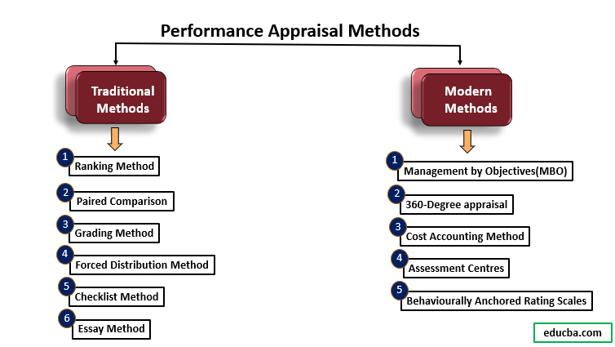

Gifford (2017) Describes performance management as the attempts of the organisation to enhance or maintain an employee's performance in line with the organisation's objectives enabling employee accountability. Similarly, Gifford (2017) and Armstrong (2006) manage employees within an agreed framework of planned goals with clear competencies of the assigned job description.
Are Appraisals Effective in WHST?
Performance appraisals are a significant part of the Performance management process described above; WHST's current system is completed twice yearly based on KPI data and organisational values. Only store managers are appraised by their line manager, and the output has a bonus-related contribution. (Scollen, 2023). Data suggests that in FY21/22, 83% achieved a rating of “Strong”, 3% “Developing”, 2% “Outstanding”, 0% “Role Modelling”, The highest accolade attracting the most significant bonus contribution, and 13% missing data. A self-assessment is submitted to enable the line manager to review each point. However, sales results are often circumstantial and are relied on for overall rating. In addition, there is no specific job description, and it does not acknowledge additional duties undertaken. This often leads to disengagement or the reluctance to offer support in future. As outlined below, there are criticisms of the traditional appraisal system that is currently adopted, and alternative methods could produce better results for the organisation.
Critique of the application of Performance Appraisals:
1. Lack of Objectivity: Traditional performance appraisals often suffer from subjectivity and bias. Evaluations are influenced by personal biases and relationships, leading to unfair assessments and demotivation among employees. (Murphy & Cleveland, 1995). The “Horn Effect”. This is when the appraisal is based on an instance of a bad result underpinning the overall rating and objective setting system. In contrast, the “Halo effect” is when the employees are appraised based on perceived positive qualities instead of the output results. (Maier, 2018)
2. Insufficient Feedback: Many performance appraisal systems focus on providing feedback only once or twice a year during formal reviews. This infrequent feedback may need to be more effectively addressed to address ongoing performance issues or provide timely guidance for improvement. (London, 2003).
3. Lack of Developmental Focus: Traditional performance appraisals often emphasise rating and ranking employees rather than fostering professional development. This limits the potential for employees to learn, improve, and contribute to organisational goals. (Buckingham & Goodall,2005).
4. Inadequate Goal Alignment: Performance appraisals may not effectively align individual goals with organisational objectives. If there is a misalignment, leading to demotivation and a lack of clarity regarding expectations. (Cascio & Aguinis, 2005).
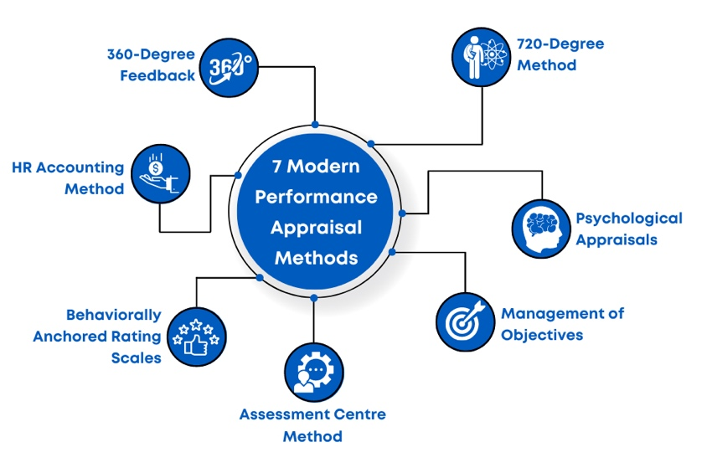
Application and Advancement of Appraisals in a VUCA World:
Many academics and organisations have sought to change the Appraisal system for years due to its reliance on past data and behaviours instead of future growth and talent planning. It is theorised that the sudden surge in change and adaption has been forced due to recent labour market challenges and organisational concerns with retention in the post-Brexit, pandemic era. (Cappelli & Tavis, 2016)
Examples below:
- Continuous Feedback and Coaching: Organisations are shifting towards more frequent and informal feedback, such as regular check-ins and coaching sessions. This allows for real-time guidance, clarification of expectations, and ongoing performance improvement. (Bersin, 2013). Many organisations such as IBM and GAP have moved towards the real-time objective setting, focusing on employee growth (Cappelli &Tavis, 2016)
2. Goal Setting and Cascading: Performance management practices focus on setting clear and measurable goals that align individual efforts with organisational objectives. This ensures that employees understand their roles and responsibilities, fostering a sense of purpose and motivation. (Locke & Latham, 2019).
3. 360-Degree Feedback: Some Organisations, such as Google and Tesla, embrace multi-source feedback systems, where feedback is collected from multiple stakeholders, including peers, subordinates, and managers. This provides a more comprehensive and balanced assessment of an individual's performance. (Bracken , Timmreck, Fleenor, & Summers, 2001) The benefit of this process is that several perspectives give the employee an overview of their performance from several colleagues. However, due to the resources operating model of WHST, this model is likely to be unsustainable.
Emerging Trends:
Emerging performance management practices may vary across industries and organisations. Therefore, organisations must explore and customise these practices to align with their unique culture and objectives. Many organisations have changed their performance management systems in recent years but have not found a consensus on one example to adopt. (Chowdhury, Hieo & Shaninger, 2018).
Below is a successful retail example that WHST could adopt.

Case Study Example:
Gap Inc., a multinational retail company, implemented a performance management approach called "GPS" (Grow, Perform, Succeed without Ratings). It focussed on ongoing feedback, coaching, and development conversations throughout the year. The company shifted away from the traditional annual performance reviews and emphasised continuous dialogue and goal setting. (Margolis, 2015) Gap Inc eliminated rankings as they believed these had an adverse effect on employee morale. The “GPS” system gives employees and managers autonomy to set goals. Instead of managers submitting appraisal templates to HR, HR is regarded as a resource to provide managers and employees with tools, coaching and support to enhance their performance. Johnson (2017) acknowledges the success of GAP's early pioneering; in 2014, gap achieved an 86% employee engagement score and a 4.2/5.0 rating for the quality of conversations. It should be noted that it needs to be clarified where or how the data was measured and its validity.
The Role of the HR Profession in Designing people practices:
The role of HR in designing people practices is critical to ensure effective talent management and organisational success. HR professionals are responsible for developing and implementing people practices that align with the organisation's strategic objectives and promote a positive work culture. (Brockbank & Ulrich, 2005) Similarly, Armstrong (2016) states that the role of HR is to contribute to a high-performance culture and to create positive employment relationships between employees and line managers. This underpins the requirement to re-design WHSTs appraisal systems and review the more comprehensive performance management process.
Models of Influence, persuasion, and Negotiation HR:
Several models of influence in HR describe how HR professionals can effectively exert influence within organisations. Many models and theories underpin the importance of HR partnership with organisation strategy by aligning policies and practices. (Ulrich,1997; Beer, 1984;Guest, 1997)
Boxall (2011) suggests that HR professionals can influence performance outcomes by implementing a coherent set of HR practices that support employee skills, motivation, and engagement. It is essential to recognise that the HR dynamic is complex, and various internal and external factors can influence the design and implementation of policies and practices. Organisations need to adapt or diversify several models to suit their requirements. (Ulrich, 1997)

Recommendation: Est Cost £600k ROI: 1.2M
Line Manager Coaching, progressive review structure:
Quarterly objectives with monthly Check- In’s, focussing three goals one KPI metric, one Team development and one Personal development objective closely aligned with the business objective.
- Remove the overall Rating structure and separate compensation scheme to eliminate bias and unfairness. ( Chowdhury, Hieo & Shaninger, 2018)
- Simplify business objectives and remove compliance complexities. (Gifford, 2022)
- Create a simple framework for record-keeping that focuses on personal and professional growth.
Reviewing Success Quarterly: Retention % of Management, internal Progression, employee satisfaction scores, Stress related absence.
Conclusion:
Cespedes (2022) outlines that the purpose of a review is to evaluate job performance whilst developing the employee's skills in line with the job role. He outlines that research shows that people become high performers by identifying development areas and receiving regular feedback. This report has also highlighted many other instances of regular coaching and feedback positively affecting performance. It is demonstrated throughout the report that contemporary literature and research emphasise the ineffectiveness of the traditional yearly appraisal for improving employee engagement and performance. (Gifford,2017)
As the recommendation suggests, WHST should review the current twice-yearly appraisal and rating system and adopt a continuous feedback and objective-setting model. It is important to note that the review of success and ROI must be monitored regularly and adapted to reflect the internal and external HRM context and employee aspiration.
As the report has reflected, there has yet to be a consensus on the correct appraisal system. (Chowdhury, Hieo & Shaninger, 2018). It requires the agility and expertise of HRM to adapt and implement strategies that align with the organisation's objectives to influence and engage employees.

References:

- Armstrong, M. (2006) Performance Management: Key Strategies and Practical Guidelines. 3rd Edn. London. Kogan Page
- Armstrong, M. (2016) Armstrong’s Handbook of Management and Leadership for HR. 4th Edn. London. Kogan Page
- Beer, M., Spector, B., Lawrence, P. R., Quinn, D., & Walton, R. E. (1984). Managing Human Assets: The Ground-breaking Harvard Business School Programme. California. Free Press
- Bersin, J. (2015). Becoming Irresistible: ‘A New Model for Employee Engagement’. Deloitte Review. Available at: URL: https://www.mindsetmanage.com/images/PartnerPortal/consulting-services/research/Deloitte-Josh-Bersin-New-Model-for-Engagement.pdf Issue 16 pp234-236 (Accessed: 23rd May 2023)
- Buckingham, M., & Goodall, A. (2005). The One Thing You Need to Know About Great Managing, Excellent Leading, and Sustained Individual Success. New York. Free Press Available at URL: https://www.academia.edu/25113937/_Buckingham_2005_The_One_Thing_You_Need_to_Know_About_Great_Managing_Great_Leading_and_Sustained_Individual_Success (Accessed 23rd May 2023)
- Boxall, P., & Purcell, J. (2011). Strategy and Human Resource Management (3rd ed.). Palgrave Macmillan. Available at URL: https://books.google.co.uk/books?hl=en&lr=&id=cjRuEAAAQBAJ&oi=fnd&pg=PP1&dq=6.%09Boxall,+P.,+%26+Purcell,+J.+(2011).+Strategy+and+human+resource+management+(3rd+ed.).+Palgrave+Macmillan.London&ots=97Ir-5jk3y&sig=t_qEjnnf-RFyHfKIb9WYy23AHrk#v=onepage&q&f=false (Accessed: 23rd May 2023)
- Bracken, D. W., Timmreck, C. W., Fleenor, J. W., & Summers, L. (2001). ‘360-degree feedback from another angle’. Human Resource Management Journal . Pp 3-20 Available at: DOI:10.1002/hrm.4012 (Accessed: 23rd May 2023)
- Brousseau, K. R., Driver, M. J., Eneroth, K., & Larsson, R. (2006). The Ethics of Human Resource Management. Human Resource Management Journal. 20(1)5-14 Available at DOI:10.5771/0935-9915-2009-1-5 20(1)5-14 (Accessed: 23rd May 2023)
- Cappelli, P. & Tavis, A. (2016) ‘The Performance Management Revolution’ Harvard Business Review Available at URL: https://hbr.org/2016/10/the-performance-management-revolution (Accessed 22nd May 2023)

- Cascio, W. F., & Aguinis, H. (2005) ‘Emerging Performance Management Practices’. Applied Psychology in Human Resource Management. 44 I3 pp 219-235 Available at DOI https://doi.org/10.1002/hrm.20068 (Accessed 22nd May 2023)

- Cespedes, F V. (2022) ‘How to Conduct a Great Performance Review’. Harvard Business Review Available at URL: https://hbr.org/2022/07/how-to-conduct-a-great-performance-review (Accessed: 22nd May 2023)
- Chowdry, S., Hieo, E., Schaninger, B (2018) ‘Harnessing the Power of Performance Management’. Mckinsey Available at URL: https://www.mckinsey.com/capabilities/people-and-organizational-performance/our-insights/harnessing-the-power-of-performance-management (Date Accessed: 22nd May 2023)

- Gifford, J. (2022) Performance Management: An Introduction. Available URL: https://www.cipd.org/uk/knowledge/factsheets/performance-factsheet/#one (Accessed: 17th May 2023)
- Gifford, J. (2017) Changing Trends in Performance Management. –[PODCAST] Available at URL:https://youtu.be/PfXEceZ zND0 (Accessed: 23rd May 2023)
- Guest, D. E. (1997). ‘Human Resource Management and Performance: A Review and Research Agenda’. International Journal of Human Resource Management, 8(3), 263-276.Available at: DOI: https://doi.org/10.1080/095851997341630 (Accessed: 22nd May 2023)

- Jain, A. (2021) 5 Performance Trends You Should Look Out For. Available at URL: https://amazingworkplaces.co/5-performance-appraisal-trends-you-should-look-out-for/ (Accessed:22nd May 2023)

- Johnson, S. (2017) Performance Navigators at GAP. Available at URL: https://www.linkedin.com/pulse/performance-navigators-gap-sandhya-johnson?utm_source=share&utm_medium=member_ios&utm_campaign=share_via (Accessed: 27th May 2023)
- Murphy, K. R., & Cleveland, J. N. (1995). Understanding performance appraisal: Social, organisational, and goal-based perspectives. Available at: URL: https://books.google.co.uk/books?hl=en&lr=&id=CnpuE09Vit0C&oi=fnd&pg=PP15&dq=Murphy,+K.+R.,+%26+Cleveland,+J.+N.+(1995).+Understanding+performance+appraisal:+Social,+organisational,+and+goal-based+perspectives.&ots=mewiv5Kni_&sig=1Dl2UUrGa2GvbtQnOEuj9pOcmR4#v=onepage&q=Murphy%2C%20K.%20R.%2C%20%26%20Cleveland%2C%20J.%20N.%20(1995).%20Understanding%20performance%20appraisal%3A%20Social%2C%20organisational%2C%20and%20goal-based%20perspectives.&f=false (Accessed 22nd May 2023)
- Locke, E. A., & Latham, G. P. (2019). ‘The Development of goal setting theory: A Half-Century Retrospective’. Motivation Science, 5(2), 93–105. Available at: DOI: https://doi.org/10.1037/mot0000127 (Accessed: 23rd May 2023)
- London, M. (2003). Performance appraisal effectiveness: Lessons from the past and directions for the future. International Human Resources Management. Available at DOI: https://doi.org/10.1111/1468-2370.00076 (Accessed:22nd May 2023)
- 21. Maier, S. (2018) Performance Appraisals and The Halo Effect. Available at: URL:https://hrdailyadvisor.blr.com/2018/12/12/performance-appraisals-and-the-halo-effect/ (Accessed: 27th May 2023)

- Scollen, V. (2023) Email to Amberlea Knowles 2nd February 2023 Unpublished
- Scollen, V (2023) Email to Amberlea Knowles 20th March 2023 Unpublished
- Ulrich, D. (1997). ‘Human Resource Champions: The Next Agenda for Adding Value and Delivering Results’. Harvard Business Press. New York.
- Ulrich, D., & Brockbank, W. (2005). The HR value proposition. Harvard Business Review, 83(5), 1-11, Boston, Massachusetts Available at URL: http://dl.acher.ir/books/management/hr/Dave%20Ulrich_%20Wayne%20Brockbank%20-%20The%20HR%20Value%20Proposition-Harvard%20Business%20Review%20Press%20%282005%29.pdf (Accessed: 25th May 2023)
- WHSmith plc (2022) About us. Available at URL: https://www.whsmith.co.uk/help/about-us/about-us/hel00022/
(Accessed: 25th May 2023)
- WHSmith (2022) Annual Reports and Accounts. Available online: URL:https://www.whsmithplc.co.uk/sites/whsmith-corp/files/whsmith-ar22.pdf (Accessed: 25th May 2023)

