DS 1 Template

My Screenshots/Photos
- Please add 4–6 screenshots or photos of your digital life.
- You can use your phone or laptop.
- For each screenshot, write one or two sentences explaining what it shows.

Screenshot/Photo 1
iphone
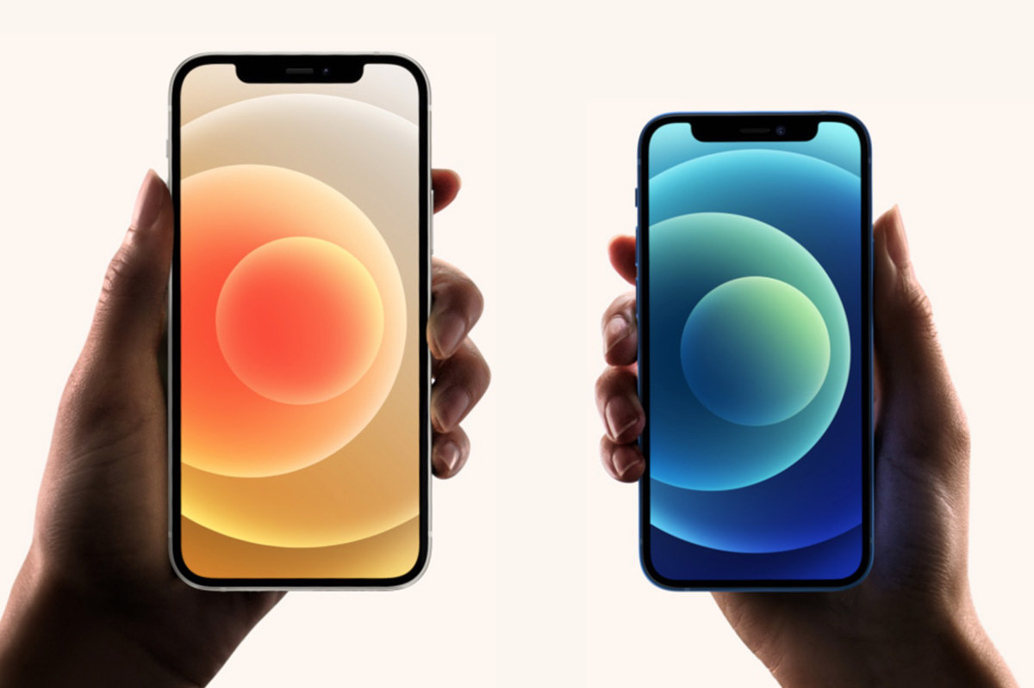
in my day to day I use my iphone. This helps with my digital skills because it teaches me how to use other digital platforms also it is a form of communication.
Using my iphone on a day to day basis can help me with lots of other things ie; research, online safety, photography and creativity.

Screenshot/Photo 2
smart television
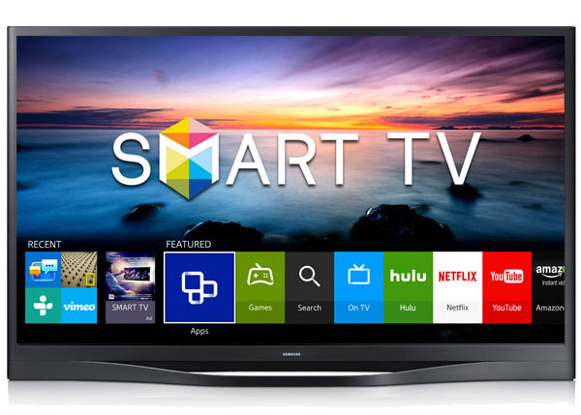
[this shows the lazy side of my digital skiils, reason being is that I only use it to watch programs or other media platforms ie; youtube,Netflix,bbc iplayer ect ]
On the plus side it can also teach you how to use remote controls, connecting other devices to the television

Screenshot/Photo 3
PlayStation 5
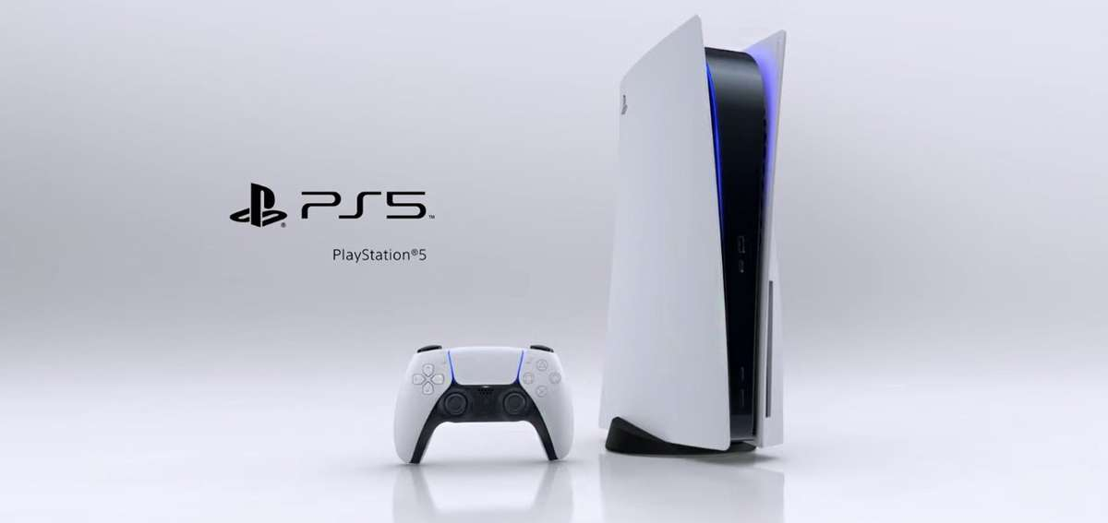
[by playing my PlayStation I learnt how to set up the devise and to be able to connect it to the internet also to be able to have online communication with friends and family ect ]
It also taught me problem solving skills by playing different games and interacting with people all over the world

Screenshot/Photo 4
Alarm clock
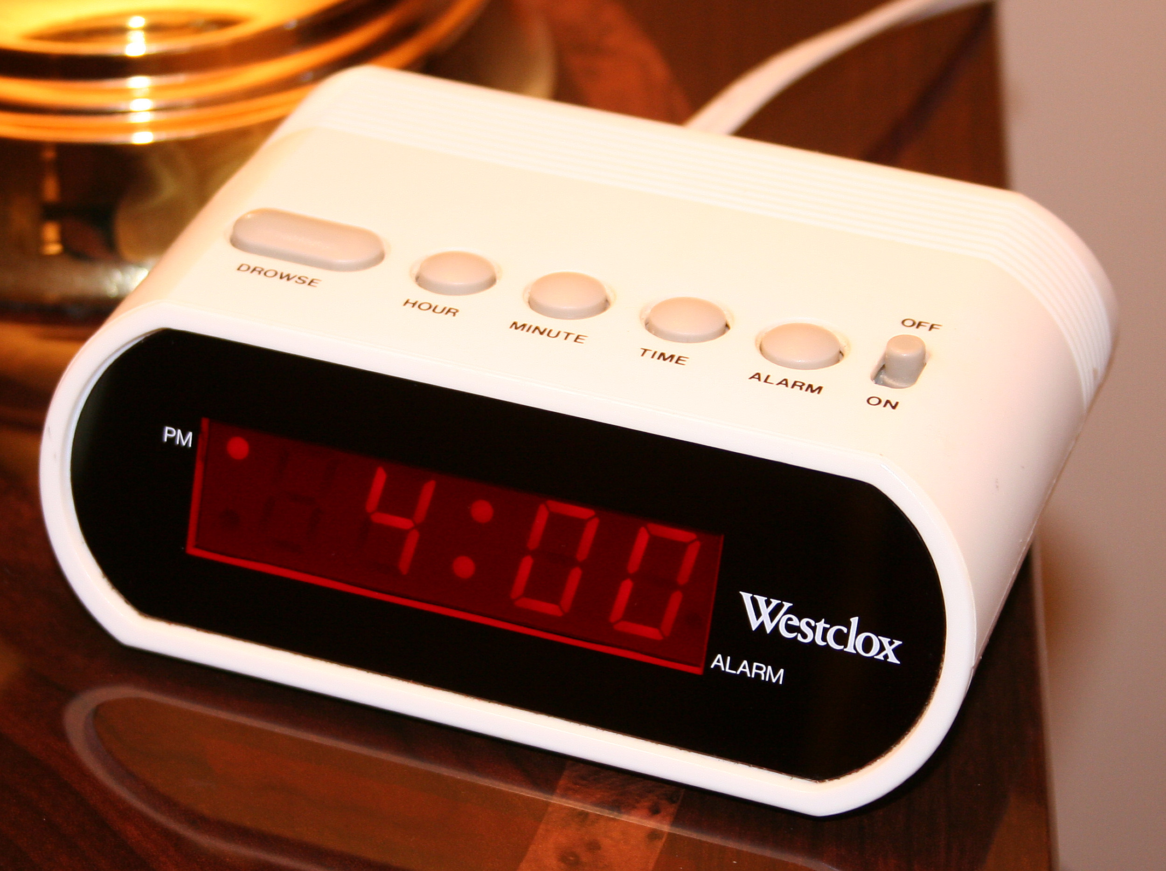
[this is a key component to digital skills for me reason being is it helps me keep track of time when im feeling tired it a reminder that its time to get up and attack the day ]
It also develops routine and helps with following instructions

Screenshot/Photo 5
Bluetooth speaker
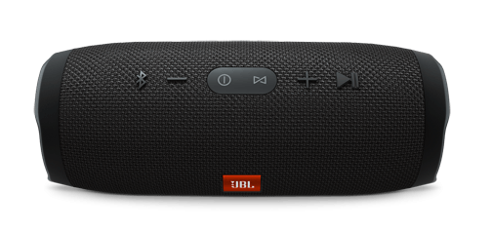
[what this shows of my digital skiils is that I can manage devices also understanding wireless technology .
It also treaches me how to use stings and menus
Also if the Bluetooth was not to connect to a device it teaches me problem solving skills

Screenshot/Photo 6
[laptop]

This helps me with my digital skiils by making me be able to create files,power point,word ect.
It also taught me internet research skills and to communicate through emails and apps like skype,zoom

My Short Reflection
- Write 5–8 simple sentences about your digital life.
- You can use the sentence starters below if helpful.

Sentence starters
- I use digital tools to …
- I feel confident when I …
- I want to improve …
- I often use these tools: …
- I sometimes feel nervous about …
- I hope this module will help me …
- Digital skills are important for me because …
You can write more if you want.

Submission Checklist
Before you submit, please check:
​​​ ☐ I added 4–6 screenshots
☐ I wrote short sentences for each screenshot
☐ I wrote my short reflection
☐ My work is my own
☐ My file opens correctly
​​☐ My file opens correctly

