Responsibility,
2022-2023
Authorized by: Mark Jones
HNC Process Operations Engineering
Operational and
Maintenance Acitivies

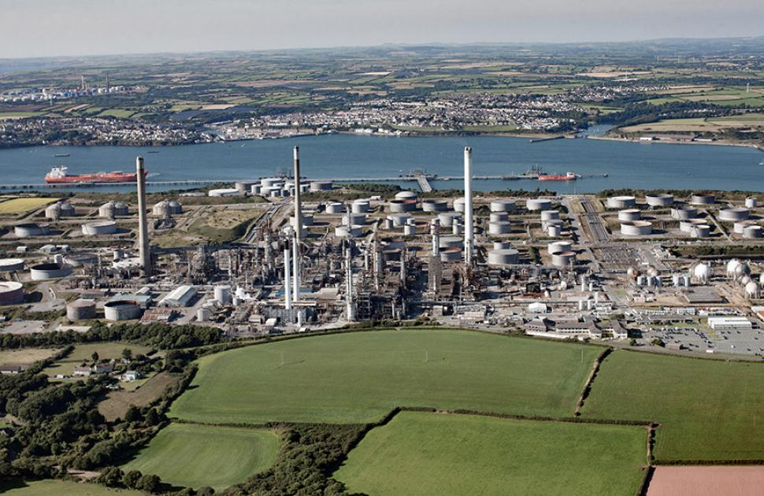

Contents Page

Introduction ……………………………………………………………………… Page 2

Task 1 ……………………………………………………………………………. Page 2 - 6

Task 2 ……………………………………………………………………………. Page 8 - 21

References ……………………………………………………………………… Page 7

Introduction

The following assignment will discuss the different aspects of the Unifiner Process Unit at Valero and the different maintenance activities on the unit. The second part of the assignment will be based on my learning development and aspects of training I have accomplished already.

Task 1 (LO1)

Introduction
For this task I will be demonstrating an understanding and knowledge of the Unifiner process unit at Valero Oil Refinery in Pembroke. This report will go into detail about how the Unifiner process unit operates and the different equipment and maintenance activities carried out to ensure this unit runs efficiently and environmentally safe.

Process Description

The Unifiner (Unit number 4 at Valero) is a process unit that is used to ensure that naphtha has had all of its impurities removed, so it can be split into different feeds for further processing. The different feeds for processing include a feed for the platformer unit, a feed for naphtha storage and a feed for the isomerization unit. The impurities that are removed from the naphtha are:
- H2S (Hydrogen Sulphide) – Extremely hazardous, fatal if over a certain PPM.
- Nitrogen
- Oxygen
- Metals picked up during the process.

The Unifiner splits into two different trains and two different splitters before joining again and being sent further on.

The Unifiner first works by the cold naphtha feed first coming in at the north end of the unit, where it is preheated in an exchanger. This naphtha feed comes from storage. Once the naphtha feed has gone through the exchanger it is then mixed with an already hot naphtha feed and is sent to a surge drum, where the naphtha mixtures mix. From the surge drum then the naphtha mixture is disposed of to 3 different pumps, these pumps are used to pump the mixture to the different trains. Both trains and both splitters are almost a mirror of each other, however train B has a second reactor, due to the high level of nitrogen in the second train.
From train A and B then, the naphtha mixture goes to the stripper section where the heavy and light products separate for further processing. They then split again after the splitter and go through a splitter circuit 1 and 2, which again mirror each other.

Maintenance Activities and Equipment

In order for a process unit to operate safely and efficiently there are lots of equipment used and maintenance activities carried out on them to ensure this happens. The equipment used includes:
- Steam turbines
- Centrifugal pumps
- Exchangers

Steam Turbines
Steam Turbines are used to convert thermal energy from steam to mechanical energy. Once the steam is distributed and catches on the blades located on the turbine rotor. This then provides a force on the rotor and creates a rotational movement for the shaft. The turbine shaft is connected to another device using a coupling. This allows for the motion to be transferred into processes such as pumping or electrical generation.

A steam turbine is made up of multiple components, these are:

- Shaft – The shaft is attached to the rotor. This catches the steam to provide movement. The shaft is important because it transfers the force to another process. Shafts require balancing to reduce vibration and bearing wear.
- Coupling - The coupling is used to attach equipment through the shafts and transfer the movement. These are designed to break if a certain RPM or unwanted force is provided.
- Rotor - The rotor is used to catch the steam. The blades can come in different shapes and forms. The angle of the blades can be changed to increase the efficiency of the turbine.
- Bearings - White metal bearings are the most common type used in steam turbines. The bearings feature both a high static and dynamic load capability and can be changed in situ.
- Governor - Used to control the speed of the turbine and to stop the turbine from running at a higher speed than designed.

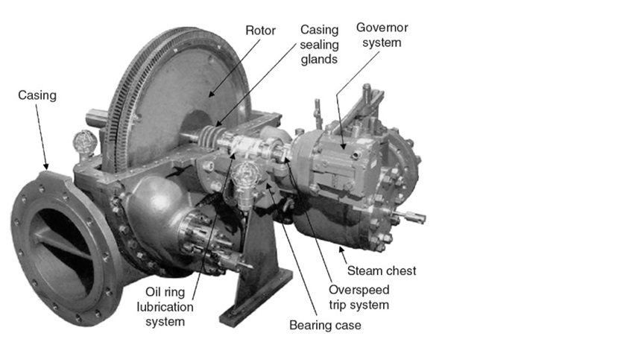
Image above is of a typical steam turbine found on the refinery.

Due to the demand of steam turbines and the frequent rotating equipment, it is important that frequent checks are carried out on turbines. These checks are done depending on the demand of the component. These checks include:
- Oil change – an oil change of a turbine can be done at any time, the turbine does not need to be offline for an oil change to be carried out. An oil change would need to be carried out if the oil was of a dirty colour, an oil change prevents damages occurring to bearings or seals, as dirt in the oil can damage the surfaces, making them weaker and prone to breakage.
- Trip checks – carrying out trip checks confirms that the trip arm of the turbine works, which is the most important safety feature of a turbine. Trip checks will be carried out as part of a yearly turbine PM or can be carried out if a nuisance trip arm is detected.
- Bearing Condition Check – Bearings are checked using a contact check or a vibration check. This will show if the bearing is making contact all around the shaft or if the bearing is emitting excessive vibration. If contact is not complete, the white metal bearing is adjusted by removing the material. Vibration checks are used in conjunction to check bearing conditions without opening the turbine.

Centrifugal Pumps
Centrifugal pumps are the most common piece of equipment within a process. They are used to pump products, utility requirements and oils to systems that require them.
On a process unit, a pump will almost certainly have a driving force behind them, either a steam turbine or an electric motor. This gives the power to the pump to send the product wherever it needs to go. A pump works on the principle of centrifugal force. The product comes in the suction of the pump, sits on the vanes inside the pump and forces it ways around the pump, moving the impeller inside the stuffing box, which produces force which forces the product out, thus ‘pumping’ it out the discharge to its next destination.
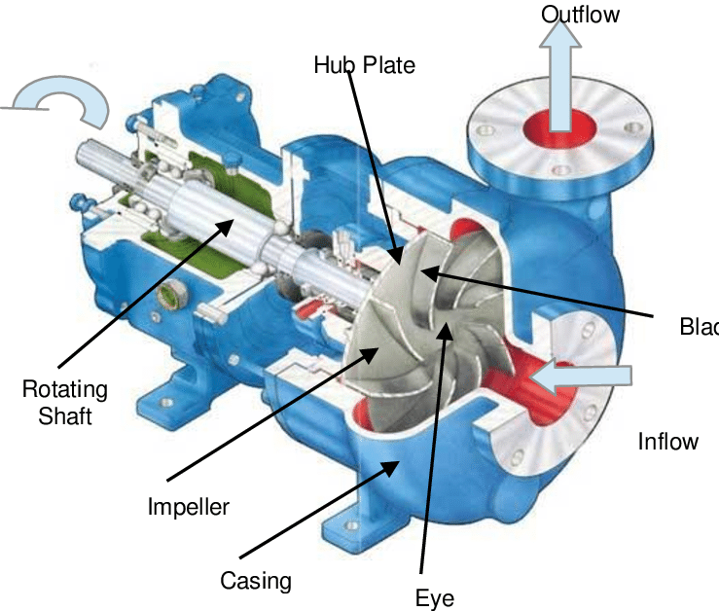
The image above shows a simple centrifugal pump and its components.
There is frequent maintenance carried out on centrifugal pumps which include:
- Vibration and Temperature checks – these are done on a period depending on the pumps requirements. For example, a pump that is the most important on the unit which pump product to the heaters will be checked weekly, in comparison to a pump that has a lower demand will be checked monthly. These checks are carried out so early diagnosis can be determined, to avoid the pump having to come offline, or a spare can be set up, if there is no spare.
- Daily gauge checks – these are done again to determine early diagnosis. If a gauge is fluctuating then it can determine an issue with the pump.
- Oil changes – these can be carried out when the pump is online and an oil change will need to be done when the oil is dirty.

Most centrifugal pumps on the unit will have a spare pump on hand, which can be put online when the online pump needs to come offline. The spare pump will have a different driving force, one being a steam turbine the other being an electric motor.

Heat Exchangers
Heat exchangers are used in different aspects. Some are used to introduce heat and some are used to cool product, they are called fin fans.
These are important parts of the process as it sets the product to the required temperature in order to become processed further. If these are not to the required temperature then the products can be off spec, thus not being an efficient process or efficient product. Exchangers are checked daily on routine rounds when an operator walks around their unit.
When checking an exchanger, it is important to check the inlet and outlets and to ensure none of the flanges are leaking. The flanges leaking need to be detected as the products can be hazardous and can contain h2s which is extremely hazardous.
It is also important to check the gauges of exchangers as a fluctuating gauge can determine a fault, or a low reading gauge can determine a fault.

When running a process unit, it is important to know the process, know the sounds and sights of a process unit, so that when an unusual noise or sighting occurs, it can be reported straight away and rectified. This is so that the products produced on the unit or the process the unit carries out, ensures the outcome is to the required spec and to the required demand.

References

V.NAVEEN KUMAR. (2012). STUDY OF POWER GENERATION TECHNOLOGY IN STEAM. [Online]. Crazy Engineering. Available at: http://crazyengineeringksd.blogspot.com/2012/06/project-on-power-generation-technology.html [Accessed 7 January 2023].

J.C Statharas. (2019). Main Components of a Centrifugal Pump. [Online]. Research Gate. Available at: https://www.researchgate.net/figure/Main-components-of-a-centrifugal-pump-Taken-from-47_fig1_336242931 [Accessed 7 January 2023].

Michael Smith. (2022). Useful information on centrifugal pumps. [Online]. Michael Smith Engineering. Available at: https://www.michael-smith-engineers.co.uk/resources/useful-info/centrifugal-pumps#:~:text=A%20centrifugal%20pump%20is%20 [Accessed 12 January 2023].

Chris Woodford. (2020). How do Heat exchangers work. [Online]. Explain That Stuff. Available at: https://www.explainthatstuff.com/how-heat-exchangers-work.html#:~:text=It%20works%20by%20burning%20natural,and%20the%20w [Accessed 12 January 2023].

Task 2 LO2
The following task is based on my learning development and capabilities on site.

Job Position

Trainee process operator, on a Unifiner and Hydrotreater process unit at Pembroke Oil Refinery, Valero.

Job Description and Responsibilities

Carry out routine checks on the unit and assist maintenance in completing tasks on the unit, to ensure the unit runs safely and efficiently. Routine checks include:
- Checking all pumps and motors for excessive vibrations or excessive heat, which could troubleshoot a problem on the unit.
- Topping up and changing oils for compressors, pumps and turbines.
- Sampling of diesel on the hydrotreater unit. Checking the incoming feed and the end product.
- Checking fin fans and exchangers for any leaks, broken belts or generic damage
Assisting maintenance and locking out equipment and carrying out tests to ensure the work area they’re working in, is safe. Jobs assisting maintenance include:

- Carrying out turbine trip checks with roto department.
- Isolate and de-pressure instrumentation for instrument PMs or instrument changes.
- Isolate and de-pressure other equipment such as pumps and turbines for roto to work on
- Carry out gas testing and area checks to determine if the area is safe for maintenance to work in.

CV


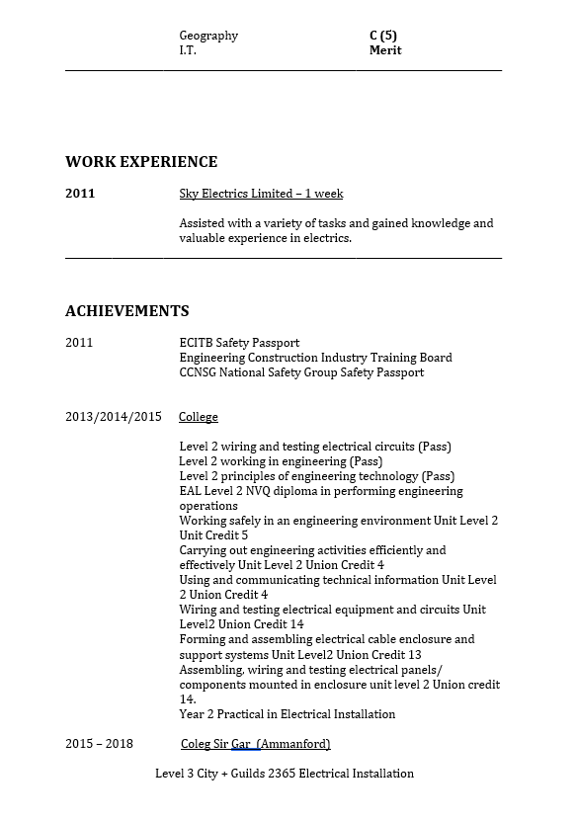

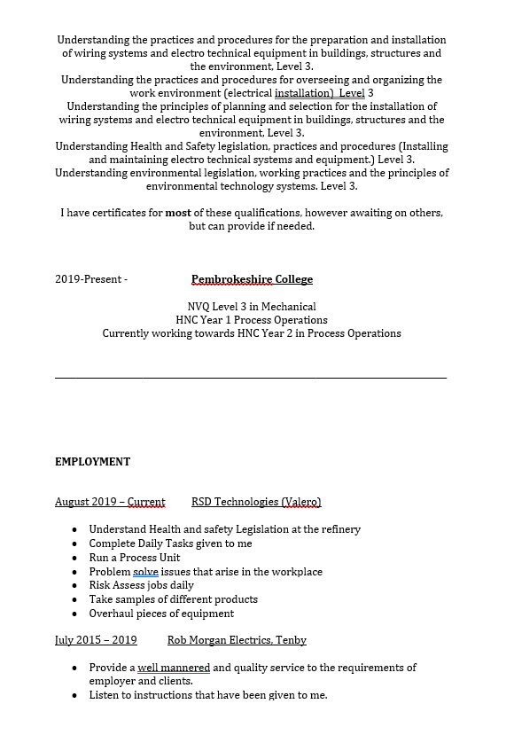

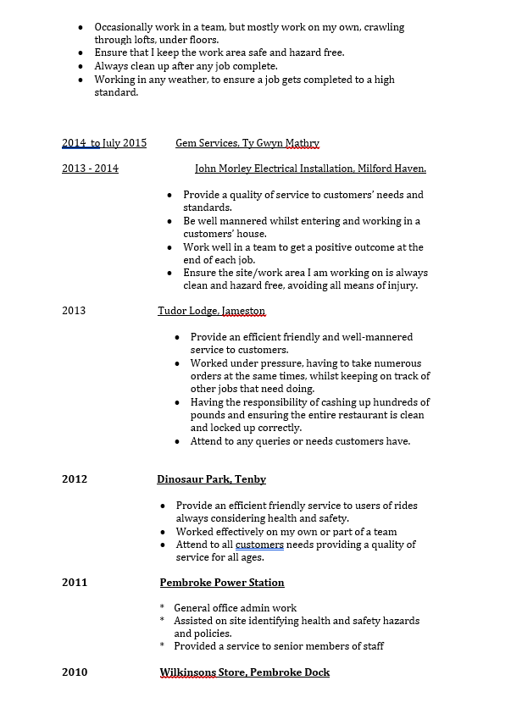

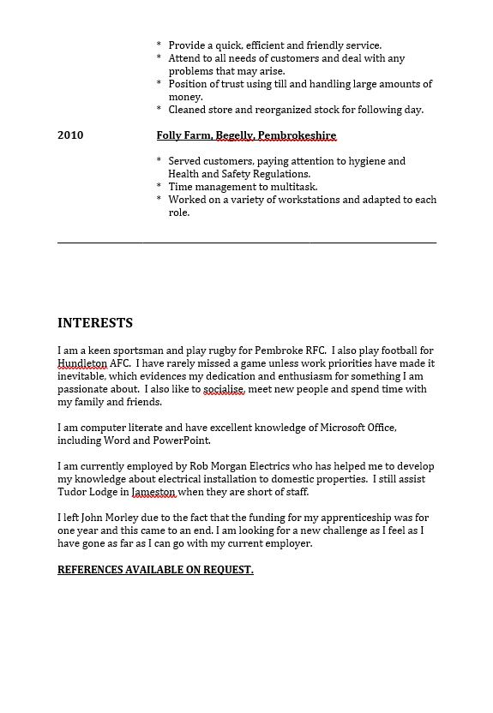

Current Development Action Plan

As of January 2023, I was offered a trainee position on the Unifiner process unit at Valero in Pembroke. Being a trainee means I will be following and tracing process lines from start to finish and learn the unit to ensure I get a good knowledge and understanding, meaning I can run the unit safely and professionally on a permanent basis.
Once I have learned the process lines and the maintenance activities that go on with the different equipment, I will have a walk around with the head of the unit and a written test to confirm I understand the unit. Then I will have a consolidation period where I will be analysed for 6 months to determine I can run the unit safely and efficiently and be kept on permanent.
As time goes on, I would like to progress and learn other units and even a panel on the unit, to further my knowledge and understanding.

Technical Competence

The following are different training courses I have completed that show my competence within the refinery. They are all company certified certificates, meaning I have undertaken the required training and pass the required tests.



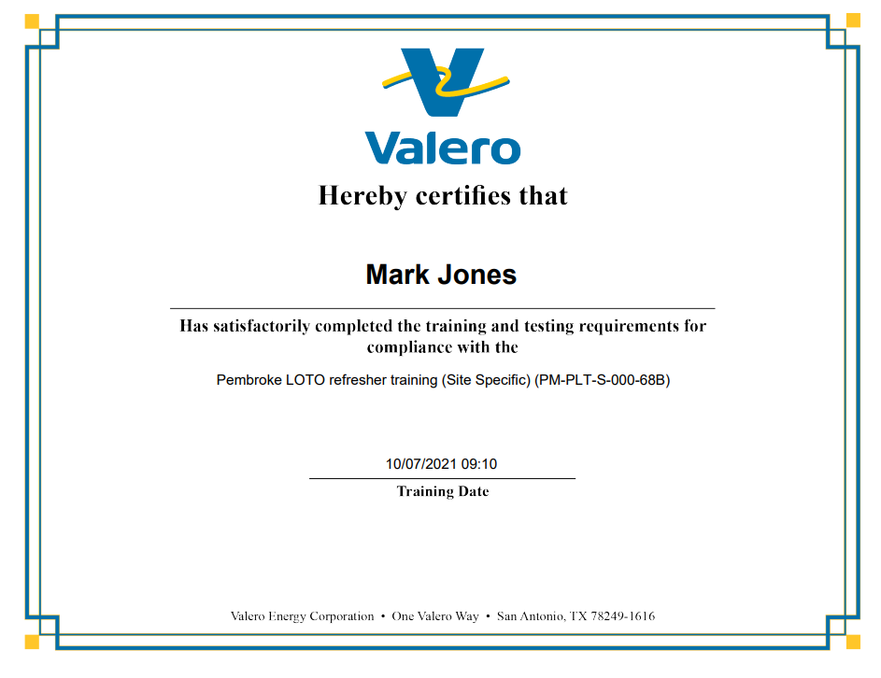





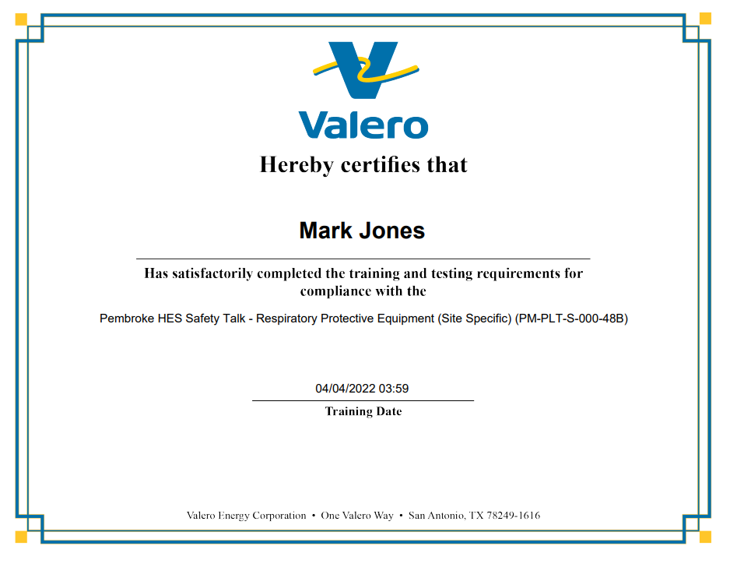

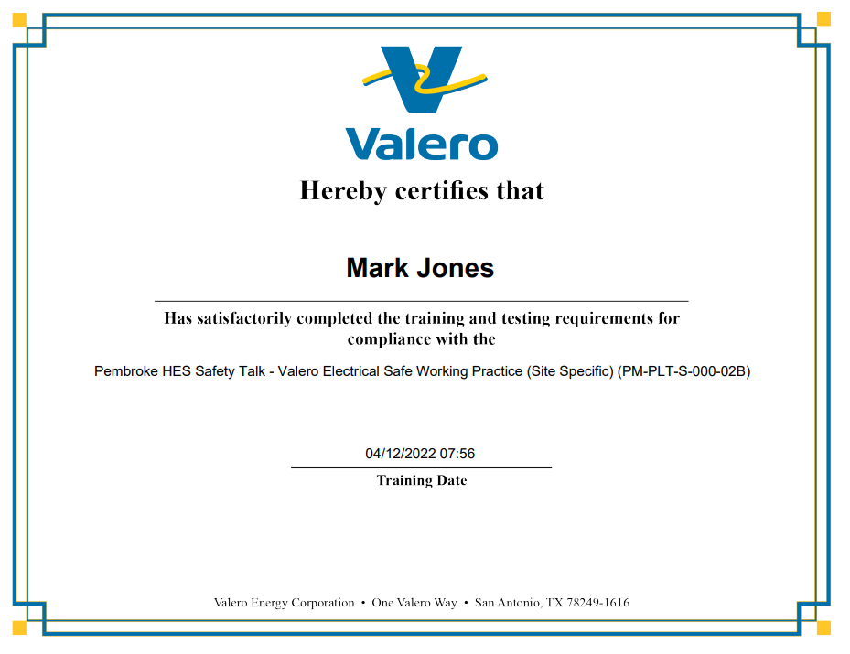

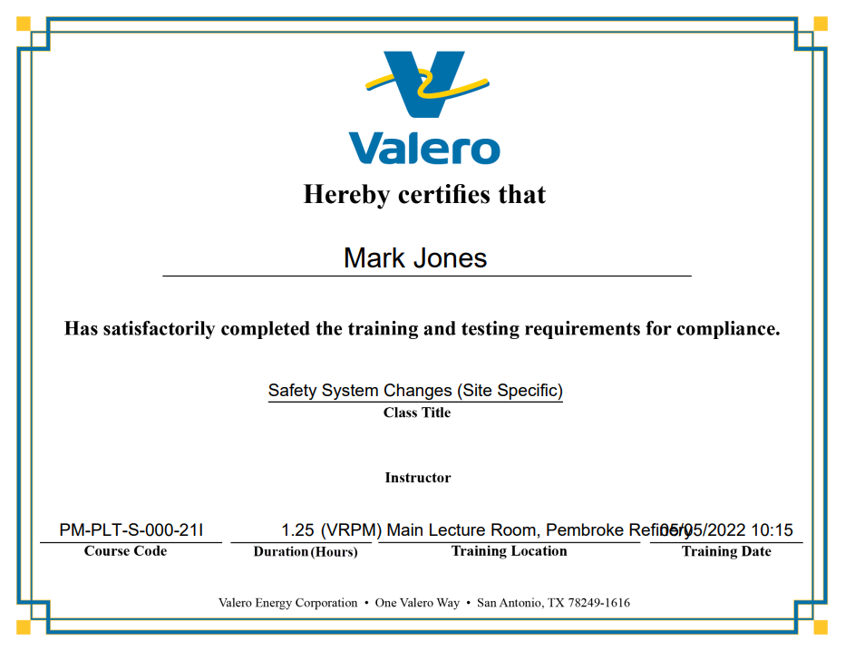



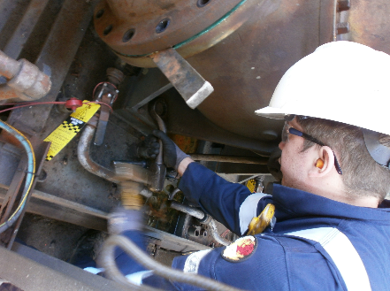

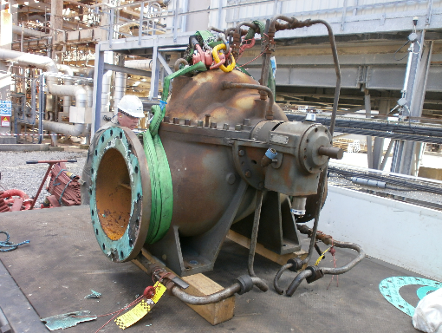

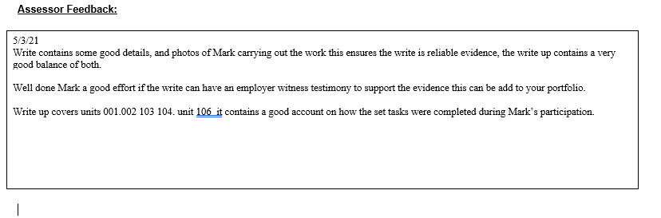

The following is assessor feedback from my NVQ report. The report was based on a removal of a turbine.

Description of the Training Programme

Year 1:

- College based, learning different trades such as; Pipefitting, electrics, mechanical fitting, welding and project based. The project was to make a mechanical can crusher, from recycled products.
- Half terms and Easter – spent on site getting to grips different areas and basic knowledge of the site.

Year 2:

- Site based, went into the Rotary equipment department for 18 months to gain a knowledge of pumps, turbines and machines that fabricate metals.
- Day release once a week, to complete NVQ Level 3 in mechanical and finish BTEC Diploma off.

Year 3:

- Still in roto department, moving over to process operations. Gaining a knowledge of different process units and areas within operations.
- Day release to complete first year of HNC, which includes; Maths, Mechanical Principles, Environmental Impacts, Maintenance Strategies and Process Control.

Year 4:

- Process operations, rotations still ongoing around different units.
- Day release to college to complete year 2 of HNC; Process Safety Management and Process Engineering Practice.

Upon completion of the 4 years, I will have obtained HNC in process Operations and an NVQ Level 3 in Mechanical, which will aid me in the future.

