BA International Hotel Management

Student Journal (Learning Log)

Title: “Does the required skill set of a Food & Beverage employee change, based on the type of business and the type of service that the food and beverage operation utilizes?”

Student Name: Dianna Dancs
Student ID number: 2029955@student.uwtsd.ac.uk
Food & Beverage Operations BMIH4002
Lecturer: Tristan Hawkins

Table of Contents
Introduction 3
Does the Food and Beverage employee skill requirement change? 4
Personal reflection 6
Conclusion 7
References 8

Introduction
Food and beverage business services extend to include hospitality companies that focus on food. Several different food and drink services are investigated in this study. It examines service-specific personnel abilities in more detail. In addition to this, it considers one's previous experiences and how new knowledge might lead to greater achievement.

Does the Food and Beverage employee skill requirement change?
In the hospitality sector, the skill set needed for a food and beverage employee might change based on the kind of company and the kind of service that the food and beverage operation offers (Davis et al., 2018). This student journal compares different F&B businesses in terms of the kinds and styles of service provided as well as how the hard and soft skill sets needed by the staff vary depending on the degree of service provided.
Fine dining: Since fine-dining establishments are noted for their upscale ambience, their staff members need to possess a certain set of skills to live up to patrons' expectations (Cousins and Weekes, 2020). Employees in fine-dining establishments must be excellent communicators to connect with customers. The staff should be able to describe the various courses on the menu, the ingredients, and the cooking methods employed to make each dish (Kim, 2019). Restaurants that specialise in fine dining demand that their staff members have a thorough knowledge of wine and can suggest wines to go with specific dishes. To guarantee that guests have a memorable dining experience, staff members should also be able to multitask and perform well under pressure (Motarjemi and Lelieveld, 2014).

Figure: Fine Dining
Source: (Kim, 2019)
Outstanding customer service is likewise a top priority at fine-dining establishments. Workers should be passionate about providing guests with good service, possess excellent presenting abilities, and be informed about the restaurant's cuisine and ingredients (Zutshi, 2019). Additionally, upscale eating establishments may demand that staff members hold a degree or certification in culinary arts or hospitality.
Fast food: In contrast, fast-food establishments demand an entirely different skill set from their staff members (Johnston, Clark and Shulver, 2012). Fast-food personnel must be able to operate quickly and efficiently because these establishments are known for their quick and effective service. Workers need to process orders promptly, handle cash effectively, and provide exceptional customer service (Manning and Soon, 2016). They should also be able to keep their workstation tidy and organised, adhere to food safety regulations, and collaborate effectively with others.
Café: Café staff members are responsible for making their customers feel at home in a more laid-back setting. A cafe employee needs to be able to strike up a conversation and make customers feel welcome. The many varieties of coffee and the brewing techniques required to create them must also be known to cafe staff. Employees should also be able to suggest complimentary dishes, like pastries, sandwiches, or breakfast items, to go with the coffee.
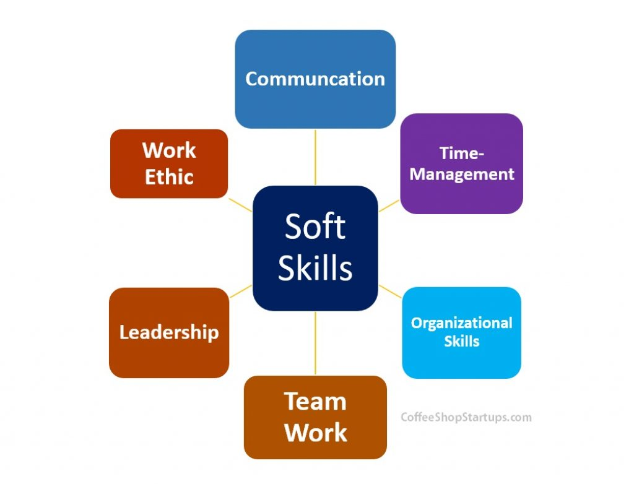
Figure: Skills
Source: (Meganck, Smith and Guidry, 2020)
Bar: A bar is another form of F&B establishment. Bars are recognised for their positive and vibrant ambience, therefore staff members must be able to foster a space that promotes mingling and enjoyment (Islam, 2022). Because they will be interacting with customers in a social situation, bar staff members need to be effective communicators and can strike up a conversation. They must be aware of the many alcoholic drink varieties, such as beers, wines, and spirits. Employees at bars must be able to mix drinks, pour beer, and give advice to patrons by pairing particular drinks with foods or suggesting drinks depending on their tastes.

Personal reflection
My previous work experience has taught me that providing excellent service to customers is the single most important aspect of the hospitality industry. The contentment of one's visitors is of the utmost significance. When I first started working here, I ran into a few obstacles, but my supervisor was there to help me get beyond them. Working taught me how to properly arrange things like napkins, cutlery, and spice sets, and so on. I have passable communication abilities, but I feel like I could improve in this area with further practice.
Employers must make sure that their employees receive the right training, according to the industry. Training covers both hard and soft skills, such as interpersonal and customer service abilities as well as learning how to use tools or cook food (Motarjemi and Lelieveld, 2014). I have discovered the value of both hard and soft skills in the job as a student in the hospitality sector, and I think both are equally vital for F&B personnel.

Conclusion
As was demonstrated earlier, the many types of food and beverage service each require a unique set of hard and soft abilities. This company is dependent on employees who interact with customers. So, workers are required to continuously improve and advance.

References
Cousins, J.A. and Weekes, S. (2020). Food and beverage service. 9th ed. London: Hodder Education.
Davis, B., Lockwood, A., Alcott, P. and Pantelidis, I.S. (2018). Food and beverage management. 6th ed. London: Routledge.
Islam, Md.A. (2022). Industry 4.00: Skill Set for Employability Industry 4.00: Skill Set for Employability. SSRN Electronic Journal. doi:https://doi.org/10.2139/ssrn.4038277.
Johnston, R., Clark, G. and Shulver, M. (2012). Service operations management : improving service delivery. 5th ed. Harlow: Pearson.
Kim, K.-J. (2019). Demographic analysis of buffet restaurants using Kano model : Buffet (hotel, fine dining, normal dining). Korean Journal of Hospitality & Tourism, 28(2), pp.93–109. doi:https://doi.org/10.24992/kjht.2019.02.28.02.93..
Manning, L. and Soon, J.M. (2016). Food Safety, Food Fraud, and Food Defense: A Fast Evolving Literature. Journal of Food Science, 81(4), pp.R823–R834. doi:https://doi.org/10.1111/1750-3841.13256.
Meganck, S., Smith, J. and Guidry, J.P.D. (2020). The skills required for entry-level public relations: An analysis of skills required in 1,000 PR job ads. Public Relations Review, 46(5), p.101973. doi:https://doi.org/10.1016/j.pubrev.2020.101973.
Motarjemi, Y. and Lelieveld, H. (2014). Food Safety Management : a Practical Guide for the Food Industry. Burlington: Elsevier Science.
Zutshi, A. (2019). How to develop well-informed and assured teams to embed food safety compliance in the UK catering and hospitality industry. Perspectives in Public Health, 139(6), pp.294–295. doi:https://doi.org/10.1177/1757913919872783.

