Fabiha Begum
Student Number: 1813640
Module Name: Digital Skills and Research Method
Lecturer: Joy Botu

Table of Contents
- Introduction
- Modern Technology (Mobile Phones)
- Social Media (Marketing, Information Gathering, Communication)
- Evidence of Social Media
- Conclusion

Introduction
Over the last 100 years, technology has been constantly improving in the most exaggerative ways. To this day technology has become one of the most important operators within the infrastructure of our society. It has been suggested by an NYU professor, Adam Alter, that 40% of people are addicted to the internet, showing that social media is checked at least 36 times within an hour by the average person (Michael Osuch and Steven Turner, 2017). With this being shown, there are evidently many advantages and disadvantages of modern-day technology being used within the workplace – which I will be discussing in this report, as well as social media being used as a tool for marketing.
Modern Technology
Mobile Phones
Mobile phones have shown to become very crucial within modern day technology. Before this, telephones were the earliest technological inventions created by Alexander Graham Bell and Antonio Meucci.
Eventually the mobile phone was invented by Martin Cooper, and since then has been rapidly improving constantly. Now, instead of only being able to send and receive calls like the telephone, you can send and receive text messages, images, videos, as well as accessing the internet, emails and so much more. This alone shows how vital mobile phones have become as they play an important part to communication.
There are two forms of communication, one being asynchronous which is defined as “communication in real time and can at once both send and receive messages” and the other being asynchronous which is defined as “communication in which there is a slight or prolonged delay between the message and the response; the interactants must alternate between sending and receiving messages”. Both forms of communications have their pros and cons, however, asynchronous communication is found to be easier for people as communication takes place for when it is most convenient for them (Andrew Maund, 2017)

Differences of Apple iPhone and Samsung Androids
In the technological industry there are many businesses competing against each other to become the best seller of mobile phones. Apple and Samsung are two very popular brands that are in known competition with each other, with the Samsung Galaxy S10e being ranked first and the iPhone XS Max being ranked second – as the most used mobile phones in 2019 (Gareth Beavis and John McCann, 2019).
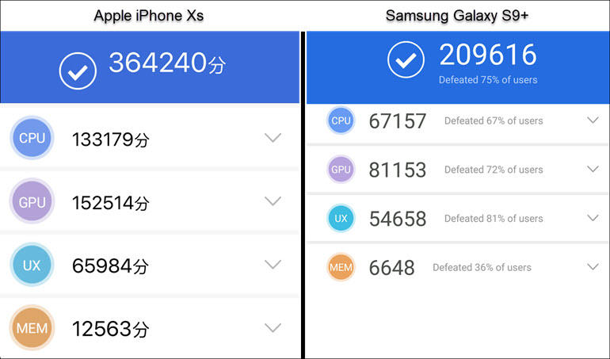
However, the differences between the two smart phones are that the Apple iPhone is found to be much easier to use by consumers. The smart phone offers multiple different uses that the Samsung smart phone does not. For example, the iPhone XS has a stronger and faster speed, making it easier for consumers to access what they desire without the worry of it slowing down whereas the Samsung S10e has a much slower hardware, proven in the table below (Michael Krigsman, 2018)
(Michael Krigsman, 2018)
Although the Apple iPhone is found to be much faster, the Samsung Galaxy has many advantages in comparison to the iPhone, for example, the Samsung Galaxy has become known to be able to hold a lot of storage space, as it comes with a MicroSD card expansion slot, allowing consumers to increase storage capacity. This is found to be very useful and beneficial for the workplace as it can consume a lot of data and hold documents twice as much as the iPhone. This can allow higher efficiency and productiveness of the staff.
There are many differences between the two smartphones however, they do have some similarities that allows businesses to thrive. The two smartphones allow contactless payments to be made for any checkout that enables them. Apple released their Apple pay in October 2014 and Samsung released their Samsung pay in August 2015. This has become beneficial for businesses, especially those that are cash free. It allows more secure and safer transfers and the process is quicker as it does not require any information to be provided.
Mobile phones are also useful for businesses to promote and advertise their goods and services. This is a faster way to spread knowledge of their business and allowing consumers to make purchases by simply accessing their websites on the smartphone. There are many risks to using mobile phones for this method as it does not prove its authenticity and it could potentially lead to data leakage which would become a crisis for any business.
Social Media
Marketing
Social media is a popular tool used for marketing within businesses, it is used to share and gather information online. Facebook, LinkedIn, Instagram and more all obtain different forms of social media tools to increase communication with their consumers. This can be done by requesting reviews or offering exclusive promotions or offers, etc. This is an effective way for businesses to promote their brand or company, when consumers give feedback or constructive criticism, there then is awareness already being spread and it then become the word of mouth spread, allowing their business to continuously expand in this sector. Businesses that use social media always thrive in every other aspect from the exposure.
Information Gathering
Information gathering can be used by companies to help understand their consumers better and work on improving their business. This way companies can learn to accommodate to the needs and wants of their consumers by knowing exactly what they are asking for – by seeing how much interaction is happening with their brand, allowing them to form a strategy to significantly increase their brand value. However, there are many down sides found by information gathering, one of them being that there may be an information overload. For example, while gathering information, there may inaccurate data which can be a risk towards a business as it will not give definite results to help with any marketing strategies (Jamie Macdonald, 2016)
Communication within the workplace
Using social media for communication within the workplace allows employees and employers of different positions share and receive information and resources (Jessica Miller-Merrell, 2013). There are many different social media platforms that allow businesses to stay in touch with one another. For example, WhatsApp is a commonly used social media platform for businesses to be able to quickly send messages or important information with each other. This creates a strong bond within the business as there is a strong level of communication allowing everything to run more smoothly. Facebook is another social media platform used by businesses as Facebook enables you to create a business profile and add people into the group. By using this, employees can easily access the page to view any new updates of changes within their company. It also allows the employers to make announcements of any achievements made by their employees, boosting staff morale.
Advantages and Disadvantages to Social Media
Some advantages of social media is that is promotes brand recognition, if a business is found to be on social media it will more likely increase interaction with customers as it much more accessible for them. Brand loyalty is also promoted along with this as a recent study has shown that 53% of people in the USA show more loyalty towards brands that they follow and engage with on social media (Jay Baer, 2019). Another benefit is that social media literally costs zero to nothing, this is the easiest method of marketing as it requires no purchases to be made, it is a free platform to be used by anyone.
However, some disadvantages are that businesses are not in control of feedback. This means that incoming negative comments cannot be stopped, and it can become a risk if there is a significant number of them for your company. A way to stop this could be to limit the number of comments enabled to your posts or your profiles. Another disadvantage can be businesses can suffer from extortion. On social media, there are many culprits with ill intent that may try to hurt brand images, this is very dangerous for smaller companies with a lower following count as they may not have the help required to prevent these things.
Professional Online Business Presence
For my business, I use Instagram as a way for myself to interact with my consumers. Instagram allows me to share images of my work and enables the audience to leave me any comments and likes. It can also be used to send and receive direct messages. An advantage of using Instagram as a business platform is that Instagram allow you to create a professional business profile linked with Facebook, so you initially get two profiles in one process. It also allows consumers to find a way to contact your business as Instagram allows a chosen method to be shown on your profile to be contacted on – shown in the images of my business profile below.

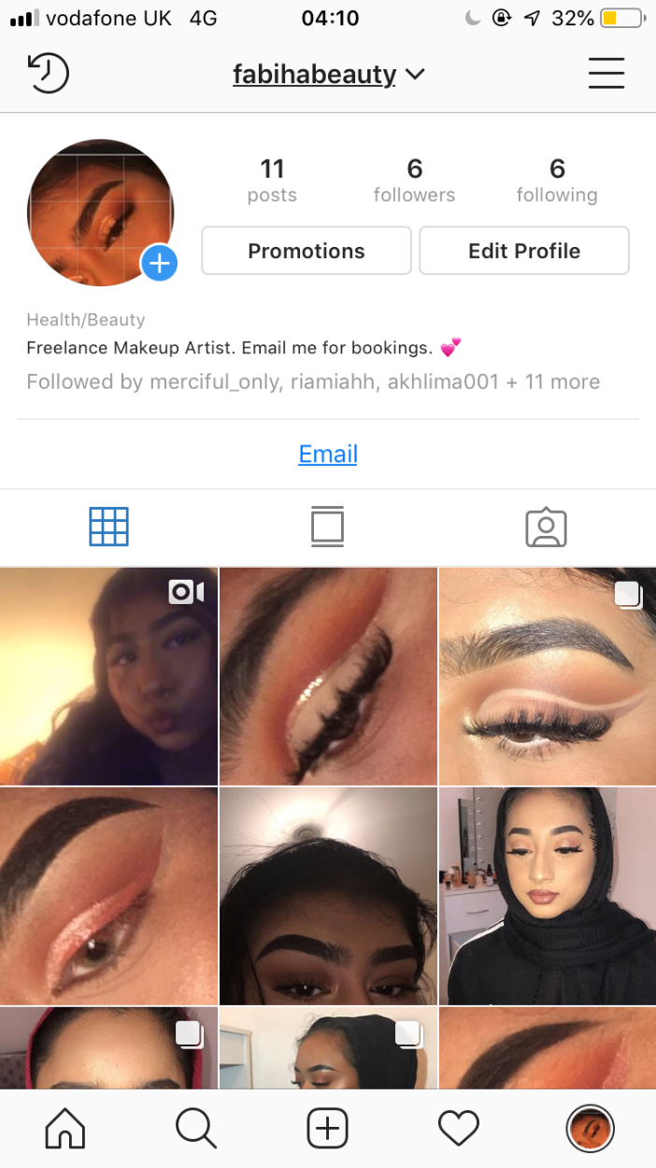

Conclusion
In conclusion, it is very much a fact that technology plays a huge factor in the 21st century. It is more commonly for communication, making it extremely vital. For businesses, it has been found to make the work much easier and more efficient. A downside that I have found in modern technology is that everything is becoming more digital that face to face communication is much rarer as everything is more internet based now. Although technology is much more reliable and faster, it is still a risk for smaller businesses which can be due to lack of security.

References
Andrew Maund, M. S. P. K. T. (2017) Certificate in Higher Education: Skills for the Workplace Student Yearbook. London: SAGE publications Ltd.
Karehka Ramey (2012) Modern Technology Advantages and Disadvantages [Online] Available at: https://www.useoftechnology.com/modern-technology-advantages-disadvantages/
[Accessed: 29th April 2019]
Michael Osuch and Steven Turner (2017) Addiction to modern technology: what science says Available at: https://www.elsevier.com/connect/addiction-to-modern-technology-what-the-science-says
[Accessed: 29th April 2019]
Gareth Beavis and John McCann (2019) The best smartphone of 2019: 15 top mobile phones tested and ranked Available at: https://www.techradar.com/uk/news/best-phone
[Accessed 29th April 2019]
Brett Nuckles (2017) iOS Vs. Android: Which is better for business? Available at: https://www.businessnewsdaily.com/9906-ios-vs-android-business.html
[Accessed: 29th April 2019)
Michael Krigsman (2018) Apple Vs. Samsung Phones: We compare the Galaxy S series and the iPhone XS Available at: https://www.zdnet.com/article/apple-vs-samsung-phones-we-compare-the-galaxy-s-series-and-the-iphone-xs/
[Accessed: 29th April 2019]
Michael Chui et al, (2012) The social economy: Unlocking value and productivity through social technologies Available at: https://www.mckinsey.com/industries/high-tech/our-insights/the-social-economy
[Accessed: 29th April 2019]
Jamie Macdonald (2016) The Pros and Cons of 10 Information Gathering techniques for Projects Available at: https://www.business2community.com/strategy/pros-cons-10-information-gathering-techniques-projects-01437727
[Accessed: April 29th April 2019]
Jessica Miller-Merrell (2013) The Power of Social Media for Workplace Communication and Distribution Available at: https://workology.com/social-media-enterprise-communciation/
[Accessed: April 29th, 2019]
Jayson DeMers (2014) The Top 10 Benefits of Social Media Marketing Available at: https://www.forbes.com/sites/jaysondemers/2014/08/11/the-top-10-benefits-of-social-media-marketing/#1f82baa11f80
[Accessed: 29th April 2019]
Jay Baer (2019) 53% of Americans Who Follow Brands in Social Are More Loyal To Those Brands Available at: https://www.convinceandconvert.com/social-media-research/53-percent-of-americans-who-follow-brands-in-social-are-more-loyal-to-those-brands/
[Accessed: 29th April 2019]
Anis Rahman (2017) Disadvantages of social media marketing for business Available at: https://successgainer.com/blog/category/social-media-marketing/disadvantages-of-social-media-marketing-for-business/
[Accessed 29th April 2019]

