Assignment 1 – Business Programming – Report

Luke Evans

BIT

Contents
Assignment 1 – Business Programming – Report 1
Luke Evans 1
BIT 1
Program Documentation 3
Appendix 5

Program Documentation

The programming language chosen for this project was VB and the software used to create the program was Visual Studio using a Windows form Application.
Screenshot 1 in the Appendix shows a warning message that pops up when the program is launched. This issue will be addressed further on in the report. The program can still be run by clicking “Yes” on the pop us and runs completely fine.
Screenshot 2 in the Appendix shows what the user is greeted with when the program is properly opened, the Main Menu. The Main Menu offers 3 buttons for the user to choose from and each will take them to a new form. The “Add New Data” button will take them to a form where they can add new data to the spreadsheet, the “View All Data” button” will essentially show them all the data that is stored in the spreadsheet in a presentable form and the “Find Records” form can help them with any specific queries that they have with the data.
Screenshot 3 in the Appendix shows the code that went into the making of the Main Menu. As you can see from the comments next to the code, each button was programmed to take the user to its respective form.
Screenshot 4 in the Appendix shows the Add data form which is where the user is taken after clicking that specific button on the main menu. The user is greeted by an empty data grid and text boxes to type in. The user is required to enter suitable information into these text boxes. Once the data has been added, the user can proceed to click the “Add Data” button.
Screenshot 5 in the Appendix shows the aftermath of the “Add Data” button; all information that the user has typed into the text boxes have been transferred to the data grid ready to be exported. The text boxes also get cleared after the button is clicked in case the user wishes to enter in different information.
Screenshot 6 in the Appendix shows the code that was used to make the “Add Data” button transfer the information from the text boxes to the data grid. As you can see, each labelled text box transferred its data to its respective column within the data grid. The code also shows the how the text boxes are cleared to make way for new information and it saves the user time because otherwise they would have to delete the information in each box 1 by 1.
Screenshot 7 in the Appendix shows the beginning of the code that is designed to export the information from the data grid to the excel spreadsheet which would happen after the “Export Data” button was clicked. Unfortunately, this is where the initial issue with the program comes in; this button does not work and has code which brings up that warning. The first part of the code is meant to find the spreadsheet; however, the second part which declares all variables necessary for the export is where the issue lies. Some of the variables come up as errors in the code and this is presumably an issue with excel. Due to this outcome, the code that is shown in Screenshots 7-9 in the appendix is what would have allowed the data to be exported if this issue didn’t occur.
Screenshot 10 in the Appendix show the View Data form which is accessed through the Main menu button. The user is greeted with 8 list boxes that represent the tables in the spreadsheet. The button “Get Data” is supposed to retrieve the data from the spreadsheet and display it for the user in the form.
Screenshot 11 in the Appendix shows the excel spreadsheet with limited data in it. Due to the issues with exporting data to the spreadsheet, example data had to be used just to show that data can be claimed back from the spreadsheet to view. Screenshot 12 in the Appendix simply shows this data in the spreadsheet being sent back to the program.
Screenshot 13 in the Appendix shows the code that was written for the data retrieval example. This code isn’t the end product for this form due to it not being able to display letters, only digits; however, it still shows off the general aim of what the form should do once completed.
Screenshot 14 in the Appendix shows the Find Records form which doesn’t seem to display properly. This form, when opened through the Main Menu, does not display what it should at all which is an issue that is yet to be explained. As you can see from the forms design view, what the form should do is calculate the medals percentage (Bronze, silver, gold) for all the male and female swimmers. The user gets to choose which gender they wish to make the query for. Unfortunately, no code has been added to this form to do the calculations due to the previous issues.
The majority of the code included in the program included suitable use of comments to explain what each part did.
VB as a language, at least in this setting, is rather easy to use because for non technical people code is written after opening up a button in VB. It makes it a lot easier to start writing a program in comparison to other languages such as C#.

Appendix
Screenshot 1:
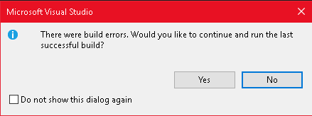
Screenshot 2:
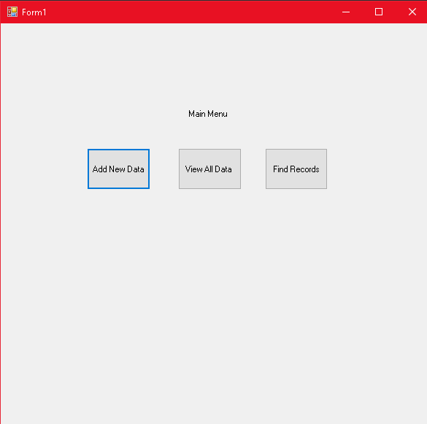

Screenshot 3:
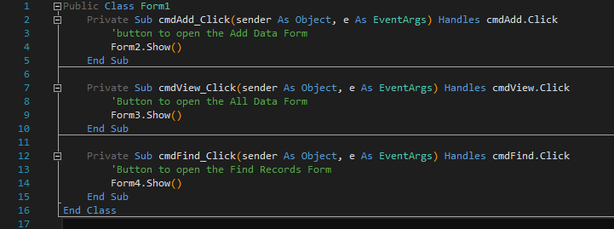
Screenshot 4:
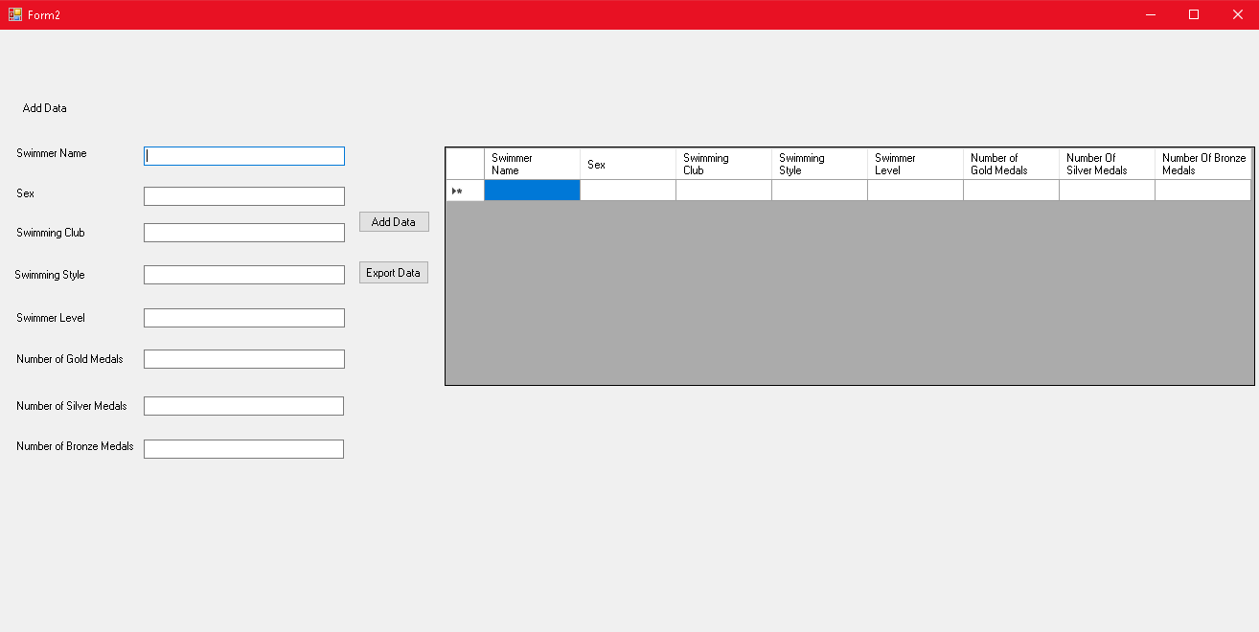

Screenshot 5:
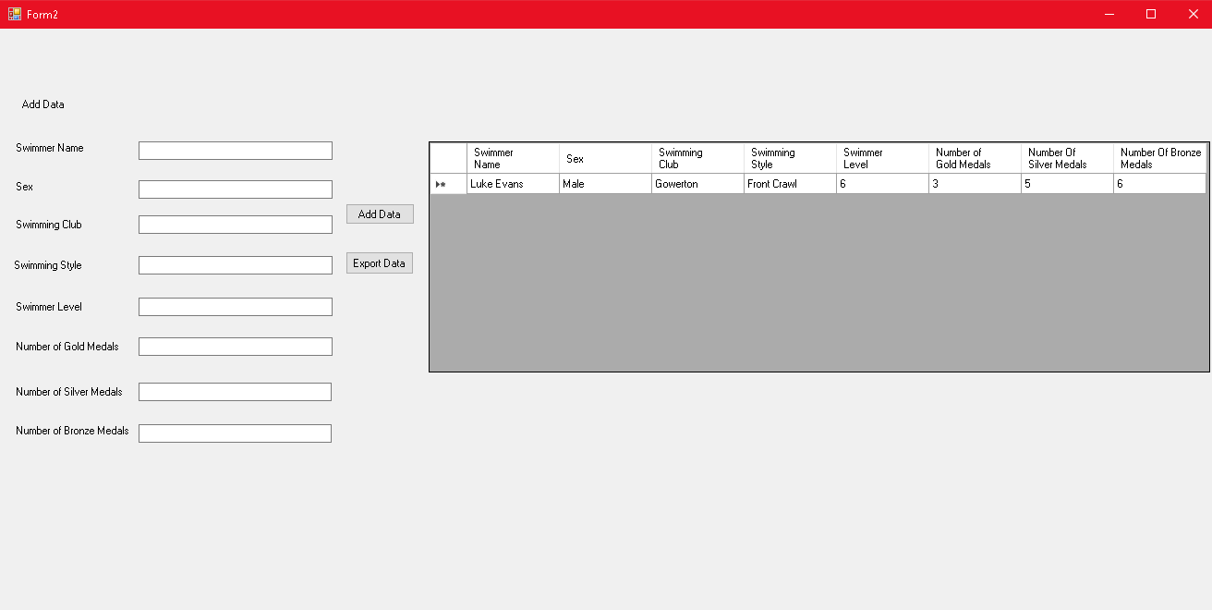
Screenshot 6:
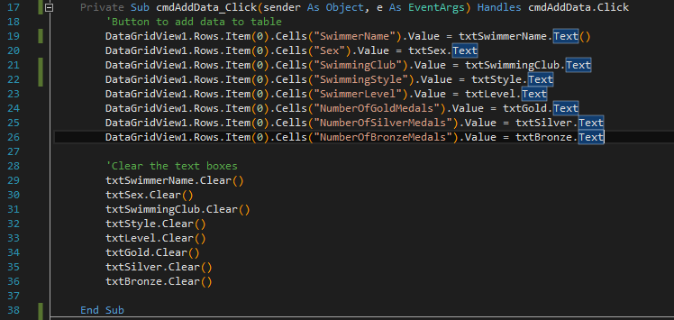
Screenshot 7:
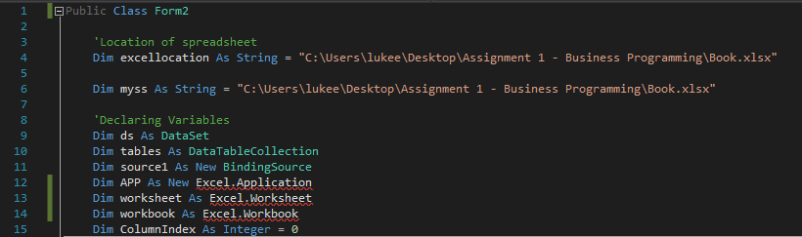
Screenshot 8:
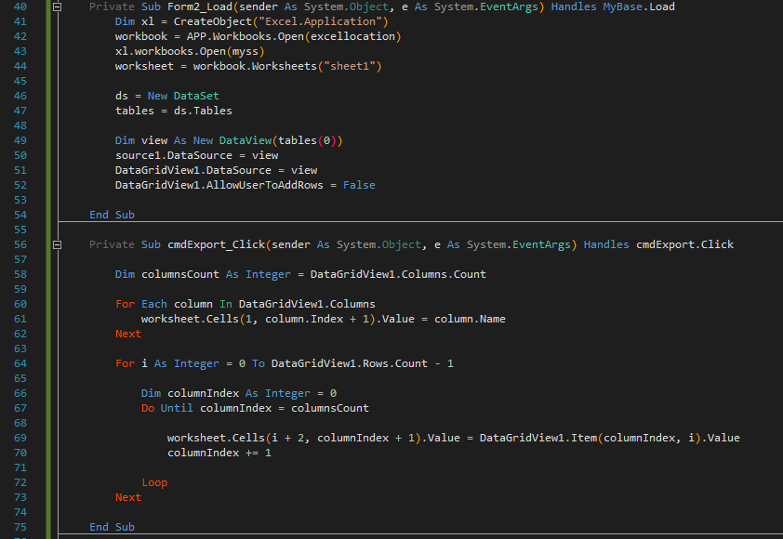
Screenshot 9:
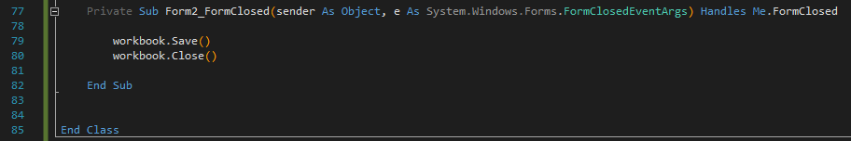

Screenshot 10:
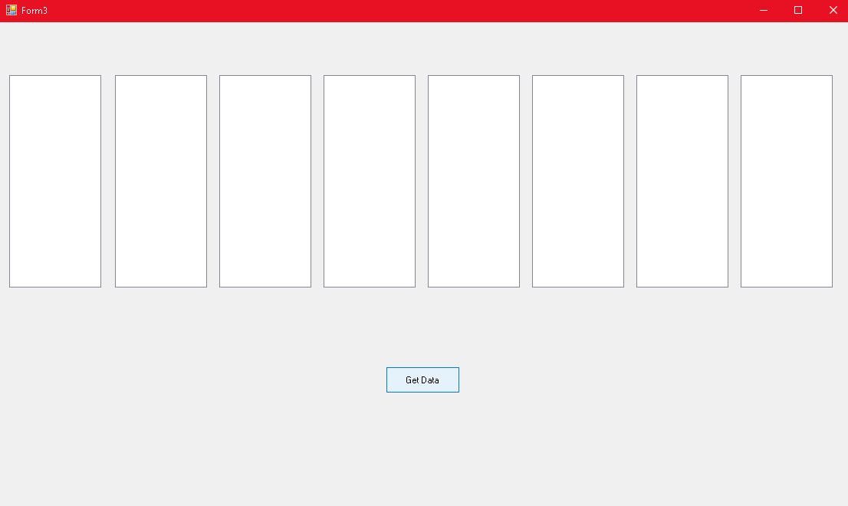
Screenshot 11:
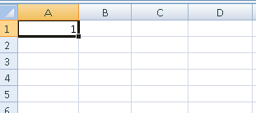

Screenshot 12:
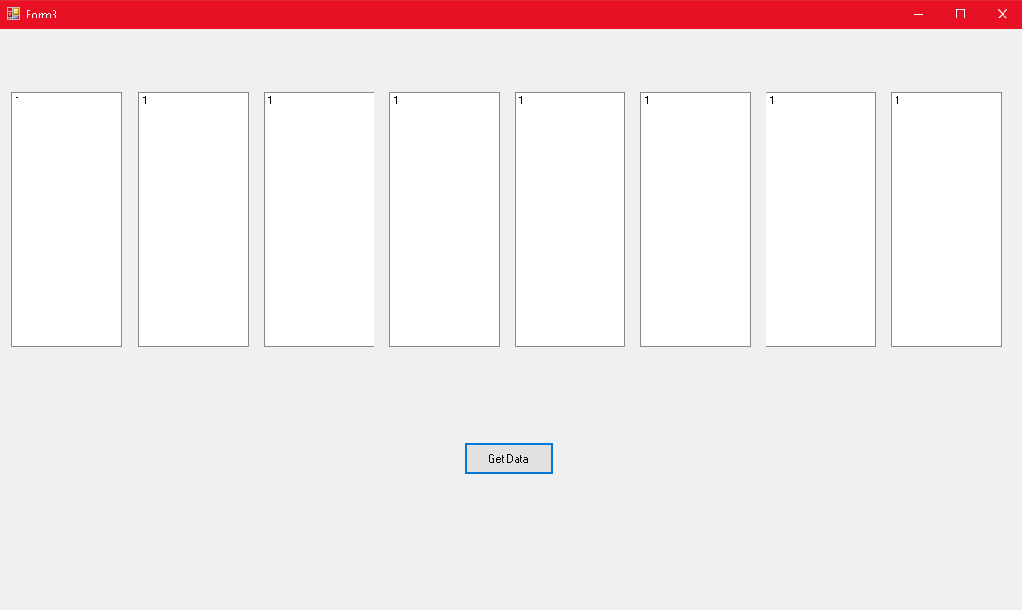
Screenshot 13:
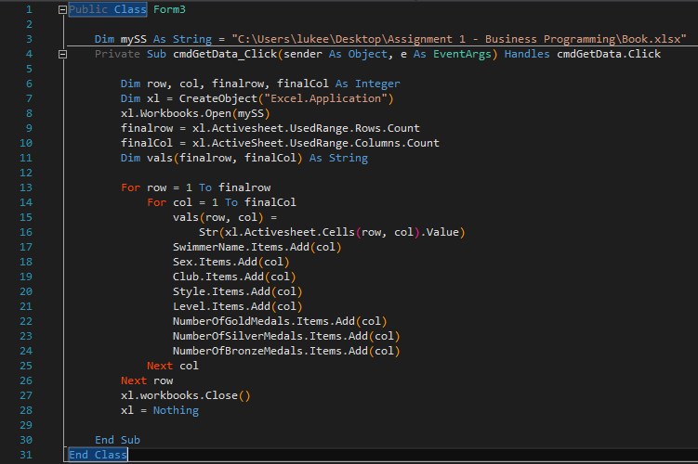

Screenshot 14:


