

UNIVERSITY OF WALES ST TRINITY DAVID

MODULE: GLOBAL BUSINESS ENVIRONMENT
LCBB4011

ASSIGNMENT: PORTFOLIO

BY GEORGIANA PITICAS 2315601

LECTURER: CHARLES OHAM

TABLE OF CONTENTS

ELEMENT 1- Introduction & Community Outreach...................03

ELEMENT 2- Map.......................................................................09

ELEMENT 3- PowerPoint............................................................10

ELEMENT 4- Individual Discussion & Conclusion....................13

REFERENCE LIST......................................................................15

Introduction

The Northeye site is a former prison in the Rother district, south-east England that has not been used since 1992. The campus still retains some of the prison buildings. In 2023, the Home Office bought the site, which announced that it would be used as housing for male asylum seekers from Iran, Afghanistan, and other areas. Later, it was stated that it would be used as an immigration detention site.
In March 2023, the home office announced a proposal: to open accommodation for single male asylum seekers from the affected countries of Iran, Afghanistan and other war zones in 3 areas of the UK, one of them being the former HM Northeye prison in Bexhill. The Rother District Council and the East Sussex County Council stated in March 2024 that they had been informed of this proposal a day before it was made public, and they are currently assessing what this proposal implies. In May 2023, both councils shared their concerns over this proposal and ensured proper consultation with the public would happen to ensure questions were answered as soon as the home office provided them with the details. Due to the improper use of the Rother district council logo in documentation and public manifestations, the council stated they have no involvement with the protests, and there is no update to share at that time. In September 2023, both councils said the home office wanted to use the north eye site to detain people who had entered the country without permission. At the end of 2023, Chancellor Doug Oliver stated that the purchase of the northern by the home office has been completed, but no decision has been made about how it will be used. The early 2024 update stated that the home office has not yet decided what will happen with the plan and its future.

ELEMENT 1

Community outreach

The reason I am putting together this portfolio is to look at the current situation, give a clear overview of what the locals had made to support their beliefs, the different ethnicities, and cultural differences within the rother district, as well as my personal view on how the situation could be handled moving forward.

In order to discuss the northern site home office plan, it is imperative to look at the demographics surrounding the Rother district. I’ve noticed that the percentages had changed from the 2011 census to 2021. An increase has been noted in the “mixed or multiple ethnic groups” with 0.7% as well as in the “Asian, Asian British or Asian Welsh” category with 0.3%. The category “ black, black British, Black Welsh, Caribbean or African” saw a 0.3% increase, whilst the majority noted in the category of “white” saw a decrease of almost 2.5%. Census (2021).
The demographics show that in the Rother district, there is a majority of British nationals, but other ethnic groups are present. These other groups have been on the rise since 2011. Personally, I believe the community has welcomed them slowly and got used to other traditions gradually. If the plan goes ahead, it would be too much for the community, it will become harder to absorb and understand, mainly because there are plenty of locals over 50 than young adults (according to the 2021 census).
Due to the lack of communication between the council, home office, and the community, the other district residents decided to gather to try to put a stop to this proposal by voicing their concerns in diverse ways. Jeffrey Newnham has created a crowdfunding page in order to set up a legal challenge; the goal has been met in only 2 days, which shows the resident's real concern. Several other residents within the area had made their concerns known when interviewed by local and national newspapers; most of them raised the issue about the resident's safety, as offering shelter to over a thousand single-man refugees will increase the risk of wrongdoings.

Even the Home Secretary, Suella Braverman, stated that there is a possibility that people coming via a boat into the UK (asylum seekers) have some kind of agenda, and there are concerns about the ‘heightened levels of criminality’ related to prostitution, drugs, or exploitation as well as the asylum seekers being themselves at risk of being exploited. Syal, R. (2023).
Currently, the government uses over 400 hotels to house asylum seekers, which costs over 8 million pounds a day. Building this type of centre would lower the cost. Unfortunately, it will require a considerable sum of money to transform the site into something that works, and it does not guarantee it will be cost-effective overall.
In April, May and June 2023, Rother and East Sussex residents had been protesting to “save” the Northeye, saying “no” to Northeye and to “deport illegal migrants” Some of them said that they specifically moved from big cities to the coast because of its safety and would not feel as safe if this plan goes ahead, as others stated that if the home office would’ve decided to shelter refugees families, the idea would not be so scary. Luthra, P. (2023).

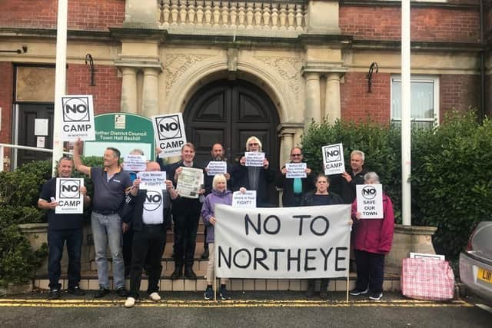In the picture above, protesters are outside Bexhill Town Hall in August 2023. Keep It Reel Media (2023).

In the picture above, protesters in Bexhill Town Centre. D. Young (2023)
They was organize by the Bexhill community enghagenment team who has the leder Councillor Doug Oliver
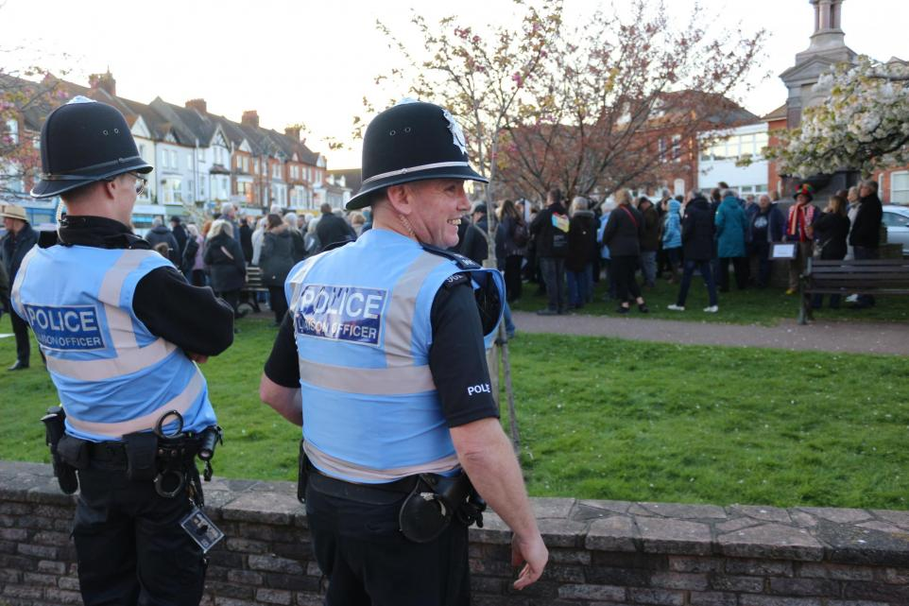
In the picture above, there is a large group of protesters in front of Bexhill Town Hall and two Police Liaison Officers ensuring everyone's safety. Martin, S. (2023).

From protests to letter updates, residents have tried to keep the community actively involved by ensuring all the information they have gathered reaches even those who cannot participate due to illness or disability. Below is a letter my household received on the 31st of March 2024 with the latest update on the Northeye situation.

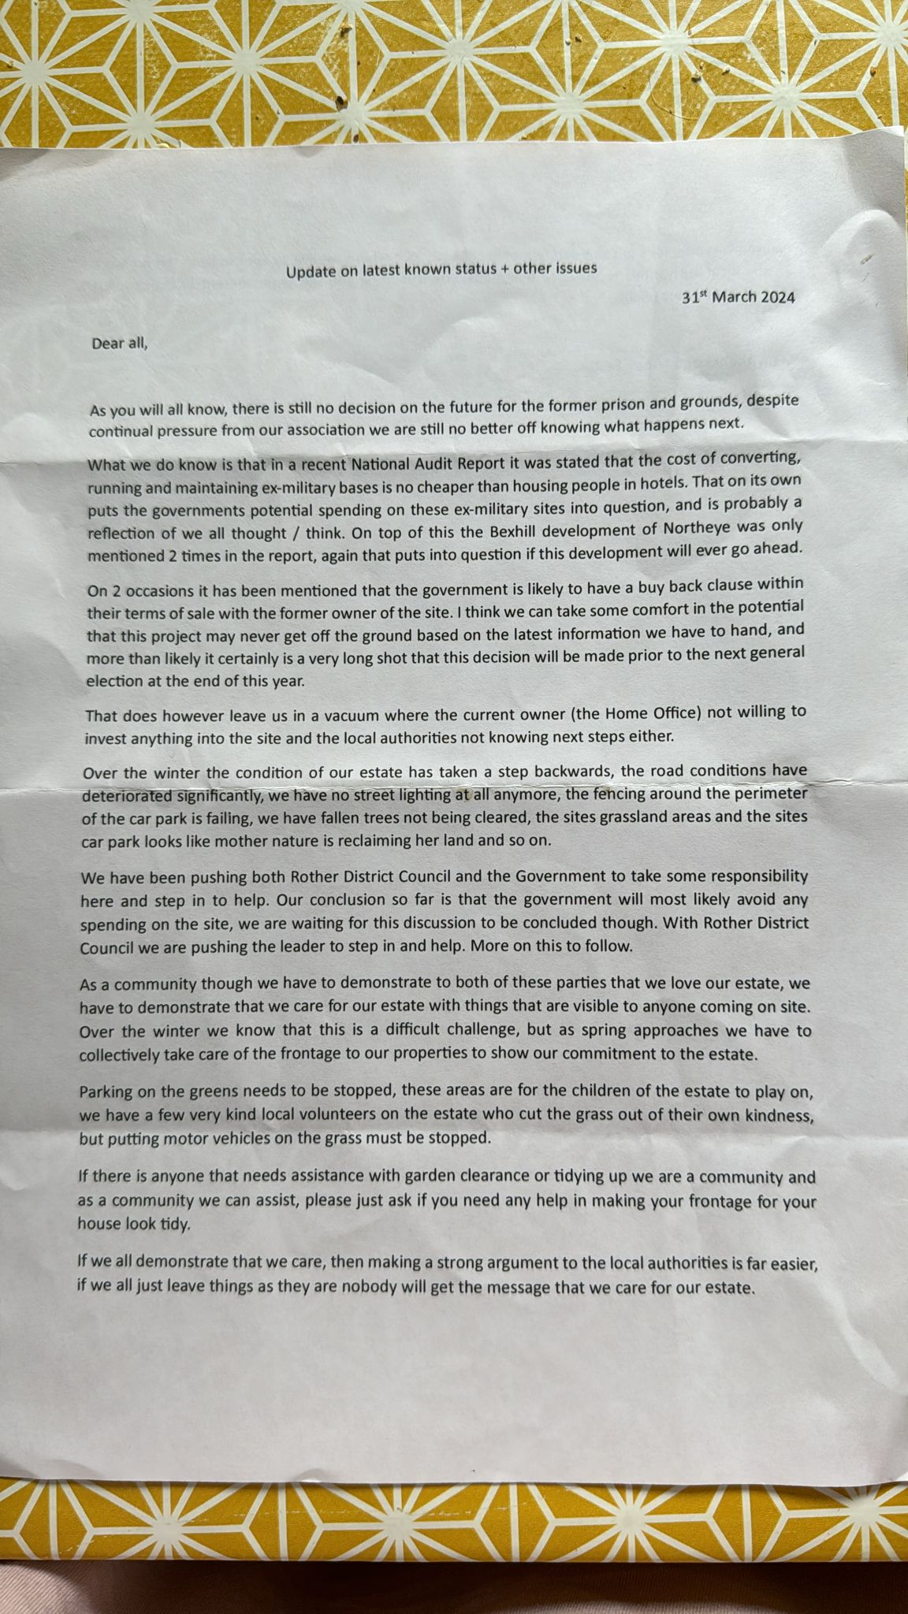


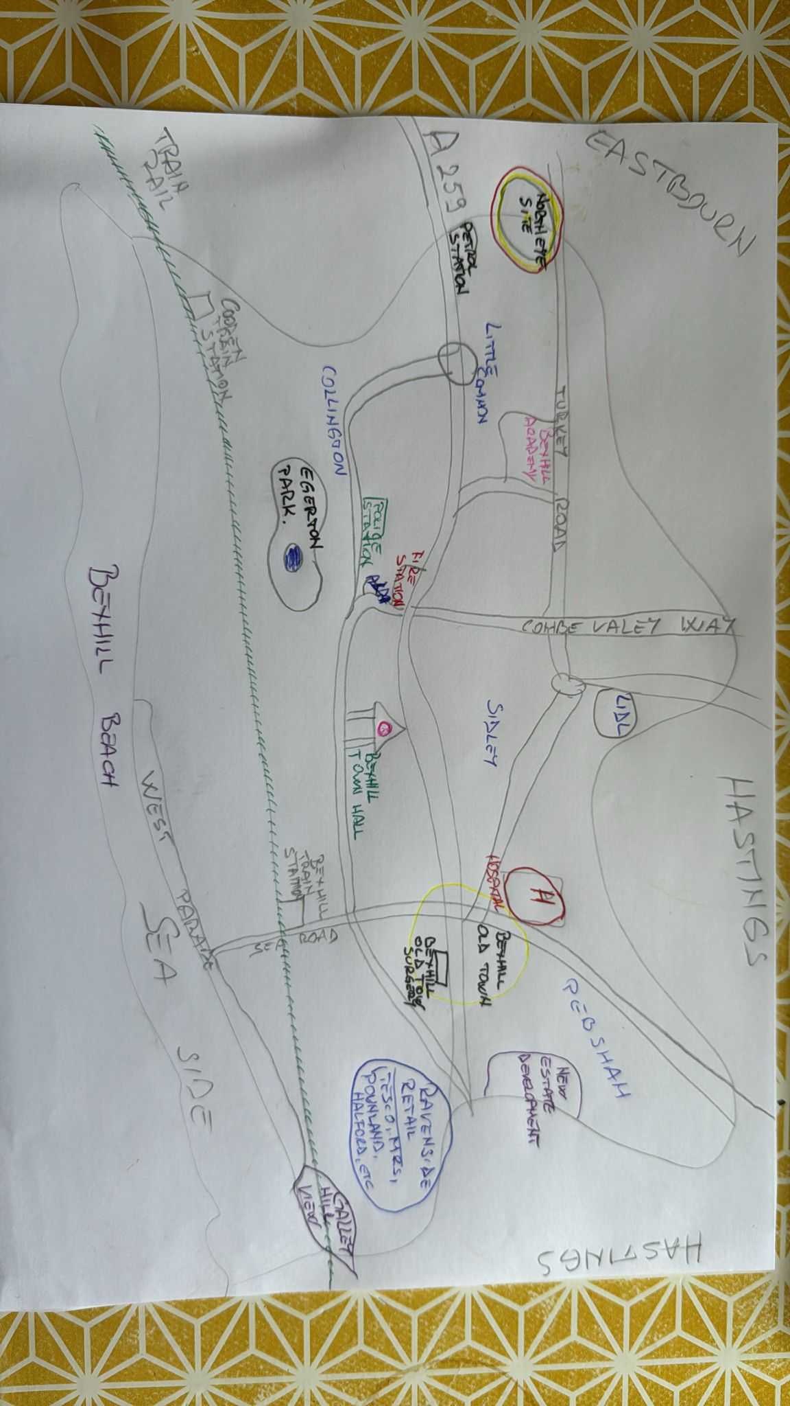
Element 2

This stakeholder map shows the main buildings, roads, and shops in Bexhill Town and the Northeye site. And how is situated the Northeye site and why people from Bexhill community are not to happy about it.
Bexhill on Sea it is a relatively small town but it has all the necessery buildings( school’s, hospital,fire station, police station, big and small supermarkets and some of the most delicious restaurants) to make it feel cosy and welcome and it make me feel like HOME.

Element 3

Slide 1
Slide 2
Slide 3 |  | Reference: Marwick A., 2022 ‘Northeye Bexhill Campus aerial’ available at: https://en.wikipedia.org/wiki/HM_Prison_Northeye#/media/File:Northeye_Campus,_Bexhill_(aerial)_(1).jpg
Slide 4 |  | Reference:  Newnham, J. (2023). Northeye. [online] Northeye. Available at: https://save-northeye.org/ [Accessed 10 Aug. 2024].
Slide 5
Slide 6 |  | Reference:  Office, H. (2023). Bexhill update. [online] GOV.UK. Available at: https://www.gov.uk/government/publications/asylum-accommodation-bexhill/bexhill-factsheet [Accessed 11 Aug. 2024].

Element 4

My personal opinion on the Northeye situation is that in the Rother area, there was a functional prison until 1992; there is not something new that the older generation residents had not been faced with already. The land hasn’t been used for 32 years, and the aim of the home office is to create something that the UK does need, as there has been an increase in asylum seekers since 2022. The uncertainty regarding the higher criminality rate due to housing these refugees is a strong point that the home office and other officials must take into consideration as there is an older and at-risk generation in the area, many care home facilities and a tourist destination. In order to minimise these risks, if the plan goes ahead, clear guidelines must be drawn out from the start, such as how the asylum seekers can be properly and safely integrated into the UK, as I believe every person has potential and can use its talents to make themselves useful. For example, there is a high need for care assistants for care facilities in the Rother and East Sussex communities. Many East Europeans come to the UK to work in this field, starting from basic training and working alongside seniors to gain experience and safely deliver care to those in need. The immigrants can do so too, especially those who have some knowledge about this area (previously worked in a hospital and so on). They can also help improve the infrastructure, garbage disposal, and street cleaning. It is challenging for everyone to find something, but it could be better than not using their skills. The backlog of asylum seekers is relatively high; the community issue is that the Bexhill Northeye former prison camp could be better used as social housing for the Rother and East Sussex residents struggling to make ends meet.

The question that comes to mind is, “How did the UK manage to get into this situation firsthand? " I believe it is because of the lack of organisation and communication between the government and the affected councils. There wasn’t a plan put in place, no trial and error, just decisions made on the spot, and it became overwhelming quickly, therefore the need for alternatives and long-term solutions.

Another question that arises regarding this situation is, “Why does the home office does not provide transparency?” In March 2023, a representative came forward, saying what the plan was. Still, it took plenty of time and lots of effort from the affected councils to receive and update the statement, to be able to know how to prepare the public, and how to try to make it easier for the community. The last update given by the home office happened early this year, saying that no official decision has been made on how to use this site. It makes the residents anxious whether to continue to fight for their beliefs or if the battle has already been won.

Kieran Mullan, Conservative MP for Bexhill and Battle, has recently joined the battle. He is eager to get answers from the Labour government, residents are hopeful he will get an update so there will be no confusion forwards. Wright, C. (2024).

Conclusion

In conclusion, the Northeye former prison camp is an actively debated subject among the residents of Rother and East Sussex Councils due to its potential and importance to the safety of the community. Personally, I have no political involvement nor interest, but as an active member of the community, it is essential to know how this situation will unveil and, if the home office does decide to go ahead with the proposed plan, how they plan to promote diversity and equality while keeping the safety of its residents.

Reference List

- Census (2021). How life has changed in Rother: Census 2021. [online] Ons.gov.uk. Available at: https://www.ons.gov.uk/visualisations/censusareachanges/E07000064/ [Accessed 12 Aug. 2024].
- Keep It Reel Media (2023). Northeye protestors outside Bexhill Town Hall. Available at: https://www.sussexexpress.co.uk/news/politics/bexhill-campaigners-hold-silent-protest-against-governments-asylum-centre-plans-at-northeye-4240598 [Accessed 11 Aug. 2024].
- Luthra, P. (2023). Why we oppose the plans for Northeye. [online] Hastingsonlinetimes.co.uk. Available at: https://hastingsonlinetimes.co.uk/hot-topics/politics/why-we-oppose-the-plans-for-northeye [Accessed 10 Aug. 2024].
- Martin, S. (2023). Protesters outside Bexhill Town Hall voicing their anger over plans for Northeye. Available at: https://www.theargus.co.uk/news/23469734.bexhill-large-crowd-gathers-protest-northeye / [Accessed 10 Aug. 2023].
- Newnham, J. (2023). Northeye. [online] Northeye. Available at: https://save-northeye.org/ [Accessed 10 Aug. 2024].
- Office, H. (2023). Bexhill update. [online] GOV.UK. Available at: https://www.gov.uk/government/publications/asylum-accommodation-bexhill/bexhill-factsheet [Accessed 11 Aug. 2024].
- Syal, R. (2023). Does Suella Braverman have evidence to link boat arrivals to crime? The Guardian. [online] 26 Apr. Available at: https://www.theguardian.com/politics/2023/apr/26/does-suella-braverman-have-evidence-to-link-boat-arrivals-crime [Accessed 12 Oct. 2024].
- Wright, C. (2024). Northeye: MP joins campaign for certainty over detention centre. [online] Bbc.com. Available at: https://www.bbc.com/news/articles/c4ng19j8w2ko [Accessed 10 Aug. 2024].
- Young, D. (2023). Bexhill Protesters. Available at: https://www.hastingsindependentpress.co.uk/articles/news/northeye-protestors-blame-merriman-and-tory-government/ [Accessed 10 Aug. 2024].

