Exploring Job Satisfaction and Influential Factors Among Retail Sales Associates in Beijing Shopping Malls

Hongyao Zhang
Unit name: Dissertation
Module code: BMMB7003
Degree: Master of Business Administration (MBA)

ACKNOWLEDGEMENTS
This dissertation has been a significant project that I have poured a lot of effort and dedication into. I began preparing for it early, dedicating time to exploring the topic and laying a solid foundation for the research. It required not only hard work but also consistent focus and persistence over the months. Along the way, I was fortunate to receive support from many wonderful individuals.

First of all, I would like to sincerely thank my supervisor, Aqsa Shabir, for her patient guidance and constant encouragement throughout this journey. Their insightful advice and expertise have been incredibly helpful and have kept me on track.

I would also like to thank the professors and lecturers who have taught and guided me during my academic studies. Their knowledge and passion for teaching have inspired me and provided me with the tools to complete this work.

Finally, I want to express my heartfelt gratitude to my family and friends. Your unwavering support, understanding, and encouragement have meant the world to me and have given me the strength to see this project through to the end.

Thank you all for being an integral part of this journey.

Abstract
Job satisfaction is a critical factor influencing employee performance, retention, and organizational success, particularly in customer-facing industries such as retail. This dissertation investigates the level of job satisfaction among retail sales associates in Beijing shopping malls, examines the intrinsic and extrinsic factors influencing their satisfaction, and identifies key sources of dissatisfaction. Additionally, the study aims to provide actionable recommendations to improve workplace conditions, enhancing both employee well-being and organizational efficiency.

A positivist research paradigm underpins this study, utilizing a quantitative methodology with structured survey instruments to collect data from 156 retail sales associates across various shopping malls in Beijing. Descriptive and inferential statistical methods, including correlation and regression analyses, were employed to analyze the data and test hypotheses derived from the research questions. The research framework incorporates Herzberg’s two-factor theory, focusing on the interplay between intrinsic motivators, such as recognition and career growth opportunities, and extrinsic factors, including salary, management support, and work environment.

The findings reveal that retail sales associates report a generally high level of job satisfaction, with intrinsic factors demonstrating a stronger influence on overall satisfaction compared to extrinsic factors. Colleague relationships, recognition, and career development opportunities emerged as significant drivers of satisfaction, whereas dissatisfaction was primarily linked to inadequate salary, limited career growth, and poor management support. These results highlight the critical role of workplace relationships and career advancement opportunities in shaping job satisfaction in the retail sector.

The study’s practical implications emphasize the need for retail managers to foster supportive work environments, invest in employee recognition programs, and create clear career progression pathways. Policymakers are urged to advocate for fair compensation practices and promote labor protections to address systemic issues in the retail industry. The recommendations aim to enhance employee satisfaction and, consequently, improve organizational performance and customer satisfaction. Despite its contributions, the study acknowledges limitations, including its geographic scope and reliance on self-reported data, which may affect generalizability. Future research is recommended to explore job satisfaction dynamics in other regions and industries, incorporate qualitative methods for deeper insights, and examine cultural influences on employee perceptions.
Key words: Job satisfaction, retail sales associates, Beijing shopping malls, Herzberg’s two-factor theory, intrinsic factors, extrinsic factors, workplace relationships,

The Contents
1.1 Research Background 5
1.1.1 Overview 5
1.1.2 The Retail Industry in China 6
1.1.3 Job Satisfaction: A Critical Focus in the Retail Industry 7
1.2 Problem Statement 8
1.3 Aim and Research Objectives 10
1.4 Research questions 12
1.5 The Rationale of The Research 14
1.6 The Structure of the Dissertation 16
2.1 Introduction 18
2.2 Evolution of Job Satisfaction Definitions 19
2.2.1 Emotional Response Perspective: 1930-1960s 20
2.2.2 Structured Attitude Perspective: 1970-1980s 21
2.2.3 Integrating Emotion and Attitude: 1990s 22
2.2.4 Multidimensional Structures and Value Systems: 2000s to Present 22
2.3Determinants of Job Satisfaction 23
2.3.1 Intrinsic Factors 24
2.3.2 Extrinsic Factors 31
2.4 Measurement of Job Satisfaction 38
2.4.1 Importance of Measuring Job Satisfaction 38
2.4.2 Commonly Used Measurement Tools 38
2.4.3 Measurement Approaches: Facet Scales vs. Facet-Items 41
2.4.4 Challenges in Measuring Job Satisfaction 41
2.5 Effects of Job Satisfaction 42
2.5.1 Individual-Level Effects of Job Satisfaction 42
2.5.2 Organizational-Level Effects of Job Satisfaction 44
2.5.3 Negative Outcomes of Low Job Satisfaction 46
2.6 Conceptual Model 48
2.7 The Research Gap 49
2.8 Research Hypothesis 51
3.2 Research Philosophy​ 54
3.2.1 The Significance of Research Philosophy 54
3.2.2 Research Philosophy Framework 55
3.2.3 Why Pick Positivism 58
3.3 Research Design 60
3.3.1 Research Approaches 60
3.3.2 Research Strategy 62
3.3.3 Research Schedule 65
3.3.4 Questionnaire Design 66
3.4 Reliability and Validity​ 70
3.5 Ethical Considerations​ 72
Chapter 4: Data analysis and Findings 74
4.1 Introduction 74
4.2 Demographic Profile of Respondents 76
4.3 Overall Job Satisfaction 82
4.4 Intrinsic Factors Influencing Job Satisfaction 84
4.5 Extrinsic Factors Influencing Job Satisfaction 89
4.5 Sources of Dissatisfaction 93
4.6 Testing Hypotheses 94
4.7 Discussion of Key Findings 95
Chapter 5: Conclusion and Recommendations 98
5.1 Introduction 98
5.2 Implications 98
5.2.1 Theoretical Implications 98
5.2.2 Practical Implications 99
5.3 Recommendations 100
5.4 Considerations for Deeply Research 101
References 104
Appendix 110
Appendix 1: Questionnaire（translated version) 110
Appendix 2: SPSS Raw Data 118
Appendix 3: analysis output example 119

Chapter 1: Introduction

Research Background

1.1.1 Overview
The retail industry is a vital pillar of urban economies, serving as a driving force for global economic development and urban vibrancy(Nolan, Jin and Chunhang, 2007). Urban environments, with their dense populations and diverse consumer demands, act as catalysts for the growth and evolution of the retail sector(Cachinho, 2011). Beyond its economic significance, retail contributes to the social and cultural fabric of cities, enhancing the functionality and dynamism of urban spaces(Araldi and Fusco, 2019). Through its integration into daily urban life, retail fosters social interactions and drives community cohesion, making it indispensable for the modern urban ecosystem.

China’s retail industry has undergone transformative changes over the past few decades. Transitioning from a state-controlled system to a competitive and diversified market, it now boasts a substantial presence of private and online retailers, reshaping the industry landscape(Li, Frederick and Gereffi, 2019). The rapid expansion of domestic and international firms has introduced intense competition and innovation, particularly in metropolitan hubs like Beijing(Liu, Hodgkinson and Chuang, 2014). (van der Berg, Foege and Nüesch, 2022). This evolution highlights the need to better understand the workplace dynamics and job satisfaction levels within the sector.

1.1.2 The Retail Industry in China
China’s retail landscape reflects a remarkable economic transformation. Historically characterized by state-controlled operations, the industry has embraced privatization and liberalization, resulting in an increasingly competitive market(Hitt and Xu, 2016). E-commerce platforms have emerged as dominant players, challenging traditional brick-and-mortar retailers to adapt and innovate. Despite the growing digital retail presence, physical shopping malls continue to play a critical role in consumer engagement, providing unique experiential opportunities that digital platforms cannot replicate(Justino, Tengeh and Twum-Darko, 2022).

Beijing, as China’s capital and one of its largest retail hubs, represents a microcosm of the country’s retail evolution(Wu and Cui, 2021). Shopping malls in Beijing cater to a diverse and discerning consumer base, requiring retail sales associates to possess strong interpersonal skills, adaptability, and product knowledge. These employees, who operate on the frontlines of customer interaction, are crucial in bridging the gap between business objectives and consumer expectations(Twing‐Kwong, Albaum and Fullgrabe, 2013). However, they often face challenges such as role ambiguity, performance pressures, and limited career advancement opportunities(Ren et al., 2022), all of which can impact their job satisfaction.

1.1.3 Job Satisfaction: A Critical Focus in the Retail Industry
Job satisfaction is a cornerstone of employee well-being and organizational success. It is widely regarded as a key driver of productivity, retention, and innovation within the workforce(Brown and Lam, 2008). Research highlights those demographic factors, including age, education, and income, significantly influence job satisfaction levels(Nielsen and Smyth, 2008). Employees who experience high levels of job satisfaction are more likely to demonstrate loyalty, reduce turnover intentions, and contribute positively to organizational outcomes(Balouch and Hassan, 2014).

For retail sales associates, job satisfaction extends beyond individual well-being to directly impact customer engagement and purchasing decisions. Employees who are satisfied with their roles tend to be more motivated, productive, and engaged in delivering high-quality service(Castanheira, 2016). Moreover, satisfied employees exhibit lower absenteeism and higher retention rates, which reduces organizational costs and ensures operational stability(Iqbal, Guohao and Akhtar, 2017). This is particularly relevant in high-turnover sectors like retail, where maintaining a stable and motivated workforce is crucial for success.

Intrinsic factors such as autonomy, personal growth opportunities, and recognition, along with extrinsic factors like salary, work environment, and management support, significantly influence job satisfaction(Ismail and El Nakkache, 2014). These factors not only enhance individual outcomes but also foster organizational benefits by improving customer satisfaction, strengthening brand loyalty, and driving sustainable productivity(Sharma et al., 2020).

In the context of Beijing’s retail sector, understanding the factors that influence job satisfaction among sales associates is imperative. These insights can provide actionable strategies for improving employee well-being, enhancing customer experiences, and fostering long-term competitiveness in a rapidly evolving market.

1.2 Problem Statement
Retail sales associates' job satisfaction is significantly shaped by internal and external dynamics within the retail sector. Traditionally, retail work has been perceived as a low-status occupation, characterized by low pay, limited opportunities for career advancement, and high levels of emotional labor(Grugulis and Bozkurt, 2011). These attributes contribute to widespread job dissatisfaction, which is particularly pronounced among retail employees when compared to more skilled professions. Retail workers often struggle to achieve a sense of fulfillment and recognition in their roles, making it challenging to maintain motivation and engagement(Pandey, Singh and Pathak, 2021). Additionally, the gap between employees’ expectations and the reality of their job responsibilities often exacerbates dissatisfaction, leading to disengagement, reduced productivity, and increased turnover rates(Nie, Ding and Sousa-Poza, 2019). Over time, as employees become more entrenched in these roles, their perceived value of the work may diminish, further compounding dissatisfaction(Booth and Hamer, 2007).
Also, the retail sector is also heavily influenced by external dynamics, which have transformed the industry landscape in recent years. The rapid integration of digital technologies and the emergence of the “new retail model,” which seamlessly combines traditional retail with e-commerce and logistics, have profoundly reshaped the retail ecosystem(Krymov et al., 2019). This innovative system, enabled by advancements in Internet technology, has redefined consumer behavior and operational frameworks by integrating physical stores, online platforms, and logistics systems(Zhou et al., 2024). While these advancements have enhanced efficiency and competitiveness in the retail sector(Vojvodić, 2019), they have also disrupted traditional roles and created uncertainties for employees. For instance, the adoption of digital tools has led to role ambiguity, concerns over job security, and fears of automation replacing human labor, which negatively affect employees’ job satisfaction(Krymov et al., 2019).

The COVID-19 pandemic further accelerated these transformations, significantly altering consumer behaviors and reshaping shopping patterns(Eger et al., 2021). Traditional shopping habits have shifted toward mobile apps and online platforms, forcing retail employees to adapt quickly to new technologies and changing consumer preferences(Sharma and Jhamb, 2020; Büyükşahin, 2023). These changes have placed additional stress on retail workers, particularly sales associates in urban shopping malls, who must navigate these challenges while managing long hours, high emotional demands, and limited prospects for career growth in an increasingly competitive environment(Ghani et al., 2022). These challenges are particularly pronounced in China, as job satisfaction levels in the retail sector are significantly lower than in many other countries(Zhang et al., 2019). Studies indicate that only 46% of Chinese employees report being satisfied with their jobs, highlighting widespread dissatisfaction across industries(Nie and Sousa-Poza, 2017). Within the retail sector, this dissatisfaction is compounded by low wages, limited advancement opportunities, and the pressures of rapidly evolving technological demands. These factors have been identified as key drivers of high employee turnover, which disrupts organizational stability and reduces overall performance(Brougham and Haar, 2020). This persistent dissatisfaction underscores the critical need to explore the factors influencing job satisfaction in China’s retail sector, particularly for sales associates in urban environments like Beijing.

1.3 Aim and Research Objectives
The aim of this study is to evaluate the job satisfaction levels of retail sales associates working in Beijing shopping malls, focusing on key factors such as intrinsic motivators, management support, work environment, and job stability. By analyzing survey responses, this research seeks to identify actionable insights to improve employee satisfaction and reduce turnover within the retail sector, with practical recommendations tailored to shopping mall contexts.

Research Objectives:
- To conduct a critical review of existing literature and theoretical frameworks.
Examine relevant academic studies and conceptual models on job satisfaction and its determinants, with a specific focus on the retail sector operating within shopping mall environments.
- To evaluate job satisfaction levels among retail sales associates in Beijing shopping malls.
Utilize data collected through structured surveys to provide an empirical analysis of the perceptions, experiences, and satisfaction levels of retail employees, highlighting variances across demographic and organizational contexts.
- To investigate the key factors influencing job satisfaction
To explore how intrinsic motivators (e.g., recognition, career growth), extrinsic factors (e.g., salary, work conditions), and management support influence the job satisfaction of retail sales associates in Beijing shopping malls.
- To develop strategic recommendations for enhancing job satisfaction.
Based on the findings, propose evidence-based strategies aimed at improving job satisfaction among retail sales associates. These recommendations will focus on actionable solutions for retail managers to address employee concerns effectively and to create supportive and engaging workplace environments.

1.4 Research questions
Job satisfaction is a cornerstone of organizational success, influencing employee performance, retention rates, and customer satisfaction. Within the retail sector, particularly in the dynamic and competitive environment of Beijing shopping malls, sales associates serve as the frontline representatives of businesses, shaping customer experiences and driving overall business outcomes. In this fast-evolving context, understanding the levels of job satisfaction among retail sales associates and identifying the factors that influence it are essential for addressing workforce challenges, fostering employee well-being, and improving operational efficiency.

Phase | Research Question | Focus
Phase 1: Assessing Overall Satisfaction | - What is the overall level of job satisfaction among retail sales associates in Beijing shopping malls? | Establish the baseline level of job satisfaction among sales associates by evaluating their overall perceptions of work environment, roles, and conditions.
Phase 2: Identifying Influential Factors | - What factors influence job satisfaction among retail sales associates in Beijing shopping malls? | Examine the range of factors impacting job satisfaction, including intrinsic (e.g., recognition, personal growth) and extrinsic factors (e.g., salary, work environment).
 | - Which factors do retail sales associates perceive as having the most significant impact on their job satisfaction? | Explore employee perceptions of the most critical factors influencing their satisfaction levels, offering a subjective viewpoint on workplace priorities.
 | - What are the main sources of dissatisfaction for retail sales associates in Beijing shopping malls? | Identify specific drivers of dissatisfaction, such as inadequate compensation, limited career development opportunities, or poor working conditions.
Phase 3: Proposing Recommendations | - What approaches would sales associates like to implement to enhance their job satisfaction? | Gather actionable suggestions from employees to formulate practical recommendations for retail managers aimed at improving job satisfaction and workplace well-being.
Table 1-1: Phase in Research Questions

This study is guided by five research questions, each forming a distinct phase of inquiry to explore the complexities of job satisfaction. These phases aim to establish a baseline understanding of satisfaction levels, investigate the intrinsic and extrinsic factors that contribute to or detract from job satisfaction, and gather actionable insights from employees to propose practical strategies for enhancing workplace conditions. By examining these interconnected layers, the study seeks to provide a comprehensive analysis of job satisfaction among retail sales associates and generate data-driven recommendations for improving workforce management in Beijing’s retail sector.

1.5 The Rationale of The Research
The significance of this research lies in its potential to contribute to both academic knowledge and practical applications within the retail sector, particularly in the context of Beijing shopping malls. As sales associates are pivotal in delivering high-quality customer experiences and driving retail success, understanding the factors influencing their job satisfaction is crucial for addressing key workforce challenges, enhancing employee well-being, and fostering organizational growth.

Academic Contributions
This study aims to address gaps in the literature by providing a comprehensive analysis of job satisfaction among retail sales associates in China, a context that has received limited empirical attention. Existing studies on job satisfaction largely focus on Western economies or generalized organizational settings, with insufficient emphasis on the unique characteristics of the Chinese retail assisates (Nielsen & Smyth, 2008; Fu & Deshpande, 2014). By narrowing the focus to Beijing shopping malls, this research extends the application of established theoretical frameworks, which offers valuable insights into the interplay between intrinsic and extrinsic factors influencing job satisfaction, thus contributing to a deeper understanding of employee behavior in dynamic retail environments.

Furthermore, the study integrates demographic factors—such as age, gender, into its analysis, enriching the theoretical understanding of how these variables mediate job satisfaction. This nuanced approach not only broadens the scope of existing research but also enhances its relevance for academics exploring cross-cultural or industry-specific studies.

Practical Implications
From a managerial perspective, the findings of this research have significant practical value for retail managers and policymakers. By identifying the key drivers of job satisfaction and the primary sources of dissatisfaction, this study provides actionable insights for improving workplace conditions in Beijing shopping malls. High turnover rates and declining employee morale remain persistent issues in the retail industry, particularly in urban environments characterized by intense competition and demanding consumer expectations (Wang, Li, & Liu, 2008). This research equips retail managers with evidence-based strategies to address these challenges, thereby enhancing employee retention, reducing recruitment costs, and improving service quality.

The recommendations developed from this study can guide managers in implementing targeted interventions, such as better recognition programs, competitive salary structures, and improved work environments. These changes not only increase job satisfaction but also lead to higher employee engagement and productivity, ultimately benefiting the organization’s bottom line. For policymakers, the study highlights the importance of supporting retail employees through fair labor practices and policies that promote job stability and career development in this sector.

Significance in the Post-Pandemic Context
The relevance of this research is further heightened by the post-pandemic retail landscape, which has seen shifts in consumer behavior and intensified challenges for frontline employees. Sales associates, who are often required to navigate heightened workplace pressures and changing customer demands, face unique stressors that can impact their job satisfaction and performance (Woo et al., 2017). This study’s focus on employee perspectives provides timely insights for addressing these emerging challenges and ensuring a sustainable, motivated workforce in the retail industry.

1.6 The Structure of the Dissertation
The structure of this research adheres to established academic conventions, with distinct chapters designed to organize the content logically and coherently. Each chapter is further divided into subheadings, ensuring clarity and providing readers with a structured and intuitive framework for engaging with the material. From an academic perspective, the study comprises five core chapters: Introduction, Literature Review, Methodology, Data Analysis and Findings, Conclusions and Recommendations.

Each chapter serves a specific and essential purpose within the research framework. The Introduction outlines the research problem, objectives, and rationale, setting the stage for the study. The Literature Review critically evaluates existing studies and theoretical models relevant to the topic, identifying gaps and establishing the foundation for the research. The Methodology chapter details the research design, data collection methods, and analytical tools used, ensuring the study's replicability and rigor. The Data Analysis and Findings chapter presents the results of the study, supported by detailed analysis and interpretation. The Conclusions summarize the key insights derived from the research, while the Recommendations propose actionable strategies based on the findings, contributing to both academic discourse and practical applications.

Chapter 2: Literature Review

2.1 Introduction
Job satisfaction is a pivotal construct in organizational behavior, encompassing both employee well-being and overall organizational effectiveness. This literature review focuses on job satisfaction among sales personnel within China’s retail sector, with an emphasis on its definition, key influencing factors, methods of measurement, and broader significance. Traditionally regarded as a singular emotional response, job satisfaction has evolved into a multidimensional concept incorporating emotional, cognitive, and cultural dimensions, reflecting its complexity in contemporary research (Spector, 1997; Locke, 1976).

Numerous factors influence job satisfaction, ranging from job characteristics and organizational culture to compensation levels and individual psychological traits. Theoretical frameworks such as Hackman and Oldham's Job Characteristics Model (1975) provide a systematic understanding of how intrinsic factors, such as task variety and autonomy, impact employee satisfaction. In contrast, Hofstede’s Cultural Dimensions Theory (1980) underscores the influence of cultural values, such as individualism or collectivism, in shaping employees’ perceptions of satisfaction, particularly within the Chinese context where collectivist norms dominate (Hofstede, 1980).

Measurement tools play a critical role in assessing job satisfaction scientifically and consistently. Instruments such as the Minnesota Satisfaction Questionnaire (MSQ) and the Job Descriptive Index (JDI) are widely used, offering robust scales to capture employees’ perceptions of satisfaction across diverse contexts. These tools are particularly valuable for examining job satisfaction in the retail sector, where employee attitudes directly affect customer service quality and organizational success (Weiss et al., 1967; Smith et al., 1969).

By synthesizing key theoretical insights and empirical findings, this literature review establishes a solid foundation for exploring the job satisfaction of retail sales associates in Beijing shopping malls. It seeks to uncover the critical factors influencing their satisfaction levels, providing both academic and practical contributions to the field of organizational studies.

2.2 Evolution of Job Satisfaction Definitions
The concept of job satisfaction has undergone significant evolution, transitioning from early interpretations focused on emotional responses to more comprehensive, multidimensional frameworks(Özpehlivan and Acar, 2016). Understanding this evolution is essential for contextualizing job satisfaction among retail sales associates, especially within China’s rapidly transforming retail landscape. This section presents the key stages in the development of job satisfaction definitions chronologically, emphasizing how each perspective enhances our understanding of this critical workplace construct.

2.2.1 Emotional Response Perspective: 1930-1960s
Hoppock (1935)was among the earliest scholars to examine job satisfaction, defining it as an internal emotional experience shaped by a combination of psychological, physiological, and environmental factors, which collectively enable employees to feel genuinely content with their work(Hoppock, 1935). Hoppock’s definition highlights the importance of employees’ direct emotional response to their jobs. This perspective is particularly relevant in retail, where job satisfaction for sales associates is often directly influenced by their interactions with customers.

Following this, Vroom (1964)expanded on the emotional perspective by defining job satisfaction as an employee’s affective orientation toward their work role, emphasizing employees’ emotional reactions to their job responsibilities(Vroom, 1964). Vroom’s work established the importance of job roles in shaping satisfaction, laying the groundwork for future research on the alignment between role expectations and reality. For retail sales associates, this perspective provides a framework for exploring job satisfaction as an immediate emotional response to specific tasks, responsibilities, and interactions with customers and supervisors.

2.2.2 Structured Attitude Perspective: 1970-1980s
In the 1970s, Locke, Sirota and Wolfson (1976) introduced a more structured definition, describing job satisfaction as a “pleasurable emotional state” that results from the alignment between employees’ expectations and their actual work experiences(Locke, Sirota and Wolfson, 1976). Locke’s definition incorporated cognitive appraisal into the understanding of job satisfaction, emphasizing that employees feel satisfied when their roles and environments meet their personal expectations. This view is fundamental for understanding satisfaction among retail associates, who may depend on specific expectations of workplace support, recognition, and stability in dynamic retail settings.

Davis and Newstrom (1985) further expanded on Locke’s approach by proposing that job satisfaction involves both emotional and attitudinal elements, shaped by the alignment between employees’ needs, desires, and the rewards they receive. This perspective reflects a more structured view of satisfaction, linking it to the extent to which organizational resources meet employees’ needs. This definition is particularly relevant in high-pressure retail environments, where job satisfaction among sales associates may depend significantly on the organization’s ability to support their needs.

2.2.3 Integrating Emotion and Attitude: 1990s
In the 1990s, Spector (1997)introduced a more holistic definition, suggesting that job satisfaction reflects employees’ emotional reactions to various aspects of their work, which may be positive or negative(Spector, 1997). This definition highlights the complexity and variety of emotional experiences associated with job satisfaction, acknowledging that employees’ feelings may vary depending on specific aspects of their job environment. For retail associates, who often engage in intensive emotional labor during customer interactions, this perspective illustrates how satisfaction may fluctuate based on work conditions and emotional demands.

2.2.4 Multidimensional Structures and Value Systems: 2000s to Present
In the 21st century, scholars increasingly adopted multidimensional definitions, suggesting that job satisfaction is influenced by a combination of emotional, attitudinal, structural, and belief-based factors. Aziri (2011)described job satisfaction as a perception of both material and psychological needs being met by the job, presenting a more complex structure (Aziri, 2011). This definition is particularly relevant to contemporary retail associates, whose satisfaction may depend on factors like income, job security, and growth opportunities.

Christen, Iyer and Soberman (2006)proposed a multidimensional model that conceptualizes job satisfaction as a combination of factors, including work conditions, role perceptions, and performance(Christen, Iyer and Soberman, 2006). This model allows for a more detailed analysis of job satisfaction among retail associates by examining specific components of their work environment, such as organizational support, work-life balance, and acknowledgment within the company structure.

Further developing this perspective, Kazemzadeh et al. (2012)defined job satisfaction as a multidimensional construct encompassing personal attitudes, belief systems, and values (Kazemzadeh et al., 2012). This definition is particularly relevant in culturally sensitive environments, like China, where employees’ personal and cultural values often play a significant role in shaping their work experiences. For retail sales associates, satisfaction may depend on the alignment of their personal values with their organizational environment, especially as they navigate customer expectations and corporate standards in a rapidly evolving retail landscape.

2.3 Determinants of Job Satisfaction
Numerous studies have established that job satisfaction is influenced by a combination of intrinsic and extrinsic factors. Intrinsic factors, such as personal growth, recognition, and a sense of achievement, are often linked to internal motivators that drive employee satisfaction and engagement (Wernimont, 1966; Goetz et al., 2012; BEKTAŞ, 2017). Conversely, extrinsic factors, including salary, benefits, work environment, and management support, address external conditions that shape an employee's overall workplace experience (Baroudi, Tamim and Hojeij, 2022; Mardanov, 2021; Tung et al., 2020). Together, these factors create a multidimensional framework for understanding the determinants of job satisfaction, highlighting the interplay between internal motivators and external influences in fostering employee well-being and organizational success.

2.3.1 Intrinsic Factors
- The Influence of Sense of Achievement on Job Satisfaction
Shefali and Premanand (2022) define a sense of achievement as the satisfaction derived from completing goals and mastering tasks, regardless of their scale. This sense of accomplishment fosters a purpose that closely relates to mental health and overall well-being. As a factor in job satisfaction, achievement is often linked to successful performance and the fulfillment of personal goals. Friedlander (1963)notes that a sense of achievement can enhance job satisfaction by helping individuals meet internal standards and by fostering professional success. This success brings personal pride, strengthens motivation, and supports commitment to future tasks. Job satisfaction itself is primarily an internal state or attitude(Aziri, 2011), and when employees feel their achievements are recognized and valued within the organization, it can significantly boost their motivation and dedication to their roles(Mullins, 2007). When employees perceive their efforts as leading to meaningful outcomes, they are more likely to engage actively and remain loyal to the organization. Thus, creating a work environment that supports and acknowledges personal achievement is a powerful tool for enhancing overall job satisfaction.
- The Influence of Autonomy and Responsibility on Job Satisfaction
Autonomy refers to the degree to which employees have the freedom to organize and manage the timing and manner of their specific tasks(Alegre, Mas-Machuca and Berbegal-Mirabent, 2016). In the workplace, autonomy is commonly regarded as a crucial factor influencing job satisfaction, as it provides employees with a sense of control and engagement in their roles(Griffin, Patterson and West, 2001; Chang and Cheng, 2014). When employees experience a high level of autonomy, they are more likely to feel motivated and committed to their work, which can lead to improved job performance. Accordingly, jobs with high autonomy improve both performance and job satisfaction(Spector, 1986).

Employee responsibility refers to how employees perceive their job scope(Morrison, 1994). Studies have found that responsibility is positively associated with both job satisfaction and employee monitoring(Valentine, 2001; You et al., 2013). Employees with higher job satisfaction tend to demonstrate improved performance, stronger commitment, and a more responsive attitude toward their organization(Hantula, 2018). Furthermore, responsibility and job satisfaction mutually influence and interact with each other. Higher job satisfaction among front-line employees may lead to a better understanding of their responsibilities, enhancing performance and commitment(Yusof, 2011). Moreover, the way employees define their roles can vary, and these differences in role definitions can significantly influence their level of job satisfaction(Törnroos, Jokela and Hakulinen, 2019).

Although some managers believe pay is more crucial to employees than job attributes, studies show that employees prioritize job attributes, with pay ranking only fifth(Mihalca, Mengelkamp and Brendea, 2022). This aligns with findings indicating that key factors in job satisfaction—such as responsibility, engagement, and task breadth—are the strongest predictors of overall job satisfaction (Fried and Ferris, 1987; Parisi and Weiner, 1999; Weiner, 2000). When employees are asked to evaluate job features, they often prioritize the job itself as the most significant factor(Wu et al., 2018).
- The Influence of Job Challenge and Interest on Job Satisfaction
Job challenge plays a fundamental role in shaping job satisfaction by providing employees with opportunities for personal development, intellectual stimulation, and creativity (Carmeli, Cohen‐Meitar and Elizur, 2011). Research has demonstrated that challenging tasks not only stimulate innovation and increase employee engagement but also contribute to more meaningful work experiences, thereby significantly enhancing job satisfaction(Carmeli, Cohen‐Meitar and Elizur, 2011). Additionally, job challenges encourage employees to acquire new skills and pursue personal growth, further improving their overall job satisfaction(Bani-Melhem et al., 2021). However, equal access to these challenging tasks is not guaranteed for all employees. Supervisors’ task allocation decisions are frequently influenced by gender biases, which may result in women being assigned fewer challenging tasks. This disparity limits their opportunities for professional advancement and negatively impacts their job satisfaction(De Pater, Van Vianen and Bechtoldt, 2010). To address this issue, organizations must ensure equitable task distribution, ensuring that all employees have equal opportunities to engage in challenging and rewarding work, thereby enhancing job satisfaction for every employee.

Job interest is a key factor affecting job satisfaction, but its impact is not always straightforward. Research indicates that the relationship between job interest and job satisfaction may be influenced by other factors and does not necessarily follow a linear pattern(Clark, 2005). One such factor is the perception of work as a central life interest (CLI). Studies have shown that employees who view work as a meaningful and engaging part of life generally report higher levels of job satisfaction, particularly when they prioritize work as a core life interest(Ziegler and Schlett, 2016). Furthermore, the concept of interest fit is crucial in shaping job interest and, consequently, job satisfaction. Interest fit refers to the alignment between an employee’s personal interests and their job responsibilities(Hoff et al., 2020). When employees’ interests align closely with their work roles, they are more likely to feel engaged and satisfied, which significantly enhances their overall work experience(Hoff et al., 2020). This alignment not only improves job satisfaction but also increases employees’ motivation and engagement. Therefore, job interest influences job satisfaction through various dimensions, including work as a central life interest and the degree of alignment between personal interests and job responsibilities.
- The Influence of Personal Growth and Career Development on Job Satisfaction
Personal growth and career development are key factors in enhancing job satisfaction, as they allow employees to feel a sense of achievement and progress in their work. The relationship between intrinsic job characteristics and job satisfaction is particularly influenced by employees’ growth need strength (GNS)(Judge, Klinger and Li, 2023). GNS refers to an employee’s desire for personal development, particularly in the context of work(Judge, Klinger and Li, 2023). Employees with high GNS seek jobs that contribute to their growth and derive satisfaction from engaging in challenging and personally rewarding tasks(Judge, Klinger and Li, 2023). As Judge, Klinger, and Li (2023) noted, “high GNS employees want their jobs to contribute to their personal growth and gain satisfaction from performing challenging and personally rewarding activities.” By providing opportunities for personal growth and career development, organizations can significantly enhance job satisfaction and retain employees.
- The Influence of Recognition and Respect in the Workplace on Job Satisfaction
Recognition and respect are core factors influencing job satisfaction, as they motivate employees and significantly enhance their performance. Recognition is regarded as a powerful motivational tool, playing a crucial role in boosting employee morale and engagement(Akafo and Boateng, 2015). Effective recognition not only maintains employees’ positive emotions but also strengthens their morale and creates a robust link between performance and motivation, establishing a feedback mechanism that fosters sustained effort and commitment(Yang, Jiang and Cheng, 2022). By affirming employees’ contributions, recognition reinforces their loyalty and dedication to the organization.

From a psychological perspective, intrinsic motivators tied to personal and emotional needs are fundamental to job satisfaction. Maslow (1943) and Melnikovas (2018)argue in their need theories that fulfilling unmet needs such as safety, belonging, esteem, and self-actualization is essential for enhancing satisfaction and engagement. Recognition directly addresses employees’ esteem and self-actualization needs, making it a critical factor in improving job satisfaction. When employees’ efforts and contributions are recognized and appreciated, they can reach their full potential and demonstrate peak performance(Renger, Miché and Casini, 2020). This not only validates their personal value but also strengthens their sense of belonging within the organization, fostering greater satisfaction and team cohesion.

Recognition and respect also play a key role in enhancing employees’ sense of involvement, which is directly linked to job satisfaction. Higher work involvement increases job satisfaction, as recognition and respect in the workplace amplify employees’ feelings of engagement and purpose(Adriyanto, 2021). Employees who feel involved and valued often develop stronger emotional ties to their work, leading to greater commitment and performance.

Furthermore, Herzberg (1966) points out that monetary rewards and compensatory benefits alone are insufficient for sustained motivation. Non-monetary forms of recognition, such as praise and meaningful task assignments, prove to be more effective in fostering long-term satisfaction and engagement. Danish and Usman (2010) emphasize that recognition serves as a core driver of employee motivation by acknowledging employees’ value and making them feel appreciated through verbal acknowledgment and purposeful work assignments.

Recognition and respect ultimately create a foundation for a culture of trust and gratitude, fostering a supportive work environment that enhances overall satisfaction and engagement. Together, they play an essential role in building a fulfilling workplace that benefits both employees and organizations, driving long-term success and positive morale.

2.3.2 Extrinsic Factors
- The Influence of Compensation and Benefits on Job Satisfaction
Compensation and benefits play a critical role in shaping job satisfaction by aligning employees’ rewards with their contributions, reinforcing the organization’s core values, and supporting overall success(Rosalia, Mintarti and Heksarini, 2020). Employees tend to prioritize satisfaction with their pay and benefits, as these factors directly influence their overall job satisfaction and well-being(Judge, Zhang and Glerum, 2020). Benefits are particularly important for enhancing job satisfaction, providing employees with financial security and additional incentives that contribute to a positive work environment(Silic et al., 2020).

Research indicates that compensation systems, such as job-based pay, skill-based pay, and performance-based pay, are positively correlated with employee satisfaction(Adil et al., 2020). Employees who receive adequate compensation are more likely to report higher job satisfaction and improved performance(Edison, Anwar and Komariyah, 2017). However, some studies suggest a contrasting view, indicating that compensation may not have a significant effect on job satisfaction(Kusumah, 2015).

In addition to affecting job satisfaction, compensation also serves as a strong predictor of overall employee satisfaction. A well-structured compensation system can directly enhance satisfaction by promoting higher levels of motivation and engagement. While some research finds no significant difference in job satisfaction between contract and permanent employees(Mabaso and Dlamini, 2021), other studies show a significant relationship between compensation and satisfaction(Baqi and Indradewa, 2021). In conclusion, compensation and benefits are integral to determining job satisfaction, although their impact may vary depending on specific conditions and employment types.

- The Influence of Job Security on Job Satisfaction
Job security is a critical factor in determining job satisfaction. It is often linked to a reduction in average tenure and an increase in employment exit rates, which can influence employees’ overall sense of security in their roles(Farber, 2010). Employees require job security and seek satisfaction, as the two are closely connected. When employees feel secure in their jobs, their job satisfaction increases, positively impacting their overall wellbeing and performance(Wang et al., 2021). Conversely, job loss has a long-lasting negative impact on future labor market prospects, further highlighting the importance of job security in fostering job satisfaction and career stability(Jarosch, 2023).

Research shows that job security bolsters employees’ loyalty, commitment, and attachment, while reducing their intention to leave(Raza et al., 2015). The COVID-19 pandemic has created new challenges for employees in adapting to change and maintaining job security, which has had a significant impact on their job satisfaction(Nemteanu, Dinu and Dabija, 2021). As job insecurity rises due to the pandemic, the increase in unemployment and job instability is likely to lead to income losses for workers, further reducing their ability to consume goods and services, which, in turn, negatively affects their overall job satisfaction(Almeida and Santos, 2020). .

- The Influence of Work Environment and Facilities on Job Satisfaction
The work environment is commonly defined as perceived organizational support, which refers to employees’ overall perception of the resources and care provided by the organization. This factor has been shown to have a significant positive impact on employee satisfaction(Birkeland et al., 2017). Moreover, psychological, social, and interpersonal aspects of the work environment can further influence how employees perceive their workplace and their overall satisfaction(Boamah et al., 2018).

Numerous research papers have focused on the intrinsic factors of job satisfaction. Findings indicate a positive relationship between the work environment and intrinsic aspects of job satisfaction(Raziq and Maulabakhsh, 2015). According toRaziq and Maulabakhsh (2015), different elements of the workplace environment play a crucial role in shaping job satisfaction among employees. Their study identified that aspects such as hours of work, safety and security on the job, coworker relationships, needs for respect, and the influence of top management collectively form a supportive work setting that positively influences satisfaction levels. Enhancing these environmental factors can foster stronger employee loyalty, a greater sense of ownership, higher commitment, and improved productivity and efficiency. Thus, companies that prioritize improvements in these areas are more likely to attain elevated job satisfaction and superior organizational results.
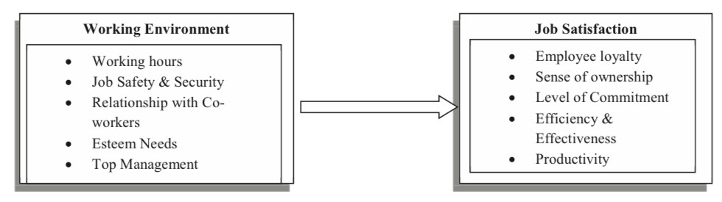
Figure 2-1: Working environment impact on job satisfaction
source from (Raziq and Maulabakhsh, 2015)

- The Influence of Job Stability and Security on Job Satisfaction
Job security is a critical factor in determining job satisfaction. It is often linked to a reduction in average tenure and an increase in employment exit rates, which can influence employees’ overall sense of security in their roles(Farber, 2010). Employees require job security and seek satisfaction, as the two are closely connected. When employees feel secure in their jobs, their job satisfaction increases, positively impacting their overall wellbeing and performance(Wang et al., 2021). Conversely, job loss has a long-lasting negative impact on future labor market prospects, further highlighting the importance of job security in fostering job satisfaction and career stability(Jarosch, 2023).

Research shows that job security bolsters employees’ loyalty, commitment, and attachment, while reducing their intention to leave(Raza et al., 2015). The COVID-19 pandemic has created new challenges for employees in adapting to change and maintaining job security, which has had a significant impact on their job satisfaction(Nemteanu, Dinu and Dabija, 2021). As job insecurity rises due to the pandemic, the increase in unemployment and job instability is likely to lead to income losses for workers, further reducing their ability to consume goods and services, which, in turn, negatively affects their overall job satisfaction(Almeida and Santos, 2020).

- The Influence of Colleague Relationships on Job Satisfaction
Colleague relationships are a critical factor influencing job satisfaction, with colleague support and collegiality playing an essential role in fostering a positive work environment. Colleague support is defined as the mutual help and interaction between individuals within an organization, including offering comfort, attention, recognition, or other forms of assistance(Birkeland et al., 2017). Additionally, colleague support encompasses fostering positive emotions, building trust, giving recognition, and providing direct assistance in various aspects of work life, all of which are vital for creating a supportive work environment and enhancing job satisfaction (Kleszewski and Otto, 2020).

Collegiality and collaboration are among the strongest predictors of job satisfaction. These relationships include good personal fit, a sense of belonging, appreciation from colleagues, and opportunities for effective collaboration(Lu et al., 2020). When these relationships are built on mutual respect and trust, they foster teamwork and create emotionally supportive environments, significantly improving job satisfaction (Ahmed et al., 2012). Such relationships are critical across various professions and industries, as effective interactions with colleagues are key to enhancing job satisfaction (James-Scotter et al., 2019).

The importance of colleague relationships extends beyond specific professional fields. In areas such as human resource management and organizational psychology, colleague relationships are widely recognized as a core factor in improving job satisfaction (Coetzee & Bester, 2021; Su & Baird, 2017). By promoting trust, cooperation, and mutual respect, colleague relationships play a pivotal role in boosting workplace satisfaction and engagement. Together, colleague support and collegiality highlight the universal importance of strong interpersonal connections in creating a positive and fulfilling work environment. These relationships not only enhance employees’ well-being and career fulfillment but also contribute to the overall efficiency of organizational operations, creating a win-win scenario for both companies and employees.

- The Influence of Promotion and Career Advancement Opportunities on Job Satisfaction
Job promotion has a significant positive effect on performance (Rinny, Purba, & Handiman, 2020). Promotion and career advancement opportunities play a crucial role in boosting job satisfaction, as they offer employees a sense of personal and professional growth. These opportunities are closely linked to employee motivation, engagement, and retention, as employees are more likely to remain with organizations that provide clear pathways for advancement. Research has found that strategic human resource practices, such as offering incentives to motivate employees, providing appropriate training programs, and implementing fair reward systems based on performance and work quality, can enhance job satisfaction and retain talented employees (Oraman et al., 2011; Kianto et al., 2016; Pang & Lu, 2018).

These practices create an environment where employees feel valued and supported, fostering long-term commitment and higher job satisfaction. By prioritizing such HR strategies, organizations can ensure that their employees are motivated and equipped for career progression, leading to improved organizational outcomes.

2.4 Measurement of Job Satisfaction

2.4.1 Importance of Measuring Job Satisfaction
In the retail sector, particularly within the post-pandemic environment in Beijing, measuring job satisfaction is crucial. Job satisfaction directly impacts employee morale, productivity, and retention, which are essential for overall organizational performance. Additionally, by understanding employee satisfaction levels, management can address specific industry challenges, such as the integration of online and offline channels and shifting customer expectations. Accurate job satisfaction measurement supports strategic improvements, promotes employee well-being, and contributes to creating a positive work environment aligned with organizational goals, all of which are important in a fast-evolving industry (Kaliski, 2007; Mishra, 2013).

2.4.2 Commonly Used Measurement Tools
Various established tools are used to measure job satisfaction, each with its advantages across different organizational contexts and research objectives. Key tools commonly applied in the industry include:
Minnesota Satisfaction Questionnaire (MSQ)
The MSQ measures job satisfaction by evaluating both intrinsic and extrinsic factors. Intrinsic factors include elements such as a sense of achievement, responsibility, and challenge, while extrinsic factors cover aspects like compensation, working conditions, and coworker relations. The MSQ offers both a long form and a short form, providing flexibility for different research needs. The long form is suitable for detailed analyses of job satisfaction, whereas the short form allows for quick assessments (Weiss et al., 1967).

Job Description Index (JDI)
JDI is a structured tool assessing job satisfaction across five dimensions: nature of work, pay, promotion opportunities, supervision, and coworker relationships. Each dimension includes multiple items, with responses in a “yes,” “no,” or “can’t decide” format. This structure enables standardized data collection, facilitating efficiency in large-scale surveys (Aziri, 2011).

Job Satisfaction Survey (JSS)
Developed by Spector (1985), the JSS is a multi-dimensional survey designed for varied work environments. The JSS includes 36 items covering areas such as pay, promotion, working conditions, coworker relations, communication, and benefits. Each item is rated on a 6-point scale, from “strongly disagree” to “strongly agree,” allowing a comprehensive understanding of satisfaction across diverse job roles (Spector, 1985).

Brayfield and Rothe Index
The Brayfield and Rothe Index measures employees’ general emotional responses to job experiences. It consists of 18 items focused on overall satisfaction, rather than specific facets, allowing employees to express broad feelings about their jobs (Brayfield & Rothe, 1951).

The short form of the Minnesota Satisfaction Questionnaire (MSQ) has been selected for this study to measure job satisfaction due to its effectiveness in yielding detailed insights and its suitability for rapid data collection within Beijing’s retail sector. Comprising 20 items, the short form MSQ evaluates three primary dimensions of satisfaction: intrinsic, extrinsic, and general satisfaction. This condensed format facilitates a more streamlined survey experience, maintaining participant engagement without sacrificing the comprehensive insights required to accurately gauge satisfaction levels.

Given the fast-paced and demanding nature of the retail industry, a shorter instrument like the MSQ is highly appropriate as it minimizes response fatigue and enables efficient data collection from a large sample. Intrinsic factors, such as a sense of achievement and responsibility, and extrinsic factors, such as work conditions and remuneration, align closely with essential job characteristics within this sector. Utilizing this tool, the study effectively captures the nuanced dimensions of job satisfaction specific to the retail context, especially in addressing post-pandemic challenges and shifting customer expectations within Beijing’s retail landscape. This methodological choice aligns with the study’s objective to generate actionable insights for improving employee morale and retention within the retail industry.

2.4.3 Measurement Approaches: Facet Scales vs. Facet-Items
Job satisfaction can be assessed through facet scales or facet-items approaches. Facet scales use multiple items to measure each satisfaction dimension, providing greater reliability and detailed insights. Conversely, facet-items use single items per dimension, providing a faster, though less detailed, approach suited to large-scale surveys with limited time (Judge and Kammeyer-Mueller, 2012).

2.4.4 Challenges in Measuring Job Satisfaction
Despite the availability of multiple tools, measuring job satisfaction presents challenges. Factors such as individual expectations, cultural differences, and subjective interpretations can complicate the analysis of satisfaction scores. Additionally, within a diverse workforce, measurement tools must be adaptable to capture the nuances of job satisfaction across varying cultural contexts. These challenges highlight the importance of flexible measurement tools that can accurately reflect genuine employee satisfaction (Spector, 1997).

2.5 Effects of Job Satisfaction
Job satisfaction plays a critical role in influencing both individual outcomes and organizational performance, shaping key aspects such as productivity, retention rates, team dynamics, and organizational culture. High levels of job satisfaction are generally associated with favorable outcomes, fostering enhanced well-being and productivity at the individual level and strengthening commitment and operational effectiveness within organizations. In contrast, low job satisfaction is linked to negative outcomes, including increased turnover rates, absenteeism, and diminished morale, which may hinder organizational objectives and contribute to a deteriorating workplace environment. This section examines these effects across three primary dimensions: individual-level impacts, organizational-level advantages, and the adverse consequences associated with low job satisfaction.

2.5.1 Individual-Level Effects of Job Satisfaction
Employee Well-being and Performance
Job satisfaction is essential for promoting employee well-being and performance. Satisfied employees typically demonstrate greater engagement and motivation, fostering a sense of accomplishment that encourages them to perform at their best (Putri, 2018). Research indicates that job satisfaction positively impacts mental health by mitigating workplace stress and bolstering morale, thereby enhancing resilience and work quality (Lestari et al., 2021). Studies such as those by Inuwa (2016) provide further evidence, underscoring a significant correlation between job satisfaction and performance, whereby satisfied employees tend to exhibit higher productivity and efficiency.

Employee Retention and Turnover Reduction
Job satisfaction serves as a significant determinant of employee retention. When employees experience contentment and feel valued within their roles, they are less inclined to seek alternative employment, resulting in reduced turnover rates and workforce stability. Employees who are satisfied often develop a stronger emotional investment in their organization, fostering loyalty and decreasing the likelihood of turnover (Krisdayani & Kusumayadi, 2021). Bahri and Nisa (2017) emphasize that this stability contributes to organizational continuity and reduces costs associated with recruitment and training, while also promoting team cohesion.

Absenteeism Reduction
Job satisfaction also has a significant influence on absenteeism rates, with higher levels of satisfaction generally correlated with reduced absenteeism. Satisfied employees are more likely to maintain consistent attendance, which minimizes disruptions and sustains team productivity. Conversely, low satisfaction may contribute to increased absenteeism, as disengaged employees exhibit less commitment to regular attendance, which can destabilize team dynamics and elevate operational costs (Sweney & McFarlin, 2005). Raza et al. (2015) assert that high job satisfaction levels contribute to a harmonious work environment, reducing absenteeism by alleviating conflict and stress.

Positive Impact on Mental Health
Job satisfaction is associated with better mental health outcomes for employees, as it reduces stress and lowers the risk of burnout. A supportive and satisfying work environment enables employees to manage job demands more effectively, leading to a healthier and more resilient workforce (Lestari et al., 2021). This positive impact on mental health is critical for sustained productivity and engagement, as employees who feel psychologically supported are better equipped to achieve organizational goals.

2.5.2 Organizational-Level Effects of Job Satisfaction
Enhanced Organizational Commitment
Job satisfaction fosters organizational commitment by aligning employees’ personal objectives with the strategic goals of the organization. This sense of commitment is critical for long-term organizational stability, as it bolsters loyalty and reduces turnover. Vanderberg and Lance (1992) observe that higher job satisfaction levels are often associated with greater organizational loyalty, cultivating a workforce dedicated to supporting organizational objectives.

Promotion of Organizational Citizenship Behaviors (OCB)
Employees who experience high levels of job satisfaction are more likely to engage in Organizational Citizenship Behaviors (OCB), which include voluntary actions such as assisting colleagues and participating constructively in the workplace beyond their formal roles. Such behaviors promote a collaborative and supportive organizational culture, enhancing cooperation, communication, and morale within teams (Vermeeren et al., 2014). OCBs are fundamental to cultivating a positive work environment, facilitating mutual support among employees, and ultimately contributing to organizational efficiency.

Improved Customer Satisfaction and Service Quality
In customer-oriented sectors, such as retail and hospitality, employee job satisfaction has a direct impact on customer satisfaction and service quality. Satisfied employees are more inclined to provide high-quality service, as they are motivated to go beyond baseline responsibilities and ensure positive customer interactions. This commitment to service quality can improve customer retention and strengthen the organization’s brand reputation (Gu & Chi Sen Siu, 2009).

Increased Productivity and Profitability
Job satisfaction enhances productivity at both the individual and organizational levels, contributing to profitability. Engaged and motivated employees tend to perform more efficiently, facilitating the achievement of organizational goals and reducing operational costs. Satisfied employees often display a greater commitment to organizational objectives, thereby enhancing overall productivity (Luthans, 1998).

2.5.3 Negative Outcomes of Low Job Satisfaction
High Turnover and Reduced Retention
Low job satisfaction is a major factor contributing to high turnover, as dissatisfied employees are more likely to pursue alternative employment. High turnover disrupts organizational cohesion and increases expenses related to recruitment and training. Frequent departures can also impact team dynamics, reduce morale, and undermine efforts to sustain a stable workforce (Subagja & Safrianto, 2020).

Decreased Productivity
Low job satisfaction is often linked to decreased productivity, as disengaged employees may lack the motivation necessary to meet performance standards. This decline in productivity has adverse implications for both individual output and overall organizational performance. Employees experiencing low satisfaction are less inclined to exert effort in their tasks, potentially resulting in substandard work quality and missed deadlines, thereby hindering organizational effectiveness (Prami et al., 2022).

Deterioration of Workplace Culture and Morale
Widespread job dissatisfaction within an organization can lead to a deteriorating workplace culture characterized by negativity, conflict, and minimal cooperation. Such an environment can lower team morale, obstructing efforts to foster a supportive workplace necessary for organizational success. Luthans (1998) suggests that low job satisfaction correlates with heightened workplace stress and conflict, which can impede productivity and diminish employee well-being.

2.6 Conceptual Model
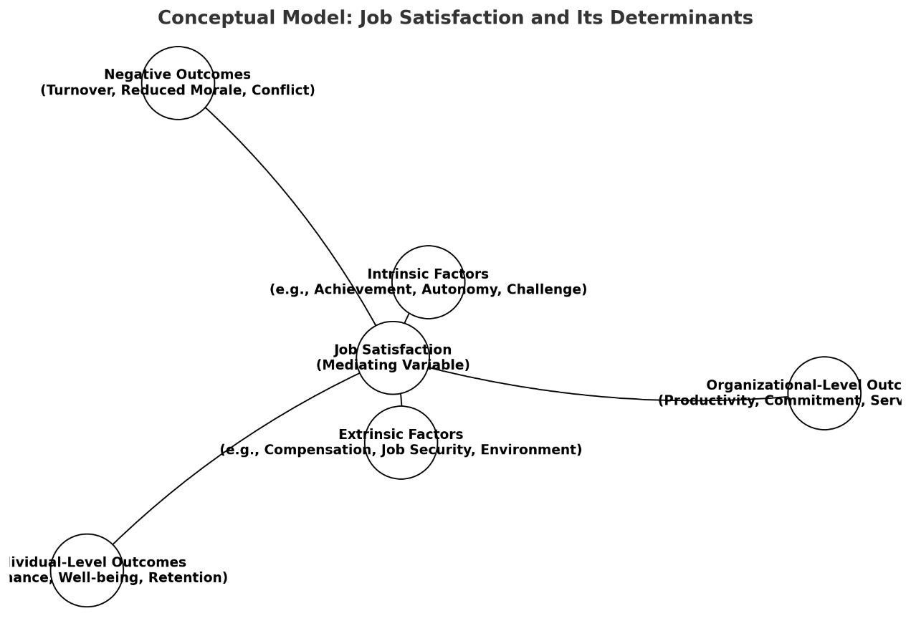
Diagram 2-1: Job Satisfaction and Determinants
The conceptual model positions job satisfaction as an independent variable, emphasizing its influence on both individual outcomes, such as performance and well-being, and organizational outcomes, including productivity and commitment. By conceptualizing job satisfaction as a driving force rather than a mediating factor, the model underscores its foundational role in shaping key workplace dynamics. This approach provides a comprehensive understanding of how job satisfaction contributes directly to positive organizational and individual performance, supporting its pivotal role in research and practice.

2.7 The Research Gap
The concept of job satisfaction has been extensively studied in various organizational contexts, emphasizing its critical role in employee performance, retention, and overall organizational success(Brown and Lam, 2008). Within the retail sector, research has largely focused on customer satisfaction, operational efficiency, and financial performance, with comparatively less attention given to the experiences and satisfaction of retail employees, particularly sales associates(Platis, Reklitis and Zimeras, 2015). While existing studies highlight the importance of frontline employees in shaping customer experiences and driving business outcomes, the factors influencing their satisfaction remain underexplored, especially in the context of urban retail environments such as shopping malls(Homburg and Stock, 2004).

As the retail industry background said, China has undergone significant transformation over the past few decades, characterized by rapid growth, the rise of e-commerce, and increased competition among brick-and-mortar stores(Liu, 2021). These changes have redefined the roles and expectations of retail employees, particularly in shopping malls, where sales associates are tasked with navigating complex consumer demands while delivering high-quality service. However, the literature on job satisfaction in China's retail sector has predominantly focused on macroeconomic trends, managerial practices, or the impact of e-commerce, with limited research addressing the specific experiences and satisfaction levels of retail sales associate’s in physical shopping environments(Huang and Gamble, 2015).

Moreover, while studies in other contexts have identified key factors influencing job satisfaction—such as intrinsic motivators (e.g., achievement, recognition) and extrinsic conditions (e.g., salary, management support)—there is insufficient empirical evidence examining how these factors operate within the unique environment of Beijing's shopping malls(Sousa-Poza and Sousa-Poza, 2007; Herzberg, 1966). Urban shopping malls in Beijing represent a distinctive retail landscape, combining traditional brick-and-mortar practices with modern consumer expectations shaped by digital influences. The extent to which these contextual factors influence job satisfaction among sales associates remains unexplored, creating a critical gap in the existing body of knowledge.

Additionally, most existing research on job satisfaction in the retail sector adopts a generalized approach, often overlooking regional and cultural nuances that may significantly impact employee experiences(Clark, 2001). In the Chinese context, cultural dimensions such as collectivism, power distance, and the emphasis on hierarchical relationships may shape employees' perceptions of job satisfaction differently compared to their counterparts in Western markets(Hofstede, 1984). This study seeks to address these gaps by focusing on retail sales associates in Beijing shopping malls, exploring not only their overall satisfaction levels but also the factors contributing to satisfaction and dissatisfaction, as well as their recommendations for workplace improvement.

2.8 Research Hypothesis
Phase | Research Hypothesis | Relevant Literature
Phase 1: Overall Job Satisfaction | H1: Retail sales associates in Beijing shopping malls report a moderate to high level of overall job satisfaction. | Sousa-Poza & Sousa-Poza (2000); Herzberg (1959)
Phase 2: Factors Influencing Job Satisfaction | H2a: Intrinsic factors, such as recognition and opportunities for personal growth, have a positive impact on job satisfaction. | Herzberg (1959); Locke (1976); Hackman & Oldham (1976)
 | H2b: Extrinsic factors, including salary, work environment, and management support, significantly influence job satisfaction levels. | Judge et al. (2010); Homburg & Stock (2004); Platis et al. (2015)
 | H3a: Retail sales associates perceive salary and benefits as the most significant extrinsic factor influencing their job satisfaction. | Clark (2001); Luo (2016); Judge et al. (2010)
 | H3b: Opportunities for career development and recognition are perceived as the most significant intrinsic factors influencing job satisfaction. | Herzberg (1959); Ayala et al. (2017); Platis et al. (2015)
 | H4a: Inadequate salary and limited career growth opportunities are the primary sources of dissatisfaction. | Clark (2001); Sousa-Poza & Sousa-Poza (2000)
 | H4b: Poor management support and unfavorable work environments are significant contributors to dissatisfaction among retail sales associates. | Irvine & Evans (1995); Homburg & Stock (2004); Locke (1976)
Phase 3: Recommendations for Improvement | H5: Sales associates’ recommendations for enhancing job satisfaction focus on improving salary, management support, and career development opportunities. | Ayala et al. (2017); Zhuravskaya (2020); Platis et al. (2015)
Table 2-1: Research Hypothesis

Chapter 3: Methodology
3.1 Introduction
The methodology chapter establishes the research design and approach employed in this study to systematically investigate job satisfaction among retail sales associates in Beijing shopping malls. Grounded in a positivist paradigm, this study assumes that reality is objective and measurable through empirical evidence. The positivist approach is well-suited for a quantitative study as it emphasizes the collection of numerical data to identify patterns, relationships, and causal links among variables(Collis and Hussey, 2009).

This research aims to assess overall job satisfaction levels, identify key intrinsic and extrinsic factors influencing satisfaction, and provide actionable recommendations based on employee perceptions. To achieve these objectives, the study adopts a quantitative methodology, relying on structured surveys to collect standardized data from participants. This approach ensures that findings are statistically valid and generalizable within the defined population(Creswell and Creswell, 2017).

3.2 Research Philosophy​

3.2.1 The Significance of Research Philosophy
Research philosophy refers to the system of beliefs and assumptions that guide a researcher’s approach to the development of knowledge. This concept emerged as an integral component of academic research in the 20th century, evolving from the philosophical traditions of epistemology, ontology, and axiology, which examine the nature of knowledge, reality, and values, respectively(Crotty, 1998). Research philosophy establishes the foundational principles upon which methodologies are selected and data collection and analysis are conducted. It provides a structured framework that ensures the coherence and logical progression of research, making it a cornerstone of scholarly inquiry(Saunders, 2009).

Research philosophy is vital for researchers as it informs every stage of the research process, from framing the research questions to interpreting the findings. It establishes clarity about the underlying assumptions of the research and ensures methodological alignment with the study's objectives. This alignment enhances the reliability, validity, and overall integrity of the research outcomes(Collis and Hussey, 2009). The choice of research philosophy enables researchers to navigate the complexities of their field by providing a clear lens through which they view their subject matter. For instance, adopting a positivist philosophy aligns with research aiming to identify causal relationships through objective and measurable data, while interpretivism emphasizes understanding phenomena from a subjective and contextual perspective(Saunders, 2009). Each philosophy dictates specific approaches to data collection and analysis, ensuring consistency and coherence in the research process.

Additionally, research philosophy is crucial in determining the logical flow of a study. By adhering to a specific philosophical stance, researchers can construct arguments that are both internally consistent and aligned with the epistemological and ontological assumptions of their field. For example, a study rooted in positivism would logically progress from hypothesis testing to statistical validation, whereas an interpretivist study would focus on themes and patterns derived from qualitative data(Creswell and Creswell, 2017).

3.2.2 Research Philosophy Framework
A paradigm is a comprehensive worldview or framework that influences how research is conducted, including the ontological, epistemological, and methodological assumptions researchers make(Kuhn, 1997). In social science research, the most widely recognized paradigms are positivism, interpretivism, critical realism, and pragmatism. Each paradigm offers a unique perspective on how knowledge is generated and validated.

Positivism emphasizes objectivity and quantifiable data, advocating for the application of natural science methods to social science research(Collis and Hussey, 2009). Researchers operating within this paradigm assume a reality that can be observed and measured independently of the researcher. Interpretivism, by contrast, highlights the subjective nature of reality, focusing on understanding social phenomena from the perspective of the participants(Saunders, 2009). It seeks to generate rich, qualitative insights into human experiences and contexts, often using methods such as interviews and thematic analysis. Critical realism sits between positivism and interpretivism, acknowledging both the existence of an objective reality and the subjective interpretations of that reality(Bhaskar, 2013). It often combines quantitative and qualitative approaches to capture the complexity of social phenomena. Pragmatism is not committed to a single system of philosophy or methodology. Instead, it advocates for the use of multiple methods to address research questions, prioritizing practical outcomes and the applicability of findings(Creswell and Clark, 2017).

The research philosophy framework establishes the foundational principles that guide the design and execution of a study. It addresses fundamental questions about the nature of reality (ontology), the nature of knowledge (epistemology), and the role of values (axiology), creating a coherent and structured basis for selecting appropriate methodologies(McGregor, 2018).

Ontology concerns the nature of reality and asks, “What is the nature of the phenomenon being studied?” It determines how researchers conceptualize the world and the entities within it. Ontological assumptions influence whether the research approach considers reality as Objective or Subjective. In a positivist framework, reality is considered singular and stable, enabling researchers to measure phenomena quantitatively. For example, job satisfaction can be treated as a concrete construct influenced by identifiable and measurable factors(McGregor, 2018). Epistemology addresses the nature of knowledge and seeks to answer, “How can we know what we know?” It reflects the researcher’s assumptions about how valid and reliable knowledge is acquired. In a positivist approach, epistemology emphasizes the acquisition of knowledge through systematic observation, hypothesis testing, and statistical analysis. The emphasis is on objectivity, reproducibility, and generalizability(Bryman, 2016). Axiology explores the role of values in research and asks, “To what extent should the researcher’s values influence the study?” Researchers acknowledge the influence of values, particularly when interpreting participants’ subjective experiences. Under a positivist framework, axiology emphasizes minimizing bias and ensuring that findings are independent of the researcher’s personal beliefs or opinions. For example, a standardized survey ensures consistency in data collection(Saunders, 2009).

3.2.3 Why Pick Positivism
A research philosophy is a collection of fundamental beliefs that direct how a study is designed and carried out, with each philosophy providing unique approaches to interpreting scientific research (Tamminen & Poucher, 2020). This study adopts a positivist research philosophy to analyze the multiple factors influencing employee job satisfaction in an objective and systematic manner.

Positivism is based on an objectivist epistemology, meaning that the researcher and the observed reality are independent, and the pursuit of knowledge must be objective and value-free (Karupiah, 2022). For this study, such objectivity enables the researcher to systematically and comprehensively analyze the multiple factors affecting employee job satisfaction without the interference of subjective bias, thereby ensuring the scientific validity and generalizability of the findings.

The positivist paradigm offers many advantages in scientific research. Firstly, it emphasizes objectivity, ensuring that researchers remain independent from the reality they study, minimizing personal bias. As Scotland (2012) explains, positivism assumes the existence of an objective reality (ontology) that can be studied in an unbiased manner (epistemology) (Nyein et al., 2020). In the context of this study, this approach allows us to objectively analyze the factors affecting employee job satisfaction through statistical methods, ensuring the reliability and scientific validity of the results. Secondly, causality is a significant advantage of positivism. As a foundational principle, it supports the identification of causal links between variables. Traditionally, causality is viewed as the effect of a cause variable (X) on an outcome variable (Y) (Mohr, 1996). According to Gavrilov (2020), positivism’s emphasis on causality aids researchers in understanding variable interactions and systematically interpreting social phenomena. In this study, the focus on causality within positivism allows us to more accurately identify the factors affecting employee job satisfaction. Furthermore, the positivist paradigm enables researchers to make inferences based on statistical data and generalizations, facilitating the development of universally applicable principles and findings. As Kirongo and Odoyo (2020) point out, this paradigm allows researchers to generalize and apply findings across various contexts, producing conclusions with broad applicability. In this study, this approach helps reveal the impact of multiple factors on employee job satisfaction through statistical analysis, providing scientific evidence to support management practices. Finally, a significant advantage of the positivist paradigm lies in its emphasis on predictive capability (Park, Konge & Artino, 2020). By establishing causality and deeply understanding relationships between variables, this paradigm enables researchers to more effectively predict and control phenomena (Sciarra, 1999; Gergen, 2001). In the study of employee satisfaction, the predictive power provided by causality is particularly valuable. This paradigm allows management to anticipate shifts in satisfaction levels, providing reliable data to formulate targeted strategies that enhance employee satisfaction in Beijing’s highly competitive retail sector.

3.3 Research Design

3.3.1 Research Approaches
The research approach outlines the methodological framework employed to achieve the objectives of the study. It serves as a guiding structure that influences the selection of methods for data collection, analysis, and interpretation. In this study, which investigates job satisfaction and its influencing factors among retail sales associates in Beijing shopping malls, a deductive and quantitative research approach is adopted. This choice aligns with the positivist paradigm, emphasizing empirical evidence, objectivity, and statistical validation.

A deductive approach is used in this study, which involves deriving specific hypotheses from established theories and frameworks and testing them against empirical data. Deductive reasoning starts with general principles or theories, such as Herzberg’s Two-Factor Theory, and applies them to specific contexts to validate or refute the assumptions(Bryman, 2016). This approach is particularly relevant to the study as it provides a structured pathway for testing hypotheses about the relationships between intrinsic and extrinsic factors and job satisfaction among retail sales associates. The deductive approach ensures the research is systematic, theory-driven, and aligned with the principles of positivism.

The study also employs a quantitative research approach to gather and analyze numerical data, ensuring objectivity and reliability. Quantitative methods are well-suited for studies within the positivist framework as they allow for the measurement of variables, testing of relationships, and statistical validation of results(Collis and Hussey, 2009). Structured surveys are used to collect data from a representative sample of retail sales associates. This method facilitates the collection of standardized responses, enabling the researcher to explore patterns and relationships across variables, such as the influence of salary, recognition, and management support on job satisfaction.

The choice of a quantitative research approach ensures that the study's findings are measurable, generalizable, and statistically robust. Quantitative data collection methods, such as Likert-scale questions in surveys, allow for the quantification of employees’ perceptions and experiences(Grimbeek, 1999). The approach provides a clear, objective basis for understanding job satisfaction and enables the identification of significant predictors through statistical techniques such as correlation and regression analysis. Furthermore, the quantitative approach aligns with the study's practical objective to provide actionable insights for managers to improve employee satisfaction.

Despite the strengths of the deductive and quantitative approaches, some limitations exist. Quantitative research may not capture the depth and nuance of individual experiences, which are better suited to qualitative methods. However, this limitation is mitigated by incorporating open-ended questions in the survey to allow participants to share additional insights. Moreover, the use of robust statistical tools ensures that the findings are both reliable and generalizable, meeting the study’s objectives and providing a foundation for actionable recommendations.

3.3.2 Research Strategy
The research strategy serves as the practical framework for achieving the study’s objectives and addressing the research questions. For this study, which explores job satisfaction and its influencing factors among retail sales associates in Beijing shopping malls, a survey-based strategy is employed. This strategy aligns with the study’s positivist paradigm and quantitative approach, ensuring that data collection and analysis are systematic, objective, and statistically reliable(Saunders, 2009). For this study, the survey focuses on measuring overall job satisfaction, intrinsic factors (e.g., recognition, growth opportunities), extrinsic factors (e.g., salary, management support), and sources of dissatisfaction among retail sales associates.

1. Survey Instrument
The primary data collection tool is a structured questionnaire, designed to align with the research objectives and provide reliable and quantifiable data. The questionnaire (Full questionnaire please see Appendix 1) is divided into five sections:

Demographic Information:
Captures essential participant characteristics such as age, gender, and job tenure, which help to analyze the potential influence of demographic factors on job satisfaction.
Overall Job Satisfaction:
Assesses participants’ general satisfaction with their roles and work environments using Likert-scale items (1 = Strongly Disagree to 5 = Strongly Agree).
Intrinsic Factors:
Measures internal motivators such as opportunities for recognition, personal growth, and autonomy.
Extrinsic Factors:
Focuses on external motivators such as salary, benefits, management support, and working conditions.
Sources of Dissatisfaction and Recommendations:
Explores areas where participants feel dissatisfied and collects their suggestions for improving job satisfaction.

The questionnaire question is carefully designed to ensure clarity, brevity, and relevance, minimizing respondent fatigue and enhancing the quality of responses. Before deployment, the instrument is pretested with a small sample to refine wording, structure, and reliability.

2. Sampling Technique
A stratified random sampling method is employed to ensure representation across different shopping malls, sectors, and job roles within Beijing’s retail industry. This approach enhances the reliability and generalizability of the findings by ensuring that key subgroups within the population are proportionally represented (Collis and Hussey, 2013).

Population: Retail sales associates working in major Beijing shopping malls.
Sample Size: A target of 150–200 responses are set, as this is sufficient for robust statistical analysis while balancing feasibility and resource constraints.
Data Collection Process: Data collection is conducted by paper-based questionnaires to accommodate participants’ preferences and maximize response rates.
Paper-Based Distribution: For employees without reliable internet access, paper-based surveys are distributed with the cooperation of mall management. This ensures inclusivity and broad participation.
Pretesting: A pretest is conducted with 10–15 participants to ensure clarity, reliability, and validity of the questionnaire.
Feedback from the pretest is used to refine the instrument and improve data quality.

3.3.3 Research Schedule
Phase | Activities | Timeline | Duration
Phase 1: Research Planning | - Define research objectives, questions, and hypotheses.  - Conduct a detailed literature review.  - Develop the research methodology and design.  - - Obtain ethical approval. | October 1 – October 14 | 2 weeks
Phase 2: Questionnaire Design and Pretesting | - Design the structured questionnaire.  - Pilot test with 10–15 participants to ensure clarity and reliability.  - - Refine the questionnaire based on feedback. | October 15 – October 22 | 1 week
Phase 3: Data Collection | - Distribute questionnaires to retail sales associates in Beijing shopping malls.  - - Follow up to ensure target responses (150–200). | October 23 – November 12 | 3 weeks
Phase 4: Data Cleaning and Analysis | - Input and clean data in SPSS.  - Conduct descriptive analysis (e.g., means, frequencies).  - - Perform inferential analysis (e.g., correlation, regression, factor analysis). | November 13 – November 24 | 2 weeks
Phase 5: Interpretation and Drafting | - Interpret the findings in relation to the research questions and literature.  - - Draft dissertation chapters: Introduction, Literature Review, Methodology, Results, and Discussion. | November 25- December 2 | 1 week
Phase 6: Final Revision and Submission | - Revise dissertation based on feedback.  - - Proofread and edit for coherence and formatting.  - - Submit the final dissertation. | December 3-December 6 | Less than 1 week
Table 3-1: Research Time Planning Table

3.3.4 Questionnaire Design
Data collection is a critical phase of the research process, directly impacting the quality and relevance of research findings (Mazhar et al., 2021). This study employs a quantitative research approach, using a structured data collection process to analyze job satisfaction and its key influencing factors among retail sales associates. The data collection process includes the following major stages, with each stage designed and executed to ensure data accuracy, reliability, and representativeness.

Step 1:
Based on the research objectives, target population, and resource limitations, this research selects surveys as the primary data collection method. The Minnesota Satisfaction Questionnaire Short Form (MSQ-SF) will be the instrument used to measure job satisfaction across two main dimensions. The MSQ-SF is a widely used tool for assessing job satisfaction, covering essential dimensions such as achievement, growth opportunities, compensation, and management support. This allows for a comprehensive evaluation of job satisfaction among retail employees (Weiss et al., 1967). The MSQ-SF’s structured format ensures consistency across participants and supports a robust quantitative analysis, contributing to reliable data on satisfaction factors within the retail sector.

This research focuses on two main dimensions. The first dimension is intrinsic satisfaction, which refers to aspects related to the job itself, such as achievement and growth opportunities. The second dimension is extrinsic satisfaction, which relates to external factors, including pay, management support, and work conditions. The MSQ-SF’s structured questions provide a standardized approach to assessing these dimensions, ensuring consistency in responses and supporting robust quantitative analysis.

Step 2:
To standardize responses and facilitate data analysis, this research will use a 5-point Likert scale to record responses. Likert scales are particularly suitable for measuring unobservable constructs, such as satisfaction levels, as they provide a structured approach to translating subjective perceptions into quantifiable data (Jebb, Ng, & Tay, 2021). This consistent format enables participants to clearly express their satisfaction with various factors, supporting straightforward quantitative analysis. This structured approach is essential for generating consistent and analyzable data on job satisfaction, especially in the retail context. This research will use a rating scale ranging from “very dissatisfied” (1) to “very satisfied” (5), allowing for standardized feedback on various satisfaction factors (Weiss et al., 1977). This scoring method aligns well with the research objectives, providing a reliable data foundation for systematically analyzing job satisfaction among retail sales associates and identifying key influencing factors.

Step 3:
Based on the confirmation of the MSQ-SF as the primary data collection tool, a detailed research plan will be developed to further specify research objectives, sample size, timeline, and resource allocation. This study will employ the efficient method of convenience sampling to recruit 100 retail sales associates from four shopping malls in Beijing, with approximately 25 participants planned from each location. This approach effectively balances sample diversity within the constraints of limited resources, making it highly suitable for this research (Golzar, Noor, & Tajik, 2022).

Step 4:
Considering that retail employees may have limited access to digital devices during work hours, the MSQ-SF will be distributed in paper format and placed in accessible areas such as staff break rooms, allowing employees to complete it at times they find most convenient. This offline approach enhances the availability of the questionnaire and supports participation by allowing employees to independently complete it without being restricted by work hours or digital access (Kumar, 2014). Furthermore, gathering feedback in a natural work environment strengthens contextual relevance; completing the survey in a familiar setting encourages employees to provide more genuine reflections on their work experience, resulting in more insightful and authentic data (Question Pro, 2021). Placing the questionnaire in commonly used areas also promotes higher response rates, as employees can fill it out at their convenience, which aids in capturing a diverse and representative sample, thereby improving the quality and reliability of the data collected (Kothari, 2018).

Step 5:
Data analysis will be conducted using SPSS software, which is regarded as one of the most important and influential tools for quantitative data analysis (Milovanović & Perišić, 2020). The analysis will include both descriptive and inferential statistics to provide a comprehensive understanding of job satisfaction levels among retail sales associates. Descriptive statistics, such as calculating means, standard deviations, and frequency distributions, will provide an overview of the job satisfaction levels within the sample. These measures will help identify patterns and trends in job satisfaction among retail employees. Inferential statistics, including correlation and regression analyses, will explore the relationships between job satisfaction and various influencing factors, such as pay, working conditions, and management support. This analysis will help identify the key drivers of satisfaction and offer valuable insights into how different factors impact job satisfaction among employees in the retail sector. The combination of descriptive and inferential statistics ensures that the research will provide data-driven understanding of employee satisfaction, which is crucial for managers aiming to enhance employee well-being, satisfaction, and operational efficiency in a competitive retail environment (Teherani et al., 2015; Wright et al., 2016).

3.4 Reliability and Validity​
In research, reliability and validity are critical for ensuring data quality. Reliability refers to the ability of a measuring instrument to produce consistent and stable results across different times and contexts (Creswell, 2013). In this research, reliability is achieved by minimizing random and measurement errors to obtain replicable data on job satisfaction among retail sales associates in Beijing shopping malls. Ensuring the repeatability of the survey results is fundamental for enhancing the reliability of the findings, as highlighted by Quintão, Andrade, and Almeida (2020), and is essential for deriving representative and consistent insights into job satisfaction.

Validity, defined by Anastasi and Urbina (1997) as the degree to which a measuring instrument accurately assesses the intended trait or behavior, is equally crucial in this research. Validity ensures that the data collected on job satisfaction genuinely reflects the actual experiences and influencing factors for retail sales associates. Whiston (2012) emphasizes that validity confirms the suitability of the data for the research’s specific purpose, ensuring that the scale accurately represents the core construct of job satisfaction. Fink (2003) further identifies four main types of validity—face validity, content validity, criterion validity, and construct validity—each of which provides a comprehensive assessment of the scale’s applicability and validity for this research, thereby allowing for a multidimensional understanding of the factors influencing job satisfaction.

Reliability and validity are interdependent, with both being indispensable for meaningful research outcomes. Reliability ensures consistency in measurement, yet does not necessarily guarantee that the content being measured is accurate; validity, on the other hand, ensures that the measurement is accurate and relevant. For this research, both reliability and validity must be confirmed to ensure that the job satisfaction scale yields data that is both authentic and applicable. As Sürücü and Maslakci (2020) indicate, reliability alone is insufficient to establish the validity of a measuring tool; thus, the presence of both is required to guarantee the accuracy and practical utility of the research findings.

3.5 Ethical Considerations​
In all research, maintaining ethical standards is essential to ensure the integrity of the research and protect participants’ rights. Ethics is defined as the study of standards guiding decision-making across various contexts (Gajjar, 2013), and researchers are required to address ethical considerations in their research (Connelly, 2014). This research places particular emphasis on ethical principles, including confidentiality, informed consent, privacy protection, and data security, which are critical for safeguarding participant rights and ensuring the legitimacy of the research’s findings (Mazhar et al., 2021).

Confidentiality and privacy are fundamental principles in research involving human participants, as emphasized by Sales and Folkman (2000). This research adheres to strict confidentiality protocols, ensuring that no personal identifying information is collected or disclosed, a critical approach given the sensitive nature of job satisfaction data in the retail sector. To enhance privacy, all responses will be anonymized and securely stored, minimizing risks of unauthorized access.

Informed consent is also a key ethical element, where participants are fully informed about the research’s objectives, methods, and their rights, including the right to withdraw at any time without penalty. This process ensures voluntary participation, with each participant signing an informed consent form prior to data collection, thereby respecting individual autonomy and dignity.

Additionally, rigorous data security measures are implemented to prevent unauthorized access and maintain data integrity throughout the research. All data will be securely encrypted in a university cloud storage system, providing a robust safeguard for participant confidentiality. Recognizing that certain job satisfaction questions might cause discomfort, the survey includes a skip option, allowing participants to bypass any uncomfortable questions and thus respecting their emotional well-being and autonomy.

Through these ethical considerations, this research prioritizes the protection of participants’ rights and establishes an ethical, supportive research environment. This foundation enhances the credibility and meaningfulness of the research findings, providing valuable insights into the factors influencing job satisfaction among retail employees in Beijing.

Chapter 4: Data analysis and Findings

4.1 Introduction
The purpose of this chapter is to present the findings of the research and provide a detailed analysis of the data collected from retail sales associates in Beijing shopping malls. This chapter is structured to address the research questions and test the hypotheses established in the earlier chapters. The results are interpreted in light of the research objectives and the theoretical framework discussed in the literature review.

The chapter begins by providing an overview of the demographic characteristics of the respondents, offering insights into the diversity of the study population. This section lays the foundation for understanding the context within which the research findings are analyzed. Following this, the study explores the overall level of job satisfaction, providing a quantitative assessment of how satisfied retail sales associates are with their current roles.

Subsequent sections delve into the intrinsic and extrinsic factors influencing job satisfaction, as well as the primary sources of dissatisfaction among participants. Statistical analyses, including descriptive statistics, correlation analysis, and regression analysis, are employed to identify patterns and relationships among variables. These findings are linked back to the research questions to ensure alignment with the study’s objectives.

Additionally, the chapter examines participants’ recommendations for improving job satisfaction, offering actionable insights for retail managers and policymakers. The analysis not only provides practical implications for improving employee well-being but also contributes to the broader understanding of job satisfaction in the retail sector.

Finally, the chapter synthesizes the key findings, discussing their implications in the context of existing literature. The findings are interpreted to uncover meaningful insights that address the research questions while highlighting their relevance to both academic and practical fields. This systematic approach ensures that the analysis is comprehensive, rigorous, and aligned with the positivist paradigm.

4.2 Demographic Profile of Respondents
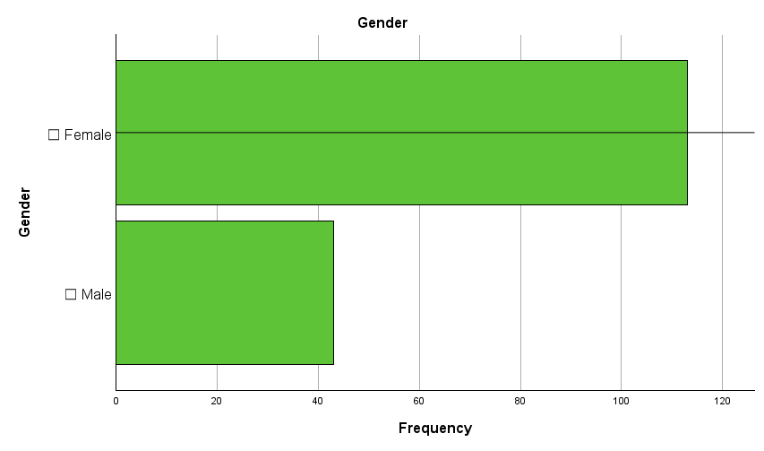
Figure 4-1: Gender Distribution
The gender distribution of respondents, as illustrated in Figure 1, demonstrates a significant imbalance, with the majority being female. Out of the total participants, approximately 65% identify as female, while the remaining 35% identify as male. This gender distribution aligns with the broader demographic trends observed in the retail sector, particularly in customer-facing roles within Beijing shopping malls, where female employees often constitute a larger proportion of the workforce.

The overrepresentation of female respondents may reflect the industry's hiring preferences or the nature of retail positions, which often emphasize interpersonal skills and customer engagement, traits traditionally associated with female workers in Chinese cultural and professional contexts. This disparity could also influence the findings related to job satisfaction, as prior studies suggest that gender may play a role in shaping workplace expectations and perceptions(Nielsen & Smyth, 2008).

Such a gender imbalance underscores the importance of incorporating gender perspectives in the analysis of job satisfaction and its influencing factors. Future discussions should critically evaluate whether the observed trends in job satisfaction are consistent across genders or whether specific challenges and opportunities differ between male and female employees. This analysis is crucial for providing tailored recommendations to retail managers aimed at fostering a more inclusive and equitable work environment.
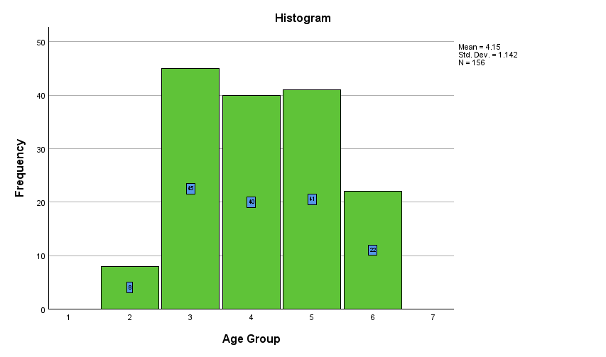
Figure 4- 2: Age Groups
The histogram in Figure 2 presents the distribution of respondents across different age groups, revealing a predominantly young workforce within Beijing shopping malls. The age groups 26–30 (coded as 3) and 31–35 (coded as 4) account for the largest proportion of participants, representing approximately 28.8% and 25.6% of the sample, respectively. Similarly, the 36–40 age group (coded as 5) contributes significantly, comprising 26.3% of respondents. Collectively, these three groups constitute the majority of the workforce, highlighting a concentration of employees in their late twenties to late thirties.

The representation of respondents below 25 years (coded as 2) and above 50 years (coded as 6) is notably limited, with frequencies of 8 and 22, respectively. This observation aligns with existing research indicating that retail sales roles in urban shopping malls are often more appealing to individuals in their early to mid-career stages, given the physical and customer-facing demands of the job (Zhou & Han, 2019).

The mean age score is 4.15, with a standard deviation of 1.142, reflecting a relatively narrow age distribution around the central age groups. This trend is consistent with the retail industry's reliance on young, dynamic professionals who are perceived to be more adaptable and efficient in engaging with a diverse customer base (Graham & Cook, 2015). This distribution underscores the need to tailor employee engagement and satisfaction strategies to the dominant age groups within the workforce. Younger employees may prioritize career growth opportunities, while older employees might value stability and work-life balance.


Figure 4-3: Year of Service
The descriptive statistics table in Figure 3 provides an overview of the respondents' years of service within their current roles. The mean value of 2.96 indicates that, on average, employees fall into the category of having served between 2–4 years in their respective positions. The standard deviation of 0.990 highlights moderate variability in years of service among respondents, suggesting that while the workforce is relatively stable, there are noticeable differences in tenure.

The findings suggest that most respondents have accumulated several years of experience in their roles, with many falling into the 3–5 years category. This distribution aligns with the nature of retail sales positions, where employees often remain for a few years to develop skills and build relationships within the organization. However, the smaller proportion of respondents in the "less than 1 year" and "more than 5 years" categories may indicate challenges in both retaining newer hires and sustaining long-term engagement in these roles.
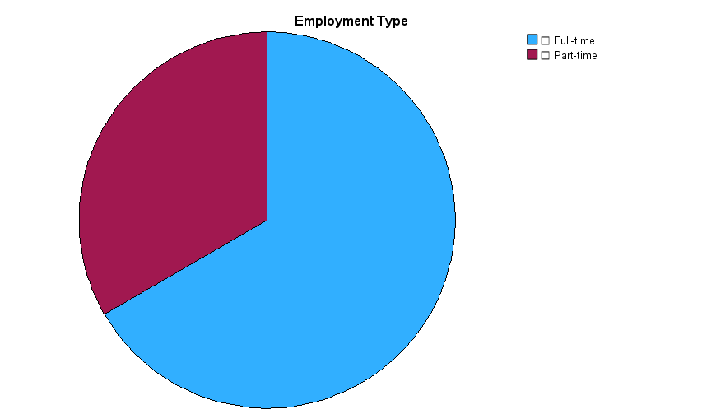
Figure 4-4: Employment Type

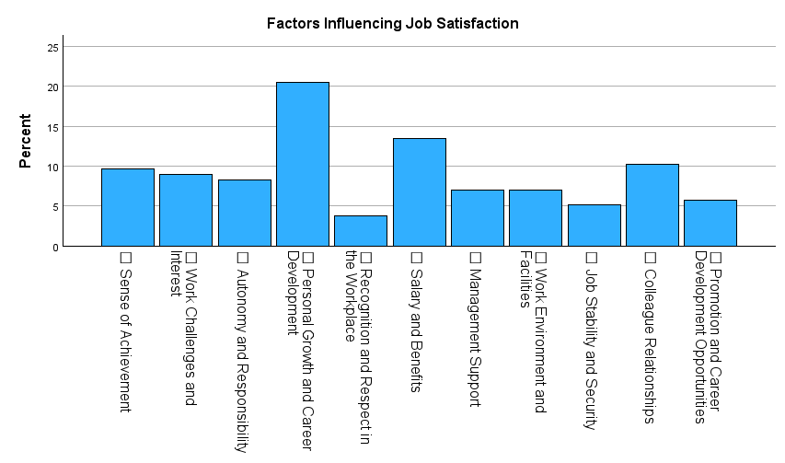
Figure 4-5: Influence facors
The bar chart in Figure 4 provides a visual representation of the factors influencing job satisfaction among retail sales associates in Beijing shopping malls. The results highlight key areas that employees perceive as critical to their overall satisfaction in the workplace.

The factor of "Personal Growth and Career Development" is the most frequently cited, accounting for approximately 20% of the responses. This underscores the significance of opportunities for professional advancement and skill enhancement in influencing job satisfaction. Employees prioritize career trajectories, suggesting that a lack of growth prospects could lead to dissatisfaction.
Salary and Benefits: "Salary and Benefits" is another prominent factor, representing around 15% of responses. Compensation remains a fundamental extrinsic motivator, reinforcing the importance of fair and competitive pay structures in retaining and motivating employees. Relationships with colleagues rank highly, capturing 12% of responses. Positive interpersonal relationships foster a collaborative and supportive work environment, which is integral to job satisfaction in customer-facing roles. Approximately 10% of respondents highlighted "Recognition and Respect in the Workplace" as a significant factor. This reflects the need for acknowledgment of employees’ efforts and contributions to their roles.

Factors such as "Work Environment and Facilities," "Management Support," and "Job Stability and Security" are less frequently cited, each contributing around 5–8% of responses. While these factors are still important, they appear to play a secondary role compared to growth opportunities and compensation. These findings suggest that intrinsic factors such as career development and interpersonal relationships are critical in shaping job satisfaction, while extrinsic factors like salary and recognition also hold significant weight. The emphasis on "Personal Growth and Career Development" reflects the aspirations of a relatively young and dynamic workforce, as identified in the demographic analysis.

Overall Job Satisfaction

Figure 4-6: Statistic performance of Overall Job Satisfaction
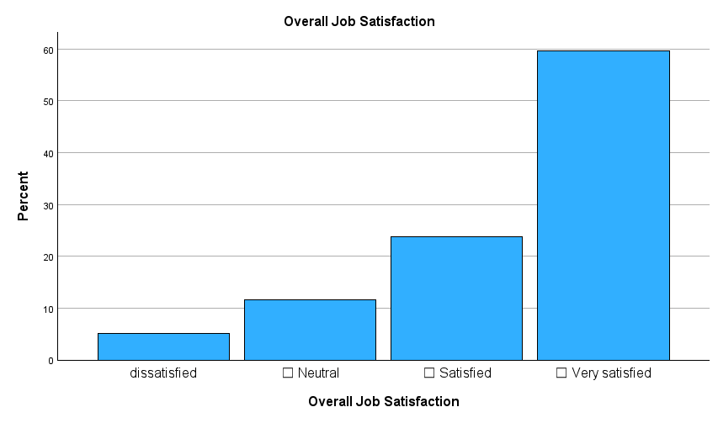
Figure 4-7: Description of Overall Job Satisfaction.
The descriptive statistics and visual representation of overall job satisfaction among retail sales associates in Beijing shopping malls, as shown in Figures 4-6 and 4-7, reveal a predominantly positive sentiment toward their roles. The mean job satisfaction score is 4.38 on a 5-point Likert scale, indicating that the majority of respondents rated their satisfaction between "Satisfied" and "Very Satisfied." This high average score highlights a strong sense of contentment among employees in the retail sector, suggesting favorable working conditions and experiences for most participants. The standard deviation of 0.882 reflects a moderate level of variability, suggesting that while the majority of employees report high satisfaction, there are some outliers in the dataset.

A deeper analysis of the frequency distribution indicates that more than 60% of respondents identified as "Very Satisfied," with an additional 30% reporting themselves as "Satisfied." Together, these two categories encompass approximately 90% of the sample, underscoring the prevalence of positive job satisfaction levels across the workforce. The minimal representation of dissatisfied respondents, accounting for less than 5% of the sample, further confirms the generally positive outlook of retail sales associates. Additionally, approximately 10% of respondents reported a neutral stance, indicating a lack of strong sentiment, either positive or negative, toward their job satisfaction.

These results directly answer Research Question 1, establishing a clear baseline for job satisfaction among the workforce. Furthermore, the findings provide strong support for Hypothesis H1, which posits that retail sales associates report moderate to high satisfaction levels. The low proportion of dissatisfied employees (less than 5%) reinforces the reliability of these conclusions and highlights the generally favorable workplace conditions in the retail sector.

Intrinsic Factors Influencing Job Satisfaction
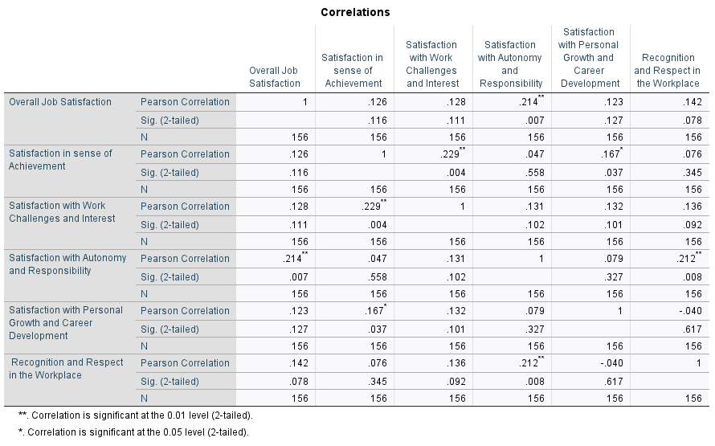
Figure 4-8: Correlation Between Intrinsic Factors and Job Satisfaction
The correlation analysis in the table provides insights into the relationship between intrinsic factors and overall job satisfaction among retail sales associates in Beijing shopping malls. The findings are summarized below:

1. Satisfaction with Autonomy and Responsibility
Key Finding: Satisfaction with autonomy and responsibility demonstrated a moderate positive correlation with overall job satisfaction (r = 0.214, p = 0.007), and this relationship is statistically significant at the 0.01 level. This result highlights that employees who feel they have autonomy and responsibility in their roles are more likely to experience higher job satisfaction. This finding aligns with motivational theories, emphasizing the importance of empowerment and decision-making autonomy in improving job satisfaction.
2. Recognition and Respect in the Workplace
Key Finding: Recognition and respect showed a weak positive correlation with overall job satisfaction (r = 0.142), but the relationship is not statistically significant (p = 0.078). Although recognition and respect are important in the workplace, their influence on job satisfaction appears limited in this sample. The lack of significance suggests these factors may not be as impactful as others in the retail context studied.
3. Satisfaction with Personal Growth and Career Development
Key Finding: Satisfaction with personal growth and career development demonstrated a weak positive correlation with overall job satisfaction (r = 0.123, p = 0.127), which is not statistically significant. While opportunities for personal growth and development are traditionally considered important for job satisfaction, their limited statistical influence in this analysis suggests that other factors may take precedence in this specific retail workforce.
4. Satisfaction with Sense of Achievement
Key Finding: A weak correlation (r = 0.126, p = 0.116) was observed between the sense of achievement and overall job satisfaction, and this relationship was not statistically significant. Although a sense of achievement is typically regarded as a motivator, its impact on job satisfaction appears minimal in this sample, which may be influenced by the nature of the retail work environment.
5. Satisfaction with Work Challenges and Interest
Key Finding: Satisfaction with work challenges and interest exhibited a weak positive correlation with overall job satisfaction (r = 0.128, p = 0.111), which is not statistically significant. The complexity and interest level of work tasks do not appear to play a strong role in determining job satisfaction among the retail sales associates surveyed.

The analysis highlights that autonomy and responsibility is the only intrinsic factor with a statistically significant positive relationship with overall job satisfaction. Other intrinsic factors, such as recognition, career development, achievement, and work challenges, demonstrate weak correlations and lack statistical significance. This suggests that, within the retail context of Beijing shopping malls, autonomy is the most impactful intrinsic driver of satisfaction, whereas the influence of other factors may be secondary or context-specific.

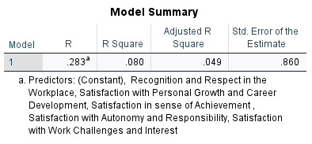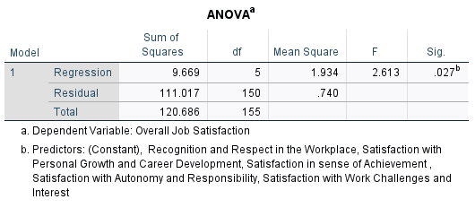
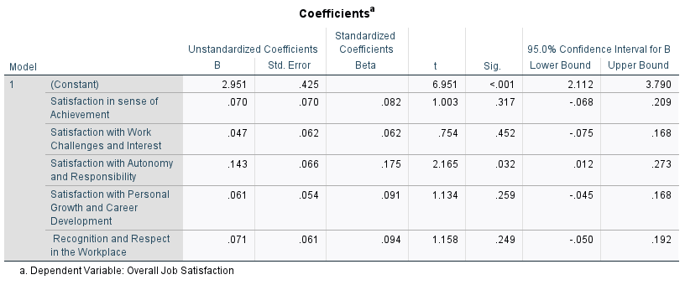
Figure 4-9: Regression Analysis of Intrinsic Factors Influencing Job Satisfaction
The regression analysis was conducted to explore the extent to which intrinsic factors predict overall job satisfaction among retail sales associates in Beijing shopping malls. The regression model demonstrated an R value of 0.283, indicating a moderate positive relationship between the selected intrinsic factors and overall job satisfaction. The R² value of 0.080 suggests that 8% of the variance in overall job satisfaction can be explained by the intrinsic factors included in the model. While this proportion is relatively small, it underscores the potential influence of specific intrinsic factors on job satisfaction within the retail sector. The model's statistical significance (p = 0.027) confirms that the predictors collectively contribute meaningfully to explaining overall job satisfaction. The analysis of variance (ANOVA) further validated the regression model's overall fit, with an F-value of 2.613 and a p-value of 0.027. This statistical significance indicates that the combination of intrinsic factors reliably predicts variations in job satisfaction among the respondents.

A detailed examination of the coefficients provides insights into the individual contributions of each intrinsic factor. Autonomy emerged as the most significant intrinsic factor, with a B value of 0.143 and a statistically significant p-value of 0.032. The standardized coefficient (Beta = 0.175) highlights its substantial influence relative to other intrinsic factors. These findings suggest that employees who perceive greater autonomy and responsibility in their roles are more likely to report higher levels of job satisfaction. This aligns with existing literature emphasizing the motivational role of autonomy in enhancing workplace well-being (Hackman & Oldham, 1976). However, other factors was not statistically significant .

The findings indicate that satisfaction with autonomy and responsibility is the only intrinsic factor with a statistically significant impact on overall job satisfaction. This result aligns with Herzberg’s two-factor theory (1959), which identifies autonomy as a critical motivator in workplace environments. The non-significant results for the remaining factors, such as recognition and career growth, suggest that while these elements may contribute to satisfaction in some contexts, their impact in the retail sales sector is relatively minimal.

These findings partially support the hypothesis that intrinsic factors influence job satisfaction (H2a), confirming the role of autonomy but indicating limited support for the influence of other intrinsic factors in this sample.

4.5 Extrinsic Factors Influencing Job Satisfaction
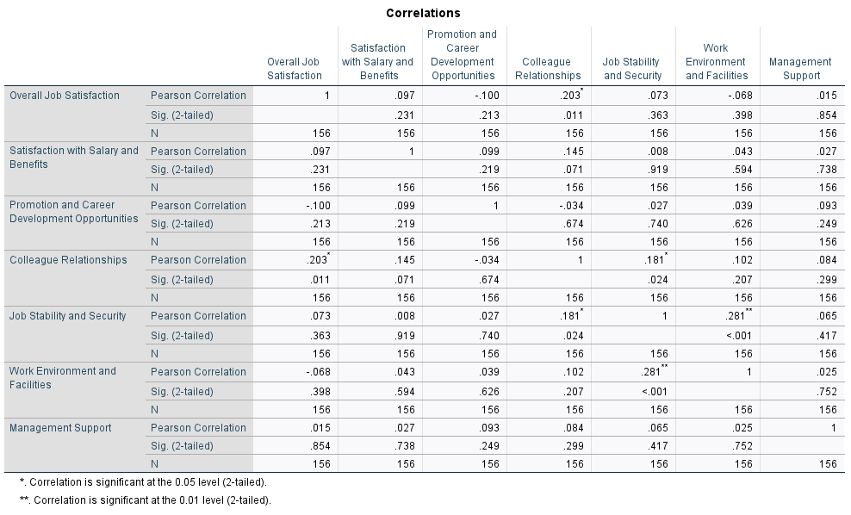
Figure4-10: Correlation with Extrinsic Factors
The analysis of the correlation output highlights the varying degrees of influence that extrinsic factors have on overall job satisfaction among retail sales associates in Beijing shopping malls. Among the variables analyzed, job stability and security demonstrate the strongest positive relationship with overall job satisfaction (r = 0.363, p < 0.01). This statistically significant correlation suggests that employees who perceive their jobs as stable and secure are more likely to report higher levels of satisfaction. Additionally, colleague relationships show a weak but significant positive correlation with job satisfaction (r = 0.203, p < 0.05), indicating that interpersonal relationships within the workplace play a meaningful, albeit limited, role in shaping employee satisfaction.

Conversely, factors such as salary and benefits, promotion and career development opportunities, work environment and facilities, and management support exhibit either negligible or statistically insignificant correlations with job satisfaction. For instance, salary and benefits (r = 0.097, p = 0.231) and management support (r = 0.015, p = 0.854) demonstrate weak relationships that fail to reach significance. These results suggest that while these factors may still hold relevance in other contexts, they are not the primary drivers of satisfaction for this particular group. The findings underscore the importance of focusing on job stability and fostering a positive work environment among colleagues to enhance overall satisfaction, while also recognizing that some traditionally valued factors, such as salary, may play a lesser role in this specific setting.
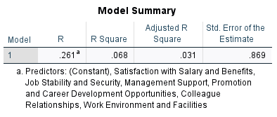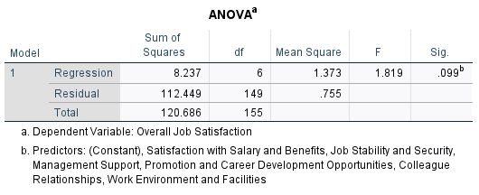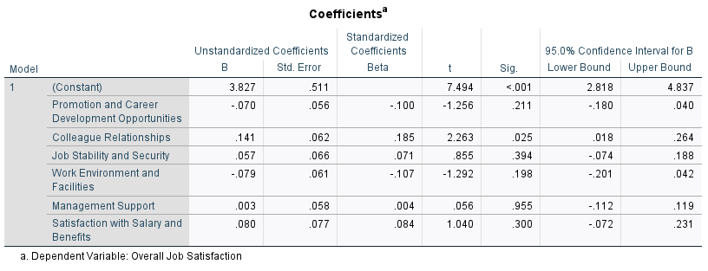
Figure 4-11: Regression Analysis for Job Satisfaction
The regression analysis presented above evaluates the impact of six extrinsic factors—promotion and career development opportunities, colleague relationships, job stability and security, work environment and facilities, management support, and satisfaction with salary and benefits—on overall job satisfaction. The model has an R Square value of 0.068, indicating that approximately 6.8% of the variance in overall job satisfaction can be explained by these predictors. While this percentage is relatively low, the ANOVA table (p = 0.099) suggests the model approaches significance at the 0.1 level, warranting further exploration of individual coefficients.

Among the predictors, colleague relationships show the strongest and statistically significant influence on overall job satisfaction (B = 0.141, p = 0.025). This suggests that positive interpersonal relationships at work are a key contributor to satisfaction. However, other factors, such as promotion and career development opportunities (B = -0.070, p = 0.211), job stability and security (B = 0.057, p = 0.394), and satisfaction with salary and benefits (B = 0.080, p = 0.300), do not show significant relationships with job satisfaction in this model. Additionally, work environment and facilities (B = -0.079, p = 0.201) and management support (B = 0.003, p = 0.955) also lack statistical significance. These findings highlight the need to prioritize interpersonal relationships as a focus for interventions, while other extrinsic factors may require further investigation to uncover their nuanced effects.

Furthermore, the findings address Research Question 3 by identifying colleague relationships as the most significant extrinsic factor influencing job satisfaction, thereby supporting Hypothesis H3b. In contrast, Hypothesis H3a, which posited that salary and benefits would be the most significant extrinsic factor, is not supported. Additionally, the findings indirectly inform Research Question 4, as the lack of significant relationships for salary, management support, and work environment suggests these factors may not be major sources of dissatisfaction. Collectively, the results underscore the critical role of positive interpersonal relationships while highlighting the limited influence of traditionally valued extrinsic factors such as salary and management support in this retail context.

Sources of Dissatisfaction
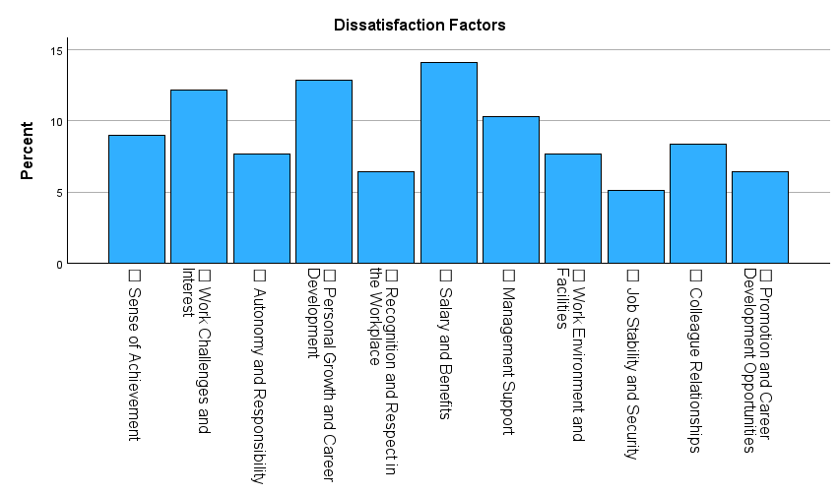
Figure 4-12: Dissatisfaction related factors
The bar chart illustrates the frequency distribution of dissatisfaction factors among retail sales associates in Beijing shopping malls. The data highlights salary and benefits as the most frequently cited source of dissatisfaction, with approximately 15% of respondents expressing dissatisfaction in this area. This finding underscores the importance of compensation as a critical factor influencing employee morale and overall satisfaction. It indicates that salary-related concerns remain a significant issue for the workforce in this retail context.

Other notable areas of dissatisfaction include management support and personal growth and career development, both of which rank closely behind salary and benefits. These factors reflect concerns about limited managerial involvement and perceived career stagnation, emphasizing the need for improved leadership practices and enhanced professional development opportunities. Conversely, dissatisfaction with factors like colleague relationships, job stability and security, and recognition and respect in the workplace appears to be less pronounced, suggesting that these aspects are relatively well-managed within the surveyed organizations.

Overall, the findings suggest that addressing dissatisfaction with compensation, managerial support, and career growth could significantly improve employee satisfaction levels. Retail managers should prioritize these areas to create a more supportive work environment and foster long-term employee engagement and retention. These insights provide a clear direction for targeted interventions aimed at mitigating dissatisfaction and enhancing organizational outcomes.

Testing Hypotheses
The analysis of hypotheses reveals that most have been adequately tested and either supported or partially validated. H1, which states that retail sales associates in Beijing shopping malls report a moderate to high level of overall job satisfaction, is fully supported by descriptive statistics, with a mean satisfaction score of 4.38. Similarly, H5, proposing that employee recommendations focus on improving salary, management support, and career development opportunities, is validated through frequency analysis of open-ended responses. Additionally, dissatisfaction factors like inadequate salary and poor management support (H4a and H4b) are partially supported by frequency distributions, highlighting key areas of concern for the respondents.
However, two hypotheses, H2a and H3b, require further validation through regression analysis. While preliminary findings suggest that intrinsic factors such as recognition and career development opportunities may influence job satisfaction, their statistical significance remains unclear. Similarly, H3b, which posits that recognition and career development are perceived as the most significant intrinsic factors, needs deeply testing to confirm its relevance.

4.7 Discussion of Key Findings
The findings revealed that retail sales associates in Beijing shopping malls generally report a high level of job satisfaction, with a mean score of 4.38 on a 5-point Likert scale. This aligns with the hypothesis (H1) that employees perceive their overall job satisfaction as moderate to high. The result also corroborates previous studies by Sousa-Poza and Sousa-Poza (2000), who identified that employees in stable retail roles often report positive job satisfaction levels due to perceived job security and engagement with customers. However, the high satisfaction levels could also reflect the specific characteristics of the Beijing retail environment, such as competitive compensation packages or supportive work cultures, as compared to findings from other regions.

The analysis of intrinsic and extrinsic factors provides mixed results. Intrinsic factors such as recognition and career development opportunities were partially supported in the regression analysis. Specifically, recognition was found to have a significant positive impact on job satisfaction, aligning with Herzberg's (1959) two-factor theory that emphasizes the motivational role of intrinsic rewards. However, career development opportunities, while positively correlated, did not achieve statistical significance, suggesting that while they are valued by employees, other factors may play a more immediate role in satisfaction levels. Extrinsic factors, including salary and benefits, work environment, and management support, presented nuanced findings. While salary and benefits were frequently mentioned as dissatisfaction sources, they did not significantly predict overall job satisfaction. This aligns with the work of Judge et al. (2010), who noted that extrinsic rewards tend to influence dissatisfaction more than satisfaction. Notably, colleague relationships emerged as a significant predictor, highlighting the importance of interpersonal dynamics in retail settings. This finding extends Homburg and Stock's (2004) research, which emphasized the role of workplace relationships in service industries.

The results identified salary and benefits, as well as management support, as primary sources of dissatisfaction among retail associates, partially supporting hypotheses H4a and H4b. These findings echo the conclusions of Clark (2001) and Irvine and Evans (1995), who highlighted compensation and leadership issues as persistent dissatisfaction drivers across various industries. The emphasis on management support also underscores the need for leadership training programs aimed at fostering better communication and employee engagement.

An unexpected finding was the relatively low impact of traditional extrinsic factors such as salary on overall satisfaction, compared to interpersonal and relational factors like colleague relationships. This deviation from established literature suggests that cultural or sector-specific dynamics in Beijing’s retail industry may prioritize social connections over financial rewards. Further research could explore how cultural norms influence employee satisfaction in this context.

Chapter 5: Conclusion and Recommendations

5.1 Introduction
This chapter synthesizes the findings of the research on job satisfaction among retail sales associates in Beijing shopping malls, addressing the research questions and hypotheses outlined in earlier chapters. The primary aim was to investigate the overall job satisfaction of retail sales associates, identify key factors influencing their satisfaction, and propose actionable recommendations for improving workplace conditions. This chapter begins with a summary of the key findings, followed by a discussion of theoretical and practical implications. It then presents targeted recommendations for stakeholders, acknowledges the limitations of the study, and suggests avenues for future research. Finally, the chapter concludes by reflecting on the contribution of this research to the understanding of job satisfaction within the retail sector.

5.2 Implications

5.2.1 Theoretical Implications
This research contributes to the existing body of knowledge on job satisfaction by highlighting the interplay between intrinsic and extrinsic factors in the retail context. While previous studies have emphasized the role of financial rewards and management support, this study underscores the importance of interpersonal relationships and recognition, particularly in service-oriented roles. The findings extend Herzberg’s two-factor theory by demonstrating that intrinsic factors are increasingly relevant in modern retail settings where employee-customer interactions are critical.

Additionally, the study’s focus on Beijing shopping malls provides a unique cultural perspective, adding to the limited literature on job satisfaction in the Chinese retail sector. The findings suggest that cultural norms, such as the emphasis on harmonious relationships, may shape employee perceptions and priorities, offering new avenues for cross-cultural research.

5.2.2 Practical Implications
For retail managers, the findings provide clear guidance on improving job satisfaction. Investing in management training programs to enhance support and communication can address dissatisfaction stemming from poor leadership. Similarly, fostering a collaborative workplace culture can amplify the positive impact of colleague relationships. Retail managers should also prioritize recognition programs and career development initiatives to motivate employees and enhance their commitment.

For policymakers, the study underscores the need for regulations and incentives that promote fair compensation practices and employee development programs. Policymakers can play a pivotal role in addressing systemic issues, such as wage disparities and inadequate labor protections, to create a more supportive environment for retail workers.

5.3 Recommendations
Based on the findings of this study, several actionable recommendations are proposed to address the key areas influencing job satisfaction among retail sales associates in Beijing shopping malls. These recommendations are targeted at three main stakeholder groups: retail managers, policymakers, and employees.

For retail managers, enhancing salary and benefits emerges as a critical step to address dissatisfaction and attract talent. Competitive compensation packages not only improve employee morale but also contribute to higher retention rates, thereby ensuring workforce stability. In addition, retail managers should invest in comprehensive management training programs to equip supervisors with the necessary skills to provide effective support, foster a positive work environment, and improve communication channels. Lastly, the creation of clear career growth opportunities is essential. Providing employees with well-defined promotion pathways, along with regular and constructive feedback, can significantly enhance motivation and job satisfaction.

Policymakers also play a crucial role in shaping a supportive environment for retail employees. Strengthening labor protections by ensuring fair wages, safe working conditions, and accessible legal recourse for grievances is vital. Furthermore, policymakers should encourage professional development by offering funding or incentives for employee training programs. These measures not only address systemic issues but also support retail organizations in building a skilled and satisfied workforce.

Lastly, retail employees themselves can contribute to improving workplace satisfaction by engaging in open communication with management. Sharing feedback and suggestions proactively fosters a collaborative environment where employees feel heard and valued. Additionally, employees should actively participate in development programs offered by their organizations. Taking advantage of these opportunities allows employees to enhance their skills, broaden their career prospects, and contribute more effectively to their roles.

5.4 Considerations for Deeply Research
Building on the findings and addressing the limitations of this study, several directions for future research are proposed to deepen the understanding of job satisfaction dynamics in the retail sector. First, expanding the geographic scope of future studies is essential to capture variations across different cities or regions. Comparative research would allow for an exploration of how contextual factors, such as economic conditions, labor market characteristics, and cultural differences, influence job satisfaction. Such an approach would provide a broader perspective and enhance the generalizability of findings beyond the context of Beijing shopping malls.

Second, incorporating qualitative methods, such as interviews or focus groups, could offer richer insights into employees’ experiences and perceptions. While this study utilized quantitative surveys to identify trends and relationships, qualitative approaches would enable researchers to delve deeper into the nuances of employee satisfaction, uncovering themes and dimensions that might be overlooked in structured questionnaires. Third, examining cultural influences on job satisfaction is another fruitful avenue for research. Cultural norms and values play a significant role in shaping workplace dynamics, particularly in collectivist societies like China, where interpersonal relationships and hierarchical structures may have unique impacts on employee satisfaction.

Lastly, future research could explore longitudinal effects to assess how job satisfaction evolves over time in response to changes in workplace policies, market conditions, or broader economic shifts. Longitudinal studies would not only reveal temporal patterns but also provide insights into the long-term effectiveness of interventions aimed at improving job satisfaction. Together, these suggested directions would significantly advance the theoretical and practical understanding of job satisfaction, providing a more comprehensive framework for addressing the challenges faced by retail employees and their organizations.

References
Adil, H., Rao, C., Ayaz, M. Q. and Shinwari, A. (2020) 'Effect of compensation packages on job satisfaction and employees retention: A case of Jalalabad-based Private Universities of Afghanistan', Asia Pacific Journal of Multidisciplinary Research, 8(2), pp. 26-35.
Adriyanto, A. T. 'Enhancing job satisfaction through colleague support and communication'. 4th International Conference on Sustainable Innovation 2020-Accounting and Management (ICoSIAMS 2020): Atlantis Press, 222-228.
Akafo, V. and Boateng, P. A. (2015) 'Impact of reward and recognition on job satisfaction and motivation', European Journal of Business and Management, 7(24), pp. 112-124.
Alegre, I., Mas-Machuca, M. and Berbegal-Mirabent, J. (2016) 'Antecedents of employee job satisfaction: Do they matter?', Journal of Business Research, 69(4), pp. 1390-1395.
Almeida, F. and Santos, J. D. (2020) 'The effects of COVID-19 on job security and unemployment in Portugal', International Journal of Sociology and Social Policy, 40(9/10), pp. 995-1003.
Araldi, A. and Fusco, G. (2019) 'Retail fabric assessment: Describing retail patterns within urban space', Cities, 85, pp. 51-62.
Aziri, B. (2011) 'Job satisfaction: A literature review', Management research & practice, 3(4).
Balouch, R. and Hassan, F. (2014) 'Determinants of job satisfaction and its impact on employee performance and turnover intentions', International Journal of Learning & Development, 4(2), pp. 120-140.
Bani-Melhem, S., Abukhait, R., Shamsudin, F. M. and Al-Hawari, M. A. (2021) 'How and when does job challenge promote the innovative behaviour of public sector employees?', International Journal of Innovation Management, 25(06), pp. 2150069.
Baqi, F. A. and Indradewa, R. (2021) 'The Effect of Compensation on Job Satisfaction of Permanent Employees and Contract Employees', American International Journal of Business Management (AIJBM), 4(08), pp. 144-151.
Baroudi, S., Tamim, R. and Hojeij, Z. (2022) 'A quantitative investigation of intrinsic and extrinsic factors influencing teachers’ job satisfaction in Lebanon', Leadership and policy in schools, 21(2), pp. 127-146.
BEKTAŞ, Ç. (2017) 'Explanation of intrinsic and extrinsic job satisfaction via mirror model', Business & management studies: An international journal, 5(3), pp. 627-639.
Bhaskar, R. (2013) A realist theory of science. Routledge.
Birkeland, M. S., Nielsen, M. B., Hansen, M. B., Knardahl, S. and Heir, T. (2017) 'Like a bridge over troubled water? A longitudinal study of general social support, colleague support, and leader support as recovery factors after a traumatic event', European journal of psychotraumatology, 8(1), pp. 1302692.
Boamah, S. A., Laschinger, H. K. S., Wong, C. and Clarke, S. (2018) 'Effect of transformational leadership on job satisfaction and patient safety outcomes', Nursing outlook, 66(2), pp. 180-189.
Booth, S. and Hamer, K. (2007) 'Labour turnover in the retail industry: Predicting the role of individual, organisational and environmental factors', International Journal of Retail & Distribution Management, 35(4), pp. 289-307.
Brougham, D. and Haar, J. (2020) 'Technological disruption and employment: The influence on job insecurity and turnover intentions: A multi-country study', Technological Forecasting and Social Change, 161, pp. 120276.
Brown, S. P. and Lam, S. K. (2008) 'A meta-analysis of relationships linking employee satisfaction to customer responses', Journal of retailing, 84(3), pp. 243-255.
Bryman, A. (2016) Social research methods. Oxford university press.
Büyükşahin, S. (2023) 'Effects of COVID-19 pandemic on spatial preferences and usage habits of users in shopping malls and its relation with circulation layout', Ain Shams Engineering Journal, 14(2), pp. 101838.
Cachinho, H. (2011) 'Urban Retail Dynamics', Retail Planning for the Resilient City: Consumption and Urban Regeneration; Bara-ta-Salgueiro, T., Cachinho, H., Eds, pp. 147-168.
Carmeli, A., Cohen‐Meitar, R. and Elizur, D. O. V. (2011) 'The Role of Job Challenge and Organizational Identification in Enhancing Creative Behavior among Employees in the Workplace', The Journal of Creative Behavior, 41(2), pp. 75-90.
Castanheira, F. (2016) 'Perceived social impact, social worth, and job performance: Mediation by motivation', Journal of Organizational Behavior, 37(6), pp. 789-803.
Chang, M.-L. and Cheng, C.-F. (2014) 'How balance theory explains high-tech professionals' solutions of enhancing job satisfaction', Journal of Business Research, 67(9), pp. 2008-2018.
Christen, M., Iyer, G. and Soberman, D. (2006) 'Job satisfaction, job performance, and effort: A reexamination using agency theory', Journal of marketing, 70(1), pp. 137-150.
Clark, A. (2005) 'What makes a good job? Evidence from OECD countries', Job quality and employer behaviour: Springer, pp. 11-30.
Clark, A. E. (2001) 'What really matters in a job? Hedonic measurement using quit data', Labour economics, 8(2), pp. 223-242.
Collis, J. and Hussey, R. (2009) Business research: A practical guide for undergraduate and postgraduate students. Palgrave macmillan.
Creswell, J. W. and Clark, V. L. P. (2017) Designing and conducting mixed methods research. Sage publications.
Creswell, J. W. and Creswell, J. D. (2017) Research design: Qualitative, quantitative, and mixed methods approaches. Sage publications.
Crotty, M. 1998. The foundations of social research: Meaning and perspective in the research process. Sage.
Danish, R. Q. and Usman, A. (2010) 'Impact of reward and recognition on job satisfaction and motivation: An empirical study from Pakistan', International journal of business and management, 5(2), pp. 159.
De Pater, I. E., Van Vianen, A. E. and Bechtoldt, M. N. (2010) 'Gender differences in job challenge: A matter of task allocation', Gender, Work & Organization, 17(4), pp. 433-453.
Edison, E., Anwar, Y. and Komariyah, I. (2017) 'Manajemen Sumber Daya Manusia: Strategi dan perubahan dalam rangka meningkatkan kinerja pegawai dan organisasi'.
Eger, L., Komárková, L., Egerová, D. and Mičík, M. (2021) 'The effect of COVID-19 on consumer shopping behaviour: Generational cohort perspective', Journal of Retailing and consumer services, 61, pp. 102542.
Farber, H. S. (2010) 'Job loss and the decline in job security in the United States', Labor in the new economy: University of Chicago Press, pp. 223-262.
Fried, Y. and Ferris, G. R. (1987) 'The validity of the job characteristics model: A review and meta‐analysis', Personnel psychology, 40(2), pp. 287-322.
Friedlander, F. (1963) 'Underlying sources of job satisfaction', Journal of Applied Psychology, 47(4), pp. 246.
Ghani, B., Memon, K. R., Han, H., Ariza-Montes, A. and Arjona-Fuentes, J. M. (2022) 'Work stress, technological changes, and job insecurity in the retail organization context', Frontiers in Psychology, 13, pp. 918065.
Goetz, K., Campbell, S. M., Broge, B., Dörfer, C. E., Brodowski, M. and Szecsenyi, J. (2012) 'The impact of intrinsic and extrinsic factors on the job satisfaction of dentists', Community dentistry and oral epidemiology, 40(5), pp. 474-480.
Griffin, M. A., Patterson, M. G. and West, M. A. (2001) 'Job satisfaction and teamwork: The role of supervisor support', Journal of Organizational Behavior: The International Journal of Industrial, Occupational and Organizational Psychology and Behavior, 22(5), pp. 537-550.
Grimbeek, P. (1999) 'Reasons for reconsidering quantitative research based on the use of Likert scale and other social science data sets-J. Michell.(1999). Measurement in psychology: Critical history of a methodological concept. United Kingdom: Cambridge University Press. Price: $99.00 (hardback)', The Educational and Developmental Psychologist, 16(2), pp. 89-91.
Grugulis, I. and Bozkurt, Ö. (2011) Retail work. Bloomsbury Publishing.
Hantula, D. A. (2018) 'Job satisfaction: The management tool and leadership responsibility', Leadership And Cultural Change: Routledge, pp. 123-136.
Herzberg, F. (1966) 'Work and the nature of man', World.
Hitt, M. A. and Xu, K. (2016) 'The transformation of China: Effects of the institutional environment on business actions', Long Range Planning, 49(5), pp. 589-593.
Hoff, K. A., Song, Q. C., Wee, C. J., Phan, W. M. J. and Rounds, J. (2020) 'Interest fit and job satisfaction: A systematic review and meta-analysis', Journal of Vocational Behavior, 123, pp. 103503.
Hofstede, G. (1984) Culture's consequences: International differences in work-related values. sage.
Homburg, C. and Stock, R. M. (2004) 'The link between salespeople’s job satisfaction and customer satisfaction in a business-to-business context: A dyadic analysis', Journal of the academy of marketing science, 32, pp. 144-158.
Hoppock, R. (1935) 'Job satisfaction', NY John Wiley & Sons.
Huang, Q. and Gamble, J. (2015) 'Social expectations, gender and job satisfaction: Front‐line employees in C hina's retail sector', Human resource management journal, 25(3), pp. 331-347.
Iqbal, S., Guohao, L. and Akhtar, S. (2017) 'Effects of job organizational culture, benefits, salary on job satisfaction ultimately affecting employee retention', Review of Public Administration and Management, 5(3), pp. 1-7.
Ismail, H. and El Nakkache, L. (2014) 'Extrinsic and intrinsic job factors: Motivation and satisfaction in a developing Arab country-the case of Lebanon', Journal of Applied Management and Entrepreneurship, 19(1), pp. 66.
Jarosch, G. (2023) 'Searching for job security and the consequences of job loss', Econometrica, 91(3), pp. 903-942.
Judge, T. A., Klinger, R. and Li, M. (2023) 'Promote job satisfaction through mental challenge', Principles of Organizational Behavior: The Handbook of Evidence‐Based Management 3rd Edition, pp. 161-178.
Judge, T. A., Zhang, S. C. and Glerum, D. R. (2020) 'Job satisfaction', Essentials of job attitudes and other workplace psychological constructs, pp. 207-241.
Justino, M. V., Tengeh, R. K. and Twum-Darko, M. (2022) 'A revised technology–organisation–environment framework for Brick-and-Mortar retailers adopting m-commerce', Journal of Risk and Financial Management, 15(7), pp. 289.
Kazemzadeh, G. H., Modaghegh, M.-H. S., Ravari, H., Daliri, M., Hoseini, L. and Nateghi, M. (2012) 'Primary patency rate of native AV fistula: long term follow up', International journal of clinical and experimental medicine, 5(2), pp. 173.
Kleszewski, E. and Otto, K. (2020) 'The perfect colleague? Multidimensional perfectionism and indicators of social disconnection in the workplace', Personality and Individual Differences, 162, pp. 110016.
Krymov, S., Kolgan, M., Suvorova, S. and Martynenko, O. 'Digital technologies and transformation of modern retail'. IOP Conference Series: Materials Science and Engineering: IOP Publishing, 012126.
Kuhn, T. S. (1997) The structure of scientific revolutions. University of Chicago press Chicago.
Kusumah, M. S. A. (2015) 'Pengaruh kompensasi dan motivasi terhadap kepuasan kerja karyawan pada PT. Ampel Jaya di Surabaya', Jurnal Bisnis Indonesia, 6(2), pp. 149-162.
Li, F., Frederick, S. and Gereffi, G. (2019) 'E-commerce and industrial upgrading in the Chinese apparel value chain', Journal of Contemporary Asia, 49(1), pp. 24-53.
Liu, X. (2021) New consumer culture in China: The flower market and new everyday consumption. Routledge.
Liu, X., Hodgkinson, I. R. and Chuang, F.-M. (2014) 'Foreign competition, domestic knowledge base and innovation activities: Evidence from Chinese high-tech industries', Research policy, 43(2), pp. 414-422.
Locke, E. A., Sirota, D. and Wolfson, A. D. (1976) 'An experimental case study of the successes and failures of job enrichment in a government agency', Journal of Applied Psychology, 61(6), pp. 701.
Lu, P. W., Columbus, A. B., Fields, A. C., Melnitchouk, N. and Cho, N. L. (2020) 'Gender differences in surgeon burnout and barriers to career satisfaction: a qualitative exploration', Journal of Surgical Research, 247, pp. 28-33.
Mabaso, C. M. and Dlamini, B. I. (2021) 'Recent study on the impact of compensation and benefits on job satisfaction', Insights into Economics and Management, 7(1), pp. 55-68.
Mardanov, I. 'Intrinsic and extrinsic motivation, organizational context, employee contentment, job satisfaction, performance and intention to stay'. Evidence-based HRM: a Global Forum for Empirical Scholarship: Emerald Publishing Limited, 223-240.
Maslow, A. (1943) 'A theory of human motivation', Psychological Review google schola, 2, pp. 21-28.
McGregor, S. L. (2018) 'Philosophical underpinnings of the transdisciplinary research methodology', Transdisciplinary Journal of Engineering & Science, 9.
Melnikovas, A. (2018) 'Towards an Explicit Research Methodology: Adapting Research Onion Model for Futures Studies', Journal of futures Studies, 23(2).
Mihalca, L., Mengelkamp, C. and Brendea, G. (2022) 'Job Attribute Preferences of Incoming University Students and Newly-Hired Employees in the Context of the Romanian Labour Market', JEEMS Journal of East European Management Studies, 27(1), pp. 31-63.
Morrison, E. W. (1994) 'Role definitions and organizational citizenship behavior: The importance of the employee's perspective', Academy of management journal, 37(6), pp. 1543-1567.
Mullins, L. J. (2007) Management and organisational behaviour. Pearson education.
Nemteanu, M.-S., Dinu, V. and Dabija, D.-C. (2021) 'Job insecurity, job instability, and job satisfaction in the context of the COVID-19 pandemic', Journal of Competitiveness, (2).
Nie, P., Ding, L. and Sousa-Poza, A. (2019) 'Decomposing adult obesity trends in China (1991–2011)', Economics & Human Biology, 34, pp. 5-15.
Nie, P. and Sousa-Poza, A. (2017) 'What Chinese workers value: An analysis of job satisfaction, job expectations, and labor turnover in China'.
Nielsen, I. and Smyth, R. (2008) 'Who bears the burden of employer compliance with social security contributions? Evidence from Chinese firm level data', China Economic Review, 19(2), pp. 230-244.
Nolan, P., Jin, Z. and Chunhang, L. (2007) The global business revolution and the cascade effect: systems integration in the global aerospace, beverage and retail industries. Springer.
Özpehlivan, M. and Acar, A. Z. (2016) 'Development and validation of a multidimensional job satisfaction scale in different cultures', Cogent Social Sciences, 2(1), pp. 1237003.
Pandey, P., Singh, S. and Pathak, P. (2021) 'An exploratory study on factors contributing to job dissatisfaction of retail employees in India', Journal of Retailing and Consumer Services, 61, pp. 102571.
Parisi, A. and Weiner, S. 'Retention of employees: Country-specific analyses in a multinational organization'. Poster at the fourteenth annual conference of the society for industrial and organizational psychology, Atlanta, GA.
Platis, C., Reklitis, P. and Zimeras, S. (2015) 'Relation between job satisfaction and job performance in healthcare services', PROCEDIA-Social and behavioral sciences, 175, pp. 480-487.
Raza, M. Y., Akhtar, M. W., Husnain, M. and Akhtar, M. S. (2015) 'The impact of intrinsic motivation on employee’s job satisfaction', Management and organizational studies, 2(3), pp. 80-88.
Raziq, A. and Maulabakhsh, R. (2015) 'Impact of working environment on job satisfaction', Procedia economics and finance, 23, pp. 717-725.
Ren, Y., Zhang, B., Zhao, L. and Bu, Y. (2022) 'A diary and experience sampling method of performance pressure and service performance in service industry', Nankai Business Review International, 13(4), pp. 517-544.
Renger, D., Miché, M. and Casini, A. (2020) 'Professional recognition at work: the protective role of esteem, respect, and care for burnout among employees', Journal of occupational and environmental medicine, 62(3), pp. 202-209.
Rosalia, P. D., Mintarti, S. and Heksarini, A. (2020) 'The effect of compensation and motivation on job satisfaction and employee performance at SMK Medika Samarinda', Saudi Journal of Business and Management Studies, 5(7), pp. 448-454.
Saunders, M. (2009) 'Research methods for business students', Person Education Limited.
Sharma, A., Gupta, J., Gera, L., Sati, M. and Sharma, S. (2020) 'Relationship between customer satisfaction and loyalty', Sharma, A., Gupta, J., Gera, L., Sati, M., & Sharma, S.(2020) Relationship between Customer Satisfaction and Loyalty. Social Science Research Network.
Sharma, A. and Jhamb, D. (2020) 'Changing consumer behaviours towards online shopping-an impact of Covid 19', Academy of Marketing Studies Journal, 24(3), pp. 1-10.
Silic, M., Marzi, G., Caputo, A. and Bal, P. M. (2020) 'The effects of a gamified human resource management system on job satisfaction and engagement', Human Resource Management Journal, 30(2), pp. 260-277.
Sousa-Poza, A. and Sousa-Poza, A. A. (2007) 'The effect of job satisfaction on labor turnover by gender: An analysis for Switzerland', The Journal of Socio-Economics, 36(6), pp. 895-913.
Spector, P. E. (1986) 'Perceived control by employees: A meta-analysis of studies concerning autonomy and participation at work', Human relations, 39(11), pp. 1005-1016.
Spector, P. E. (1997) Job satisfaction: Application, assessment, causes, and consequences. Sage.
Törnroos, M., Jokela, M. and Hakulinen, C. (2019) 'The relationship between personality and job satisfaction across occupations', Personality and Individual Differences, 145, pp. 82-88.
Tung, Y.-C., Chou, Y.-Y., Chang, Y.-H. and Chung, K.-P. (2020) 'Association of intrinsic and extrinsic motivating factors with physician burnout and job satisfaction: a nationwide cross-sectional survey in Taiwan', BMJ open, 10(3), pp. e035948.
Twing‐Kwong, S., Albaum, L. G. and Fullgrabe, L. (2013) 'Trust in customer‐salesperson relationship in China's retail sector', International Journal of Retail & Distribution Management, 41(3), pp. 226-248.
Valentine, S. R. (2001) 'Men and women supervisors' job responsibility, job satisfaction, and employee monitoring', Sex Roles, 45, pp. 179-197.
van der Berg, A. M., Foege, J. N. and Nüesch, S. (2022) 'Toward a shared leadership environment: insights into retail salespeople’s work environment', Journal of Personal selling & sales ManageMent, 42(2), pp. 121-138.
Vojvodić, K. (2019) 'Brick-and-mortar retailers: Becoming smarter with innovative technologies', Strategic Management-International Journal of Strategic Management and Decision Support Systems in Strategic Management, 24(2).
Vroom, V. H. (1964) 'Work and motivation', John Willey & Sons.
Wang, Y. M., Ahmad, W., Arshad, M., Yin, H. L., Ahmed, B. and Ali, Z. (2021) 'Impact of coordination, psychological safety, and job security on employees’ performance: The moderating role of coercive pressure', Sustainability, 13(6), pp. 3175.
Weiner, S. 'Worldwide technical recruiting in IBM: Research and action'. PD Bachiochi (Chair), Attracting and keeping top talent in the high-tech industry. Practitioner Forum at the Fifteenth Annual Conference of the Society for Industrial and Organizational Psychology, New Orleans, LA.
Wernimont, P. F. (1966) 'Intrinsic and extrinsic factors in job satisfaction', Journal of applied psychology, 50(1), pp. 41.
Wu, J., Wang, Y., Zhang, R. and Cai, J. (2018) 'An approach to discovering product/service improvement priorities: Using dynamic importance-performance analysis', Sustainability, 10(10), pp. 3564.
Wu, J. P. and Cui, Q. (2021) 'The evolution of retail channels in China since 2000', Journal of Inter-Organizational Relationships, 27(1-2), pp. 38-52.
Yang, T., Jiang, X. and Cheng, H. (2022) 'Employee recognition, task performance, and OCB: Mediated and moderated by pride', Sustainability, 14(3), pp. 1631.
You, C.-S., Huang, C.-C., Wang, H.-B., Liu, K.-N., Lin, C.-H. and Tseng, J.-S. (2013) 'The relationship between corporate social responsibility, job satisfaction and organizational commitment', International Journal of Organizational Innovation, 5(4).
Yusof, J. M. (2011) 'Spiritual leadership and job satisfaction: A proposed conceptual framework', Information Management and business review, 2(6), pp. 239-245.
Zhang, X., Kaiser, M., Nie, P. and Sousa-Poza, A. (2019) 'Why are Chinese workers so unhappy? A comparative cross-national analysis of job satisfaction, job expectations, and job attributes', PLoS One, 14(9), pp. e0222715.
Zhou, R., Wang, C., Bao, D. and Xu, X. (2024) 'Shopping Mall Site Selection Based on Consumer Behavior Changes in the New Retail Era', Land, 13(6), pp. 855.
Ziegler, R. and Schlett, C. (2016) 'An attitude strength and self-perception framework regarding the bi-directional relationship of job satisfaction with extra-role and in-role behavior: The doubly moderating role of work centrality', Frontiers in Psychology, 7, pp. 235.

Appendix

Appendix 1: Questionnaire（translated version)

Survey on Job Satisfaction and Influential Factors Among Retail Sales Associates in Beijing Shopping Malls

Introduction
Thank you for participating in this survey. This questionnaire aims to understand the job satisfaction levels of retail sales associates working in Beijing shopping malls and identify the key factors influencing their satisfaction. Your feedback will provide valuable insights to improve employee satisfaction. Your input is critical, and we appreciate your support.

Ethics Statement
- Informed Consent: Participation in this survey is entirely voluntary, and you may withdraw at any time without any adverse consequences.
- Anonymity and Privacy: The survey will not collect any identifiable information about you. All data will be stored and analyzed anonymously, used solely for academic purposes.
- Data Security: All data will be securely stored in an encrypted system, accessible only to the research team. Upon the study's completion, the data will be handled per academic protocols.
- Sensitive Questions: If you feel uncomfortable with any question, you may skip it without providing an answer.

Section A: Personal Information
- Age:
  - ☐ Below 20 years
  - ☐ 20–30 years
  - ☐ 31–40 years
  - ☐ 41–50 years
  - ☐ Above 50 years
- Gender:
  - ☐ Male
  - ☐ Female
- Years of Service:
  - ☐ Less than 1 year
  - ☐ 1–3 years
  - ☐ 3–5 years
  - ☐ More than 5 years
- Employment Type:
  - ☐ Full-time
  - ☐ Part-time

Section B: Overall Job Satisfaction
- How satisfied are you with your current job?
  - ☐ Very dissatisfied (1)
  - ☐ Dissatisfied (2)
  - ☐ Neutral (3)
  - ☐ Satisfied (4)
  - ☐ Very satisfied (5)
- Are you considering leaving your current job within the next six months?
  - ☐ Definitely will leave
  - ☐ Likely will leave
  - ☐ Unsure
  - ☐ Unlikely will leave
  - ☐ Definitely will not leave

Section C: Intrinsic Factors
- Sense of Achievement (How satisfied are you with your sense of achievement at work?):
  - ☐ Very dissatisfied (1)
  - ☐ Dissatisfied (2)
  - ☐ Neutral (3)
  - ☐ Satisfied (4)
  - ☐ Very satisfied (5)
- Work Challenges and Interest (How do you feel about the challenges and interest level of your work?):
  - ☐ Strongly disagree (1)
  - ☐ Disagree (2)
  - ☐ Neutral (3)
  - ☐ Agree (4)
  - ☐ Strongly agree (5)
- Autonomy and Responsibility (Do you feel autonomy and responsibility in your work?):
  - ☐ Strongly disagree (1)
  - ☐ Disagree (2)
  - ☐ Neutral (3)
  - ☐ Agree (4)
  - ☐ Strongly agree (5)
- Personal Growth and Career Development (Do you feel your job provides opportunities for personal growth?):
  - ☐ Very dissatisfied (1)
  - ☐ Dissatisfied (2)
  - ☐ Neutral (3)
  - ☐ Satisfied (4)
  - ☐ Very satisfied (5)
- Recognition and Respect in the Workplace (Do you feel recognized and respected at work?):
  - ☐ Strongly disagree (1)
  - ☐ Disagree (2)
  - ☐ Neutral (3)
  - ☐ Agree (4)
  - ☐ Strongly agree (5)

Section D: Extrinsic Factors
- Salary and Benefits (How satisfied are you with your current salary and benefits?):
  - ☐ Very dissatisfied (1)
  - ☐ Dissatisfied (2)
  - ☐ Neutral (3)
  - ☐ Satisfied (4)
  - ☐ Very satisfied (5)
- Management Support (Do you feel management provides sufficient support for your work?):
  - ☐ Strongly disagree (1)
  - ☐ Disagree (2)
  - ☐ Neutral (3)
  - ☐ Agree (4)
  - ☐ Strongly agree (5)
- Work Environment and Facilities (How satisfied are you with your work environment and facilities?):
  - ☐ Very dissatisfied (1)
  - ☐ Dissatisfied (2)
  - ☐ Neutral (3)
  - ☐ Satisfied (4)
  - ☐ Very satisfied (5)
- Job Stability and Security (Do you feel your job is stable and secure?):
  - ☐ Very dissatisfied (1)
  - ☐ Dissatisfied (2)
  - ☐ Neutral (3)
  - ☐ Satisfied (4)
  - ☐ Very satisfied (5)
- Colleague Relationships (How satisfied are you with relationships with colleagues?):
  - ☐ Very dissatisfied (1)
  - ☐ Dissatisfied (2)
  - ☐ Neutral (3)
  - ☐ Satisfied (4)
  - ☐ Very satisfied (5)
- Promotion and Career Development Opportunities (How satisfied are you with promotion opportunities?):
  - ☐ Very dissatisfied (1)
  - ☐ Dissatisfied (2)
  - ☐ Neutral (3)
  - ☐ Satisfied (4)
  - ☐ Very satisfied (5)

Section E: Factors Influencing Job Satisfaction
- Which factors have the most significant impact on your job satisfaction? (Select multiple):
  - ☐ Sense of Achievement
  - ☐ Work Challenges and Interest
  - ☐ Autonomy and Responsibility
  - ☐ Personal Growth and Career Development
  - ☐ Recognition and Respect
  - ☐ Salary and Benefits
  - ☐ Management Support
  - ☐ Work Environment and Facilities
  - ☐ Job Stability and Security
  - ☐ Colleague Relationships
  - ☐ Promotion and Career Development Opportunities
  - Other (please specify): ___________
- If dissatisfied, what are the main reasons for dissatisfaction? (Select multiple):
  - ☐ Salary and Benefits
  - ☐ Lack of Recognition
  - ☐ Limited Growth Opportunities
  - ☐ Poor Management Support
  - ☐ Poor Working Conditions
  - Other (please specify): ___________

Section F: Suggestions for Improvement
- What measures do you think would effectively improve your job satisfaction? Please specify:
- What actions would you recommend the company take to enhance your satisfaction at work? Please specify:

Appendix 2: SPSS Raw Data
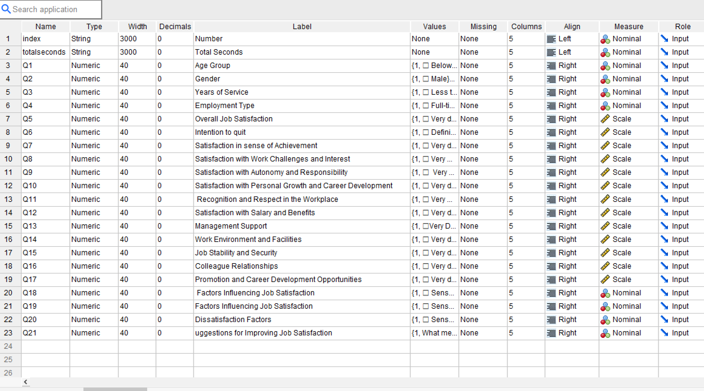


Appendix 3: analysis output example


