Final Report

- Introduction
I am the main role of environment modeling and environment texturing. My responsibility is to complete the corresponding tasks within the stipulated time, and then upload them to the team file to do the docking work with the team members. If anyone has any questions about this part feel free to come to me and I will resolve their doubts.
I also chose to play a supporting role in the scene layout, rigging part, animation part, rendering part, postproduction. The tasks of these roles are required to assist the main members of each process to complete secondary tasks, such as some repetitive, less important tasks. This not only reduces the energy consumption of the main characters, but also improves team efficiency and animation quality.
In this major project I modeled and textured the main buildings in the story, including the farmer's home, warehouse, windmill, phone booth, street signs, etc. In addition, I was involved in character animation, and I was assigned the climax of the story. The plot is that carrots are transformed into monsters under the influence of chemicals. Officer Rabbit fights the carrot monster to protect the manor from destruction. Officer Rabbit first dodged the monster's quick attack, then defeated the monster with his gun. From this fighting plot, I made nearly 20 seconds of fighting animation. In addition, during the project process, I also assisted other team members to complete part of the workload, including the texture production of characters and props.

- Processes
For the details of the process, I will divide it into three aspects: design, technology, and organization, and conduct in-depth discussions respectively.

2.1 Design
Design is an integral part of a good animation. It can exist in any part of the animation process, including but not limited to models, animations, and shots. It can determine whether the animation is innovative enough, whether it can attract the audience, whether the story is interesting, and whether the picture is intriguing.

2.1.1 Design in Model
In the discussion among team members, we used a game called road96 as a style reference and determined that the style of this animation is semi-realistic, similar to a road movie. Then I started doing mood boards for the building collections I was in charge of. I have collected all kinds of farm buildings on the Internet, some cartoon ones, some realistic ones. Because the background of the story is a desert, the house will not be very big and not as luxurious as a manor, so I decided to make a log cabin. Since the farmer, John, grows carrots, there should be a warehouse for storing carrots. The house is located on the side of the road, so there must be a street sign. There is also a phone booth on the side of the road. I also designed an iron windmill. In the story, John is the best farmer who grows carrots in the desert, and there are trophies in his house. I guess he must be proud of his carrots, so I designed some carrot elements to add to the shape of the building.
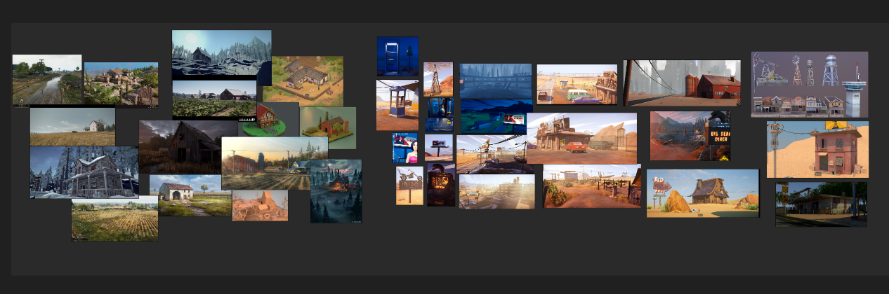
Mood Board

2.1.2 Design in Animation
The animation I am responsible for is mainly fighting clips, and how to design the action is the difficulty of this animation. The animation storyboard is the main direction for my reference. In the animation storyboard, the rabbit first avoids the attack of the carrot monster, then hides to the back of the building to avoid the monster's vision, suddenly approaches the monster quickly, and finally defeats the monster. I design the monster's attack method according to the monster's appearance, it mainly uses the root attack, such as slapping or swinging. The rabbit police officer is an anthropomorphic appearance, and its behavior should be similar to that of a human, so I designed some movements such as rolling and forward jumping for it. The rabbit's hand is five fingers, and I also designed some gun holding positions for it.
Animation not only refers to character animation, but also lens animation. A good lens also needs to be carefully polished and time-consuming to design. I designed 10 sets of shots for the animation I made. For the first shot I used the famous Hitchcock zoom to highlight the difference in size and strength between the monster and the rabbit cop. This is a special shooting technique that increases the focal length while pulling the distance between the camera and the object, so that the background can be enlarged while keeping the proportion of the subject in the lens unchanged. The size of the monster gradually becomes larger, as if it is close to the camera, which brings enough shock to the audience's vision. In addition, I also used some long-range, medium-range fixed-point shooting and follow-up shots during the fight to show the intense scenes of the fight in all directions and satisfy the audience's visual experience.

2.2 Technology
In this team project, I mainly participated in three major sections: modeling, texturing, and animation. So I will discuss the techniques I use separately from these three sections.

2.2.1 Technology in the Model
I made most of the architectural models in maya. But considering that the farmer's home as the most important building requires a certain level of detail, I imported it into zbrush for high-precision sculpting. I subdivided it into a high poly of 900 million points and started sculpting some wood textures. In the group discussion, it was confirmed that this is a wooden house, and the roof and body of the house are made of wooden planks. Carving the wood grain took me a lot of time, it was a tedious and boring job. Each plank needs a different texture, and the outlines of the growth rings need to be carved on both sides of the plank. In addition to the wood grain, I also need to engrave some wear and tear, because the story is set in a desert, and a house that stands in the wind and sand all year round will inevitably be weathered. Also, I needed to carve out the texture of the stone, since the chimney of the house and the base of the lamp are made of stone.
It took me a week to sculpt the house, after which I needed to retopology because its high face count would be an unimaginable burden on animation rendering. For topology I use ZBrush's ZRemesher feature. But this function is not very controllable. In order to achieve satisfactory results, I adjusted the parameters many times for topology. ZRemesher will make the corners of the model very sharp, which is caused by the lack of face count. In order to solve this problem, I thought of the polygon drawing tool, the principle of which is that the darker the drawing color, the higher the number of faces preserved by the topology. I use it to draw the edges of the wood to make sure there are enough faces in those places. A piece of wood with millions of points can become a model with hundreds or thousands of points after topology. This greatly reduces the face count of the model, making it compliant with animation production standards.
I redo several times during the modeling of the house because I had previously built the entire house into one model, which was not good for later sculpting and topology work. After that I modeled the house in several parts and grouped them together at the end.
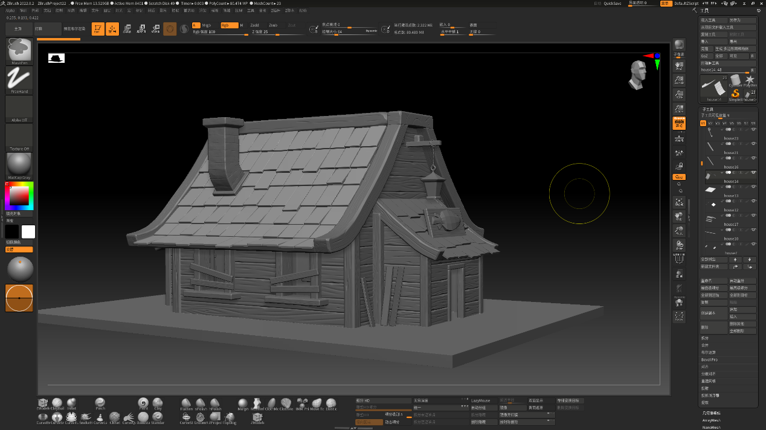
Sculpt the house in ZBrush
After the house topology is completed, the details of the high-poly model need to be projected onto the low-poly model, and before this, the topological model needs to be uv split. In this step, I use a software called RizomUV, which has a very complete and convenient operation for unfolding UV. With uv, you can use Zbrush's projection function to project the details of the high poly to the low poly, and finally export the low poly and displacement maps.
In addition to the farmer's home, the stone pillars of the street signs were also carved with ZBrush to sculpt some damage and scratches.
I also helped jirui hu to topology the model of the gun he made. Because the model obtained by his own topology is a triangular surface, and this does not meet the animation production specifications, the normal are also irregular, which is not conducive to the drawing of textures. So, I retopologized the high poly model of the gun he made with maya. And I made some modifications to the model according to his original painting, such as adjusting the base and handle of the gun. Also, I saw that there are screws in the gun head in his original painting, but there are no screws in his model, so I made the appropriate screws and moved it to the corresponding position. The chemical in the center of the gun was supposed to be the gun's ammo, and he created a cylinder as the corresponding part, which looked a little unreal and didn't have a sense of volume. Therefore, I created a larger cylinder as a glass bottle on the outer layer of the original painting and adjusted the parameters of refraction to make it seem to have a certain thickness, and the effect is more realistic. After that, I used RizomUV to unwrap the uv, and then integrated all the parts of the gun into a whole, which is convenient for later texture painting.
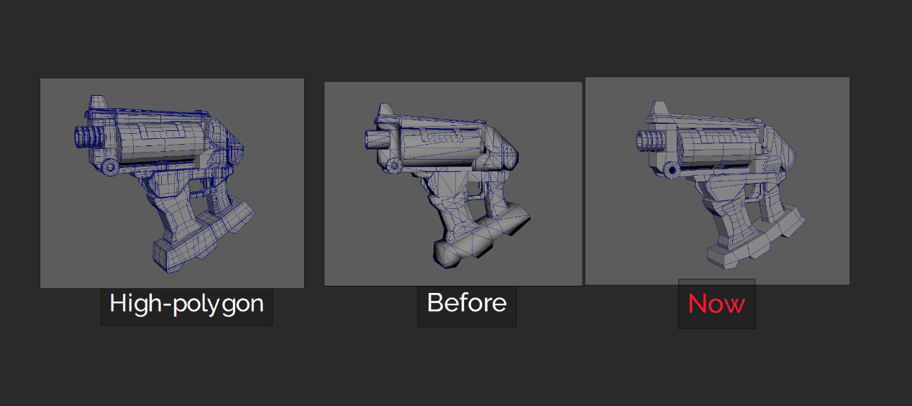
Retopology

2.2.2 Technology in Textures
I paint textures for models I create. Take the example of a farmer's home. After importing the model of the house into substance painter, I need to bake it first, because the models are interspersed with each other, which will cause corresponding effects, such as shadows. So doing this step can make the texture drawing look more realistic. After that, I started to draw the texture. First, I needed to lay down a base color, determine the properties of its base material by adjusting the metallic and roughness, and then add the appropriate color to match the visual effect. After that, some wear effects need to be added. The color and gloss of the wood eroded by the wind and sand are different from the original state, and its color will be lighter. The junction of wood and wood will be darker due to the accumulation of sand and dust. Then I need to create a layer and add a mask to make the dust effect. Adjust the amount of dust, size, distribution area, and color depth to ensure a realistic visual effect. Finally add the exported texture to Maya's shader.
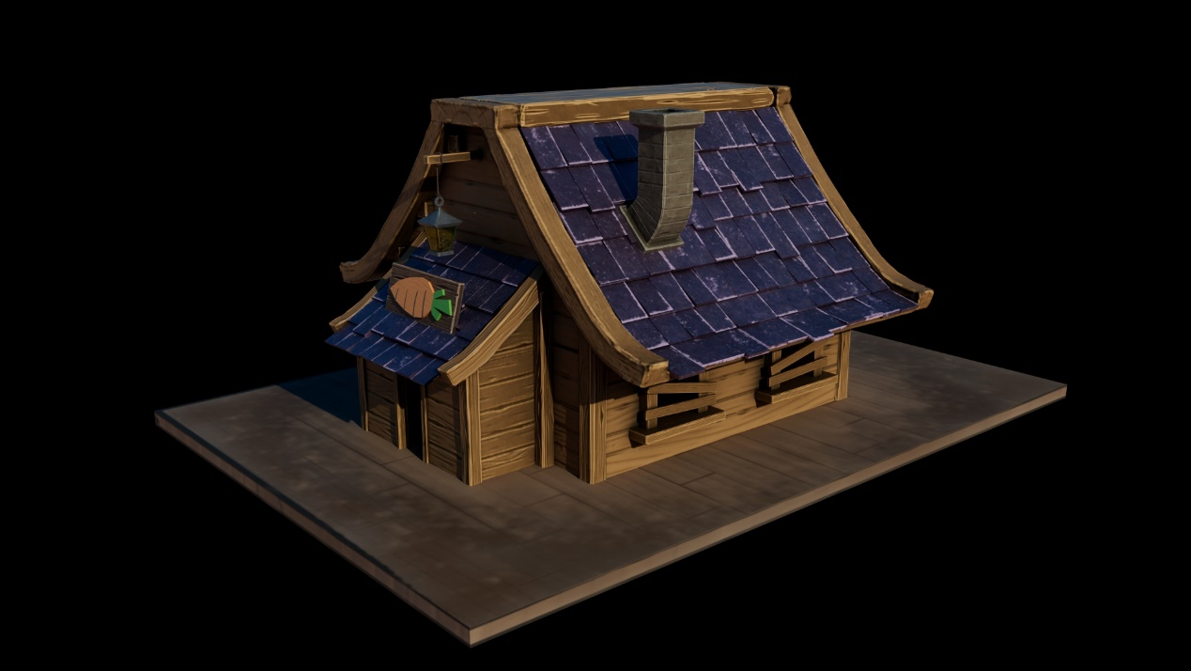
Rendering of the house
Basically, most of the texture production methods are like this. For the slogan on the phone booth, I first used Photoshop to create the corresponding images and text, and then made them into black and white images and exported them in PNG format. Import the PNG format into substance painter to map the pattern to the model through the transparent map. The middle part of the phone booth is glass, and I need to adjust the weight in its transmission so that it becomes transparent. The glass is colorless and transparent, so the visual experience of rendering is not very good, so I changed the color of its refraction to yellow, which is easier to observe.
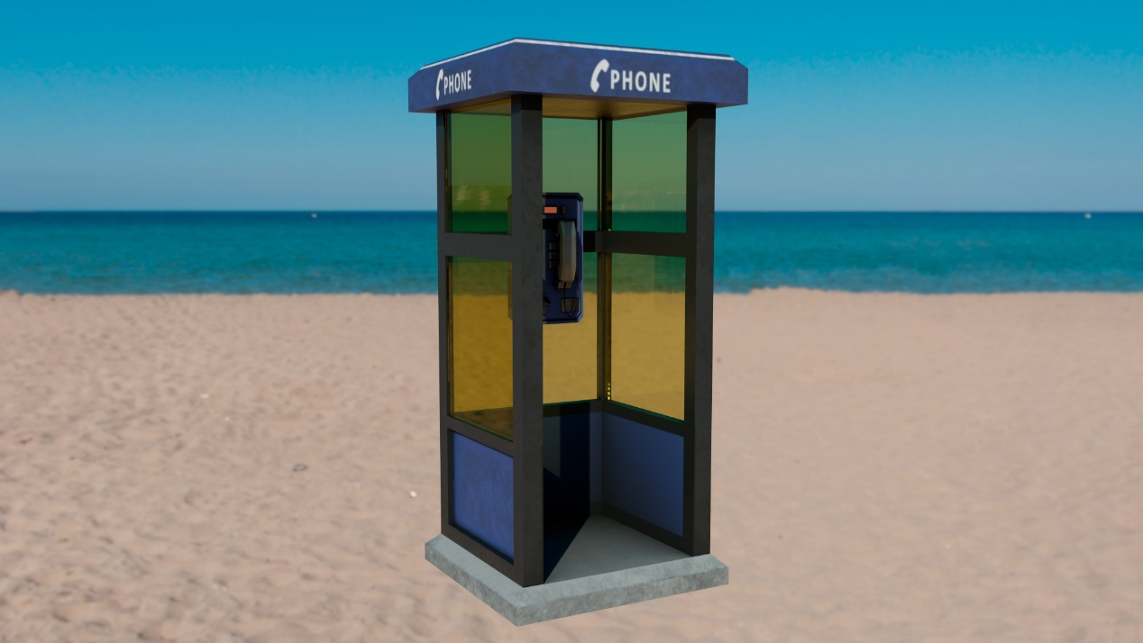
Rendering of the phone booth
On the carrot sign I drew a few shadows in imitation of the cartoon, which made it more interesting and in line with the cartoonish style of this animation.
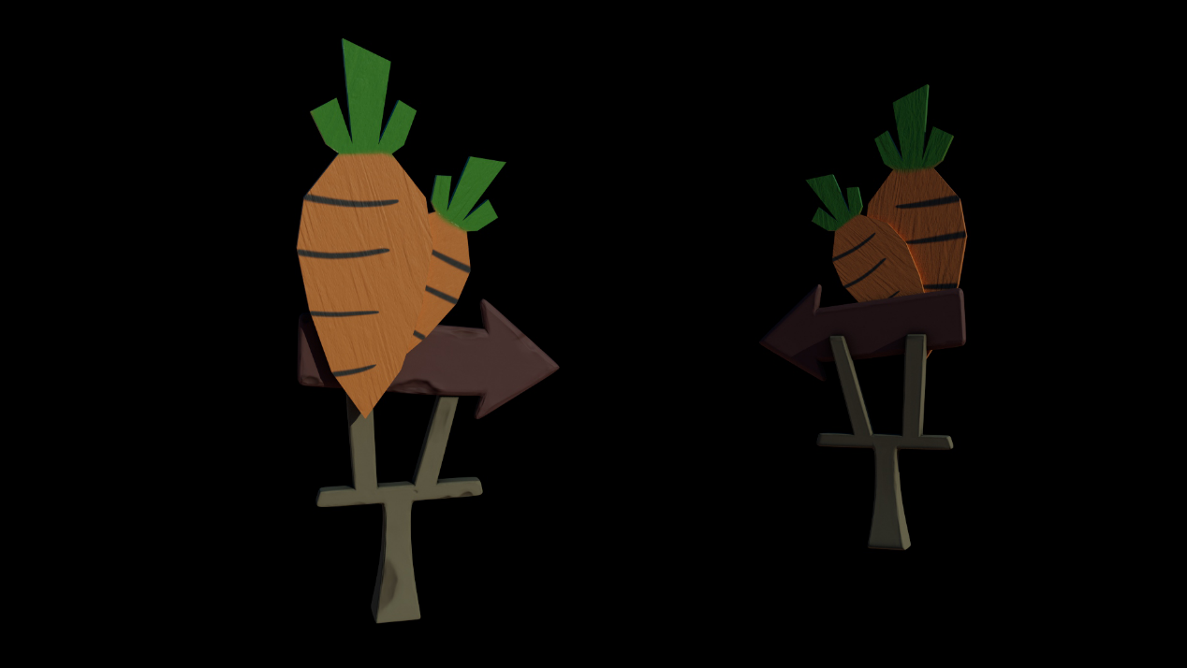
Rendering of a street sign
Windmills are mainly composed of iron shelves and iron sheets. I made a metallic texture first and then used a mask to make a darker iron layer to enhance the contrast. After that, it is necessary to make the effect of metal rust, especially the degree of oxidation at the joints and corners of the iron frame will be higher than other places. Then I also made a layer of scratches from the heightmap, which made it look more realistic. Last but not least, add a layer of dust.
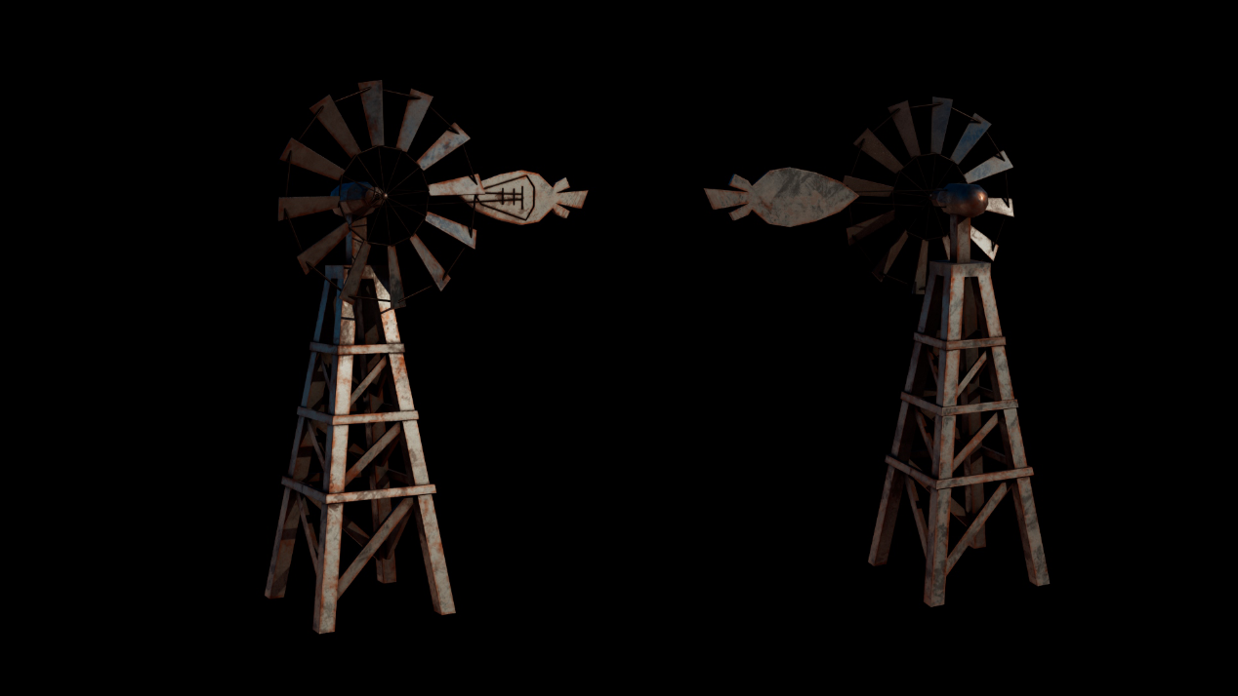
Rendering of a windmill
Warehouses are also textured in a similar way.
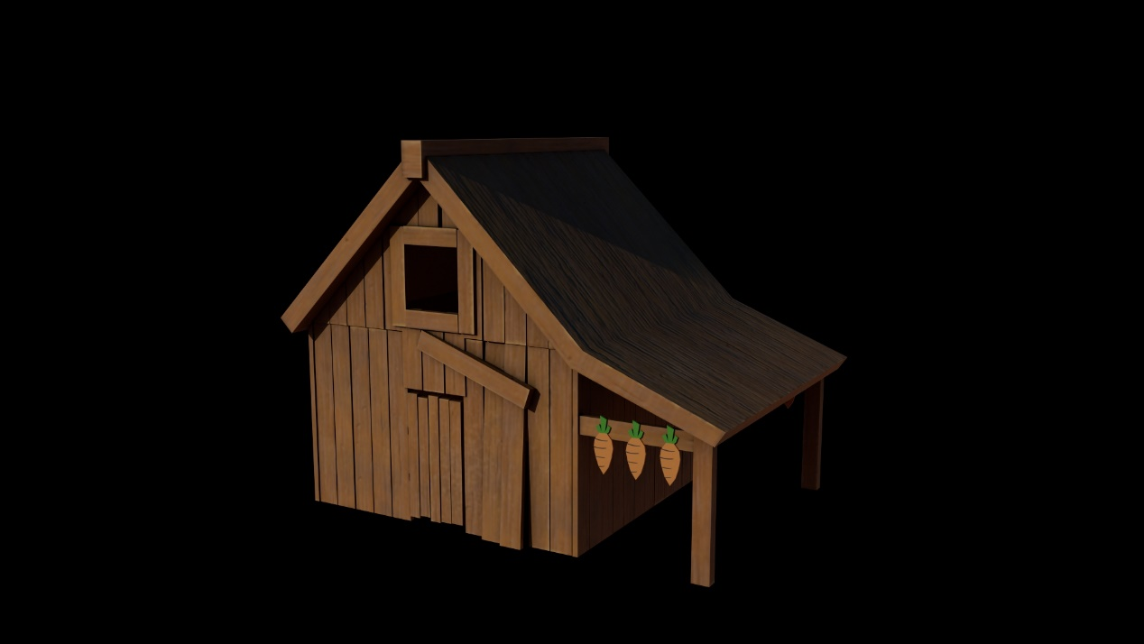
Rendering of the warehouse
In addition to the models that I am responsible for, I also help other team members with their work. The texture of the carrot monster is done by karol, but the textures he draws are relatively simple. And there is also a rendering problem in ue4, the normal map cannot be recognized. At the request of the team, I reworked the texture of the carrot monster.
I used a real carrot as a reference and painted its body orange red and the leaves dark green. The eyes and teeth are based on the original painting to make the corresponding color matching, the teeth are white, the eyes are yellow, and the pupils are dark purple. Then I used a scratch brush with a lighter orange to create the lines on the carrots. The stems on the leaves were also drawn with a brush, using a darker color for the back and a brighter color for the front. After that I started making traces of dirt, the further the roots were from the body, the darker the color. Some are also made on the head and leaves, because in the story, the radish grows in the soil, and then breaks out of the ground because of chemicals, so it will have some dirt on its body. Then spread some large pieces of mud to increase the layering. I made the overall tone of the radish a little darker because it would be more in line with the setting of its monster.
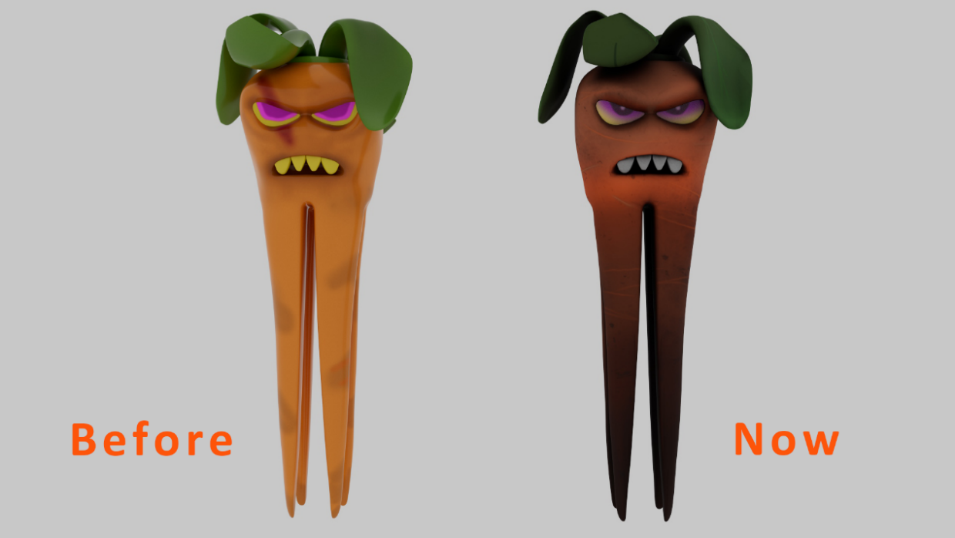
Rendering comparison of the radish monster
I also helped jirui hu paint the guns. He drew the 2d design of this firearm. When I make textures, everything is based on his original painting, and I try to restore the shape in his original painting as much as possible. First, I observed that there are many design points in his original painting, such as the spray paint of the skull on the tail of the gun, the number 03 on the base and the traces of blood and green compounds on the gun body. These are the points that I need to reproduce. I added corresponding basic materials to each part of the gun, such as the launch head of the gun is rubber, the upper part is white with aluminum, the blue part is iron, the black part is meteorite, and the ammunition in the middle is glass. The metalness and roughness of each material are different, and these need to be adjusted. Then I will make some used marks, such as scratches, the blue paint on the iron of the gun body part is worn away to reveal its original silver. In addition, the metal will oxidize, and the handle part of the gun will turn white after contact with sweat and dust. I have made all these effects. Then use a brush on the heightmap to make four recessed marks on the handle and some screw holes. Next, I used a brush to paint those design spray paints, plus a layer of blood and chemicals. For the chemical in the glass bottle, I added a layer of self-luminous channels, and made a fluorescent green effect specifically for it. Finally, I exported all the channels as textures and added them to Maya.
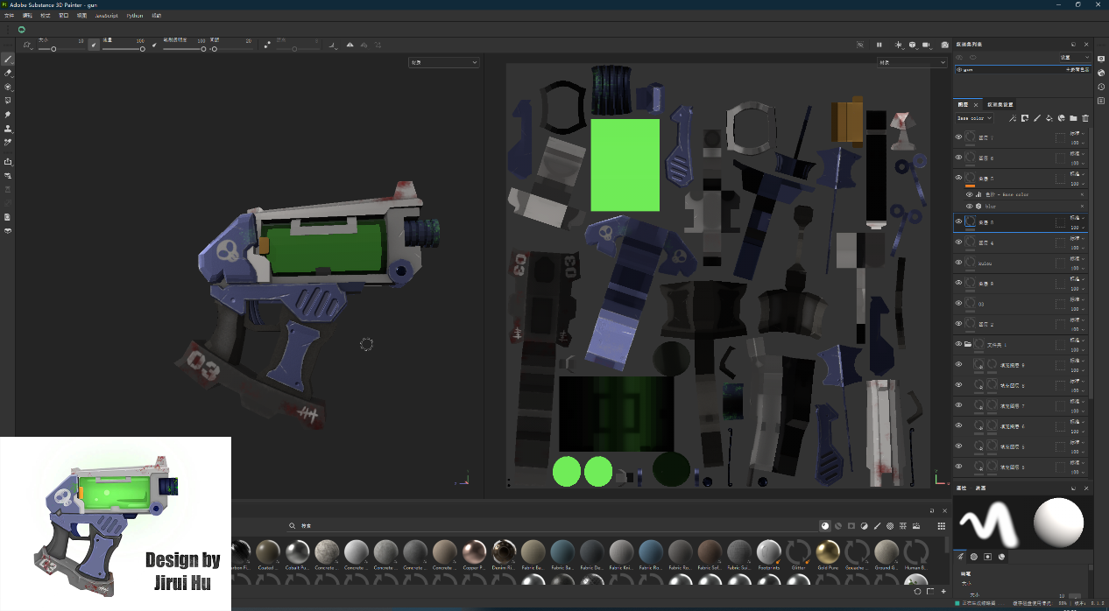
Screenshot of the texture drawing process of the gun

2.2.3 Technology in Animation
What I'm responsible for is that the fight sequence is the hardest part of the entire animation and contains a lot of technical difficulties. First, after the character is laid out, the orientation is not facing the coordinate axis, so the parameters of the three axes of xyz need to be adjusted when making animation, which is very complicated. Of the entire animation clips, the animation I made for Officer Rabbit was the most complex and the most difficult, it involved running and dodging. I made a lot of dodge moves for it, including but not limited to sideflips, backflips, backhands, fish leaps, and spinner 720. When setting the keyframes of these actions, not only the standardness of the pose, but also the fluidity of the animation should be paid attention to. The IK controller and the FK controller need to be switched back and forth. The leg controller needs to be set to IK when running, and it needs to be set to FK when doing dodging, so that the legs move with the body. When the character makes an action, not only that part moves, but other parts also need to be animated. For example, running is not only about setting keyframes for the legs, but also the characters' arms should be swung together, and the head should also be shaken slightly, so that it looks more natural. In addition to the character's body, its face also needs to be animated with expressions, so that the character will not appear too rigid. When the character's movement is stiff or the movement is incoherent, I will use the curve graph editor to adjust the curve of the keyframe, and sometimes I will make it frame by frame to achieve a satisfactory animation effect. Wearing molds is a taboo in animation, so I will always check whether there are molds between models, and whether there are molds on the ground when rolling. Another very important thing is the matter of the two characters in the fight. After one character makes an action, the other character needs to make a corresponding action to interact with it. It needs to cooperate with each other, not each of them doing their own actions.

The viewing address of the animation clip I made:
https://uowtsd.sharepoint.com/:u:/t/MajorProjectProductionGroup_GRP/EVtCWyghII5Cs4GOP2GzhS4BqkQMCDBEaLWer-Nt7T9gBA?e=PzhLcV

2.3 Organisational Execution
During my participation in the production of the team project, I actively communicated with the people in the group. Regarding the issue of personnel allocation, Karol made a form, but because Chinese students were unwilling to take the initiative to express their intentions, the form was never filled out. So, I made a Chinese version of an Excel form, uploaded it to WeChat (a communication software commonly used in China), and mobilized Chinese students in the group to fill it out. After everyone fills in, I check for any flaws. According to the brief requirements, everyone needs to fill in at least three positions. After checking, I found that one of the people did not fill in the three positions. I will communicate with those team members individually. After everything is completed, I will synchronize the information to the table in the teams, and communicate with Karol on behalf of the Chinese students, and put forward some suggestions for corrections on some deficiencies in Karol's table.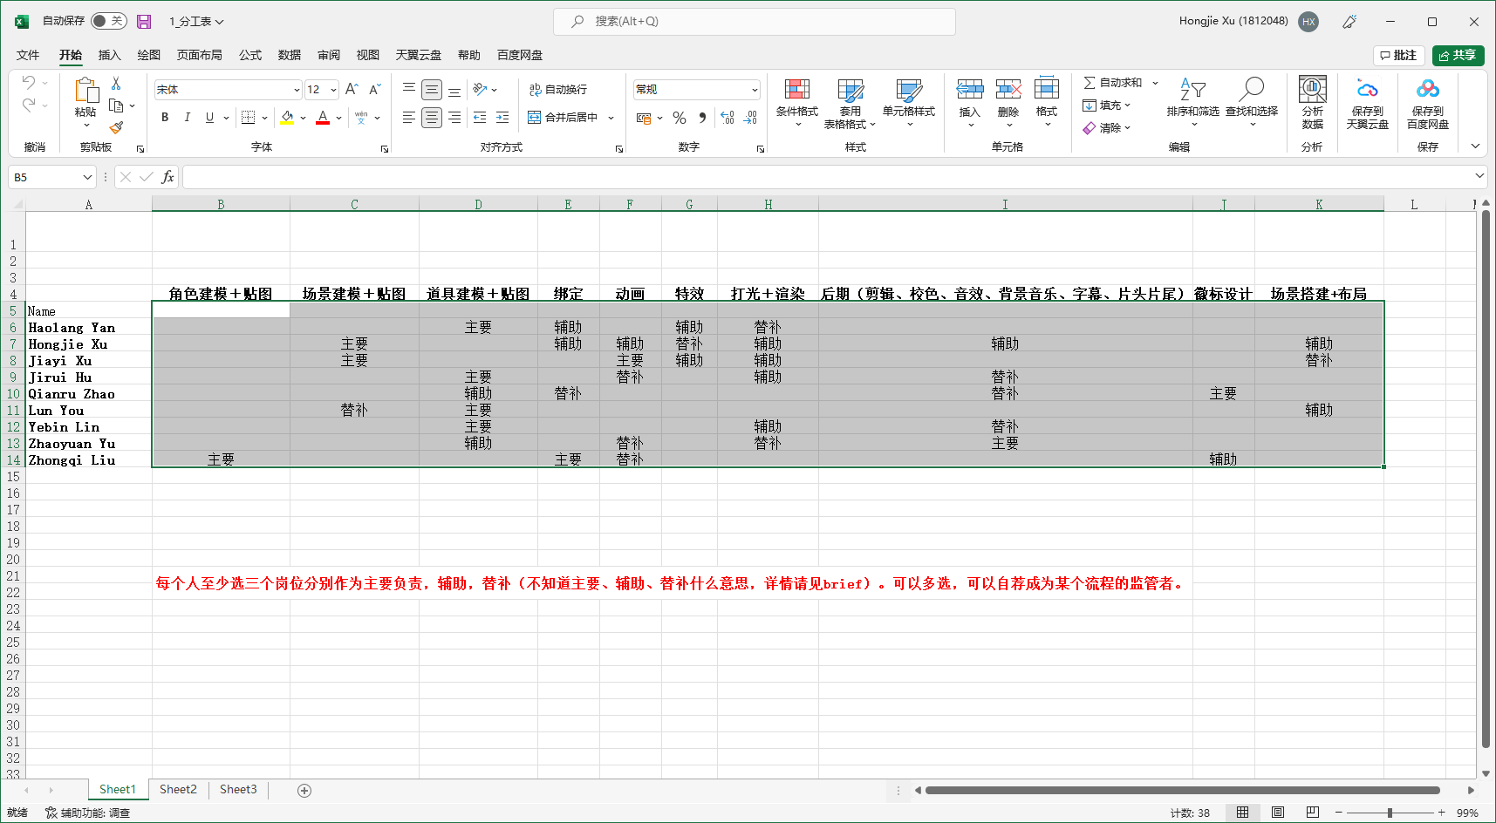
The Chinese version of the staff assignment form I made

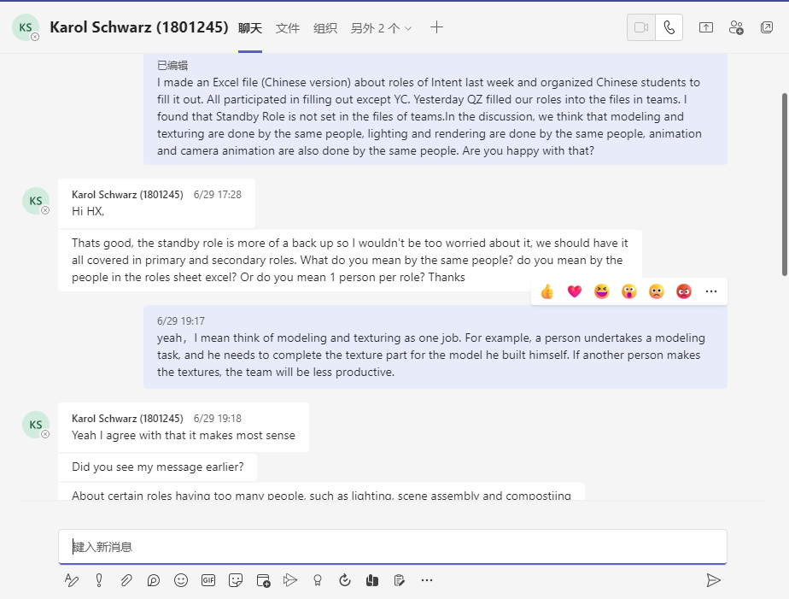
Chat with Karol

Since then, I have actively participated in discussions organized by the team on animation style and architectural layout. Besides, I referred to Disney's control of the time required for each animation process, and then drew a timetable to standardize the animation production process according to the scale of our animation project and the work efficiency of our team members. Because the modeling phase was completed before July, I did not include this phase in this table, but started with texture drawing. I allocated sufficient production time to each stage, and interspersed the rendering with the later work time, so that the rendered sequence could be advanced to the next process. This can fully improve the efficiency of time utilization and improve the work efficiency of the team. In this pipeline, I give animation the most time, because animation is the most important and complex part, and its quality can directly affect the final effect of the entire team project. With this table, team members can plan their working hours accordingly and understand the process of the entire project.

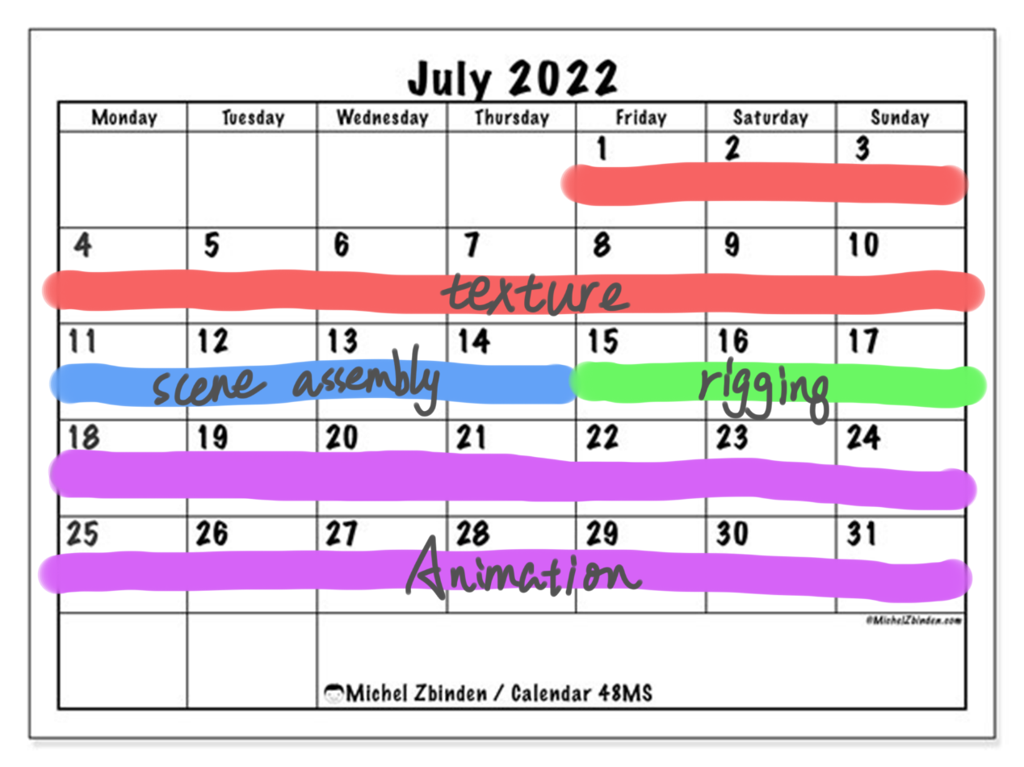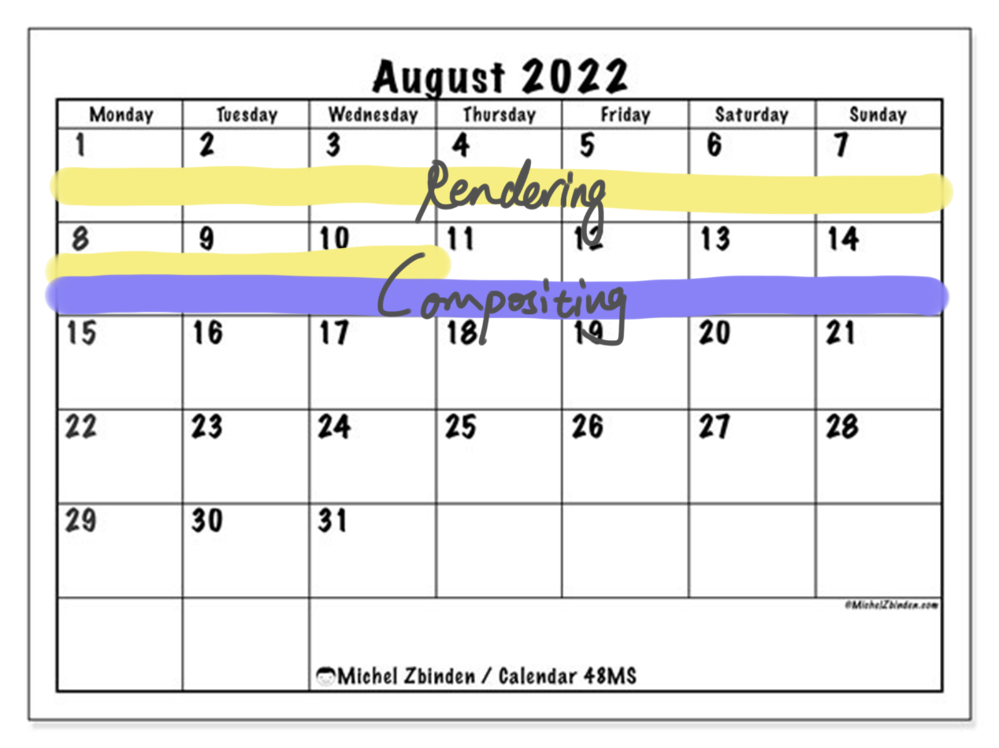
Schedule
- Methodologies
I made this animation strictly according to the Disney animation pipeline process. Maya is the main software I use. Of course, I also use other software as auxiliary tools to improve production efficiency, such as using ZBrush to make high-precision models, using RizomUV to unfold uv, and using Substance painter to draw textures. And the use of these software is self-taught on the Internet. When I encounter technical difficulties in production, I will look for the reasons. After finding the problem, I will search the Internet or consult the relevant knowledge of the official software documentation to obtain the solution.
In terms of animation, I refer to the movements in floor exercise for some of the characters' dodging movements. I first went to the Internet to find relevant videos, then decomposed the sequences of the videos, parsed several key frames of the movements, and finally debugged them in Maya. When the movement of a certain posture is not clear, I will imitate it myself, and feel how the hands and feet are placed and moved more naturally. Then adjust the movements for the characters in maya based on my own personal experience.
In addition, I also encountered a maya virus called Putiantongqing, which can infect the maya files in the computer and cause maya to have unknown errors. The most frightening part of it is that it can be spread through the maya project file. As long as the virus-carrying file is opened, the computer will be infected. I found this virus from a file sent to me by a team member. I immediately searched for relevant information on the Internet and found that Maya has officially launched a method for killing this virus. I cleaned my computer according to this method and informed the team members of the harm of the virus and helped them clean up the virus. Prevent viruses from threatening my team's projects.
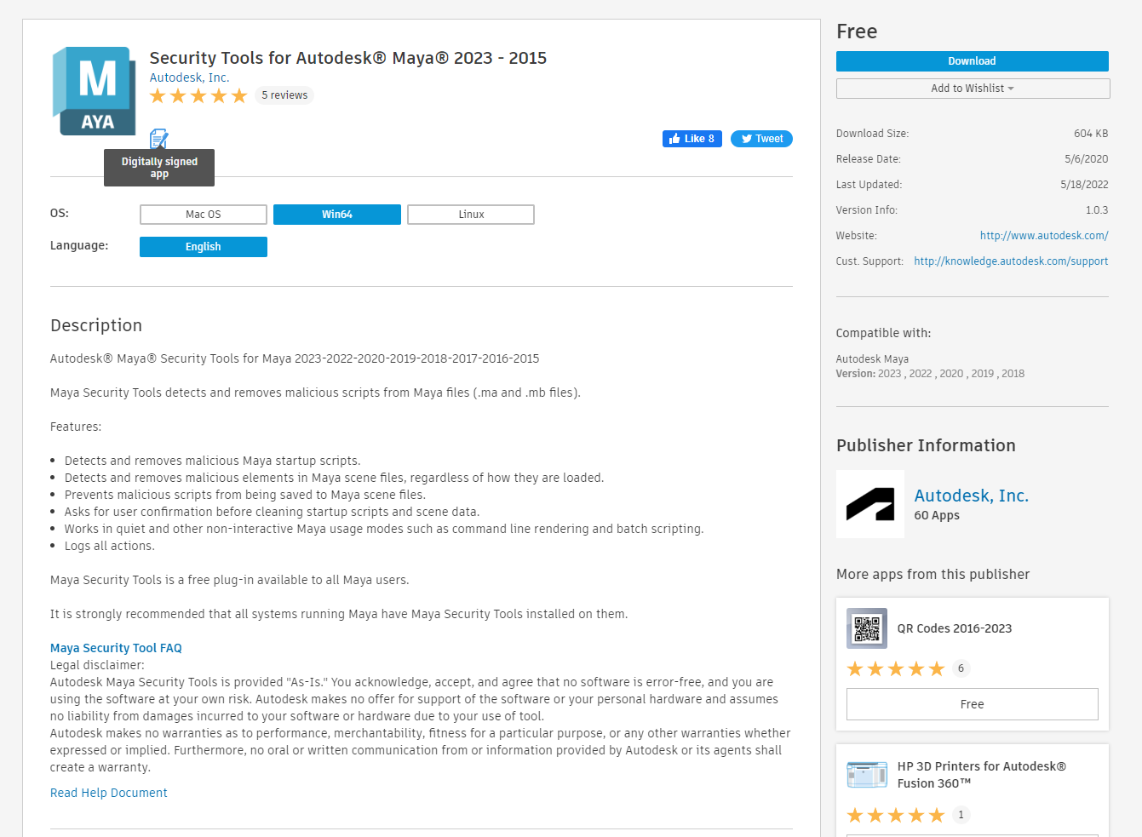
Security Tools for Autodesk Maya

- Conclusions and Analysis
Through this teamwork, I gained a lot of things, not only the improvement of software operation technology, but also the importance of team communication.
Technically, I understand the importance of wiring. The building model cannot be built as a whole, it needs to be created in parts and finally grouped. If a whole is built, it is very unfavorable for wiring and high-mode mapping. After using high-mode to map low-mode, its wiring will be messed up, not beautiful, and the details will not be perfectly displayed. Although this is my first attempt at stylized work, I am very satisfied with the final result. I also learned a lot about animation, such as how to make these complex scrolling actions, how to control the fluidity between actions, etc. Through the training of this team project, I have become more proficient in software manipulation. I consider myself to have fulfilled my responsibilities and obligations perfectly.
As for the team, I feel the charm of cooperation. The ability of one person is limited, but in the team, everyone can use their strengths and avoid their weaknesses, complement each other in ability, and greatly improve work efficiency. Although problems such as time difference, language, and file transfer were encountered during the production of the project, these problems were solved perfectly through the unremitting efforts of team members. When I work, I often report my progress to the team members and seek their advice on my work. Of course, there are also members who are reluctant to actively communicate, causing some problems of poor information. People don't know what he is doing, so some tasks are completed repeatedly. In the future, team members will need to communicate more frequently and learn from each other to create better work.

