Developing the ability to make stone tools is often seen as an important transition in early hominid behaviour. Discuss this statement by reference to both hominids and other primates

Early Hominids (of the Australopithecine and Homo genus’) evolved on the African continent approximately 4-5 million years ago (Ma) (Johanson & Edgar, 1996) and as a part of this there are many evolutionary and behavioural adaptations that have led to the culmination of Homo sapiens - us. One of these adaptations is the ability to create tools, more specifically stone tools. Thus, in this essay I shall discuss to what degree this ability to manufacture stone tools could be seen as a major turning point in hominid evolution. For this I will be examining the earliest known examples of stone tools while also looking at the brain capacities of hominids and what this could suggest about tool use. I will then take a look into primate tool use, specifically anvil stones and what they can suggest about tool manufacture and stone tools. Finally, I will make a judgment on the statement “the ability to make stone tools is often seen as an important transition in early hominid behaviour” and assess to what extent this is true.
The earliest known examples of stone tools, with a specific Hominid species connection, are from Gona, Ethiopia (Figure 1) and date from 2.6-2.5 Ma (Semaw, 2000). When comparing these dates to the (current) timeline of hominid evolution we can see that there are two species of Hominids that lived in this time Australopithecus africanus and Australopithecus garhi. It has been suggested by Semaw (2000) that it was A. garhi which created these tools, due to the proximity of A. garhi fossils, and thus the first hominids in history to manufacture stone tools. So, what makes A. garhi so special? What gives this hominid the ability to create tools? For a long time, it was thought that only the Homo genus could produce sophisticated stone tools, but the assemblage found at Gona with A. garhi suggests this idea to be incorrect. The specimens that have been found are skull fragments (Figure 2) for A. garhi, which when examined gives us an estimated cranial capacity of 450cc (which is equal to other contemporary Australopithecines) however this is tiny when compared to Homo sapiens capacity of 1409cc (Ankel-Simons, 2000, p. 179). Thus, it may be possible to rule out brain size as a limiting factor when looking at the early creation of stone tools, however this is limited as tools created by A. garhi are very primitive and unrefined even when compared to other, later, Oldowan stone tools (the Gona tools are an earlier variety of Oldowan tools (Semaw, 2000)), which we know to be made by the earliest Homo lineages, but it is also possible that these could have been created by contemporary Australopithecines as we know that they could have had the ability for stone tool manufacture, evidenced by A. garhi and the evidence of even earlier stone tools known as Lomekwi dating to around 3.3 Ma (Harmand, et al., 2015) though we cannot tie these tools to one specific species. Overall, analysis of ancient stone tools and those species which created them can provide us with some insight as to the importance of stone tool making to the evolution of hominids, and how linked this practice is to hominid behaviour.

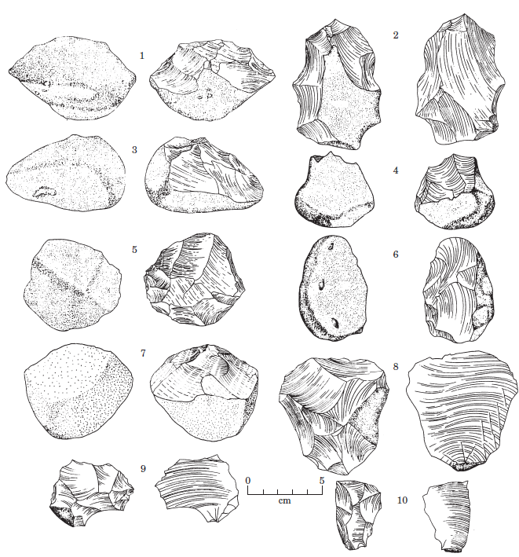
Figure 1: Artefacts from Gona, Ethiopia (Both Cores (1-7) and flakes (8-10)), taken from Semaw (2000)

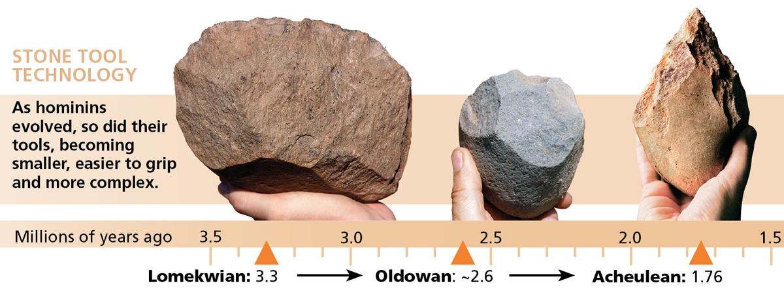
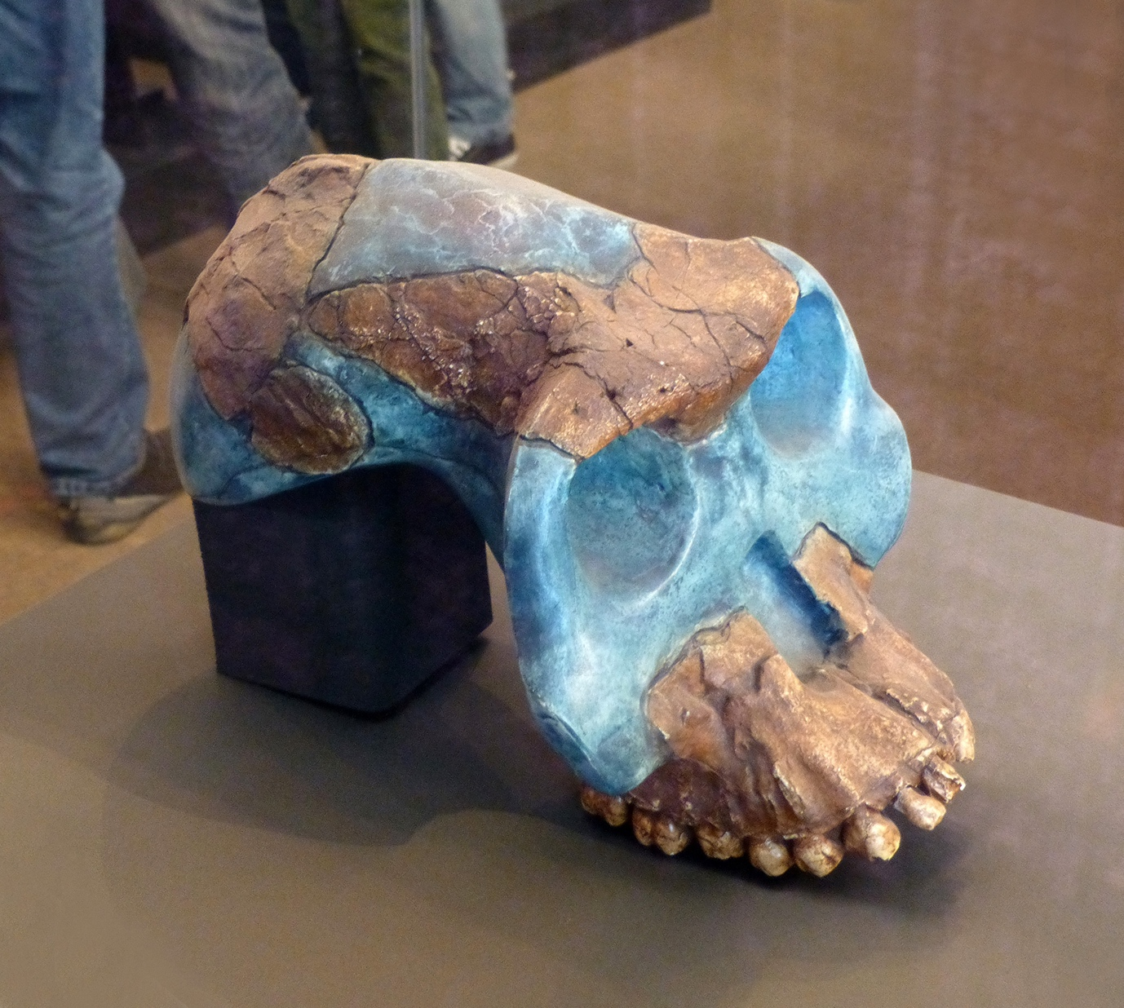
Figure 2: Evolution of stone tools, taken from (Waterman, 2015).
Figure 3: Australopithecus garhi, found at Bouri formation, Ethiopia (Asfaw, White, Lovejoy, Latimer, & et al, 1996) (Specimen BOU-VP 12/130) showing the size of the cranium. Taken from Wikipedia (Anon, 2017).

The Evolution of stone tools themselves can tell us a lot about hominids, from early Oldowan tools up to Acheulean and Mousterian(Figure 3) (Domínguez-Rodrigo, et al., 2014), and even into polished axes of the Neolithic (Zhao, Wu, Wang, & Yuan, 2002). The oldest known stone tools are Lomekwi tools (Harmand, et al., 2015). There is a lot of uncertainty involving Lomekwi tools, but Harmand and her team believe that this is an independent family of stone tools previous to the Oldowan family. Thus, it is unknown how these earlier Lomekwi tools helped shaped Hominid evolution, though it is suggested that these stone tools could have been an influencer into the later Australopithecine and Homo lineages in how they evolved. The next earliest stone tools where the Oldowan family, known as mode I, and can be found in Gona, Ethiopia 3.3 Ma to northern China 1.6 Ma, used from A. garhi to Homo habilis and Homo erectus (Johanson & Edgar, 1996). We can see that these Oldowan tools are very primitive when compared to later Acheulean and Mousterian industries, and this can tell us a lot about hominid behaviour, it seems as the Hominid lineage evolved so did our tool set. This suggests to us that the development of stone tools is clearly an important development in hominid behaviour, becoming smaller and more precise, from the knapping of Oldowan tools to the careful knapping and pressure flaking of Acheulean tools.
When looking at our contemporary relatives, the great apes, we can see abundant tool use. Chimpanzees are known to use hammer and anvil techniques (Mercader, Panger, & Boesch, 2002). When excavated in similar manners to modern archaeological sites we can see a number of interesting aspects to this use of stones. The hammer and Anvils are used by chimpanzees to crack open the hard shells of nuts (Figure 4), and when these sites are analysed you can see the intelligent thought that goes into this process. Chimpanzees will gather igneous rocks (3 -15 kg) or lateritic soil crust (soil rich in iron and aluminium, approx. 6kg) from several hundreds of meters away (Mercader, Panger, & Boesch, 2002), and will only use material of this type for the hammer stones, chimpanzees have also been known to also select anvil stones from large distances as well (though they are known to use rock outcroppings and hardwood roots). The aforementioned shows a great deal of foresight; this mixed with the fact that the nut season lasts for about 6 months (February to August) and it take about 7 years to truly learn the skill it shows a great amount of mental aptitude. So, what can this tell us about stone tool usage? And how does this relate to the path of human evolution? Our great ape cousins can tell us a lot about primitive stone tool use, but also may give a hint as to the origins of knapped stone tools. The intricate way in which chimpanzees use their environment in conjunction with gathered materials can give us an idea of the initial steps that early hominids took in stone tool use. Chimpanzee brains have an average cranial capacity of 393cc (Ankel-Simons, 2000, p. 179) which is only just smaller than that of A. garhi (approx. 440cc). Could this then be a measure of ones innate ability for sophisticated tool use? It could be suggested that due to the smaller cranial capacity of Chimpanzees their ability for stone tool usage and creation is lesser that that of Hominids. Though that itself is demeaning of our cousins, for the collection of both hammer and anvil stones, their continual use and the length of time it takes to teach this intricate skill is very sophisticated indeed though it is not the same as knapping practices. Still there are issues when comparing modern primates to ancient Hominids – they are simply not the same. Though we may use them as examples of what early stone use was like and give us an idea of how stone tool use may have began we cannot be certain. This is even more problematic as it very difficult to tell hominid tool manufacture from hammer and anvil site, as when the hammer stone makes contact some parts of both the anvil and hammer stone can break of from continual use (Figure 5) – giving us an impression of some kind of deliberate stone tool manufacture (Semaw, 2000). Thus, it is difficult to tell these sites apart.

Figure 4: Chimpanzee mother teaching her child, west Africa Taken by Etsuko Nogami

Figure 5: Fragments from Chimpanzee Hammer Stones, taken from Semaw (2000)

Knowing this information is very useful when assessing stone tool making as a transition in early hominid behaviour. As previously mentioned, before the discoveries in 2000 and 2015 it was accepted across the Palaeolithic and scientific communities that only the Homo genus could create stone tools. Yet with this novel information we know for certain that tools were created even earlier by our ancestors, some 500,000 years earlier than even the genus Homo had evolved (Gibbons, 2015). So, what can already be suggested? From the evidence we have we know that stone tool manufacture has been a part of the hominid behaviour for over 3.3 million years. Consequently it could be suggested that this ability was an important transition in hominid behaviour, right? While this is a very strong possibility I would propose that this is fundamental ability of Hominids, and great apes in general (as seen in our genetic cousins the Chimpanzee), that has allowed to evolve and adapt over time, advocates for the idea that the ability for stone tool manufacture has always been a part of hominid behaviour, one which defines hominids beyond morphological and genetic definitions. The subsequent changes and evolution in shape and (possible) functions of stone tools are something which may be attributed to changing needs, or even a biological need; the need for some kind of dopamine and endorphin release. Dopamine and Endorphins are characterised as ‘feel good’ chemicals (Michael & Borland, 2007), that is to say that they help us with feelings of happiness and positive reinforcement. This is truer of dopamine than it is for Endorphins, which are less well known in terms of the stimulates they are affected by (Michael & Borland, 2007). Today we live in a society where it is very easy to get instant gratification – where it is much easier to access quick releases of these chemicals. It could be suggested that the polishing of stone axes in Homo sapiens could be a way to get these chemicals into our system, as polishing a stone axe does not increase the usefulness of the stone tool so it could be that this polishing action is a way of releasing dopamine and endorphins into our early ancestor’s systems. Therefore it could be said that the action of making stone tools themselves in earlier Hominids, such as A. garhi, H. habilis and H. erectus could have been a driving force in the continual creation, evolution and adaptation of stone tool manufacture – as well as the intrinsic usefulness of stone tools.
This is a very abstract theory. We know that delayed gratification gives us higher levels of dopamine release than instant gratification due to putting off something or doing something that will lead to a greater outcome in the end. This could also link to stone tool creation in general as it is a hard and skilled practice, the learning of new, harder and more complicated skills could have been a key changing point for early hominids. Even with later hominids, the Oldowan industry was used for almost 1 Million years, even after the advent of newer stone technologies – though this was probably due to the amount of time it takes for the spreading of new ideas and techniques to occur. Overall this is a theory that would need significant research to come to some conclusive idea and end point, focussing on cranial fossils of our hominid ancestors, though I feel this could be explored in great detail as a legitimate theory as it could open new channels of hominid evolution and the effects of stone tool manufacture on our evolutionary history.
So, to conclude. The ability to craft stone tools is a monumental change in hominid behaviour, it has allowed us to evolve and adapt, strengthening both our minds and bodies. Though we can see from our genetic cousins that this may be an adaptation of all Hominoids, certainly we can see that in Hominids stone tool manufacture has been a great addition to our behavioural tool set. Not only has it allowed us to perform tasks better, such as butchery and nut harvesting, but it is a intrinsic addition to the evolution of our brains, allowing us to adapt and evolve into more complex beings with an increased brain capacity. Thus, it must be concluded that developing the ability to make stone tools should be seen as an important transition in early hominid behaviour, it is our lot in life to use tools but with it we have won the behavioural and biological lottery.

Bibliography
Ankel-Simons, F. (2000). Primate Anatomy. London: Acedemic Press.
Anon. (2017, April 22). Australopithecus garhi. Retrieved from Wikipedia: https://en.wikipedia.org/wiki/Australopithecus_garhi
Asfaw, B., White, T., Lovejoy, O., Latimer, B., & et al. (1996). Australopithecus garhi: A new species of early hominid from Ethiopia. Science, 629-635.
Boyd, R., & Silk, J. B. (2015). How Humans Evolved. Canada: W. W. Norton.
Breuer, T., Ndoundou-Hockemba, M., & Fishlock, V. (2005). First Observation of Tool use in wild Gorillas. PLos Biol.
Domínguez-Rodrigo, M., Diez-Matrin, F., Mabulla, A., Baquedano, E., Bunn, H., & Musiba, C. (2014). The evolution of hominin behavior during the Oldowan–Acheulean transition: Recent evidence from Olduvai Gorge and Peninj (Tanzania). Quaternary International, 1-6.
Gibbons, A. (2015). Deep roots for the genus Homo. Science, 1056-1057.
Hare, B. (2011). From Hominoid to Hominid Mind: what changed and why? Anual Review of Anthropology, 293-309.
Harmand, S., Lewis, J. E., Fiebel, C. S., Lepre, C. J., Prat, S., et al. (2015). 3.3-million-year-old stone tools from Lomekwi 3, West Turkana, Kenya. Nature, 310-315.
Johanson, D. C., & Edgar, B. (1996). From Lucy to Language. Verona: Orion.
Lewin, R., & Foley, R. A. (2004). Priciples of Human Evolution. Oxford: Blackwell.
McGrew, W. C. (1992). Chimpanzee material culture: Implications for Human evolution. Cambridge: Cambridge University Press.
Mercader, J., Panger, M., & Boesch, C. (2002). Excavation of a chimpanzee stone tool site in the African rainforest. Science, 1452-1455.
Michael, A. C., & Borland, L. M. (2007). Electrochemical Methods for Neuroscience. London: University of Pittsburgh.
Quiatt, D., & Reynolds, V. (1993). Primate behaviour: Information, social knowledge, and the evolution of culture. Cambridge: Cambridge University Press.
Semaw, S. (2000). The World´s Oldest Stone Artefacts from Gona, Ethiopia: Their Implications for Understanding Stone Technology and Patterns of Human Evolution between 2.6-1.5 Million Years Ago. Journal of Archaeological Science(27), 1197-1214.
Waterman, H. (2015, October 1). The Evolutionary Timeline Retooled. Retrieved from Discover Magazine: http://discovermagazine.com/2015/nov/18-the-evolutionary-timeline-retooled
Zhao, C., Wu, X., Wang, T., & Yuan, X. (2002). Early polished stone tools in South China evidenceof the transition from Palaeolithic to Neolithic. Beijing: Peking University.

Word count: 2460

