LECTURER : Dr Helen Parsons (Module Lead) | MODULE: LCHS4003
Portfolio – Two Tasks
anila ditta, STUDENT ID: 2232190
Introduction to Health and Social Care
2026

Contents
Poster page 1 2
Poster page 2 3
Introduction 4
Origins and Historical Development 4
Current Functioning of Residential Care Homes 4
Importance in Improving Life Quality 5
Conclusion 5
Reference 6

Poster page 1
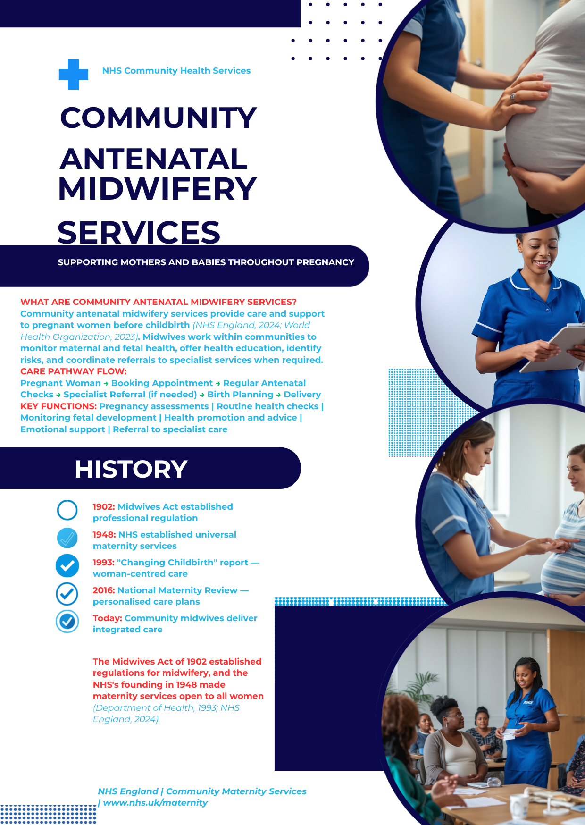

Poster page 2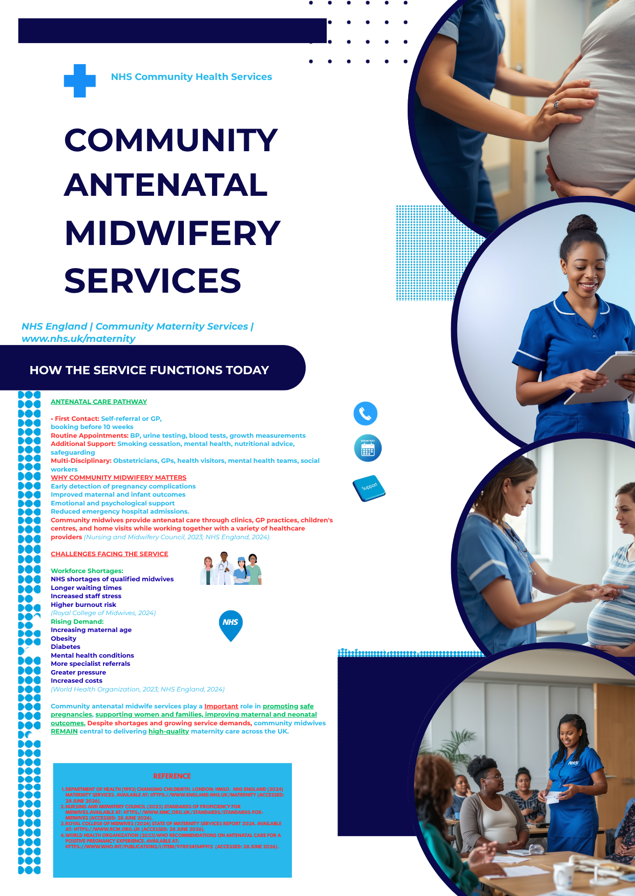

Introduction

Social care services also called residential care homes offer basic housing, personal care, and assistance with everyday activities to people who are unable to live independently due to their age, disability, or chronic medical condition (Berg, 2021). When compared to nursing homes, residential care facilities often support people with specific needs while promoting their dignity, freedom, and well-being. We will look at the history of residential care homes by looking at the historical developments that shaped their growth. We will also look at how residential care facilities now operate and how important they are to improving the quality of life for service users.

Origins and Historical Development

Residential care institutions were developed due to poor the poor Law system of the nineteenth century, when workhouses housed elderly people, people with disabilities, and those who couldn't support themselves (Historic England, 2019). These establishments were often linked to poor living circumstances, crowding, and a loss of personal dignity. Social care services began to provide more person-centered and supportive environments when the National Health Service was established in 1948 (The Kings Fund, 2023) and the welfare state gradually grew. Local governments were also urged to offer residential housing for less fortunate people with approval of the National Assistance Act (Means and Smith, 2022). The focus on promoting wellbeing, protecting vulnerable adults, and empowering people to take part in decisions about their own care is being strengthened more recently by laws like the Care Act 2014.

Current Functioning of Residential Care Homes

Residential care centers now offer 24/7 accommodation and personal care to people who need help with daily tasks including taking medications, and communicating with others (Auriens, 2025). The Care Quality Commission (CQC) in England regulates the provision of care by trained carers under the direction of managers to ensure that services fulfill national standards for quality, safety, efficiency, and responsiveness (CQC, 2024). By developing tailored care plans that take notice of each resident's preferences, cultural background, health needs, and personal facilities are increasingly embracing person-centered care. To be able to provide high-quality care, staff members also work together with medical specialists such as social workers, physiotherapists, occupational therapists, and general practitioners. Residential care facilities still face multiple challenges in despite these advantages. Providers are under a lot of strain due to a lack of workers, challenges in hiring new employees, rising operating expenses, and rising demand driven on by an aging population. These challenges may result in a shorter duration of care, more work for staff, and lower-quality support for residents. Therefore, continuous investment in staffing, training, and regulatory monitoring is necessary to provide high-quality care.

Importance in Improving Life Quality

Residential care facilities are important for improving people's quality of life because they offer an efficient, secure, and encouraging atmosphere. While maintaining as much independence as possible, residents receive help with personal care. Loneliness and loneliness, which are common among older persons, can be reduced with opportunities for social engagement, leisure activities, and emotional support. Furthermore, early identification of health issues is made possible by access to qualified personnel and coordinated healthcare services, which enhances both physical and mental welfare. Residential care facilities enable people to enjoy a higher quality of life despite age-related or long-term care needs by promoting dignity, respect, and individual choice through care.

Conclusion

Since the institutional workhouses of the 19th century, residential care homes have evolved into contemporary, person-centered social care services that put a high value on welfare, independence, and dignity. Residential care homes continue to be a vital part of the UK's social care system by providing vulnerable people safe housing, individual care, and chances to maintain a meaningful quality of life, despite the industry's ongoing challenges, such as a lack of workers and rising demand.

Reference

Auriens (2025). What is a Residential Care Home? Retirement Living Alternatives. [online] Auriens. Available at: https://www.auriens.com/article/what-is-a-residential-care-home/ [Accessed 24 Jun. 2026].
Berg, V. (2021). What Is a Residential Care home? [online] Carehome.co.uk. Available at: https://www.carehome.co.uk/advice/what-is-a-residential-care-home [Accessed 24 Jun. 2026].
CQC (2024). Guidance and regulation - Care Quality Commission. [online] www.cqc.org.uk. Available at: https://www.cqc.org.uk/guidance-regulation [Accessed 25 Jun. 2026].
Historic England (2019). The Changing Face of the Workhouse: ‘Asylums in everything but…’ | Historic England. [online] Historicengland.org.uk. Available at: https://historicengland.org.uk/research/inclusive-heritage/disability-history/1832-1914/the-changing-face-of-the-workhouse/ [Accessed 25 Jun. 2026].
Means, R. and Smith, R. (2022). The 1948 National Assistance Act and the provision of welfare services for elderly people. From Poor Law to Community Care, [online] pp.111–154. doi:https://doi.org/10.46692/9781847424945.004.
The Kings Fund (2023). Reflecting on 75 Years of Social Care | the King’s Fund. [online] The King’s Fund. Available at: https://www.kingsfund.org.uk/insight-and-analysis/projects/reflecting-75-years-social-care [Accessed 24 Jun. 2026].

