University of Wales Trinity Saint David

Student name: Andreea Lupu

Student Number: 1906519

Module Name: BMHP5003 (LON)

Lecturer:
Adesewa Ajayi

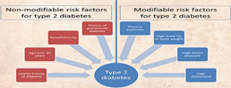
Diabetes
- NHS (2019) Diabetes is a serious health problem that can happen when your body does not produce enough natural insulin, and the glucose levels in your bloodstream rise.
- The two different types are called Type 1 and Type 2, in this presentation we will go in depth on Type 2 and its prevention. All types of diabetes are very dangerous, however, with a healthy lifestyle and some medicine it can be dismissed. Some of the main signs of having type 2 diabetes might be:
- high blood pressures
- high cholesterol
- heart attack
- stroke
- peripheral artery disease including foot ulcers and amputation
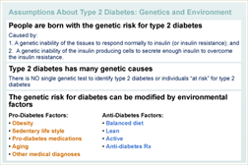
- kidney disease and renal failure

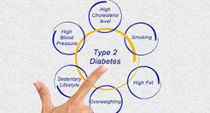

- Godfrey(2020) If ever craving a snack make something involving any type of walnuts, peanuts or almonds mixed with things like yogurt and salads.
- We want to lower fat intake, and this can be done by eating no other fats apart from virgin olive oil, it has all the natural fats needed for the body and is good for your health.
- Rely on things like beans and chickpeas for protein and good fibre within your body.
- When making a diet plan try to direct yourself towards using fruits and vegetables balanced along with any other food eaten.
- Try to weigh yourself regularly so that you can stay within a weight range.
- Find an expert that can help you find the right diet and intake for you.
- Ask someone, family or friends to join you on doing exercise outside, start with walk and then jogging.
- Make sure to never forget to take the prescribed medication as it can cause further serious damage.
- vision loss (retinopathy)
- nerve damage (neuropathy)
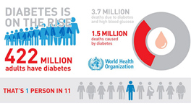


List of references
Gaesser. G. A (2007) Current Diabetes Reports, 7(1), pp 14-19
Good news for those with type 2 diabetes: Healthy lifestyle matters – Available at: https://www.health.harvard.edu/blog/good-news-for-those-with-type-2-diabetes-healthy-lifestyle-matters-2020021718827 (Accessed: 10 November 2020)
Godfrey J. Diabetes and Heart Disease: 5 Lifestyle Fixes for Head-to-Toe Health, [ONLINE] Available at https://www.endocrineweb.com/news/diabetes/59897-diabetes-heart-disease-5-lifestyle-fixes-head-toe-health, (Accessed on 15 November 2020)
Josh (2020),20 Most Common Medical Conditions affecting Older people,[ONLINE] Available at https://www.lifeline24.co.uk/medical-conditions/ (Accessed, 15 November 2020
Type 2 diabetes- Epimigrant Available at: http://www.epimigrant.eu/type-2-diabetes (Accessed:10 November 2020)
Type 2 treatment diagram: Available at: https://www.hamad.qa/EN/your%20health/Diabetes/About-Diabetes/Pages/Type-2-Diabetes.aspx (Accessed: 10 November 2020)
Torgerson J. S et all (2004) Diabetes Care, 27 (1) pp 155-161
[online] Available at https://hopkinsdiabetesinfo.org/genetic-and-environmental-risk-factors-for-type-2-diabetes/, (Accessed on 15th November 2020)

