Title of the report- Problem solving and decision making.
Name- Hannah Roberts-Davies
Name of host of organisation- Ford
Date of Report publication- 10/01/2020

Executive summary
This is a report looking at the problems faced by ford. This will highlight the company’s faults and areas that can be improved through the company. The researcher will look at nature, scope an impact on the problem ford faces, and there will be a swot analysis of the company showing what areas need working on successfully. A Pestle on macro environment will be conducted and solutions recommendations will be looked at.

Contents page

- Introduction pg 4
- Findings pg 5
2.2 Fords current problems pg 6
2.2.1 Nature, scope, impact pg 6/7
2.3 Swot Analysis pg 8
2.4 Pestle Analysis pg 9/10
3.0 Conclusion pg 11
4.0 Options pg 12
5.0 Action plan pg 13
6.0 Appendices pg 14
7.0 Acknowledgments pg 15
8.0 Reference list pg16

1.0 Introduction
This report was requested by the managing team at fords moto company, it was requested on the 04/11/2019. The report will be compiled by Hannah Roberts Davies. The deadline for the report to be sent is 10/01/2020. The purpose of the report is for an outline of the problems ford are facing as a company. The report will analysis using SWOT analysis and PESTLE to collect information needed for Ford to resolve current issues facing the company. The researcher will also give an opinion and suggestions that the researcher feels necessary to resolve issues that the company are currently or will face in future.

2.0 Findings
Ford Moto company is a global automotive and mobility company that has its headquarters in Dearborn, Michigan and Detroit. It was founded by Henry Ford and incorporated on June 16, 1003. The business also includes, design, manufacturing, marketing and serving a full line of ford cars, trucks, and sport utility vehicles, as well as luxury vehicles. The company run in four sections: Automotive, financial, services, ford and Lincoln brand vehicles, service parts and accessories across the world.
Ford is the second largest family-controlled company in the world, ford family was founded and controlled 110 years ago. Henry Ford built his first car in 1896, this was called the quadricycle. Henry Ford’s first adventure into manufacturing cars was the Detroit Automobile company that was founded in 1899. Further down the line the company was recognised as the Henry Ford company in 1901.
A year on in 1902 Henry Ford had a miss understanding with his financial backers and decided to leave the company with the rights to his name and $900, although in 1902 this was probably a lot of money.
The researcher has researched some of fords products they have on the market, Ford mobility is quite a new product, ford is focusing on future mobility solutions for the EU that includes business solutions, city solutions, citizen solutions and autonomous vehicles. Ford have the Explore Eco Sport and many other vehicles.
Ford have said in march 2018 that globally it will be creating 16 fully electrical vehicles and 40 electrical vehicles through 2020. The all-new Mustang Mach-E, a fully electric performance utility vehicle is one of fords newest electrical car modules, research has shown has shown that electric cars are better for the environment by emit less greenhouse gases and air pollutants over time than what a petrol or diesel will. This has had a big impact on the carbon footprint as electric cars ‘carbon emissions have been seen to be four times greater in places with coal dominated generation than in those with low carbon power.
There seems to be a lot of competitors like Tesla being one who are said to have better quality and at a better price range than Ford, customers are favouring Tesla because they have had plenty of good financial news over the past year unlike Ford.

2.2. The researcher has found from studying the case study that it looks like Ford moto company are having to deal with several problems as the company fails to win over Wall street. Shares are down 22 percent and the companies even made big moves like leaving the Sedan market. Wall street say that they are just frustrated and tired of waiting. Jim Hacket appealed at a presentation that he needed more patience and belief in his “thoughtful” approach in engineering a $11 billion restructuring company. The investors responded by sending shares down more than 6 percent, this is the biggest drop in a year. Ford has also had taxes fall 27 percent before interest.
It seems like Ford are not moving quick enough and there for this is resulting in Wall Street not being convinced and this will lead to further reduction in shares.
It is believed that Hacket is struggling to convince Wall street it hasn’t help matters with cancelled meeting and a series of let downs and course corrections have shaken Wall Street’s faith.
2.2.1 Nature
Fords Chief executive officer Jim Hacket says shares are down 22 percent during his tenure, even moves like leaving the America Sedan market and a deal to align with Volkswagen AG to develop new modules hasn’t helped the drop-in shares.
Earlier this month ford reported a 4.9% drop in third quarter comparative sales, shares have dropped in Americas oldest auto manufacturer into a test of Dec 2018s new year law at $7.41. Strength continued in pickup trucks sales failed to offset weakness in other categories, as tariffs overseas rise growth has taken a major hit and deteriorating sentiment for American products.
Finally, while Ford's truck sales were up, there are reasons for concern. Ford's commercial vans are doing well, but sales of its F-Series pickups -- a primary driver of profit for the company -- fell 6% in the quarter, losing ground to newer models from General Motors (NYSE: GM) and Fiat Chrysler Automobiles (NYSE: FCAU). (About See All About Our People Careers Press Centre Contact Quick Links Nasdaq MarketSite Investor Relations Diversity, I., Quick Links Nasdaq MarketSite Investor Relations Diversity, I. and Diversity, I. 2019).

Scope
Ford has more new SUVs on the way and an all-new F-150 pickup coming next year. It's not surprising that it lost some ground in the third quarter, but investors will want to hear that things are on track when Ford reports earnings on Oct. 23. (About See All About Our People Careers Press Centre Contact Quick Links Nasdaq MarketSite Investor Relations Diversity, I., Quick Links Nasdaq MarketSite Investor Relations Diversity, I. and Diversity, I. 2019).
The researcher has found from the case study that chief executive officer Jim Hacket was criticised for moving too slowly to fix fords shortcomings, this has had a big impact on shares falling as wall street isn’t being convinced that things are going to turn around and get on the right path.
Impact
As a company this would majorly affect Fords staff and investors. Being an employee of ford, they would want reassurance that the company is still going to be trading and the employees would still have a job and get wages at the difficult time. As well as the problems affecting employees it would have much more of an impact on fords investors, these stand to face a lot of money if fords company is not trading or do not meet the standards of their products.
Ford currently employs 53,000 people in Europe, across 15 factories that’s including the two sites in the Uk. The unions have said there are a lot of talks about ford, and does not yet have a figure for the number of jobs affected but Mr Armstrong said it was “safe to say it will be thousands….it will be a significant impact on the employment members”. (f.t.com.2020).

Mr Arm strong also added that if the UK left the EU without a deal it would force the business to make deeper cuts that planned.
“If we get wrong result, then expect that results will be significantly more dramatic,” he said. “This [restructuring] is to fix the base business.”(f.t.com.2020.).

2.3 SWOT analysis on Ford

As a business, ford have experienced massive success as a company, having factories across the world America now setting a good name. (see appendices 6.0 for swot analysis table).

Strengths
Over the years ford have experienced highs and lows as a company. As being one of the players of the global automotive industry, Ford has a strong brand image that give the product definition and customer loyalty. Ford has a worldwide chain that supports it apportion around the world. Another strength is the company’s revolution process that are now more effective after the launch of the one ford plan 2008.

Weaknesses
One of fords biggest weaknesses is negative media stories, when the company was being criticised after falls to win over wall street. Ford was slammed for moving too slowly to heal the company’s ills. Fords weaknesses are mostly based on the company’s limitations compared to competitors. Having a slow innovation process is a big weakness compared to other companies, ford had also had to close some of its production facilities in Europe a few years ago making the weakness even worse. For having higher costs and prices relatively higher than other competitors.
Another weakness would be 22percent of shares had dropped as ford struggles to win wall street’s trust.

Opportunities
It is seen that ford have many opportunities, such as self-driving or autonomous cars. These could increase demand for new modules and sales and would see ford moto company doing better. The publicity-greeted new technologies could also increase interest in car purchases. Ford can increase business through market inflow and product development.

Threats
One of the biggest threats for ford is based on competition and global oil prices. Ford experiences the threat of competitors like general motors and Toyota, which attract in forceful marketing and innovation. There are also things like technology firms making driverless cars that could compete against fords products.

2.4 PESTLE Analysis
Political factor
HALFWEG, Netherlands (Reuters) - Ford is spending tens of millions of euros preparing for a possible British exit from the European Union without a trade deal and has yet to decide on its longer-term plans for Britain, Ford Europe chairman Steven Armstrong said. (U.S. 2020).
There are many reasons when running a business why political factors are important. The uncertainty of Brexit will have its impact on how ford moto company operate their business chances. This will highlight each mistake the company does and how it effects factories that are already struggling in the uk.
Ford has been warned it will reconsider its uk investments if MPs cannot agree a Brexit deal. “We’ve been very consistent since the referendum that a hard Brexit, a no-deal Brexit, would be a disaster for within that of course I cant ford moto company” Mr Armstrong told the news agency. (The independent.2019.)

Ford moto company must address the political aspect as an external influence. Government support for technological innovation, increasing international trade agreements and increasing governmental effort for infrastructure in developing countries are all political factors significantly affecting ford.

Technology Factor
With any company these days technology has a massive effect on all businesses, it can have a positive impact on fords business but can also have setbacks which would be at a negative experience.
As an organisation ford would be looking for all the positive experiences that they can, technology would be a huge support to ford if used correctly. Cars are changing each year with the astounding new technology that is offered throughout the new use of technology offered.
The automotive industry is one of the UK’s fastest-changing sectors, something that is all too evident when those who only trade in their cars or vans on an irregular basis finally decide to upgrade. Much of this is as a result of technology, whether that’s simply reflecting wider consumer trends or more fundamental changes that could affect the design and role of vehicles and even how we move around in the future. (Economia.icaew.com. 2020).
The negative impact of technology for the company would be technology does not work when it should do. This would be a massive problem for the car company, it could cost a lot of money to fix technology problems they may face in the making of a new car.
The advent of driverless cars is going to disrupt and revolutionize the way people get around. While there is likely to be a net positive benefit to society, there will also be unintended consequences to consider. These negative effects range from the serious—the potential loss of millions of driving jobs along with a collapse of the traditional auto industry—to the silly (more people will be puking).

Economic
Ford moto company must always keep an eye on changing economic conditions. Thing like growth of the U.S economy, the high growth rate of developing markets and strengthening U>S dollars are all economic external factors significant to ford.
Ford has the opportunity to grow based on the slow but notable growth of the U.S. economy, which is the company’s biggest market. Ford also has the opportunity to grow in high-potential developing countries, where the company still has limited presence. (Panmore institute.2015).
Economic factors play a big role of dealing with how profitable the environment is for brands. Since the recession has passed the situation has improved. Ford has seen highly encouraging sales in China and India as they are the trading economies of the region they’ve kept performing well. Ford have seen economic growth in these areas and has resulted in an influx of foreign brands to hack into the Asian markets. Better rate of employment and higher dispensable income when the economy grows.

3.0 Conclusion
3.2 The main issues faced by ford in this report are that Ford moto company shares are falling dramatically, the company are not responding quick enough and prices on products need to looked at carefully; Ford are taking the necessary procedures by making big moves like leaving the Sedan American market but unfortunately even that didn’t help matters.
By taking certain opportunities Ford can turn weaknesses into strengths for the business to excel further and to improve profits, However, decisions that Ford make need to be represented better.

4.0 Options
Ford moto company is known worldwide as one of the veterans in car manufacturing. The company has recovered unseized positions and opportunities. The company has had years of growth but has started to have difficulties. The researcher will look will look at options to resolve and improve Fords current problems.
Looking at the researchers finding and conclusion it I seen that Ford is at an all-time low with shares down 22 percent, Ford needs to remember that price is the only one element of marketing mix that produces revenue: the element produce costs from economics, its known that the relationship between price and demand is that the higher the price, the lower the demand. The Auto moto market is seen to be price sensitive, because for almost always customer the automotive industry is quite expensive, although the demand is flexible and sellers can not consider lowering the price to up shares. Ford are needing to improve and design more electric cars like its competitors to succeed and stop shares from dropping.

5.0 Action plan
5.1 In this action plan there will be several options to help improve Fords current problems as a company, the researcher has come to a resolution that Ford need to concentrate more on manufacturing new modules at a faster speed and making more cost effective electric cars like its competitors. Having a better time scale will help improve shares, Hacket admits that some organisational changes have taken about four months longer than he expected. Ford can improve moves like this by giving a larger time scale form big projects.
Hacket said “Were about action now”, “Iv made it clear to my team we have to demonstrate results”. (Automotive news.com.2020).
Ford are needing to treat each vehicle like it is its own business and focus on how to make it profitable.

6.0 Appendices
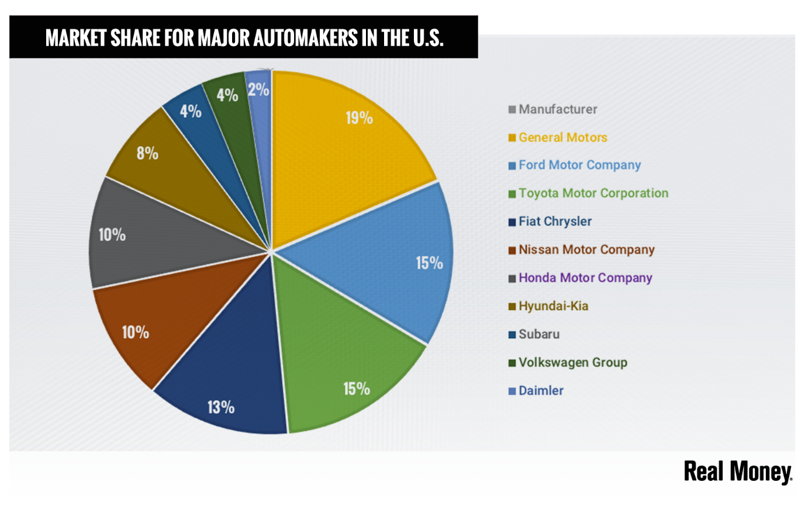(Ford company growth.google.com.2020).

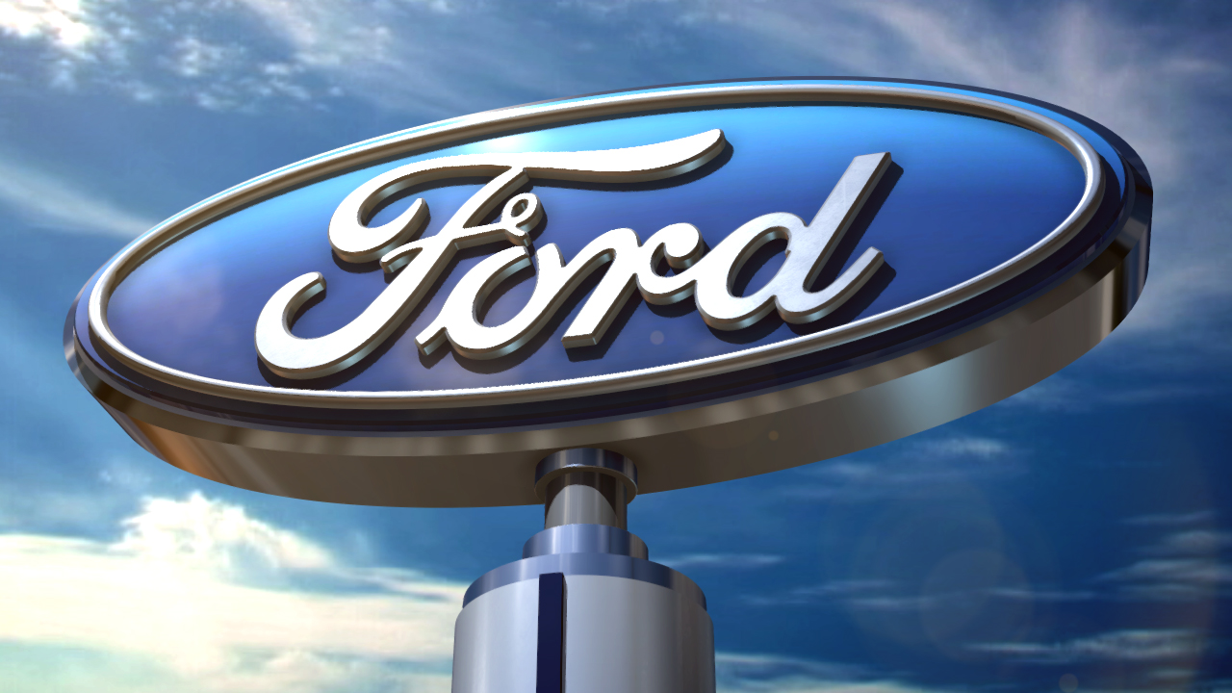
(Ford moto company.google.com.2020).
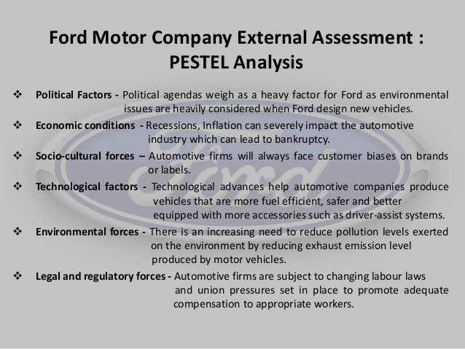
(Slideshare.net.2020).

Strengths  Strong brand name  Strong position in the American market  Popular models | Weaknesses  Slow redesign of models  Sales 22 percent  Poor reputation with investors
Opportunities  New automotive technologies  Volkswagen diesel scandal  New uses for vehicles | Threats  High oil prices  New entry of high-tech firms  High competition

References
About see all about our people careers press centre contact quick links Nasdaq Markesite Investor Relations Diversity, I,, Quick links Nasdaq markesite Investor Relations Diversity, I. and Diversity, I. (2019). Why shares of ford moto company are sagging today. (online) Nasdaq.com.Available at https://www.nasdag.com/articles/why-shares-of-ford-moto-company-are-sagging-today-2019-10-02 (accessed 7 jan.2020).

Economia.icaew.com.(2020). Hoe technology is impacting the auto motive industry. (online) Available at https://economia.icaew.com/option/october-2016/how-tech-is-impacting-the-automotive-indusrty (Accsessed 7 jan 20220).

Ford moto companySwot Analysis-panmore institute panmore institute.(2015).Ford moto company swot analysis-panmore institute.(online) available at http://panmore.com ford-moto-company-swot-analysis(acsessed 27 nov 2019).

Ft.com. (2020). Ford to cut thousands of europian jobs in saving drive/financial times. (online). Available at : https://www.ft.com/content.(Acsessed 7 jan. 2020).

Investopedia.(2020). The Unintended con sequences of self-driving-cars.(online). Available at: https://www.investpedia.com/articles/investing/090215/unintended-consequences-selfdriving-cars.asp (Acsessed 7 jan .2020).

The independent. (2019). Ford warn no-deal Brexit will force it to reconsider uk presence.(online) Available at: https://www.intependant.co.uk/news...no-deal Brexit no-deal-brexit-uk-car-manufacturing-investment-steve-armstrong. (Acsessed 7 jan.2020).

Reference list

