Problem Solving and Decision Making
Student ID: 2107120
Student Name: Mirela Oprea
Course ID: BMSW4004_BIRM
Lecturer: Chijioke Uba
Task 2: Final Report

Executive Summary
This is a formal report based on the case scenario presented in the assessment regarding the complex problem of staff shortage within the NHS. This report investigates the nature and impact of the problem along with performing a PESTLE analysis to examine the external factors contributing to the problem. A fishbone diagram is presented to demonstrate the causes and effects relating to the problem based on which solutions are given. Each of the solutions is analysed using PMI analysis and their key success indicators are listed.

Table of Contents
Introduction 4
Planning on implementing the decisions to solve the complex problem 4
The nature and impact of the employee-related complex problems and the organisations 4
PESTLE analysis identifies the macro-environmental factors leading to the complex problem 4
A Fishbone Diagram analysing the cause-and-effect of the problem 5
Solutions (PMI Analyses) 6
Discussion on the success indicators to measure the effectiveness of these solutions 7
Evaluation of the alternative solutions to absenteeism and the mitigation of the problems 7
Indicators for the effectiveness of the solutions 8
Conclusion 9
References 10
Appendices 12

Introduction
This formal report is concerned with the problems of staff shortage faced by the NHS due to a wide range of factors. The organisation has been found to be witnessing a shortage of over 100,000 staff in one of every eleven positions (Haddad and Toney-Butler, 2022). As nurses and other staff are the key care providers in healthcare, their shortage can create extreme stress on the system and affect the service provided by the system of health and social care. The aim of this study is to analyse the problems in health and social care and develop feasible solutions for addressing the issues currently experienced by the organisations. This study further evaluates the solutions individually using the technique of PMI analysis where the negative and positive attributes of the solutions are analysed along with their interest points.

Planning on implementing the decisions to solve the complex problem

The nature and impact of the employee-related complex problems and the organisations
Nature
Shortage of staff is one of the most critical challenges in healthcare as the whole service is dependent on the skills and productivity of the workforce (Quirk et al., 2018, p. 10). In the NHS and Proper Care staff, the shortage has been affecting the quality of the health system. Furthermore, the shortage of staff has been putting extra pressure on the available care providers declining the interest of existing and potential workers from remaining in or joining the healthcare workforce.
Impact
Constraints of staff have been reducing the capability of organisations like the NHS to cater to the huge number of patients that get admitted to the healthcare setting on a daily basis (Gray et al., 2018). Many patients have also been found to be on the waiting list. Therefore, the problem of staff shortage has been evidently increasing the rate of mortality and delay in patient care. Consequently, patients waiting to get treated for a long time have been deteriorating and even dying without care.

PESTLE analysis identifies the macro-environmental factors leading to the complex problem
Political factors: - An increased net outflow of nurses from the NHS after Brexit has been deepening the staff shortage in the organisation.
- The removal of the NHS bursary for attracting more professionals has been an unsuccessful effort by the government (Val et al., 2021).
Economic factors: - Healthcare organisations have been struggling with funds to afford more nurses.
- Low wages have been decreasing the appeal of the sector (Heery et al., 2020, p. 397).
- The recessing economy has been leading to staff decline in the UK.
Social factors: - The aging population has been unable to produce an adequate number of young employees.
Technological factors: - A skill gap is evident in the handling of innovative technologies in the NHS (Castle-Clarke, 2018).
Legal factors: - There are legal complaints about the NHS recruiting staff on zero-hour contracts with low wages.
Environmental factors: - NHS has a poor waste management system causing a huge medical waste criticised by communities.

A Fishbone Diagram analysing the cause-and-effect of the problem
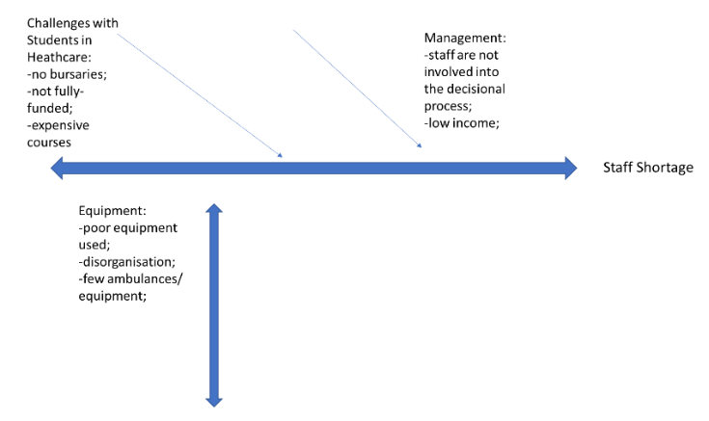
Figure 1: Fishbone Diagram for cause-effect analysis
(Source: Developed by the author)
The fishbone diagram helps in analysing a situation by identifying the cause and effect relationships between variables (Kane and Kane, 2014). The above diagram has shown the potential causes leading to the shortage of staff in the NHS and the overall healthcare system of the UK. Despite the removal of bursaries in the NHS the percentage of students taking admission has lowered. Moreover, the courses have been found to be expensive which is unaffordable for many students and the training and courses are not completely funded creating difficulties for the organisation to execute them effectively. There are also problems related to equipment including a lack of innovative equipment, shortage of ambulances, poor organisation, and technical skill gaps making service delivery difficult. The hierarchy of the NHS keeps staff unengaged in the decision-making, reducing their commitment to the organisation. The low wages and extra pressure on staff have been making the job unattractive leading to turnover and constraints in the recruitment of new staff. Brexit is a major reason for the staff shortage in the NHS.

Solutions (PMI Analyses)
Greater funding in the health system, by raising the income in healthcare
Plus: The key positive attribute of this solution is the scope of increasing the economies of scale for the NHS to enhance the capabilities of resources. An increase in funding can help the healthcare system provide standard wages to staff increasing the competitiveness of the national healthcare system. It has been found that private healthcare organisations provide greater wages compared to government settings. Furthermore, a key reason for staff shortage is also the low wage diminishing the attractiveness of the industry. Hence a higher fund can further improve the wage and interest in the organisation.
Minus: According to the opinion of Proctor, (2020), every solution has its upside and downside. The solution suggesting the increased funding implies the need for further investment into the sector. As the government is the key authority of the NHS providing the majority of the fund, therefore, it is the responsibility of the government to heighten the investment. The minus point of this solution is that the government requires more funds to be invested in the NHS.
Interesting: This solution can help the NHS attract more employees by offering a standard wage. The organisation can revive the appeal of the job placements among potential employees by offering a competitive salary similar to other sectors.
Encouraging health students through scholarships, funding
Plus: A key cause of staff shortage in healthcare has been found to be the expensive courses and their unaffordability for many students. Hence this solution of fund provision and scholarship programmes can help students who are financially weaker to pursue health education. As a larger number of students take up health education leveraging the scholarship programmes and funding facilities the organisation can ensure more number of training staff in the next few years. It can benefit both organisations and individuals as the healthcare service is likely to gain more staff with adequate knowledge and skills while more individuals can find job opportunities. This solution is expected to enhance the workforce size and capabilities in the healthcare system including the NHS in the UK.
Minus: Scholarship programmes and fund facilities are likely to need more investment from the government as the NHS is governed by the central authority. Hence this solution can lead to additional expenses for the government. There is a prominent distinction between the healthcare sector and other sectors. Scholarship programmes are likely to challenge the current infrastructure of the healthcare education system.
Interesting: As opined by Houseworth, (2020, p.193), an increase in the opportunity to access enhances the competition within a field. Therefore, the scholarship programmes and fund solution is likely to increase competition among learners in different courses. However, this solution can inevitably mitigate the problem of staff shortage for the organisation.

A stronger organisation - each department should have well-trained staff to carry out appropriate treatment of people
Plus: The main benefit of this strategy is the collective development of the organisational workforce. According to the postulation of Waters, (2022), healthcare staff need superior training and skills development opportunities to be capable of catering to the dynamic needs of patients in the sector. Through a stronger organisation and robust departmental training, the NHS can ensure that nurses and care providers have sufficient capabilities and expertise in their respective roles. Furthermore, smart workforce organisations can also aid in mitigating staff constraints in departments by distributing workers equally in every department.
Minus: This solution requires a separate specialisation course within the organisation so that individuals can develop expertise in specific areas. Organisations of specific departmental training and learning programmes can be difficult to implement.
Interesting: As per the view of Waters, (2022), a clear and definite organisation of roles and responsibilities is beneficial for all institutions and enterprises. Hence, this solution can enhance the clarity of tasks for staff in every department.

Discussion on the success indicators to measure the effectiveness of these solutions

Evaluation of the alternative solutions to absenteeism and the mitigation of the problems
The above fishbone diagram has listed key causes of staff shortage in the NHS. It has analysed the causes of the problem on three levels including students, equipment, and management. According to the PMI analysis, an increase in funding, organisation of departmental staff, and training, along with student empowerment through funding and scholarship programmes have been evaluated to be the most effective solutions for the problem of staff constraint in the National Health Service. The PMP analysis has analysed the solutions based on their plus points, minus points, and points of interest.
The developed solutions are effective in terms of addressing the high absenteeism in the organisation. As opined by Moscelli et al., (2022), a lack of motivation is the main reason for absenteeism in the workplace. The increased work pressure on existing staff has been leading to extreme exhaustion and dislike for the job. Moreover, the payment received by the staff is not justified by the amount of work they are delegated lowering their level of motivation. Therefore, increasing their wage by more funding in healthcare can improve their motivation while supportive programmes are likely to attract more students to fill the gaps in the workforce.

Indicators for the effectiveness of the solutions
Staff satisfaction: The NHS must assess the satisfaction rate of its staff on a regular interval to measure the effectiveness of the plan. It can indicate whether the pressure on the staff has decreased or not as well as whether the salary paid by the employer justifies their work.
Staff turnover rate: According to the opinion of Houseworth et al., (2022, p. 197), the success of an employee development programme can be judged based on the rate of their turnover. In the case the turnover of nurses in the NHS remains the same or increases in the next 1 or 2 years, it indicates that the plan has been a failure. On the other hand, a low turnover rate would indicate the effectiveness of the new plan.
The number of new staff: The key purpose of the solutions developed above is the mitigation of staff shortage and restoration of job attractiveness in the healthcare service of the NHS. Therefore, the number of new recruits can indicate the appeal of the job positions. A higher number will simply an improved attractiveness of the job offer.
Patient satisfaction rate: All organisations need to conduct patient surveys and take feedback from them to assess organisational performance and service quality (Sizmur and Raleigh, 2018, p. 24). Therefore, the NHS should ask patients for their feedback and survey them regarding service delivery and their experience within the organisation. It can indicate positive or negative changes in the workforce capabilities and delivery of services after the implementation of the plan.
Waiting list of patients: At present, the patient waiting list in the NHS is high due to the shortage of staff and the inability of the patients. Therefore, the organisation should review and monitor the waiting lists after plan implementation to see the efficacy of the plan to cater to the needs of patients.
Action Plan
Objective | Specific | Measurable | Attainable | Realistic | Time Bound
Employee engagement | Employee engagement is needed to conceive more potentially engaged employees in the NHS who could commit their responsibility to favour better healthcare. | Employee engagement could be measured by raising socialness and tolerance factor among diverse staff who could merge their expertise to form a potential workforce. | For employee engagement staff would be required to attain webinar sessions, training activities and group activities where they could mark each other's efficiency and raise engagement utility. | Employee engagement helps in boosting the diversification factor at NHS and it would definitely raise staff towards a potentially advanced level where they could ensure their retention for completing duties at NHS. | 3 months
Staff training | Staff training at NHS is required to provide the patients with proper treatment which is needed highly to retain the trust on the staff at NHS. Additionally, training would provide the staff at NHS to experience the fulfilment of being a part of the most concerned healthcare institute in UK. | Staff training could contribute a level up in the staff potential and their acknowledgement regarding new technologies that could raise professional recognition of the NHS globally. | Staff training could help engage different medical staff in group projects that could help them identify their weaknesses and strengths and also they could earn an opportunity to learn through experts in the group. | Staff training possibly conducts healthy belongingness among healthcare staff and shares equal space at the NHS. Moreover, it could help them raise their potential towards healthcare duties that could possibly reduce patients’ issues at the NHS. | 4 months

Conclusion
To conclude, the problems of the lack of staff in the NHS has been resulting from various causes. In the above study, the causes have been identified via the fishbone diagram with their direct and indirect effects resulting in the constraint of nurses in the organisation. Furthermore, a PMI analysis has been conducted to provide possible solutions to the identified challenges with the evaluation of the minus, plus, and interest points of each suggestion. Finally, the success indicators have been listed that can be used to measure the effectiveness of each plan after its implementation.

References
Castle-Clarke, S., 2018. What will new technology mean for the NHS and its patients?. https://apo.org.au/node/205731?utm_source=APO-view&utm_medium=more-like-this&utm_campaign=resource-mlt
CIPD., 2021. PESTLE Analysis. [online] CIPD. Available at: https://www.cipd.co.uk/knowledge/strategy/organisational-development/pestle-analysis-factsheet #gref. (Accessed date: 03/08/2022).
De Val, J., Sohal, G., Sarwar, A., Ahmed, H., Singh, I. and Coleman, J.J., 2021. Investigating the challenges and opportunities for medicines management in an NHS field hospital during the COVID-19 pandemic. European Journal of Hospital Pharmacy, 28(1), pp.10-15. https://ejhp.bmj.com/content/28/1/10.abstract
Gray, K., Wilde, R. and Shutes, K., 2018. Enhancing nurse satisfaction: an exploration of specialty nurse shortage in a region of NHS England. Nursing Management, 25(1). https://journals.rcni.com/doi/aop-pdf/10.7748/nm.2018.e1695
Haddad, L.M. and Toney-Butler, T.J., 2022. Nursing shortage. [online] NCBI. Available at: https://www.ncbi.nlm.nih.gov/books/NBK493175/. (Accessed date: 03/08/2022).
Heery, E., Hann, D. and Nash, D., 2020. Political devolution and employment relations in Great Britain: the case of the Living Wage. Industrial Relations Journal, 51(5), pp.391-409. https://onlinelibrary.wiley.com/doi/abs/10.1111/irj.12306
Houseworth, J., Pettingell, S.L., Kramme, J.E., Tichá, R. and Hewitt, A.S., 2020. Predictors of annual and early separations among direct support professionals: National core indicators staff stability survey. Intellectual and developmental disabilities, 58(3), pp.192-207. https://meridian.allenpress.com/idd/article-abstract/58/3/192/436579
JD (n.d.). How To Use the PMI Technique to Think Better. [online] Available at: https://sourcesofinsight.com/avoid-the-intelligence-trap/. (Accessed date: 03/08/2022).
Kane, R. and Kane, R., 2014. How to Use the Fishbone Tool for Root Cause Analysis. [online] Available at: https://www.cms.gov/medicare/provider-enrollment-and-certification/qapi/downloads/fishbonerevised.pdf. (Accessed date: 03/08/2022).
Moscelli, G., Sayli, M. and Mello, M., 2022. Staff Engagement, Job Complementarity and Labour Supply: Evidence from the English NHS Hospital Workforce. https://papers.ssrn.com/sol3/papers.cfm?abstract_id=4114685
Proctor, T., 2020. Creative problem-solving techniques, paradigm shift and team performance. Team Performance Management: An International Journal. https://www.emerald.com/insight/content/doi/10.1108/TPM-06-2020-0049/full/html
Quirk, H., Crank, H., Carter, A., Leahy, H. and Copeland, R.J., 2018. Barriers and facilitators to implementing workplace health and wellbeing services in the NHS from the perspective of senior leaders and wellbeing practitioners: a qualitative study. BMC public health, 18(1), pp.1-14. https://bmcpublichealth.biomedcentral.com/articles/10.1186/s12889-018-6283-y
Sizmur, S. and Raleigh, V., 2018. The risks to care quality and staff wellbeing of an NHS system under pressure. The King’s Fund: Oxford, p.24. https://www.patientlibrary.net/tempgen/171238.pdf
Waters, A., 2022. NHS staff survey underlines need for national workforce strategy. BMJ: British Medical Journal (Online), 377. https://search.proquest.com/openview/05e5666ee72f85d0e7032d09b522beb6/1?pq-origsite=gscholar&cbl=2043523
www.healthywa.wa.gov.au. (n.d.). Problem solving. [online] Available at: https://www.healthywa.wa.gov.au/Articles/N_R/Problem-solving. (Accessed date: 03/08/2022).

Appendices
Appendix 1: Slide 1:
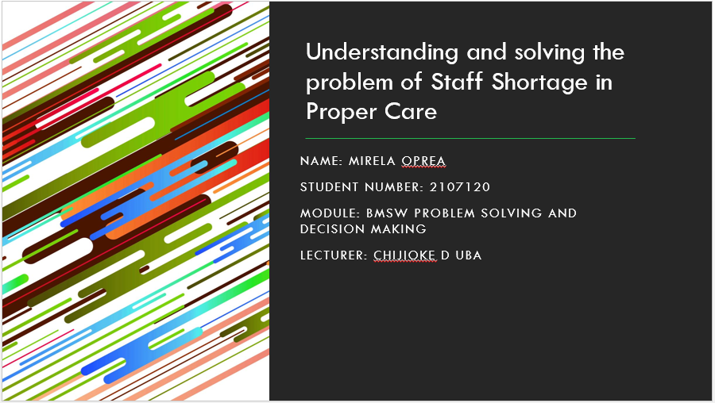
Appendix 2: Slide 2:
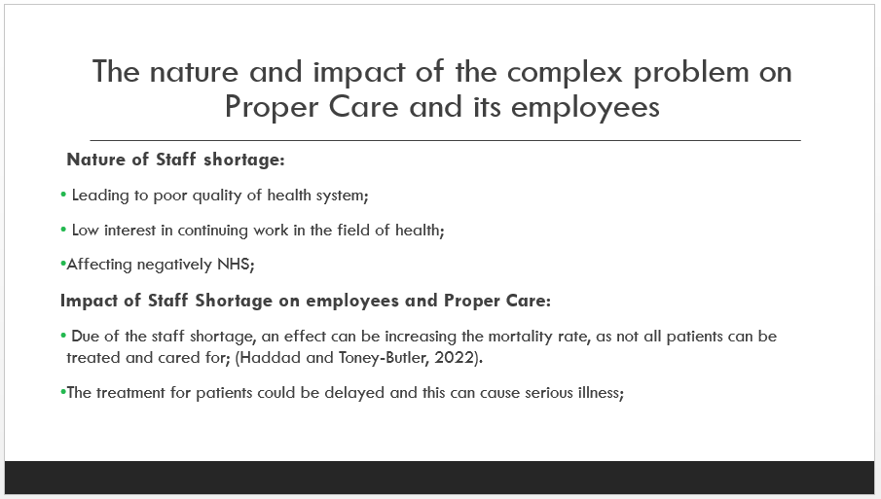
Appendix 3: Slide 3:
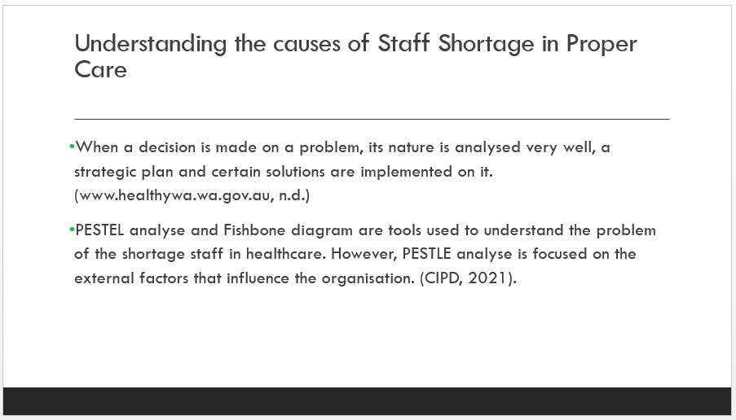
Appendix 4: Slide 4:
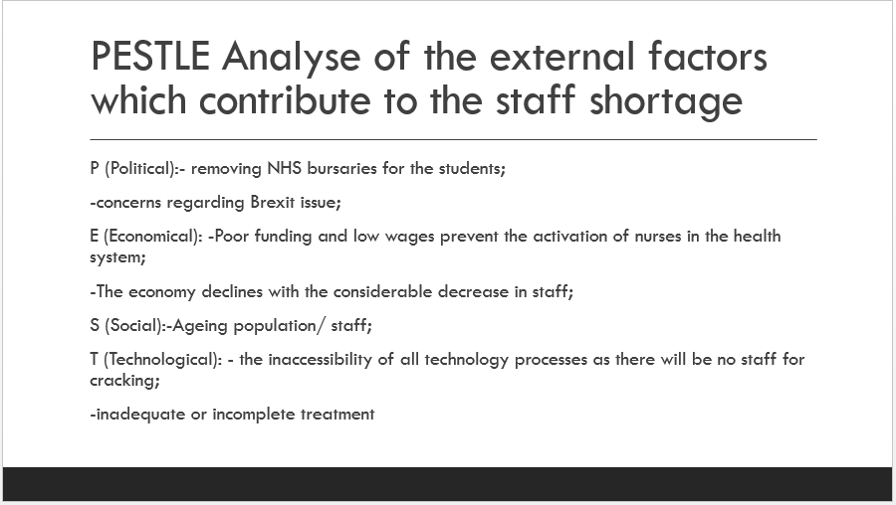
Appendix 5: Slide 5:
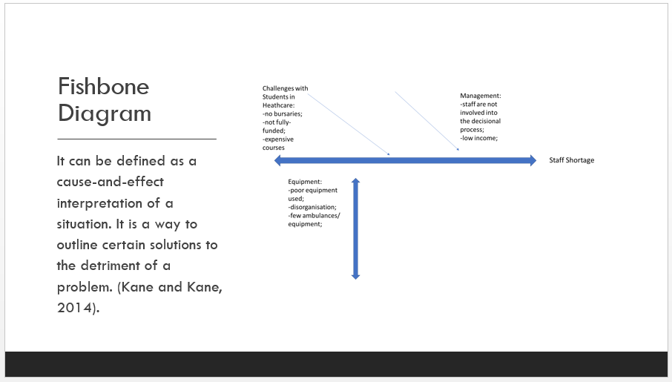
Appendix 6: Slide 6:
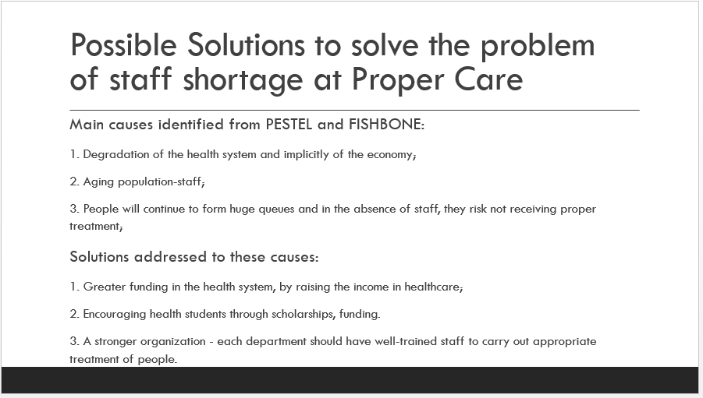
Appendix 7: Slide 7:
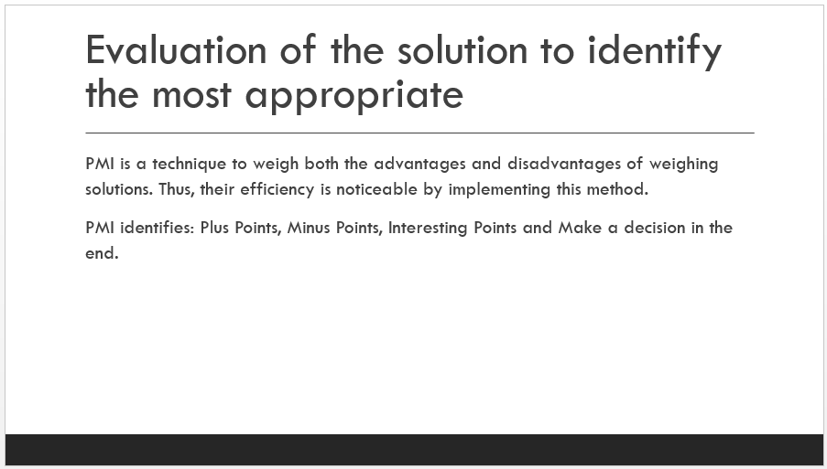
Appendix 8: Slide 8:
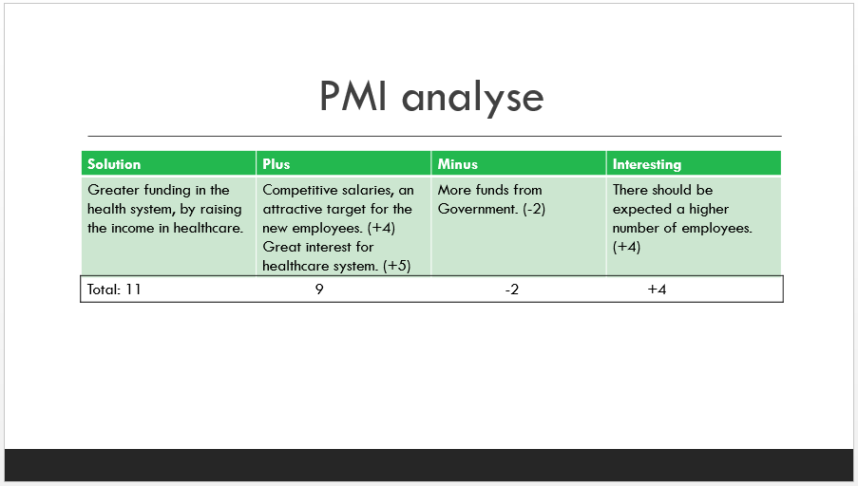
Appendix 9: Slide 9:
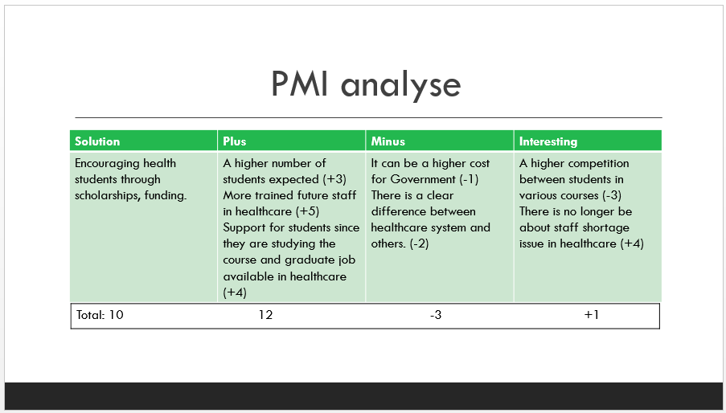
Appendix 10: Slide 10:
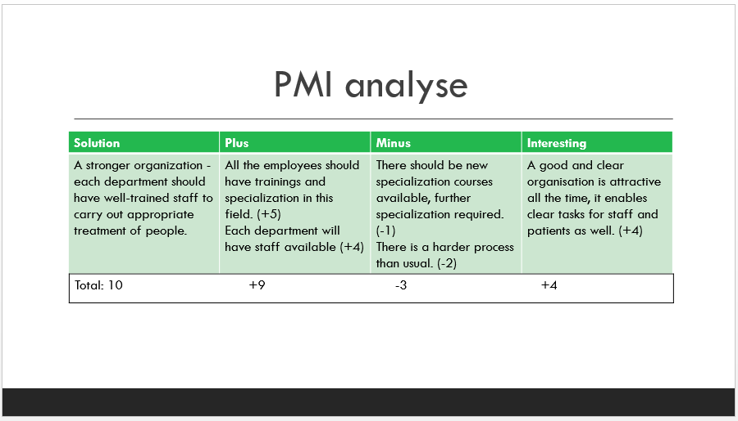
Appendix 11: Slide 11:
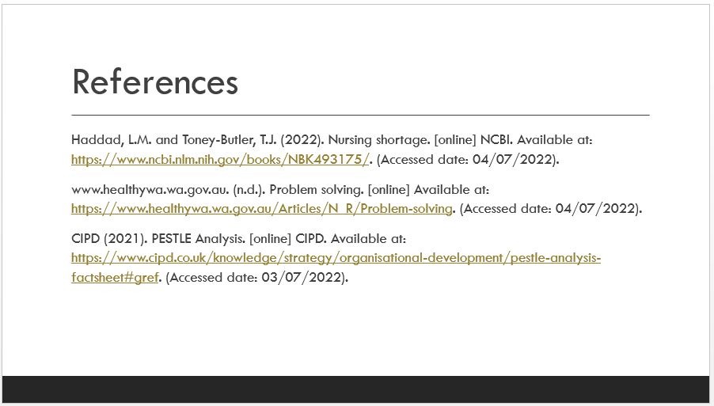
Appendix 12: Slide 12:


