VoiceTag Mobile Application Linked to Guardian Trace

Table of Contents
VoiceTag Mobile Application Linked to Guardian Trace 1
Introduction 3
Project Aim - Guardian Trace Project 3
Project Aim - VoiceTag Mobile Application 3
My Role in the Project 4
Main Idea of the VoiceTag: 4
Navigation Flow 5
System Design and Implementation Concepts (SDIC) 5
Screen Descriptions 5
Home Screen 5
Bluetooth Screen 6
Mathematical Analysis for Bluetooth Distance Estimation 7
Voice Control Screen 8
DSP link for voice recognition 8
Map Screen 10
Tools and Programming Languages 11
API Integration 12
Features of the VoiceTag App 12
Development Process 13
SWOT Analysis 13
Challenges and Solutions 14
Testing and Results 15
Project Cost Estimation 15
Conclusion 16
Future Improvements 16
What is IoT system? 17
Step by step how I created the app: 17
Code: 21
References 33

Introduction
Guardian Trace is a smart assistive tracking system designed to improve safety, accessibility, and communication for users who may require additional support in daily life. Many existing tracking systems only provide simple location monitoring and do not combine multiple technologies into one integrated solution. Guardian Trace was developed to create a more advanced and user-friendly system that combines Bluetooth communication, GPS tracking, voice recording, and mobile application integration.
As part of this project, I developed the software and mobile application component called VoiceTag. The application was created using Android Studio (freeCodeCamp.org, 2020), Kotlin (Develop Ideas, 2023), and Jetpack Compose. The app allows users to access Bluetooth scanning, location tracking through Google Maps, and voice recording features through a modern mobile interface.
The application acts as the communication layer between the user and the tracking technologies used within the project. By integrating multiple modules into one system, the project demonstrates practical mobile software engineering and system integration skills.

Project Aim - Guardian Trace Project
The aim of the Guardian Trace project is to design and develop a smart assistive tracking system that improves user safety, communication, and accessibility through integrated tracking and monitoring technologies.

Project Aim - VoiceTag Mobile Application
The aim of the VoiceTag mobile application is to develop a smart Android application that integrates Bluetooth Low Energy (BLE), GPS tracking, voice recording, and Google Maps services to support real-time tracking and assistive communication features.
Figure 1 Guardian Trace Project
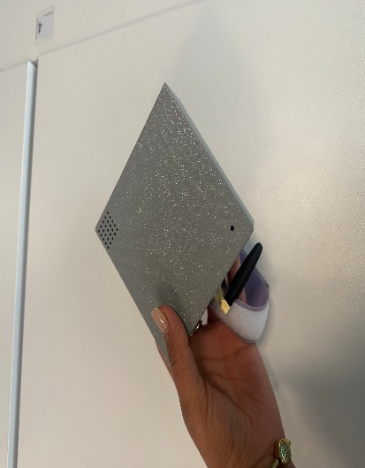
The figure 1 above shows the final physical design of the Guardian Trace smart tracking device developed.

My Role in the Project
My main responsibilities focused on mobile application development, software implementation, Bluetooth integration, Google Maps integration, voice recording implementation, user interface design, documentation, testing, and participation in team meeting minutes and collaboration scheduling throughout the development of the VoiceTag application. I contributed to the project by developing the VoiceTag Android application using Android Studio and Kotlin, while integrating Bluetooth, GPS, Google Maps, and voice recording functionalities into the mobile system.
Yacob:
As the hardware lead, I was responsible for integrating and validating the core components of the GPS tracking system, including the Arduino Nano, SIM800L EVB GSM module, and GPS module. I configured serial communication between devices, ensured proper wiring, and designed a stable power setup using external power sources and voltage regulation to meet the SIM800L’s high current requirements. I would then work with the Amani and Nariman to make sure that the app was working with the gps tracking module. And with Nariman as the lead design I was helping in seeing if the design was meeting our specification and that the design wouldn't hinder the components in working well together.
Nariman:
The Guardian Trace project was completed as a collaborative team project in which each member had specific responsibilities. My responsibility was to design a practical enclosure that could securely contain all electronic components while remaining comfortable, accessible, and safe for everyday use. This involved measuring components, planning the internal layout, creating AutoCAD models, producing prototypes, and evaluating usability. I also considered several safety factors throughout the design process, including wiring organisation, short-circuit prevention, battery protection, rounded edges, and accessibility for vulnerable users.

Main Idea of the VoiceTag:
The main idea of the system is to create a smart assistive environment that improves tracking, accessibility, and communication using integrated mobile technologies.

Navigation Flow
The VoiceTag application was designed using a modular navigation structure in Jetpack Compose. The navigation system allows users to move between different sections of the application easily using the bottom navigation bar (Boostbrands.co.uk, 2025).
The application contains four main screens:
- Home Screen
- Bluetooth Screen
- Voice Control Screen
- Map Screen
The navigation flow improves usability because users can quickly access features without restarting the application or moving through complex menus.

System Design and Implementation Concepts (SDIC)
This modular structure improves:
- readability
- maintainability
- scalability
- user experience
It also supports SDIC principles because each module works independently while remaining connected to the overall system (Tanner and Scott, 2015).

Screen Descriptions

Home Screen
The Home Screen acts as the main interface of the application, providing users with an overview of the VoiceTag system and easy navigation to other modules. The design was intentionally kept simple, accessible, and user-friendly to improve usability and readability for all users, including those who may require assistive technologies. Its main functions include serving as a welcome interface, presenting an application overview, and offering navigation access throughout the system. The Home Screen was developed using Jetpack Compose UI components such as Column layouts, Text components, and Material Design styling to create a clean and accessible interface.
Figure 2 VoiceTag Home Screen
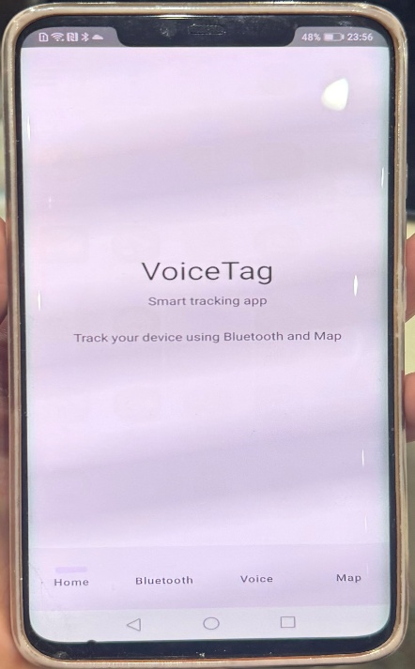

The figure 2 above shows the main interface of the VoiceTag mobile application developed in Android Studio using Kotlin and Jetpack Compose. The Home Screen provides users with a simple and user-friendly interface that introduces the application and allows navigation between the main modules, including Bluetooth scanning, voice recording, and Google Maps tracking. The interface was designed with accessibility, readability, and modern UI principles in mind.

Bluetooth Screen
The Bluetooth Screen is responsible for Bluetooth Low Energy (BLE) (K Apps, 2022) scanning and nearby device detection within the application. This module allows users to scan nearby Bluetooth devices, display detected devices, read RSSI signal values, and monitor Bluetooth activity in real time. The BLE scanner was developed using Android Bluetooth APIs and Scan Callback functions to dynamically detect and manage nearby devices. This module plays an important role in enabling communication between the smartphone and external smart devices used within the Guardian Trace system. The screen also includes key interface components such as Start Scan and Stop Scan buttons, a device list display, and scan status updates to improve user interaction and monitoring. Overall, the BLE implementation demonstrates practical mobile communication and hardware integration techniques within the application.

Figure 3 VoiceTag Bluetooth scan
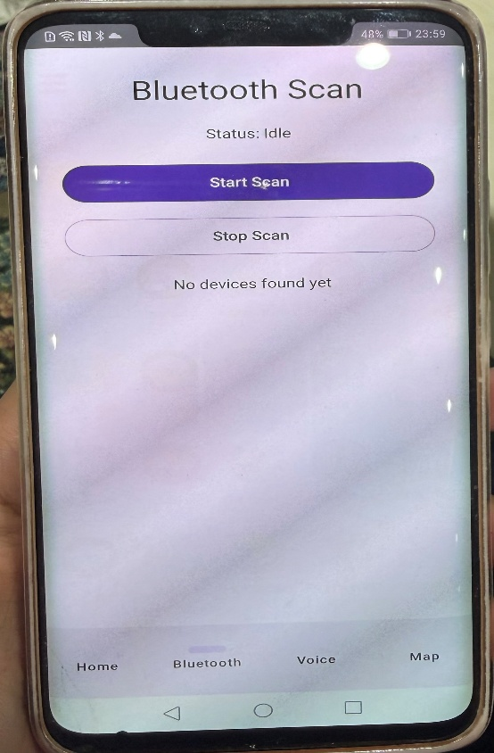
The figure 3 above shows the Bluetooth scanning module of the VoiceTag mobile application. This screen allows users to start and stop Bluetooth Low Energy (BLE) scanning using the Android Bluetooth API. The interface displays the scan status and detects nearby devices. The Bluetooth module was implemented to support smart tracking functionality and real-time device detection within the Guardian Trace system.

Mathematical Analysis for Bluetooth Distance Estimation
Path loss models can be applied to convert the recorded RSSI to distances between the mobile devices. Usually, a logarithmic path loss model for the relationship is employed. Such a model is a simple way to estimate distance with RSSI (Retscher et al., 2021). It can be expressed using the following equation:
Formula
$$d={10}^{\left(\frac{A-RSSI}{10β}\right)}$$
where d is the distance between the reference node and any nodes in [m], A is the RSSI at reference distance (1 m) and 𝛽 is a propagation constant (in free space = 2).

example:
- A = -59 dBm
- RSSI = -75 dBm
- β = 2
$$d={10}^{\left(\frac{-59-(-75)}{10×2}\right)}$$

$$d={10}^{0.8}=6.3m$$
So, the estimated distance is approximately 6.3 metres.
dBm (decibel-milliwatts) is a measurement unit used to represent Bluetooth signal strength. RSSI values are commonly measured in dBm, where stronger signals have values closer to zero and weaker signals have larger negative values (MyAmplifiers, 2022).

Voice Control Screen
The Voice Control Screen allows users to record audio directly through the smartphone microphone using the Android MediaRecorder API. This module provides functions such as starting and stopping audio recordings, storing recorded audio files, and displaying recording status updates in real time. The purpose of this feature is to improve accessibility and communication within the assistive tracking system by enabling users to capture voice input easily. The recording system was implemented using Android MediaRecorder services, demonstrating the integration between software systems and smartphone hardware services. Additionally, the interface was designed with large buttons and simple controls to enhance usability and accessibility for all users.

DSP link for voice recognition
When the user says a command, the microphone receives an analog audio signal:
$$x(t)$$
This signal is then converted into a digital signal by sampling:
$$x[n]=x(nT_{s})$$
Where:
- $x(t)$= original analog voice signal
- $x[n]$= digital sampled voice signal
- $T_{s}$= sampling period
- $n$= sample number
The sampling frequency is:
$$f_{s}=\frac{1}{T_{s}}$$
This means the voice is changed into numbers that the app or API can process.
Noise filtering
DSP can reduce background noise using a filter:
$$y[n]=x[n]*h[n]$$
Where:
- $x[n]$= input voice signal
- $h[n]$= filter response
- $y[n]$= filtered output signal
- $*$= convolution
This helps the system hear the command more clearly.
Frequency analysis
Speech can also be analysed using the Fourier Transform:
$$X[k]=\sum_{n=0}^{N-1}{x[n]}e^{-j2πkn/N}$$
This converts the voice signal from the time domain into the frequency domain, helping the system identify speech patterns.

Figure 4 voice recorder
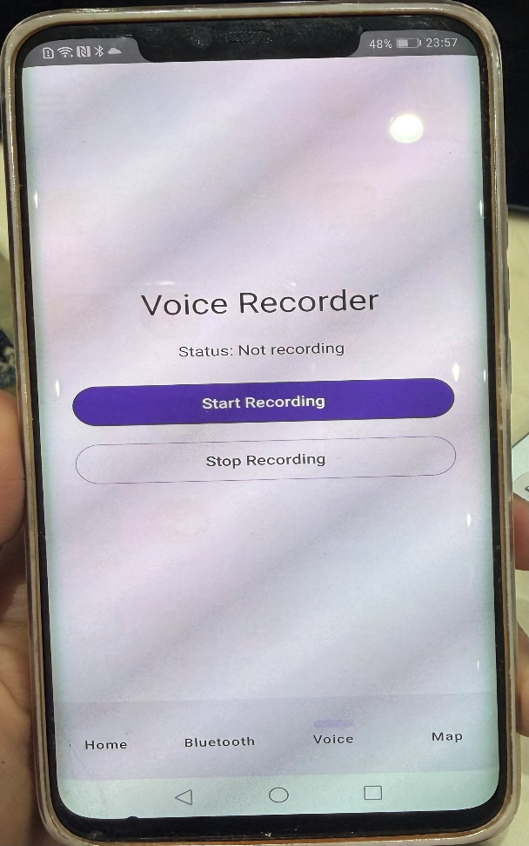
The figure 4 above shows the Voice Recorder module of the VoiceTag mobile application. This screen allows users to record audio using the smartphone microphone through the Android MediaRecorder API. The interface includes start and stop recording controls, recording status updates, and a simple accessible design. The voice recording feature improves communication and demonstrates integration between the mobile application and Android hardware services.

Map Screen
The Map Screen integrates the Google Maps API and GPS location services into the application to provide real-time location tracking and mapping functionality. This module allows users to display their current location, track GPS positions, display map markers, and move the camera dynamically based on location updates. Google Maps integration was implemented using Google Play Services and fused location providers to ensure accurate and efficient location tracking. The Map module significantly improves the practical functionality of the Guardian Trace system by providing real-time location awareness and smart tracking capabilities. Additionally, the GPS tracking system demonstrates important mobile development concepts such as API integration, location services, mobile mapping technologies, and real-time user interaction. This screen is considered one of the most important parts of the application because it connects the software system with real-world location tracking functionality (Develop Ideas, 2023).
Figure 5 Map screen
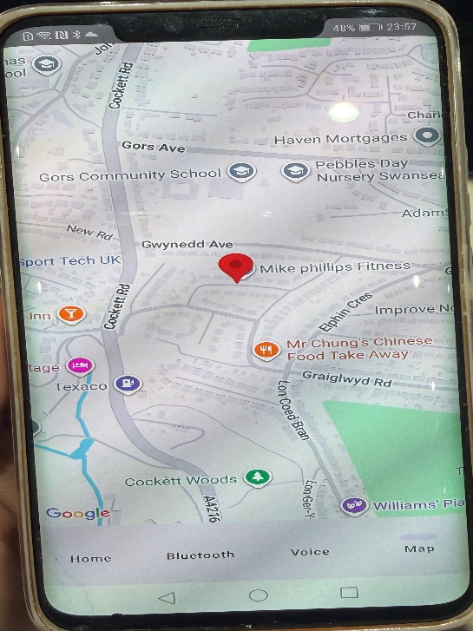
The figure 5 above shows the Google Maps module integrated into the VoiceTag mobile application. The map interface displays the user’s GPS location using Google Maps API and Android location services. A location marker is used to identify the tracked position on the map. This functionality improves real-time tracking and demonstrates integration between the mobile application, GPS technologies, and external mapping APIs.

Tools and Programming Languages
Several modern software development technologies were used during the implementation of the VoiceTag mobile application. Android Studio was used as the main development environment for designing, programming, testing, and debugging the application, while also providing emulator support, debugging tools, and integration with Android libraries. Kotlin was selected as the primary programming language because it is the official Android development language recommended by Google and offers improved readability, safety, and modern programming features. Jetpack Compose was used to design the user interface (UI), enabling the development of modern Android interfaces using declarative programming methods and improving overall UI development efficiency. In addition, Git and version control tools were used to organise project files and manage development changes throughout the implementation process, supporting efficient project management and software maintenance (Google Developers, 2019).

API Integration
The VoiceTag application integrates several important APIs to provide smart tracking, communication, and accessibility features. The Google Maps API was used for map display, GPS tracking, and location markers, while Android Bluetooth APIs enabled Bluetooth Low Energy (BLE) scanning, nearby device detection, and RSSI signal reading. The MediaRecorder API was implemented to support voice recording, microphone access, and local audio file storage. API integration allowed the application to communicate with device hardware and external services efficiently, improving functionality, supporting real-time tracking and recording, and reducing development complexity. These APIs were essential for implementing the core features of the VoiceTag system, including Bluetooth communication, GPS location tracking, Google Maps integration, and voice recording.
Figure 6 the API key
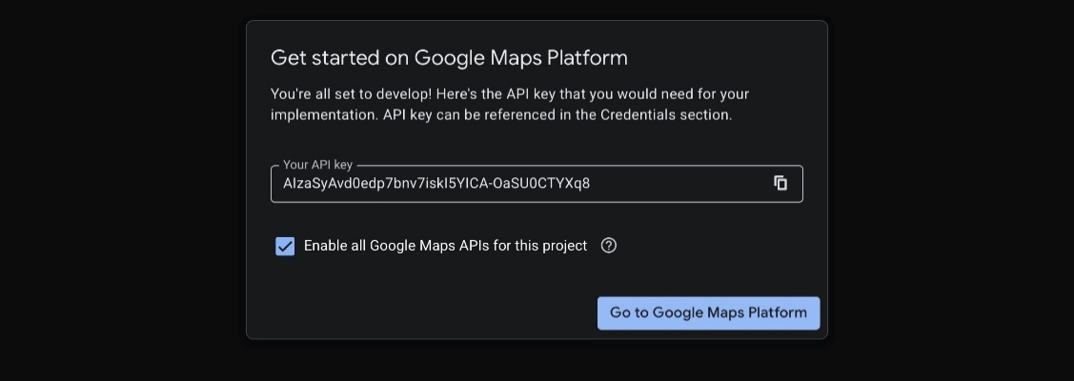
The figure 6 above shows the Google Maps Platform API setup used during the development of the VoiceTag mobile application.

Features of the VoiceTag App
The VoiceTag mobile application was developed with several smart features designed to improve tracking, accessibility, and communication within the Guardian Trace system.
One of the main features of the application is Bluetooth Low Energy (BLE) scanning and device detection. The Bluetooth module allows users to scan nearby Bluetooth devices, detect available devices, monitor Bluetooth activity, analyse RSSI signal strength, and support smart tracking functionality. The BLE system was implemented using Android Bluetooth APIs and ScanCallback services to enable communication between the smartphone and external smart devices used within the Guardian Trace system.
The application includes a voice recording feature developed using the Android MediaRecorder API. The Voice module allows users to start and stop audio recordings, store recordings locally, and access microphone services. This feature improves communication and accessibility, especially for users who require assistive support or voice-based interaction. The interface was designed with simple controls and large buttons to enhance usability and user accessibility.
Google Maps API and Android location services were integrated into the application to provide GPS tracking and map functionality. The Map module allows users to display real time GPS locations, view interactive maps, place location markers, and support tracking functionality. This feature improves the practical usability of the application by allowing users to monitor location data directly from the smartphone interface.
The application includes several additional features to improve usability and system organisation. A clean and accessible user interface was developed using Jetpack Compose, while a bottom navigation system allows easy movement between modules. The application uses a modular architecture consisting of Bluetooth, Voice, Map, and User Interface modules, improving maintainability and scalability. The system also supports smart assistive tracking through Bluetooth communication, GPS technologies, and real-time interaction using live Bluetooth scanning and location updates.

Development Process
The development of the VoiceTag mobile application followed several structured software engineering stages. These stages helped organise the project and improve the overall implementation process.
The planning stage focused on researching project requirements, analysing system objectives, and identifying the technologies required for development. During this phase, research into smart tracking systems, Bluetooth Low Energy (BLE) technologies, and Google Maps integration was conducted, while user requirements and application features were identified and planned. This process helped define the overall structure and functionality of the VoiceTag application before implementation began.
The design stage focused on creating the application architecture and user interface structure. The application was divided into independent modules, including the Home Screen, Bluetooth Module, Voice Recording Module, and Map Module, following SDIC principles. The user interface was developed using Jetpack Compose with a focus on simplicity, readability, accessibility, and easy navigation. Navigation flow and screen layouts were planned before coding began to improve software organisation and maintainability.

SWOT Analysis
A SWOT analysis was completed to evaluate the strengths, weaknesses, opportunities, and threats related to the VoiceTag mobile application and the Guardian Trace system (Sammut-Bonnici and Galea, 2015).
Strengths
The VoiceTag application includes several strengths that improve functionality and usability. Its modular system design separates the application into Bluetooth, Voice, Map, and User Interface modules, improving maintainability and scalability. The application also integrates Bluetooth Low Energy (BLE) scanning, Google Maps GPS tracking, and real-time location monitoring to support smart tracking functionality. In addition, the clean Jetpack Compose interface and simple navigation system improve accessibility, usability, and real-time user interaction (Breevaart et al., 2025).
Weaknesses
Although the application functions successfully, several limitations were identified during development. Bluetooth communication can be affected by distance, walls, interference, and environmental conditions, which may reduce tracking accuracy. The application currently supports Android devices only and does not include iOS support. In addition, RSSI signal values may fluctuate depending on the environment, reducing distance estimation accuracy. The current version also has limited cloud integration, as data is stored locally and does not support online cloud-based tracking (Brown, 1945).
Opportunities
Several future opportunities could improve and expand the VoiceTag project further. Developing an iOS version would increase accessibility and support a wider range of users. Future versions could also integrate with wearable devices, IoT systems, and smart home technologies to enhance smart tracking capabilities. Cloud-based integration could provide remote monitoring, live tracking, and data synchronisation features. In addition, machine learning and advanced filtering algorithms could improve Bluetooth distance estimation accuracy, while an emergency notification system could automatically send alerts to caregivers or family members when needed (Bader, 2006).
Threats
Several threats may affect the future development of the VoiceTag application. Technical challenges with Bluetooth, GPS services, and API integration may cause compatibility issues across devices. The system also depends on external APIs such as Google Maps, which may change over time. In addition, Bluetooth and GPS signals can be affected by interference and environmental conditions, reducing tracking accuracy. Limited development time and potential privacy and security concerns related to location tracking and voice recording are also important risks (Zaman et al., 2026).

Challenges and Solutions
Several challenges were encountered during the development of the VoiceTag application. Bluetooth and location permissions initially prevented BLE scanning from functioning correctly, but this was solved using Android runtime permission requests with ActivityResultContracts. Google Maps integration also caused issues due to incomplete API key and manifest configuration, which were resolved by configuring the Google Maps API correctly in the Google Cloud Console and AndroidManifest.xml file. Voice recording errors occurred because of incorrect MediaRecorder setup and missing microphone permissions, but these were fixed through proper configuration and improved error handling. Bluetooth signal instability caused RSSI fluctuations due to environmental interference, so RSSI analysis and distance estimation models were researched to improve accuracy. User interface and navigation challenges were solved using Jetpack Compose and modular navigation structures, improving maintainability and user experience. In addition, debugging and testing were continuously performed using Android Studio tools and emulators to resolve runtime errors, while structured planning methods helped manage time and project deadlines effectively.

Testing and Results
Testing was performed throughout the development process to evaluate the functionality of the VoiceTag mobile application. The Bluetooth, Voice, Map, and Navigation modules were successfully tested using Android devices and services, including Bluetooth scanning, voice recording, GPS tracking, Google Maps integration, and user interface navigation. However, due to hardware limitations and the incomplete Guardian Trace prototype, some advanced hardware integration tests could not be fully completed.

Project Cost Estimation
The VoiceTag mobile application was developed mainly using free software development tools and educational technologies. Most of the application development costs were related to testing devices and development resources rather than software licenses.
Item | Estimated Cost
Android studio | Free
Kotlin programming language | Free
Jetpack compose | Free
Google maps API | Free
Android emulator | Free
Smartphone testing device | Existing personal device
Internet/ Development resources | £10 – £20

Hardware Cost Estimation
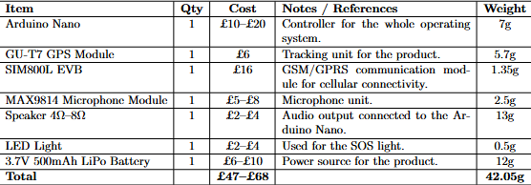

Conclusion
The VoiceTag mobile application was successfully developed as the software component of the Guardian Trace project. The project demonstrated the integration of multiple Android technologies including Bluetooth Low Energy (BLE), Google Maps API, GPS tracking, voice recording, and modular user interface design.
Throughout the project, I was responsible for mobile application development, software implementation, Bluetooth integration, voice recording functionality, Google Maps integration, documentation, and collaboration support. The application was developed using Android Studio, Kotlin, and Jetpack Compose following modular software engineering principles and SDIC concepts.
The project successfully demonstrated Bluetooth scanning functionality, GPS location services, voice recording integration, modular application navigation, modern Android UI design, and API integration techniques within the VoiceTag mobile application.
Although complete integration testing with the final Guardian Trace hardware prototype could not be fully completed due to hardware development limitations, the mobile application successfully demonstrated the core software functionalities within the Android environment.
The project also improved my:
- programming skills
- Android development knowledge
- software engineering understanding
- debugging and testing abilities
- teamwork and communication skills
Overall, the project achieved its main objectives and provided valuable practical experience in mobile software development, assistive technologies, and smart system integration.

Future Improvements
Although the VoiceTag mobile application successfully achieved its main objectives, several future improvements could further enhance its functionality, usability, and performance. Future development may include creating an iOS version to improve cross-platform accessibility, adding cloud-based tracking for remote monitoring and real-time updates, and integrating wearable devices, IoT systems, and smart home technologies to expand assistive tracking capabilities. Bluetooth distance estimation could also be improved using machine learning, advanced signal filtering, and improved RSSI analysis. Additional features such as emergency alert systems, voice command integration, user accounts, cloud databases, and secure data storage could further improve accessibility, security, and user interaction. Future user interface enhancements may also include dark mode, animations, responsive layouts, and advanced accessibility settings.

What is IoT system?
An IoT system (Internet of Things system) (Karimi and Atkinson, 2013) is a network of smart devices that connect to the internet and communicate with each other to collect, share, and process data automatically. These devices can include sensors, smartphones, smart watches, cameras, home appliances, wearable devices, and tracking systems.

Figure 7 Team Meeting Minutes and Collaboration Schedule
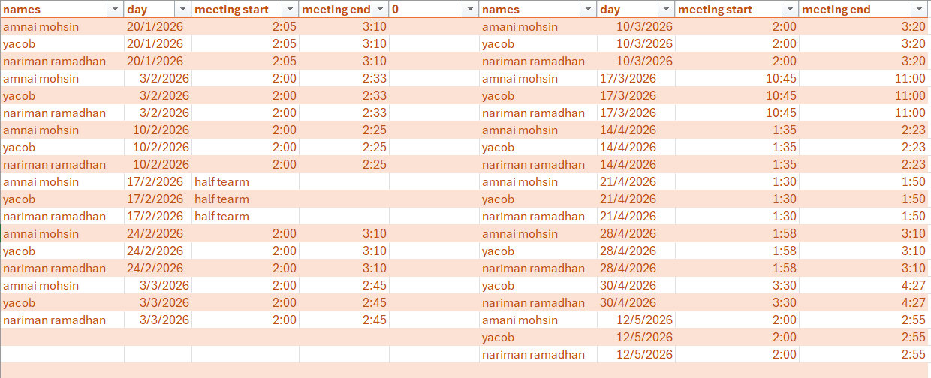
The figure 7 above shows the project meeting records and collaboration schedule completed throughout the development of the Guardian Trace project. The table includes team member names, meeting dates, meeting start times, and meeting end times recorded during the project lifecycle.

Step by step how I created the app:
Figure 8 Android Studio Platform Used for VoiceTag Development
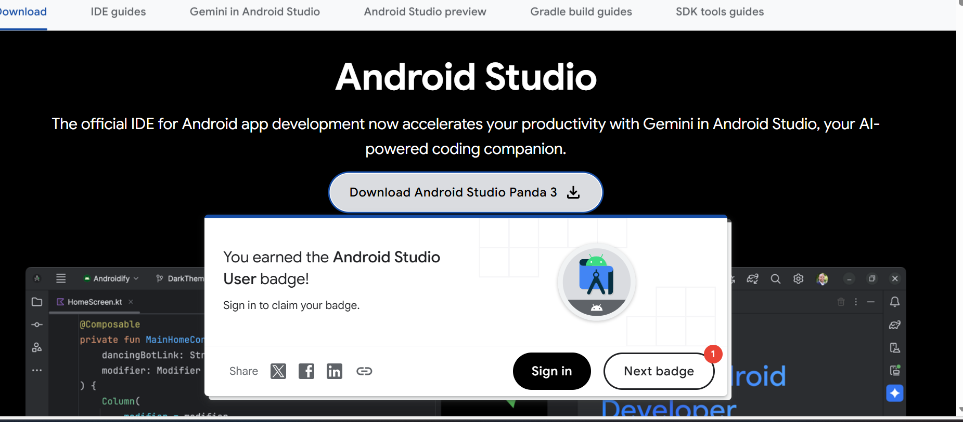

Figure 9 Android Studio Project Workspace
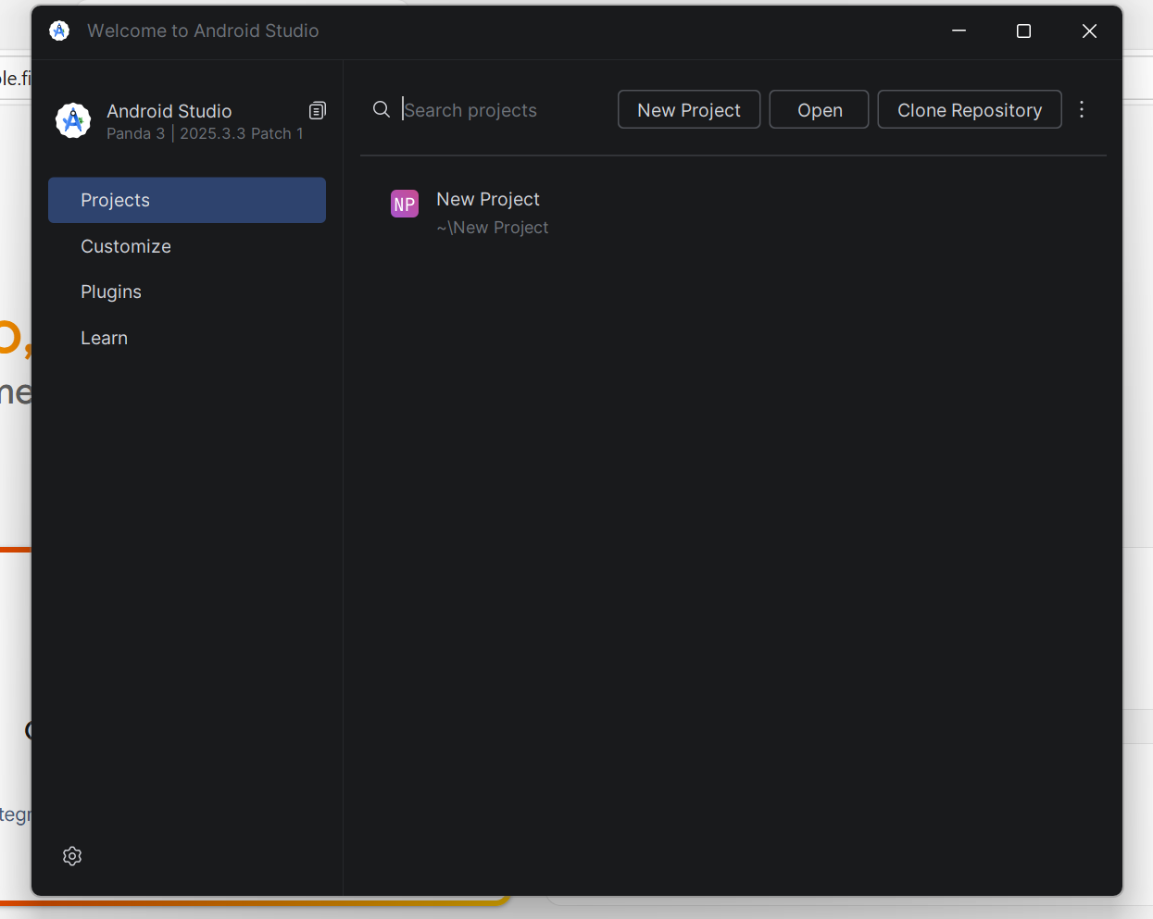

Figure 10 VoiceTag Project Structure in Android Studio
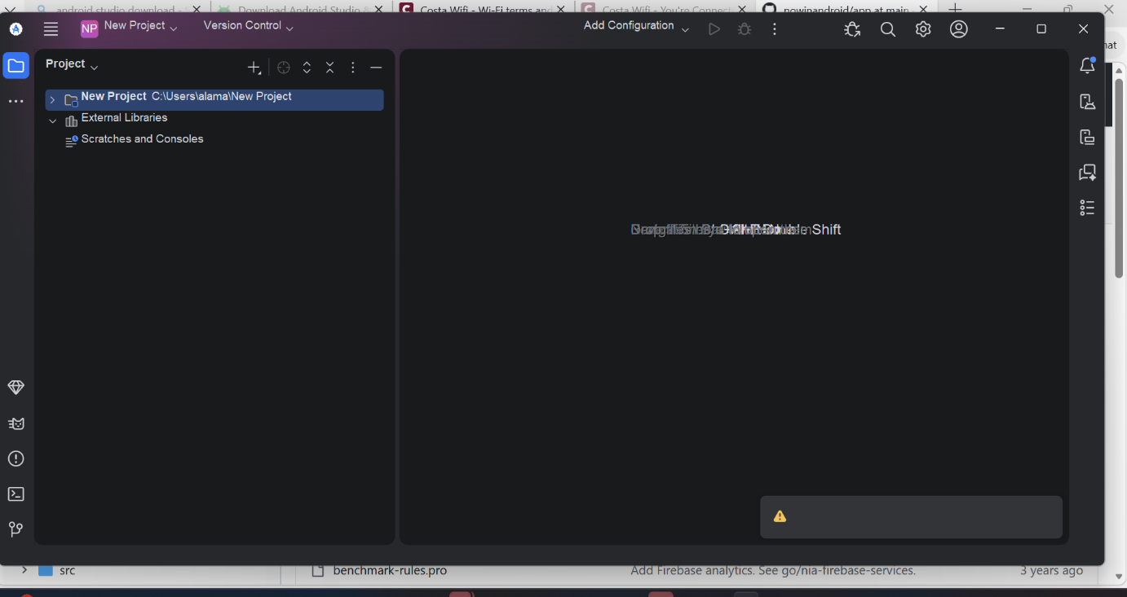

Figure 11 Creating a New Android Studio Project
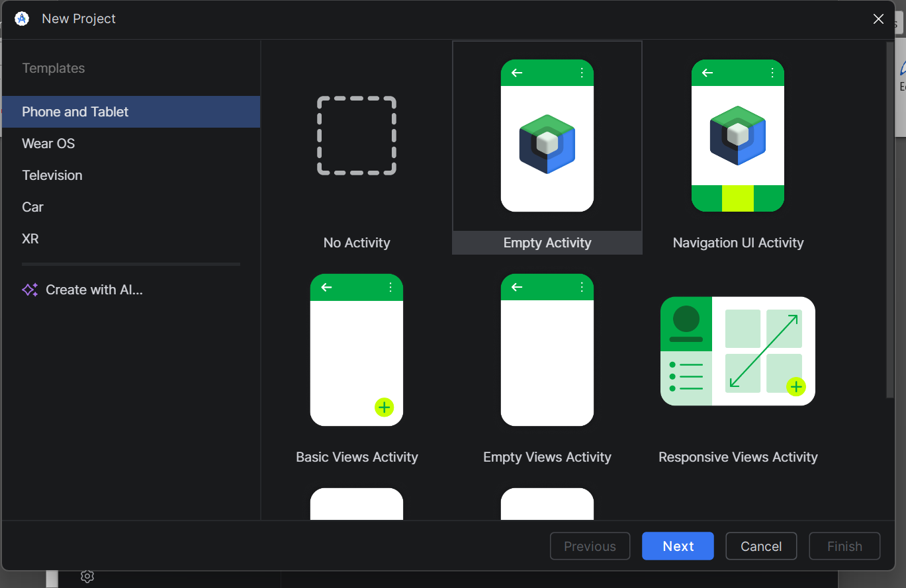

Figure 12 VoiceTag Application Configuration in Android Studio
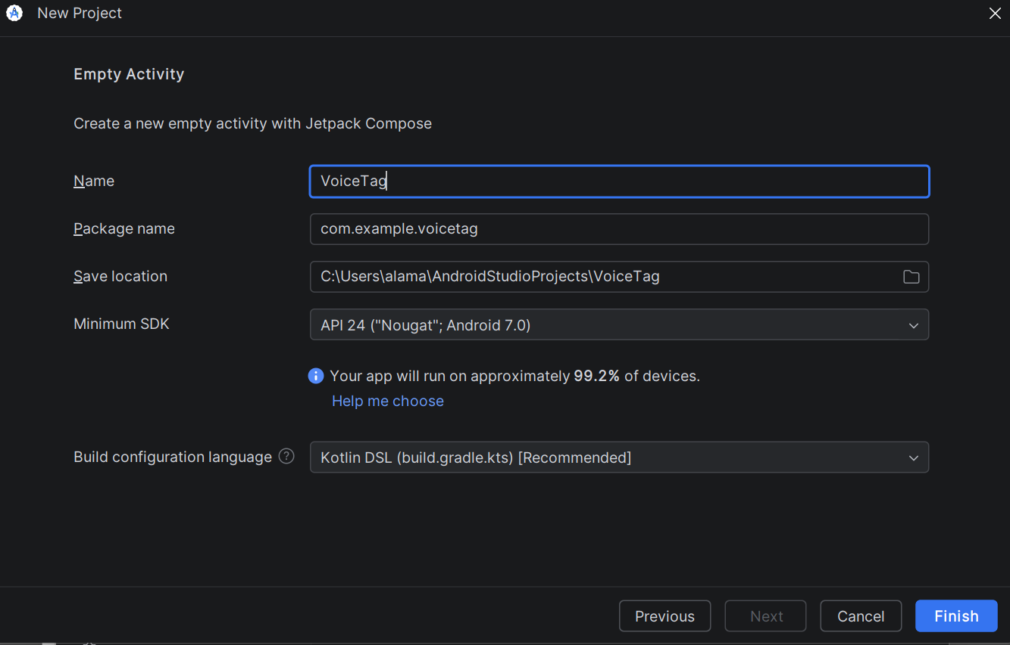
The figure 12 above shows the configuration stage of the VoiceTag mobile application during project creation in Android Studio. The project name, package structure, save location, minimum Android SDK version, and Kotlin build configuration were defined during this setup process.
Figure 13 VoiceTag Source Code Implementation in Android Studio
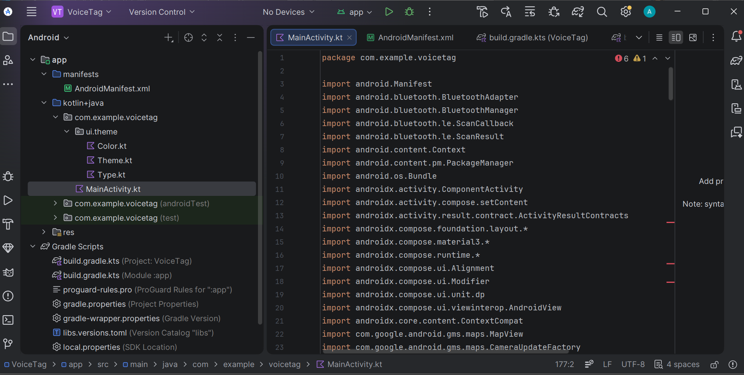

Code:
The following code sections demonstrate the implementation of the main functionalities developed within the VoiceTag mobile application using Kotlin and Jetpack Compose in Android Studio.

MainActivity.kt code:
package com.example.voicetag

import android.Manifest
import android.annotation.SuppressLint
import android.bluetooth.BluetoothAdapter
import android.bluetooth.BluetoothManager
import android.bluetooth.le.ScanCallback
import android.bluetooth.le.ScanResult
import android.content.Context
import android.media.MediaRecorder
import android.os.Bundle
import androidx.activity.ComponentActivity
import androidx.activity.compose.setContent
import androidx.activity.result.contract.ActivityResultContracts
import androidx.compose.foundation.layout.*
import androidx.compose.material3.*
import androidx.compose.runtime.*
import androidx.compose.ui.Alignment
import androidx.compose.ui.Modifier
import androidx.compose.ui.unit.dp
import androidx.compose.ui.viewinterop.AndroidView
import com.google.android.gms.location.LocationServices
import com.google.android.gms.maps.CameraUpdateFactory
import com.google.android.gms.maps.MapView
import com.google.android.gms.maps.model.LatLng
import com.google.android.gms.maps.model.MarkerOptions
import java.io.File

class MainActivity : ComponentActivity() {

private val requestPermissions =
registerForActivityResult(ActivityResultContracts.RequestMultiplePermissions()) {}

override fun onCreate(savedInstanceState: Bundle?) {
super.onCreate(savedInstanceState)

val bluetoothAdapter = getBluetoothAdapter()

requestPermissions.launch(
arrayOf(
Manifest.permission.ACCESS_FINE_LOCATION,
Manifest.permission.RECORD_AUDIO
)
)

setContent {
VoiceTagApp(bluetoothAdapter, this)
}
}

private fun getBluetoothAdapter(): BluetoothAdapter? {
val manager = getSystemService(Context.BLUETOOTH_SERVICE) as BluetoothManager
return manager.adapter
}
}

enum class Page {
Home, Bluetooth, Voice, Map
}

@Composable
fun VoiceTagApp(
bluetoothAdapter: BluetoothAdapter?,
context: Context
) {
var page by remember { mutableStateOf(Page.Home) }

Scaffold(
bottomBar = {
NavigationBar {
Page.entries.forEach { item ->
NavigationBarItem(
selected = page == item,
onClick = { page = item },
icon = {},
label = { Text(item.name) }
)
}
}
}
) { padding ->
Box(
modifier = Modifier
.fillMaxSize()
.padding(padding)
) {
when (page) {
Page.Home -> HomeScreen()
Page.Bluetooth -> BluetoothScreen(bluetoothAdapter)
Page.Voice -> VoiceScreen(context)
Page.Map -> MapScreen(context)
}
}
}
}

@Composable
fun HomeScreen() {
Column(
modifier = Modifier
.fillMaxSize()
.padding(28.dp),
horizontalAlignment = Alignment.CenterHorizontally,
verticalArrangement = Arrangement.Center
) {
Text("VoiceTag", style = MaterialTheme.typography.headlineLarge)
Spacer(modifier = Modifier.height(10.dp))
Text("Smart tracking app")
Spacer(modifier = Modifier.height(30.dp))
Text("Track your device using Bluetooth and Map")
}
}

@SuppressLint("MissingPermission")
@Composable
fun BluetoothScreen(bluetoothAdapter: BluetoothAdapter?) {
var devices by remember { mutableStateOf(emptyList<String>()) }
var status by remember { mutableStateOf("Idle") }

val scanner = bluetoothAdapter?.bluetoothLeScanner

val scanCallback = remember {
object : ScanCallback() {
override fun onScanResult(type: Int, result: ScanResult) {
val name = result.device.name ?: "Unknown Device"
val address = result.device.address
val device = "$name - $address"

if (device !in devices) {
devices = devices + device
}
}
}
}

Column(
modifier = Modifier
.fillMaxSize()
.padding(28.dp),
horizontalAlignment = Alignment.CenterHorizontally
) {
Text("Bluetooth Scan", style = MaterialTheme.typography.headlineMedium)
Spacer(modifier = Modifier.height(20.dp))
Text("Status: $status")
Spacer(modifier = Modifier.height(20.dp))

Button(
onClick = {
devices = emptyList()

if (scanner == null) {
status = "Bluetooth not available"
} else {
status = "Scanning..."
scanner.startScan(scanCallback)
}
},
modifier = Modifier.fillMaxWidth()
) {
Text("Start Scan")
}

Spacer(modifier = Modifier.height(10.dp))

OutlinedButton(
onClick = {
scanner?.stopScan(scanCallback)
status = "Stopped"
},
modifier = Modifier.fillMaxWidth()
) {
Text("Stop Scan")
}

Spacer(modifier = Modifier.height(20.dp))

if (devices.isEmpty()) {
Text("No devices found yet")
} else {
devices.take(5).forEach {
Text(it)
}
}
}
}

@Composable
fun VoiceScreen(context: Context) {
var status by remember { mutableStateOf("Not recording") }
var recorder by remember { mutableStateOf<MediaRecorder?>(null) }

val file = File(context.cacheDir, "voice.3gp")

Column(
modifier = Modifier
.fillMaxSize()
.padding(28.dp),
horizontalAlignment = Alignment.CenterHorizontally,
verticalArrangement = Arrangement.Center
) {
Text("Voice Recorder", style = MaterialTheme.typography.headlineMedium)
Spacer(modifier = Modifier.height(20.dp))
Text("Status: $status")
Spacer(modifier = Modifier.height(20.dp))

Button(
onClick = {
try {
recorder = MediaRecorder().apply {
setAudioSource(MediaRecorder.AudioSource.MIC)
setOutputFormat(MediaRecorder.OutputFormat.THREE_GPP)
setAudioEncoder(MediaRecorder.AudioEncoder.AMR_NB)
setOutputFile(file.absolutePath)
prepare()
start()
}

status = "Recording..."
} catch (e: Exception) {
status = "Error: ${e.message}"
}
},
modifier = Modifier.fillMaxWidth()
) {
Text("Start Recording")
}

Spacer(modifier = Modifier.height(10.dp))

OutlinedButton(
onClick = {
try {
recorder?.stop()
recorder?.release()
recorder = null
status = "Saved successfully"
} catch (e: Exception) {
status = "Stop failed"
}
},
modifier = Modifier.fillMaxWidth()
) {
Text("Stop Recording")
}
}
}

@SuppressLint("MissingPermission")
@Composable
fun MapScreen(context: Context) {
val locationClient = remember {
LocationServices.getFusedLocationProviderClient(context)
}

AndroidView(
modifier = Modifier.fillMaxSize(),
factory = {
MapView(context).apply {
onCreate(null)
onResume()

getMapAsync { map ->
locationClient.lastLocation.addOnSuccessListener { location ->
val position = if (location != null) {
LatLng(location.latitude, location.longitude)
} else {
LatLng(51.5074, -0.1278)
}

map.addMarker(
MarkerOptions()
.position(position)
.title("VoiceTag Location")
)

map.moveCamera(
CameraUpdateFactory.newLatLngZoom(position, 16f)
)
}
}
}
}
)
}

AndroidManifest.xml code:
<manifest xmlns:android="http://schemas.android.com/apk/res/android">

<uses-permission android:name="android.permission.ACCESS_FINE_LOCATION" />
<uses-permission android:name="android.permission.RECORD_AUDIO" />
<uses-permission android:name="android.permission.BLUETOOTH_SCAN" />
<uses-permission android:name="android.permission.BLUETOOTH_CONNECT" />

<application
android:allowBackup="true"
android:label="VoiceTag"
android:supportsRtl="true"
android:theme="@style/Theme.VoiceTag">

<meta-data
android:name=" AlzaSyAvd0edp7bnv7iskl5YICA-OaSU0CTYXq8 "
android:value="AlzaSyAvd0edp7bnv7iskl5YICA-OaSU0CTYXq8" />

<activity
android:name=".MainActivity"
android:exported="true">

<intent-filter>
<action android:name="android.intent.action.MAIN" />
<category android:name="android.intent.category.LAUNCHER" />
</intent-filter>

</activity>

</application>

</manifest>

build.gradle dependencies
implementation("com.google.android.gms:play-services-maps:18.2.0")
implementation("com.google.android.gms:play-services-location:21.0.1")

References
Alessandro, E. and Redondi (2016). Pairing W-Fi and Bluetooth MAC addresses through passive packets capture ANTLab Advanced Network Technologies LABoratory. [online] Available at: https://www.politesi.polimi.it/bitstream/10589/138894/3/el-tesi.pdf [Accessed 15 May 2026].
Bader, S.D. (2006). Colloquium: Opportunities in nanomagnetism. Reviews of Modern Physics, 78(1), pp.1–15. doi:https://doi.org/10.1103/revmodphys.78.1.
Boostbrands.co.uk. (2025). What Is A Navigation Flow?: Master the Art of User Navigation Flow! [online] Available at: https://www.boostbrands.co.uk/glossary/navigation-flow [Accessed 24 May 2026].
Breevaart, K., Woerkom, M. van, Wang, J. and Planken, N. (2025). Strengths-Based Leadership: A Critical Review to Guide Future Research. Journal of Leadership & Organizational Studies. doi:https://doi.org/10.1177/15480518251342658.
Brown, W.F. (1945). Virtues and Weaknesses of the Domain Concept. Reviews of Modern Physics, 17(1), pp.15–19. doi:https://doi.org/10.1103/revmodphys.17.15.
Develop Ideas (2023). How to implement Google Map in android studio kotlin. [online] YouTube. Available at: https://www.youtube.com/watch?v=E0H9-sXVUrE [Accessed 17 Apr. 2026].
freeCodeCamp.org (2019). Kotlin Course - Tutorial for Beginners. YouTube. Available at: https://www.youtube.com/watch?v=F9UC9DY-vIU [Accessed 1 Mar. 2026].
freeCodeCamp.org (2020). Android Development for Beginners - Full Course. YouTube. Available at: https://www.youtube.com/watch?v=fis26HvvDII [Accessed 25 Feb. 2026].
GeeksforGeeks (2024). Best Practices for Mobile App Development in 2025. [online] GeeksforGeeks. Available at: https://www.geeksforgeeks.org/android/best-practices-for-mobile-app-development/?utm_source [Accessed 15 May 2026].
Google Developers (2019). Meet Android Studio | Android Developers. [online] Android Developers. Available at: https://developer.android.com/studio/intro [Accessed 25 May 2026].
K Apps (2022). Android Bluetooth Low Energy Guide (Connect to a BLE sensor) - Android Studio Tutorial with Kotlin. [online] YouTube. Available at: https://www.youtube.com/watch?v=qyG-SDfYNBE [Accessed 21 Apr. 2026].
Karimi, K. and Atkinson, G. (2013). What the Internet of Things (IoT) Needs to Become a Reality. [online] Available at: https://files.iccmedia.com/pdf/freescale140527.pdf [Accessed 26 May 2026].
Lackner, P. (n.d.). The Jetpack Compose Beginner Crash Course for 2023 💻 (Android Studio Tutorial). [online] www.youtube.com. Available at: https://www.youtube.com/watch?v=6_wK_Ud8--0 [Accessed 23 Mar. 2026].
MyAmplifiers (2022). What Is dBm? Signal Strength Guide – How to Boost Weak 4G/5G. [online] MyAmplifiers. Available at: https://www.myamplifiers.com/articles/what-is-dbm-344/ [Accessed 25 May 2026].
Rath, T. and Conchie, B. (2009). Strengths Based Leadership. NHRD Network Journal, 2(5), pp.146–147. doi:https://doi.org/10.1177/0974173920090531.
Retscher, G., Zariqi, P., Oliva, A., Pachon, P., Pablo, J., Cantu, C. and Madawalagama, S. (2021). Bluetooth Distance Estimation for COVID-19 Contact Tracing. LBS, [online] 2021. doi:https://doi.org/10.34726/1748.
Sammut-Bonnici, T. and Galea, D. (2015). SWOT Analysis. Wiley Encyclopedia of Management, [online] 12(1), pp.1–8. doi:https://doi.org/10.1002/9781118785317.weom120103.
ScienceInsights. (2026). What Is dBm in Signal Strength? A Clear Explanation. [online] Available at: https://scienceinsights.org/what-is-dbm-in-signal-strength-a-clear-explanation/ [Accessed 25 May 2026].
Seong, J.-H. and Seo, D.-H. (2017). Environment Adaptive Localization Method Using Wi-Fi and Bluetooth Low Energy. Wireless Personal Communications, 99(2), pp.765–778. doi:https://doi.org/10.1007/s11277-017-5151-x.
Tanner, M. and Scott, E. (2015). A Flipped Classroom Approach to Teaching Systems Analysis, Design and Implementation to Second Year Information Systems University Students. Journal of Information Technology Education: Research, [online] 14, pp.219–241. doi:https://doi.org/10.28945/2266.
Zaman, S., Alhazmi, K., Aseeri, M.A., Ahmed, M.R., Khan, R.T., Kaiser, M.S. and Mahmud, M. (2026). Security threats and artificial intelligence based countermeasures for internet of things networks: A comprehensive survey. IEEE Access, 9, pp.94668–94690. doi:https://doi.org/10.1109/ACCESS.2021.3089681.

