Component 1 Portfolio Template
Cover Page

Name: Osaheni Nabulele ID: 2335292

Programme: BSc Health and Social Care

Assignment Title: Component 1: Online Portfolio of Set Exercises

Module code: BMHP5015

Module: Changemakers: Building your Personal Brand for Sustainable Employment

Lecturer: Olufemi Oluranti

Submission Date: 05/07/2026

Task 1 – Personal Brand
I base my personal brand for a prospective career in health and social care on professionalism, compassion, integrity, and a commitment to delivering high-quality care. A personal brand denotes the way individuals convey their identity, values, competencies, and reputation to others. As an aspiring health and social care practitioner, I seek recognition for my effective communication, respect for diversity, and collaborative work with service users, families, and interdisciplinary teams. Such characteristics are crucial for building trust and providing people-centred care.
To attain my career objectives, I must persist in cultivating my personal brand through ongoing professional growth, education, and experiential learning. This encompasses enhancing my communication, leadership, and problem-solving abilities while upholding professional standards and ethical conduct. Engaging in training courses, attending workshops, and soliciting input from coworkers and supervisors would enhance my professional identity and employability. Furthermore, cultivating a favourable online presence via professional networking sites can increase my visibility among prospective employers.
Rampersad (2008) asserts that true personal branding entails the alignment of personal values, strengths, and professional objectives to establish a believable and consistent professional identity. Trust and professionalism hold enormous significance in health and social care. Moreover, Schmitt (2009) highlights the importance of experience in shaping brand perceptions. In the healthcare sector, positive contact with service consumers, coworkers, and employers substantially enhances the development of a robust professional reputation.
By consistently enhancing my skills, acquiring pertinent experience, and exhibiting professionalism, I can fortify my personal brand and augment my prospects of attaining my long-term job objectives within the health and social care industry.

Task 2 - Network Map and Rationale
Personal Network Map and Critical Rationale
PERSONAL NETWORK

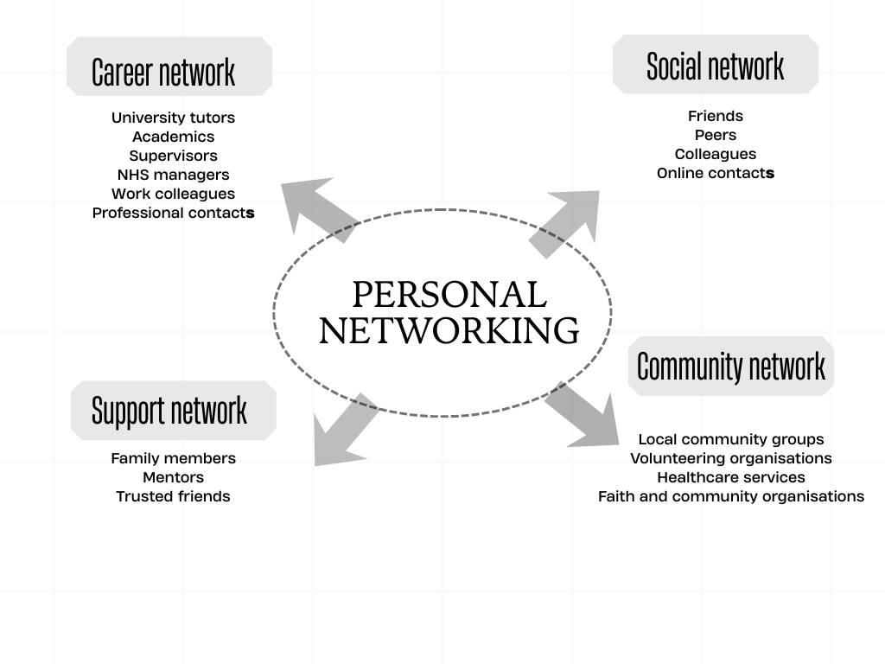
A personal network is a vital asset that facilitates job advancement, personal well-being, and professional development. My network comprises employment, support, social, and community contacts, each contributing uniquely to my personal and professional objectives. The career dimension includes university professors, placement supervisors, NHS personnel, and healthcare professionals who offer guidance, expertise, and possibilities for professional advancement. These ties provide me with significant insights into the health and social care sector, thereby enhancing my employability.
The support network includes family members, siblings, close friends, and mentors who offer mental assistance during difficult times. The assistance they provide sustains resilience and motivation while managing work, studies, and personal obligations. Social connections enhance wellness by alleviating isolation and facilitating the development of communication and interpersonal skills.
Collaborating with community-based partnerships that encompass local organisations, religious institutions, and volunteer opportunities enhances my understanding of various populations and reinforces my dedication to person-centred care. Granovetter (2009) contends that weak links are especially advantageous, as they frequently provide access to novel information and opportunities that intimate relationships may not supply. This indicates that broadening professional and community networks may improve future job opportunities.
Nonetheless, I could enhance my network by increasing interactions with professional associations and healthcare executives beyond my immediate workplace. Rampersad (2008) asserts that real personal branding entails cultivating significant relationships that advance personal and professional goals. Consequently, actively cultivating an expansive professional network may enhance job prospects while preserving the robust support networks that foster my wellbeing and success.

Task 3- Blog
Blog Title: Workforce Challenges in Health and Social Care in the UK
There are major staffing problems in the UK's health and social care business right now, which is affecting the quality of care and the delivery of services across the country (Harvey, 2024). Around the UK, the job market is still having trouble, which affects both hiring new staff and keeping old ones in health and social care services (Team, 2021). Based on recent changes in the job market, it looks like these stresses will continue.
According to Harvey (2024), a solid and skilled workforce is necessary to help patients and other vulnerable people in society in the right way. These employees are crucial to health and social care services. Care providers and healthcare groups across England are under pressure, though, because of a lack of workers and a higher demand for services (Harvey, 2024). According to the study by the Care Quality Commission, adult social care services are still having problems with finding enough workers to meet the growing demand for their services (Harvey, 2024).
Changing employment trends and the number of people working continue to affect the availability of workers in key industries across the UK economy, according to the most recent data from the labour market (Team, 2025). Because of a lack of workers, current employees may have to handle more work, which will make it harder to provide adequate care to service users (Harvey, 2024). As Harvey (2024) says, more pressure at work can also lead to higher stress levels, lower job happiness, and burnout among people who work in health and social care.
Those who are contemplating working in health and social care need to be very aware of these problems with the current staff. This is because the sector is always changing to meet new needs and adapt to changes in the job market (Team, 2025). Harvey (2024) says that health and social care are still important areas that can make a difference in people's and groups' lives across the UK. Even though these areas are still having trouble finding workers, this is still the case. Health and social care services might be able to stay open in the future if more money is spent over a longer length of time on workforce planning and better ways to hire people
A better understanding of current workforce problems will equip future workers to recognise the importance of supporting workforce development in health and social care settings.
Task 4- NHS Equality, Diversity and Inclusion Quiz (250 words equivalent)
1: The NHS Equality, Diversity, and Inclusion Improvement Plan aims to decrease inequities, promote fairness, and ensure inclusive treatment and opportunities in NHS services and workplaces.
2: Proper career progression, leadership opportunities, and equal development for all staff are the NHS EDI Improvement Plan's goals to minimise the gender pay gap.
3: The theoretical framework of intersectionality emphasises that race, gender, disability, and socioeconomic status can influence healthcare experiences.
4: A mentally and academically secure NHS environment fosters a sense of value, support, and confidence among workers, enhancing teamwork, wellness, patient safety, and care quality.
5: The NHS EDI Development Plan pushes for the equitable treatment of internationally recruited personnel by enhancing inclusion, providing career advancement possibilities, and fostering a workplace environment where they are esteemed and appreciated.
6: Leadership is important in advancing EDI by fostering inclusive environments, addressing disparities, and providing equitable opportunities for staff and patients throughout the NHS.
7: The NHS EDI Transformation Plan seeks to mitigate health inequities by fostering equitable opportunities for all personnel, guaranteeing impartial recruitment and career advancement, and providing access to training regardless of educational background.
8: The NHS EDI Development Plan emphasises collecting and interpreting protected characteristic data to identify inequalities, track progress, and provide equitable access, treatment, and opportunity for all staff and patients.
9: Flexible working practices foster equity and inclusion by allowing employees with varying personal, familial, health, or cultural requirements to efficiently balance work and life, thereby mitigating discrimination and enhancing workforce diversity.
10: A strategy in the NHS EDI Improvement Plan is to establish a workplace where employees feel secure in voicing concerns regarding bullying or harassment without fear of retribution.
Task 5- A Letter to Yourself
My dear younger me,
I recall a challenging phase in your life when you had to return to a workplace where you had previously endured adverse treatment and distressing recollections. Returning to that situation induced anxiety, tension, and emotional fatigue. Simultaneously, you attempted to reconcile your employment with academic pursuits and familial obligations. Your worries frequently seemed unacknowledged, and the persistent pressure undermined your confidence and emotional health. It was a demanding period that prompted you to doubt your capacity to endure.
Upon reflection, I acknowledge that cultivating emotional intelligence would have enabled you to navigate those challenges more adeptly. Emotional intelligence encompasses the recognition of one's emotions, comprehension of their impact on conduct, and the ability to respond judiciously rather than reactively. Had you taken the time to contemplate your emotions and articulate them calmly, you might have encountered less frustration and been more adept at seeking support from trusted individuals. Acquiring the ability to comprehend your emotions would have facilitated the preservation of confidence under stressful circumstances.
Resilience would have been of similar significance. Resilience does not entail evading issues or feigning that all is OK. It is the capacity to rebound from adversity, adjust to alterations, and persist in progress despite obstacles. Despite the initially overwhelming nature of the circumstances, it was not enduring. Each challenge encountered imparted essential lessons regarding endurance, patience, and personal development.
If I could give you one piece of advice, it would be to have faith in yourself and recognise that seeking assistance is a manifestation of strength, not frailty. Exhibit self-compassion, maintain optimism, and refrain from permitting transient challenges to dictate your destiny. The hardships you encountered contributed to the development of the resilient, confident, and driven individual you are becoming. Continue to have faith in yourself, as your ability to overcome challenges is far greater than you perceive.
Your sincerely,
Older Self.
.

Task 6- GANTT Chart (200 words equivalent)
Gantt Chart for Achieving Future Employment Goals in Health and Social Care
Activities/Tasks | Jan-Mar 2026 | Apr-Jun 2026 | Jul-Sep 2026 | Oct-Dec 2026 | Jan-Mar 2027 | Apr-Jun 2027 | Jul-Sep 2027 | Oct-Dec 2027
Complete Health and Social Care Qualification | ✓ | ✓ | ✓ | ✓
Improve Academic and Research Skills | ✓ | ✓ | ✓
Attend Professional Training and Workshops |  | ✓ | ✓ | ✓ | ✓
Gain Practical Experience Through Placement/Volunteering | ✓ | ✓ | ✓ | ✓ | ✓ | ✓
Develop Communication and Teamwork Skills | ✓ | ✓ | ✓ | ✓ | ✓ | ✓ | ✓ | ✓
Update CV and Cover Letter |  |  | ✓ | ✓
Search for Employment Opportunities |  |  |  | ✓ | ✓ | ✓
Submit Job Applications |  |  |  |  | ✓ | ✓ | ✓
Attend Interviews |  |  |  |  |  | ✓ | ✓
Secure Employment and Continue Professional Development |  |  |  |  |  |  | ✓ | ✓

Explanation
My health and social care career Gantt chart show how to succeed. I prioritise my Health and Social Care qualification for professional practise. While learning, I will develop my academic writing and research skills to generate evidence-based work and employ research findings. I want to learn about health and social care laws, regulations, and best practises at professional workshops.
Placements, volunteering, and paid work will improve my employability. I will gain confidence, professional abilities, and service user understanding from this. I will improve my communication, teamwork, and interpersonal skills over the next two years to work with colleagues, service users, and families.
As graduation approaches, I will update my CV and cover letter with my qualifications, successes, and experience. I will then aggressively apply for jobs and prepare for interviews. Final step: getting a health and social care employment and improving my skills through professional development. With this strategy, my career goals are clear.

Task 7- Making Changes- Report
As a care home manager, I would replace paper-based documentation with an electronic care planning and record-keeping system. Digital records improve staff communication, eliminate documentation errors, promote person-centred care, and speed up resident information access. The care home would fulfil regulatory criteria and improve care with this adjustment.
To properly implement this change, I would employ Lewin's three-stage change model—unfreezing, altering, and refreezing. During unfreezing, workers would gather and examine the change's rationale. To eliminate ambiguity and develop trust, employees would be encouraged to voice concerns and ask questions. The changing stage would include intensive training to provide staff the confidence and skills to use the new system. Technical help would be provided during implementation. Regular monitoring, refresher training, and feedback would make the new approach part of daily practice during refreezing to ensure long-term viability.
This transformation requires several management and leadership abilities.
1: Clear communication skills are needed to convey the new system's benefits and engage people during installation.
2: Leadership is needed to inspire and help personnel adjust.
3. Problem-solving and decision-making skills help solve technical difficulties, allocate resources, and respond rapidly to implementation challenges.
Despite the benefits, various obstacles may impede the change. Staff resistance, especially from paper-based documenters or those who distrust new technology, is a major obstacle. Brown et al. (2015) explain that repeated organisational changes without effective employee involvement can lead to change cynicism, which lowers staff commitment and willingness to adopt new initiatives. To reduce opposition, include staff in planning, consult them frequently, and provide reassurance and support throughout the process.
Compliance with regulatory standards during transition is another difficulty. According to O'Neill (2024), effective management, clear documentation, and ongoing monitoring are essential to balance quality care with CQC compliance. Thus, regular audits and monitoring would keep electronic records accurate, secure, and legal and professional.
Finally, a culture of continuous development is essential for successful deployment, as it encourages staff to provide input and evaluate the new system. When implementing healthcare reforms, McDeavitt (2024) stresses constructive professional communication and positive feedback. Open communication and ongoing learning would boost staff confidence and assure the long-term effectiveness of the new electronic care planning system.

Reference List
Brown, M., Kulik, C.T., Cregan, C. and Metz, I. (2015). Understanding the Change-Cynicism Cycle: The Role of HR. Human Resource Management, 56(1), pp.5–24. doi:https://doi.org/10.1002/hrm.21708.
Burnes, B. (2003). Managing change and changing managers from ABC to XYZ. Journal of Management Development, 22(7), pp.627–642.doi:https://doi.org/10.1108/02621710310484768.
Granovetter, M. (2009) ‘The Strength of Weak Ties’, Journal of Economic Sociology, 10(4), pp.31–50. doi:10.17323/1726-3247-2009-4-31-50.McDeavitt, J.T., Wade, K.E.,
McDeavitt, K. (2024) Some Comments in Response to Chelliah et al. Journal of Adolescent Health, 75(3), p.521. doi: https://doi.org/10.1016/j.jadohealth.2024.05.018.
Smith, R.E. and Worsowicz, G. (2012). Understanding Change Management. PM&R, 4(2), pp.141–143. doi:https://doi.org/10.1016/j.pmrj.2011.12.001.
O´Neill, A. (2024). Balancing CQC compliance and care. BDJ In Practice, 37(11), pp.436–436. doi:https://doi.org/10.1038/s41404-024-2918-0.
Rampersad, H.K. (2008). A new blueprint for powerful and authentic personal branding. Performance Improvement, 47(6), pp.34–37.
Schmitt, B. (2009) ‘The concept of brand experience’, Journal of Brand Management, 16(7), pp. 417–419. doi: https://doi.org/10.1057/bm.2009.5.
Team, L.M. (2025) Labour market overview, UK. [online] ONS. Available at: https://www.ons.gov.uk/employmentandlabourmarket/peopleinwork/employmentandemployeetypes/bulletins/uklabourmarket/may2025 [Accessed 19 May 2026]

