What are the first 1000 days?
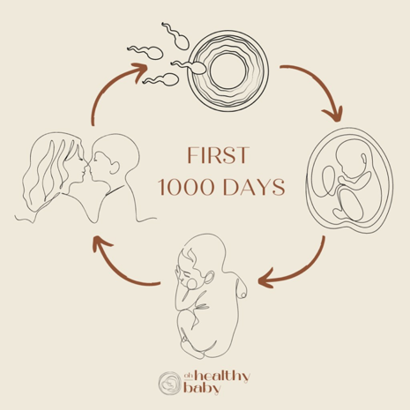
Image (Source: Ohhealthybaby, n.d.)
The first 1000 days refers to the period between conception and the child’s second birthday (Karakochuk et al., 2018). This period is crucial for a child’s health, brain development and wellbeing (Yates, 2015). During the first 1000 days, the foundations of a child’s development are laid, and the trajectory is established (House of Commons, 2019).
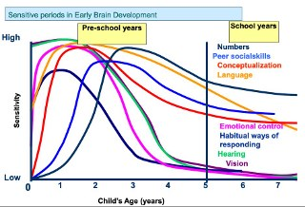
(Source: Southeast Regional Intersectoral Committee, 2011)
As stated by HM Government (2021), the first 1000 days of life is the most vulnerable time of a child’s life. Barnardo’s (2019, quoted in House of Commons, 2019, pp. 7) says that when development falls behind the norm of the first 1000 days, it is more likely they will continue to fall behind others who have had a better start to life. This is supported by Yates (2015) who says that stress and malnourishment will result in a reduced energy to develop brain functions and therefore we unintentionally increase the inequalities in our society at this very early start. If these adversities are left unaddressed, the hardships they have faced can stay with them throughout their lives and can harm themselves as well as others (House of Commons, 2019).
This can be shown in the graph above. The graph shows that the first 1000 days are crucial for the development of a child. It shows that most areas of brain development peak and develop well before a child is two years old. After this time, the child’s sensitivity towards these skills falls dramatically. This shows that the first 1000 days are fundamental for the development of a child and that the brain grows quicker in the first 1000 days than any other time in life (Yates, 2015). This is supported by the Welsh Government (2024) who states that a baby is born with one hundred billion brain cells and that through a stimulating and loving environment, connections are established.

Likhar and Patil (2022) say that the first 1000 days sets the foundation for the child’s long-term health and that development depends on good nutrition during pregnancy and the early years of life. During the first 1000 days, the developing brain is vulnerable, and poor nutrition can be a dangerous threat to a child’s development. According to Harvard University (2015), when the brain senses a threat, it can activate a stress response, and this response can have a serious threat on the developing brain. This is because when an infant is experiencing toxic stress, they are at risk of permanent changes to the brain’s architecture, which can lead to mental disorders and poor health outcomes in their adulthood (Franke, 2014). Therefore, with proper nutrition in the first 1000 days, the brain is given the correct nutrients needed to develop without stress and the infant is given the best opportunity to develop, learn and thrive (Likhar and Patal, 2022).

Ted Talk on the first 1000 days and whether they determine the rest of our lives.
The first 1000 days by UNICEF
Nutrition in the first 1000 days by UNICEF

What is Exceptional Caregiving?
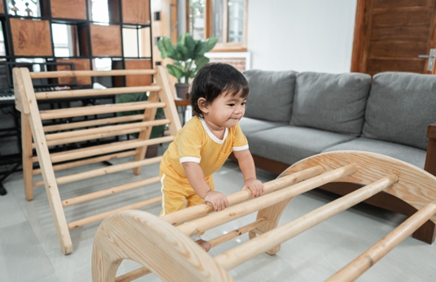
(Source: Hey Sleepy Baby, n.d.)
Exceptional caregiving refers to a caregiver being an enabling adult who gives outstanding care to the children they are responsible for. This includes being a nurturing and loving presence to the child, while offering an enabling environment (Birth to 5 Matters, 2021). The World Health Organisation (2018) states that exceptional caregiving is important in the first 1000 days as it supports the development of the child.

According to Harvard University (2024), more than one million neural connections are formed every second. These connections are formed by the experiences that a child has. These experiences include interactions with adults, and the activities that are offered to them (Stead, 2024). Therefore, the environment that caregivers create for an infant sets the stage for lifelong learning. Adolph, and Hoch (2019) state that motor skills create opportunities for exploration and enable babies to create new opportunities. This is supported by Emmi Pikler, who advocated for freedom of movement (Mason, 2023). This freedom of movement relates to free, uninterrupted play (Mason, 2023). Sandseter and Kennair (2011) suggest that children need to encounter calculated risks to develop their own risk-taking skills. By providing challenges in an early years setting, infants are able to take on challenges that promote their development and confidence (Stead, 2024). This can be shown through risky play. An example of an introduction to risky play in the first 1000 days is Pikler’s triangle, which is a climbing frame designed for babies (Lily and River, 2022). The apparatus encourages an infant free movement and balance, which allows an infant to develop their motor skills independently and build their self-confidence (Marlen, 2019).
Video of a baby's development from using the Pikler Triangle.

The importance of an enabling environment is shown in the curriculum for funded non-maintained nursery settings. It states that it is important that the environment is not only physical, but also emotional, so that strong relationships between the practitioner and child are made (Welsh Government, 2022a). Relationships between practitioners and children have a positive impact on the world and can be shown through Bronfenbrenner’s ecological theory. In this theory, children are at the core of an ever-expanding world, which can be made up of four systems which are directly influencing the child (Sadownik, 2023). One of these systems is the microsystem, which includes people who have direct contact and influence on the child (Sadownik, 2023). This includes an early year's practitioner.

The importance of relationships between infants and caregivers can also be shown in John Bowlby’s attachment theory. The Attachment theory's focus point is on the bonding between caregivers and children, particularly the impact this has on their development (Keenan et al., 2016). According to Wilson-Ali et al. (2019), Bowlby believed that children need to develop close attachments to be provided with security during the absence of their main caregiver. This can be shown through Elinor Goldschmied’s key person approach. According to Barnardos (2016), the key person approach is a method of care in early years settings where the focus is aimed at enabling attachments between children and practitioners. In this approach, the practitioner is given a small group of children in which they are responsible for and forms an attachment with each child through the environment (Murphy, 2022). Attachments between infants and practitioners are vital as the nurturing environment created by strong relationships develop an infant's mental health. This is supported by the Department for Education (2023), who claim that children in safe environments, with adults that they trust learn to self-regulate their emotions and communicate their needs effectively.

What is the role of an Early Years Practitioner in supporting children and their families in the first 1000 days?
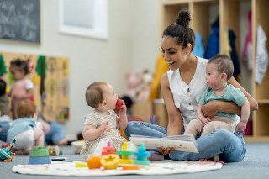
(Source: JustChildren, 2023)
The role of an Early Years practitioner in supporting children within the first 1000 days is to be an enabling adult (Welsh Government, 2022a). This includes safeguarding and providing a secure environment. Safeguarding in the first 1000 days is important as this is a critical time during development (House of Commons, 2019). The NSPCC (2025) state that over half a million children suffer from abuse in the UK every year. Therefore, the role of a practitioner is to identify signs of abuse and report concerns to their designated safeguarding person (Welsh Government, 2022b). According to Maslow (1943), children need structure in their lives as inconsistency and unpredictability can cause children to feel anxious and unsafe. Therefore, children need a routine in place that they can count upon and thrive under, especially through difficult times. Therefore, secure environments bring children the opportunity to play and develop, away from the stress from the world around them (Laxton and Cooper, 2022).

Early Years practitioners must support families during the first 1000 days. This includes offering emotional support and being a person for the parents to offload onto. Education Scotland (2020) highlights that some find the experience of being a parent challenging, and that there may be times where practitioners need to offer support and signpost to other service providers. It is important that an early year practitioner gives tailored advice as children’s experiences in life are unique and not all support is catered towards that child’s needs. This is supported by government legislation which states that professionals who are working in partnership ensure that families are receiving holistic support that tailors to their specific needs (Childcare Act 2006). Therefore, it is important to work in partnership with parents and other service providers. Partnership working refers to a broad range of actions and can be described as people and organisations coming together to achieve a common purpose (Community Change, 2010). Working in partnership with parents is essential in the first 1000 days as research shows that involving parents into children’s learning is the most important factor in enabling children to do well in life (Department of Education, 2021).

Maternal Factors and Support Strategies
Marmot (2010) states that what happens in the womb has lifelong effects on an individual's health. Therefore, it is important to consider the maternal factors that could impact development. Indrio et al. (2023) state that by focusing on the mother's health during pre-conception, the development and health of the newborn is improved. Likhar and Patil (2022) believe that poor maternal nutrition during pregnancy can result in poor birth outcomes. The NHS (2023) states that a balanced diet is needed during pregnancy, with plenty of fruit and vegetables to provide vitamins and minerals. This is needed as poor diets lacking in nutrients, such as iron and calcium, can cause pre-eclampsia and postpartum haemorrhages (UNICEF, n.d.). They can also lead to stillbirths, low birthweight and developmental delays (UNICEF, 2024).
One support service that is offered during pregnancy is the Foodwise in Pregnancy app, which is developed by NHS Wales professionals. The Cwm Taf Morgannwg University Health Board (n.d.) states that the Foodwise in Pregnancy app features nutrition advice with recipe and meal planning, and exercise advice and practical ideas to keep active during pregnancy.
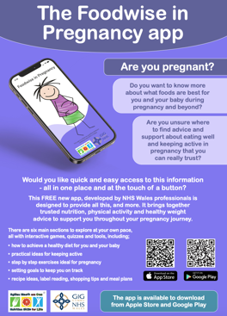 (Source: NHS Wales, n.d.)
UNICEF (2018) recommends that babies should be breastfed in the first six months of life, and continued up to two years old or beyond, with the provision of safe nutritious food. Likhar et al. (2022) states that a breast milk provides all the nutrients a baby will need develop. Additionally, colostrum aids in immunity building and infection prevention (Likhar et al., 2022). Capitani et al. (2023) believes that inadequate breastfeeding can result in developmental problems. This is supported by Indrio et al. (2023) who state that cognitive development is linked with exclusive breastfeeding in the first 6 months of life. While some mothers state that if it was not for the support from their local hospital, they would have given up on breastfeeding, many women have reported that they have felt a lack of support with breastfeeding on the labour wards (House of Commons, 2019). Many mothers report that they have suffered from anxiety and depression as a result of worrying about breastfeeding, and not receiving adequate support (House of Commons, 2019). Therefore, support is needed to give help mothers during breastfeeding. Breastfeeding support groups can help with the difficulties that mothers may be facing and enable mothers to share experiences with other mothers (Cardiff and Vale University Health Board, n.d.). Cardiff and Vale University Health Board (n.d.) provide breastfeeding support groups led by health visitors and the maternity services Seren team most days a week.

These support groups are available here
An excellent charity that provides support during conception, pregnancy and after birth. Tommy’s
A brilliant website by the NHS which gives advice during pregnancy, birth and parenthood. Better Health - Start for Life

What are the challenges in providing high quality care?
Poverty
There are many challenges in providing high quality care. Poverty can include low income, poor housing conditions, and lack of resources to fulfil basic needs (Child Poverty Action Group, 2024b). Poverty is a huge challenge in the UK due to the cost of living crisis. According to the Child Commissioner for Wales (2024), 30% of children in Wales are living in poverty. In fact, child poverty is expected to rise further (Child Poverty Action Group, 2024a). Capitani et al. (2023) suggest that these adverse situations compromise the ability for parents to provide nurturing care for their children. This is supported by NHS Wales (2023) who state that poverty effects a parent’s ability to provide the basic needs to support their child.
Poverty affects a child's health. This is supported by the Royal College of Paediatrics and Child Health (2022) who argue that children living in poverty have less access to medical care. This is because of costs relating to travel, parking and loss of earnings (Royal College of Paediatrics and Child Health, 2024). Additionally, dental care has become difficult for children living in poverty. Bidmead et al. (2024) state that NHS waiting lists have become excessively long. Children’s dental health is deteriorating and has become a national problem, yet 8 in 10 NHS practices are not taking on new children for treatment (Dentistry, 2022). Parents living in poverty are unable to afford private dental treatment, and children’s health is suffering as result (Bidmead et al., 2024).

Covid-19
The COVID-19 pandemic has had significant impacts on early childhood education and care. The pandemic impacted the sector in several ways, including setting closures and child development (UK Parliament, 2021). Although prior to the pandemic there were issues recruiting and retaining staff in the early years sector, COVID-19 has continued to impact this (UK Parliament, 2021). Ofsted (2021) report the ongoing decline of the number of childcare providers has continued. Infact, the number of childcare providers registered with Ofsted is down by 4% since August 2020 (Ofsted, 2021).
The pandemic has put vulnerable children at risk. According to the Children's Society (2020), children who are living in households with domestic violence and poverty face increased hardship. This is supported by Harvard niversity (2015) who note that prolonged stress responses can harm young children's development. While confined at home, young children are not receiving the support they got before the pandemic. During lockdown, young children do not have access to trusted adults beyond their household (NSPCC, 2020). This results in abuse and neglect not being caught by health workers, early years practitioners or social workers.
The Child Commissioner (2020) reports that over one million children did not have access to the outdoors during lockdown. This is directly impacted children's development. Outdoor play is an essential part of development and encourages young children to make their own choices and to build their independence (Tinney, 2022). Gray (2011) states that during the pandemic, there were less opportunities for children to play outdoors, which has led to poor mental health, including feelings of anxiety and depression. This is supported by the UK Parliament (2021) who suggests that infants who have had lack of access to early years settings are showing a lack of emotional and behavioural development.


Activities that provide meaningful learning

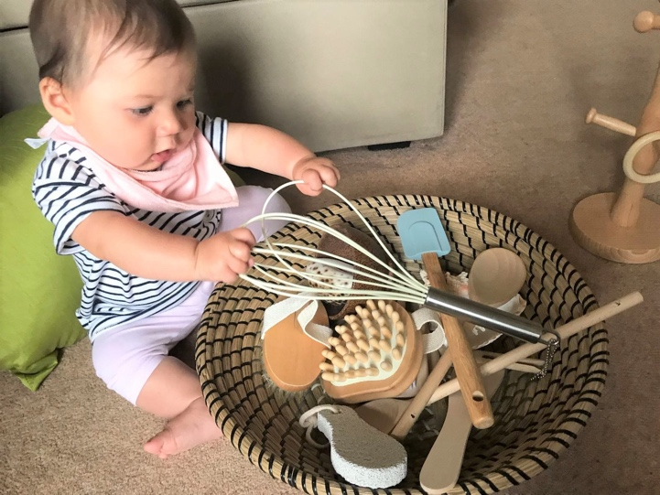
(Source: Early Impact, 2024)
Treasure Baskets
Elinor Goldschmied was a teacher who worked in an institution for single mothers and babies, where she developed the idea of heuristic play (Murphy, 2022). Through this, Goldschmied introduced sensory learning to babies through her idea of treasure baskets (Murphy, 2022). Treasure baskets are a collection of around 100 natural household and recycled objects placed in a wicker basket (Froebel Trust, 2024).
Objects can include:
- Loofah
- Brush
- Pegs
- Keys
- Spatulas
- shells
(Goldschmied and Jackson, 1994)

Infants can gain sensory experience from the simplest of things, such as the different textures of household objects (Stead, 2024). This is supported by Goldschmied and Jackson (1994) state that treasure baskets help support brain development as they provide a vast variety of everyday items which cater to different sensory needs. NHS Borders (n.d.) states a baby's brain is growing faster than at any other time in their life and they start absorbing the senses around them as soon as they are born. Treasure baskets allow babies to develop their cognitive skills through problem-solving, memory and reasoning. This is because babies can choose whether to play with an item, how long they interact with the treasure basket and how they explore it by using their mouth or hands (Forbes, 2004). This is why it is important during the first 1000 days for an infant to be provided with a rich sensory experience.

Podcast clip on Elinor Goldschmied by the Froebel Trust
https://vimeo.com/951127930
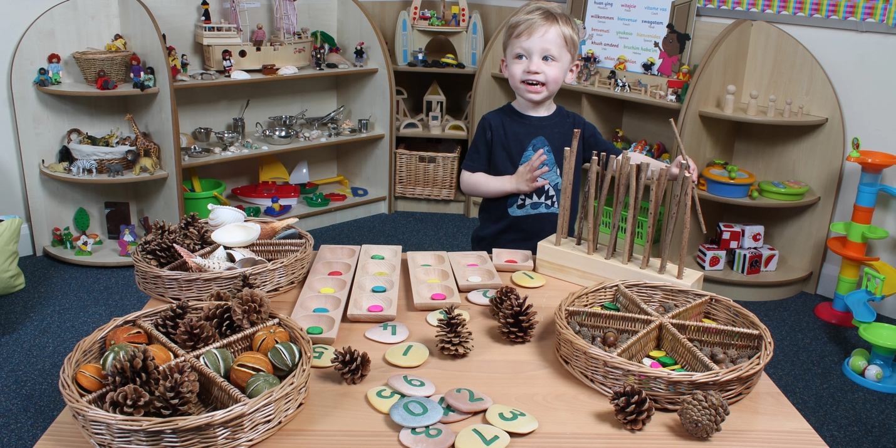(Source: EYR, 2020)
Loose Parts
According to Play Wales (2017) children need to be in environments where they can manipulate and where they can invent and develop their own ideas through play. This can be done through loose parts. It was created by Simon Nicholson in 1971 in his paper called ‘The Theory of Loose Parts’ (Play Wales, 2017). The list is endless. The list of loose parts that can be used are limitless, but can include natural items such as pinecones, sticks, shells and stones (Play Wales, 2017). Loose parts can also be scrap materials such as tyres, guttering, crates, planks of wood (Play Wales, 2017). Loose parts is an open-ended type of play which offers limitless possibilities (Play Wales, 2017). For example, a stick becomes a magic wand, a walking stick or can be put in water to float. Loose parts can support a child’s cognitive development. This is because loose parts enable a child's creativity, curiosity and imagination (Play Scotland, n.d.) Loose parts also provides children with meaningful learning. This is because it offers children independence and opportunities to think, plan and make decisions (Welsh Government, 2022a).

International Approaches
(Source: Sightlines Initiative, 2024)
Te Whāriki is the early years curriculum in New Zealand. The curriculum has four principles which are entwined with five strands (Ministry of Education, 2017). These four principles are empowerment, holistic development, family and community, and relationships (Ministry of Education, 2017). Te Whāriki covers the education of children from birth to five years old (Ministry of Education, 2017). While the Welsh government recognises that development is rapid from birth to age five, the curriculum is aimed for ages three to four (Education Wales, 2022).
Te Whāriki recognises that each child is on a unique journey in life (Ministry of Education, 2017). This is similar to the Welsh curriculum, which acknowledges that all children come from unique backgrounds (Welsh Government, 2022a). The curriculum is presented in both English and Māori, which shows that New Zealand is proud of their culture (Ministry of Education, 2017). Infact, the curriculum states that children will learn Māori, the indigenous language of New Zealand (Ministry of Education, 2024). Similarly, the Welsh curriculum is proud of Wales’ identity as the curriculum values the Welsh language and states that the language should be taught in all settings (Wales Government, 2022a).
Te Whāriki has a strong emphasis on the relationships between teachers and families. This is supported by Te Mahau (2024) who states that responsive relationships between teachers and parents support all aspects of the child’s learning, and that the children’s understanding of themselves and their relationships with others in the early years are crucial for positive life outcomes. Similarly, the Welsh Government (2022a) recommend that settings work collaboratively with parents as this will provide positive experiences.

Video about Te Whāriki turning twenty

