Network Operating Systems and Services
Configure and Manage the Virtualised Enterprise Network

Student Name: Olha Kozmenko
Student ID: 2335644
Module Code: ACCA5023

Contents

Introduction 1
1. Routing 2
1.1 Routing in Birmingham (Windows1 / B-DC) 2
1.2 Routing in London (Linux1 / L-CD) 2
2. Domain Server (Birmingham) 3
2.1 Forest Creation (olha.local) 4
2.2 A Records 5
2.3 Reverse Lookup Zone / PTR Records 5
3. Encrypted Connection (Site-to-Site VPN) 5
4. Users 6
5. Domain Membership 8
6. DHCP Server 10
7. Test and Troubleshoot 10
8. Disk Drive 12
9. IIS Server 13
10. Remote Desktop Services 14
Conclusion 15
References 16

Introduction
This report documents the configuration and testing of the virtualised enterprise network for NOSS London 2026 Inc, continuing the topology built in Coursework 1.

1. Routing

1.1 Routing in Birmingham (Windows1 / B-DC)
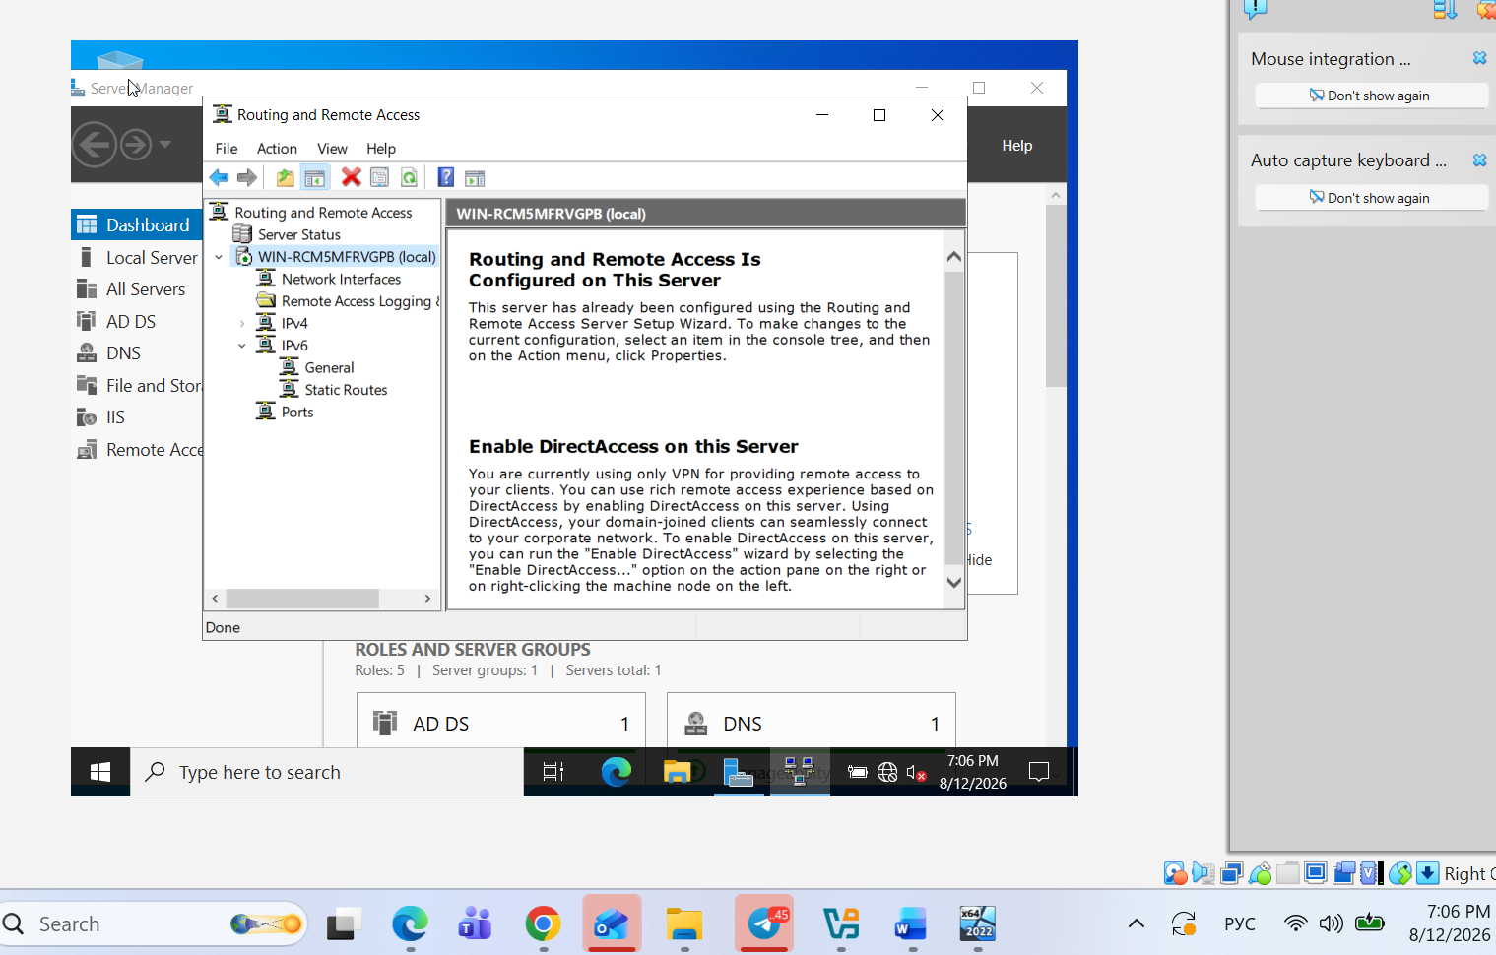
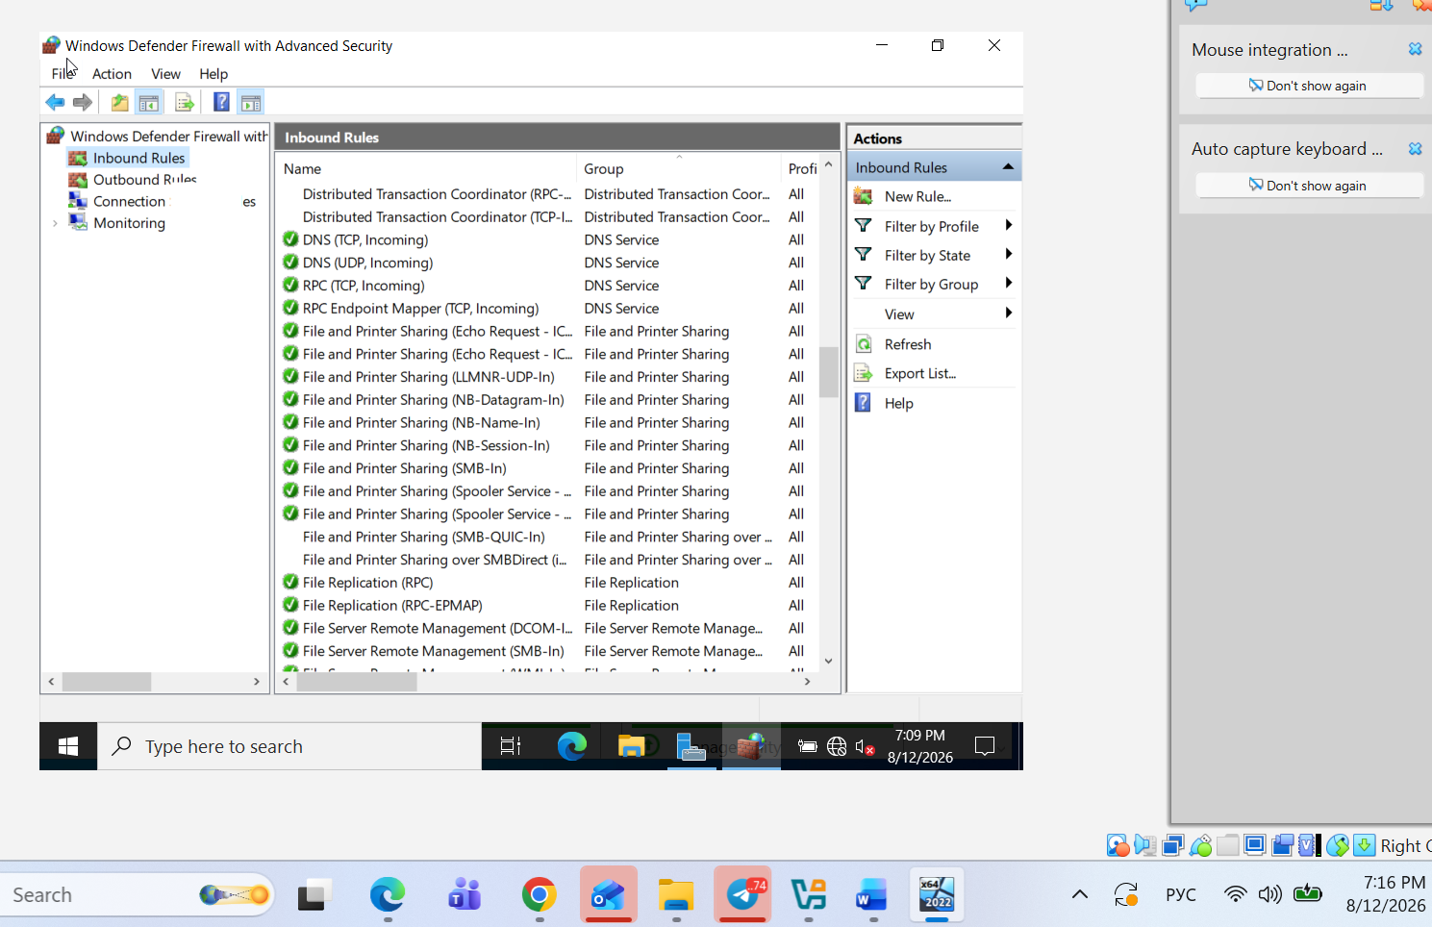

1.2 Routing in London (Linux1 / L-CD)
Routing and Remote Access Service (RRAS) is a Windows feature that lets a server work as a router between two or more networks. In this project, RRAS on Windows1 (B-DC) allows traffic to move between the Birmingham network (172.16.1.0/24) and the link to London (10.0.0.0/30). Without RRAS, the Birmingham and London networks would stay completely separate, and devices on one side would not be able to reach devices on the other side.

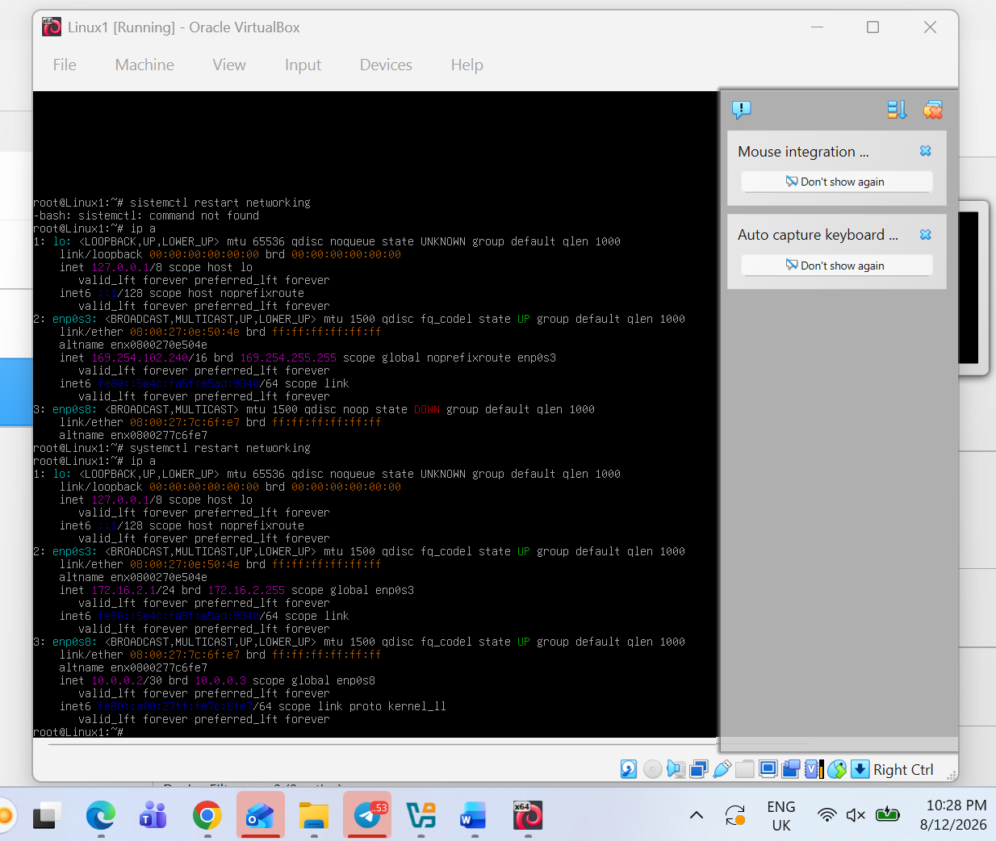

The screenshot shows the result of the "ip a" command on Linux1. It confirms that the London LAN interface (enp0s3) now has the static address 172.16.2.1/24, and the new WAN interface (enp0s8) has the address 10.0.0.2/30, connecting Linux1 to Windows1 across the link between Birmingham and London. Both interfaces are in the "UP" state, which means they are active and ready to send traffic.

2. Domain Server (Birmingham)

2.1 Forest Creation (olha.local)
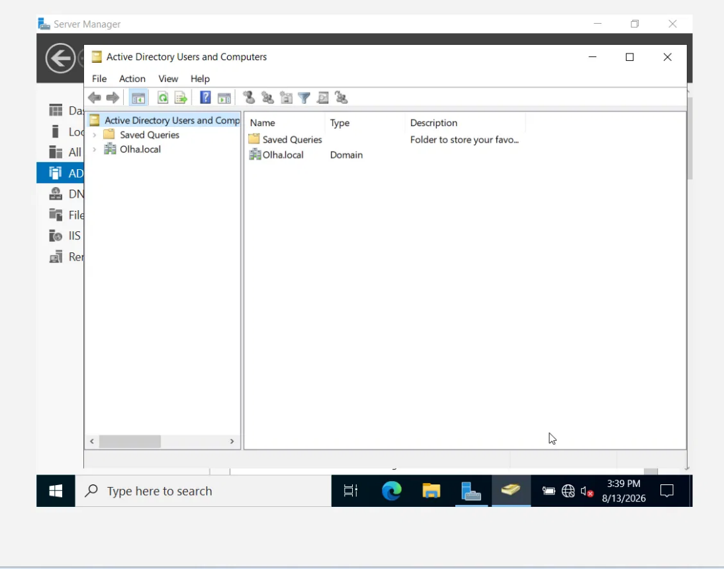

Active Directory Users and Computers console showing the domain "Olha.local" created on B-DC (Windows1).

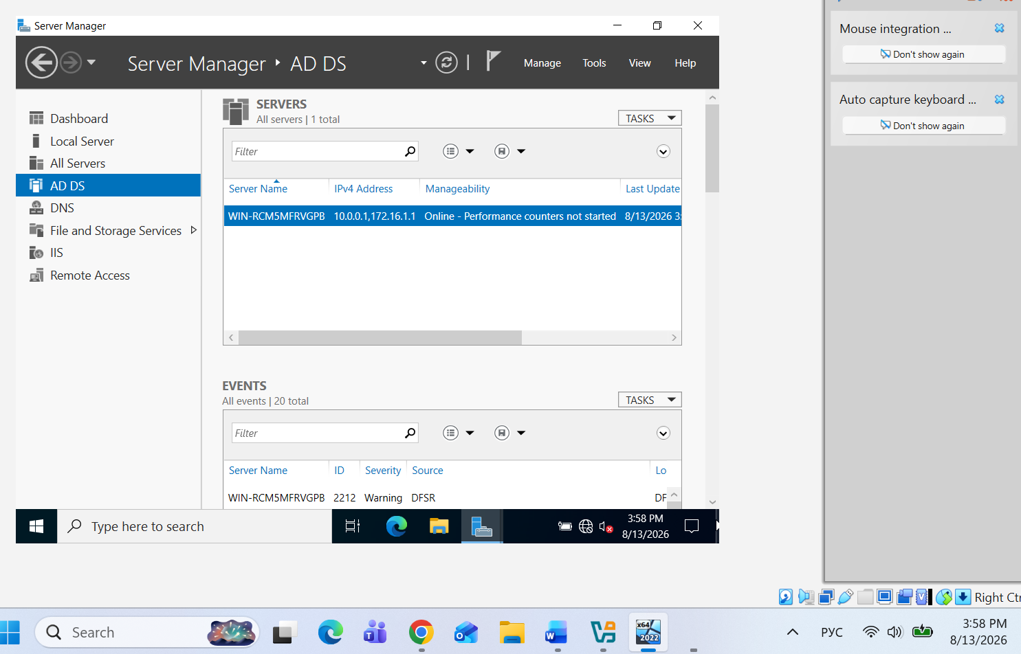

Server Manager AD DS dashboard confirming that Active Directory Domain Services is installed and running on WIN-RCM5MFRVGPB (Olha.local).

2.2 A Records
An A record (Address record) maps a hostname to an IPv4 address in DNS, so devices can find each other by name instead of remembering IP addresses. In this network, A records were created for B-DC, L-CD, ClientS1, and ClientL1, pointing to their IP addresses in the Birmingham and London networks.

2.3 Reverse Lookup Zone / PTR Records
A reverse lookup zone does the opposite of a normal DNS zone: instead of turning a name into an IP address, it turns an IP address back into a hostname, using PTR (Pointer) records. This is useful for troubleshooting and logging, since it lets administrators identify which device an IP address belongs to.

3. Encrypted Connection (Site-to-Site VPN)
A Virtual Private Network (VPN) creates a secure, encrypted connection between two networks over a link that is not fully trusted, so that data travelling between them cannot be easily read or intercepted. In this project, a Site-to-Site VPN connects the Birmingham network (172.16.1.0/24) to the London network (172.16.2.0/24) across the link between B-DC and L-CD. This is important because Birmingham and London are treated as separate offices; the VPN allows them to communicate as if they were part of one private network, while still protecting the traffic between the two sites. The VPN was configured after Routing and Remote Access, since RRAS already provides the routing foundation that the VPN connection uses.
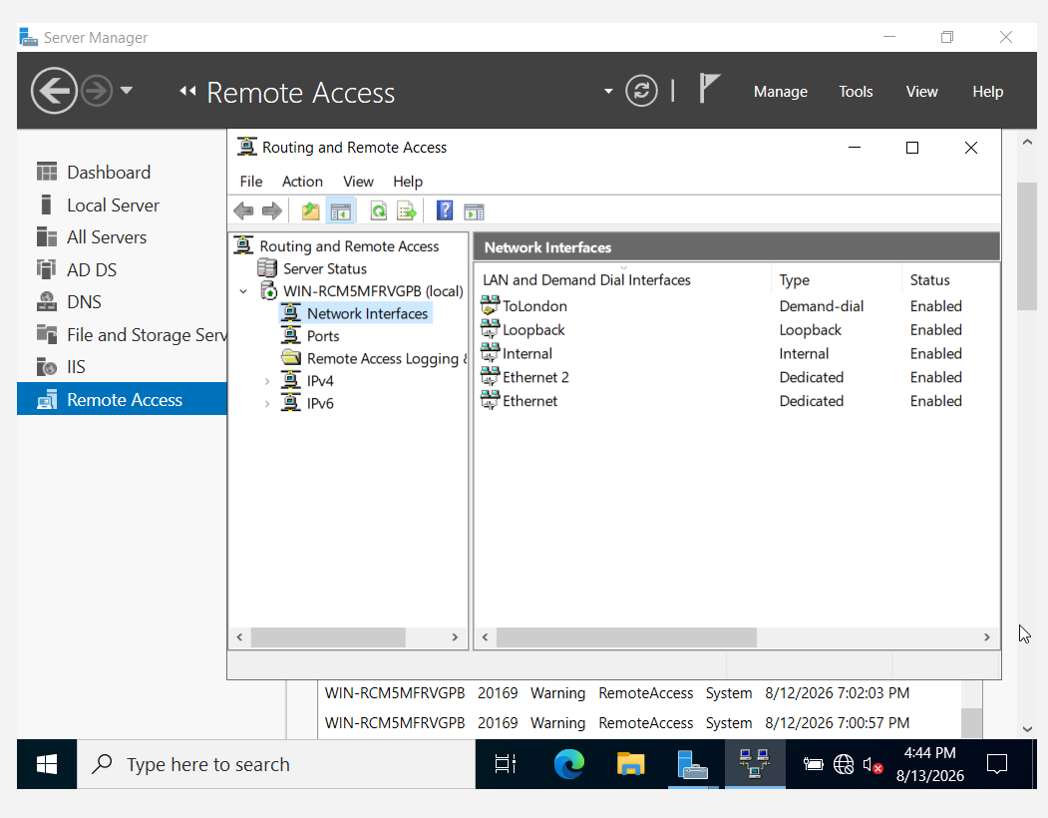

4. Users
User accounts were created manually through Active Directory Users and Computers, since the lecturer's users_list_updated.xlsx file was not available on Moodle. Three sample accounts were created (Olha Gonza, Nataliya Ivanova, Olena Martines) with logon names following the required first-initial.lastname format (o.gonza, n.ivanova, o.martines). Each account was given a password and enabled, ready to be used for domain login and testing.

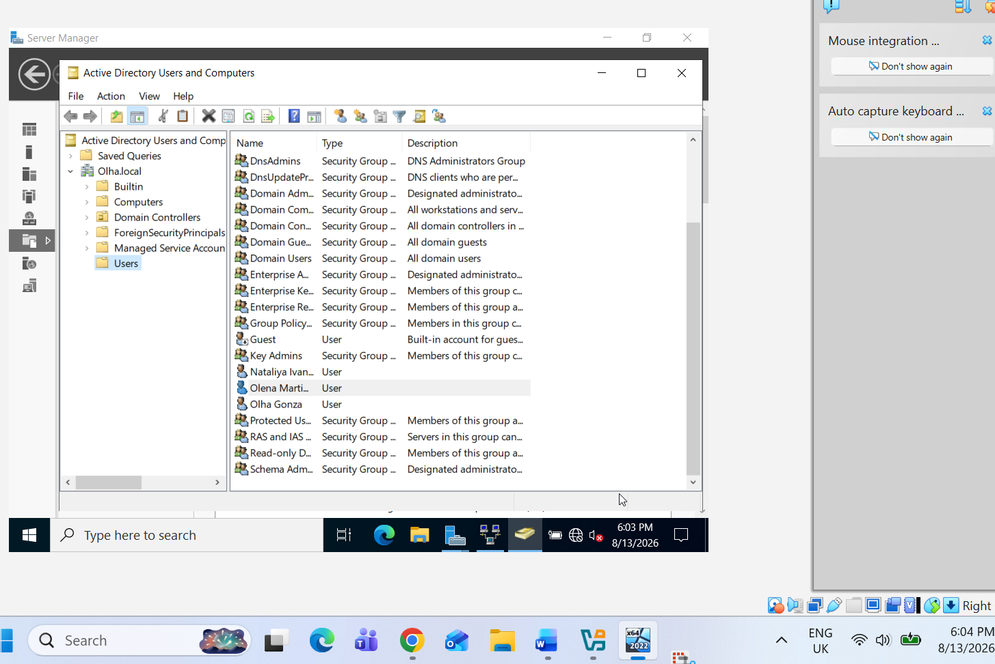

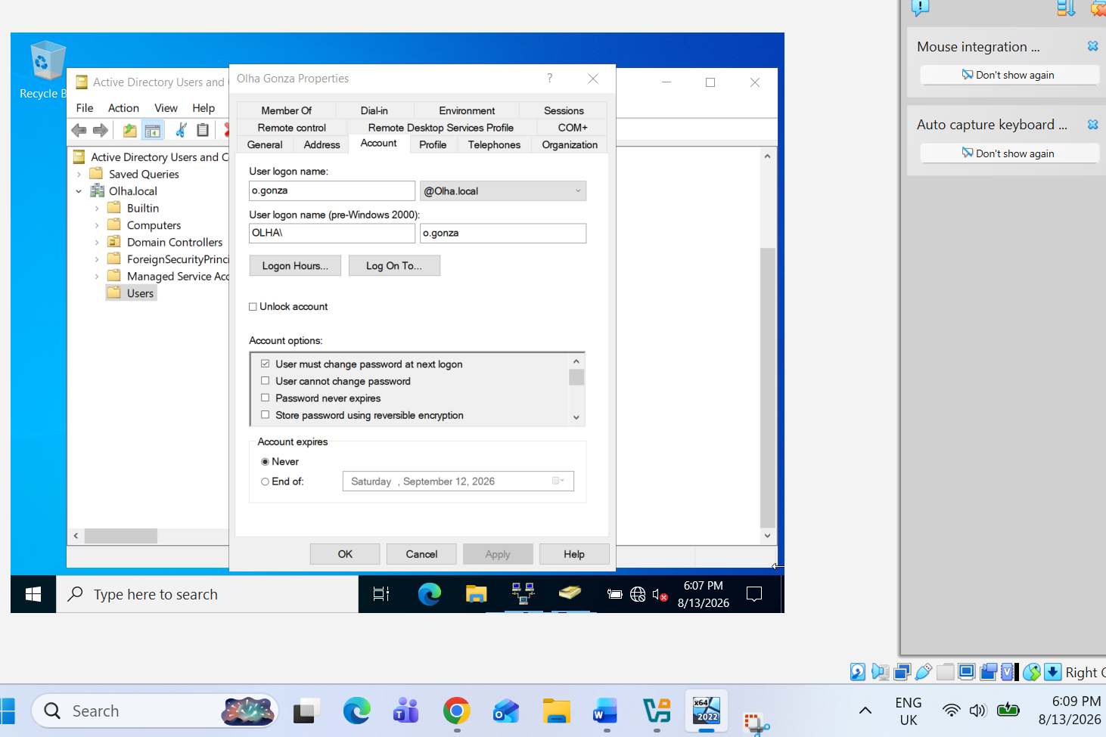

5. Domain Membership
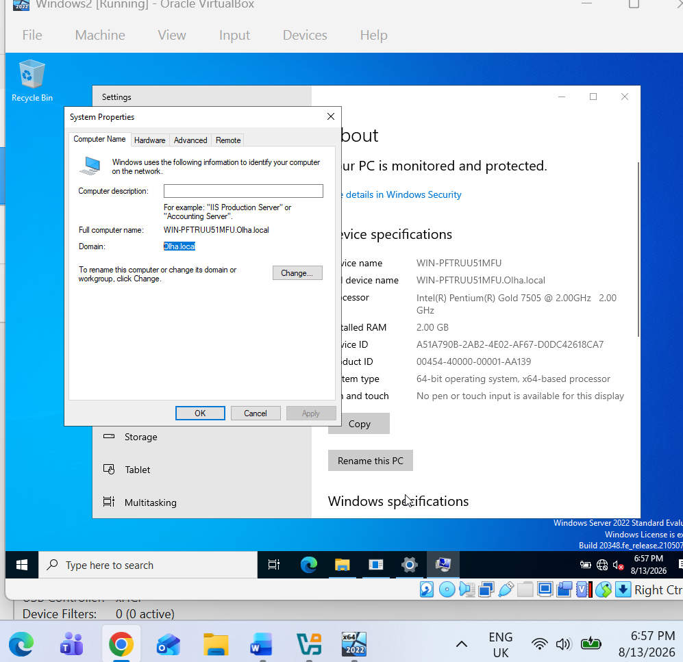

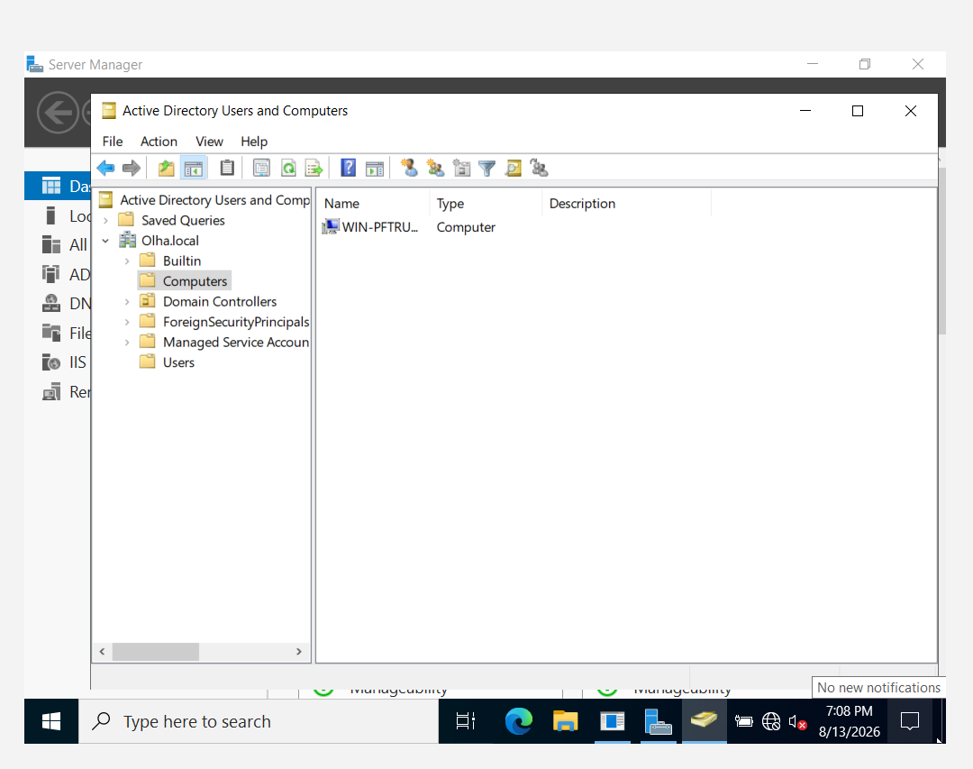
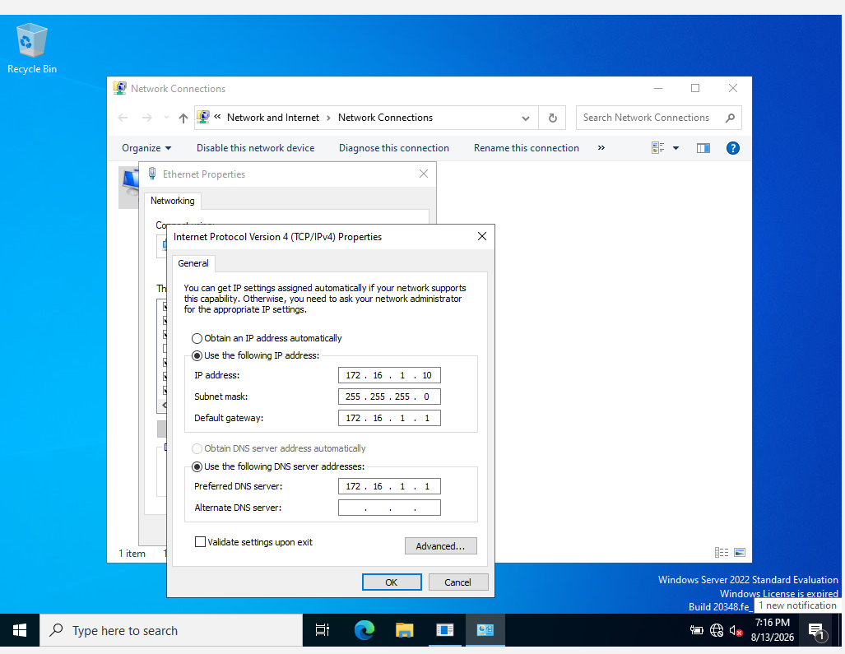

ClientS1 (Windows2) was joined to the Olha.local domain through System Properties → Change → Domain, using the Administrator credentials. After a restart, the machine appeared in Active Directory Users and Computers under the Computers container, confirming successful domain membership. The client's default gateway is set to 172.16.1.1, which is the IP address of B-DC (Windows1), allowing the client to reach other networks through the server acting as the router.

6. DHCP Server
Dynamic Host Configuration Protocol (DHCP) is a service that automatically assigns IP addresses, subnet masks, default gateways, and DNS servers to devices on a network, so administrators do not need to configure each device manually. In this project, B-DC (Windows1) is configured as the DHCP server for the Birmingham network, with a scope range of 172.16.1.10 to 172.16.1.20. L-CD (Linux1) is configured as a DHCP Relay Agent, which forwards DHCP requests from client devices in the London network to the DHCP server in Birmingham, since the two networks are on different subnets. This allows client devices in both offices (ClientS1 and ClientL1) to receive their IP address automatically, rather than needing static configuration.

7. Test and Troubleshoot
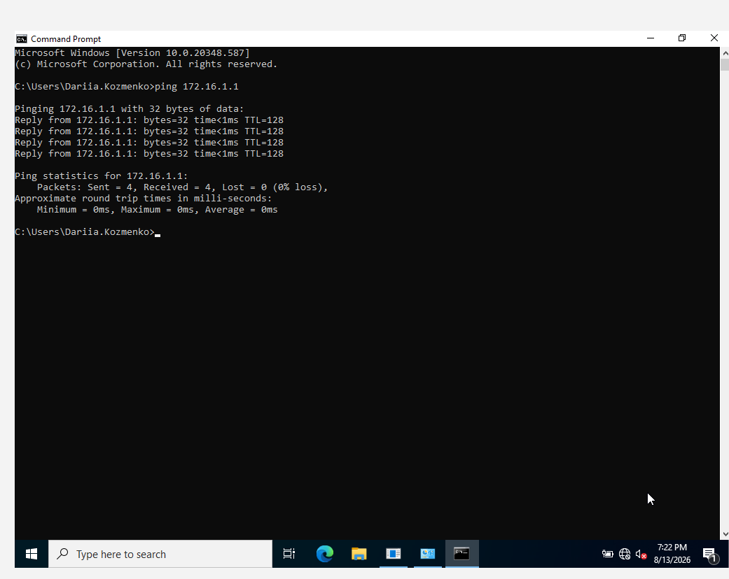
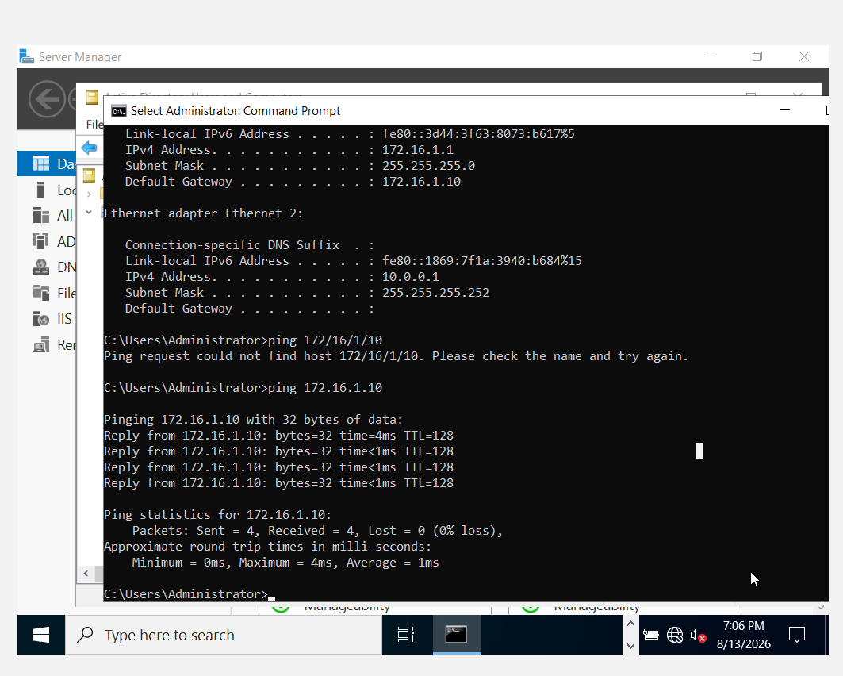
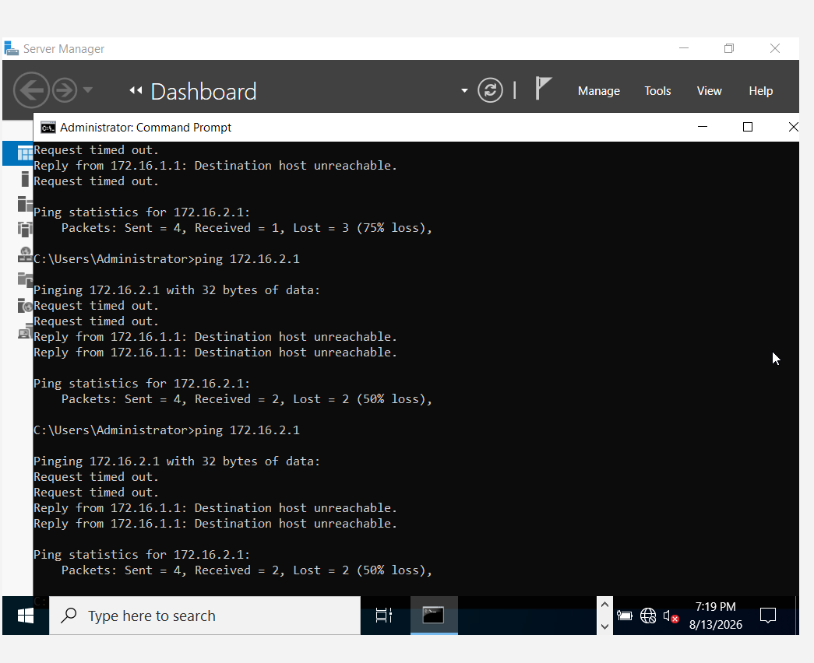
Connectivity was tested by pinging between the client and the server in both directions, and between the Windows and Linux networks. Ping from ClientS1 (172.16.1.10) to B-DC (172.16.1.1) succeeded immediately, confirming the local Birmingham network works correctly. Ping from B-DC to ClientS1 also succeeded. When pinging across sites, from B-DC (172.16.1.1) to L-CD (172.16.2.1), the first packets timed out while the demand-dial VPN interface ("ToLondon") was establishing the connection, and later packets received replies once the tunnel was active. This confirms that the Site-to-Site VPN and routing configuration correctly connect the Birmingham and London networks, even though the connection is not permanently open and takes a moment to establish on demand.

8. Disk Drive
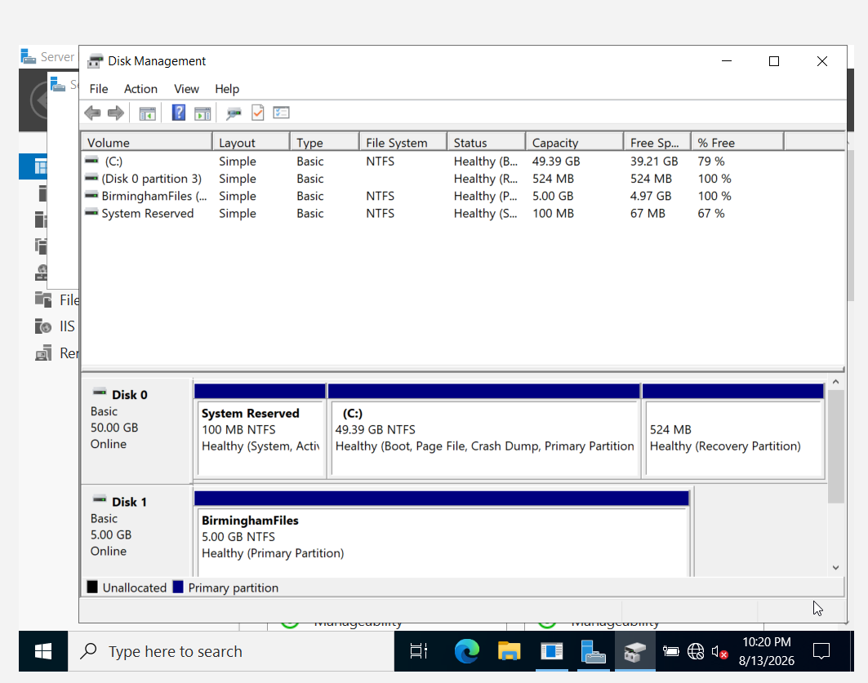

A second virtual disk (5 GB) was added to B-DC (Windows1) through VirtualBox, initialized, and formatted as drive E: with the volume label "BirminghamFiles". This drive was then shared over the network so that Domain Users have Full Control access, allowing staff across both offices to store and manage shared company files, while other network users are restricted to Read-only access to protect the data from unauthorised changes.
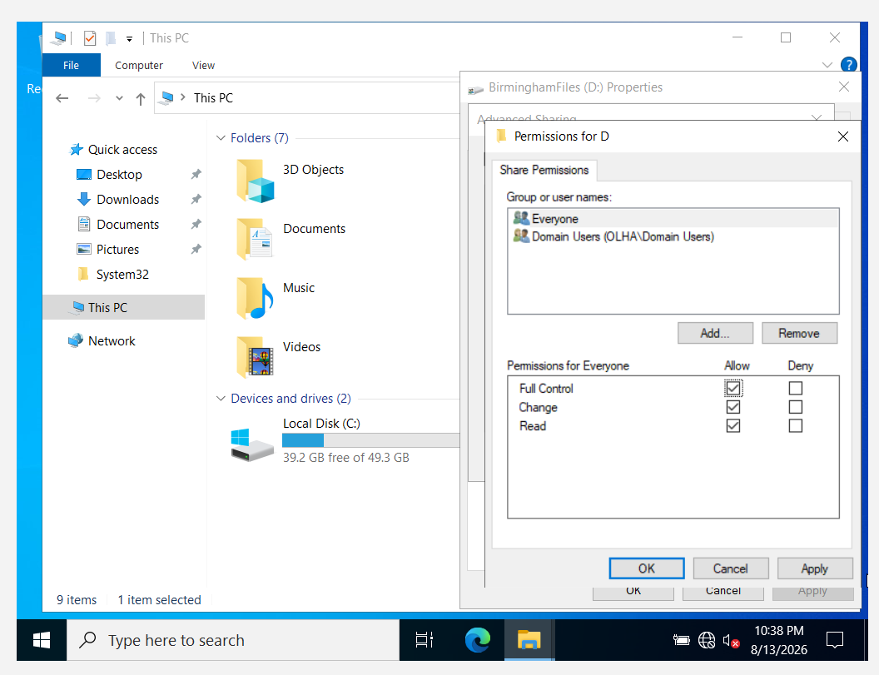

9. IIS Server
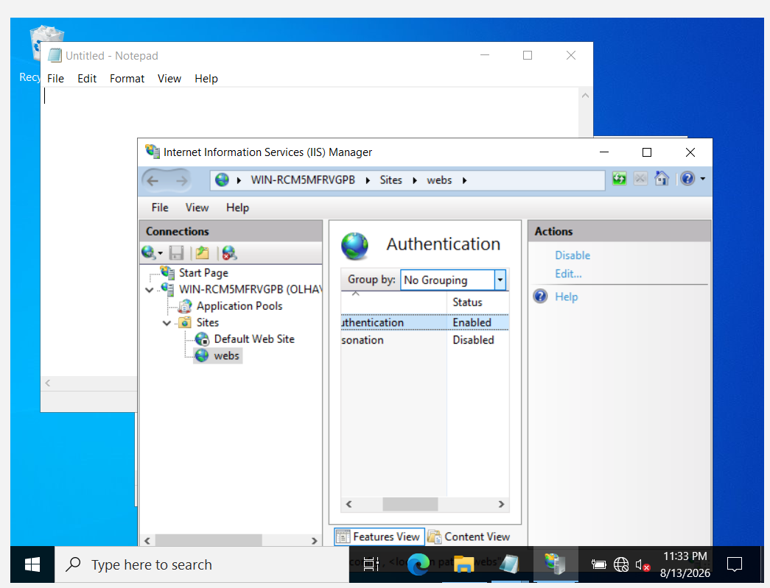
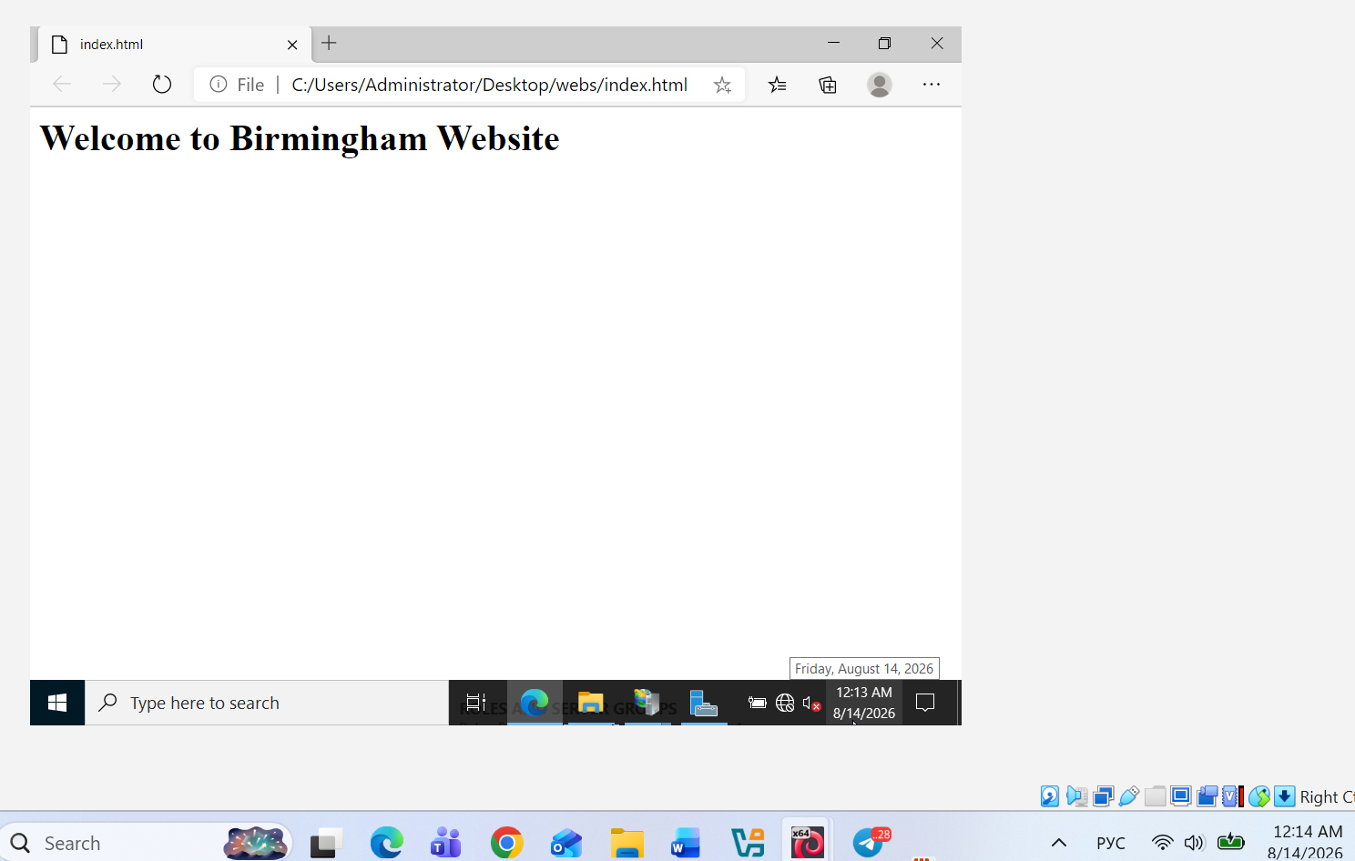

Internet Information Services (IIS) is a web server role in Windows Server that hosts websites and makes them accessible over the network. A website named "webs" was created on B-DC, using webs.olha.acca as the host name, with Windows Authentication enabled so that only authenticated domain users can access the site. The homepage displays "Welcome to Birmingham Website", confirming the site is functional. IIS is important in this project because it allows the Birmingham office to host an internal company website that staff can reach from anywhere on the network, rather than relying on external hosting.

10. Remote Desktop Services
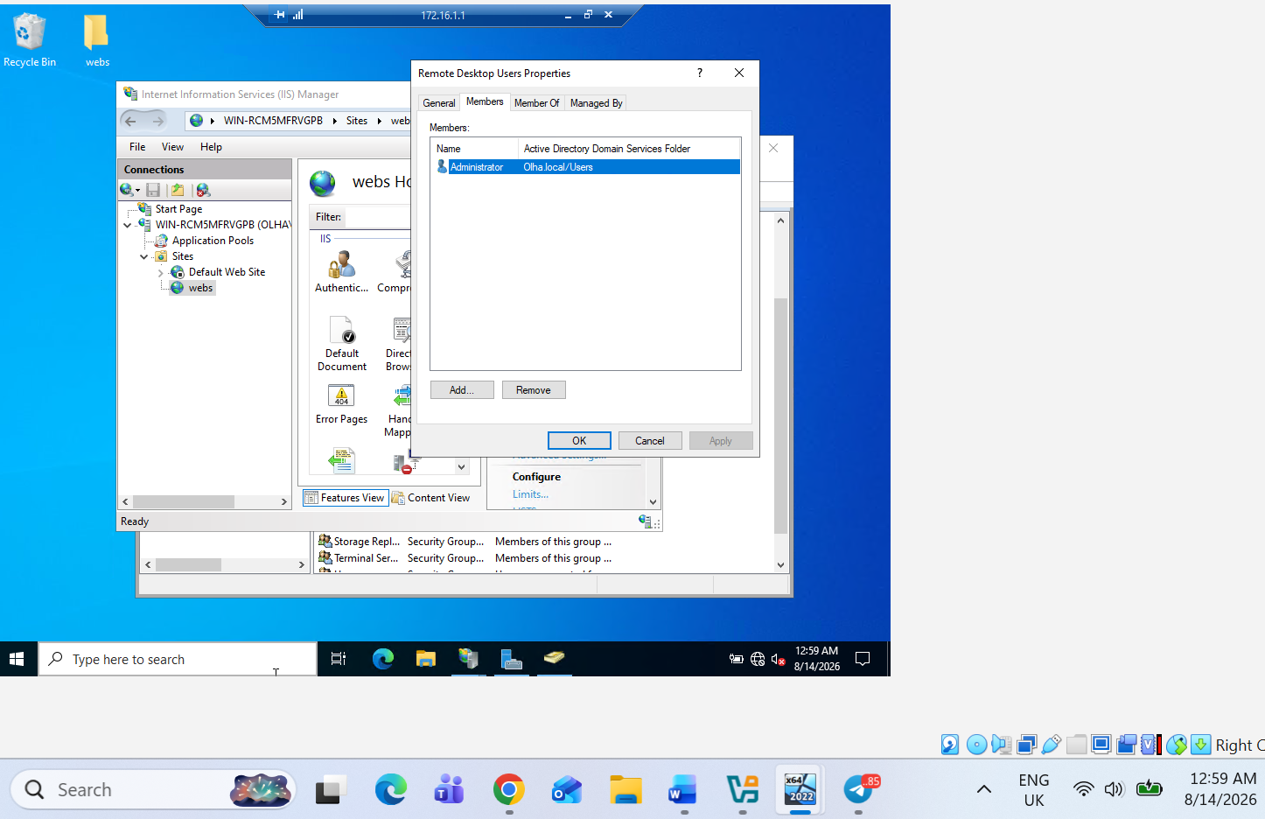
Remote Desktop Services (RDS) allows administrators to connect to and control a server remotely, as if they were sitting at it directly. Remote Desktop was enabled on B-DC (Windows1), and a connection was successfully established from ClientS1 (Windows2) using the domain administrator account (Administrator@Olha.local). This is important because it allows IT staff to manage and troubleshoot the server from any client machine on the network, without needing physical access to the server itself — which is especially useful across two office locations like Birmingham and London.

Conclusion
This report has documented the configuration of a virtualised enterprise network for NOSS London 2026 Inc, building on the topology created in Coursework 1. Routing was configured between the Birmingham and London offices using RRAS on B-DC and IP forwarding on L-CD, and a Site-to-Site VPN was added to secure the connection between the two sites. An Active Directory domain was created to centrally manage users and computers, with DNS records, DHCP, and domain membership configured for client devices in both offices. A shared drive was set up for file access with appropriate permissions, and both an internal website (IIS) and Remote Desktop Services were configured on the server, allowing staff to access company resources and manage the server remotely. Together, these configurations demonstrate a functional, centrally managed network connecting two office locations, meeting the core requirements of the NOSS London 2026 Inc infrastructure.

References

• Microsoft (2024) Remote Access overview. Available at: https://learn.microsoft.com/en-us/previous-versions/windows/it-pro/windows-server-2012-r2-and-2012/dn614140(v=ws.11) (Accessed: 13 August 2026).
• Microsoft (2024) Active Directory Domain Services overview. Available at: https://learn.microsoft.com/en-us/windows-server/identity/ad-ds/get-started/virtual-dc/active-directory-domain-services-overview (Accessed: 13 August 2026).
• Microsoft (2025) DNS zones in DNS Server on Windows Server. Available at: https://learn.microsoft.com/en-us/windows-server/networking/dns/zone-types (Accessed: 13 August 2026).
• Microsoft (2025) DNS reverse lookups in Windows and Windows Server. Available at: https://learn.microsoft.com/en-us/windows-server/networking/dns/reverse-lookup (Accessed: 13 August 2026).
• Microsoft (2025) What is DHCP Server in Windows Server?. Available at: https://learn.microsoft.com/en-us/windows-server/networking/technologies/dhcp/dhcp-top (Accessed: 13 August 2026).
• Microsoft (2023) Introduction to IIS architectures. Available at: https://learn.microsoft.com/en-us/iis/get-started/introduction-to-iis/introduction-to-iis-architecture (Accessed: 13 August 2026).
• Microsoft (2025) Remote Desktop Services overview in Windows Server. Available at: https://learn.microsoft.com/en-us/windows-server/remote/remote-desktop-services/overview (Accessed: 13 August 2026).

