
DIGITAL SKILLS AND RESEARCH METHODS : ASSIGNMENT 2 - RESEARCH REPORT
IMPACT OF VIRTUAL LEARNING ENVIRONMENT

MODULE CODE : BMSW4003S
STUDENT NAME: COVETE MARIA
VIORICA
STUDENT ID: 2128947

TABLE OF CONTENT
1.0 INTRODUCTION 2

2.0 BACKGROUD 2

3.0 AIMS AND OBJECTIVES 3

4.0 RESERACH METHODOLOGY 3

5.0 RESULTS 4

6.0 DISCUSSION 12

7.0 CONCLUSION 13

REFERENCES 14

APENDIX ……………………………………………………………………………………….15

1.0 INTRODUCTION
Overview of virtual learning environment (VLE)
Virtual learning environment is one of the popular learning and teaching tools which is especially designed for educational institutions to enhance the learning experience of students. This platform is used by teachers and students to improve the learning environment in the classroom. This tool includes different types of technology such as computers, laptops, software, the internet in the learning process, which helps both students and teachers achieve goals. This concept was introduced in the early 1990s, which has been utilized in universities for the purpose of achieving educational related goals.

2.0 BACKGROUD
LITERATURE REVIEW- VIRTUAL LEARNING ENVIRONMENT
According to Torres Martín and et.al., (2021), VLE is one of the best technology which is used by teachers and students to enhance the courses of study in the educational classrooms. This tool is especially designed for the purpose of creating a positive learning environment. The major benefit of using this tool is that it helps facilitate teachers management, so that they can easily find out solutions. It is really beneficial for students as it allows them to benefit from self paced learning which helps them to gain the future career opportunities to learn new skills. The best thing about VLE is that it helps in relationship building which is needed in learning process. Not only this, it offers complete flexibility and accessibility which is not present in traditional school methods and systems. By using VLE, students can easily improve their technology and technical skills (Ryan and Poole, 2019).
Tan, Chan and Mohd Said, (2021) Argues that VLE have some challenges also which includes lack of social and emotional skills because the classes take place over the internet there is not much interaction between people learning in online classes. Due to lack of face to face communication some students may face issues like online distractions, technical issues and sense of isolation. There are different types of technologies which is used for virtual learning such as mobile technologies, videoconference apps, web-conference, internet connection, microphones, software tools and emails. While learning process through VLE, people may face IT risks such as software and hardware failure, malicious hackers and viruses. It is essential to follow some important legislation related to these technologies such as the data protection act, copyright act and computer misuse act (Ryan and Poole, 2019).

3.0 AIMS AND OBJECTIVES
Aims of this research
To investigate the impact of virtual learning environment on users of educational institutions in the UK: A study on university of Wales trinity saint David (UWTSD)
objectives
- To study the concept of virtual learning environment
- To analyse significance of virtual learning environment in enhancing the students' performance at institution
- To evaluate the impact of virtual learning environment on UWTSD users
- To recommend the best strategies to UWTSD for improving virtual learning environment

4.0 RESERACH METHODOLOGY
Research Type
There are mainly two types of research which can be used by research such as quantitative and qualitative. For analysing the impact of VLE on users, qualitative research type has been selected (Mohajan, 2018). Moreover, aspects related to VLE and students performance are theoretical which in turn can be analysed with the help of qualitative investigation.
Research Approach
There are mainly three types of research approach such as inductive, deductive and abductive which can be used by researcher. For the current study, inductive research approach has been used to analyse the significance of VLE in enhancing the performance of students.
Data collection
For addressing research objectives data is gathered from both the important sources such as secondary and primary data. Under primary data collection, survey is conducted on 17 users of UWTSD through the means of questionnaire (Zhou and et.al., 2018). In order to develop brief thesis for qualitative research, secondary data collection has been used with the help of books and journals, magazines, articles, previous data.
Sampling
For the purpose of survey, researcher needs to select appropriate sample method so that suitable results can be obtained. For the current study, 17 users of UWTSD have been selected using simple random sampling method (Mohajan, 2018).
Data Analysis
In order to analyse the responses gathered from survey method, researcher is using thematic perception test technique. The reason behind choosing this technique is that it helps in analysing data effectually and help researchers meet aims and objectives. For the current study, several themes have been prepared to analyse data.

5.0 RESULTS
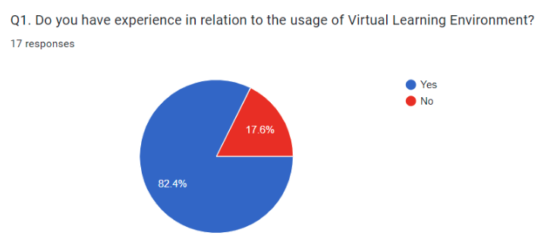
Participants | Responses
14 | Yes
3 | No

On the basis of above diagram, it has been interpreted that majority of the students have experience in relation to the usage of virtual learning environment (Hamutoglu and et.al., 2020). Among 17 users, there were 82.4% users who said yes and stated that with the help of VLE, they are able to enhance their performance. 17.5% of users says no because they have no experience using VLE, they are using traditional method only.

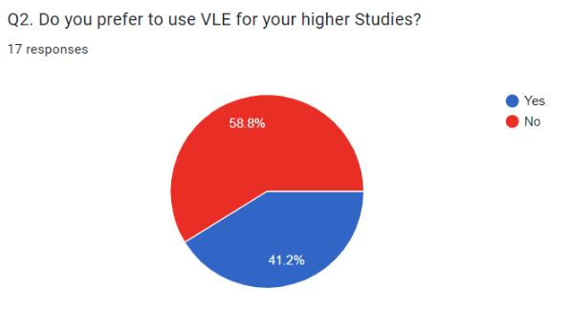

Participants | Responses
7 | Yes
10 | No

From the above chart it has been identified that 41.2% of users prefer to use VLE for their higher studies because they think it is the most effective tool from which they can enhance self paced learning and get new opportunities in the future that will help them learn new skills (Hamutoglu and et.al., 2020). Among 17 users, 58.8% of users says no because they think face to face interaction cannot be obtained through VLE as it is online learning tool.

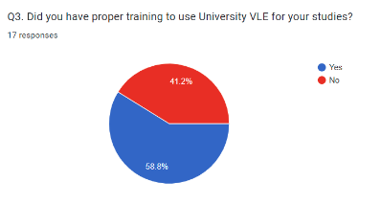
According to above chart, it has been noted that 58.8% of users have proper training to use VLE for studies which helps them achieve learning opportunities, While 41.2% of students says no.
Participants | Responses
7 | Yes
10 | No
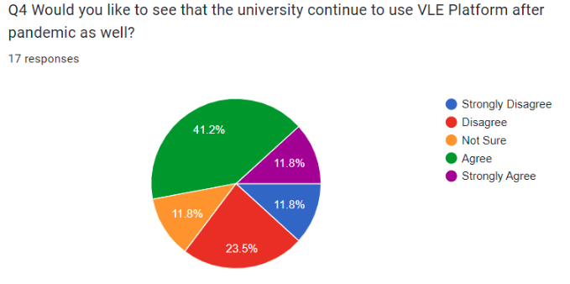
Participants | Responses
2 | Strongly disagree
4 | Disagree
2 | Not sure
7 | Agree
2 | Strongly agree
As per the above mentioned record, it has been interpreted that most of the users agree on fact that they want to see university continue to use VLE Platform after covid-19 pandemic as well. Among all the 17 users, 23.5% of users disagree and 11.8% of people are not sure, strongly disagree and strongly agree.
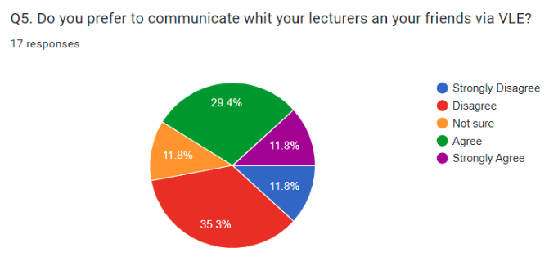

Participants | Responses
2 | Strongly disagree
6 | Disagree
2 | Not sure
5 | Agree
2 | Strongly agree

When it is asked users that they prefer to communicate whit their lectures and friends via VLE, almost 29.4% of people agree, 35.3% of users disagree. While 11.8% of students says that they are not sure about it, strongly disagree and strongly agree.
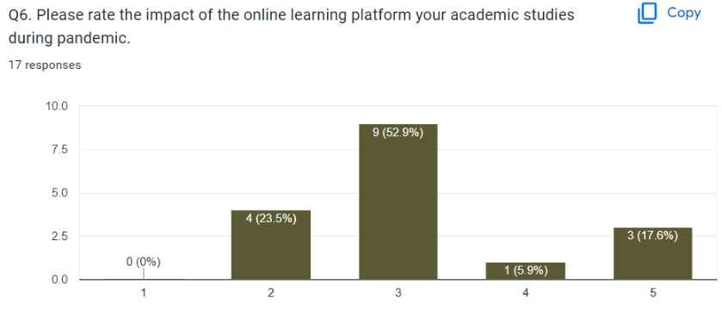

Participants | Responses ratings
1 | 1
3 | From 2-3
4 | From 4-5
9 | 9

From the above chart, it has been notified that when it is asked users that provide rating on the impact of the online learning platform academic studies during covid-19 pandemic, 23.5% of users has given 4 out 10, 52.9% of student has given 9 out of 10, 17.6% of users has rated 3 out of 10, 5.9% of students has given 1 out 10. Some of them stated that they have faced technical issues while learning from online tools, some of them commented that online learning platform helped them achieved good knowledge while few of them said that online distractions has lowered their productivity (Boulton, Kent and Williams, 2018).
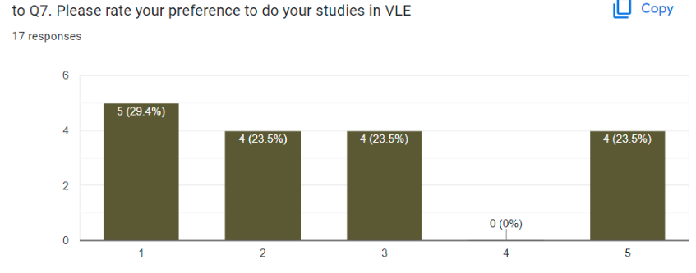
when it is asked students to give ratings on preference to do studies in VLE, almost students have rated it 4 out of 5. 29.4% of users has given 5 out of 5 rating as they think it helps in improving virtual communication and collaboration skills.

Participants | Responses
13 | Yes
4 | No

From the above chart, it has been evaluated that 76.5% of users think e-learning platform provide appropriate support to complete their assignment, while rest 23.5% of users says no and stated that e-learning tools does not offer support to them while completing their work.
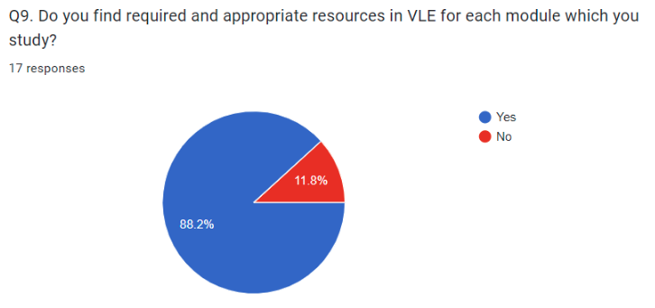

Participants | Responses
15 | Yes
2 | No

From the above mentioned diagram, it has been notified that 88.2% of users says that they find appropriate resources in virtual learning environment while studying module in the classroom, While some of them that is 11.8% of users says no.

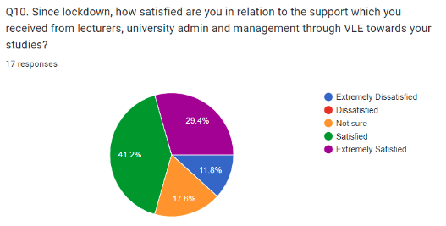

Participants | Responses
2 | Extremely dissatisfied
1 | dissatisfied
2 | Not sure
7 | Satisfied
5 | Extremely Satisfied

From the above analysis, it has been noted that 41.2% of users satisfied that they are being provided with support from lecturers during learning process in the university (Hamutoglu and et.al., 2020). Around 17.6% of people say that they are not sure whether admin and management team support them during their studies through VLE. 29.4% people are extremely satisfied with the support given by lecturers on the other hand, 11.8% of people extremely dissatisfied with it.

6.0 DISCUSSION
When it was asked from the respondents that whether they are using VLE than it was found that most of the users are using VLE as an effective tool. They further added that their daily learning were relatively depended on new tools related to learning (Ryan and Poole, 2019). However, few of them have disagreed and answered no, because they think traditional method is more beneficial for them the reason behind that is with the help of traditional method they are able to enhance face to face conversation which is not present in VLE.
During survey when it was inquired about whether they prefer to use VLE for higher education, it was found out that 7 out of 17 users says no, rest says that it is very beneficial for them to use VLE, they would like to use tools of VLE for higher studies as it will help in increase their performance and solve issues by using digital tools and strategies. They further added that this is being regarded as one of the most effective tools by which they can easily manage work and assignments (Odrekhivskyy and et.al., 2019). Even during and after pandemic, these communications and virtual learning tools has been adopted by users for communicating with each other and share their knowledge. There were 10 users who have proper training to use VLE for studies which is very effective for them rest 7 users out of 17 says, university has not provided them proper training.
When participants were inquired in relation to their preference to communicate with lecturers and friends via VLE, 5 out of 17 people were agree, they explain that the major purpose of VLE Is to improve communication between two people while learning and it helps in encouragement of digital culture in the classroom. The reason behind is that now the world is becoming digital in every aspect and institutions are using tools and strategies of VLE in order to increase productivity among students (Bogusevschi, Muntean and Muntean, 2020). Some people think that VLE is time-consuming because it takes a lot of time and knowledge to use technology which cannot be performed by each student few user may face problem while using tool and software while learning online. The experience in relation to the usage of VLE was dealing with distractions as user feel distracted during online class. It is recommended to create learning positive environment ensuring everyone is attentive during online classroom session.

7.0 CONCLUSION
To conclude, secondary and primary research was conducted to identify and explore various aspects of virtual learning environment used by the institutions and its challenges and importance. The results of the research was stored, interpreted, investigate and gathered with the help of appropriate tools and techniques. With the help of thematic perception test techniques, impact of VLE on users has been identified effectually. Finally, suggestion has been given to improve and promote the services of Virtual learning environment.

REFERENCES
Books and Journals
Bogusevschi, D., Muntean, C. and Muntean, G. M., 2020. Teaching and learning physics using 3D virtual learning environment: A case study of combined virtual reality and virtual laboratory in secondary school. Journal of Computers in Mathematics and Science Teaching. 39(1). pp.5-18.
Boulton, C. A., Kent, C. and Williams, H. T., 2018. Virtual learning environment engagement and learning outcomes at a ‘bricks-and-mortar’university. Computers & Education. 126. pp.129-142.
Hamutoglu, N. B. and et.al., 2020. Evaluating students experiences using a virtual learning environment: satisfaction and preferences. Educational Technology Research and Development. 68(1). pp.437-462.
Mohajan, H. K., 2018. Qualitative research methodology in social sciences and related subjects. Journal of Economic Development, Environment and People. 7(1). pp.23-48.
Odrekhivskyy, M. and et.al., 2019. Problems of the Intelligent Virtual Learning Environment Development. In MoMLeT (pp. 359-369).
Ryan, E. and Poole, C., 2019. Impact of virtual learning environment on students’ satisfaction, engagement, recall, and retention. Journal of medical imaging and radiation sciences. 50(3). pp.408-415.
Tan, K. H., Chan, P. P. and Mohd Said, N. E., 2021. Higher education students’ online instruction perceptions: A quality virtual learning environment. Sustainability. 13(19). p.10840.
Torres Martín, C. and et.al., 2021. Impact on the virtual learning environment due to COVID-19. Sustainability. 13(2). p.582.
Zhou, D. and et.al., 2018. A survey on network data collection. Journal of Network and Computer Applications. 116. pp.9-23.
APPENDIX
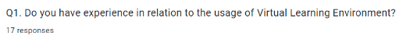
- yes
- No
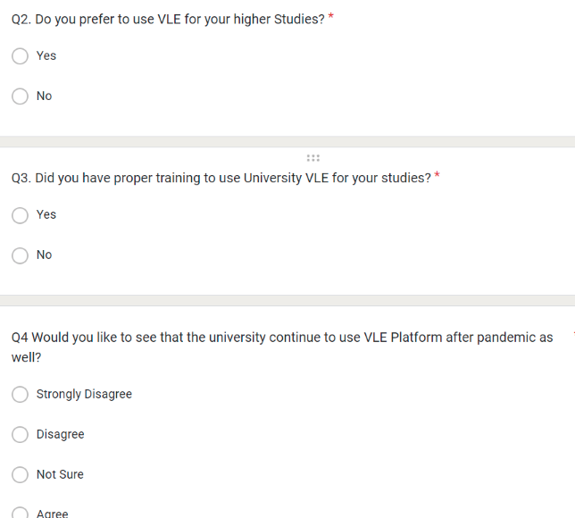
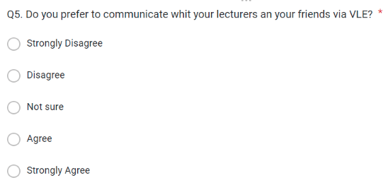

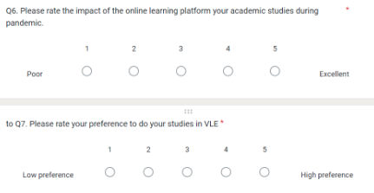
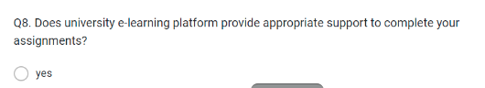
- No



