University of Wales Trinity Saint David

28/04/2026

Computer Architecture and Operating Systems
Module Name: Computer Architecture and Operating Systems
Module Code: ACCA4022

Student Name: Vasile-Eduard Cornila
Student ID: 2423608
Group Number: 1

Lecturer’s Name: Redhwan Al Amri

Table of Contents
Introduction 3
Key functions of general operating systems 3
Use of Windows OS CLI commands 6
Process management 6
File and directory management 7
Network testing and monitoring 8
User management 8
Task scheduling 9
Use of Linux OS CLI commands 10
Process management 10
File and directory management 11
Network testing and monitoring 12
User management 13
Task scheduling 13
Use of Windows OS Scripts 14
Script 1: Simple system audit (batch_audit.bat) 14
Script 2: Bulk folder creator (batch_bulk_folders.bat) 16
Use of Linux OS scripts (Bash) 17
Script 1: System + network report (bash_sys_net_report.sh) 18
Conclusion 21

Introduction
Operating systems (OS) are the core system software that manage a computer’s hardware and software resources, acting as a bridge between applications and physical components. This report summarises key OS functions and demonstrates practical command-line skills in Windows and Linux, including process, file, network, user and scheduling tasks. Screenshots are included throughout as evidence of commands and outputs, alongside relevant OS monitoring views, linking the discussed concepts to results observed on the test systems.

Key functions of general operating systems
General-purpose operating systems such as Microsoft Windows, Linux distributions and macOS provide a consistent platform for applications by abstracting hardware resources and coordinating how they are shared [1], [2]. A core function is process management, where the OS creates and terminates processes, schedules CPU time, and performs context switching so multiple programs can run responsively [1], [2]. This also includes monitoring and control mechanisms that allow administrators to identify resource-heavy tasks and manage system performance [1], [2].
Figure 1: Windows task manager processes tab showing the current active applications and their impact on system performance.
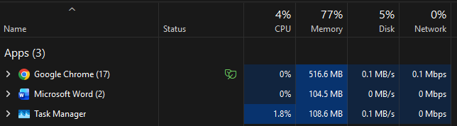
Closely related is memory management. This involves controlling and coordinating primary memory (RAM) by allocating and freeing memory for processes and managing virtual memory [1], [2]. The OS tracks which regions of memory are in use, prevents processes from interfering with each other, and maintains performance using techniques such as paging and swapping (and, on some systems, segmentation) so that multiple programs can run concurrently even when physical RAM is limited [1], [2].
Figure 2: Linux “free -h” output showing RAM and swap usage (memory + virtual memory).
Another key function is file and storage management. In an OS, this involves organising, storing, retrieving, and securing data on physical hard drives and SSDs [1]. It is also responsible for mapping logical files, creates hierarchical directory structures, tracks free space, and handles file permissions to ensure only authorised users and processes can read, write or execute resources [1], [2].
Figure 3: Drive properties showing capacity and free space on windows
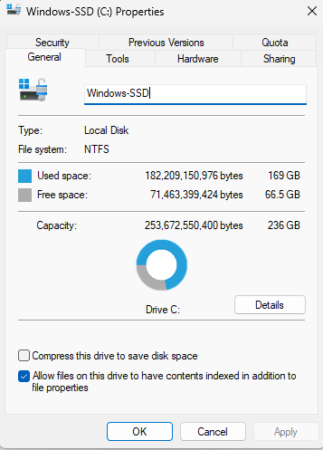
Operating systems also provide device and I/O management, which is how the system controls hardware such as disks, keyboards, printers and network adapters without every application having to know how each device works [2]. The OS relies on device drivers and kernel I/O subsystems to translate requests (for example, “read this file” or “send this data”) into device-specific operations [2]. To keep the computer responsive, it uses techniques such as interrupts, buffering and I/O queues (and sometimes spooling, e.g., for print jobs) so data can be moved efficiently between hardware and software [2]. This “device independence” is important because it improves portability: applications can use the same standard interfaces while the OS handles hardware differences in the background [2].
Figure 4: Linux “lsblk” output showing block devices, partitions and mount points (device/storage management).
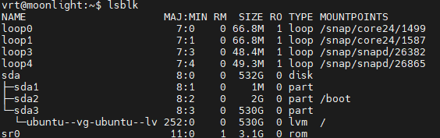
Networking is another core function in modern operating systems [1], [2]. It allows computers to connect, communicate and share resources (such as files, printers and services) across local and wide area networks [1], [2]. Most OSs include built-in networking stacks such as TCP/IP and provide socket interfaces so applications can send and receive data locally or remotely [1], [2]. The OS also includes tools that let administrators check connectivity and monitor throughput, active connections and listening services, which is useful for troubleshooting network issues and spotting unexpected connections or services [1], [2].
Figure 5: output showing successful basic network connectivity (ICMP test) and response times on a Linux OS
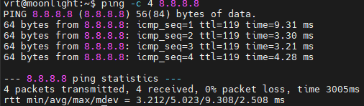
Finally, security and protection are shared responsibilities in an operating system, meaning they affect almost every part of the system [1], [2]. The OS ensures resources such as files, memory and devices are accessed only by authorised users and processes by enforcing authentication, authorisation and auditing [1], [2]. It also separates user mode from kernel mode to limit what applications can do and reduce the impact of crashes or malicious software [1], [2]. In multi-user environments, user and group management helps control permissions and policies so access is granted based on identity and privilege [1], [2]. Many OSs also support virtualisation and containerisation, allowing workloads to run in isolated environments with controlled resource use, which can improve security and portability when deploying applications [1], [3].

Figure 6: Windows security showing real-time protection and scan status
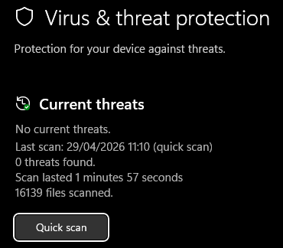

Use of Windows OS CLI commands
This section demonstrates Windows command-line administration using a mix of PowerShell cmdlets and classic CMD tools. For each command, a screenshot shows the command typed and the resulting output. Where possible, options/switches are used so the output is more useful than the defaults (for example filtering, extra detail, or a clearer output format).
Process management
“Get-Process -Name <name>” lists matching running processes and basic resource information (for example CPU time and memory usage). It is useful for checking whether an application is running and spotting processes that are using a lot of resources [4].
“taskkill /f /pid <PID> /t” ends a process using its PID. /f forces termination, and /t also ends child processes started by that process. This is useful when a program is frozen and will not close normally [5].
Figure 7: PowerShell window showing, “Get-Process -Name SpotifyLauncher” and the process list output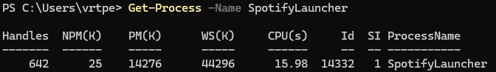
Figure 8: Command prompt showing “taskkill /f /pid 14332 /t” and the success message/output
File and directory management
“Get-ChildItem -Path C:\Temp -Recurse -Force” lists items in a folder recursively. -Recurse includes subfolders, and -Force includes hidden/system items, which is useful when you want a full audit of a folder tree [6].
“icacls "<path>" /grant vrtpe:(F) /T” changes NTFS permissions (ACLs). /grant adds permissions (here (F) means full control), and /T applies the change through subfolders, so permissions stay consistent across the directory tree [7].
Figure 9: PowerShell showing “Get-ChildItem -Path C:\Temp -Recurse -Force” and the resulting file list.
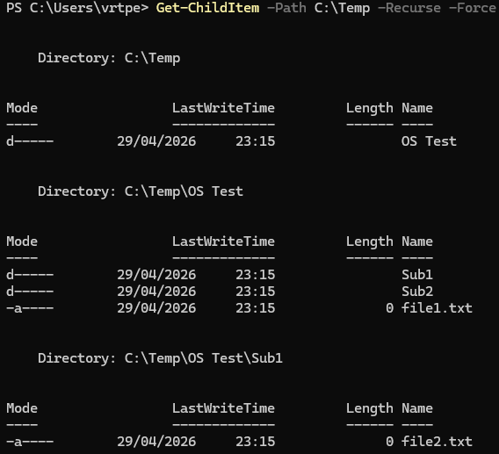

Figure 10: CMD showing the “icacls” command and the processed files/output.
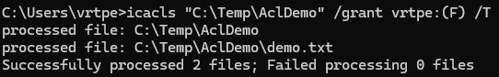
Network testing and monitoring
“Test-Connection -ComputerName 8.8.8.8 -Count 4” sends ICMP echo requests (like ping) to check basic connectivity. -Count 4 limits the test to four replies, which keeps the output short and easy to screenshot [8].
“Get-NetTCPConnection -State Established” lists TCP connections that are currently Established. This filter is useful because it focuses on active connections instead of showing every possible connection state [9].
Figure 11: PowerShell showing “Test-Connection” command and the reply
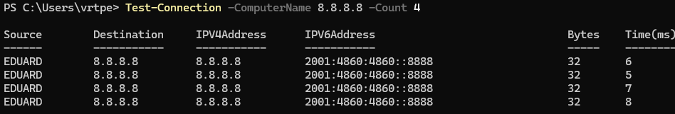
Figure 12: PowerShell showing “Get-NetTCPConnection -State Established” and the list of connections
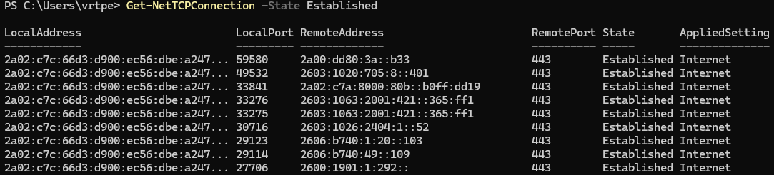
User management
“net user <username> /add” creates a local user account. This is a simple example of user administration from the command line, which links to OS security and access control [10].
“net user <username>” shows details for that account (for example whether the account is active and password-related settings). This is useful to confirm the account was created as expected [10].
Figure 13: CMD showing “net user <username> /add” and confirmation output
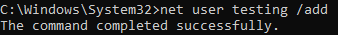

Figure 14: CMD showing “net user <username>” and the account details output
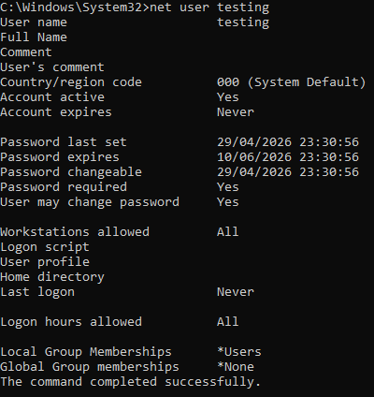
Task scheduling
“schtasks /create /sc daily /tn "DemoTask" /tr "notepad.exe" /st 09:00” creates a scheduled task that runs daily. /tn sets the task name, /tr sets the program to run, and /st sets the start time [11].
“schtasks /query /tn "DemoTask" /v /fo LIST” checks the task exists and prints verbose details in a LIST format, which is easier to read in a report screenshot [12].
Figure 15: Command Prompt showing “schtasks /create ...” and the success output.

Figure 16: Command Prompt showing “schtasks /query ... /v /fo LIST” and the task details output.
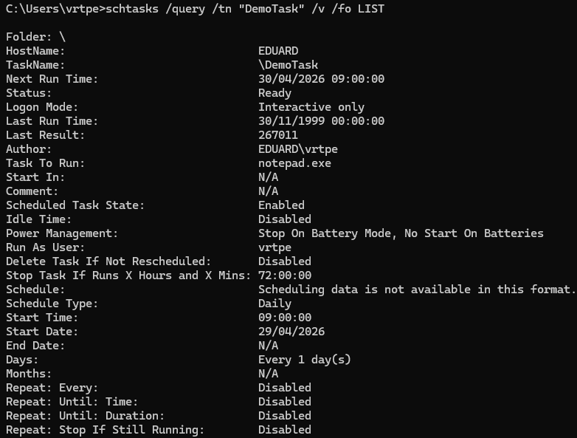

Use of Linux OS CLI commands
This section demonstrates Linux command-line administration using Bash on an Ubuntu Server system. Each command is shown with options to produce clear or more detailed output than the defaults. Screenshots are included as evidence, showing both the command entered and the resulting output.

Process management
“ps -ef” shows a full snapshot of running processes. It is useful for confirming what is running and identifying the user and command responsible for a process [13].
“top” provides a real-time view of processes and overall CPU/memory usage. It is useful for quickly spotting high CPU or high memory processes while the system is running [14].

Figure 17: Terminal showing “ps -ef” output with several processes listed.
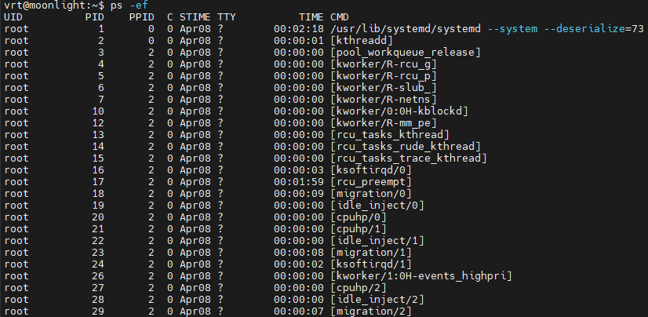
Figure 18: Terminal showing “top” with CPU/memory summary and process list.
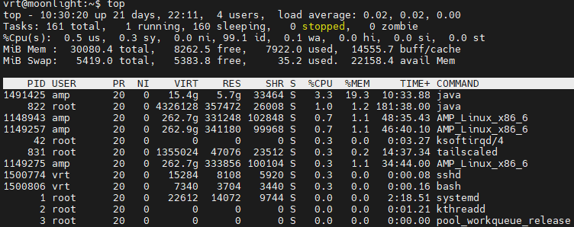

File and directory management
“ls -lah” lists files in a directory using long format, including hidden files, with human-readable sizes. This is useful for checking permissions/ownership and quickly seeing file sizes [15].
“df -h” displays mounted file systems and disk usage in a human-readable format. It is useful for checking available space and diagnosing low-disk issues [16].

Figure 19: Terminal showing “ls -lah” output (permissions, owner, size).
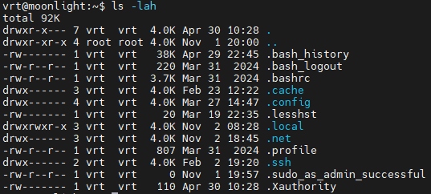
Figure 20: Terminal showing “df -h” output with mount points and usage.
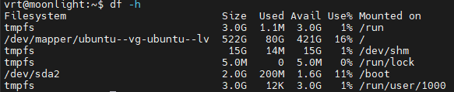

Network testing and monitoring
“ping -c 4 8.8.8.8” tests basic network connectivity by sending 4 ICMP echo requests. “-c 4” limits the output to 4 [17].
“ss -tuln” lists listening TCP/UDP sockets. “-t” and “-u” select TCP/UDP, “-l” shows listening sockets, and “-n” disables name resolution for faster, unambiguous output [18].
Figure 21: Terminal showing “ping -c 4 8.8.8.8” with packet loss and round-trip times. 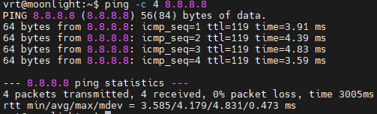
Figure 22: Terminal showing “ss -tuln” and listening ports/services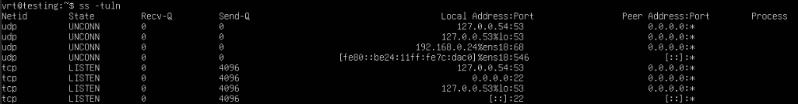

User management
“id <user>” displays a user’s UID, GID and group memberships. This is useful for verifying identity and permissions in a multi-user system [19].
“sudo useradd -m -s /bin/bash <user>” creates a new user account. “-m” creates a home directory, and “-s” sets the login shell, demonstrating basic account setup from the CLI [20].
Figure 23: Terminal showing “id <user>” output (uid/gid/groups).
Figure 24: Terminal showing “sudo useradd -m -s /bin/bash <user>” and any confirmation/no-output.
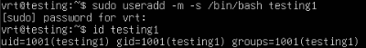

Task scheduling
“crontab -l” lists the current user’s cron jobs. This is useful for verifying recurring scheduled tasks configured for that user [21].
“systemctl list-timers --all” shows system timers, including inactive ones, which provides evidence of scheduled tasks managed by systemd on the system [22], [23].
Figure 25: Terminal showing “crontab -l” output, in this case “no crontab for vrt”.
Figure 26: Terminal showing “systemctl list-timers --all” output.
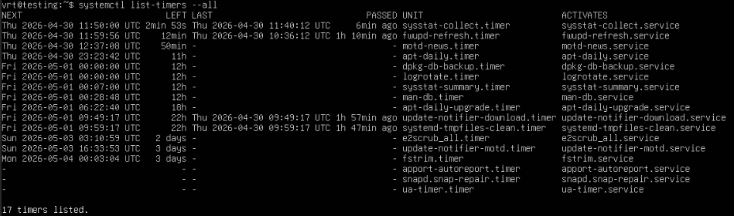

Use of Windows OS Scripts
This section demonstrates two simple Batch scripts that automate routine Windows administration tasks [24]. Each script uses variables, user input, arithmetic, loops, and conditional logic, and is supported with screenshots of the script code and the script running [24].

Script 1: Simple system audit (batch_audit.bat)
This script creates a quick “audit” report and saves it to a text file. It asks the user for an output folder, checks the folder exists (and creates it if needed), then writes basic system, network, and process information to a log file. This is useful because it turns several manual commands into one repeatable script.
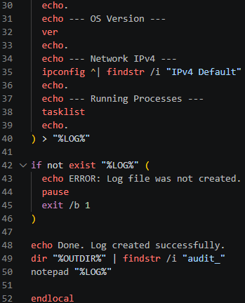
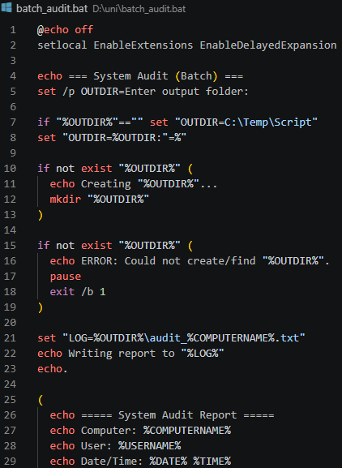
Figure 27: batch_audit.bat code shown in Visual Studio Code.

Figure 28: Command Prompt showing batch_audit.bat being run and the script output, with the output folder of my choosing
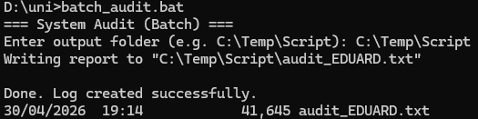
Figure 29: Part of the “generated audit_EDUARD.txt" opened in a text editor
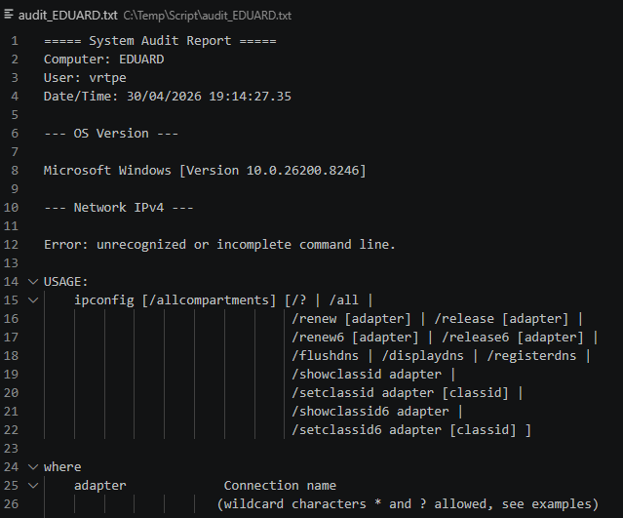
This script uses variables (e.g, “OUTDIR”, “LOG”), user input(“set /p”) [25], and conditionals (“if”, “if not exist”) [26] to create an output folder and save a repeatable audit report. It automates several commands into a single run, which saves time and helps keep evidence consistent.

Script 2: Bulk folder creator (batch_bulk_folders.bat)
This script asks for a parent folder, a base name, and a number. It then creates folders like “Lab_1”, “Lab_2”, etc. If a folder already exists, it skips it and counts it, which demonstrates practical error-avoidance in automation.
Figure 30: “batch_bulk_folders.bat” shown in Visual Studio Code
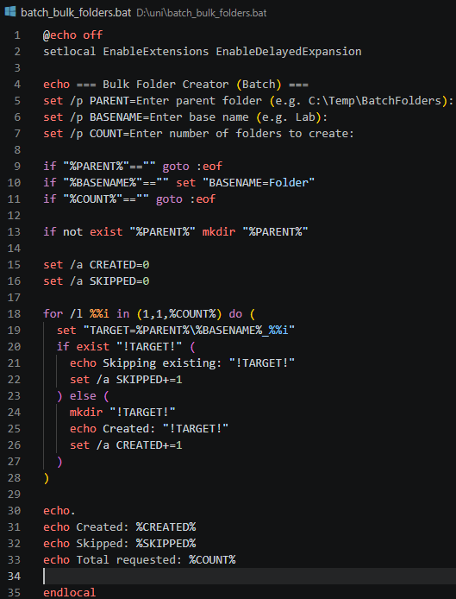

Figure 31: Command Prompt showing the script running, with my entered values and output.
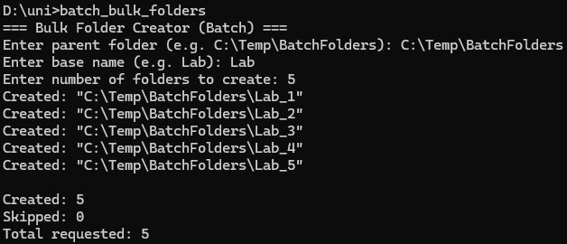
Figure 32: File Explorer showing the folders created inside the parent directory.
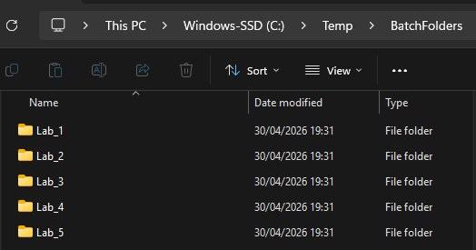
This script uses variables and user input to decide where and what to create, then uses a “for /l” loop [27] and arithmetic counters (“set /a”) [25] to create multiple folders and summarise results. The “if exist” check prevents errors and shows how automation can handle real situations where folders may already exist [26].

Use of Linux OS scripts (Bash)
This section demonstrates two simple Bash scripts created and run [28]. Each script uses variables, user input, arithmetic, and control flow (loops/conditionals), and is supported by screenshots of the script code and the script running in the terminal [28].

Script 1: System + network report (bash_sys_net_report.sh)
This script prompts for a report name, then generates a short system and network summary (hostname, uptime, disk usage, memory, IP address, and open listening ports). It saves the output to a timestamped text file.
Figure 33: “bash_sys_net_report.sh” code shown in a text editor.
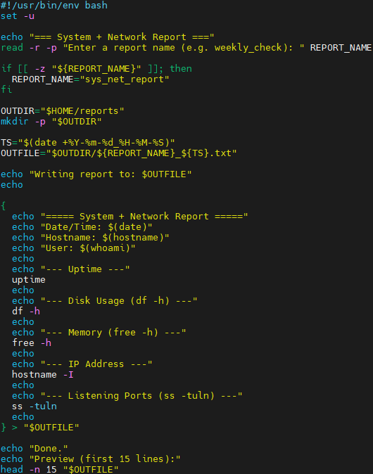

Figure 34: Terminal showing “chmod +x bash_sys_net_report.sh” and running the script.
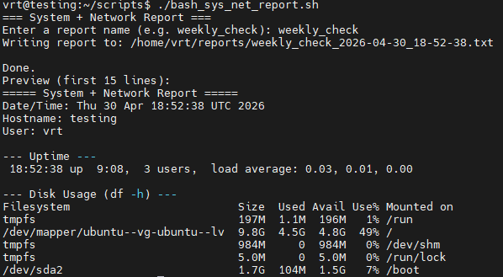
Figure 35: Terminal showing the generated report file preview/output. 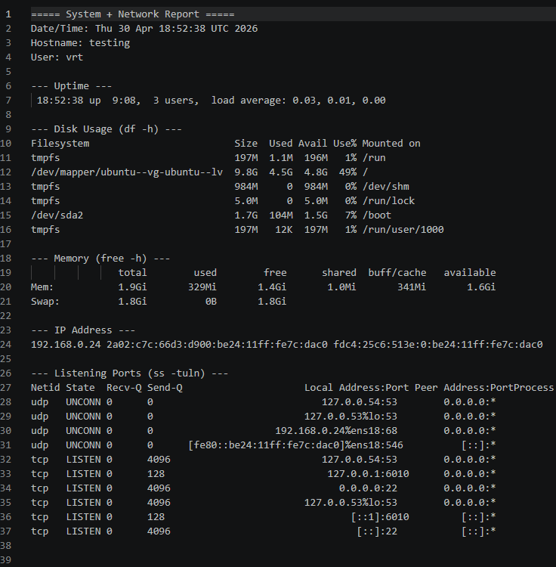

This script uses variables (“REPORT_NAME”, “OUTDIR”, “OUTFILE”), user input (“read -r”) [29], and conditionals (“if”) to create a report with a meaningful filename [28]. It automates common system checks into one repeatable command, which makes it easier to collect consistent evidence.
Script 2: Interactive cleanup + stats (bash_cleanup_stats.sh)
This script asks for a folder path and a file extension to target (e.g. .log), counts matching files, shows their total size, then asks for confirmation before deleting them. It demonstrates safe scripting with a “preview then confirm” workflow.
Figure 36: “bash_cleanup_stats.sh” code shown in a text editor.
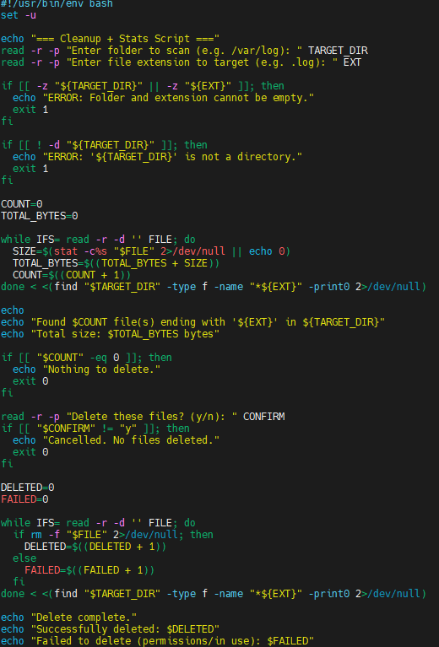
Figure 37: Terminal showing running the script, the count/size output, and the confirmation prompt.
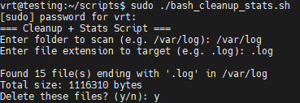
Figure 38: Terminal showing the final “Deleted X file(s)” message (or “Cancelled” if you choose no).
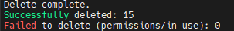
Figure 39: Terminal showing the final “Deleted X file(s)” message, however the user doesn’t have sufficient permissions.
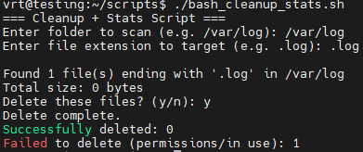
This script uses user input, arithmetic (“$((...))”) [28], a loop (“while read ...”) [28] and conditionals to safely delete files only after showing a summary and asking for confirmation. This kind of script is useful for routine cleanup tasks while reducing the risk of accidental deletion, or deletion by an unauthorised user. The file search and cleanup behaviour is implemented using standard utilities such as find [30], stat [31], and rm [32].

Conclusion
This report reviewed the key functions of general-purpose operating systems and then demonstrated how those concepts can be applied in practice using Windows and Linux command-line tools. Across both platforms, the operating system consistently provides core services such as process scheduling, memory management, storage organisation, device and I/O coordination, networking, and security controls. The monitoring screenshots and command outputs provided evidence of these functions in use and showed how administrators can observe and manage system behaviour.
The Windows CLI tasks demonstrated practical management of processes, files, networking, users and scheduled tasks using a combination of PowerShell and CMD utilities. Using options and switches (such as filtering, recursive listing, and verbose output) helped produce clearer and more useful results than default commands. The Linux CLI tasks showed equivalent administration capabilities through Bash commands for process inspection, storage checks, connectivity testing, socket monitoring, user identity management, and scheduling through cron and systemd timers.
The scripting tasks further highlighted the value of automation. The Batch scripts showed how common administrative actions can be turned into repeatable procedures using variables, user input, loops, arithmetic counters, and conditional logic. Similarly, the Bash scripts demonstrated control flow and safe automation patterns, such as generating reports with consistent formatting and using confirmation prompts to reduce the risk of accidental deletion. Overall, the work demonstrates transferable skills across both operating systems: using command-line tools to collect evidence, interpret system state, and automate routine tasks in a structured and auditable way.

References

[1] | R. H. A.-D. a. A. C. Arpaci-Dusseau, “Operating Systems: Three Easy Pieces,” 2023. [Online]. Available: https://pages.cs.wisc.edu/~remzi/OSTEP/.
[2] | F. K. a. R. M. R. Cox, “Unix-like teaching operating system,” August 2024. [Online]. Available: https://pdos.csail.mit.edu/6.828/2024/xv6/book-riscv-rev4.pdf.
[3] | P. B. G. a. G. G. A. Silberschatz, Operating System Concepts, Hoboken, NJ, USA: Wiley, 2017.
[4] | Microsoft, “Get-Process,” 2026. [Online]. Available: https://learn.microsoft.com/en-us/powershell/module/microsoft.powershell.management/get-process.
[5] | Microsoft, “taskkill,” 2026. [Online]. Available: https://learn.microsoft.com/en-us/windows-server/administration/windows-commands/taskkill.
[6] | Microsoft, “Get-ChildItem,” 2026. [Online]. Available: https://learn.microsoft.com/en-us/powershell/module/microsoft.powershell.management/get-childitem.
[7] | Microsoft, “icacls,” 2026. [Online]. Available: https://learn.microsoft.com/en-us/windows-server/administration/windows-commands/icacls.
[8] | Microsoft, “Test-Connection,,” 2026. [Online]. Available: https://learn.microsoft.com/en-us/powershell/module/microsoft.powershell.management/test-connection.
[9] | Microsoft, “Get-NetTCPConnection,” 2026. [Online]. Available: https://learn.microsoft.com/en-us/powershell/module/nettcpip/get-nettcpconnection.
[10] | Microsoft, “net user,” 2026. [Online]. Available: https://learn.microsoft.com/en-us/windows-server/administration/windows-commands/net-user.
[11] | Microsoft, “schtasks create,” 2026. [Online]. Available: https://learn.microsoft.com/en-us/windows-server/administration/windows-commands/schtasks-create.
[12] | Microsoft, “schtasks query,” 2026. [Online]. Available: https://learn.microsoft.com/en-us/windows-server/administration/windows-commands/schtasks-create.
[13] | man7.org, “ ps - report a snapshot of the current processes.,” man7.org, 2026. [Online]. Available: https://man7.org/linux/man-pages/man1/ps.1.html.
[14] | procps-ng, “top(1) — display Linux processes,” procps-ng manual,” Gitlab, 2026. [Online]. Available: https://gitlab.com/procps-ng/procps/-/blob/master/man/top.1.
[15] | Free Software Foundation, “ls invocation,” GNU Coreutils Manual, 2026. [Online]. Available: https://www.gnu.org/software/coreutils/manual/html_node/ls-invocation.html.
[16] | Free Software Foundation, “df invocation,” GNU Coreutils Manual, 2026. [Online]. Available: https://www.gnu.org/software/coreutils/manual/html_node/df-invocation.html.
[17] | man7.org, “ping(8) — send ICMP ECHO_REQUEST,” man7.org, 2026. [Online]. Available: https://man7.org/linux/man-pages/man8/ping.8.html.
[18] | Debian, “ss(8) — another utility to investigate sockets,” Debian Manpages, 2026. [Online]. Available: https://manpages.debian.org/testing/iproute2/ss.8.en.html.
[19] | man7.org, “id(1) — print real and effective user and group IDs,” man7.org, 2026. [Online]. Available: https://man7.org/linux/man-pages/man1/id.1.html.
[20] | man7.org, “useradd(8) — create a new user,” man7.org, 2026. [Online]. Available: https://man7.org/linux/man-pages/man8/useradd.8.html.
[21] | man7.org, “crontab(1) — maintain crontab files,” man7.org, 2026. [Online]. Available: https://man7.org/linux/man-pages/man1/crontab.1.html.
[22] | s. (project), “systemctl(1),” freedesktop.org, 2026. [Online]. Available: https://www.freedesktop.org/software/systemd/man/latest/systemctl.html.
[23] | s. (project), “systemd.timer(5) — Timer unit configuration,” freedesktop.org, 2026. [Online]. Available: https://www.freedesktop.org/software/systemd/man/latest/systemd.timer.html.
[24] | Microsoft, “cmd,” Microsoft, 2026. [Online]. Available: https://learn.microsoft.com/en-us/windows-server/administration/windows-commands/cmd.
[25] | Microsoft, “set — Sets or displays environment variables,” Microsoft, 2026. [Online]. Available: https://learn.microsoft.com/en-us/windows-server/administration/windows-commands/set_1.
[26] | Microsoft, “if,” Microsoft, 2026. [Online]. Available: https://learn.microsoft.com/en-us/windows-server/administration/windows-commands/if.
[27] | Microsoft, “for,” Microsoft, 2026. [Online]. Available: https://learn.microsoft.com/en-us/windows-server/administration/windows-commands/for.
[28] | GNU Project, “Bash Reference Manual,” GNU Project, 2026. [Online]. Available: https://www.gnu.org/software/bash/manual/.
[29] | GNU Bash Manual, “read — bash builtin,” GNU Bash Manual, 2026. [Online]. Available: https://www.gnu.org/software/bash/manual/bash.html#index-read.
[30] | man7.org, “find(1) — search for files in a directory hierarchy,” man7.org, 2026. [Online]. Available: https://man7.org/linux/man-pages/man1/find.1.html.
[31] | man7.org, “stat(1) — display file or file system status,” man7.org, 2026. [Online]. Available: https://man7.org/linux/man-pages/man1/stat.1.html.
[32] | man7.org, “rm(1) — remove files or directories,” man7.org, 2026. [Online]. Available: https://man7.org/linux/man-pages/man1/rm.1.html.

