Script
Hello everybody, today we will be understanding the brilliant use of mise-en-scène incorporated within the film Psycho directed by Alfred Hitchcock. We will be deconstructing how the lighting, framing and props generate a specific atmosphere and mood.
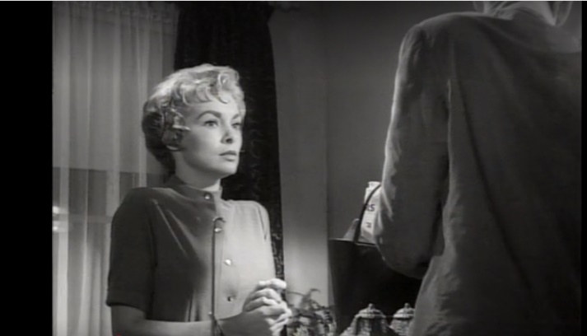
Slide 3
Within Psycho there is a continuous shift between victim and villain for the character of Marion. This is best demonstrated when she arrives at the hotel. Almost instantaneously the audience feels apprehensive. Alfred Hitchcock creates this feeling by implementing excellent mise-en-scène. A sense of danger is created. For example, the lighting is relatively dark, and a thunderstorm can be heard. These two factors create the sensation of danger. Within this scene mise-en-scène is used yet again to obscure the audience.
Marion is clearly a confidant and defiant individual as she has just stolen forty-thousand dollars to be with her lover, and lied to the police. However, within this frame she is portrayed as vulnerable and weak. The positioning of Marion is extremely interesting because she is on the left-hand side of the frame, whereas Norman is situated on the right-hand side. According to Missouri Southern State University the “left is often seen as negative, whereas right is seen as positive” (page 2 paragraph 4 line 4) It makes sense for Hitchcock to position Marion on the left side of the frame as she has sinned by committing thieved. Within this specific frame, the viewer becomes slightly confused. Marion is having to look up at Norman, this symbolises her lack of control and power. Norman is a relatively tall individual therefore, blocking a greater portion of the frame. His face is also hidden from view. Combining these two factors makes Norman appear more sinister and foreshadows the idea that harm might occur during the stay at the hotel.
Slide 5
In this eye level medium shot, subtle foreshadowing is present. In the office window a reflection of Norman can be seen. This ties perfectly into the plot twist where it is revealed at the end that Norman has disassociated identify disorder. This means the character believes he is himself and his diseased mother thus creating an imaginary alter ego.
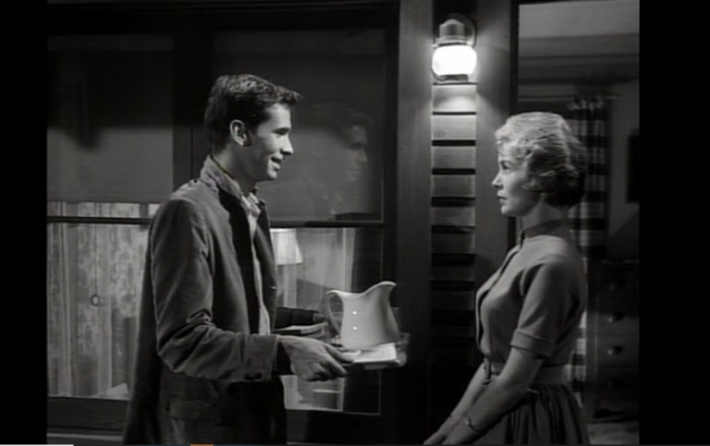
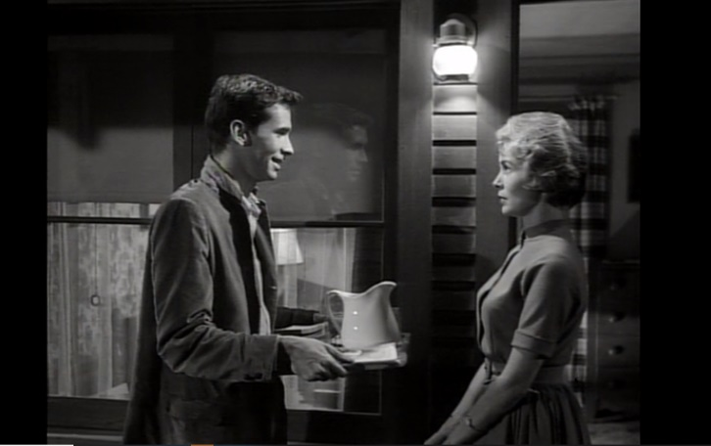
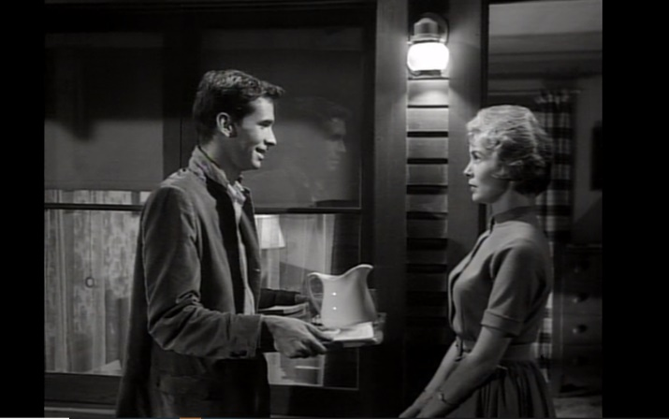

This frame portrays Norman as an innocent fragile hotel manager. This is reinforced due to the props and framing implemented. If we apply the four quadrants, the top and bottom half drastically contrast with one another. The bottom half of the frame shows Normans offering a tray of sandwiches he specifically made for Marion. This embraces a sign of his caring and kind nature. This enables the audience to relax as we believe he is harmless. However, the top half is a complete contrast as it displays Norman and Marion conversing as well as Normans reflection. This suggests that Normans split personality or imaginary alter ego is always present.
In this sequence only one half of Norman is revealed, this represents the one side we are familiar with, the sweet and inocent hotel manerger. Its also apparent that Norman is physically holding a tray of food, an interesting concept could be that this shows a maternal instinct as a mother would bring out food to a guest. His mother is always present.
Slide 7
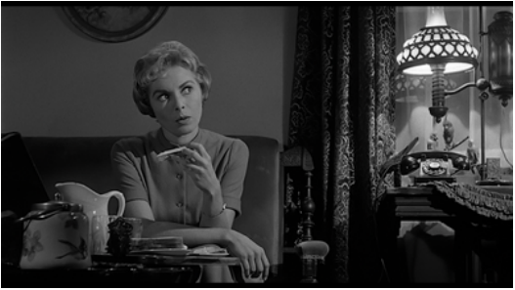
This particular scene demonstrates the excellent use of mise-en-scène. We will be specifically deconstructing how the props, lighting and framing creates a specific mood and atmosphere. Hitchcock not only decided to surround each character with important objects but, drastically lightens the face of Marion and Norman with different tones to create atmosphere and suspense.

During the conversation between Norman and Marion a medium shot is cleverly implemented. The viewer almost instantaneously notices a wide variety of different prominent objects. For example, Marion is primarily surrounded by circular and curved objects. The lamp, two vessels in the foreground and the picture frame are all rounded. According to Missouri Southern State University “Psychologists often explain that soft, rounded shapes make us feel more comfortable and secure” (page 3 paragraph 2 line 6) This gives me the impression that Hitchcock did this to drastically contrast with Normans framing. Where sharp, pointed objects can be observed within the frame therefore making the audience feel vulnerable and scared. The positioning of these objects help the development of Marion’s character, a warmth is created around her therefore enables us to endear her.
The positioning to the characters in correlation to the light source is extremely fascinating. For instance, Hitchcock decided to situated Marion near and slightly behind the light. This enables a similarity to be established because her face is well lit, like the light therefore, creating a glowing warmth. Marion isn’t an evil individual yes, she has stolen $40,000, to be with her boyfriend but she isn’t a malicious person. Hitchcock creates the sense of redemption due to the lighting implemented. Marion isn’t hidden or consumed by shadows therefore, not dominated by her darker side of nature, but bathed in bright light. The lighting and cinematography gives the audience a sense of false security. This is achieved due to the soft shaped objects and the bright lighting.
Slide 9
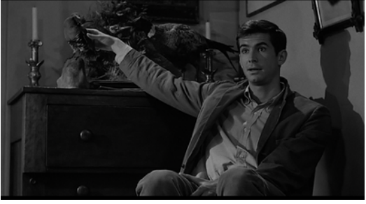
The mood and atmosphere created within this frame contrasts considerably compared to the pervious. Hitchcock has achieved this by incorporating different lighting, framing and mise-en-scène. Norman is situated far away from the light. This creates a harsh line across his face separating the light from the shadow. This is “re-emphasizing the clash of his dual personality” Schmidt, M (paragraph 5 line 3). Within this frame Norman is relatively dark due to low lighting. This creates an unusual atmosphere and indicates that something is being hidden from the viewers. The light is kept to a minimum therefore sharp, angular shadows are created. (on the wall and ceiling above) Behind Norman a shadow can be seen, could this be suggesting that his split personality or imaginary alter ego is always present.
Next, we will be discussing how Hitchcock uses camera angles to create a unique mood and atmosphere. The camera appears below eye level to give the character a menacing stance. All the pictures in the background are slightly tilted suggesting that Norma’s world is off balance and kilter. An uncomfortable feeling is created as we are not used to viewing world from this prospective / angle.
The low camera angle makes Norman an authoritative figure creating the sense of power. Norman is positioned relatively high up and takes up the majority of the frame therefore, making Marion appear venerable.
Slide 11
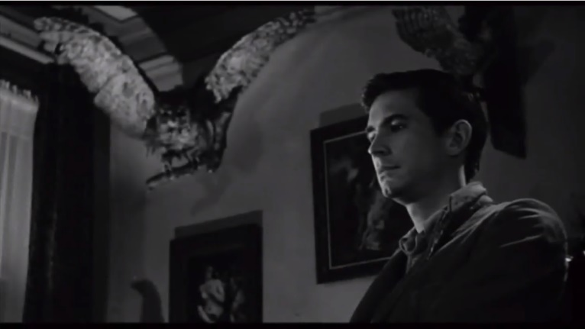
The primary purpose of this shot is to capture the sinister intentions of Norman, Hitchcock does this by incorporating specific props, lighting and framing. In the majority of frames Norman is portrayed as being powerful and dominating yet in this frame he comes across as weak and venerable.
This is reinforced with the owl situated in the top left-hand corner. The positing of the owl is extremely interesting because a predatory feel is created due to it staring directly into the camera. Notice how a gloomy shadow is also casted over Normans face. This was done to draw the attention of the audience towards the owl and not Norman. The lighting is predominately fixated on the owl therefore, dominating the frame. Hitchcock told Truffaut during an interview that “Owls belong to the night world; they are watchers, and this appeals to [Norman’s] masochism”
In this frame the stuffed owl towers above Norman. The owl is almost replicating his stuffed mother. The significance of this is although his mother is dead, she still has control of his actions. The owls incorporated within the scene hover around Norman almost like dark, sinister angels. The other interpretation is the owl represents Norman. The owl looks predatorial almost like Norman is towards Marion. This particular impression is created when he leans forward.
Slide 12
If the rule of thirds is applied, it makes it easier to establish what objects to focus on. The intersection of the lines is the most important subjects within the frame. In this case it is Norman and the owl. If we split the frame up into quadrats each section tells a story. In the top left the owl can be seen, this helps portray the character of Norman. In the top we obviously have our character and another stuff bird can be seen. The bottom left a painting of a naked women can be seen. Voyeurism is used as a motif throughout the film, this painting mirrors Normans sexual conflicts. He tries to dress up as his mother as well as spying through a peep hole to see Marion changing. The bottom right hand corner a little bit of the painting can be seen, again it is a naked woman being burnt to death, this is another sign that emphases voyeurism through symbolic codes.

References
Schmidt, M (2016) http://www.imagesjournal.com/issue02/features/psycho.htm#top (accessed on 18th of October 2019)
Michael Howarth, Missouri Southern State University https://www.google.com/url?sa=t&rct=j&q=&esrc=s&source=web&cd=1&cad=rja&uact=8&ved=2ahUKEwiUzIWW3qvlAhXNRBUIHY71BxgQFjAAegQIARAC&url=https%3A%2F%2Fjournals.sfu.ca%2Fmsq%2Findex.php%2Fmsq%2Farticle%2Fdownload%2F54%2Fpdf&usg=AOvVaw0CqtAAmsAdKqaCztTCxpgR (accessed on 17th of October 2019)

