

Applied Leadership and Management in the Workplace
Module Assignment Submission
Student Name: | Kirsty Morgan
Student Number: | 2316853
Module No: | BMSK4013
Module Title: | Management Communication

Statement of Confirmation of Authenticity
By the act of making this submission, the student declares that this is the work of the student named above. The work has not, in whole or in part, been knowingly presented elsewhere for assessment, or where assessment has been built on a previous assessment, this has been identified. Where materials have been used from other sources it has been properly acknowledged. If this statement is untrue, the student acknowledges that an assessment offence has been committed.
Attention is drawn to the plagiarism and unfair practice policies of both the University and of ILM.

Contents

Communication Cycle and Communication Models 2-6
Tone, Language and Formality 7
Range of Verbal and Written Communication 8-9
Motivation Theories 11-13
Factors that affect motivation in the workplace 14-15
Conflict 16
Conclusion 17
Personal Communication 18
References 19-20
Appendix A - Personal Development Plan 21
Appendix B - Communication Style Questionnaire 22-23

Communication Cycle and Communication Models
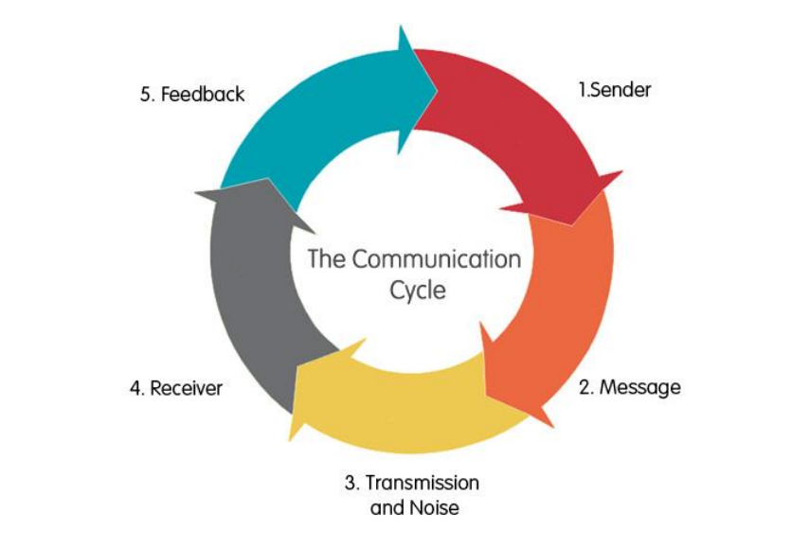
The communication cycle is the process of relaying information between sender and receiver. This process begins with the sender, who decides what the message is, how they will relay it, and which medium is the best way to share the message.
For example, during a team meeting, the manager (sender) with extensive knowledge regarding the business test the team are currently testing (message) using a digital platform (channel). Agents (receivers) from different beliefs with the content I am discussing interpret the subject matter (message) based on their own skills, knowledge, taking into consideration all the elements under each of the communication cycle.
The strengths of the communication cycle are clarity and conciseness, active listening, assertiveness, and adaptability in communication. These are factors that both affect senders and receivers, this highlights the importance how effective communication depends on many elements in different environments.
The communication cycle weaknesses are that people may not decode the message properly where they can misunderstand the message, the other person (sender) could also be in a bad mood so they would not reply to you where this cycle needs to be a two-way process for this to work.
In my workplace this communication cycle would not work as this cycle is not a two-way communication, within my workplace you need a two-way communication for you to work well together and work as a team to get things completed properly.

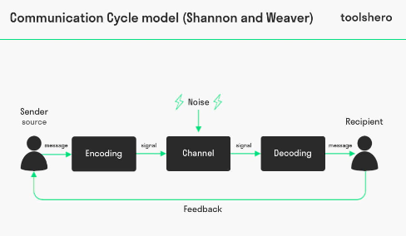

Shannon and Weaver, 1948
The Shannon and Weaver model is a model that consists of basic elements such as a source, encoder, medium, decoder, receiver, and noise. This describes the way the information flows from a sender straight through to a receiver. In contrast, a transaction is a model which describes both sender and the receiver engaging simultaneously. (Study.com, 2023)
The strengths of Shannon and Weaver model is that it provides a simple and clear way to identify and analyse the key components and factors of any communication process. This helps to clarify the roles and responsibilities of the sender and the receiver; it also helps to evaluate the effectiveness and efficiency of the transmission and the way the message is received.
However, the Shannon and Weaver communication model is not perfect. As well as not focussing on differences in human interpretation, it has also been criticized for over-simplifying the process, this makes the communication seem linear and one-way communication.
In my workplace this model would work daily as the Shannon and Weaver communication cycle is a widely used framework and is a great communication method to be used in the industry I work in. The model can be applied to various situations, in my workplace the sender can be anyone who initiates communication, such as a manager, colleague, or employee. The receiver then can be anyone who receives the message, including colleagues or superiors. The message refers to the pathway through which the message is transmitted, within my workplace the message is usually delivered via the following methods: email, Microsoft teams, telephone, and face to face. This communication model works well within my workplace as this gives clear communication, reduced errors, improved collaboration, efficient problem solving and increased employee engagement. By using this model, you can foster a more productive and collaborative work environment.

3
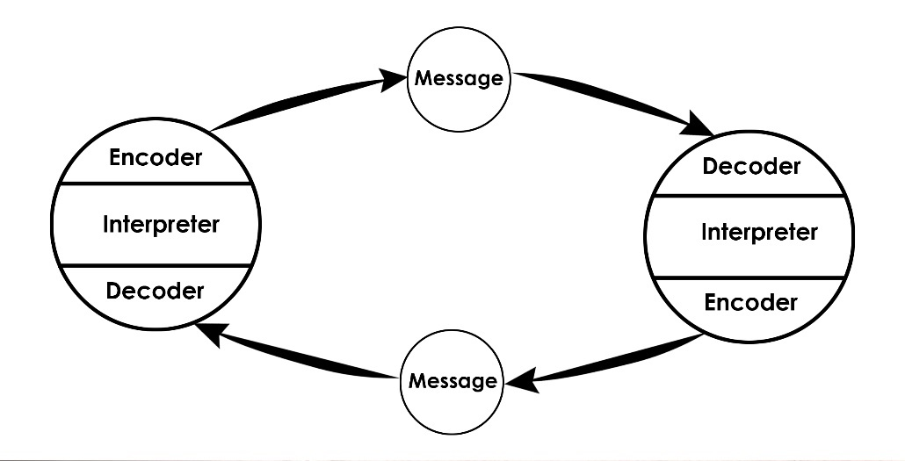

Schramm, 1954
Schramm’s model regards the communication process between and encoder and a decoder. Most importantly, this model accounts for how people interpret the message differently. Schramm has argued that a person’s background, experiences, and knowledge are factors in which they impact how someone interprets the message. (LibreTexts, 2021).
The Schramm’s model is based on three basic components: a source, a destination, and a message. The process starts with an idea in the mind of the source. This idea is then encoded into a message using signs sent to the destination. The destination needs to encode and interpret the signs to reconstruct the original idea/message.
The overall strengths and advantages of the Schramm’s model of communication is its recognition of interactivity, transactionality, multidimensionality, adaptability, feedback mechanisms, cultural sensitivity, and practical applicability. The Schramm’s model introduces a feedback loop between the sender and the receiver. The role of feedback is one innovation of the model in comparison to earlier models of communication. This communication cycle is seen as a dynamic interaction in which two participants exchange messages.
The disadvantages and weaknesses of this communication model is that it cannot deal with multiple levels of communication and complex communication processes. There can only be two sources communicating in the model, many sources complicate the process, and the model can not be implemented. The message sent and received might be interpreted differently than intended. (Adobe Express, 2020).
The Schramm communication model would be of use within my workplace as there are many different people with different backgrounds, experiences, and knowledge within Admiral. Messages can be interpreted differently which could make communication a lot more difficult if the message is not received properly and in the way the sender intends to relay the message. I see this communication cycle as a good barrier as not all messages which always be relayed in the way the sender intends to relay the message. This is a good communication cycle for my workplace as with the communication cycle this would be a positive due to the challenges, we come across this day in age with different backgrounds.

4

Berlo, 1960
Berlo’s communication cycle was developed in 1960. The Berlo communication model is known for its effective communication that occurs when the sender of a message and its receiver are on the same level or are roughly similar. (SMCR Model of Communication, 2020).
For example, if a speaker has exceptional communication skills, the receiver should have comparable listening skills for effective communication to occur between them. Furthermore, Belor defines communication as any type of information that is being sent or transferred to a receiver. To get from the source and message to the receiver, the message goes through the channel. Berlo’s S-M-C-R communication model identifies all the senses are the channels that help us communicate with each other. Our sense of hearing lets us know that someone is speaking to us. (Pumble, n.d.).
The strengths of the Berlo communication cycle are this cycle is very important as a framework that introduces the fundamental elements of communication – source, message, channel, and receiver. Its simple aid in understanding the basic communication needs and process and serves as a starting point for learners and practitioners. (Berlo's Advantages and Disadvantages, 2024).
The disadvantages of the Berlo communication cycle are lack of feedback as this is one of the major criticisms the model has had due to its limited consideration of feedback. Feedback is crucial for assessing whether the message was understood as intended. Oversimplification is also a disadvantage along with no consideration of noise, within the framework noise is not integrated fully and noise can significantly affect the encoding and decoding of messages which can lead to misunderstandings. (Berlo's Advantages and Disadvantages, 2024).
In my workplace the Berlo communication cycle would work as this ensures your message is clear, consistent, and impactful. The Berlo communication cycle is simple yet a powerful framework that can help improve the business’s communication.

In comparing the 4 models, some basic components and interactions reappear in most of the models. They include the idea that a sender encodes information in the form of a message and sends it to a receiver through a channel. The receiver needs to decode the message to understand the initial idea and provides some form of feedback. The significant differences between the models are they all want to deliver the same message; each communication model has an encoding and decoding system. The Berlo and Shannon and Weaver communication model are both a linear transmission model, even though they are both linear models they have opposite ways of how the want the message to reach the receiver, both models only deal with one way communication. The Shannon and Weaver model is useful for technical communication and not caring regarding the human perception where as the Berlo’s communication model is useful for human communication and not caring regarding encoding, decoding and noise. The Schramm model and the communication cycle are both circular models of communication which has a two-way communication.
Interference in communication is called ‘noise’. Noise can be physical noise, such as a loud room conversation, but it can also be caused by many other sources. The act of communication can be derailed by the following types of noise, which deflect your audiences focus away from your message, physical noise. (Communication for Professionals, 2014).

Tone, language, and formality
Tone, language, and formality are crucial aspects of communication that can greatly impact the effectiveness and outcome of interactions.
Formality refers to the level of structure, politeness, and professionalism used in communication, I am currently a senior manager and daily I must use the right communication when speaking to my agents or senior managers, this means the way my body language is and the way I make eye contact. Although I do often also use informal language in casual settings to create a sense of familiarity and rapport. Formality within my workplace influences the level of engagement and attention from my audience, the more professional and formal you come across the better other colleagues/people look at you.
Within my workplace formality is one of the most important aspects of communication within the workplace. The reason being is because your colleagues will then respect the level you are in, and you have a great working relationship with your peers. Your colleagues will look at your body language, the tone you speak to them in and that will then gage how much buy in you have from your colleagues and management.
Within the workplace you then chose with tone you speak to a colleague in, as if you are conducting a meeting or need to put a point across to one of your colleagues then you would speak more formal and more of an understanding tone, if you are conducting a catch up, general talk with your colleagues then you do not need to come across formal and be more informal.
Structure with different audiences within the workplace is important, for example if you were conducting a team meeting and had a presentation to present to your work colleagues, there is structure in place, and you know what you are going into the meeting knowing what you want out of it and you will be more confident in front of your colleagues.
Content and modes within the workplace with different audiences are also important because content needs to be informative and relevant to the information you want to present. Different modes of communication are also important due to if you need to get hold of a work colleague with a matter of urgency, then you wouldn’t send them an email, you would contact them via the telephone.
Tone with different audiences within the workplace are important as it all depends on who you are speaking to and the situation you are in, there are different tones such as the following:
- Uplifting Tone
- Focusing Tone
- Serious Tone
- Supporting Tone
The different tones are linked into how other people perceive you and how you come across.

Assessing verbal and written communication within the workplace:
Verbal communication within the workplace
 | How is it used? | Advantages | Disadvantages
Face to Face | Face to Face within the office. | Can observe body language.  Improves job satisfaction.  Provides clarity to conversations.  Establishes trust.  More personable. | Time consuming and can often require travel to the office.  Busy office schedule could mean be difficult to organise face-to-face with staff.
Telephone Call | Via mobile phone or teams. | Personable.  Faster communication.  Simple communication. | Poor quality of the call.  Decreases the face-to-face communication skill.  Miss non-verbal cues.
Video Call | Via mobile phone or teams. | Improved communication.  Can observe body language.  Ensure the receiver of the message is listening. | Technical issues such as buffering/freezing on a video call.  Constant distractions.  Communication challenges.

Written communication within the workplace

 | How is it used? | Advantages | Disadvantages
Email | To relay a message to other employees with the email being of importance. | Can copy in more than one person.  Can keep track or save the thread of emails. | Emails could get lost and not read if the person receiving the email has many emails coming through.  The email could be sent to the wrong person.
Teams | Quick messages to individual people.  Information updates.  Team Groups. | Can see when a person is always in a meeting or available.  Can get hold of the person quickly and promptly.  Information can be sent quickly.  Can see if a person has read your message. | Someone may not see the message/muted the person messaging.  Doesn’t use teams as much.  People can put themselves into a meeting without being in a meeting to not be disturbed
Text/What’s App | To send messages to a work group.  If a member of staff needs to get hold of you urgently in/out of work. | Can see if someone has read your message.  Can get hold of someone quickly. | People do not want to be contacted out of working hours.  Don’t want staff to have your mobile number/personal information.

Motivation theories
Motivation is the desire to act in service of a goal the person wants to achieve. It’s the crucial element in setting and attaining our objectives through every aspect. Motivation is one of the driving forces behind human behaviour. It fuels competition and sparks social connection. (Psychology, 2023).
The differences between intrinsic and extrinsic motivation are that intrinsic motivation is when someone is motivated by personal desires, while extrinsic motivation is when they’re motivated by possible rewards or to avoid consequences. (Intrinsic and Extrinsic motivation, 2020).
The three theories of motivation are the following, McGregor (X-Y Theory), Herzberg (Two factor theory of motivation hygiene) and Maslow (Hierarchy of needs).
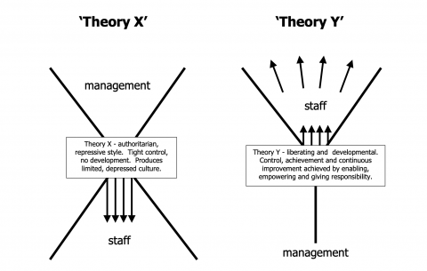
McGregor created Theory X and Theory Y of human work motivation and explained two styles of management known as authoritarian (Theory X) and participative (Theory Y). Theory X management assumes most people will attempt to avoid work whereas Theory Y managers trust their people to take ownership of their work.

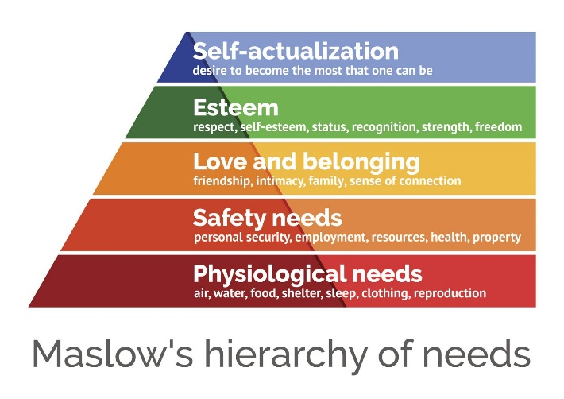
Maslow stated that people are motivated to achieve certain needs and that some needs take over others. Our most basic need is for psychical survival daily, and this will be the first thing that motivates our behaviour. Once that level is fulfilled the next level up is what motivates us, and so on.

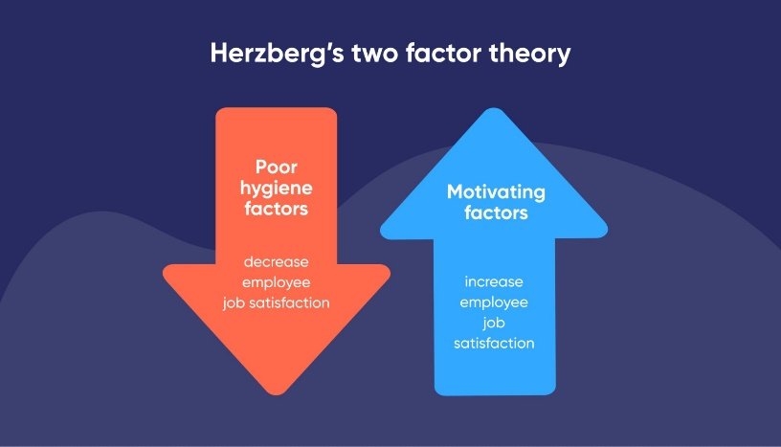

Herzbergs two-factor theory is a motivation theory that suggests the satisfaction and dissatisfaction within the workplace are influenced by two sets of factors: hygiene and motivators. Hygiene factors are a basic job necessity, such as working conditions and salary, that, if these are not met, can cause dissatisfaction.
The three motivation theories are completely different, and all have different ways of motivation, one theory (McGregor) shows that management either think staff will complete their workload or avoid their workload. While the Maslow stated that people are motivated by their certain needs and Herzbergs theory suggests that motivation is based on working conditions and salary.
I think that all three motivation theories could work within the workplace but each motivation theories would only work within different work settings, as each of them have their own strength and weaknesses, it all depends on what the business is looking to achieve.
I think that the McGregor theory would work well within my workplace as staff are left to their own devices and the management group (Theory Y) will trust their people to complete their workload and tasks that are asked of them. If the agents do not complete their workload, then there are consequences. The McGregor theory is the best motivation theory in my opinion, as if you do not complete your workload then there is the hierarchy that you would need to explain yourself to. Each motivation theory has strengths and weaknesses which would work in different settings of a business. Another factor that would be considered in motivating people in my workplace is taking Herzbergs motivation theory as most of the people within my workplace focus on salary, benefits and working conditions to increase their motivation to achieve better within the workplace.

Factors that affect motivation in the workplace
The key factors that affect motivation within the workplace are salary, relationships with colleagues, flexibility, and professional development opportunities. (Talent Solutions, 2024).
Factor | Effect on Performance and Motivation | Workplace Example
Job Satisfaction | Employees that find their jobs fulfilling and meaningful can significantly impact their motivation. (Talent Solutions, 2024). | In my workplace, the more you enjoy your job, the better you do. The job is very hard with the workload you need to complete, so in my workplace to keep this motivation level high, I would change the workload and the give the agents different work to do.
Recognition | Recognition is a powerful feedback tool. When employees feel valued, they're more engaged, motivated, and likely to go the extra mile for their company. Organizations with formal employee recognition programs have 31% less voluntary turnover than organizations that don't have any program at all. (The Importance Of Employee Recognition, 2023). | Within my workplace, recognition is a major factor for the agents and management to be happy. The job is so tedious on times and are expected to do a lot of work, having recognition from senior management along with awards e.g. vouchers/time off does really give the agents a boost and feel recognised within the workplace.
Salary and Reward | The main reason for offering pay, and benefits is to influence employee behaviour, so they want to join and stay with an employer and do their best in the job. (Knowledge and Rewards, 2024). | Within my workplace first of all reward is very important as if you are an agent that performs well you will receive star shares into your allocation. Depending on the role you are in the share scheme changes and the better you do, the more money you get. With regards to salary, the higher you are within the workplace, the higher the salary, this then gives motivation to work hard to get into a higher role and have a better salary.
Leadership and Management Style | Most would agree that managers who effectively leverage employee strengths and rally individuals around team goals will achieve a more favourable performance outcome than those who withhold feedback or provide little support to team members. A person's management style can also impact overall employee engagement. (How Management Styles Affect The Workplace , 2024). | Within my workplace, leadership and management style is very important as some managers have a teacher, child way of communication which doesn’t work well with many people. The more trust you put into your employees the better you will get out of them, if you treat them like an adult and don’t micro-manage them.
Work-Life Balance | Having a good work-life balance isn't just about relaxing: it's also about improving productivity within the workplace, and when you switch off in the evening, you're much more likely to return to work the next day feeling fresh and ready to go. (Why Is Worklife Balance So Important, 2023). | Work-life balance within the workplace is important as many people today have kids and within my workplace most people work from home, this enables them to complete the school run on their breaks and not have to look for child-care elsewhere which reduces stress and have the great work-life balance.

Upon completion of my motivational questionnaire, it shows that my communication style is assertive communication.

Conflict
Workplace conflict is an inevitable in some situations within the workplace, it is challenges sometimes to understand why people tend to disagree with each other and more so within the workplace. The definitions of conflict are poor communication, different values, different interests, personality clashes and poor performance. (Workplace Conflict & How To Manage It, 2024).
An example within the workplace for conflict is that there are managers with different outlook on their roles, one manager could have a vision whilst one manager focuses on numbers and the other manager is all about the people, this causes conflict within the workplace as looking out for the people I think is more important as if the staff are enjoying where they work then the company will get a better result from their staff. The manager who has the focuses on numbers could potentially forget their staff and strive to hit the targets that are required of them. The manager who has the vision is in between the manager with number and people as they potentially bring their thoughts to life. This causes conflict within the workplace as there would be many disagreements between the staff as they all want different things to come out of their staff. I am also aware that there is sometimes poor communication between these managers as they all strive for different things and fight for what they think will work best. For this conflict to be successful then there would have to be good communication procedures in place along with a structure in place to ensure that each manager’s vision is taken into consideration but comes together to make a good team and a better outcome.

Conclusion
With the research I have done for this assignment, I have learned that communication is a learned behaviour, it is the essential vehicle of influence and there are different sets of behaviours with communication. Communication is adaptable and can be changed and improved over time. We can be the most skilled people but without communication we do not connect and then without communication there is no influence.

Personal Communication
I have completed a personal development plan to discover my strength and weaknesses and what I would like to achieve within my workplace. Please see appendix A.

References
2.4: Models of Interpersonal Communication. (2021, August 6). Social Sci LibreTexts. https://socialsci.libretexts.org/Courses/Pueblo_Community_College/Interpersonal_Communication_-_A_Mindful_Approach_to_Relationships_(Wrench_et_al.)/02%3A_Overview_of_Interpersonal_Communication/2.04%3A_Models_of_Interpersonal_Communication
California, U. of S. (n.d.). What is Workplace Conflict & How to Manage It | USC Online Communication Degree. Communicationmgmt.usc.edu. https://communicationmgmt.usc.edu/blog/conflict-in-the-workplace
Das, B. (2023, August 9). SMCR Model of Communication: Advantages & Disadvantages. StudyMassCom.com. https://studymasscom.com/communication/berlos-smcr-model-advantages-and-disadvantages/
Main, P. (2023, May 9). Theories of Motivation. Www.structural-Learning.com. https://www.structural-learning.com/post/theories-of-motivation
Morgan McKinley. (2024). Top 9 Factors That Impact Employee Motivation | M3S Solutions. Www.morganmckinley.com. https://www.morganmckinley.com/uk/employers/talent-solutions/insight/top-9-factors-impact-employee-motivation
Pumble. (2022, February 25). 8 Communication models explained. Knowledge Hub. https://pumble.com/learn/communication/communication-models/
Schramm’s Model of Communication. (2020). Adobe Spark. https://express.adobe.com/page/WrJMByBwQIBLv/#:~:text=This%20model%20can%20not%20deal
Shannon-Weaver Model of Communication: History, Features & Application Video. (2020). Shannon-Weaver Model of Communication: History, Features & Application - Video & Lesson Transcript | Study.com. Study.com. https://study.com/academy/lesson/shannon-weaver-model-of-communication-history-features-application.html
SpriggHR. (2020, February 2). Extrinsic & Intrinsic Motivation Examples - What’s the Difference? • SpriggHR. SpriggHR. https://sprigghr.com/blog/hr-professionals/extrinsic-intrinsic-motivation-examples-whats-the-difference/#:~:text=Intrinsic%20motivation%20comes%20from%20within
Study. (2023). what-is-professionalism-in-communication-definition-skills. Study.com. https://study.com/academy/lesson/what-is-professionalism-in-communication-definition-skills.html#:~:text=Professional%20communication%20is%20the%20use
Suff, P., & Reilly, P. (2023). In the Know: Reward and Performance Management of Knowledge Workers. https://www.employment-studies.co.uk/system/files/resources/files/mp47.pdf
Symonds, C. (2023, August 1). Management styles: What makes a good leader? Factorial. https://factorialhr.com/blog/management-styles/#:~:text=Ultimately%2C%20management%20styles%20impact%20the
Why employee work-life balance matters (and how you can improve it). (2017, March 10). Benenden Health. https://www.benenden.co.uk/be-healthy/work/why-employee-work-life-balance-matters-and-how-you-can-improve-it/#:~:text=Why%20is%20a%20good%20work
Wickham, N. (2023, July 6). The Importance of Employee Recognition: Statistics and Research. Quantum Workplace. https://www.quantumworkplace.com/future-of-work/importance-of-employee-recognition

Appendix A – Personal Development Plan
Areas To Improve | Goal | Specific actions you need to improve | Support/Resources do you need to achieve your goal | When do you plan to achieve it?
Work-Life Balance | Get the balance correct | Not overwork myself.  Ensure I am not taking on too much work. | Delegate work to different colleagues.  Use of holidays to have a break. | 1/12/2025.
Recognition | Promotion to the next level manager | Shadow a team manager. | Attend team meetings instead of my manager.  Research on how to become a great team manager.  Gain extra knowledge. | 01/12/2025.

Appendix B – Communication Style Questionnaire
Communication Style Questionnaire
Thank you for taking the time to provide feedback on my communication style. Your input is invaluable in helping me improve my communication skills and better understand how I can effectively communicate with others. Please be honest and constructive with your responses.

Section 1: Clarity and Confusion
- How would you rate the clarity of my communication? (Scale 1-5, where 1 is unclear and 5 is very clear)
I would rate your communication at 5, wherever there are changes or anything I need to know about it is communicated straight away.
- Are my messages concise and to the point, or do they often feel lengthy or wordy?

Your messages are never lengthy or wordy, if there is a message you need to communicate this is normally done over teams and discussed so if there are any issues regarding what is being communicated is answered there and then.

- Have you ever felt like you had to ask for clarification or repetition when I’m communicating?
The only time I have had to ask for clarification is if I don’t understand something that has been sent over via email and need to ensure that I am understanding the information correctly.

Section 2: Active Listening
- Do you feel like I actively listen to what you’re saying, or do you often feel like I’m not fully engaged? (Scale: 1-5, where 1 is not at all and 5 is always)
I would score you 5 within this area, whenever I bring an issue up to you, you are always fully engaged, and I always have your full attention.

- Do you feel like your opinions or concerns are being dismissed or ignored when I’m communicating with you?
No, I always feel you go above and beyond when I am communicating with you and if I have any concerns, you always ensure if you do not know the answer then you go and find the answer and let me know the answer.

- Do you feel like I’m trying to understand your perspective and respond thoughtfully?
Yes, even though you may not respond straight away you always get back to me and you always take a two-way approach when understanding as you see it from an agent’s perspective and not just a manager’s perspective.

Section 3: Emotional Intelligence
- How would you rate my emotional intelligence in our interactions? (Scale: 1-5, where 1 is low and 5 is high)
4

- Do you feel like I’m sensitive to your emotions and able to respond empathetically?

You can respond empathetically but I also can see you take on other people’s problems when discussed and it becomes a burden as you are so empathetic you feel the need to help everyone, even though this is a good trait to have, this can sometimes affect your emotions.

- Have you ever felt like I’m not understanding or acknowledging your emotions?

I feel sometimes that when you have your own life events going on outside work, sometimes you cannot fully understand or acknowledge my emotions until you have come out of your bubble with what has happened outside of work but when everything is ok and you come around, you are great!

