
Report
Computer Architecture

[Date]
Lyubomira andreeva - 22071052
Bsc Cloud Computing


Contents
Contents 2
Intruduction 3
Computer configuration list: 4
VGA Cable 5
Also known as D-sub cable, analog video cable. DVI Cable 5
HDMI Cable PS/2 Cable 5
Ethernet Cable 5
Audio Cable 5
USB Cable Computer Power Cord 5
Crucial 4GB DDR3L-1600 SODIMM 5
CT51264BF160BJ 5
Configuration list for Scenario 2 7
Corsair CMK16GX4M2B3200C16 Vengeance LPX 16 GB (2 x 8 GB) DDR4 3200 MHz C16 XMP 2.0 High Performance Desktop Memory Kit, Black 8
Justification for my choice 11
Additional storage for Scenario 2 12
Different aspects of RAID: 13
Access to NAS drive description: 15
References 17
References 20
References 20
Bibliography 21
Appendix: 21

Intruduction

When we talk about, computers we have to know some basic things. And here I will mention them. “The first is Motherboard which is basis and on which they are disposed many different internal components as a processor, memory, expansion slots. The motherboard is directly or indirectly, connect with every section of the computer. The major motherboard components are Central Processing Unit or it is the computer brain. It can calculate complicate mathematical and logical calculation and executing programs and so on. In other hand one more very important component is Random Access Memory, which is responsible to save dynamic data, to increase computer performance, while you are working. Likewise very important component is Basic Input Output System which is the link between hardware and software in a computer system. Read Only Memory is used for loading and running software and it is separate from the main memory – RAM. Cosmo battery is other component, small chips, which prevent configuration when the PC power is off. The computer cash memory is a small block of high-speed memory. The Bus, Chipsets (NorthBridge and Sauthbridge), ect.” We will take the necessary relating to the our requirement and will look them in more detail. “
Patrick Kamau, January, 08.2020
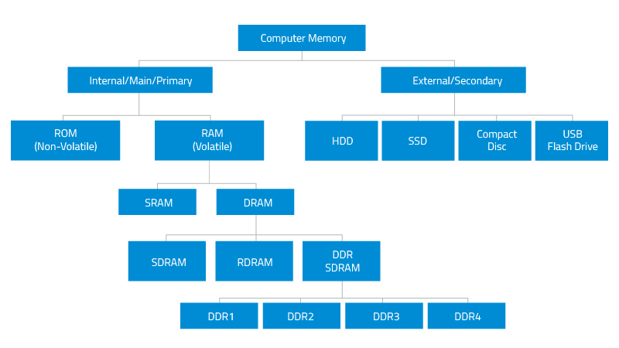
Clear picture of structure of Memory created my author, DRAM, 25/10/2018

Computer configuration list:
I am going to present my suggestion for the configuration of the computer for the Scenario 1 in the table below:

Components | Features | Quantity | Approximate price
Power Supply Unit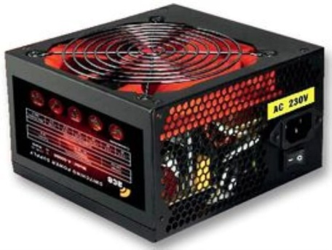 | - Outputs: 3x 5.25", 1x 4-way, 2x SATA and 1x 6-pin PCIe connector  - 20 or 24-pin motherboard power connector  - 12cm silent red fan for better ventilation  - ATX 12V compliant for all types of CPU and mainboard | 1 | £ 21
CPU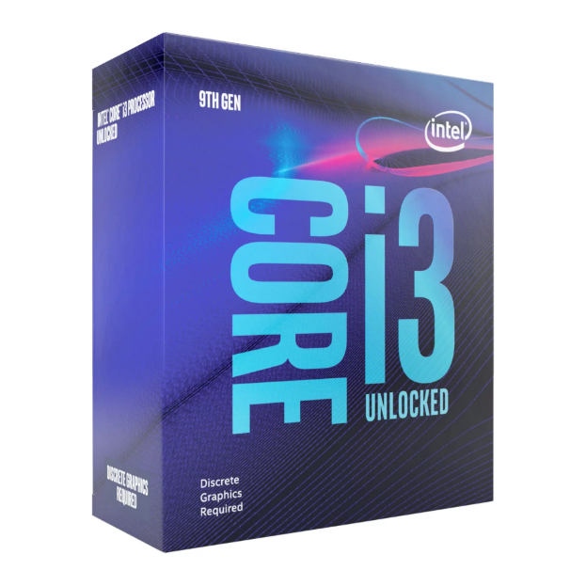 | The i3-9100F features four cores.  Maximum turbo frequency 4.2 GHz.  Cache memory up to 6 MB  Features:  - 3.6 GHz Base Clock  - 4.2 GHz Turbo Clock  - 4 Cores / 4 Threads  - 6MB Cache Size  The Graphics card must be installed. | 1 | £70
Motherboard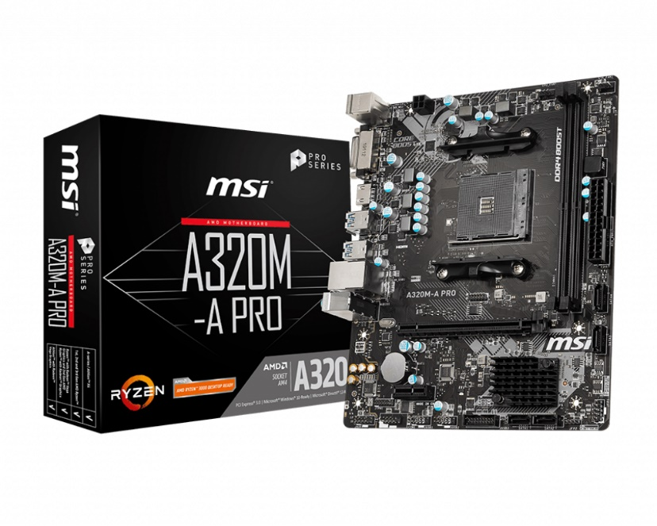 | MODEL NUMBER:  A320M-A PRO  - Memory Type: DDR4  VIDEO OUTPUTS:  - DVI  - HDMI  Network connectivity  LAN (RJ45)  - Form Factor  Micro-ATX | 1 | £45
Operating system | Windows 10 home  Permanently valid | 1 | £16
Optional Software | Microsoft office 365  subscription to 1 year | 1 | £60
Case | Antec VSK2000-U3 Black Micro ATX Computer Case.  Micro ATX  2 x USB 3.0 / Audio Front Ports  1 External 5.25" Drive Bays  1 Internal 3.5" Drive Bays | 1 | £44
Cables | VGA Cable  Also known as D-sub cable, analog video cable.  DVI Cable  HDMI Cable  PS/2 Cable  Ethernet Cable  Audio Cable  USB Cable  Computer Power Cord | 1  1  1  1  1  1  1  1  1  1 | £43,50
Computer data storage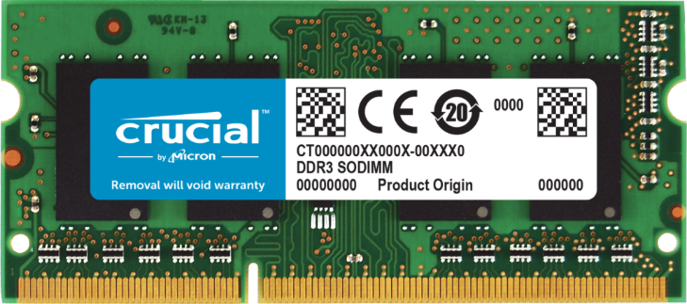 | Crucial 4GB DDR3L-1600 SODIMM  CT51264BF160BJ  Speed - DDR3-1600  Warranty - Manufacturer's Limited Lifetime  CAS latency - 11  DRAM family - Crucial  Density - 4GB  Brand - Crucial  Module type - SODIMM | 1 | £24
Input device – Mouse, keyboard webcam, microphone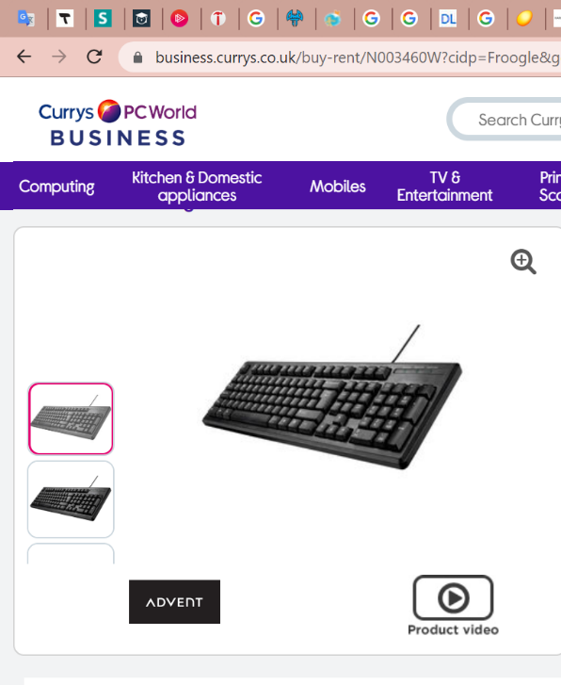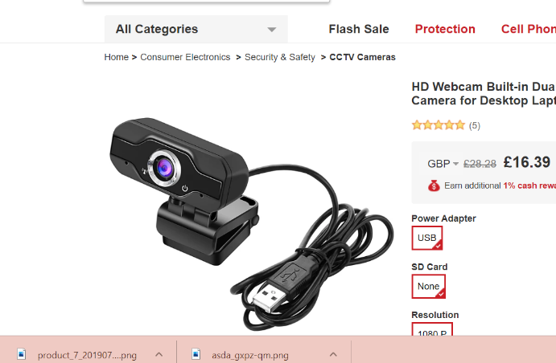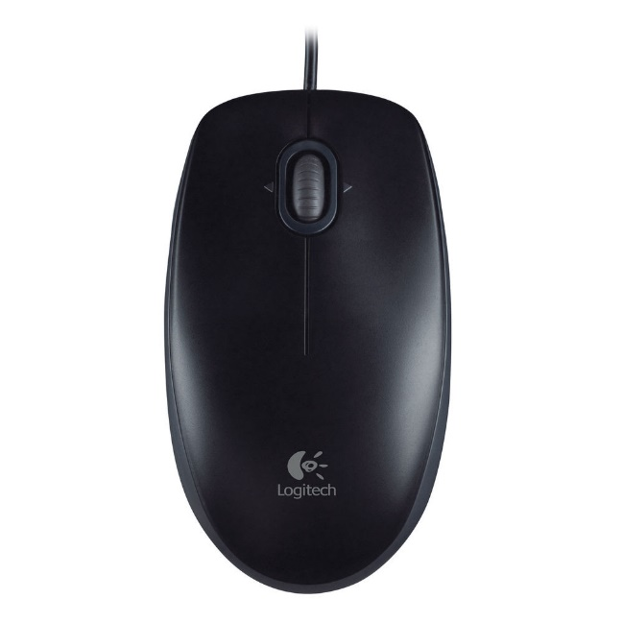  output devices -Monitor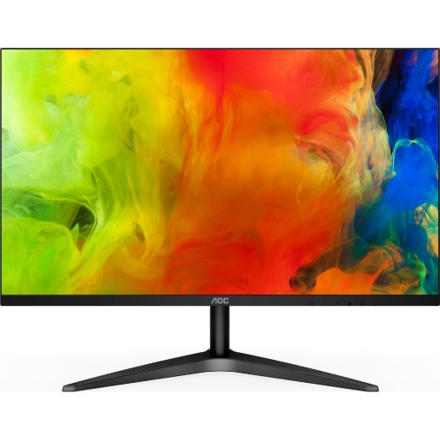 | Mouse  Keyboard  Webcam  Microphone  AOC 24B1XH Full HD 23.8" LED Monitor | 1  1  1  1  1 | £9  £6  £17  £7  £100
Table 1 for the Scenario 1 - Configuration list (Source: Created by the author)
“I choose this Power Supply Unit, because of the micro ATX, which means a small form factor and this is suitable for all types CPU. The price is also good and meets the criterion of low cost. According to Scenario 1 an elderly person wants Personal Computer suitable for internet surfing and youtube videos, he won’t play games. That is why I choose CPU chip. Entry-level memory which includes also budget notebooks. Perfect for use with the standard Windows and Chrome OS. I chose it because we don’t need large space just they want to run chrome and that is why this is perfect choice. And obviously the price will be bigger. The CPU is the most important part of the computer that why I choose some which is better that the criteria of the elderly person. And a little bit more expensive we can choose as well cheaper for example chip with two cores, which will be enough, but I want to think in prosperity and had chosen something not very simple and not very high quality, something average. In the description shows that CPU there is not features of Graphics card, that means have to be installed if they want to see something on the computer display. The motherboard is very important as well I choose one, which is with good capacity and fast speed and micro ATX to be suitable for other parts of our computer and assemble in the box. And this person wants small form factor of the PC and big monitor to see nicely. For input device I have chosen because of the low price, a simple mouse and keyboard, with normal size, webcam and microphone. An output device I found this big monitor, which is not very expensive and very good size to be clear everything on it. LED technology will provide good quality image, lower energy consumption, longer lifetime and faster switching. I want to buy as well different cable to power the audio and video, computer, monitor and so on. I will set up the newest windows 10 for operating system, because is easy to operate with it and has more convenience. Optional Software I choose, because they want to use word processing function and with windows 365, they can use everything – Word, Excel, PowerPoint and so on.”
(Base on different authors from shopping sites as Amazon and so on, every sites is in my reference list)
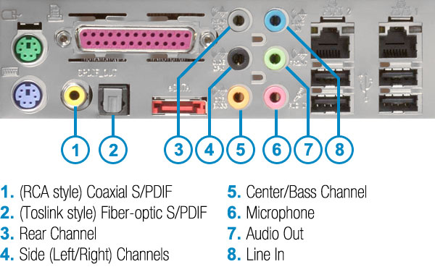
Created by author

Configuration list for Scenario 2
Components | Feature | Quantity | Approximate price
CPU | Model Ryzen 9 3900X  12 cores, 24 threads, 4.6 GHZ boost clock, 105W TDP  Compatible with 500 & 400 chipset Series AM4 motherboards | 1 | £400
PSU | - EVGA SuperNOVA 220-G3-1000-X1,1000 G3, 80 Plus Gold 1000W, Fully Modular, Eco Mode with New HDB Fan, 10 Year Warranty, Includes Power ON Self Tester, Compact 150mm Size, Power Supply.  Fan size/ Bearing: 130mm Hydraulic Dynamic Bearing for ultra quiet performance. Operating Temperature 0° to 50° C  Heavy duty protections, including OVP, UVP, OCP, OPP, and SCP  10 year Warranty. | 1 | £250
Motherboard | BRAND: Gigabyte  MODEL NUMBER: TRX40 AORUS MASTER  WARRANTY: 3 Years  CHIPSET: AMD TRX40  CPU SUPPORT:  AMD Ryzen Threadripper (3rd Gen.)  CPU SOCKET TYPE: AMD Socket sTRX4  MEMORY TYPE: DDR4  VIDEO OUTPUTS:  N/A  Chipset  AMD TRX40  Memory  8 x DDR4 DIMM | 1 | £500
Memory | Corsair CMK16GX4M2B3200C16 Vengeance LPX 16 GB (2 x 8 GB) DDR4 3200 MHz C16 XMP 2.0 High Performance Desktop Memory Kit, Black  SPD Voltage 1.2 Volt, SPD Speed: 2133MHz  DDR4 SDRAM | 1 | £70
GPU | Equipped with 8GB GDDR6 memory  Supports 4K H264 decoding and encoding rendering formats. Features a VR ready premium solution. Utilizes an intelligent sharpening technology | 1 | £425
Case | Item Weight 4,04 Kg  Package Dimensions 51 x 43 x 26 sm  Item model number KZ05  Color Black | 1 | £30
SSD | - Blue 3D NAND 4TB 2,5 SATA 6 GBPS Solid State Drive (S400T2B0A)  4TB SSD  - WDS400T2B0A - WD Blue PC SSD 2.5”/7mm cased  - 3D NAND  - SATA III - 6Gb/s  - Read 560MB/s  - Write 530MB/s  - 95k/82k IOPS  - 5 Year Warranty | 1 | £430
CPU Cooler | SCYTHE  SCMG-5100  6.5 x 5.75 x 3.94 inches  L x W x H 6.5 x 5.75 x 3.94 inches  Black | 1 | £73
Card reader | Brand name UGREEN  Item Weight 81.6 g  Product Dimensions 6.8 x 5.5 x 1.5 cm  Item model number 30333  Series 30333  Color black  Processor Type 5X86  Processor Count 1  RAM Size 4 GB  Computer Memory Type DDR3 SDRAM  Hard Drive Interface ATA  Voltage 5 volts  Hardware Platform PC  Operating System Mac OS X | 1 | £14
Monitor | Screen technology IPS  Screen size 27"  Resolution Full HD 1920 x 1080p  Viewing angle 178° / 178°  Frequency range - Horizontal: 31 - 83 kHz  - Vertical: 56 - 76 Hz  Brightness 250 cd/m²  Response time 5 ms  Native contrast ratio 1000:1  Dynamic contrast ratio 1,000:1  Connections HDMI 1.4 x 2  Audio output Audio out x 1  Speakers 2  Audio power 5 W  Sound enhancement Waves MaxxAudio  Box contents - Dell S2719H Full HD 27" IPS Monitor  - HDMI 1.4 cable  - Power cable  - Power adapter  Weight - 4,98  3 years warranty | 1 | £200
speakers, headphones, surround sound monitoring system with SPDIF | Headphones  Brand Betron  Connections Bluetooth, Wired  Model Name S2 Headphones  Colour Black  Connector Type Bluetooth  Headphones Jack 3.5 mm  Material Leather  Headphones Form Factor On Ear  Control Type Remote  - Speakers  Right speaker:19 cm H x 8 cm W x 15 cm D (1 kg)  - Left speaker:19 cm H x 8 cm W x 14.5 cm D (0.8 kg) | 1 | £23  £90
LiNKFOR Bi-Directional Toslink to Coaxial Converter 192 kHz Optical SPDIF to Coaxial and Coaxial to Optical SPDIF Coaxial | Noise-free Transmission, Sampling Rate up to 192 KHz 24bit, Provide You Home Theater.  Supports LPCM2.0/ DTS/ Dolby AC3/ 5.1CH, Achieve Lossless Digital Audio Conversion, Make Our Converter to Be an Ideal Tool for Your Shocking Home Theater.  1m Optical Cable Provided for Long-distance Transmission | 1 | £13
Total Price |  |  | £2,518

Justification for my choice
“By the Scenario 2 we are looking for CPU, which important factors are speed and productivity. That is why I choose 12 cores, which means high speed 3,8 GHz and that will provide me the best performance for my PC. This powerful processor with multi-threaded performance that destroys everything in its path. If the Central Processing Unit is the brain of logical thinking section in my Personal computer the GPU is the heart of it, which helps to render graphical user interface into visually attractive icons and design. GPU is the creative side of the CPU. The GPU is needs where some more strenuous workloads require extra horsepower. GPU is useful for the process, which is specially-designed to handle intensive graphics rendering tasks. Graphics like this require each separate frame to be individually 'drawn' by the computer, which requires a large amount of power. The most of PC in high class include a dedicated graphics card, which occupies one of the motherboard's PCIe slots. They have their own dedicated memory allocation built into the card, which is reserved exclusively for graphical operations. For example, 3D modelling software such as AutoCAD makes use of GPUs for model rendering. Since the people who work with this form of programme have to make many minor changes in a short time, the Computer on which they operate needs to be able to easily re-render the model. The best GPU, which I choose is the best for 4k video. The next part is Power supply unit, which I found with compact size, 10 years warranty and ultra quiet performance and in the same time higher efficiency. A power supply provides electric power for the modules. This is devices installed into the driven component. Computer power supplies, for example, convert AC current to DC current and are usually located at the back of the device case along with at least one ventilator. Most computers also use a switched-mode power supply, which switches DC voltage from AC current. The motherboard is like a mother of other components, it is the main printed circuit board. I choose that motherboard, because it is suitable for CPU, which I had chosen and there will be no compromised on PCIe 4.0 performance and speed. DDR4 XMP Support Up to 4400MHz and beyond.
AORUS has tested platform that ensures proper profile compatibility up to and beyond 4400MHz. Conception of multi-zone light display. The consumer has total control over the LEDs surrounding the motherboard, with full RGB support and a revamped RGB Fusion 2.0 device. That sounds opportune for our 4 k video resolution. When we talk about the memory, you need your machine to perform at its best, and RAM is crucial for that. RAM is important, when we need high speed performance. Not only that, but temperature management is also easier thanks to the ether-layer PCB, which also helps when it comes to overclocking. Corsair’s is also quite versatile, and tests have proven that it is compatible with all motherboards. Further, it is also significantly smaller than most other solutions, thanks to its low-profile heat spreader. This RAM which I had chosen we have a big capacity and a huge space to operate. There are two types of memory: internal and external. Internal memory , also known as "core or primary memory," refers to the memory that holds small quantities of data that can be easily accessed as the machine runs. External memory , also known as the "secondary memory," refers to a storage device that can persistently retain or store data. The storage devices may be fixed or removed. Examples are hard disc drives or solid state drives, USB flash drives, and compact discs. When we talk about internal memory we meets Random Access Memory and Read Only Memory ROM stands for memory, read-only. It is non-volatile which means that even without control, it can retain data. This is primarily used for starting or booting a computer. When the operating system is loaded, the device uses RAM, which stands for random access memory, which temporarily stores data while other tasks are being performed by the central processing unit ( CPU). The smaller the CPU needs to read data from the main or secondary memory (storage device) and more RAM on the chip, which helps the machine to run faster. RAM is fast but it's unreliable, meaning that if there is no fuel, it won't retain data. Therefore, it is important to save data to the storage device before turning off the programme. SSD's do have many other advantages over hard drives. For example, when data is scattered, or broken up into several locations on the disc, the read output of a hard drive declines. An SSD's read performance doesn't decrease depending on where data is stored on the drive. Hence it is not necessary to defragment an SSD. Since SSDs do not magnetically store data they are not susceptible. SSD is a type of mass storage device similar to a Hard disk drive. It can read and writing data store data in a permanent state even without power. If he want security he need SSD to store his videos and to be sure he can not lose them. I choose one with good capacity and I cover all my needs with that. Western Digital SSD range has the same reliability and performance expectations that come with the mechanical hard drives and they didn't disappoint. They managed to create speeds of up to 530 MB / s write and 560MB / s Read speeds using 3D Nand Technology. In order to maintain performance in heavy workloads, the CPU requires adequate cooling and thankfully there are coolers available to suit any need. One of them is on my configuration list. Quiet 120mm Kaze Flex fan for high airflow and static pressure with silent operation. Addition fan clip for adding 2nd fan for maximum performance. My card reader at the same time is with 4 Cards with 2 TB Maximum Capacity total. Loaded with 4 card slots, the Ugreen Micro SD Card Reader provides simultaneous access to 4 cards and holds you away from endless unplugging and re-plugging problems. Supports up to 2 TB card size, far higher than most traditional card readers, to optimise the efficient transfer of data. 5Gbps Faster Speed, More Time Enjo. Data transfer rate up to 5Gbps - 10x faster than USB 2.0(480Mbps), this USB Card Reader enables you to transfer 1GB files in seconds. Also backward compatible with usb 2.0 and usb 1.1. Compatible with Windows XP/Vista/7/8/8.1/10, Mac OS, Linux, Chrome OS etc and support multiple memory cards. The monitor, which I had chosen has got superior sound for perfect audio quality and share the view with wide viewing angles. Is suitable for 4k video with perfect resolution. In-plane switching technology means you get vibrant colours – greater than 99% sRGB coverage in fact – making it great for photo and video editing. Betron S2 Wireless headphones with mic and remote control is the best suitable for high performance. They are with a superb audio system, these wireless headphones deliver truly powerful sound. And in the end but not least SPDIF convertor to provide a surround sound monitor system.”
(my description is base on a characteristics of my components from different authors from the shopping sites and DRAM Modules, 25/10/2028)

Additional storage for Scenario 2
NAS drive: The table include information created by author:
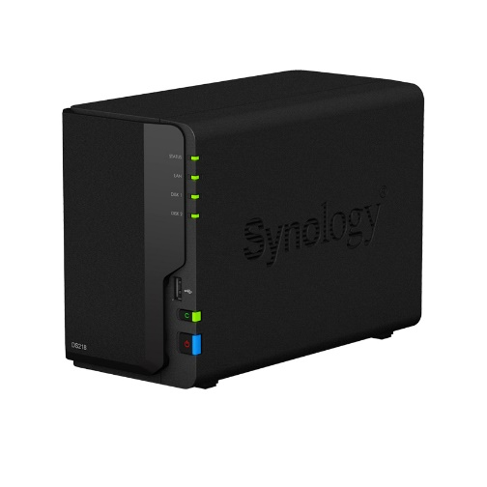 | Feature  Synology DiskStation DS218 with 16TB WD Red HDD  2 x 8TB WD Red Hard Drives  by Synology | Quantity  1 | Approximate price  £591

“NAS drives is using for Consider an appropriate Network Attached Storage (NAS) device. As its name suggests, a NAS is high-capacity storage that connects with home or office network so you select can access your files from mobile devices and PCs without plugging in to the drive. Some NAS drives are pre-populated with discs, which are often already formatted for use in a specific RAID configuration, while others are "diskless." I want a NAS that has higher memory, processor, and network capabilities specifications. Software can get around that problem, such as the ever-useful VLC Media Player utility, and some NAS units work with Chromecast, Apple TV, Roku, Android phones/tablets, and other types of hardware.”
By (Joel Santo Domingo, John Burek 3 Feb 2020)
I chose that model of NAS drive, because it meets the requirements for large storage space and more SSD it is never superfluous especially when it comes to work and creativity.
“Synology DiskStation DS218 with 16TB WD Red HDD 2 x 8TB WD Red Hard Drives. Synology DiskStation DS218 is a high-performance and compact 2-bay NAS, specifically designed for offices and home users to effectively manage, protect, and share data. Its new 64-bit quad-core processor supports 10-bit 4K H.265 video transcoding to enrich multimedia entertainment. Synology DS218 is backed by Synology’s 2-year limited warranty. Synology DS218 is a high-performance 2-bay network attached storage solution equipped with a 64-bit quad-core 1.4GHz processor and 1GB memory, delivering excellent sequential throughput at over 112 MB/s reading and 112 MB. DS218 is also optimised for 10-bit 4K H.265 video transcoding via Video Station.” (comms-express.com, by seller)

Different aspects of RAID:

Description of RAID:
“RAID is a storage solution that aims to enhance some combination of fault tolerance, storage management, and performance. RAID acts as a type of virtualization storage, which incorporates multiple physical discs into one logical volume. RAID operates by saving data with or without parity in either a mirrored or stripped manner. Where to set up the RAID is noted through the RAID rates.
Mirrored RAID stores the data stored on two drives, thereby offering a complete replication. This is a especially fault-tolerant approach, but halves the RAID 's ability because it saves twice all. It allows quicker read times as it is possible to process two simultaneous read requests independently. In comparison, as the data is saved twice, writes take longer.
Striped RAID saves data with strong read and write throughputs across multiple hard drives, saving for instances where multitasking is necessary. Striping is also used to test for errors, alongside a parity bit.
A parity bit is applied to the end of the data string and is used to correct errors. Parity bits, however, can only search for errors and not correct them. Given this, when used in combination with data striping, the parity bit will restore the original data alongside the data on other discs. The amount of discs that can break in the array and be restored depends on the degree of RAID.
There are different levels of Redundant Array of Independent Disks:
- Level 0 - RAID 0 does not provide any extra fault tolerance or redundancy but is designed to improve drive throughput. Using striping, the data is transferred to the discs, without mirroring or redundancy, spreading the data equally across the tape.
- Level 1 - Like RAID 0, RAID 1 makes use of mirroring without striping or parity.
- Level 2 - Rarely used in modern day time, RAID 2 uses Hamming-code-parity bit-level striping. All internal disc rotations are synced, and each sequential bit of data is stored on a separate drive.
- Level 3 - RAID 3, which is also uncommon, uses parity striping at the byte-level. As with RAID 2, all rotation of the disc is synchronised, and data is stripped so that each sequential byte is on a separate drive. Bits of parity save for a dedicated disc.
- Level 4 - Unlike the two previous RAIDs, RAID 4 uses dedicated parity block-level striping to save chunks of predetermined size data to each disc; one disc is dedicated to parity bits only. RAID 4 also provides users the advantage of parallelism, where there is no need to spread a single read / write operation across all drives to read data; this allows for more operations to run at once.
- Level 5 - RAID 5 uses block-level striping with distributed parity only — meaning that the bits of parity are scattered over all drives. RAID 5 requires at least three discs, and up to one disc will fail without affecting the data; however, a second disc should fail.
- Level 6 - RAID 6, like RAID 5, used parity block striping, but then used double parity, meaning that two parity bits are stored for each string of data. It requires extra tolerance for errors, including up to two broken discs. This, however, is at the cost of higher demands for results.
- Level 10 - RAID 10 incorporates data striping with mirroring to allow for greater tolerance to faults. Multiple drives can fail, and the data can be restored as long as no mirror has lost all of its drives.”
Elle K (Course Author and former technical writer at Linux Academy and Cloud Assessments with a focus on DevOps and a love of Linux.), 10/06/2019

For my needs according to the Scenario 2 subtitle 2 I had chosen RAID storage solution and here I will explain cost effective redundancy for my needs.
According to my Scenario I need high speed performance and security for my data. My opinion base on the RAID levels, which I chose from above, is to cover my needs I got to take Level 10.
“In this configuration one disk drive is a mirror of the other, meaning they both have the same data on them. Raid 10 arrays consist of two or more RAID 1 arrays equal in size. The data is striped and mirrored in a RAID 10 series. This gives both performance and data security a boost. The biggest drawback to a RAID 10 array is that every portion of the disc is limited to the smallest disc in the series.” (Matthew Mister, on Sep 26, 2019)
Level 1 and 2 will be as well suitable just the problem that will be storage space. I have got a huge space and a lot external space and I think there is not problem for me to choose them.
Description how my PC will access the data on the NAS drive and what data transfer speed will be achieve.
“After doing some research I can only get high speed if you’re using Gigabit Ethernet. Units LAN Data Rate first, let's be straight on the details. There is regular ethernet of 100 Mbps which is what most people have at home. The 100 Mbps per second is 100 Megabits. Which translates into 12.5 megabytes (MBps or MB / s) per second. Converting to MBs is much simpler because that's something we 're all familiar with, rather than bits. This means that if you do not have a gigabit router or switch and gigabit network card on your computers or NAS, you will be able to transfer a file over your home network at a maximum speed of 12.5 MBps. It's also impossible to get that theoretical maximum in the real world actually. You are likely to end up somewhere between 4 and 8 MBps. When you get something really small like 1 MBps or less, then there are explanations I'll list below. Hard Drive Speed is also important, when we talk about the speed. One big limiting factor is the speed of the hard drive. When you have a 5400 RPM machine the transfer rate would be much slower than if you have two RAID 0 model SSD drives. Won’t be able to past that without going to more expensive configurations like RAID 0,1, or 5 with actual hardware RAID controllers. And things get easier when you step up to an SSD. However, you will most likely need a super-fast NVMe SSD drive to get the results you need (near 110 MB / s). These drives are capable of reading and writing up to 3000 MB / s, way above the Gigabit Ethernet. Even if you have a fast hard drive, the data must still be transferred from the hard drive to your motherboard and to the network card afterwards. Bus velocity makes a big difference. When you're using an older PCI bus, for example , the data transfer rate is just 133 MB / s. That might sound higher than the average for gigabit ethernet and it is, but the bus is shared across the entire network, so you're never really achieve this speed. After I got an 4K video camera, I was forced to buy a NAS in order to manage all that extra data.”
(Aseem Kishore, 24/10/2012)

Access to NAS drive description:

“NAS head is a special server consisting of a CPU, a RAM cache and a channel bus. NAS systems are networked devices that contain one or more hard drives, often arranged in logical, redundant storage, or RAID containers. Network-attached storage eliminates the burden of servicing the file from other network servers. Using network file sharing protocols usually they have access to files. Compared to file servers, the advantages of network-attached storage include quicker access to data, simpler management and easy configuration. While other applications can theoretically be run on a NAS device, it is not meant to be a general purpose server. For example, NAS units typically have no keyboard or monitor, and are managed and configured over the network, often using a browser. There is no need for a fully functional operating system on a NAS device, so often a stripped-down operating system such as FreeNAS is used, a Simplified FreeBSD Edition.”
(Vlado Damjanovski, 18/09/2013)

References
1. M. P. f. S., n.d. www.onbuy.com. [Online]
Available at: https://www.onbuy.com/gb/aoc-24b1xh-full-hd-238-led-monitor-black-black~c8679~p10353502/?exta=gshp&stat=eyJpcCI6Ijk5LjA4IiwiZHAiOjUuOTUsImxpZCI6IjMwMDQ2Njc5IiwicyI6IjEwMCIsInQiOjE1OTY1MzkxMTIsImJtYyI6IjMuOSJ9&lid=30046679&gclid=CjwKCAjwsan5BRAOEiwALzomX2k
2. Amazon, n.d. www.amazon.co.uk. [Online]
Available at: https://www.amazon.co.uk/Betron-S2-Bluetooth-Headphones-Earphones-black/dp/B078C6FSN4/ref=sr_1_3_sspa?dchild=1&keywords=headphone+the+best+for+SPDF&qid=1596797697&sr=8-3-spons&psc=1&spLa=ZW5jcnlwdGVkUXVhbGlmaWVyPUFFSlRIQzVDQUNJWUYmZW5jcnlwdGVkSWQ9QTA0NjUx
3. amazon, n.d. www.amazon.com. [Online]
Available at: https://www.amazon.com/Mugen-Rev-CPU-Cooler-Support/dp/B06ZYB8K77/ref=as_li_ss_tl?keywords=Scythe+Mugen+Rev+B&qid=1565876266&s=electronics&sr=1-1-spons&psc=1&spLa=ZW5jcnlwdGVkUXVhbGlmaWVyPUExTUhaSFU2NkVQVlBYJmVuY3J5cHRlZElkPUEwNzQzMjk3MjU0VEtQODAxUDNCUiZl
4. Amazon, n.d. www.amazon.com. [Online]
Available at: https://www.amazon.com/EVGA-Supernova-Modular-Warranty-220-G3-1000-X1/dp/B01LZ3SFB3/ref=sr_1_1?dchild=1&keywords=EVGA%2BSuperNOVA%2B220%2BG3%2B1000X1&linkCode=ll2&linkId=cb3d99849e7488de9a60cdf385281ecc&qid=1596742912&sr=8-1&tag=rlncg40d-20&th=1
5. Bennett, R., 2020. filmora.wondershare.com. [Online]
Available at: https://filmora.wondershare.com/video-editing-tips/best-graphic-cards-4k-video-editing.html
[Accessed 28 06 2020].
6. Bill Thomas, M. R. U., 2020. www.techradar.com. [Online]
Available at: https://www.techradar.com/news/best-processors
[Accessed 03 08 2020].
7. Case, P. p., n.d. www.amazon.co.uk. [Online]
Available at: https://www.amazon.co.uk/Kaza-KZ05-Gaming-Acrylic-Panel/dp/B08428FTXX/ref=asc_df_B08428FTXX/?tag=googshopuk-21&linkCode=df0&hvadid=394382810309&hvpos=&hvnetw=g&hvrand=5245431356702782951&hvpone=&hvptwo=&hvqmt=&hvdev=c&hvdvcmdl=&hvlocint=&hvlocphy=9046085&
8. Definition, S., 2011. techterms.com. [Online]
Available at: https://techterms.com/definition/ssd
[Accessed 13 01 2011].
9. Fan, P., n.d. cpc.farnell.com. [Online]
Available at: https://cpc.farnell.com/ace/psuace600br/psu-600w-black-atx-red-fan-ace/dp/CS22141?mckv=saMUkG9HK_dc|pcrid|395592567287|kword||match||plid||slid||product|CS22141|pgrid|83089512472|ptaid|pla-930318536761|&CMP=KNC-GUK-CPC-SHOPPING&gclid=CjwKCAjwsan5BRAOEiwAL
10. harrington, S., Posted 2 years ago. hardsoft-support.kayako.com. [Online]
Available at: https://hardsoft-support.kayako.com/article/66-computer-cable-types-and-descriptions
[Accessed 08 Updated a year ago].
11. Kamau, P., 2020. turbofuture.com. [Online]
Available at: https://turbofuture.com/computers/the-motherboard-components
[Accessed 08 01 2020].
12. M, A., 2019. premiumbuilds.com. [Online]
Available at: https://premiumbuilds.com/ram/best-ram-for-ryzen-9-3900x/
[Accessed 23 09 2019].
13. PC, C. p., n.d. www.amazon.co.uk. [Online]
Available at: https://www.amazon.co.uk/dp/B0143UM4TC?linkCode=gs2&tag=tdgdb09-21
14. PC, o. p. f. m., n.d. www.currys.co.uk. [Online]
Available at: https://www.currys.co.uk/gbuk/computing/pc-monitors/pc-monitors/dell-s2719h-full-hd-27-ips-monitor-black-10178628-pdt.html?istCompanyId=bec25c7e-cbcd-460d-81d5-a25372d2e3d7&istFeedId=4d7eb93e-055f-499d-8ee5-1cdcc50d67d1&istItemId=wiltlxpqi&istBid=tztx&src
15. PremiumBuilds, 2019. premiumbuilds.com. [Online]
Available at: https://premiumbuilds.com/cpu-coolers/best-cpu-coolers-for-ryzen-9-3900x/
[Accessed 15 08 2019].
16. PremiumBuilds, 2020. premiumbuilds.com. [Online]
Available at: https://premiumbuilds.com/power-supplies/best-power-supplies-for-ryzen-9-3900x/
[Accessed 21 04 2020].
17. purchase, C. r., n.d. www.amazon.co.uk. [Online]
Available at: https://www.amazon.co.uk/UGREEN-Reader-Memory-Adapter-Simultaneously/dp/B01ANDA8GE?ref_=Oct_s9_apbd_otopr_hd_bw_bT8WQh&pf_rd_r=W5H5PVRYE90W5J2WSX9T&pf_rd_p=7379d064-72f9-510f-8f72-c437f42370e0&pf_rd_s=merchandised-search-10&pf_rd_t=BROWSE&pf_rd_i=43054503
18. Purchase, H. D., n.d. www.expertreviews.co.uk. [Online]
Available at: https://www.expertreviews.co.uk/internal-hard-drives/1406336/best-internal-hard-drive
19. purchase, M. f. R. o., n.d. www.awd-it.co.uk. [Online]
Available at: https://www.awd-it.co.uk/gigabyte-trx40-aorus-master-amd-ryzen-threadripper-rgb-ddr4-e-atx-wifi-motherboard-socket-strx4.html
20. Purchase, M., n.d. www.awd-it.co.uk. [Online]
Available at: https://www.awd-it.co.uk/msi-a320m-a-pro-amd-ryzen-micro-atx-ddr4-motherboard-socket-am4.html?gclid=CjwKCAjwsan5BRAOEiwALzomX8n7S53ncpJdC5Y4hkwblRBjUhIkJOEWAz_S3-pwddTvP4v0z-0MjRoCzOEQAvD_BwE
21. purchase, N. d., n.d. www.comms-express.com. [Online]
Available at: https://www.comms-express.com/products/synology-diskstation-ds218-with-16tb-wd-red-hdd//?keyword=&campaign=9260958127&ad=94354809579&ADtype=&Productcode=783789062&gclid=CjwKCAjwmrn5BRB2EiwAZgL9oopYlvdSezHhZypKYjECT456BvgLB1pe4baNkzEwbTVj2m_d3hhBlxoC9HgQAv
22. purchase, P. k., n.d. business.currys.co.uk. [Online]
Available at: https://business.currys.co.uk/catalogue/item/N003460W?cidp=Froogle&gclid=CjwKCAjwsan5BRAOEiwALzomX3XLb4qc1POadyvfzKIxT8LK1fdd4lzZMFRPIjeIGWSF5f2SqDlnURoCTPkQAvD_BwE&gclsrc=aw.ds#video
23. purchase, P. m., n.d. cpc.farnell.com. [Online]
Available at: https://cpc.farnell.com/trust/21674/primo-desk-microphone-for-pclaptop/dp/CS31811?mckv=szJP8tnfc_dc|pcrid|395500563072|kword||match||plid||slid||product|CS31811|pgrid|81645187374|ptaid|pla-891694252683|&CMP=KNC-GUK-CPC-SHOPPING&gclid=CjwKCAjwsan5BRAOEiwAL
24. Purchase, P. m., n.d. www.postofficeshop.co.uk. [Online]
Available at: https://www.postofficeshop.co.uk/office-equipment/computing-accessories/computer-mice/logitech-b100-optical-usb-mouse-910-001246?gclid=CjwKCAjwsan5BRAOEiwALzomX4M0jbqX0i_08TC2t6z5vyb67D0HXb6FIsjvZo2RSnKhBRs7W7NBqRoCEAoQAvD_BwE
25. purchase, P. w., n.d. www.lightinthebox.com. [Online]
Available at: https://www.lightinthebox.com/en/p/hd-webcam-built-in-dual-mics-smart-1080p-web-camera-usb-pro-stream-camera-for-desktop-laptops-pc-game-cam-for-os-windows10-8_p8033832.html?currency=GBP&litb_from=paid_adwords_shopping&sku=1_45%7C444_27165%7C1010_24318%7C
26. purchase, R., n.d. www.amazon.co.uk. [Online]
Available at: https://www.amazon.co.uk/dp/B07SXMZLP9/ref=asc_df_B07SXMZLP91596704400000/?tag=georiot-trd-21&ascsubtag=trd-gb-1322888947132084200-21
27. purchase, S. c., n.d. www.amazon.co.uk. [Online]
Available at: https://www.amazon.co.uk/LiNKFOR-Bi-Directional-Toslink-Converter-Switcher/dp/B07ZNR4N9F/ref=redir_mobile_desktop?ie=UTF8&aaxitk=5nVXlYVXPtn9wV-a6uYUCQ&hsa_cr_id=7311350020102&ref_=sbx_be_s_sparkle_mcd_asin_0
28. purchase, S., n.d. www.overclockers.co.uk. [Online]
Available at: https://www.overclockers.co.uk/wd-blue-3d-nand-4tb-2.5-sata-6gbps-solid-state-drive-wds400t2b0a-hd-574-wd.html?gclid=CjwKCAjw97P5BRBQEiwAGflV6Vyg6XDbI-IB7Sde2R7aqRcKfjJHw9iuQyz5RUIgPnKYn8Vyg-eDBxoCA88QAvD_BwE
29. purchase, S. o., n.d. www.bose.co.uk. [Online]
Available at: https://www.bose.co.uk/en_gb/products/speakers/stereo_speakers/companion-2-series-iii-multimedia-speaker-system.html?mc=05_PS_SS_PL_00_GO_&gclid=CjwKCAjwmrn5BRB2EiwAZgL9ov9CIdsGViIhAtPDTuO9HrwmhIC6zXQR4npQSphsG3ao1Oq4Ke3s-BoCq7sQAvD_BwE&gclsrc=aw.ds#v=com
30. Raza, A., 2020. www.easypcmod.com. [Online]
Available at: https://www.easypcmod.com/7-best-ram-for-amd-ryzen-9-3900x-3967
[Accessed 08 07 2020].
31. Rouse, M., 2019. searchstorage.techtarget.com. [Online]
Available at: https://searchstorage.techtarget.com/definition/network-attached-storage
[Accessed 07 2019].
32. Safford, M., 2020. www.tomshardware.com. [Online]
Available at: https://www.tomshardware.com/reviews/cpu-buying-guide,5643.html
[Accessed 01 02 2020].
33. seller, C. o., n.d. uk.farnell.com. [Online]
Available at: https://uk.farnell.com/molex/88741-8300/lead-dvi-a-to-vga-2m/dp/9973915?gclid=CjwKCAjwsan5BRAOEiwALzomXz6IIFuy6K0iVT9FPdWY0Gsky3_Cgne31B1EUInAM4fETIuQnyDsyhoCgxkQAvD_BwE&gross_price=true&mckv=suKWRMB3q_dc|pcrid|432050828585|plid||kword||match||slid||produ
34. seller, P. p. w., n.d. digitallicense.nl. [Online]
Available at: https://www.digitallicense.nl/windows-10-home-uk-oem-32-64-bits/?___store=us&___from_store=default&gclid=CjwKCAjwsan5BRAOEiwALzomX7RANOylPzt3nvwNNF_j-IMIaUH5S3IIRO4sTZVdWWo8WF7gh519RhoCj_8QAvD_BwE
35. Shepherd, A., 2020. www.itpro.co.uk. [Online]
Available at: https://www.itpro.co.uk/hardware/30399/what-is-a-gpu
[Accessed 27 02 2020].
36. Shift, S., 2020. premiumbuilds.com. [Online]
Available at: https://premiumbuilds.com/graphics-cards/best-graphics-cards-for-ryzen-9-3900x-3950x/
[Accessed 01 02 2020].
37. sites, b. t. c. o., n.d. www.newegg.com. [Online]
Available at: https://www.newegg.com/global/uk-en/p/N82E16811129232?item=N82E16811129232&source=region&nm_mc=knc-googleukadwords-global-pc&cm_mmc=knc-googleukadwords-global-pc-_-pla-_-cases+%28computer+cases+-+atx+form%29-_-N82E16811129232&gclid=CjwKCAjwsan5BRAOEiwALzo
38. sites, C. P. s. w., n.d. www.awd-it.co.uk. [Online]
Available at: https://www.awd-it.co.uk/intel-core-i3-9100f-4.2ghz-turbo-quad-core-coffee-lake-cpu-processor-lga-1151.html?gclid=CjwKCAjwsan5BRAOEiwALzomX9JRQ6c8VKbJZHfZ1NoigN7mMecVvXr0DSTpxh26WU5_MiN_O4jJCBoC4A4QAvD_BwE
39. Supply, P., 2019. www.techopedia.com. [Online]
Available at: https://www.techopedia.com/definition/1756/power-supply
[Accessed 13 12 2019].
40. Zak, R., 2019. www.maketecheasier.com. [Online]
Available at: https://www.maketecheasier.com/use-the-optical-s-pdif-port-windows10/
[Accessed 12 03 2019].

References
41. K, E., 2019. linuxacademy.com. [Online]
Available at: https://linuxacademy.com/blog/linux/raid-explained/
[Accessed 10 06 2019].
42. Modules, D., 2018. atpinc.com. [Online]
Available at: https://www.atpinc.com/blog/computer-memory-types-dram-ram-module
[Accessed 25 10 2018].

References
43. Damjanovski, V., 2013. CCTV. 3th edition ed. 09: 18.
44. Kishore, A., 2012. www.online-tech-tips.com. [Online]
Available at: https://www.online-tech-tips.com/computer-tips/understanding-lan-network-transfer-speeds/
[Accessed 24 10 2012].
45. Mister, M., 2019. www.promax.com. [Online]
Available at: https://www.promax.com/blog/the-best-raid-for-performance-and-redundancy
[Accessed 26 09 2019].

Bibliography
46. P. m. f. S., n.d. www.techbuyer.com. [Online]
Available at: https://www.techbuyer.com/664691-001-hp-8gb-1x8gb-pc3-12800r-1rx4-server-memory-30847/

Appendix:
”Two major types of RAMs exist: Dynamic RAM and Static RAM. DRAM Is widely used as the main computer memory. In an integrated circuit, each DRAM memory cell consists of a transistor and a capacitor, and a data bit is placed in the condenser. Since transistors often leak a small amount, the condensers can discharge gradually, allowing the information contained in it to drain; thus, DRAM must be refreshed every few milliseconds to maintain data. SRAM Is composed of 4 to 6 transistors. It keeps data in the memory as long as power is supplied to the system, unlike DRAM, which needs to be periodically refreshed. As such, SRAM is more costly but quicker, making DRAM the more prevalent memory in computer systems.” (DRAM Modules, 25/10/2028)

