Siddika Begum
| siddikabegumuni@gmail.com
PROFILE
I am a hardworking, reliable and trustworthy individual. Who can work both in a team or independently using my own initiative. I possess excellent interpersonal skills, which allow me to interact well with both adult and Children’s from all backgrounds and cultures. I also have excellent time-management skills and experience working as a customer advisor. I am willing to undertake any training required to further my career. my availabilities are Wednesday, Friday, Saturday and Sunday
EDUCATION & QUALIFICATIONS
Level 4 CertHE Health and Social Care 2027
City College - Cache Level 2 Diploma Childcare in Education 2010
City College - NVQ Level 3 Children’s Care, learning & Development
2010
Grade (Pass)
South and City College - NVQ Business Administration Studies 2009
South Birmingham College - NVQ Level 1 OCR Initial Text Processing/OCR Modular Text Processing Award (Basic 2008
Key Skills and Communication
Hodge Hill Girls School - GCSE English D
Maths E 2005
WORK EXPERIENCE
Teaching Assistant | Hamd House Nursery Apr 2024 to Aug 2016
- kept track of child´s progress and development, sharing regular updates with parents and carers to support their learning journey.
- Built strong, trusting relationships and parents and carers, working together to the meet the individual needs of child.
- worked collaboratively with colleagues, offering support and contributing to a positive team environment.
Administrative | Civil Service Dec 2021 to Present
My Primary role is to process post via Digital Mail Service, depends on the company requirements at the time of my assignment, preceding guidance updating the systems and handling customer data sensitively will be the key aspects.
- Comfortable using variety of software packages and digitals systems in day to day work.
- Confident speaking with customers and providing customer service experience.
- Experience in handling outstanding payments and supporting with costumers with overdue accounts.
- Able to set up realistic payment plans tailored to customers circumstances.
- skilled in working with vulnerable customers in a patient outstanding and professional manner.
Nursery Nurse | Ambassador Resourcing Agency Jun 2018 to May 2018
- kept track of child´s progress and development, sharing regular updates with parents and carers to support their learning journey.
- Built strong, trusting relationships and parents and carers, working together to the meet the individual needs of child.
- worked collaboratively with colleagues, offering support and contributing to a positive team environment.
- Created a welcoming and inclusive setting where children felt safe, valued and supported, taking into account their cultural background and individual needs.
- Raised any concerns regarding child´s well being or family circumstances with the nursery manager in a professional and confidential matters.
Customer Advisor | Sigma Financial Group/Scottish Power Jul 2017 to Jan 2018
- I am confident speaking with customers and pride myself on building positive relationships, through empathy, active listening, and give genuine understanding their needs.
- I have experience using a range of IT and telephony system to support customer remotely and resolve queries efficiently.
- I have worked in debt collection helping customers find manageable payment solutions by setting up payment methods and affordable payment plans for account in early arrears.
- I regularly handling billing enquiries, taking meter readings and explaining bills in a clear and simple way to customers could understand how their charges had been calculated.
Nursery Teacher | Beehive Childcare Ltd May 2008 to Oct 2021
- kept track of child´s progress and development, sharing regular updates with parents and carers to support their learning journey.
- Built strong, trusting relationships and parents and carers, working together to the meet the individual needs of child.
- worked collaboratively with colleagues, offering support and contributing to a positive team environment.
- Created a welcoming and inclusive setting where children felt safe, valued and supported, taking into account their cultural background and individual needs.
- Raised any concerns regarding child´s well being or family circumstances with the nursery manager.
- ADDITIONAL INFORMATION.
Learned a new language or developed a new technical skill independently Languages – Bengali; English; Urdu
Technical skills - Microsoft Word Microsoft Excel (basic formulas, formatting, data entry) Microsoft PowerPoint Email (Outlook, Gmail) Internet research and web browsing Data entry
- INTERESTS- Reading books ,cooking ,Gym
- REFERENCES - Sobia Akhter | Beehive Nursery Limited
Personal Statement
My career goal is become play therapist because I want to support children developing emotionally and help them overcome challenges they may face. I understand that children do not always have the confidence or vocabulary to express how they feel, and I believe play can provide them with a safe and effective way to communicate, being able to support a child through difficult experiences and contribute to their emotional well-being is a career that I find both meaningful and rewarding. My studies have given me the knowledge and confidence to work towards this goal. I have achieved a Level 4 Certificate of Higher Education in health and social care, which has help me develop on understanding of child development, safeguarding, communication mental health, and person centred practice, this qualification has strengthened my awareness of the importance of treating every child as an individual and recognising that will have different needs and experiences.
I also hold S/NVQ Level 3 in Children’s Care Learning and Development and a CACHE Level 2 Diploma in Childcare and Education. These qualifications have provided me with a good understanding of children’s physical, emotional, social and cognitive development. They have also shown me how important it is to create a supportive environment where children feel secure respected and encouraged to learn and grow.
In addition, I have completed NVQ Level 1 and 2 in Business Administration Key skills in communication Level 1 and OCR Text processing Award, Although these qualification are different from childcare, they have helped me develop valuable transferable skills, including organisational written communication, record keeping and confidence in using computer software, I understand that these skills are important when recording observations, monitoring children’s progress and monitoring children progress and maintaining accurate and confidential information.
I believed my personal qualities are one of my greatest strengths, I am patient caring and approachable, I enjoy building positive relationships based on trust and respect I understand the importance of listening carefully remaining calm in challenging situations and adapting my approach to meet each child’s induvial needs, I also valued teamwork and recognise that working closely with parents carers teachers, and other professional is essential to achieving the best outcomes for children.
I am keen to continue developing my knowledge of child technology and therapeutic practice. I welcome feedback because I see, it is as an opportunity to improve and develop my skills further. I believe I would be a valuable employee because I committed, reliable and genuinely passionate and supporting children, I am motivated to continue learning throughout my career and to provide high standard of care that promotes children emotional well-being and personal development. My qualification transferable skills and enthusiasm for helping others have prepared me for the next step towards, becoming play therapist, and I look forward to making positive contribution to both children and the organisation I work for.
Personal SWOT analysis

Strengths | Weaknesses
- the ability to understand people’s reactions  - knowledge of psychology | - to be flexible and open to change
Opportunities | Threats
Professional development and specialist training such as trauma – informed practice, neurodiversity attachment, or autism- focused intervention, can broaden your expertise and career prospects.  Experience in different setting, such as schools, CAMHS charities increase explicabilities.  Progress on to Level 5 Health and social care. | Geographical limitations, fewer opportunities in some areas.  Changing on recent legislation or professional standards requirements

(Leigh, 2009)
Goals | List the actions to complete to achieve the goal | Support/resources needed | Target date | Review date
Enhance therapeutic play skills | Attend specialist play therapy training courses and workshops; also observing other play therapist, apply new techniques. | Access to CPD courses, workshops, online learning resources, and apply new skills in practice. | 01/01/2027 | 07/072027
Strengthen knowledge of Child development, safeguarding, and mental health. | Strengthen my knowledge on safeguarding and mental health. Complete the training; read the current research and professional guidance. of safeguarding and mental health. | Volunteer or work in setting such as schools, nurseries, children’s services, or healthcare environments, observe experienced professionals and reflect on practice. | 01/01/2027 | 01/07/2027
Gain the qualification required to become play therapist. | To research accredited Play Therapy courses, complete level 5 qualification, and apply for a post graduate play therapy programme. | Receive guidance from a tutor or mentor, information from professional bodies, funding support, study materials, and time to complete the course. | 01/01/2027 | 01/07/2027
PERSONAL DEVELOPMENT PLAN
Critical Reflecting on LCHS4009 component I presentation Assessment (Gibbs ‘Reflective Cycle)

According to BiteSize Learning (2024) Gibbs Reflective Cycle, created by graham Gibbs in 1998, is a framework that encourages people to think carefully about their experiences, so they learn from them. The model is divided into six stages, helping individual explore what happened their thoughts and emotions, what they did well, what they could improve, and how they apply these lessons in similar situations in the future.
The LCHS4009 Component 1 assessment required me to deliver an presentation that demonstrated my understanding of the chosen topic through evidence-based discussion and effective communication, I prepared by researching relevant lecture, ongoing the presentation into logical structure, and designing supporting slides, during the presentation, I am to communicate my ideas clearly while maintain eye contact- engagement with the audience and adhering the allocated time.
Feelings
At the beginning of the presentation process, I felt quite confident because I understood the topic well and had completed thorough research, However, as the presentation day got closer. I became increasingly anxious, public speaking has always made me nervous and I worried about forgetting important points or speaking to quickly, before presenting, I felt tense and lacked confidence but once I started speaking I gradually become more comfortable, although am still aware of my nerves, I was pleased that I managed to complete the presentation without losing my train of thoughts afterwards, I felt relieved and proud of myself but I also recognised that there were aspect of my delivery that I could improve
Evaluation
Looking back, I believe there were several thought in my presentation, I had researched the topic thoroughly and supported my discussion with, I also organised the presentation logically making it easier for the audience to follow my points, my slides were clear, usually simple and included key information rather when large amounts of text which made them easier to understand.
Analysis
This experience thought me that preparing the content is only one part of delivering and effective presentation although I know my subject well, communicating that knowledge confidently is equally important I released that my presentation focused mainly remembering the information rather than practicing how I would deliver it, in hindsight I think recording or presenting to friends or classmates beforehand would have helped me identify issues with my speaking pace body language, and eye contact.
The experience also reminded me that strong communication skills are essential in healthcare professional, I will need to explain information clearly to patient work effectively.
Conclusion
Overall, I am satisfied with my performance because I successfully communicated the main point of my presentation and demonstrated my understanding of the topic, However I also recognised that there is room for improvement
Action Plan
To improve my presentation skills, I plan to begin preparing earlier so I have more time to practice, instead of only rehearsing the content I will focus on improving my delivery by practicing in front friends, family or classmates and recording myself to evaluate my performance, I also intend to ask for feedback before future. Presentations so I can make improvement in advance. To manage my anxiety, I will use techniques such as deep breathing and positive visualisation before presenting, by applying strategies, I have to become more confident communicate more effective and continue developing the professional kills required for both academic studies and my future career in health care.

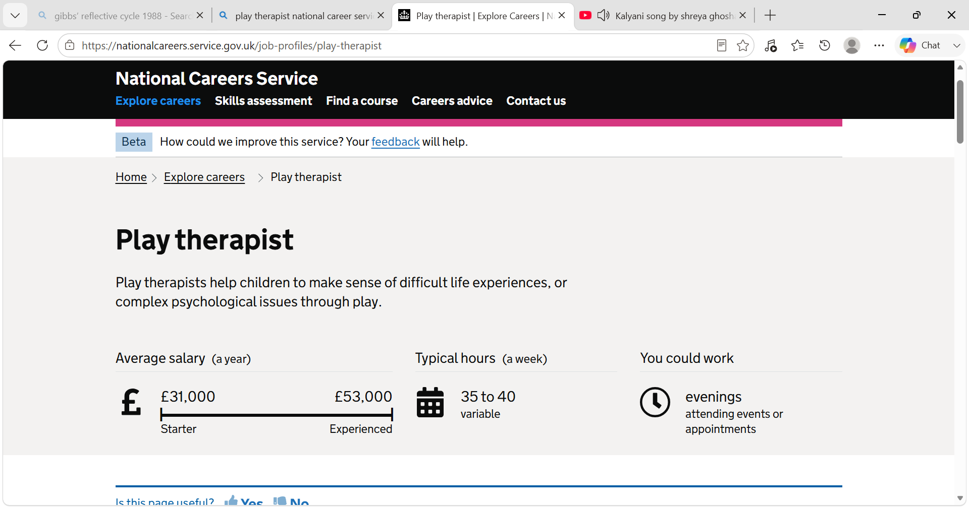

References
BiteSize Learning. (2024). The gibbs reflective cycle, explained. In BiteSize Learning. https://www.bitesizelearning.co.uk/resources/gibbs-reflective-cycle-explained-diagram-examples (accessed on 23/07/2026)
Leigh, D. (2009). SWOT analysis. Handbook of Improving Performance in the Workplace: Volumes 1-3, 1–3(2), 115–140. https://doi.org/https://doi.org/10.1002/9780470592663.ch24

