Premier Inn Analysis on the impact of external environment on employee recruitment and retention
Research Proposal
BA International Hotel Management
Personnel resourcing and development BMIH5005
Tutor: Deborah Lloyd
Sebastian Garbaty

Executive summary
The external environment plays a crucial role in the operations and outcomes of businesses, influencing such factors as recruitment and retention. The hospitality industry, which includes the well-known Premier Inn chain in the United Kingdom, faces a variety of external challenges, including economic fluctuations, technological advancement, and shifting societal values. Premier Inn's strengths are its brand recognition, network, and pricing strategy, according to a SWOT analysis. However, their primary focus on the British market and inability to distinguish themselves from other budget hotel chains are weaknesses. Opportunities exist in international expansion and digital transformation, while threats consist of rising inflation, competition from platforms such as Airbnb, and shifting customer preferences.
PESTEL Evaluation research shows Brexit has created employment uncertainty, primarily as a result of the end of free movement between the UK and the EU. To counteract these difficulties, Whitbread has implemented countermeasures such as increased pay scales and a focus on employee well-being. Brexit and global unpredictability have put pressure on Premier Inn's operational costs, influencing room reservations and occupancy rates. Changing societal values and the influence of online job reviews have a significant impact on the employer brand and recruitment strategies of Premier Inn. Premier Inn, a subsidiary of Whitbread, employs sophisticated technological tools in its recruitment and retention processes. In response to the impact of the Covid-19 pandemic on the labour market, Premier Inn has prioritised employee retention by increasing wages and providing bonuses. The recruitment practises of the hotel chain are affected by the employment laws of the United Kingdom, which emphasise equal opportunities, discrimination, and workers' rights. Premier Inn prioritises employee retention with strategies centred on professional development, employee bonus scheme, competitive compensation, and a supportive work environment. Premier Inn's strategies are influenced by external forces, such as economic uncertainty and technological advancements. Their innovative and forward-thinking retention strategy demonstrates their adaptability and commitment to their workforce. While Premier Inn faces a variety of external challenges, their ability to innovate, adapt, and maintain a balance between demands and pressures will determine their future success. The journey of the company demonstrates the importance of strategic vision and adaptability in the face of external challenges.

Contents
Executive summary 1
Introduction 3
Premier in SWOT 4
Strength 4
Weakness 4
Opportunity 4
Threat 4
Premier Inn PESTEL 5
Political 5
Economical 5
Social 6
Technological 6
Environmental 6
Legal 7
Premier Inn employee Retention Rate 7
Dealing with external impact management 8
Conclusion 8
Recommendations 9
References 10

Premier Inn Analysis, on the impact of external environment on employee recruitment and retention

Introduction
The external environment in which businesses operate presents an abundance of obstacles and opportunities that have a substantial impact on their operations and outcomes. However, is the fundamental nature of the external challenge positive or negative? Challenges are often viewed with apprehension, but they can foster innovation, resilience, and adaptability in organisations. If they are not managed effectively, they can also impede growth and profitability (Sharma, 2019). Recruitment and retention of personnel is a vital aspect that is profoundly influenced by the external environment. Analysing the effect of the external environment on employee recruitment and retention reveals a complex interplay of factors. Economic fluctuations, talent competition, societal values, technological advancements, and regulatory modifications can either facilitate or hinder the acquisition and retention of top talent (Armstrong & Taylor, 2014). Economic downturns may increase the number of job seekers, but they can also reduce job security, making it difficult to retain employees. Similarly, in an age of technological progress, businesses that lag behind may find it challenging to attract digitally savvy talent, thereby affecting their recruitment processes. Examining Premier Inn Hotel, a leading hospitality chain in the United Kingdom, offers valuable insight into the challenges that organisations face in the real world with regard to employee recruitment and retention. Like many in the hospitality industry, Premier Inn (2023) faces a number of obstacles. For instance, personnel shortages are often an urgent concern. This could be the result of a number of factors, such as the seasonal nature of hotel employment and the allure of opportunities in other industries. According to Ivanovic and Blazevic (2009), inadequate training can also inhibit employee retention. Employees who feel unprepared for their roles or who believe they are not professionally growing are more likely to seek employment elsewhere (Hayes & Ninemeier, 2023). Ineffective management is a significant deterrent to employee retention. Not only are employees who perceive a lack of support or feel undervalued more likely to quit, but their dissatisfaction can also affect the recruitment process. Potential recruits frequently rely on the reviews and experiences of current or former employees when considering an employer, and negative feedback can deter potential talent (Marchington & Wilkinson, 2012).

Premier Inn PESTEL
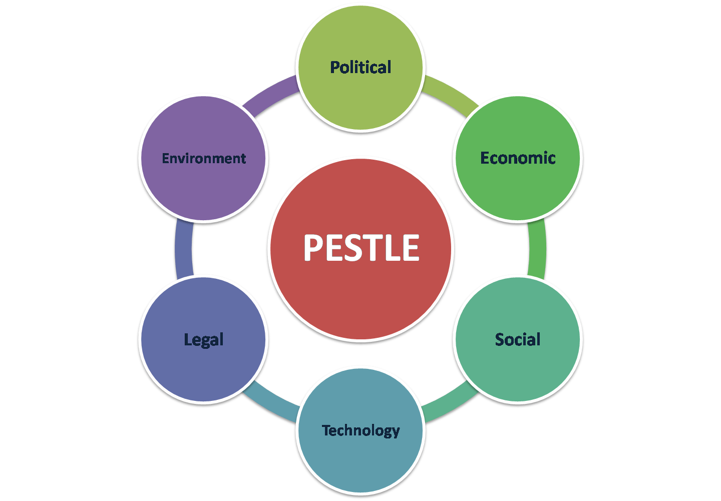

Political
The unfolding of Brexit has increased employment-related uncertainty in the United Kingdom. Notably, the end of free movement between the UK and the EU has likely diminished the talent pool, a matter of particular importance for industries such as hospitality that have historically relied on EU workers for staffing (Muvija & Peters, 2021). In addition, the government's shifting stance on immigration and employment regulations has added complexity to the recruitment landscape (Beech, 2022). Despite these obstacles, Whitbread (2023) has taken extraordinary measures to preserve a significant portion of its workforce. In an effort to navigate these politically charged waters, Whitbread (2023) is implementing strategies that include increased pay scales, the provision of retention incentives, and a heightened focus on the well-being of its employees, thereby ensuring that their market position remains strong despite the change.

Economical
The economic ramifications of Brexit and the fluctuating value of the pound sterling have exerted pressure on operational costs. A weakened currency has increased the cost of imported goods, thereby influencing pricing strategies as the price of raw materials has risen due to the conflict in Ukraine and the hotel chain's profit margins will increase (Graham 2022). In addition, the broader economic slowdown, caused by uncertainties in the UK and around the world, has affected consumer spending power. Due to the sensitivity of travel and leisure to economic fluctuations, Premier Inn has experienced fluctuations in room reservations and overall occupancy rates. The economic ripple effects, ranging from decreased business travel to reduced leisure tourism budgets, have had a direct impact on their bottom line (Flatch 2022). In response, Whitbread (2023) has adopted strategic pricing, diversified offerings, and cost-effective operational measures in order to maintain their market position and cater to their customers' changing economic circumstances.

Social
Transitioning further into the realm of social factors, the recruitment and retention strategies of Premier Inn are influenced by changing societal values and perceptions. In the current digital era, online job reviews on platforms such as Glassdoor (2023) and Indeed (2023) play a crucial role in shaping the employer brand of an organisation. While Whitbread portrays a positive image of itself, online reviews frequently raise concerns about poor management, which may deter prospective employees. These platforms are frequently utilised by prospective employees to evaluate the work environment, company culture, and advancement opportunities. Negative online reviews or complaints can significantly hinder Premier Inn's ability to attract and retain top talent. In addition, the growing emphasis on work-life balance, professional development, and organisational culture has altered the workforce's expectations. Premier Inn must stay abreast of these social dynamics and maintain a positive online reputation not only for recruitment purposes, but also to retain its current workforce in the highly competitive hospitality industry.

Technological
In 2023, Whitbread PLC has integrated cutting-edge technological innovations into its recruitment and retention procedures. Organizations like Whitbread can improve recruitment, selection, and onboarding by utilising the capabilities of automation and digital technology. According to CIPD (2023), tech-driven processes can offer increased accessibility, improved candidate experiences, and quicker outcomes. However, technology integration requires a delicate balance.

Environmental
Research indicates that since the Covid 19 pandemic, Whitbread has placed a significant emphasis on retaining its employees through various pay increasing schemes. These initiatives began in 2021, when Premier Inn's parent company, Whitbread (2023), announced to the BBC that they intend to spend millions of dollars on wage increases and retention bonuses in response to ongoing staff shortages. Significant labour shortages have plagued the hospitality industry, resulting in numerous open positions. Whitbread estimates that the wage increases will cost between £12m and £13m, and that the retention bonuses will cost an additional £10m. Despite these obstacles, the company has recently experienced a stronger-than-expected recovery, with strong UK demand since the removal of Covid19 restrictions, and is slowly returning to pre-pandemic levels this year. In contrast to pre-pandemic levels from three years ago, however, the organization's revenue was 39 percent lower last year. While this indicates a short-term response to the current state of the labour market, the article does not describe any long-term employee retention programmes or strategies that Whitbread may be implementing to prevent future occurrences of this nature. According to Webber (2021), Whitbread, the owner of Premier Inn, intends to offer a summer retention bonus to hotel and restaurant employees in 2022, allocating £10 million for this purpose. This action is in response to severe labour shortages in the hospitality industry, particularly in tourist areas and the city of London. Despite these obstacles, Human Resources was able to overcome the problems caused by environmental impact. As a result of retaining more employees during the pandemic, Whitbread is in a better position than many of its competitors. The company also recently increased hourly employee pay rates by more than 5 percent in order to remain competitive and to show appreciation for their efforts following the lockdown, which was the most recent obstacle to overcome.

Legal
The UK's employment law, which includes equal opportunities, discrimination, and workers' rights, dictates the hiring procedures the company must adhere to (Gov 2023). Compliance with these laws ensures that Premier Inn does not discriminate inadvertently and maintains a diverse workforce. Moreover, health and safety regulations, particularly post-pandemic, have heightened the importance of ensuring a safe working environment, impacting both the recruitment of personnel equipped to manage such requirements and the retention of employees through a demonstrated employer commitment to their wellbeing.

Premier in SWOT
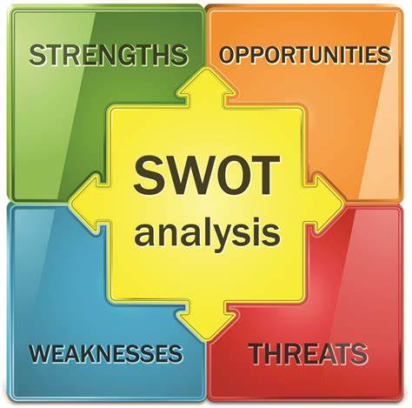

Strength
Premier Inn is the leading hotel brand in the United Kingdom, supported by a vast network of properties across the country. Their established brand recognition ensures the continued trust and loyalty of their customers. In addition, their cost-effective pricing strategy and reputation for clean, dependable, and quality service have allowed them to maintain a dominant position in the mid-range hotel segment (Hanlon 2022). Whitbread has a well-designed hierarchy level that facilitates employees' continuous development.

Weakness
Premier Inn is primarily focused on the United Kingdom, which restricts its global growth potential despite its significant presence. In addition, they face difficulties in differentiating themselves from other budget hotel chains as their prices increase by 8 percent (Partridge, 2022). Additionally, their reliance on the United Kingdom market makes them susceptible to regional economic downturns and tourism slumps.

Opportunity
There is a tremendous opportunity for international expansion on a larger scale, particularly in emerging tourist destinations or cities. They can also use digital transformation to improve customer experiences, from expedited reservations to in-room amenities (Ordorica 2021). Sustainable and eco-friendly initiatives consistently appeal to the modern, environmentally conscious traveller, giving them a competitive advantage in the market. Therefore, there is room for additional initiative (Premier Inn 2023).

Threat
Premier Inn faces challenges as a result of rising inflation, which can increase operational costs, such as those for utilities and supplies, thereby impacting the hotel's profitability and pricing strategies. Higher prices may discourage budget-minded travellers, causing them to seek out less expensive options (Ordorica 2021). Concurrently, platforms like Airbnb have revolutionised the lodging industry by offering localised, customised experiences at frequently competitive prices (Hall et all 2022). This paradigm shift requires traditional hotel chains like Premier Inn to innovate and adapt to changing customer preferences (Price 2021). Premier Inn's continued market success depends on its ability to strike a balance between offering quality service at competitive prices and competing with non-traditional lodging options. But the biggest problem that Premier Inn is currently facing is the negative online reviews posted by former employees who are complaining about the management throughout the United Kingdom (Glassdoor 2023), (Indeed 2023). This indicates that there is a massive problem, as these reviews are not located in one area, so service recovery must be planned to stop the problems (Marchington & Wilkinson 2012) By providing additional training to the manager and hiring additional managers to share the workload, employees will feel supported at work.

Premier Inn employee Retention Rate

Premier Inn maintains a high rate of employee retention, recognising that a devoted workforce is the foundation of consistent service excellence and operational efficiency (Premier Inn 2023). A well-structured approach that prioritises continuous professional development, competitive compensation, and a supportive work environment is central to their retention strategy. Whitbread (2023) has demonstrated adaptability by implementing wage increases and retention bonuses, particularly in light of the challenges posed by post-pandemic labour market fluctuations Webber (2022).

Dealing with external impact management

The retention strategy of Premier Inn has been significantly influenced by external factors, ranging from Brexit-related economic uncertainty to more recent global events (Flach, 2022). The hotel chain's proactive response to these challenges demonstrates its dedication to protecting its employees. The decision to offer retention bonuses during periods of severe labour shortages, for instance, exemplifies Premier Inn's flexibility in adapting its strategy in response to external pressures (Webber, 2021). Moreover, in an ever-evolving digital age, Premier Inn continues to refine its retention strategies to align with societal shifts and technological advancements. Premier Inn's approach to employee retention is essentially dynamic and forward-thinking, driven by a keen awareness of the external environment and an unwavering dedication to its employees (Whitbread, 2023).

Conclusion
In the intricate web of modern business operations, the external environment has a significant impact on the operation and performance of organisations. Its positive and negative effects are evident in the recruitment and retention of employees. The analysis of Premier Inn, a leader in the hospitality industry in the United Kingdom, provides a lens for discerning the effects of these external forces in the real world. Numerous external forces have influenced Premier Inn's development, from the economic tremors of Brexit to technological advancements. The SWOT analysis highlights both their inherent strengths, such as brand recognition, and their weaknesses, such as a model that is predominately UK-centric. Opportunities, such as potential international expansions, contrast with impending dangers, such as the rising popularity of platforms like Airbnb. The PESTEL analysis delves deeper into the numerous factors that influence Premier Inn. Employment dynamics have been reshaped by political contexts, such as the aftermath of Brexit. Economic pressures, such as a fluctuating pound sterling and a broader economic slowdown, have cast a shadow over consumer behaviour, thereby impacting hotel operations. Changes in society, exacerbated by the impact of digital platforms and evolving work values, have an immediate effect on employee recruitment and retention. The proliferation of technology in recruitment processes, environmental challenges such as the COVID-19 pandemic, and increasingly stringent employment law all contribute to Premier Inn's extensive range of external forces. Nonetheless, at the centre of these complexities lies a fundamental principle: even the most daunting obstacles can be overcome. They can encourage originality, resilience, and adaptability. Premier Inn's forays into digital transformation, wage increases in response to market shortages, and eco-friendly initiatives support this view. As organisations navigate these turbulent waters, the key to their continued success will be their capacity to adapt, innovate, and maintain a balance between operational demands and external pressures. The external environment, with its numerous challenges and opportunities, is neither intrinsically negative nor positive; its impact is determined by a company's response, strategic vision, and adaptability. Premier Inn's journey exemplifies this dynamic interplay and the dogged pursuit of success despite external obstacles.

Recommendations
Developing a strategy that puts hotel managers to the test to ensure they support the team and maximise learning opportunities. By infiltrating secret employees into hotels as part of a learning programme to aid in the development of managers. This strategy can provide a broader perspective by considering online reviews.

References

Armstrong, & Taylor, S. (2014) Armstrong’s handbook of human resource management practice (13th edition.). Kogan Page. Full details and actions for Armstrong's handbook of human resource management practice. (uwtsd.ac.uk) [Accessed 31 Oct. 2023].
BBC (2021) Premier Inn owner Whitbread warns of staff shortages as demand recovers. BBC News. [online] 26 Oct. Available at: https://www.bbc.co.uk/news/business-59048014 [Accessed 30 Oct. 2023].
Beech, J. (2022) HR Magazine - 2023 predictions for UK immigration policy as skills shortages escalate. [online] HR Magazine. Available at: https://www.hrmagazine.co.uk/content/comment/2023-predictions-for-uk-immigration-policy-as-skills-shortages-escalate [Accessed 30 Oct. 2023].
Flach. A (2022) The economic Impact of Premier Inn hotels. Study final 2022. Available online PDF The-Economic-Impact-of-Premier-Inn-hotels_2022-study_final.pdf (whitbread.co.uk) [Accessed on 30th Oct 2023].
Glassdoor (2023) Company Review Premier inn. https://www.glassdoor.co.uk/Reviews/Premier-Inn-Reviews-E37496.htm(Accessed on 31th Oct 2023).
GOV.UK (2023) Discrimination: your rights. Act published 2011 [online] GOV.UK. Available at: https://www.gov.uk/discrimination-your-rights/discrimination-at-work [Accessed 30 Oct. 2023].
Graham, A. (2022) Premier Inn owner Whitbread warns of cost spikes as it returns to profit. [online] The Independent. Available at: https://www.independent.co.uk/business/premier-inn-owner-whitbread-warns-of-cost-spikes-as-it-returns-to-profit-b2067375.html [Accessed 30 Oct. 2023].
Hall, C.M., Prayag, G., Safonov, A., Coles, T., Gössling, S. and Naderi Koupaei, S. (2022) Airbnb and the sharing economy. Current Issues in Tourism, [online] 25(19), pp.1–11. doi:https://doi.org/10.1080/13683500.2022.2122418. [Accessed 30 Oct. 2023].
Hanlon, A. (2022) The Pricing - Quality Model | Smart Insights. [online] Smart Insights. Available at: https://www.smartinsights.com/marketing-planning/marketing-models/pricing-quality-model/ [Accessed 30 Oct. 2023].
Hayes, D. K., & Ninemeier, J. D. (2023) Human resources management in the hospitality industry. John Wiley & Sons. Hayes, Ninemeier: Human Resources Management in the Hospitality Industry, 2nd Edition - Instructor Companion Site (wiley.com) [Accessed 30 Oct. 2023].
Indeed (2023) Premier in company review. https://uk.indeed.com/cmp/Premier-Inn/reviews?cmpratingc=mobviewjob&from=mobviewjob&tk=1hc2gquask98k801&fromjk=3c013d3da90c08ef&jt=Nights+Team+Member+%E2%80%93+London+Stansted+Airport+Premier+Inn&attributionid=mobvjcmp [Accessed on 30th Oct 2023]
Ivanovic, & Blazevic, M. (2009) HUMAN RESOURCE MANAGEMENT IN THE HOSPITALITY INDUSTRY. Tourism and Hospitality Management, 15(1), 107–116. https://doi.org/10.20867/thm.15.1.10 [Accessed 29 Oct. 2023].
Muvija, M. and Peters, C. (2021) Premier Inn Says Labor Issues and Brexit Threaten Full Recovery in 2022. [online] Skift. Available at: https://skift.com/2021/10/27/premier-inn-says-labor-issues-and-brexit-threaten-full-recovery-in-2022/ [Accessed 30 Oct. 2023].
Ordorica, S. (2021) Council post: A look at emerging markets and opportunities for international expansion. [online] Forbes. Available at: https://www.forbes.com/sites/forbesbusinesscouncil/2021/06/03/a-look-at-emerging-markets-and-opportunities-for-international-expansion/ [Accessed 30 Oct. 2023].
Partridge, J. (2022) Whitbread plans to offset rising costs with higher Premier Inn room rates. The Guardian. [online] 12 Jan. Available at: https://www.theguardian.com/business/2022/jan/12/whitbread-plans-to-offset-rising-costs-with-higher-premier-inn-room-rates [Accessed 30 Oct. 2023].
Premier Inn (2023) Business. [online] www.premierinn.com. Available at: https://www.premierinn.com/gb/en/business.html [Accessed 30 Oct. 2023].
Sharma (2019) Management techniques for employee engagement in contemporary organizations (Sharma, N. Chaudhary, & V. K. Singh, Eds.). IGI Global. https://doi.org/10.4018/978-1-5225-7799-7 [Accessed 31 Oct. 2023].
Webber, A. (2021) Whitbread to award retention bonus in attempt to fill vacancies. [online] Personnel Today. Available at: https://www.personneltoday.com/hr/whitbread-to-award-retention-bonus-in-attempt-to-fill-vacancies/ [Accessed 30 Oct. 2023].
Whitbread PLC (2023) Management. [online] Whitbread PLC. Available at: https://www.whitbread.co.uk/about-us/management/ [Accessed 30 Oct. 2023].

