Liam Gardiner 1904791

What is the value of art?

Table of Contents
Introduction 1
Literature review: what is art Etymologically. 2
History of Art……………………………………………………………………………………………………………………3
Art with an Intrinsic value 4
Art with an Extrinsic/political value 5
What is the value of art? PEST Analysis 6
Political 7
Economical ………………………………………………………………………………….…………..……..8
Social…………………………………………………………………………………………..………………..…9
Technological…………………………………………………………………………………..…………….10
What is Value? ………………………………………………………………………………….…………11
Conclusion ………………………………………………………………………………………..………….12

​
​
​
​
​
​
​
​
​
​
​​

​ Literature review

​
​
​​
Marx and Art
Leo Tolstoy What is art
​

Introduction
what is art Etymologically?

More than 65,000 years ago, a Neanderthal reached out and made strokes in red ochre on the wall of a cave, and in doing so, essentially became the first artist on Earth, scientists claim’ according to Sample (2018). Artists have been a part of humanity since the times of Neanderthals. From the ancient times as a means of communication and expression with marks scribed into walls.

The word Art is derived from the Latin Ars, which originally meant “skill” or “craft.” These meanings are still primary in other English words derived from Ars, such as “artifact” (a thing made by human skill) and “artisan” (a person skilled at making things)’ (Glass, 2018).

‘The nature of art has been described by philosopher Richard Wollheim as ‘one of the most elusive of the traditional problems of human culture’. The definition of art is open, subjective, and debatable’ (Martinique, 2016).

According to Christopher Newfield, a professor of English at the University of California he discusses the limitations of numbers regarding certain subjective disciplines like art. Due to the subjective nature of art The measuring system we use i.e., numbers, and fitting a numerical cost on the value of art can be limiting as the art or subject matter and its function is not as quantifiably measurable as some subjects.
Arts therapeutic value is said to be highly beneficial for people’s mental health and wellbeing, he explains how only measurable subjects get presidency in education systems and within the capitalist world that we live in today (Newfield, 2019).

Leo Tolstoy states in the book ‘What is art’, historically ‘Art is nothing more than amusement for rich people’ (Tolstoy, et al). in current society Art it seems can be whatever anyone says, it seems there is very little anyone can do to define exactly what is or is not Art.

To attempt to outline a clear definition of what is art or its exact value, is this to put boundaries on the concept of freedom of expression, on part of anyone’s individual process of creating artwork and henceforth their imagination. It seems natural that people want to try to understand subjects, to find a meaning or definition. Do people learn to understand what something is from what its not by a process of elimination almost?

When artists in current day make invisible art, people may be seeking for a definitive meaning or value of art, could it be as boundless as the universe and one of the only things which has no exact definition symbolising freedom of thought/expression?, with processes and structures made individually, but could it be that art is for people to enter a way of understanding not always with the mind? more of a feeling of understanding or to escape a limited mindset and enter new versions of perspectives and realities. Due to the limitless possibilities of what art can be historically it may have been more edged towards skill and beauty during the renaissance with paintings originally to paint something mimicking the object or person would be considered good. “Mimesis, basic theoretical principle in the creation of art. The word is Greek and means “imitation” (though in the sense of “re-presentation” rather than of “copying (Britannica)

The Stanford encyclopaedia of Philosophy’s definition of art states ‘Any definition of art has to square with the following uncontroversial facts: entities (artifacts or performances) intentionally endowed by their makers with a significant degree of aesthetic interest, often greatly surpassing that of most everyday objects’ (Adajian, 2018).

furthermore, this research will explore the different ways art and drama are valued,
(How and why is it measured?
What is the purpose function & importance in today’s world?

Clearly, we can see everyday objects have been used for to make art here. In modern day society many people make reactionary art which could be said is void of craft or skill. A banana gaffer taped to a wall, made by Italian Maurizio Cattelan, titled Comedian (2019) (figure 1) (Russeth, 2019).

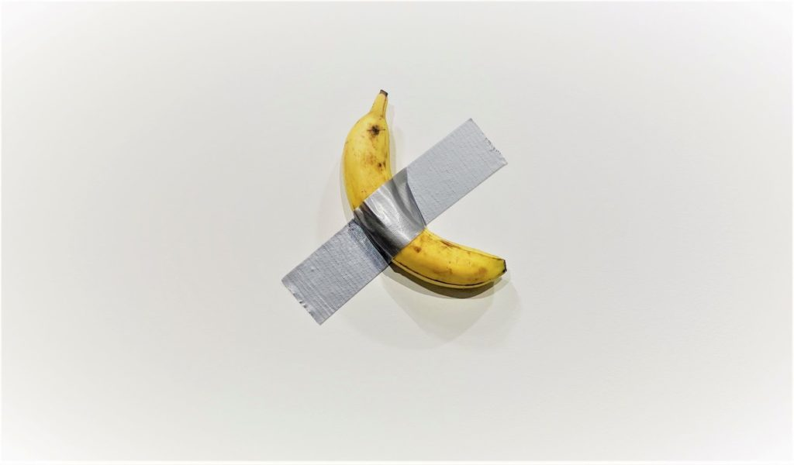
Figure 1 - Maurizio Cattelan, Comedian, 2019, mixed media (banana and Duct tape), Art Basel, Miami Beach, U.S.

This piece sold for £95,430.00 then another addition for £119,278.50.
What makes this of such large cost or value? The sheer audacity that anyone can make up anything and call it art and yet it still sells, this is how it is but is it right? It gives a reaction and is that all that is needed some form of reaction or attention.

If the original meaning of the term art is lacking in skill in the hand, perhaps it is in the mind’s eye. However, anyone can see it is perishable, the absurdness of it could reflect the fragility and meaninglessness of life? Perhaps this is an evolution of arts conventional term skill. So, it is an open field for anyone to do anything. Could it be similar to the way people weaponize a subject (Powell, 2022), in this case art. Is this just an evolution of the term art or is this manipulation of a boundaryless subject. The Boundless subjective meaning of Art has its pros and cons in current day 2023 it is more inclusive with less elitism however it can be rife with questionable works when it comes to skill and craft.

The original term Art ARS meaning skill or craft to think of a skill or craft is more of a n action word reading the book art as a verb by Charlotte day delves into this meaning (Day et al, 2014) could be a verb, so what if art was defined as an action rather than a physical thing that is so subjective opens the door for manipulation exploitation of the term. As a verb it would be more about the act of doing it, valuing the act itself of doing it and perhaps it would give more clarity on it all.

Considering Karl Marx theory of value; everything has value/cost (i.e., in a capitalist perspective) from the book Capital. Vol 1 (Alizadeh, 2019) time of labour can be measured but skill of an artist is not a directly measurable quality specifically due to the perceived subjectivity of Art.

Historically craftworkers were looked down upon and were of a lower class. Art has evolved or devolved into a minefield of subjectivity of what art is. The contrast between the skills in craft makers and what skills are in arts and certain artists the ancient meaning of the word art may be coming full circle as skills and crafts are becoming more in demand from tv shows on pottery, upcycling for the human desire to use one’s hands and manual dexterity/ coordination have gone by the wayside for some time until recently there has been a resurgence in demand.

The term Anything can be art is the cliché here. In 2021 the Italian artist Salvatore Garau created Io Sono which means I am. He sold an ‘invisible’ – yes, non-existent – sculpture for £12,000. (Dafoe, 2021)
Is Io Sono a play on Descartes philosophical quote I think therefore I am?
see figure two below is just one of Salvatore’s invisible artworks.

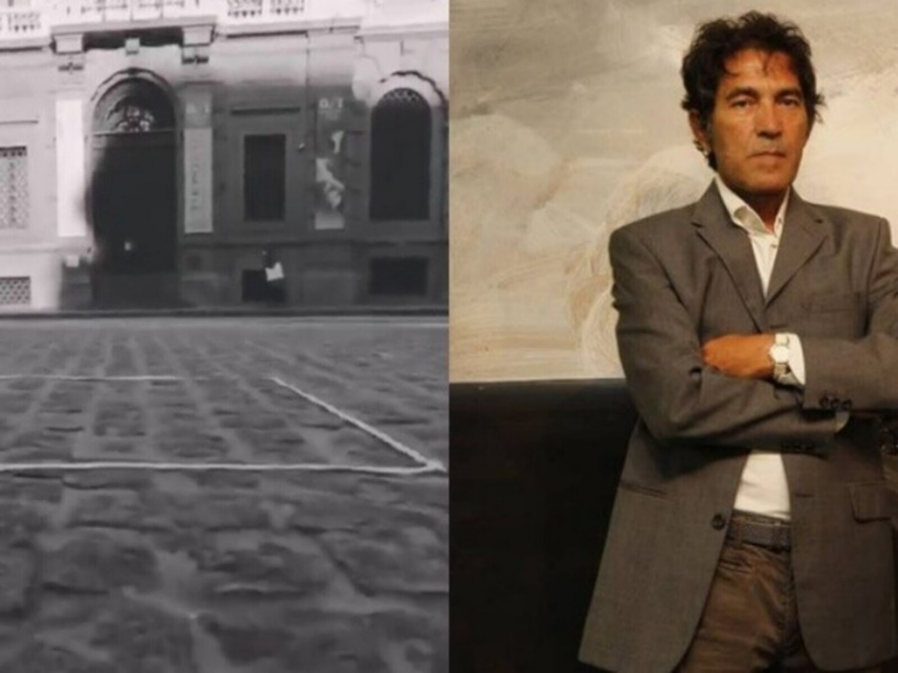
Figure 2, Salvatore Garau Io Sono 2021, medium invisible sculpture piazza Della Scala, Milano

‘Beauty is in the eye of the beholder, but what happens when it’s undetected by the eye?’ (Diaz, 2021) Are we killing art? (Webb, 2023) The weaponization of everything (Powell, 2022), does the word Art need boundaries, is it a mockery? As there are no boundaries nobody can really say otherwise. Is art a case of reality wars and a form of mental warfare to see who can go to the extreme and standing proud in one’s own so-called perspective of one’s own creation even if there’s nothing physically there?

Art with an Intrinsic value

An innate/intrinsic value of a painting from a child would likely be given an innate or intrinsic value from their caregiver/parent often regardless of what it looks like. Just an example of an intrinsic value like other values i.e., the fixed rate to a labour worker where there is a given set value, whether it be a labour of love or otherwise.

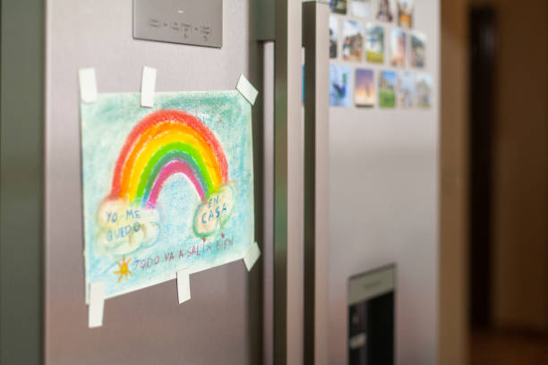
Figure 3 Moya, Rainbow drawn by a child.

Art with an Extrinsic/political value

works from Artist Banksy now has extrinsic value, after becoming well known in the street arts scene although when he first started out this would not have been the case like with many artists as people do not give a value to anyone or everyone either something has to be aesthetically pleasing or previous knowledge of their fame or status is known.

Banksy’s work can be provocative and often politically driven by different perspectives of reality which can be profound. The work of Banksy and his messages are about his artwork not about his identity, and it could be seen to view art for art’s sake although not disclosing his identity and appealing to the non-elitist by largely not promoting the monetization of his works as he makes it for the people which the public resonate with. Banksy’s fame also from the mystery of his identity feeds into what an artist archetype is (Paul, 2022) However Banksy is now a worldwide known name and brand which is run by many people. Numerous artist/musicians alike have worn masks through history for different motives, one of the reasons could be to separate their identity from the art they produce (Mohn, 2021).
Below are some of Banksy’s famous Street artworks displayed today on his home streets of Bristol for the public to see.

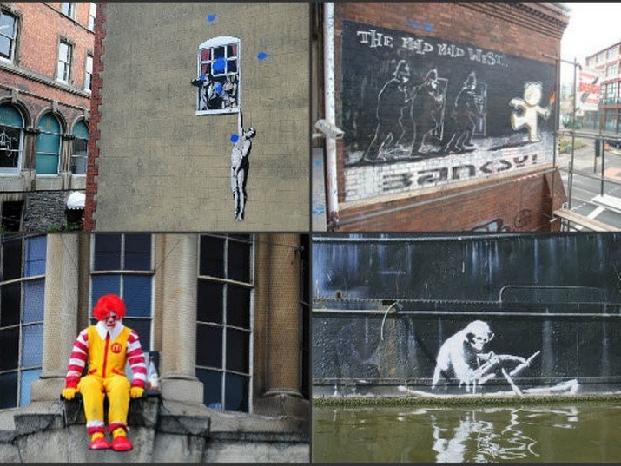
Figure 4, Banksy image from top right; The mild mild west, circa 1990’s Hamilton house stokes croft Bristol.
Image top left; Well-hung lover Frogmore Street Bristol circa 1990’s
Image bottom right Grimm reaper 2003 on the side of the Thecla (now in the M shed Wapping wharf Bristol)
Image bottom left depressed Ronald McDonald in front of the Bristol Museum. (Rice, 2023)

What is the value of art? PEST Analysis
A pest analysis was chosen to help structure the main themes in this dissertation. This often-used analysis tool is used to see the business profitability however I will be using this tool to highlight certain factors that affect the value of art researching the benefit of Art for community wellbeing and even therapy as opposed to direct financial benefit.

Political - Activism has been in art for centuries, dating back to the 18th century.

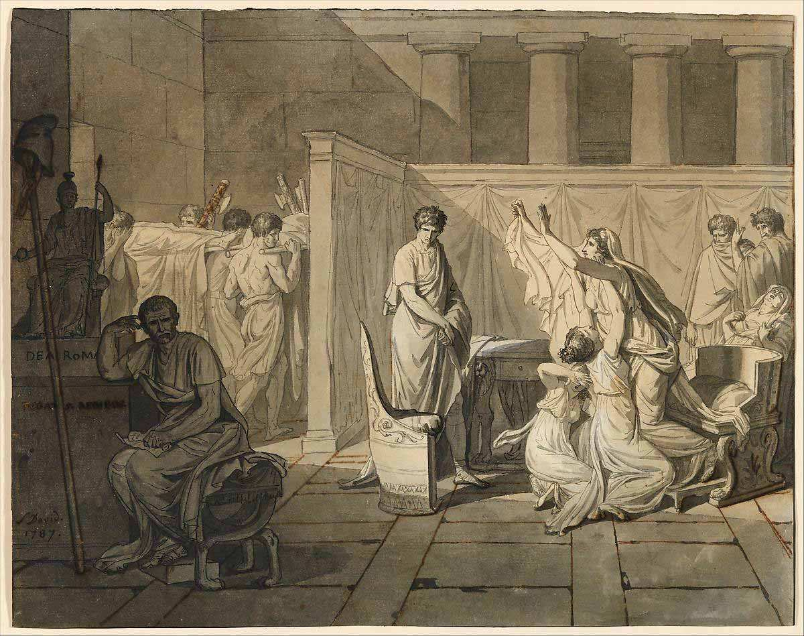

Figure 5
Artist Jacques-Louis David Study for The Lictors Bring to Brutus the Bodies of His Sons by Jacques-Louis David, 1787, via The Metropolitan Museum of Art, New York

Above is a historical example of political Art. Jacques-Louis David who was a dominant force in the French revolution, his artwork often shows his political views and connections. Davids’s painting of (Graf, 2022) an iconic figure in Roman times First sight of the death of his sons as they wanted to take over the government and restore the monarch Brutus had the sons killed.
David having a strong moral compass he attempted four times to gain success with the Prix de Rome (an Artist patronage scheme). (McMullen, 2023)
After finally succeeding access and completing the Patronage scheme, he worked to abolish the scheme at the Académie Royale. Much of the old system for training artists was changed after his departure.

Current day ways and means to provide public spaces for up-and-coming artists and creatives are poignant topics I will delve into to answer the question of what is the value of art? specifically, regarding tangible real-life spaces and places. focusing on alternative ways and not direct traditional monetary/numerically valued systems.

Art can be a used as a catalyst for political events such as the removal of the Edward Colston statue. Colston was a slave trader. The Colston statue was torn down from the plinth in Bristol and dropped into the canal on the 7th of June 2020.
The statue was originally made by John Cassidy erected in 1895. The topping of the statue has raised awareness of a lot of other historical statues around the UK with much disputed subjects (MailOnline, 2020). The swarm of highly charged political activists removing the Colston statue was a significant moment in history and created a big Hoo haa and a divide across the land of where people stand on the issue. The importance/value of the Colston statue and what happens to it or goes in place of it was subject to change. The activists and people of Bristol vehemently decided it was not part of their culture and history that they wanted to continue teaching the young and literally pedestalising.

The judge found the four defendants Sage Willoughby, Rhian Graham, Milo Ponsford and Jake Skuse who were found not guilty. After years of attempting through the legitimate legal routes, petitioning for its removal which did not work (BBC News, 2022).

Colston was once chosen as the person to embody the spirit of the city erecting the statue in 1895 when he lived there between 1680-1692. He made vast donations from the wealth he gained exploiting the slave trade he exploited the young working them hard branded them with numbers on their chest and did much worse also. Up until recently there were private schools’ university halls streets, public houses tower blocks all bearing his name. Almost all of these with his name have since been removed from the streets of Bristol, all but the private school he started which state they are planning to rename.

Below are photos of the event itself, figure 6 the now famous Colston fours acquittal speech and figure 7 the statue being thrown in the harbour water.

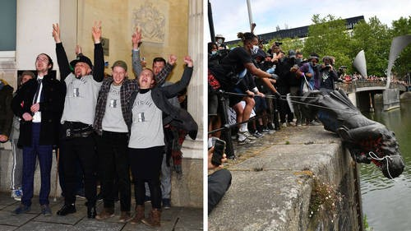
Figure 6 figure 7
C. Callen, Colston four C. Callen, Colston thrown in the harbour.
acquittal speech, 2022 a 2022, b Bristol Harbour.
Bristol crown court

Artist Mark Quinn from London hastily replaced the statue with a statue of a local black woman called Jen Reid (Bland, 2020) Jen Reid who is a black lives matters (BLM) activist from Bristol. She was contacted by Mark Quinn, about the idea of putting a statue of her he made seeing a picture of her on Instagram in place on the plinth. Following the (BLM) movement although she agreed for the general cause not everyone wanted her statue up on the plinth. Jen Reid statue Below.

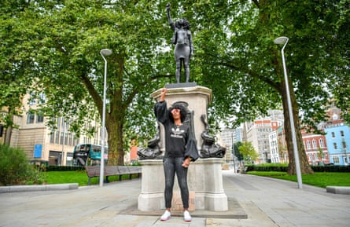

figure 8
(Emelife, 2020) Mark Quinn, ‘A surge of power’
Central Bristol

this Statue was installed but caused much controversy and uproar as it was not to some local artist liking. Black artists Thomas J price mentions “Quinn “He’s hijacked a cause that was slowly building momentum. He arrogantly seems to think that this debate wasn’t already going on without him, but it was’ according to (Heaf, 2020).
A petition of 500 (MailOnline, 2020) wanting a Darth Vader statue on the plinth in testimony to the late actor David Prowse from Bristol, whose voice was dubbed out of the final Star Wars movie. Some wanted another significant black statue there although some would also like to use the plinth like a public communal space for local artists displays. Below Darth Vader statue.

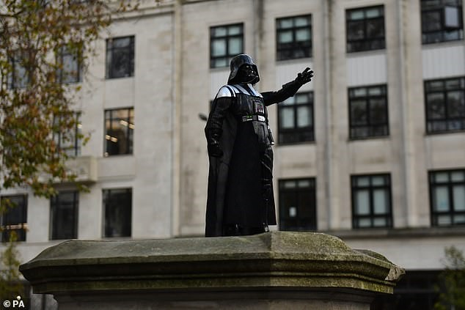
Figure 9
(Gant, 2020) Simon Francis Thomas,
Darth Vader
Central Bristol

Banksy proposes reinstating Colston statue as part of slavery memorial he suggests resurrecting the Colston statue and commissioning some statues around it pulling it down to commemorate the toppling day see below.

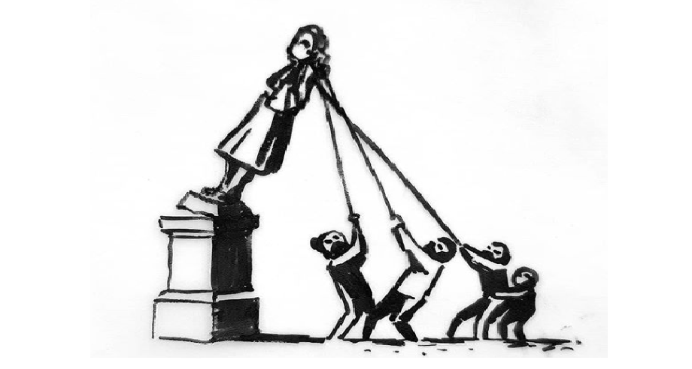
Figure 10 Banksy (Booth, 2020)

The statue of Jen Reid monument has since been removed 24 hours after its install due it not having planning permission.
and the plinth see image below is now in July of 2023 still left empty.

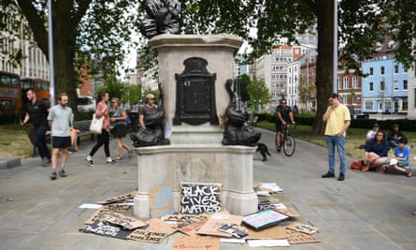

figure 11 (Wall, 2020) empty plinth.

Prior to the Colston toppling event the music group Massive Attack who Banksy works with refused to perform in Colson Hall in Bristol until The Mayor changed the name. Artists/musicians can sometimes be a catalyst to change and if change must come in the form of radical action when the powers that be are too intransigent although likely a last resort. (The Guardian, 2017).
The value of Art can come in many unmeasurable forms, freedom of speech of public opinion, to bring in change to current cultural demands and rid old unwanted historical figures.

The primary purpose of why these monuments were and are built is largely to do with the individuals commemorated in their name. The message for what they stand for, when put on a pedestal goes deep into the culture and politics of the country and world, not for the cause of art directly. Art may only be the medium to carry these messages but without it and some common understanding of the value of Art and even its definition it will be left unknown and boundless. The Boundless subjective meaning of Art has its pros and cons in current day 2023 its good for inclusivity and less elitism however it can be rife with questionable works when it comes to skill and craft.

Rishi Sunak, the current UK prime minister 2023 states.
“The arts, sport, acquisition of complex life skills: all must be sacrificed at the altar of the easily measurable” (The Guardian, 2023). i.e., maths and therefore does not value the Arts as much as maths and stem in-school curriculums. Without a society in the world that truly values Arts by adding diversity of perspectives, culture, and richness the culture and society of people would not have mediums of expression. The fabric of our society and the freedom of expression of our culture. And adding to the civilization of our society from architecture and history, intertwined within the arts and culture. Art is likely a primal form of communication for anyone to do, to express one’s message/picture/sound etc or view to another or to the public i.e., vox pop.

Whether the message be historical, like when Colston was revered or currently when (BLM) is an important message of today but either way, the real value of the art can often be overlooked by the bigger political messages and what they stand for.

The saying art for art’s sake which was originally coined by the Swiss writer Benjamin Constant in 1804 (theartstory.org, 2013).

Sometimes these big political subjects can use art as the catalyst or the medium to carry such messages and sometimes it can be difficult for people to come to a joint agreement about who they want to hold up on a pedestal and make as a hero.
Could having an empty plinth with rotations of free artists work on display be a more progressive approach to the value and purpose of art politically? It seems an open space allowing freedom of the public to create can give way to interesting works like the colourful city of Bristol with new and progressive ways not transgressive.
If art is subjective and if art reflects or imitates life, then could reality be subjective also? Often people hold different views still some truths are the same i.e., racism and when the majority speak, people’s values are more important in a community than an outdated racist.
One of the people who was freed of charges for the toppling of the Colston statue valued the statue previously at £6,000 and now after the act where it lies in the museum at £300,000. (Whitehead sky news, 2022)

Thursday 6 January 2022 20:59, UK
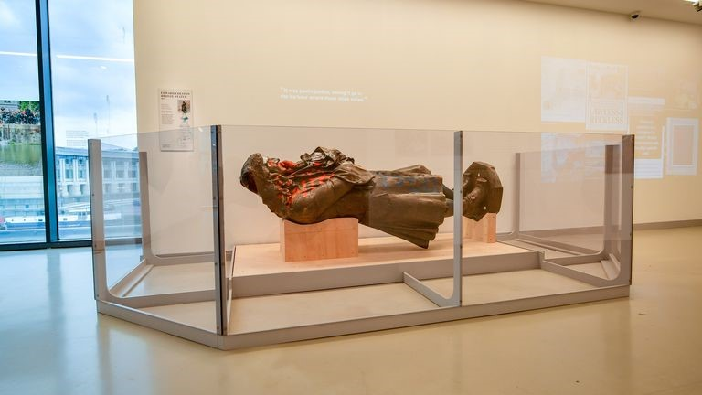
Figure 12
(Whitehead, 2022) The vandalised Colston statue on display at Bristol Museum

This almost has Damien hurst morbid feelings, an end of an era, However There are many people personally I spoke with within Bristol and the u.k who are not aware of where the statue is and have a negative opinion on what has happened to the Colston statue. Until revealing to them of its current whereabouts Spreading the information of what has happened with the statue is Vitaly important to write history now and remind people it has not been swept under the carpet, but history has been made and nobody is pedestalised on a plinth anymore. This in itself could be a humbler approach, what will be put in the place of the plinth is still yet to be decided.

Economical

There is a short documentary called the “The Colston four” produced by Arthur Cauty, Banksy made a couple of thousand more shirts of just the empty plinth.

Banksy has unveiled a new piece of artwork (pictured) inspired by protesters who toppled the statue of Edward Colston in Bristol on Sunday’.
These T shirts have since sold for up to a £12,000 as Banksy made 4 specifically for the “Colston 4” four of the defendants who pulled the statue over and were released of their charges. (Cork, 2022)
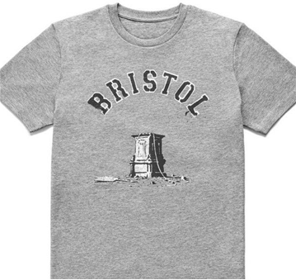
Figure 13 (Cork, 2022) Banksy c

The shirts first went on sale from £1000, more recently one of the four signed Banksy shirts gifted to one of the Colston four sold for £1200 at an auction Cork (2022). The less rare ones sell for £25. They were sold at independent shops in Bristol to raise funds for the four defendant’s legal costs just before their trial. This is a memento of the day that will go down in history. although the economic boom from the aftermath reaps benefits for many as people want to celebrate and promote this day.

In some instances, some artists use their work as direct currency as a ‘Direct barter" is a trade between two individual parties, for example, an artist trading a painting to a furniture store for a $1000 couch’ (Alan Bamberger, 2019) On the whole the UK’s Creative Industries contributes almost £13 million to the UK economy every hour. (GOV.UK, 2020)

Separating art and the artist Identity

If Art is about taking a glimpse into the mind’s eye of the person who created something. If people make Art, it gets personal. But by working incognito and behind the scenes where one never gets seen or recognised then the artwork can be seen solely for what it is hence the term Art for art’s sake. artists like Banksy who do not reveal their identity and musicians like MF DOOM who used a mask to cover his face (Hess, 2005) create mystery, but their art and music is the primary cause rather than recognition or fame.

The world of art is forever changing and evolving as is the environment we live in. From the elitist artists who only represented a certain demographic of the higher class who could afford to do art which is changing so anyone can do art and stand proud in whatever definition it is to the individual. Banksy an anti-elitist artist, one of his recent pieces sold for millions and it was designed to self-destruct straight after the sale had gone through (Villa and Villa, 2021). Banksy is sending a message out that art is for anyone and everyone certainly not only for the amusement of rich people.

Social

Personal project on the multi activity hub

Alongside this dissertation I am working on community project called Narberth multi activity hub.
The title is not specific for a reason. This is because the purpose is to have a mixed-use facility for arts activities and other personal hobbies or projects anyone wants to bring. people may find vague words/titles and projects confusing such words as Art or such titles as multi activity hub. The method in the madness is to provide a third space for people of all ages to go to without payment.

Promoting inclusivity (not elitism and exclusivity) bringing, art music projects pieces graffiti physical sports such as skating and more. When the project gets off the ground there is potential scope for a larger organisation, to put art in spaces and put spaces in art, bigger spaces in towns starting not just a local community project as in most towns there are empty vacant buildings/spaces and within sometimes empty people too. To provide a space for people to unite and get inspiration to collaborate with one another in new ways is the general purpose of this cause/organisation. Below are some photos of ideas of for the activity hub.

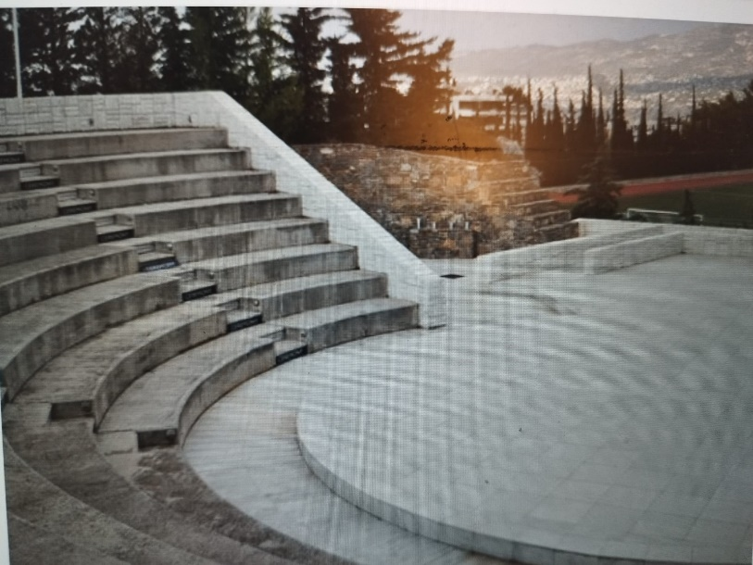
Figure 14 activity hub(amphitheatre)
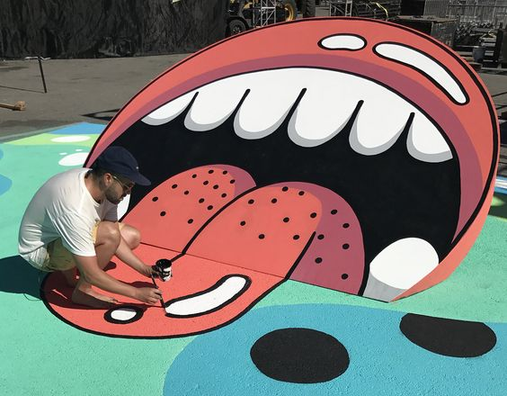
Figure 15 (Anderson, 2017) activity hub (skate centre)

The cause for the project is to create a safe third space for mixed creative outlets.

I have lost a friend to suicide and know of many others young men and women alike who go the same way from a lack of positive outlets.

Part of the issue could be that many people may underestimate the value of trying to understand what they are feeling, many people can be very well known and seem fine externally but could have tremendous issues under the surface that they themselves aren’t sure of how to deal with.
Often artists unfortunately can suffer with issues like this that is where it is not a hallmark to be one, but it is common.
To learn to articulate an emotion in a response to the world around them could make the difference of someone’s life. Many people judge as its easier than thinking, cultivating the ability to introspect and process feelings to relate in better ways. Many if not most people have a dim view of introspecting or introverts as looking within can be scary sometimes.

Not everyone articulates emotions as easily as others, for numerous reasons, often this is not clear for anyone. Cultivating a safe space where people can connect to others’ emotions, people can choose to respond in new and different ways through play physical movement sport and Arts as opposed to being stuck in a negative space and operating on autopilot without even knowing it.

Self-discovery opens many new possibilities, including the ways we enjoy making art’ (Bond, 2010) this can have a profound value in social environments once we realise our own feelings a journal article titled “Feeling our Way Toward a New Theory of Reflection in Service-Learning”.

The presence of arts in a community is linked to community safety in a neighbourhood and better social wellbeing. Research shows benefits of participating in the arts to informal education and a richer experience for youth and all ages also a pride, purpose, and ownership in a community even in poorer areas across all races also boosting economic success (Sarah Sidman, 2018). Low-income neighbourhoods with cultural resources have 14% fewer cases of child abuse and neglect, and 18% less serious crime than low-income neighbourhoods without cultural resources.
The Arts also create a common interest for all ages making a connection and promoting social inclusion which in some areas of art and artistry ones who need to put themselves forward for fame etc can promote the opposite which is elitist.

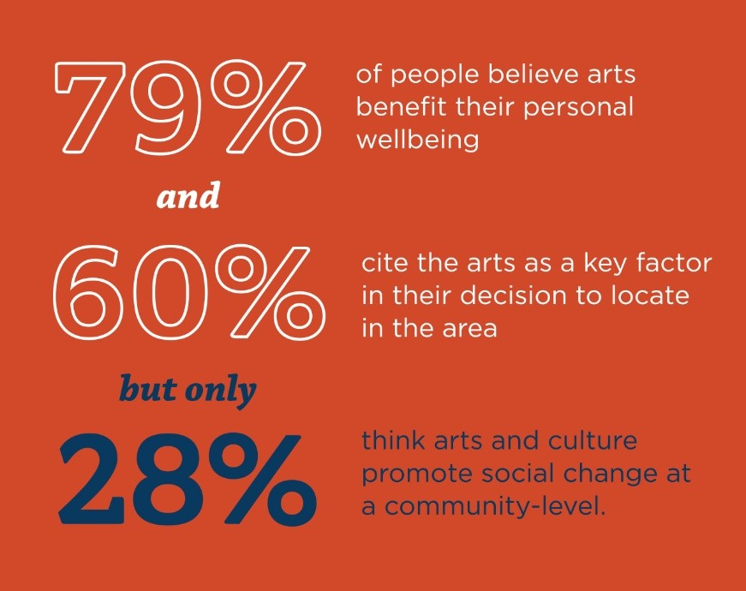
Figure 16

Corelating the statistics above with the survey below I conducted for the community project (multi activity hub) the results are quite similar from 79% considering arts will help their personal wellbeing and below 80% of the people from my group thought that a creative communal space for the wellbeing would also be beneficial.

What do you think the benefits are for having such a facility as a multi activity hub which could be inviting for a wide range of age groups?
10 out of 10 people answered this question.

Good 80%
8 resp.

quite good 10%

1 resp.
so so 10%

Dave O’Brien, a professor of cultural and creative industries at the University of Sheffield”. Comments on the class imbalance and the elitism in the arts, which have been an issue for a long time, not representing low-income areas.
There is a lack of working class from the decline in manufacturing in the UK and the society has less hungry young to make songs and films and so on. The BBC states the lack of appeal from people who are young and hungry for success from less privileged backgrounds (Tapper, 2022).

In educational institutions ‘Some faculty use art, film, literature, or music to help students make intellectual and emotional connections between service experiences and academic analysis. In addition, many of the standard pedagogical tools for reflection, such as various forms of journaling, allow for the interplay of emotional and intellectual processing’.
David Kolb 1984 ‘also acknowledges that emotion has a role in the learning process: “To learn is not the special province of a single specialized realm of human functioning such as cognition or perception. It involves the integrated functioning of the total organism—thinking, feeling, perceiving, and behaving’ So what is art’s function? What is it about humans that need to express in an individualistic way their own reality to take something from one’s own minds eye/vision and put it on canvas, sing into a microphone or dramatically express it through film etc. (Forgeard, 2022).

Art reflects life and humanity; it helps people to see things from different perspectives. It can do this in a subtle way as it encourages people to simply think (for themselves that is)! Often people follow one another’s opinion or lead perhaps even subconsciously especially in social settings people who really think for themselves is often rare we a trained from a young age to do as ones told. Asch’s conformity experiment demonstrates this on a short video very well (HeroicImaginationTV, 2011) one experiment shows the tendencies to conform to the groups opinion and the other experiment shows the dangers of conformity and how common it is.

however, it may suggest that some artists can think for themselves regardless of essentially pack mentality at least in a life-or-death situation another research paper from the national college of Ireland titled “The Dual-Factor Model of Creativity and its Relationship with Conformity” also states its
‘Conformity has a negative association with creativity’, (O’Rourke, J. 2022)
This survey also finds people with more creative potential conform less in a social setting, why is this?
Original thinkers i.e., people who stand for something, often activism is displayed in arts.

humans only have our minds i.e., ration to refer to in our heads and often much of the world doesn’t always make sense for example why is there war, why is there genocide racism and all the wrong doing’s humans digress into. So what? if there was an answer for all these questions would that help or could a governmental shift in the way art is literally valued & used to help the progression and evolution of the word and its function in society.

It could be said that Artists are comfortable not-conforming to a group or opinion. Having this ability (if it is a trait or a learned behaviour?) could save their life or others life if that experiment were a real situation.
This way of individual thinking where some creatives have this trait is evidently vital now because many people in general conform to the enforcement of taking a vaccines etc during pandemics where not only freedom of speech is infringed but the welfare of one’s own long-term health.

- Critical and independent thinking, also linked to the ability to debate and consider others opinion. People have this trait although the silencing of people and cancel culture is still very prevalent.

Why do humans need art or different forms of creative expression?

One journal article from an Australian curriculum authority states
‘an education rich in Arts maximises opportunities for learners to engage with innovative thinkers…such an education is vital to students’ success’ Assessment and Reporting Authority (ACARA), 2010, p. 3) in regards to the Stanford’s philosophical “value of Knowledge” this Australian authority seems to emphasise the value of the arts in the educational establishments.
‘Moreover, if the metanarrative is a “hidden curriculum” proviso for school music as promoting “good taste” (a troublesome concept itself, allied as it is with the dubious claims of aesthetics), it seems not to be succeeding Similarly, claims to teach for musical ‘understanding’ are misplaced. As Dewey argued, intellectual ‘understanding’ is not at stake but, rather, what musical experience does.’ (Regelski, 2022)
Essentially music is as difficult and an unmeasurable medium artistic form of expression. You don’t have to understand music theory or academia to either be able to play or feel/experience the joys of music and many great musicians were self-learned in unconventional ways.

‘Knowing how to develop critical thinking to compare leading way to innovative thinking helped by engaging in Arts activities. This is an important pedagogical skill that needs to be developed’ (Nilson, 2013)

When people fail to think critically, and they tend to follow the crowd by not questioning the status quo many people have finite thinking i.e., black and white thinking a concept theorized by jean luc Nancy (Nancy and Sparks, 2003).

even more of a reason to think critically if we are limited in this world by the quantification of everything into numbers, as we need to fight for our place, individuality and not become just another number/follow/like or person begging for subscribers dominated by algorithms that seem to know everything about us.

‘Numbers are superior to narrative because they claim an objectivism that narratives do not’ (Newfield, 2019).
It’s near impossible to imagine a world without numbers and this is not the primary conclusion although just a finding.

If the world is limited by numbers and if numbers have a higher value in terms of monetary and socioeconomical value, then they set the president.

People deal and trade art using numbers. Art is a subjective entity or medium, but numbers objectify, and this promotes finite thinking, i.e. (limited) the perfect measuring system of numbers has little relation to the world or in nature the increments metrics between one and two and so on are exact but nothing in nature in life or the world is this exact or perfect. Yet we as a species for thousands of years chose to confine ourselves to a wage a salary.

A number for the price of a piece of subjective art? What is the alternative?
If humans must measure and compete, as measuring is required for trading. Although numbers are infinite, why must we be so limited by them? Can there be any other way?
The limitation of the numerical world may be a boundary, however without a clear alternative it is just information that may or may not be useful. Numbers are a big part of what makes a civilization and has been for millions of years.

According to Christopher Newfield

“Quantification is good at stripping out context, variation, specificity, individuality, and other qualities people associate with values, standpoints, beliefs, and other effects of not being value-free”.

Ultimately many artists don’t get to make their work for many reasons, one lack of clear financial reward/support and subsequently the starving artist stereotype can cause concern of what others think of the title artist as a job and the stigma attached to it.

Technological

Valuing tangible real-world arts & spaces vs an online experiences at any cost.

The cost of everything but the value of nothing
art is a useless necessity, Wilde (2019).

Companies such as Netflix and Spotify are different although similar in so far as they are both businesses and they both need their subscribers.
This need for results and numbers goes into the discussion in some interviews conducted for research and collaboration where Ioan hefin said that the actors dependency on the box office or views is a similar notion, essentially it’s an outcome dependant mindset as opposed to being outcome independent where the reason for doing art/ acting in any of its forms is not for the laughs or the audience but for the purpose of expression, if one follow the audience for what to do then like Netflix, actors may fail to tune into their own true motives of creating something and then can become dancing monkey’s .

#The reason why such films like godfather and many films or debut music albums were made was because of nothing to do with return customers Herberg (2017) and subscribers. The simple reason why Frances’s ford Coppola or Nirvana made their music or films was because they had a strong burning desire to express something or tell a story that they knew in themselves that the world needed to hear or see.
All monthly paying viewers and subscribers are at the mercy of the big capital companies in power who look at creating sellable content with high ratings who seem to put the need of their return customers (understandable to an extent) over any original or individual expression, does this help the value of creative arts?
There’s another point that’s the fact that we rarely physically own any music or films on these websites, excellent for landfill and saving waste and space i.e., digital nomads, however we walk away with no physical thing, is art a thing which pleases the senses as humans our technology is our limbs our vision eyesight ears smell and taste, when we limit ourselves to screen attachment issues arise in this virtual world which draws us at our fingertips and eyes but to deny all other senses is limiting its value and the human desire to possess to have or own and return to (apart from the experience in memory), if we don’t pay the monthly bill so the human desire to own is played on us by these companies who attempt to own their clients in subscription.
in 2023 people are absorbed and attached to screens from phones and laptops more than ever especially after the pandemic isolation may have been a breeding ground for hobbyist pursuits although The Human need and desire for social interaction and expression is often left unmet and it may only be socially met but not creatively within the hospitality industry, including pubs caffe’s and other third spaces.

If business is a physical product or a service according to trafft.com, (2023)

could potentially all the artist’s work be assigned a basal value for a return monetary or other?

for instance, if a certain worker gets a wage why can’t an artist get one also? for an amount of likes or plays on SoundCloud Spotify YouTube.
These sites already pay out Soundcloud being the fairest to artists, it’s to the benefit of the company largely with very small royalties.

For the “Art is work people”
One solution could be to assign basal level values to artists work which get noticed by either a quality board or just a certain number of people who the artist doesn’t know who have no connection to them Is all of people’s artwork worth something? i.e., each piece play/film or song if a certain amount of public interest is reached from one person interested in a person’s work or more?

Online portals like Instagram and online blue-chip art galleries is a vastly lucrative market with huge figures although the tangible value is null and void it’s a market clinging onto physical paintings as a lot of physical mediums and valuation systems are disappearing i.e card newspapers and apparently even cash money?

The ethereal world of online art can this do away with the senses?
Online Art galleries NfTS as its not traditional Art it’s a progressive kind mostly a new breed it has more of a business direction rather than something to engage people in places with other people with physical pieces of art.

What is Value?
Value! evidently has more than one meaning.
for the purpose of this dissertation, I will be exploring the (uncountable) as the oxford dictionary definition puts it as well as the (countable) looking into the value of the intangible arts i.e. music and film the ones you can’t touch, and seeing what value may be assigned to up an coming dramatic or music artists that we can’t count or measure and ask if they can be measured in a qualitative way rather than a quantitative.
I will also be researching the hidden values of art or intrinsic value how we assign value and meaning to something that can have profound effects that is essentially impossible to quantify or objectively judge. According to the Stanford centre for the study of language and information as a philosophical perspective

Intrinsic vs. Extrinsic Value
between intrinsic value and final value (and between extrinsic value and nonfinal value), and that is that...terms to refer to such value. The intrinsic value of something is said to be the value that that thing has...” Extrinsic value is value that is not intrinsic. Many philosophers take intrinsic value to be crucial... (Zimmerman & Bradley, 2019)

Intrinsic Value
‘it could be said that Art possess certain intrinsic or sacred value – its ‘sacred’ quality. This value is different from the values an individual may assign to it but more of a universal value. The meaninglessness of human existence can be seen within arts which ironically isn’t to say it has the more important purpose but, purpose is a questionable subject for all so doing something like art can feed towards a larger unknown purpose and cause. What does it look like for a society to truly value artistic practice. If art is work then then how can it be measured compared regardless of credentials, employers, salary or other. “Word by Alison Gerber from the work of art” creates four categories (Dempsey. 2019)
pecuniary, credentialing, vocational, and relational accounts of value.
pecuniary, credentialing, can be counted or quantified.
although vocational, and relational accounts of value are not measured in countable and or quantifiable terms.

Art is an integral part of human culture. Since governments have duties arising from a general duty to enhance the freedom and development of their citizens. They have a responsibility to encourage diversity richness in the communities and this must be actioned before people have to take it upon themselves to facilitate it illegally when councillors and governors do not listen to the voice of the people and allow freedom of speech and expression. Government needs to respect the importance of arts and culture and people’s lives needs as much colour & vibrancy and freedom in any form. The form of music and arts has no great difference to religion as art has many people cherish it and engage in it for therapeutical purposes given its intrinsic values.

These principles cannot be discounted in determining the proper value of arts. It follows that good decision-making will consider the right balance between art for art’s sake, and the rights of its citizens.’ We follow by reviewing the available psychological and cognitive neuroscientific evidence that art appreciation cultivates socio-epistemic skills such as self- and other-understanding (Dempsey. 2019).

The Value of Knowledge
Epistemology and the Value Problem 4. Understanding and Epistemic Value 5. The Value of Knowledge-How 6....greater value of knowledge over true belief as instrumental value, where the instrumental value in question...epistemic value, beyond the value attached to mere true belief. 3. Virtue Epistemology and the Value Problem... (Pritchard et al., 2022)
Duncan Pritchard, John Turri, and J. Adam Carter (Stanford center for the study of language and information, 2023)

- “[uncountable, countable] how much something is worth in money or other goods for which it can be exchanged to go up/rise/increase in value to go down/fall/drop in value rising property values Sports cars tend to hold their value well.

- [uncountable] the quality of being useful or important
- [countable] the amount represented by a letter or symbol i.e a mathematical

Conclusion
valuing emotional wellbeing and free arts community activity spaces

looking deep into the needs of humans and assessing the need for interaction relation and expression in all forms, dramatic arts, and music and what its importance in understanding the intricacies and mysteries of life and why we strive for understanding in so many ways.

Before understanding, or desire, according to Maslow’s hierarchy of needs (McLeod, 2023) humans need safety and security.
certainly, although why do such things like trench art exist when people’s lives are being killed around them, they draw? The logic is to survive and stay safe but desperate times can call for desperate measures. The Art travels vastly nowadays with the internet so this could be a message from the artist to the world if you will.

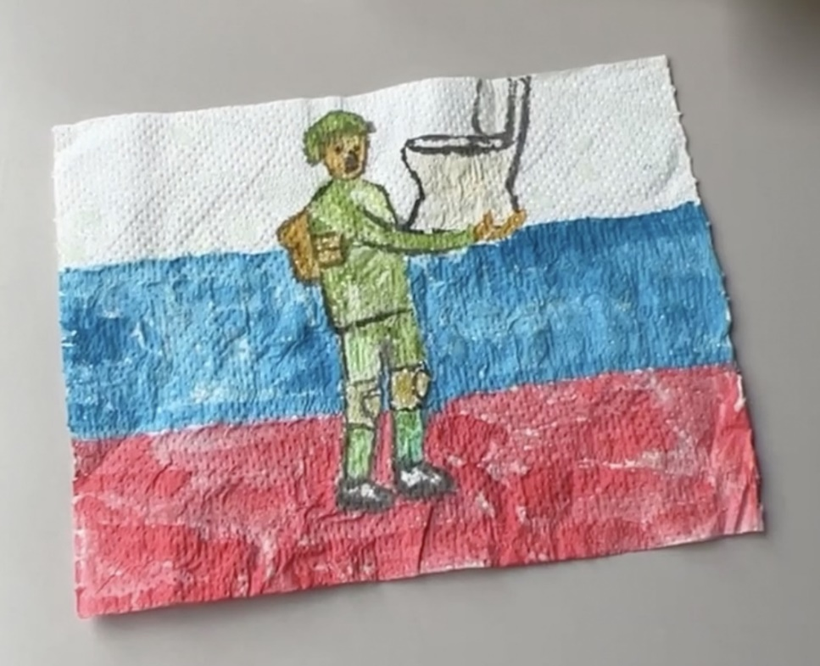

Trench art by Vasya Sai, 2022, watercolour on toilet paper Kleinman (2022)

Also, currently still in Ukraine theatre is still going on during the wars. 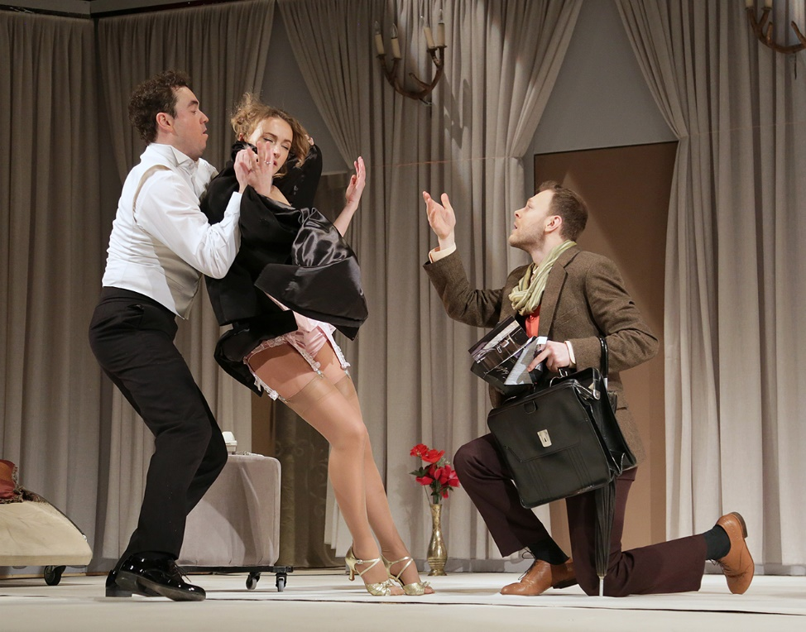

(Agabitova, 2023)
this brings us to economic and cultural value in the supply & demand of cultural commodities.

Could one of Art’s deeper purposes be to remind people of what people are here for? people will forget everyone very quickly after we die however, we go. all the jobs created by others and money brings perceived happiness until you’re not. People often turn back to something creative art or music for various reasons, to be creative may be a privilege to some, but more importantly, it could be said that doing something oneself in a way that nobody else will in an absurd way is the only thing you can do in this world that is truly free. The act of doing art can be liberating.

To help humans survive in the face of severe adversity. The ability to do something that one creates from one’s own mind hand voice or body and create something. The affinity to create something new in a world that has no rules only limited by one’s own imagination can be appealing in a box cutter world. Often there is stigma attached to the title artist perhaps why there are a lot of people of dabble but keep a day job for identity purposes. The individual creative vision that only one can see sometimes one fails to see.

The nature of the work, job, vocation or however one sees it also the age-old adage of the starving artist and how difficult it is to make a living where many people may consider it is not financially viable. Weather one goes their own way on a creative art endeavour or weather someone chooses to get the security needs from a regular 9-5 job,

it’s likely humanity need both artistic individual forms and capitalist regular type jobs due to the complexity of human existence today.
One thing for sure is there is no human culture or community that does not have a creative form of art in some way shape or form.
Sometimes we humans just exist and are operating doing what we think we must do going to our 9-5 jobs to get money to buy stuff that we probably could do without. but when we are taken aback by a piece of music, film, sculpture, or a painting it can be moving. To allow you to think and question something about yourself, the world and its surroundings in a different way creating perspective to reflect and contrast Art is a personal experience that can help to promote an individualism in the economy by pushing people to have their own opinions on subjects such as the Colston statue. Subsequently expression can be a catalyst to inspire people to do follow one’s own interests/ business or art alike. Art can affect people’s political, religious sexual or worldly views without trying to enforce it like a politician as they say a good teacher guides.

One of the phenomena in this world is that humans only have numbers as a measuring system most things in the world can be boiled down to a number even people have become a commodity weather it’s a like or a follow or a million-pound self-destructing Banksy painting. So, it begs the question why people measure something subjective in a quantifiable numerical way? The answer is that this is the system we have and there is no other quantifying measuring system but not many people investigate this or even consider it an issue as without an alternative it is just as interesting or useful as subjective art is.

Some of the bigger issues i.e., climate crisis even the world living costs have gone up and these larger issues often one solution is not the answer but a multitude of solutions in a certain direction.
Often many people value what makes logical sense above emotions or feelings. In this respect ration takes precedence over emotion for instance when things don’t stand to ration or reason people invariably put into a box of something or other that doesn’t make sense, and therefore has less use or value.
for example, a musician or painter who’s not making enough money but needing to pay the upcoming rent wouldn’t make sense to continue doing art or music full time especially if there was an eviction. Without getting a regular paying job many creatives don’t get regular enough payments so often rely on external work if not grants and bursaries, not to mention government benefits. Many creatives may be dwindling in the lower echelons of the economic breadline Jk Rowling, Oasis Ub40 Kt Tunstall just to name a few.

Why do some people say Art is work? – translation? Art has a value that is not yet met in this world? countable/uncountable?

The word work is like a chore, i.e., something that must be done regardless of personal interest. One difference between Art and work is people can put hard effort into their craft and art without it necessarily being a chore.

The point is that if we go with the art is work phrase then what is behind this used phrase? Art is of value Art deserves money? Because if we were to change the word art to building for instance or cleaning or waste collector then this would have a completely different meaning because those jobs already are valued monetary wise even as a beginner builder the jobs have a function that people pay money for. What is it that the people who say “Art is work” want? if its work do they want money or love/recognition and acknowledgement? Because having both may be confusing the matter and essentially asking for the penny and the toffee so to speak. Going with Art is work? Many would say the payment comes in being able to just do it, going back to the art as verb. But we all need to eat so could it be that trying to assign a quantitative value to artist’s work? Just like a bricklayer gets paid could and artist too get paid or even gifted goods.

What is the solution - valuing a physical environment, for creatives & arts.

Creating environments for artists could be a possible way to help give back something to individuals trying creative endeavours. If a space to make and create is not always available or if it’s the inspiration to connect with other likeminded individuals. To collaborate make something that could collectively bring other artists under one roof.

A creative workspace would be a great outlet for many people who want to make something but cannot for various reasons.
There are such schemes in places like berlin where Artists are allowed to stay in a place under an agreement weather that be some employment agreement or a freelance agreement but also there are such companies and schemes in the UK. Organisations like Creative Health Camden — Home and Artquest.org have already started places like this (Lydiate, 2009). Were an artist may have a creative workspace where others are there also to make and create.

could a functional type of Art be embodied into this space where small scale business are cultivated to make and create artisan type businesses. Handmade highly in demand as people just can’t wait to exit the virtual reality and enter the real world, get stuck in and do some craft/ pottery sculpting wood metal etc whatever it is that gets people stuck in to with something physical as the digital world of screens is so prominent and dominating humanity.

References

Adajian, T. (2018) The definition of art, Stanford Encyclopedia of Philosophy. Stanford University. Available at: https://plato.stanford.edu/entries/art-definition/ (Accessed: Feb 4, 2023).
Agabitova, M. (2023). Дамський кравець. (online) lesyatheatre. Available at: https://lesyatheatre.com.ua/ukr/plays/ladies_tailor#gallery-34 (Accessed 25 Jun. 2023).

Alan Bamberger (2019) Bartering Art - How to do it Right Trades, Exchanges, Taxes and more, Art Barter, Trade or Exchange Arrangements and Income Tax Requirements. Available at: https://www.artbusiness.com/barter.html (Accessed: February 24, 2023).

Alizadeh, A. (2019) ‘4,8,57,66’, in Marx and art. London: Rowman & Littlefield International.

BBC news (2022) Edward Colston Statue: Four Cleared of Criminal Damage, BBC News. BBC. Available at: https://www.bbc.co.uk/news/uk-england-bristol-59727161 (Accessed: June 26, 2023).

Cork, T. (2022). Colston 4 t-shirt signed by Banksy sells for £12,000. [online] BristolLive. Available at: https://www.bristolpost.co.uk/news/bristol-news/banksys-signed-colston-4-shirt-7149573 (Accessed 24 Jul. 2023).
Day, C., Parker, F.E. and Sharkey, P. (2014) Art as a verb. Caulfield East, Vic.: Monash University Museum of Art.

Dempsey. (2019). The Work of Art: Value in Creative Careers by Alison Gerber (review). Social Forces, 98(2), e44–e44.‌
Diaz, A. (2021) Artist sells invisible sculpture for over $18k, New York Post. Available at: https://nypost.com/2021/06/03/artist-sells-invisible-sculpture-for-over-18k/ (Accessed: 19 July 2023).

Encyclopaedia Britannica (2011, November 22). Mimesis. https://www.britannica.com/art/mimesis

Newfield, C. (2019) ‘The Trouble with Numerical Culture’ MLA Profession (Fall) Available at: https://profession.mla.org/the-trouble-with-numerical-culture/ (Accessed: February 22, 2023).

Forgeard, A.V. (2022) Why do societies need art and creativity to survive, brilliantio. Valerie Forgeard. Available at: https://brilliantio.com/why-do-societies-need-art-and-creativity-to-survive/ (Accessed: December 15, 2022).

GOV.UK (2020). UK’s Creative Industries contributes almost £13 million to the UK economy every hour. [online] GOV.UK. Available at: https://www.gov.uk/government/news/uks-creative-industries-contributes-almost-13-million-to-the-uk-economy-every-hour.

Heaf, J. (2020) Windrush Memorial artist: 'Marc Quinn's Jen Reid statue colonised the Colston plinth and hijacked the BLM movement. it's a con', British GQ. Available at: https://www.gq-magazine.co.uk/culture/article/marc-quinns-jen-reid-statue-thomas-j-price (Accessed: February 14, 2023).

Herberg, M. (2017). Is Netflix Destroying Our Culture? (online) The Oxford Student. Available at: https://www.oxfordstudent.com/2017/02/02/netflix-destroying-culture/.

HeroicImaginationTV (2011) Dangerous conformity, YouTube. YouTube. Available at: https://www.youtube.com/watch?v=vjP22DpYYh8 (Accessed: February 10, 2023).

Hess, M. (2005). Metal Faces, Rap Masks: Identity and Resistance in Hip Hop’s Persona Artist. Popular Music and Society, 28(3), pp.297–311. doi:https://doi.org/10.1080/03007760500105149.

Kleinman, A. (2022). On the front lines of Ukraine’s art world. [online] www.artforum.com. Available at: https://www.artforum.com/diary/on-the-front-lines-of-ukraine-s-art-world-88858 (Accessed 24 Jul. 2023).

Lydiate, H. (2009) Artists' residencies, Artquest. Arts council England. Available at: https://artquest.org.uk/artlaw-article/artists-residencies/ (Accessed: December 14, 2022).

McMullen, R.D. (2023) Jacques-Louis David, Encyclopædia Britannica. Available at: https://www.britannica.com/biography/Jacques-Louis-David-French-painter (Accessed: 23 June 2023).

McLeod, S. (2023). Maslow’s Hierarchy of Needs. (online) Simply Psychology. Available at: https://www.simplypsychology.org/maslow.html.

Mohn, T. (2021) ‘Gillian Wearing Has Turned Masks Into an Art Form’, The New York Times, 19 October. Available at: https://www.nytimes.com/2021/10/19/arts/gillian-wearing-masks.html (Accessed: 12 March 2023).

Nancy, J.-L. and Sparks, S. (2003). A finite thinking. Stanford, Calif.: Stanford University Press.

Nilson, Caroline (2013) ‘Creative Arts: An Essential Element in the Teacher’s Toolkit When Developing Critical Thinking in Children’. Australian Journal of Teacher Education. 38(1) accessed from https://www.researchgate.net/publication/267927747_Creative_Arts_An_Essential_Element_in_the_Teacher's_Toolkit_When_Developing_Critical_Thinking_in_Children

O’Rourke, J., 2022. The Dual-Factor Model of Creativity and its Relationship with Conformity (Doctoral dissertation, Dublin, National College of Ireland). available at https://norma.ncirl.ie/5673/1/jamieorourke.pdf (accessed at 02.2023)

Paul, T. (2022). ‘Famous anonymous artists who keep their identity hidden’ Prestige Available at: https://www.prestigeonline.com/sg/lifestyle/art-plus-design/famous-anonymous-artists-who-keep-their-identity-hidden/ (Accessed 4 May 2023).

Pritchard, D, Turri, J. and Carter, J.A. (2022) ‘The Value of knowledge’, Stanford Encyclopedia of Philosophy. Stanford University. Available at: https://plato.stanford.edu/entries/knowledge-value/ (Accessed: Jan 08, 2023).

Powell, N. (2022). Art and the weaponization of everything. Meer. Available at: https://www.meer.com/en/68496-art-and-the-weaponization-of-everything (Accessed : 4 May 2023)

Regelski, T.A. (2022) Musical Value and Paraxial Music Education. Action, Criticism & Theory for Music Education, 21(1). Available at:
http://act.maydaygroup.org/articles/Regelski21_1.pdf (Accessed: 12 January 2023)

Sample, I. (2018) ‘Neanderthals – not modern humans – were first artists on Earth experts claim ‘, The Guardian, 22 February. Available at: https://www.theguardian.com/science/2018/feb/22/neanderthals-not-humans-were-first-artists-on-earth-experts-claim#:~:text=More%20than%2065%2C000%20years%20ago,themselves%20through%20works%20of%20art. (Accessed: 12 January 2023)

Tapper, J. (2022). Huge decline of working-class people in the arts reflects fall in wider society. The Guardian. Available at:

https://www.theguardian.com/culture/2022/dec/10/huge-decline-working-class-people-arts-reflects-society. (Accessed: April 28, 2023).

Stanford Center for the study of language and information (2023) value, Stanford Encyclopedia of Philosophy. Stanford University. Available at: https://plato.stanford.edu/search/searcher.py?query=Value (Accessed: January 12, 2023).

theartstory.org (2013) https://www.theartstory.org/definition/art-for-art/#:~:text=The%20Swiss%20writer%20Benjamin%20Constant,his%20lectures%20of%201817%2D18., theartstory.org

trafft.com. (2023). Service Business Vs Product Business: What’s the Difference? [online] Available at: https://trafft.com/service-business-vs-product-business/ (Accessed 25 Jun. 2023).
Tolstoy, L. graf and Maude, A. (no date) ‘page 3’, in What is art? Project Gutenberg.

Value, Oxford Advanced American Dictionary at OxfordLearnersDictionaries.com. 2023 oxford university press. Available at:
https://www.oxfordlearnersdictionaries.com/definition/american_english/value_1 (Accessed: January 12, 2023).

Villa, A. and Villa, A. (2021). Infamous Self-Destructing Banksy Painting Returns to Auction. ARTnews.com. Available at: https://www.artnews.com/art-news/market/banksy-self-destructing-painting-sothebys-auction-return-1234602906/.

Webb, E. (2023) Art is eating itself, The Spectator. Available at: https://www.spectator.co.uk/article/art-is-eating-itself/ (Accessed: April 28, 2023).

Wilde, O. (2019). Lady Windermere’s Fan. S.L.: Blurb.

Zimmerman, M.J. and Bradley, B. (2019) Intrinsic vs. extrinsic value, Stanford Encyclopedia of Philosophy. Stanford University. Available at: https://plato.stanford.edu/entries/value-intrinsic-extrinsic/ (Accessed: January 10, 2023).

Images

Figure 1: Russeth, A. (2019) Is Maurizio Cattelan’s $120,000 banana sculpture a cynical sign of the times or a thrilling artwork? yes!, ARTnews.com. Available at: https://www.artnews.com/art-news/news/maurizio-cattelan-banana-basel-1202670910/ (Accessed: 19 July 2023).
Figure 2: Dafoe, T. (2021) An Italian artist auctioned off an ‘invisible sculpture’ for $18,300. it’s made literally of nothing, Artnet News. Available at: https://news.artnet.com/art-world/italian-artist-auctioned-off-invisible-sculpture-18300-literally-made-nothing-1976181 (Accessed: 20 June 2023).
Figure 3: Moya, J.M. (no date) Rainbow drawn by a boy with the message ‘stay home’ and symbol of..., Getty Images. Available at: https://www.gettyimages.co.uk/detail/photo/rainbow-drawn-by-a-boy-with-the-message-stay-home-royalty-free-image/1217131665?adppopup=true (Accessed: 19 July 2023).
Figure 4: Rice, V. (2023) Every banksy piece in Bristol and where to find them, BristolLive. Available at: https://www.bristolpost.co.uk/whats-on/music-nightlife/banksy-bristol-art-tour-map-449 (Accessed: 19 July 2023).

Figure 5: Graf, S. (2022). An Introduction to Activist Art. The Collector. Available at: https://www.thecollector.com/introduction-to-activist-art/.

Figure 6: Callen, C. (2022 a) Edward Colston statue: Four cleared of criminal damage, BBC News. Available at: https://www.bbc.co.uk/news/uk-england-bristol-59727161 (Accessed: 21 July 2023).
Figure 7Callen, C. (2022 b) Edward Colston statue: Four cleared of criminal damage, BBC News. Available at: https://www.bbc.co.uk/news/uk-england-bristol-59727161 (Accessed: 21 July 2023).

Figure 8: Emelife, A. (2020) ‘hope flows through her’: Artist Marc Quinn on replacing Colston with a black lives matter statue, The Guardian. Available at: https://www.theguardian.com/artanddesign/2020/jul/15/marc-quinn-statue-colston-jen-reid-black-lives-matter-bristol (Accessed: 22 July 2023).

Figure 9: Gant, J. (2020) Darth Vader figure is placed on plinth where slave trader Edward Colston’s statue stood, Daily Mail Online. Available at: https://www.dailymail.co.uk/news/article-9010471/Darth-Vader-figure-placed-plinth-slave-trader-Edward-Colstons-statue-stood.html (Accessed: 22 July 2023).

Figure 10: Booth, E.P. and M. (2020) Banksy’s idea for Colston plinth, Bristol24/7. Available at: https://www.bristol247.com/culture/art/banksys-idea-for-colston-plinth/ (Accessed: 22 July 2023).

Figure 11: Wall, T. (2020) The day bristol toppled Colston – and a nation began to search its soul, The Guardian. Available at: https://www.theguardian.com/uk-news/2020/jun/14/the-day-bristol-dumped-its-hated-slave-trader-in-the-docks-and-a-nation-began-to-search-its-soul (Accessed: 22 July 2023).
Figure 12: Whitehead sky news, D. (2022) Edward Colston Statue: Toppled artwork 'now worth £300,000' - 50 times its original value, Sky News. Sky. Available at: https://news.sky.com/story/edward-colston-statue-toppled-artwork-now-worth-300-000-50-times-its-original-value-12510440 (Accessed: April 26, 2023).

Figure 13: Cork, T. (2022) Colston 4 T-shirt signed by Banksy sells for £12,000, BristolLive. Available at: https://www.bristolpost.co.uk/news/bristol-news/banksys-signed-colston-4-shirt-7149573 (Accessed: April 27, 2023).
Figure 14 https://www.pinterest.co.uk/pin/218424650668869208/ (22,June,2023). Available at : https://pin.it/3fk4kua

Figure 15:Anderson, M. (2017). Designer Steven Harrington Creates a Skateable Pop-Up Sculpture Garden. (online) Eye on Design. Available at: https://eyeondesign.aiga.org/designer-steven-harrington-creates-a-skateable-pop-up-sculpture-garden/ (Accessed 24 Jun. 2023).

Appendix

Below are the results to a survey from the Multi activity hub I am working to start.
Do you have an appreciation for the arts, if so what types interests you more?
9 out of 10 people answered this question
music, making/ jamming listening
5 resp.
55.6%
visual/painting/graffiti
2 resp.
22.2%
craft making and creating
1 resp.
11.1%
dance theatre, drama
1 resp.
11.1%
design prints and materials
0 resp.
0%
film video making or editing
0 resp.
0%
sculpting, up cycling
0 resp.
0%
2
Have you ever worked or wanted to work within any of the creative industries
10 out of 10 people answered this question
no
4 resp.
40%
yes
4 resp.
40%
I'd like to
2 resp.
20%
working on something
0 resp.
0%
3
what do you not like about the idea of having a multi activity hub?
9 out of 10 people answered this question
I think its a good idea
8 resp.
88.9%
so so
1 resp.
11.1%
choice 4
0 resp.
0%
not a good idea, other concernrs state below
0 resp.
0%
4
on a scale of 1 to 10 how much or little do you think people could benefit with their mental/physical health to engage in communal spaces where people can practice either creative pursuits or mixed hobbies/activities?
Avg. 9.2
10 out of 10 people answered this question
0%0
resp.
0
0%0
resp.
1
0%0
resp.
2
0%0
resp.
3
0%0
resp.
4
0%0
resp.
5
0%0
resp.
6
10%1
resp.
7
20%2
resp.
8
10%1
resp.
9
60%6
resp.
10
5
What do you think the benefits are for having such a facility as a multi activity hub which could be inviting for a wide range of age groups
10 out of 10 people answered this question
good
8 resp.
80%
quite good
1 resp.
10%
so so
1 resp.
10%
maybe good but not for me
0 resp.
0%
not for me
0 resp.
0%
6
what physical activities/hobbies do you like t o do and or what would you like to try out
10 out of 10 people answered this question
skating, biking, scooting, any wheeled sports
4 resp.
40%
environmental pursuits
3 resp.
30%
choice 5
2 resp.
20%
any other sport/activity competitive or non competitive sport type below
1 resp.
10%
parkour slackline
0 resp.
0%
7
If you are for a community multi activity hub what would you like to see in it ?
9 out of 10 people answered this question
A variety of things that are not the same as other places. All affordable for anyone to go7 days ago
a communal space which is safe for all ages allowing people to get together without having to pay for anything and can do activities skating and more and work on projects too8 days ago
A safe place for any age group to connect, some sort of community meeting area8 days ago
Skate / scooter ramps8 days ago
A space for people to meet with suggested group activities to partake in (bike rides, art workshops etc)9 days ago
Street art workshops, poetry jams, grief circle, men's and womens circles, jams and music production workshops9 days ago
Art, music film & theatre, singing, music & dance workshops9 days ago
Strippers9 days ago
Something to bring people together to support their Mental health and well-being9 days ago
8
what could it mean to you to have people you like to associate and can mix with in a community doing different things that may not be drinking alcohol weather its a creative outlet or an activity of your interest?
Avg. 9.1
10 out of 10 people answered this question
0%0
resp.
0
0%0
resp.
1
0%0
resp.
2
0%0
resp.
3
0%0
resp.
4
0%0
resp.
5
0%0
resp.
6
0%0
resp.
7
40%4
resp.
8
10%1
resp.
9
50%5
resp.
10
9
do you think you could bring something that you are interested in i.e., hobby creative outlet/ activity sport or other to the hub for other people to engage in?
10 out of 10 people answered this question
Yes
6 resp.
60%
No
4 resp.
40%
10
Are you willing to contribute a bit of money towards this cause on a gofundme page when we establish a treasurer to save up for the land to buy to then create this multi activity hub?
10 out of 10 people answered this question
Yes
9 resp.
90%
No
1 resp.
10%

https://www.creativelyllc.com/blog/self-care-part-2-creative-hierarchy-of-needs7575581

https://www.psychologytoday.com/gb/blog/one-among-many/201309/maslow-creativity

https://www.youtube.com/watch?v=hyRpCa9Qv48

