Personnel Resourcing and Development (BMIH5005)

Title: “Impact of current challenges on the human resource department relating to Recruitment and Retention”
Research Project Proposal

Student Name: Samir Mohammed Abbas
Student ID: 2129296
Lecturer Name: Helen Evans, Emma Roberts

Table of Contents
Introduction 3
Background to the project 3
Background to Hilton 3
Challenges in Recruitment faced by Hilton 4
Challenges faced by Hilton in retention of employees 4
Literature review 5
Work of other Researchers 5
PESTLE analysis of Hilton 7
SWOT analysis of Hilton 9
Maslow's Hierarchy Needs 10
Evaluation and Conclusion 12
Conclusion 13
Reference list 14

Introduction

Background to the project
The hospitality industry presents unique challenges for human resource managers, particularly in the areas of recruitment and retention. The dynamics of the workforce, the level of competition in the industry, and the changing expectations of workers have all played a role in the decline (Armstrong, 2020). If they want to attract and retain the kind of top-tier workers who will be vital to the hotel's further growth, management teams need to be aware of and prepared to deal with these challenges. As the COVID-19 pandemic spreads, it becomes increasingly difficult for hotels to hire and retain workers. Due to shutdowns, reduced travel, and uncertain demand, layoffs and furloughs have been instituted. After a catastrophic event, human resources departments face new challenges as they attempt to rebuild the workforce and deal with rising employee expectations (Mick Marchington, 2020).

Background to Hilton
The industry of luxury hotels is led by Hilton, which is unrivalled among its competitors. The company was established by Conrad Hilton in 1919, and in the years since then, it has grown to become a dominant force in the hospitality industry all over the world. McLean, Virginia serves as the location of the headquarters for the internationally renowned Hilton hotel chain. The corporation is the owner of a number of well-known hotel chains, including Hilton, Waldorf Astoria, Conrad, Doubletree, and Hampton by Hilton, to name just a few of them (Hilton, 2023). This corporation runs one of the most extensive hotel chains in the world, which includes 6,500 individual hotels and 1.2 million guest rooms.
Hilton, as a market leader, has a diverse set of opportunities and threats. The increasing need for authentic and regionally relevant experiences among tourists is one reason, and the necessity to attract and keep top staff in a competitive labour market is another (Friedman, 2013).
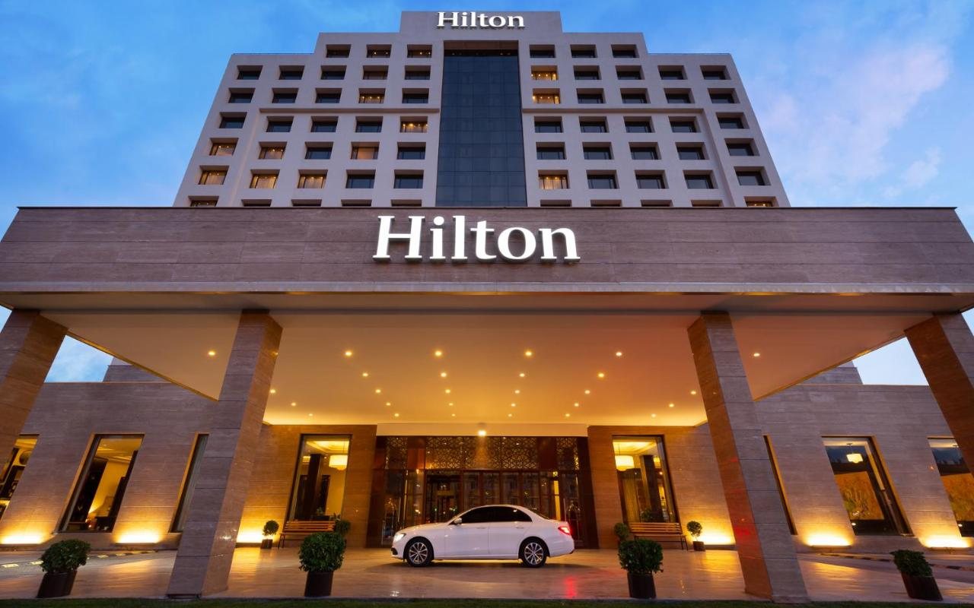
Figure 1: Hilton; Source: (Hilton, 2023)

Challenges in Recruitment faced by Hilton
In particular geographic areas or for some types of jobs, it may be challenging to find and maintain a qualified workforce. Large hotel groups like Hilton are always looking for talented new workers to keep up with their growing customer base. People move in and out of the hotel business a lot (Gallagher, 2022). High workloads, having to work extra hours, and holiday shifts can all make employees unhappy and, in the end, cause them to quit. It's possible that Hilton keeps more of its employees than other companies.

Challenges faced by Hilton in retention of employees
Like many other hotel businesses, Hilton has trouble keeping its employees. People often talk about how long and uncertain the hours are in the hotel business (Horn, 2009). Anxious workers can hurt both their work and their mood. Hilton might be able to make its employees happier and more loyal if it had policies like open hours and paid time off. Bonuses for great work are a great way to keep loyal workers working for you. Hilton needs to set up programs that give credit and money to the right people. Employees will be more loyal to their company if they see that their work is valued and appreciated. People are more likely to stay at their jobs if they like what they do there. Hilton must boost morale by fostering an environment of open dialogue and considering employees' suggestions. Issues that may be affecting employee retention can be identified and addressed with the use of surveys, regular feedback, and other chances for involvement (Jackson, 2020).

Literature review

Work of Other Researchers
Friedman (2013) states that the management of a firm's human resources, in particular recruiting and retention, is absolutely necessary to the success and continued existence of the company. Both aspects are critical for a business to address in order to keep its employees satisfied and maximize their output. The human resources manager is accountable for locating and recruiting potential individuals who possess the required level of education, experience, and abilities. The production of a firm and its standing in the market may both improve if the company hires employees who possess particular abilities. The invaluable contributions of long-term employees in terms of their knowledge, abilities, and experience to a business are indisputable (Redman and Wilkinson, 2021). If current employees are allowed to keep their jobs, the institutional knowledge of the organization will be transferred to newly hired employees and put to productive use.
Gerhart (2022) explains that because of developments in technology and the increasing prevalence of automation, certain sectors of the economy are grappling with a shortage of skilled workers. The department of human resources of Hilton requires assistance in discovering and recruiting people who are qualified to fill positions that are currently vacant. The human resources departments of companies can address this issue in a number of different ways, including allocating funds for staff training, establishing connections with nearby educational institutions, and fostering an environment that values continuous improvement.
Guerrier and Deery (2018) analyse that the unpredictability of the hospitality business, coupled with recent instances of disease outbreaks such as COVID-19, might contribute to an anxious atmosphere at the place of employment. As a direct consequence of this, people are more likely to look for work in other places. The retention rate of employees can be improved by human resource managers by placing a greater emphasis on the satisfaction of their workforce, implementing effective retention tactics, and encouraging a positive work environment.
Helms and Nixon (2022) explains that the trust of employees is tough to earn and maintain, but it is extremely rewarding for the leaders and managers who are successful in doing so. Significant levels of employee unhappiness and turnover may result for managers who are unable to communicate with and provide assistance to their workers in an appropriate manner. It is imperative that Hilton make investments in the form of training for its managers in people management, keep open lines of communication with its staff, and continually raise morale.
Horn (2009) analyses that in extremely competitive marketplaces, the value of a brand can skyrocket. Making Hilton a more appealing workplace should be the top goal of the HR department. Talk about the company's commitment to its principles and culture, as well as opportunities for growth and other perks. Even in tough economic times, a company with a solid "employer brand" can draw in and keep the best and brightest employees.
Inman, Nuala O'sullivan and Murton ( 2010) explain that Hilton needs to hire and keep hardworking, skilled workers to keep its high level of customer service and always go above and beyond what its guests expect. The quality of the staff has a direct effect on how much employees care about the customer. But the hotel's image and customers' loyalty could suffer if the service isn't consistent because of high staff turnover or a lack of basic skills. A business's growth and success depend on how well it can find and keep skilled workers.

PESTLE analysis of Hilton
To be successful in the highly competitive hospitality market, Hilton must first identify and evaluate the external elements that may have an effect on its business (Stavrou‐Costea, 2022).
Political Factors: If the political climate worsens or new regulations are enacted, it might affect Hilton's profitability. The company's bottom line and future growth prospects could be harmed by government support cuts, new laws or regulations, or the tightening of constraints that unfairly burden tourists (Jackson, 2020). The region's unrest and bloodshed could affect Hilton's profitability and operations.
Economic Factors: Hilton's prosperity depends heavily on the health of the economies in which its properties are located. There may be less need for business travel and hotel stays if the economy continues to struggle. Hilton's income and profits could be affected if currency exchange rate movements have an outsized effect on emerging market economies (Johnston, Clark and Shulver, 2012). Luxury hotel rooms and services may do better when tourists have more disposable income and are more willing to spend more.
Socio-cultural Factors: Revenue at Hilton could be impacted by changes in customer tastes and industry trends. The increasing demand for ecotourism, adventure tourism, and cultural immersion may have an impact on the hotel industry (Friedman, 2013). As the population ages and family arrangements change, the services and amenities that are most important to Hilton's target market may also evolve (Gallagher, 2022). Hilton's brand positioning and marketing efforts may be impacted by the growing importance of health and wellness, sustainability, and diversity and inclusion.
Technological Factors: The Hilton hotel could use some aid from modern technology to further enhance its service to guests. Companies can now better meet the needs of their customers thanks to developments in areas such as online booking, smartphone apps, artificial intelligence (AI), and data analytics (Mathis, 2019). There is stiff competition for Hilton from online booking platforms and smaller hotels like Airbnb. Increasing the availability of a company's goods and services on the internet is one way to boost both client loyalty and awareness of the brand.
Environmental Factors: Sustainable future ideas Consumers' sustainability awareness may change. If Hilton Hotel Group cares about the environment, it must change its business strategy (Stavrou‐Costea, 2022). Climate change threatens low-lying coastal Hilton hotels with harsh weather and increasing sea levels. The company's sustainability depends on management's ability to recognize threats and take precautions.
Legal Factors: Observance of Regulations, Company Procedures, and Safety Standards Hilton's foreign expansion is contingent on the company reaching certain targets. The cost of maintaining tabs on employees and running a business may go up or down depending on the amount to which these restrictions are eased or tightened. Copyrights, trademarks, and other forms of intellectual property are essential to Hilton's continued development and success (Tullar, 2022).
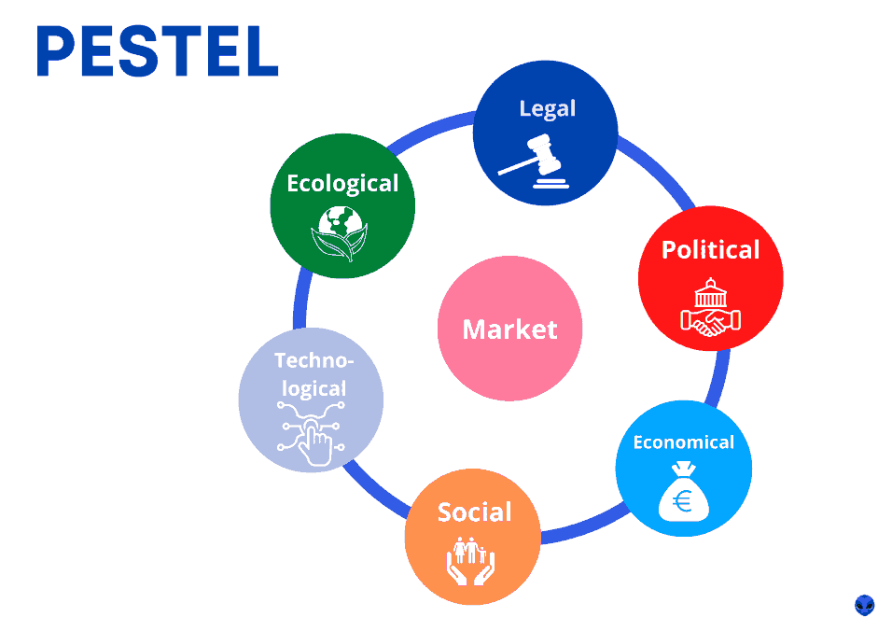
Figure 2: PESTLE Analysis; Source: (Johnston, Clark and Shulver, 2012)

SWOT analysis of Hilton
Hilton may gain a lot from conducting a SWOT analysis to improve its talent acquisition and retention efforts.
Strengths | Weaknesses
Brand reputation | Seasonal employment needs
Career opportunity | There is a lot of employee turnover in this industry.
Global operation | High cost
Training program | Unclear career pathway
Opportunities | Threats
Strong recruitment technique | Strong competition for recruiting talented employees (Formoda, 2021)
It has engagement Program | Political instability

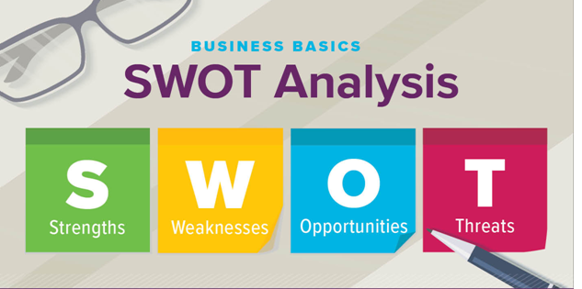
Figure 3: SWOT analysis; Source: (Keith Johnson, Harrison and Jordan, 2020)

Maslow's Hierarchy Needs
Physiological Needs: When staying at the Hilton, guests can expect immaculate accommodations, soft beds, and delectable cuisine. The accommodations at Premier Inn are always spotless, comfortable, and well-maintained (van Ours and Ridder, 2022).
Safety Needs: Guests' well-being must always come before everything else at a hotel. Hilton installs cameras, train staff, and mandate the usage of room locks to address this problem (Inman, Nuala O'sullivan and Murton, 2010). Guest education should include what to do during an evacuation.
Social Needs: Maintaining an accessible line of communication with your clientele is crucial. Hilton is able to provide a variety of common areas for its guests, such as restaurants and bars. Inviting guests to participate in events and activities enhances their time spent socially (Jackson, 2020).
Esteem Needs: The guests appreciate the staff's eagerness to help them so much. Hilton's friendly staff will always go the extra mile to satisfy guests (Wayne, 2020). Visitor satisfaction could be raised through the provision of tranquil spaces.
Self-Actualization Needs: The key to reaching one's full potential is to put time and effort into one's own interests, skills, and information (Mathis, 2019). Hilton is able to meet this need by giving its guests helpful information about the area, suggestions for fun things to do, and a safe, comfy place to relax after a day of sightseeing.
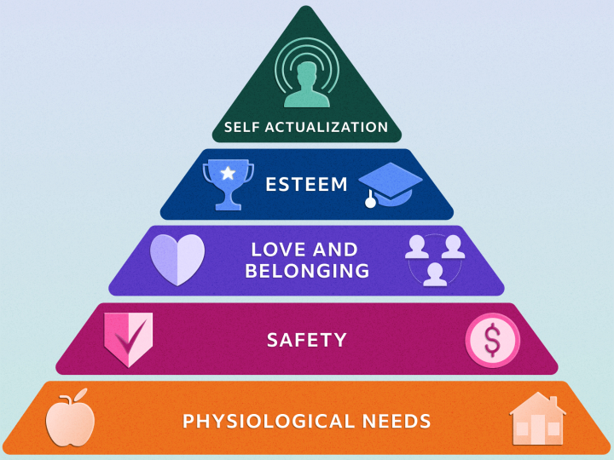
Figure 4: Maslow's hierarchy needs; Source: (Law, 2013)

Evaluation and Conclusion
Hilton is experiencing a high incidence of staff turnover in addition to a labor shortage, a skills gap, a generational shift in its personnel base, and an aging workforce (Wayne, 2020). The hotel's HR manager wants to think about the following solutions to the property's existing staffing problems:
Hilton may help its employees strike a better work-life balance by giving them the option to do some or all of their work from home, adjusting their work schedules, or working fewer hours per week (Formoda, 2021). Flexibility in meeting the demands of each employee will increase organization's prospects of attracting and retaining outstanding personnel.
Hilton must invest in its employees by providing them the opportunities to further their education and advance in the firm (Armstrong, 2020). To help employees grow in their careers, offer them chances to learn new skills and take on new responsibilities. It may raise morale and productivity in the workplace.
Staff members should have easy access to programs that promote mental health, work-life balance, and other forms of well-being. The mental and physical well-being of Hilton’s workforce will improve dramatically if it provides them with benefits like paid time off and flexible scheduling (Keith Johnson et al., 2020). True concern for workers can increase their satisfaction at work and their dedication to the company.

Conclusion
This investigation into the Premier Inn Hotel's Human Resources (HR) division examines the establishment's reactions to current personnel challenges. Because of these issues, Hilton Hotel has excessive turnover, a dearth of skilled personnel, and incompetent management (Jackson, 2020). Analysis of the Premier Inn Hotel using PESTLE, SWOT, and Maslow's Hierarchy of Needs is also presented. The challenges Premier Inn Hotel faces in attracting and retaining employees have been identified, and suggestions for improvement have been made.

Reference list
Armstrong, M. (2020). Armstrong’s Handbook Of Human Resource Management Practice. 15th ed. S.L.: Kogan Page.
Formoda (2021). Buy Ladder Online - Ladders For Sale Uk | Alton Industries. [online] Austen Group Ltd T/A Alton Ladders. Available at: https://www.customer1st.co.uk.
Friedman, A.L. (2013). Continuing Professional Development. Routledge.
Gallagher, K. (2022). Essential Study And Employment Skills For Business And Management Students. S.L.: Oxford Univ Press.
Gerhart, B. (2022). Review EssayThe growth of international human resource management. The International Journal of Human Resource Management, 19(10), pp.1989–1994. doi:https://doi.org/10.1080/09585190802324452.
Guerrier, Y. and Deery, M. (2018). Research in hospitality human resource management and organizational behaviour. International Journal of Hospitality Management, 17(2), pp.145–160. doi:https://doi.org/10.1016/s0278-4319(98)00017-6.
Helms, M.M. and Nixon, J. (2022). Exploring SWOT analysis. Journal of Strategy and Management, [online] 3(3), pp.215–251. Available at: https://doi.org/10.1108/17554251011064837.
Hilton (2023). Hotels by Hilton - Book the Best Rates Across All Brands. [online] Hilton. Available at: https://www.hilton.com/en/.
Horn, R. (2009). The business skills handbook. London: Chartered Institute Of Personnel And Development.
Inman, M., Nuala O'sullivan and Murton, A. (2010). Unlocking human resource management. London: Hodder Education.
Institute of Customer Service. (2023). Institute of Customer Service ⋆ Inspiring a Service Nation. [online] Available at: https://www.instituteofcustomerservice.com.
Jackson, T. (2020). The management of people across cultures: Valuing people differently. Human Resource Management, 41(4), pp.455–475. doi:https://doi.org/10.1002/hrm.10054.
Johnston, R., Clark, G. and Shulver, M. (2012). Service operations management : improving service delivery. 5th ed. Harlow: Pearson.
Keith Johnson, Harrison, L. and Jordan (2020). The British hotel industry. Verlag: Bristol: Jordon & Sons.
Law, H. (2013). The Coming of Age. Continuing professional development (CPD) information on the website of the Chartered Institute of Personnel and Development (CIPD)., 50(4). doi:https://doi.org/10.1002/9781118598276.ch2.
Mathis, R.L. (2019). Human Resource Management. Boston: Cengage Learning.
Mick Marchington (2020). Human resource management at work : the definitive guide. London, United Kingdom ; New York, Ny: Kogan Page.
Mick Marchington and Wilkinson, A. (2021). People management and development. Wimbledon: Chartered Institute Of Personnel & Development.
People Management. (2019). Home. [online] Available at: https://www.peoplemanagement.co.uk/.
Redman, T. and Wilkinson, A. (2021). Contemporary human resource management : text and cases. 4th ed. Harlow: Pearson.
Stavrou‐Costea, E. (2022). The challenges of human resource management towards organizational effectiveness. Journal of European Industrial Training, 29(2), pp.112–134. doi:https://doi.org/10.1108/03090590510585082.
Taormina, R.J. and Gao, J.H. (2022). Maslow and the Motivation hierarchy: Measuring Satisfaction of the Needs. The American Journal of Psychology, 126(2), pp.155–177. doi:https://doi.org/10.5406/amerjpsyc.126.2.0155.
Tullar, W.L. (2022). Theory development in human resource management. Human Resource Management Review, 1(4), pp.317–323. doi:https://doi.org/10.1002/hrm.10053.
van Ours, J. and Ridder, G. (2022). Job requirements and the recruitment of new employees. Economics Letters, 36(2), pp.213–218. doi:https://doi.org/10.1016/0165-1765(91)90192-n.
Wayne, R. (2020). Human Resource Management. 14th ed. Harlow: Pearson Education Limited.

