Project management for sustainability

  - Alexandra Olivia Safadi

Project management for sustainability
Alexandra Olivia Safadi
Assignment 1
Glenn Behenna

Contents

Executive summery
This report addressed the definition of a project manager (PM) including the roles involved within this position and the main aspects of a PM. Stakeholders were reviewed in depth including the benefits of a stakeholder-based approach. Risk management was addressed throughout the report and theories relating to each of the topics mentioned are included. Approaches to management are addressed in depth to justify what tool is most suitable for the majority of projects. Three tools are mentioned, Agile, waterfall and the PRINCE2 methodology. In order to grasp a true understanding of the tools, a table consisting of the benefits of each model is included to compare the three methodologies, alongside the lifestyle of a project.

Introduction
This report aims to critically asses the usefulness of tools and techniques for managing a project. Through evaluating approaches to project management (PM) and the different situations a project may be inclined to face, externally (PESTEL) and internally (SWOT).

Project management
A project manager (PM) involves people, processes and technology. An individual in this role is expected to communicate and collaborate affectively with employees. Being a PM involves huge responsibility and ability to take risky decisions, “Whenever you see a successful business, someone once made a courageous decision.” (Drucker, 2019)
Project management is generally known as, ‘the application of processes, methods, knowledge, skills and experience to achieve the project objectives’ (Association for Project Management, 2019). There are many interpretations of the term, due to its wide variety of tasks entailed. The role of a PM continuously changes due to changes in expectations, project growth and changed motives. A PM must stay current and move with change whilst listening to people rather than putting their own opinions before others. A favourable quote by theorist Peter Ducker emphasis that listening is a vital role in communication, “The most important thing in communication is to hear what isn't being said.” (Drucker, 2019)
As a PM, PESTEL and SWOT forces must be analysed in order to analyse risks and stakeholders.

Stakeholder
There are many attributes that fall into the role of a PM, one of these roles may be a stakeholder. A project contains people, known as stakeholders and the project goes through a life cycle also known as phases such as planning, analyse design, build test and implement from the start to the end of the project. A stakeholder definition, ‘parties with an interest in the execution and outcome of a project. They would include business streams affected by or dependent on the outcome’ (OGC, 2006).
Stakeholder management - A PM has to view their stakeholders and consider their skills to organise which ones are mostly important and which ones need to be dealt with first. A PMs ability to influence others is vital to further the success of the project, this is completed through good communication. This creates a successful organisation and project which links with Drucker’s statement, ‘organisations consist of people, people have relationships, it is the quality of the relationships that matter’ (Drucker, 2019). This statement supports that the positive influence of someone on another person is vital to create success.
Stakeholder analysis- there are stages in stakeholder analysis, it is important for a PM to Identify, Prioritise and Understand stakeholders in order to manage them successfully. This technique is used to identify and prioritise stakeholders in order for a PM to consider which objectives need to be completed first. The image below demonstrates the power and interest approach, once a PM has prioritised and identified the stakeholders PMs are then able to prioritise their duties.

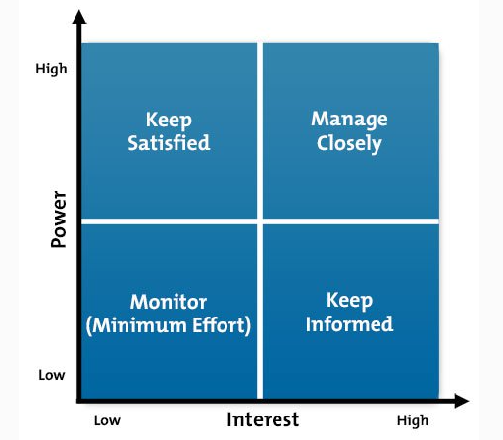Figure 1- power of interest (Thompson, 2019)

External stakeholder
External stakeholders are known as, ‘individuals, groups, and entities from outside that are affected by the consequences and outcomes of an organization's decisions’ (Boundless, 2015). An external stakeholder involves a variety of individuals. The following apply to the role of an external stakeholder… the suppliers, shareholders or trustees, the media, the general public and the end users of the product or service. PESTEL factors have the ability to affect the external stakeholders. For example, a technological barrier.

Benefits of a stakeholder-based approach
Opinion | PMs can use stakeholders’ opinions to develop the project and organisation. Opinions can mould the project at its early stages. Through considering opinions, stakeholders will feel valued whilst their input has potential to benefit the project.
Support | If a powerful stakeholder supports a PM, other stakeholders may also support the project
Communication | Through identifying and understanding stakeholders, PMs are reassured that stakeholders understand what is expected of them whilst understanding the positives of the project. Resulting in stakeholders supporting the PMs decisions.
Anticipation | PMs can anticipate individuals’ reactions to the project, and create a support network.

Risk management
Time, cost and quality could potentially be affected by the progress of a project due to a limited number of resources and factors changing externally and internally involving the corporation. Risks must be analysed and prioritised in an order of high, medium and low and a PM must then manage the risks.

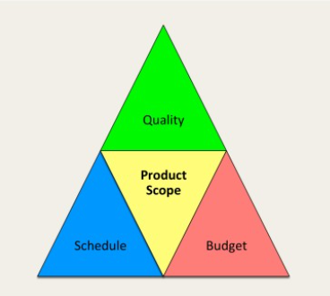Figure 2- “Golden triangle” (Warner, 2019)

Main aspects of a Project Manager
The key requirements for a successful PM are their willingness to be dynamic. For example, in a situation where their business objective is able to create more success if changes are implied, the PM must be open to put the company before any attachment to their business plan. Planning affectively is an important aspect, Douglas McGregor suggests that, “An objective without a plan is a dream”. (Armstrong, 2011) PM’s are relied on by colleagues for guidance and to be a positive influence to create an atmosphere that encourage positivity and innovation. A business plan allows future aims regarding the business to be mapped out clearly so that employees know what the goals are and what their role in their position implies. A plan is also known as a method of achieving an end goal, “Written account of intended future course of action aimed at achieving specific goals or objectives within a specific timeframe” (Armstrong, 2011)
Communication creates a healthy working environment. If a PM is a successful communicator, they are able to share their thoughts which is vital when finalising deals, creating opportunities and solving issues. Once communication is performed correctly, decisions can be implemented involving costs which leads on to the next vital attribute.
Measuring costs, businesses asses figures continuously but the importance of analysing which costs are relevant is important to avoid wasting time. (Woodruff, 2018)
A PM must manage time affectively to ensure that the most is completed to benefit the organisation within the working schedule. PMs may choose to allocate specific hours to staff to complete tasks in order of importance to ensure that the more important jobs are completed within their time frames. “there is nothing so useless as doing efficiently that which should not be done at all” (Drucker, 2019)
A PM is expected to give clear instructions to employees which creates an organised corporation. Without organisation corporations are unable to set clear goals. Clear goals allow employees to understand what is expected for them to complete.
A PM must be flexible by considering individuals targets whilst also managing their targets within the business. Obstacles may interfere and managers must be prepared for these obstacles whilst being open to changing goals throughout the projects journey. Secondly, PMs need to be dynamic with colleagues. For example, if a colleague needs time off a PM must be considerate regarding employees’ private lives whilst still managing their team. Drucker states that, ‘people have relationships, it is the quality of the relationships that matter’. (Drucker, 2019)
It is vital for a PM to communicate properly with their employees as it creates a positive environment. ‘When employees are satisfied with their jobs, they are able to efficiently perform their duties with a positive attitude.’ This supports the importance of people skills. (H, 2015)
PMs need to stay current with technological changes through society to ensure that their staff are up-to-date to keep up with customers and to give the corporations as many opportunities to thrive as possible. It is vital to stay flexible with the change as the future is unknown therefore some changes cannot be predicted but PMs must be open to the potential changes.
In terms of technology development (VUCA) volatility, uncertainty, complexity and ambiguity these terms all fall into personal life and the professional life. The term refers to the process of pace change throughout life. Professionals suggest that pace is changing rapidly, potentially driven by technology. Experts suggest that the pace (specifically technological pace) is going faster therefore the technological skills that individuals learnt in the past are becoming less useful and people skills are becoming more useful.
Projects face change, Theorist Kurt Lewin and Kotter both address ways in which to manage change in alternative ways which may be helpful to a PM.
Lewin created a three staged model known as unfreezing, change, refreeze model which involves past learning being replaced. Lewin suggests that managers implement changes and re direct tasks but changes can only be made if other individuals support and act upon them. According to Morrison, ‘the current practices and processes have to be reassessed in order for the wheels of change to be set in motion’. When corporations have been operating for a period of time they begin to operate in specific ways although stakeholders or others involved in the corporation may not be performing to the right standards. For example, employee habits. (Morrison, 2014)
Lewin (1947), ‘A change towards a higher level of group performance is frequently short-lived, after a “shot in the arm”, group life soon returns to the previous level. This indicates that it does not suffice to define the objective of planned change in group performance as the reaching of a different level. Permanency of the new level, or permanency for a desired period, should be included in the objective.’ (Morrison, 2014)
In contrast, Kotter further developed Lewin’s theory into an 8-step model where employees adopt changes after the manager has outlined the urgency for the change.
Kotter focusses on the planning to create temporary ‘wins’ which keep employees passionate and interested in the change happening. Kotter believes that to create future success changes must be made through strengthening the advantages for employees. (Mulholland, 2017)
Both theories include change in the environment and how individuals should deal with these changes.
Below is a table demonstrating the advantages and disadvantages of both theories.
Comparing the two theories
 | Advantages | Disadvantages
Lewin´s 3 step model of change | - Creates a visual summary of factors that support change  - Expands the evaluation further than data in order to analyse qualitative factors that may have an impact on the success or failure of changes being made. | - Doesn’t consider employees feelings  - Conflict as employees may be motivated by change whilst forgetting about the employees, they work with  - Requires participation from everyone  - could be considered as unrealistic as everyone needs to participate  - potential division in the workplace.
Kotter´s 8 step model of change | - Provides easy steps of guidance  - Emphasis on the preparation and acceptance of the change rather than the change  - ‘winning’ over employees for success  - fits into classical hierarchy- allowing individuals to meet their needs to progress in life. For example, esteem needs and allowing individuals to feel as if they are working towards benefiting themselves.  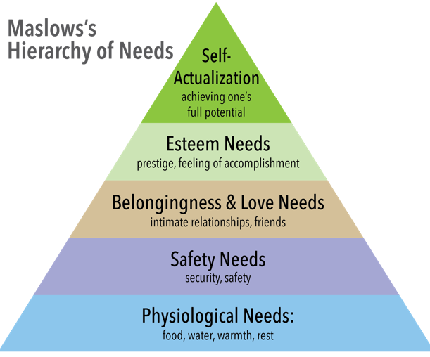Figure 3- Hierarchy (Maslow's Hierachy of Needs, 2017) | - Stages can’t be missed  - lengthy time frame for stage completion  - ‘Top-down’ theory, doesn’t encourage cocreation  - conflict if individual needs aren’t considered
(Mulholland, 2017)

Approaches to project management
Each project is unique therefore it is necessary to consider a few PM approaches for managing projects in the business industries. In this section, the waterfall approach, agile and PRINCE 2 will be discussed.
PRINCE2
‘Prince2 provides a systematic way to execute a project. This approach ensures that you meet the project goals in a logical, systematic, and organized manner.’ (Sharma, 2019)
PRINCE2 is one of the main methodologies involved in Project management. PRINCE2 aids in directing, managing and organising projects. PRINCE2 is a tool created by the UK government, used by project managers to complete projects within a time frame. This methodology involves a structure, PRINCE2 illustrates that projects must have a controlled and organised start, middle and end.
This tool involves procedures for phases within a project. The procedures are completed by employees in specific roles of the corporation. The roles involved are:
- A PM- In PRINCE2 this role involves distributing activities, producing a plan, making sure tasks are completed within the time frame. The responsibilities are alike the roles of a PM in other methodologies that have already been discussed. The main contrast is that in PRINCE2 a PM reports on project status to the project board. The project board understands the characteristics of the users, customers and suppliers involved in the organisation. The project board deal with issues that the PM arises.
- Customers- individuals involved in creating revenue for the project.
- User- individual or corporation that use the creation of the project.
- Supplier- corporation or individual involved in making the projects outcome.

The roles in the Prince2 project apply the following processes:
- Directing a Project
- Starting up a Project
- Initiating a Project
- Managing Stage Boundaries
- Controlling Stage
- Managing Product Delivery
- Closing a Project
(Sharma, 2019)
PRINCE2 methodology creates a mutual language between everyone involved in the project. PRINCE2 identifies the importance of projects breakpoints and controls. Which creates success of a project in contractual framework. Projects consist of cycles, these cycles have potential to change due to external and internal factors. PRINCE2 consists of methods which power the effects of changes in order to stop projects from deterring. (PRINCE2.COM, 2019)
Agile
There are different tools that can be used to manage an agile project. Agile creates and distributes work in ‘short bursts’ for up to a couple of weeks. These are then reiterated to clarify the ‘working deliverable’ pending to meeting customers’ needs and wants.
A traditional approach to PM demonstrates a plan and requirements during the beginning of a project. Whereas Agile begins with a basic plan of what is necessary and provide something within a small period of time, whilst making clear the needs as the project develops. One of the main features of Agile are frequent interactive processes which creates an interactive relationship between team members and stakeholders.
The role of PM is different in agile projects. A PM in an Agile project is an individual that deals with issues and manages interruptions to ensure that staff are able to concentrate on completing the work.
Agile projects must have documentation, reviews and processes as any projects do in order to meet targets, control costs and schedules, deliver benefits and avoid scope. In comparison to waterfall, Agile doesn’t highlight importance of in-depth documentation and also doesn’t aim to fully grasp all of the customers’ needs before the project can start. Alternatively, Agile highlights the value of producing an active product and adjusting it until it that meets client’s needs. The key measure of project progress is this series of working deliverables.
This is risky as the project would begin before the extent of work needed is estimated.
Agile PM is the process of which projects can be managed and implemented in small ‘chunks’ of work. Agile projects deliver value to the business in frequent small deliveries of product called features. In contrast to the waterfall methodology, where the requirements of the project would be documented upfront, then the design of the whole solution would be completed followed by the development, testing and implementation of the product.
With Agile, items are created with small logical chunks of work called ‘sprints’. Agile is a great technique to use when business needs are frequently changing or when the business wants to receive product benefits earlier. With agile, a PM is able to focus on what the business needs now and if that changes, the new business needs can be accommodated in the next generation. Agile is frequently used to manage IT projects but can also be used to manage non-IT projects. Examples of non-IT projects that are suitable for agile are facility moves, company reorganisation or changing business processes within a department. Almost every project is able to use agile if deliverables can be produced and implemented in a short period of time and can be expanded or added to with future capability.
Characteristics of agile projects-
- Sprints last 4-12 weeks
- Face to face communication is emphasised over documentation
- Business and technical team members are co located
- A sponsor who is committed to the agile process
- Requirement change anticipated and accommodated
There are other items that are crucial in an agile project that do not differ from traditional projects, these include-
- Having a vision for the end result
- Following a universally understood project lifecycle
- Requirements must be understood
- Shared and managed schedule
- Dedicated team focusses on the project
- Communication with all stakeholders is critical
Agile project management has its disadvantages such as less easy identification of project risks and poor management of resources, and many project teams don't understand how to use agile project management effectively. However, with the fast pace of business change in the 21st century many projects need to be sure they will deliver something that meets client needs at the end of the project and not expend wasted effort refining requirements that will be out of date by the time the end-product is delivered.
Even in business environments that do not change rapidly it can be difficult to fully articulate requirements without seeing a tangible product first so there is still the risk of delivering something that doesn't quite meet the client's needs. That is why agile is becoming increasingly necessary for many different types of projects. (Naybour, 2015)

Waterfall
The waterfall methodology is a common choice for software development.
Waterfall is sometimes referred to as the traditional tool of software development. This methodology began in the 1950s alongside the software development industry. history of its creation was straightforward, a tool suited to hardware development was then applied to the ‘new-born software development industry’.
The Waterfall approach focusses on 3 concepts-
- low customer involvement. Waterfall requires teams involved in the project to conduct 2 meetings with the buyer. The first is conducted prior to the project, the second is conducted once the project is complete.
- Strong project documentation. At the start of a project, demands of the consumer are documented. The work conducted by the team is focussed on this documentation. At the design stage further documents are developed. It can be challenging to manage, although Waterfall developers must complete this in order to formulate quality software.
- The sequential stages. Waterfall projects have numerous phases that must be conducted in order. The ‘traditional Waterfall model’ involves five stages. Other modern projects consist of seven stages. A disadvantage of this structured tool is the lack of flexibility. For example, it is challenging to return to a prior stage when the stage has been completed.
The other methodologies focus on building charts and creating work flow. A Waterfall chart is a project not just used in software but also used in administration of financial factors. (Sergeev, 2016)

A comparison of the benefits of each methodology
Through comparing the benefits of each methodology, a consensus can be made to which is best suited to the majority of projects.
Comparing the benefits of each methodology
PRINCE2 | Agile | Waterfall
• Applies to any project  • effective communication  • greater control on the plan by regular reviews of project progress  • stakeholders' engagement before it’s too late  • offers management greater predictability for management of change.  • promotes learning and continual improvement in companies. | - Protection of the deadline  - Up to date requirements  - Agile can be used on any type or sized project  - Provides structure whilst still enabling fast pace and change.  - Delivers projects on time and on budget whilst protecting the quality of the final deliverables. | - Simple and easy to understand and use  - Easy to manage due to the rigidity of the model  - Phases are processed and completed one at a time  - Works well for smaller projects where requirements are well understood  - Documentation produced at each phase  - Documentation available at the end of each phase  - Identifies deliverables and milestones

Life cycle the stages or process of the project
A project has a journey, a PM leads the journey from the start, middle and the end. Within the journey there are phases such as initiation, plan, execution, monitor and control and project close. These phases are also known as life cycles or the process that a project must go through. The life cycle of the project will vary due to the critical path. The critical path is the longest path is a key tool that PMs use to understand a project. (Stricker, 2018)

Conclusion
A PM is responsible for many tasks within an organisation. One of the main responsibilities of a PM is managing tasks, risks and people. Organisations face changes and a manager must be dynamic and open to adapting these changes. Kotter and Lewin both assess changes within an organisation. Each organisation is different therefore it is paramount to assess Agile, Waterfall and PRINCE2 as one may suit an organisation more than the other. Through analysing the benefits of each tool, PRINCE2 Seems to be the better suited tool as it addresses more potential outcomes. PRINCE2 allows PMs to recognise individuals that should be involved in the project and what their roles involve. The tool provides a set process for individuals to complete within a project whilst recognising that all individual team members must be involved in order to create a successful project.

