Name:Jake Havard

Student Number: 2517155

WORKSHEET 3 – TESTING (Chickens)

- Original code:
[Copy and paste your original code from Moodle into this box. Do not change it.]

eggneeded = 2
print("1: Normal food")
print("2: Supper food")
food = input("What sort of food?")
if food == "1":
eggsperday = 1
if food == "2":
eggsperday = 1.5
else:
print("Try again!")
dayslaying = int(input("how many days have your chickens been laying eggs?"))
if dayslaying <= 0 or dayslaying >14:
print("Woah!. Please enter a valid amount of days!")
if dayslaying >=1:
cakesdone = dayslaying * eggsperday // eggneeded
print(dayslaying, " Days! That's", cakesdone, "Cakes!")
else:
print("Try again!")

Code Testing

For each test below, run your code and enter the values provided. Provide a screenshot of what happened when the programme ran. Did the programme behave correctly or did it do something unexpected? Fill in a box for each test below. You should present 8 separate boxes, 1 for each test. (Note: the first box is provided as a template)

Normal food
i. 4 days (should be 4 eggs = 2 cakes)
ii. 9 days (should be 9 eggs = 4 cakes)
iii. -3 days (no cakes or error handled)
iv. 10000 days (program should catch the error – many of these eggs would be bad!)

Superfood
v. 4 days (should be 6 eggs = 3 cakes)
vi. 5 days (should be 7 eggs = 3 cakes)
vii. 1 days (should be 1 egg = 0 cakes)

Test your menu
viii. What happens if you enter “3”?

Test:
Normal food i) 4 days

Screenshot(s) of output: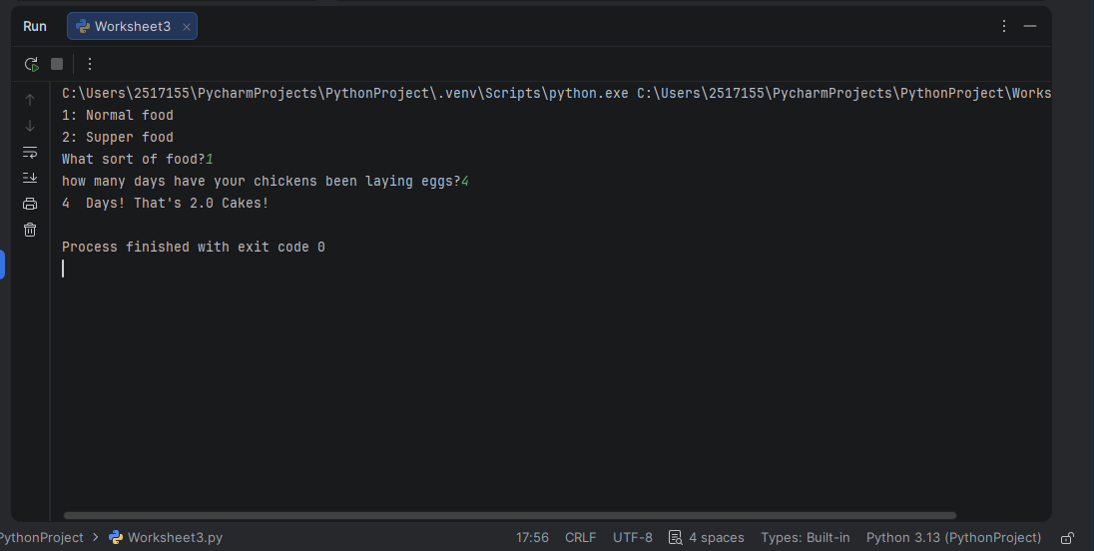
When you say that you feed your chickens normal food and they have been laying for 4 days then it comes back with the correct output of 2 cakes.

Result: Did the program behave as expected ie syntactically and logically correct?
YES/NO (delete as appropriate)

If NO, what problems were encountered and why? Suggest how things could be improved.

(Copy and paste box above for each of the rest of the tests)
Test:
Normal food ii) 9 days

Screenshot(s) of output:
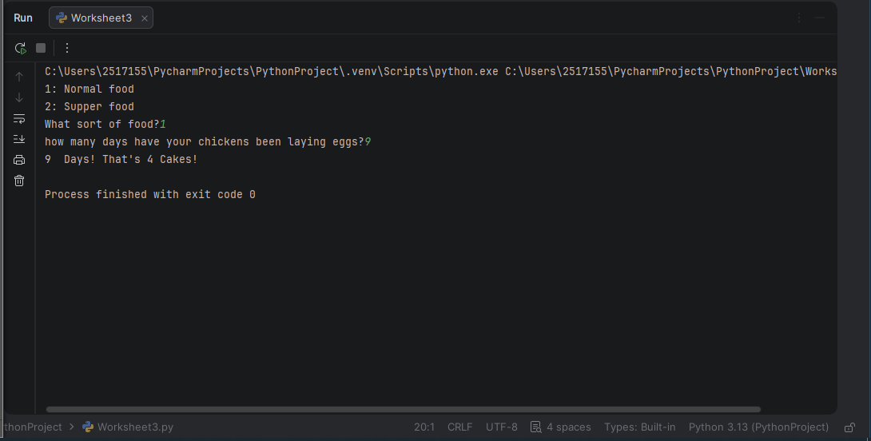
Result: Did the program behave as expected ie syntactically and logically correct?
YES/NO (delete as appropriate)

If NO, what problems were encountered and why? Suggest how things could be improved.

Test:
Normal food iii) -3 days

Screenshot(s) of output:
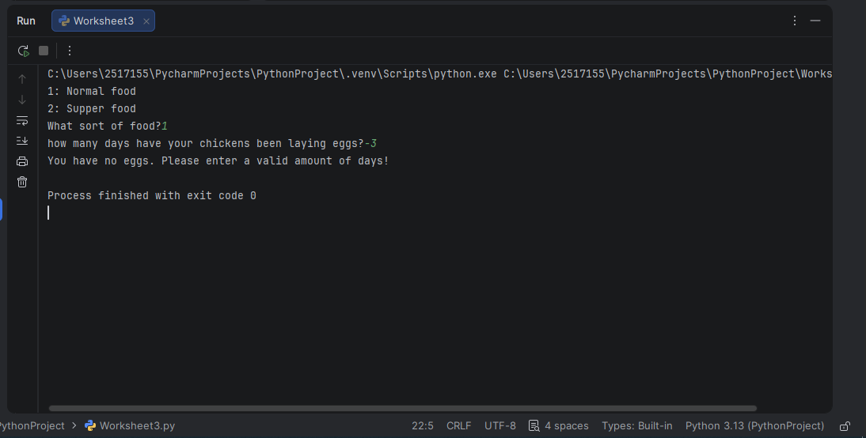
When entering -3 days, it returns an error message telling you to enter a valid amount of days.
Result: Did the program behave as expected ie syntactically and logically correct?
YES/NO (delete as appropriate)

If NO, what problems were encountered and why? Suggest how things could be improved.

Test:
Normal food iv) 10000 days

Screenshot(s) of output:
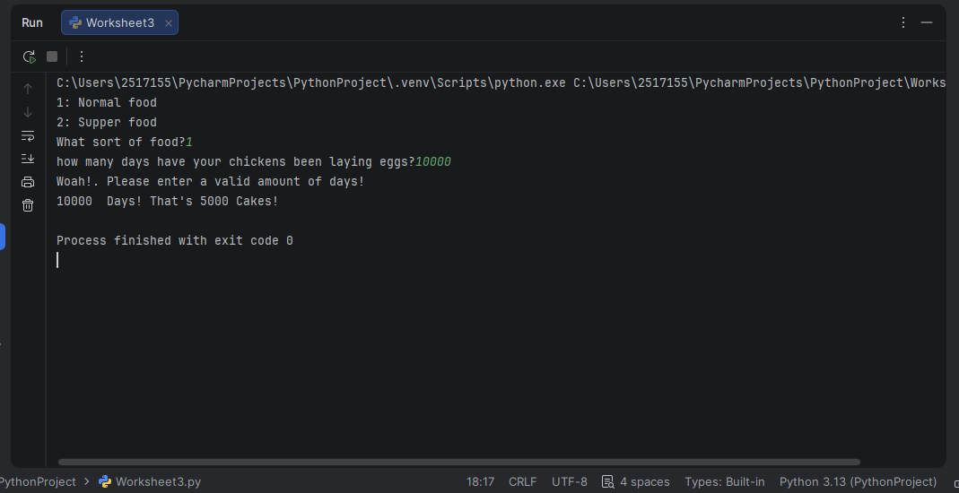
Result: Did the program behave as expected ie syntactically and logically correct?
YES/NO (delete as appropriate)

If NO, what problems were encountered and why? Suggest how things could be improved.

Test:
Superfood v) 4 days

Screenshot(s) of output:
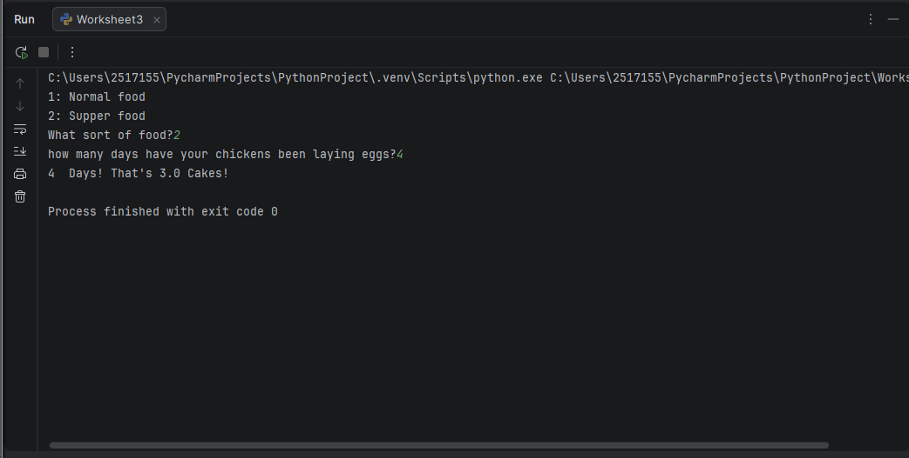
Result: Did the program behave as expected ie syntactically and logically correct?
YES/NO (delete as appropriate)

If NO, what problems were encountered and why? Suggest how things could be improved.

Test:
Superfood vi) 5 days

Screenshot(s) of output:
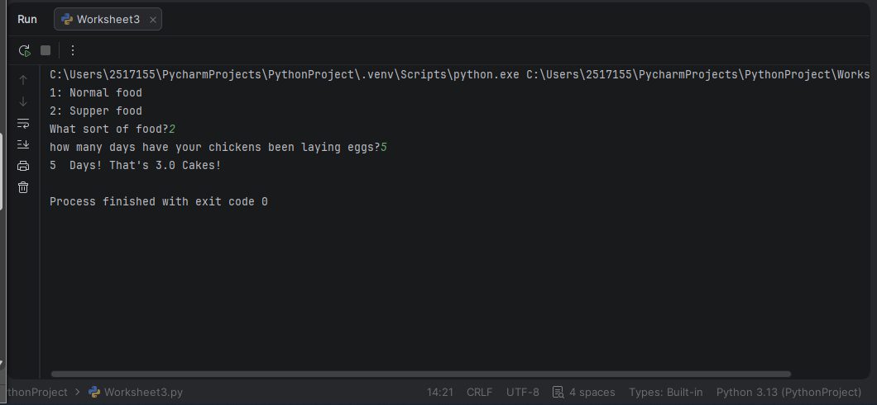
Result: Did the program behave as expected ie syntactically and logically correct?
YES/NO (delete as appropriate).

Test:
Superfood vii) 1 day

Screenshot(s) of output:
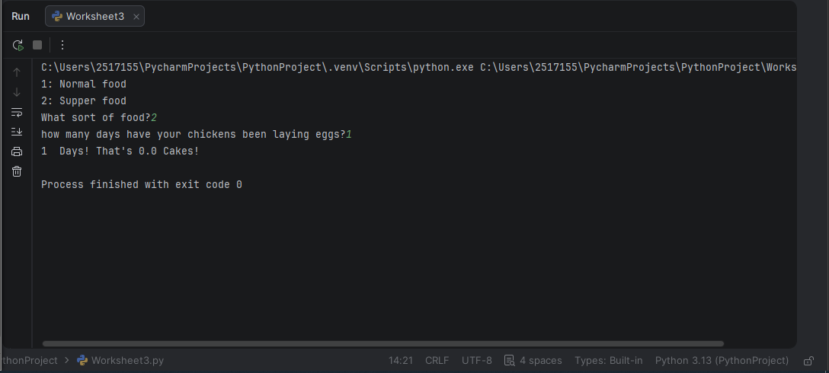
Result: Did the program behave as expected ie syntactically and logically correct?
YES/NO (delete as appropriate)

Test:
Superfood viii) Menu test
Screenshot(s) of output:
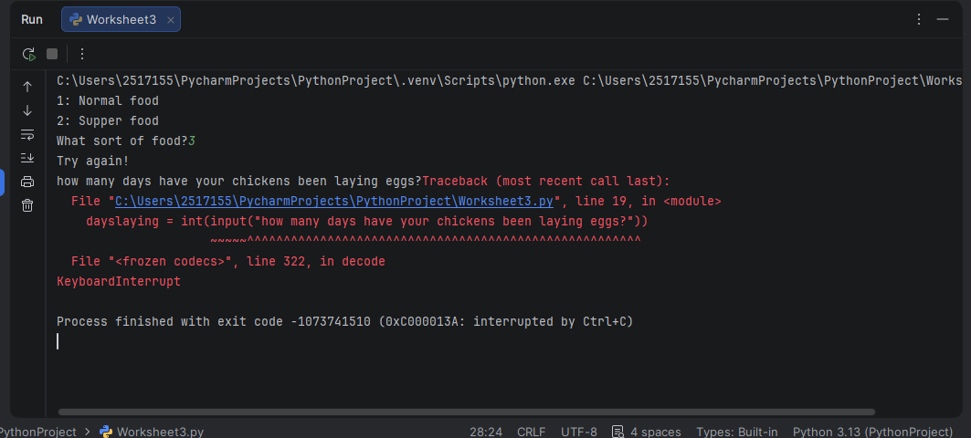
Result: Did the program behave as expected ie syntactically and logically correct?
YES/NO (delete as appropriate)
When entering 3 into the menu, it does display the “Try again” error message but it does still carry onto the next question, which isn’t correct.

- Consider the results of the above tests and revisit your original code in order to address the tests that failed. (Note: you may not be able to solve all of the problems that were originally encountered, but solve as many as you can.)

Paste your full revised code here :

[Copy and paste your full revised code here – note, do not use a screenshot]

eggneeded = 2
print("1: Normal food")
print("2: Supper food")
food = input("What sort of food?")
if food == "1":
eggsperday = 1
if food == "2":
eggsperday = 1.5
else:
print("Try again!")
dayslaying = int(input("how many days have your chickens been laying eggs?"))
if dayslaying <= 0 or dayslaying >14:
print("Woah!. Please enter a valid amount of days!")
if dayslaying >=1:
cakesdone = dayslaying * eggsperday // eggneeded
print(dayslaying, " Days! That's", cakesdone, "Cakes!")
else:
print("Try again!")

