
APPENDIX GA36a

LEVEL 4 ASSESSMENT SPECIFICATION
Student name: | Gavin Witte | Student ID number: | 1801206
Programme: | BA Youth Work and Social Education
Module: | Youth Work Practice 1: preparing the workforce
Module code: | ECYW4006 | Contribution to Overall Module Assessment (%): | 80%
Lecturer: | Alana Enoch | Internal Verifier:
Assignment Title: | Placement Portfolio | Word count (or equivalent): | 3009
Submission deadline: | 22/06/2003 | Return date of provisional marks & written feedback:
Submission method: | All written assessments, where practical and possible, must be submitted via Turnitin unless otherwise instructed by the Lecturer. (Please DO NOT put this assessment specification into Turnitin or it will match many similarities with other students’ submissions.)  Alternative submission method (if applicable):  Late submission of the assessment will result in a late penalty mark. Penalties for late submission: Up to one week late, maximum mark of 40%. Over one week late, 0%. Only the Extenuating Circumstances Panel may approve a change to submission dates.
Academic honesty / referencing: | Academic honesty is required. In the main body of your submission you must give credit to authors on whose research and ideas your work is based. Append to your submission a reference list that indicates the books, articles, etc. that you have used, cited or quoted in order to complete this assessment.

ECYW4006 Fieldwork
Introduction
This portfolio has been written following completion of a 200-hour placement with the Ceredigion Community Youth Work and Preventions Team (CCYWPT). The portfolio consists of three main components which are an observation and evaluation of the placement provider, a community profile and a summary of learning which took place and areas for further development. The observation and evaluation section will look at the structure of CCYWPT, what they do and some points to consider. The community profile focuses areas of employment, youth provision and transport amongst others in Ceredigion as this is the wider area that CCYWPT cover. To conclude the portfolio, a summary of learning is included and examples of how identified learning needs can be met in the future.
Observation and Evaluation
Ceredigion Community Youth Work and Preventions Team (CCYWPT) is a small team made up of eleven members of staff. It consists of one Team Manager, one Team Coordinator and nine youth workers six being full time and three working on a part time basis.
The team predominantly split the provisions into three areas of support; Outreach and Post 16, Preventative youth work and youth clubs and mobile provision.
Referral Process
Agencies and individuals are able to refer to the CCYWPT via a referral form. All referrals are received and undergo a screening panel where referrals are then allocated to the appropriate team and youth worker. As Ceredigion is a large rural county this is often done geographically, the County is split into three sections: North, Mid and South. Allocated youth workers then make initial contact with young people and decide on best provision with them.
Outreach and Post 16
Young people who are referred to the service who are over 16 are often those who are not in education, employment, or training (NEET). These young people have a variety of opportunities offered to them by CCYWPT.
The Inspire Project is a provision that runs in two locations within the county (Aberaeron and Aberystwyth), it offers group support to young people who are not yet ready to enter the world of employment or training for various reasons including low self-esteem and mental health issues. Some interventions offered through the inspire project include, volunteering opportunities through organisations such as the National Trust, Photography workshops and confidence building around employment such as CV writing and interview skills.
Boys and Girls groups are groups that are aimed at like-minded young people are run by same sex staff. They are designed to empower young people. Youth workers promote positive role models as often the young people who attend these groups have lacked positive male or female role models.
Individualised support is offered to young people on a one-to-one basis to work on specific needs where group work may not yet be appropriate. The youth worker and young people collaboratively create Intervention Plans with SMART (Specific, Measurable, Achievable, Realistic and Time Framed) goals to help the young person reach their full potential. These goals are reviewed and adjusted as needed every six weeks.
CCYWPT works effectively in engaging young people at post 16. Youth workers are able to build relationships with young people to work with them collaboratively and therefore establish which provision best suits their needs and their strengths. This also helps to empower young people to make informed choices for themselves and build confidence in themselves and the skills they have to offer (Jeffs & Smith, 2010).
The outreach work that CCYWPT does ties in with the Youth Work Strategy for Wales (2019) by engaging with young people aged 16 to 25 who may find it hard to access services due to being NEET (Welsh Government, 2019).
Preventative Youth Work
Three youth workers engage with young people who have been identified as being at risk of anti-social behaviour, committing crimes and becoming disengaged with school from across the seven secondary schools and one pupil referral unit. They facilitate and deliver preventative projects and workshops by working in partnership with other agencies including, the Police, Mid and West Wales Fire Service and Choices specialised drug and alcohol misuse service. The preventions youth workers also engage with young people who have recently been excluded from school performing restorative practices in order to discover why that behaviour occurred.
The preventions youth workers within the CCYWPT have developed effects ways to identify risks and trends in behaviour within the county and work well to develop multiagency projects around these issues in a dynamic needs led way (Ingram & Harris, 2001).

Youth Clubs and Mobile Provision
CCYWPT are responsible for the running of three youth clubs within the county in Aberystwyth, Aberaeron and Cardigan. Each youth club currently opens one evening a week and reaches around thirty young people and evening which equates to ninety young people a week accessing evening provisions. The youth clubs offer a space that is safe for young people to be with friends, take part in structured activities and learn about cultural and historical events.
Y Fan is a mobile provision that in affect is a youth club on wheels. It can reach young people who are rurally isolated and offer the same provisions that a youth club can. Y fan has built in Wi-Fi which enables youth workers to engage young people with activities such as X-box and film watching. It also enables youth workers to assist young people with employment opportunities such as applying for work and researching job opportunities in the area.
The youth clubs run by CCYWPT have good numbers of attendees. They are run consistently by the same members of staff in each club. This allows staff to build strong relationships with regular members and enables the young people to feel comfortable and participate on their own terms. This is an important ethos to create and is in concordance with the Youth Work in Wales Principles and Purposes which states that “Youth work is based on the voluntary engagement of young people” (Youth Work in Wales Review Group, 2022).
However, due to staffing capacity youth clubs currently only open one evening a week between 3:30pm and 6:30pm. Youth club provisions are also not run in the school holidays. If it were possible this area of service could be far more effective if youth clubs were able to open in school holidays more evenings and for a longer period of time. This would give the young people who already attend and others more opportunities to participate in meaningful activities (Sapin, 2013).

Community Profile
This community profile will focus on the county of Ceredigion. Sapin (2013) notes that a community profile is a piece of “investigative research … which involves data collection and analysis to identify the need and feasibility of projects” (Sapin, 2013). Having current information enables youth workers to build community profiles to identify local areas of need, for example, levels of unemployment, community demographics, what facilities are available and what can be done to address any gaps (Hawtin, 2007).
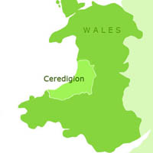

(West Wales Holiday Cottages, 2023)

About Ceredigion
Ceredigion is a rural county situated on the West coast of Wales. It covers an area of around 688 square miles (Wikipedia, 2023).
The main towns in Ceredigion are Aberystwyth, Aberaeron, Cardigan, Llandysul, Lampeter and Tregaron. Aberystwyth is the largest town with a population of 15,935, Cardigan is second largest with 4,184 and the third largest is Lampeter with a population of 2,970 (Wikipedia, 2023).
Ceredigion has a population of 71,500 (Office for National Statistics, 2022). According to the 2021 census the population can be broken down by age in the following categories:
- 0 – 15 years 10,087
- 16 – 44 years 24,043
- 45 – 74 years 28,906
- 75 + years 8,445
(Stats Wales, 2022)
In the 2021 census 96.2% of people identified as being of white ethnicity, 1.5 % as Asian, mixed ethnicity 1.2%, Black 0.5% and Arab ethnicity 0.2% (Stats Wales, 2023).
In Ceredigion 31,678 people reported that they can speak Welsh (Office for National Statistics, 2022). This equates to around 45% of the population of Ceredigion.

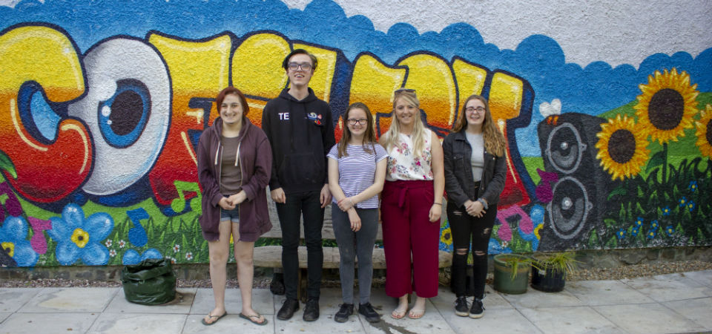

(Welsh Government, 2019)
Provisions For young People
Ceredigion is fortunate to have access to a wealth of services and opportunities available to young people. These services range from the public sector, the third sector and to charities.
Ceredigion Support and Prevention Service (formally known as Ceredigion Youth Service) is a local authority-based service which receives funding from Welsh Government and Core budget from the Local authority. The service covers the entire county and engages with young people aged 11 -25. It has a focuses on key areas such as Outreach, School Based Youth Work, Youth Clubs and holiday provisions. The aim of the service is to support the personal, social and educational development (Ceredigion Youth Service , 2023). The service also provides financial Service Level Agreements to five other youth organisations who provide opportunities to young people. Urdd Gobaith Cymru, Young Farmers Clubs, Scouts Girl Guides and RAY Ceredigion.
Area 43 is an independent charity that supports young people aged 14-25 within the Cardigan area providing information, training, support and counselling to young people (Area 43, 2023). The charity have recently opened a café in Cardigan town centre that offers an informal drop in, discounted food and opportunities for training and employment in areas such as barista and hospitality. Recently Area 43 were successful in gaining National Lottery funding to develop mental health services and interventions for young people in Ceredigion. The funding draws upon partnership working with nineteen additional youth agencies within Ceredigion including Llandysul Paddlers, Amethyst and the Girl Guides (Dyfodol Ni, 2023).
There are also youth organisations that focus on local heritage and Welsh culture. The Young Farmers Club (YFC) offer youth provisions such as Eisteddfods and Rallies within nineteen clubs in Ceredigion (Young Farmers Club Ceredigion, 2023). Similarly Urdd Gobaith Cymru offer activities, clubs and trips through the medium of Welsh to children and young people of the county with “98% of all the schools in the county take part in at least one aspect of the Urdd’s work” (Urdd Gobaith Cymru , 2023).
There are many other organisations that deliver youth provisions in Ceredigion such as Arts4Wellbeing, Mind, Tysul Youth and the New Life Church.

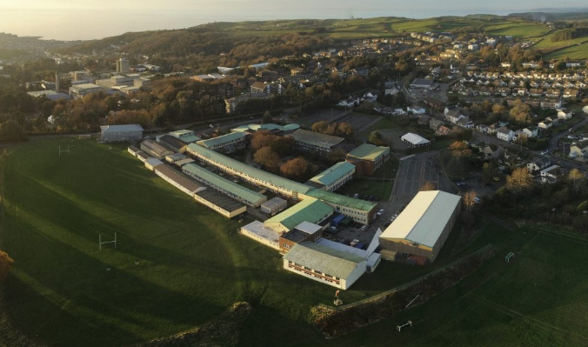

(Ysgol Penglais, 2020)
Education
There are 7 secondary schools within the county, 6 of which have a sixth form. These schools are based within the larger towns of the county. There are 2 Pupil Referral Units in the county, one which covers ages 5 to 10 and one which covers 11 – 16.
There are two Universities and two further education colleges within Ceredigion which have around 9,870 students (Universities and College Union , 2023).
When looking at the numbers for children educated at home, according to Welsh Government “Ceredigion had the highest rate, at 23.8 of every 1,000 pupils. Ceredigion has consistently reported the highest rate of home educated children since 2009/10 for both girls and boys” (Welsh Government, 2022).

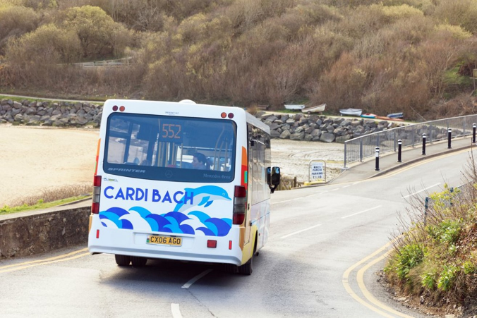

(Discover Ceredigion, 2023)
Transport
Public transport in Ceredigion can be somewhat limited due to its rurality and geographical area. The limitations in public transport means that access to services and facilities can be difficult for young people. Research commissioned by Ceredigion County Council states that around 30-40% of the population of Ceredigion experience transport poverty (Arcadis Consulting, 2016). Transport poverty can include not having access to public transport and not being able to afford transport costs such as bus fares or running costs of a car.
Many of the county’s facilities are not within walking distance for most of the population. Young people in particular rely heavily on transport from parents, friends or other family members. Routes can often be busy and too dangerous to cycle. The main towns have cycle paths however these paths often end once they get to the main A roads.

(Gyrfa Cymru - Careers Wales, 2023)
Ceredigion Employment
Data from the 2021 census reports that 27,550 people were in employment (Office for National Statistics, 2023). It states that 42,742 people were of working age population (Varbes, 2022).
According to recent data caring and personal services is the biggest job group in Ceredigion. Closely followed by teaching and education professions (Varbes, 2022). Some of the largest employers in the county are Ceredigion County Council, Hywel Dda University Health Board and Aberystwyth University.
A large industry within the summer months is tourism and hospitality. Many young people find themselves working in seasonal jobs or on temporary contracts. This does not offer job security and future prospects may be limited.
Unemployment in Ceredigion has decreased from 2.3% in 2011 to 1.8% in 2021 (Office for National Statistics, 2023). This is significantly less than the Wales average which is 3% (Nomis, 2023). The main reason for unemployment given was ‘Long term sick’, second to that was ‘studying’ (Varbes, 2022).

Summary of learning and future learning needs
Following completion of my placement with Ceredigion Support and Prevention Service I have identified some areas which I have been able to advance my learning and also some areas where I feel I need to develop my future learning. I have produced a professional development plan which includes both the learning I have done on this placement and the areas I would like to develop. The following is a summary of my professional development plan. In the areas of learning I have identified relevant National Occupational Standards (NOS) which apply.
During my placement with Ceredigion Support and Prevention Service to facilitate inclusivity within a youth work environment I was tasked with making posters to promote and advertise events that were being held. It was essential to ensure that these posters were created and published bilingually in English and in Welsh. By doing this young people can identify with the Welsh language as being that of an everyday and working language and not just as one that is used in school. This will also empower young people to use the language themselves. I feel this correlates with NOS YW19 which states that youth workers must try to “Develop a culture and ethos that promotes inclusion and values diversity” (National Occupational Standards, 2019).
With regards to my own learning development I can see that in current times in order for me to best support young people, further knowledge and development is needed within the area of LGBTQ+ community would be very beneficial in order for me to best support those young people that may identify as LGBTQ+ or be curious. Stonewall Cymru offer training on supporting LGBTQ+ children and young people (Stonewall Cymru, 2023).
During my placement I have spent some hours as a member of staff at various youth clubs within the county. A part of spending time in youth clubs that I enjoyed was the planning of future activities with the young people. This also relates to NOS YW02 which states youth workers should “Assist young people to learn and engage with the youth work process” (National Occupational Standards, 2019). Young people are paramount to the successful running of youth clubs and require regular input into the planning process that goes with it enabling them to ensure that activities are relevant and suitable to them and their needs (Sapin, 2013).
An area of my own learning which needs future development is to improve the amount of accredited learning that I am able to offer. By offering accredited learning to young people they are able to feel a sense of pride and accomplishment. Bodies such as Agored Cymru offer a variety of accredited courses which are able to be tailored to young people’s needs and interests. In the future I would like to refresh my knowledge of such courses and the accreditation process. This can be done by speaking with colleagues who routinely undertake this work. Being able to do this would help me to fulfil NOS YW11 “Plan, prepare and facilitate learning activities with young people” (National Occupational Standards, 2019).
The Outreach and post 16 are an area of youth work that I have found to have a keen interest. Through being out in the community youth workers are able to work with young people in places that they are most comfortable (National Occupational Standards, 2019). Whilst working with this cohort of young people I believe that a youth worker is required to work harder to build relationships.
Youth work is based on voluntary engagement, whilst on their territory so to speak, young people do not need to engage. However, often a young person will choose to engage with youth workers as activities, advice and options from youth workers are appealing to them. This relates well to NOS YW01 “Initiate and maintain relationships with young people” (National Occupational Standards, 2019).
A personal area for development within this part of youth work is to improve the use of Y Fan (the Mobile Youth provision) that the team have. Due to the rurality of Ceredigion there are young people within the county who do not have access to provisions (Buchroth & Parkin, 2010). By utilising Y Fan at more antisocial hours more young people will be able to benefit from youth workers and their provisions.
Whilst on placement an issue that arose was an increase in incidents involving young people carrying knives. I was involved in implementing multi agency projects which aimed to raise awareness of the consequences and risks involving carrying knives. This increased my knowledge of effective working with other agencies and how this was of benefit to the young people involved. This also relates well to NOS YW15 which states that youth workers should “Assist young people to assess risk and make informed choices in the management of their health and wellbeing” (National Occupational Standards, 2019).
I feel an area related to this that I would like to develop is my knowledge of the Youth Justice process and what this involves for a young person who is arrested for carrying a knife. As the Ceredigion Support and Prevention Service works closely with local Police I feel I would be able to discuss this further with Police Officers and Case Holding Manager’s that work within the Ceredigion Youth Justice Team that I may be able to shadow.

References
Arcadis Consulting. (2016, November). Improving Strategic Transport Connections Between Aberystwyth and Carmarthen. Retrieved from www.gov.uk: https://www.gov.wales/docs/det/report/170524-aberystwyth-carmarthen-weltag-case-report.pdf
Area 43. (2023). Who we are. Retrieved from www.area43.co.uk: https://www.area43.co.uk/youth-cafe/
Buchroth, I., & Parkin, C. (2010). Using Theory in Youth and Community Work Practice. Exeter: Learning Matters.
Ceredigion Youth Service . (2023). Who are we and what do we offer? Retrieved from Www.giceredigionys.co.uk: https://www.giceredigionys.co.uk/about/
Discover Ceredigion. (2023). Get to know the communities of Ceredigion by bus. Retrieved from Discover Ceredigion : https://www.discoverceredigion.wales/plan-your-visit/tours-and-car-free-days-out/
Dyfodol Ni. (2023). Our Pledge. Retrieved from www.Area43.co.uk: https://www.area43.co.uk/wp-content/uploads/2022/10/Partnership-Pledge-ENGLISH.pdf
Gyrfa Cymru - Careers Wales. (2023). Careers Wales Gov uk - Home. Retrieved from Careers Wales - Gyrfa Cymru : https://careerswales.gov.wales/
Hawtin, M. (2007). Community Profiling: A practical guide. Open University Press.
Ingram, G., & Harris, J. (2001). Delivering Good Youth Work - A Working Guide to Surviving and Thriving. Lyme Regis: Russell House Publishing Ltd.
Jeffs, T., & Smith, M. K. (2010). Youth Work Practice. London: Bloomsbury Publishing Plc.
National Occupational Standards. (2019, April). Youth Work National Ocuupational Standards. Retrieved from cldstandardscouncil.org.uk: https://cldstandardscouncil.org.uk/wp-content/uploads/YouthWorkNOS2019Intro.pdf
Nomis. (2023). Labour market profile - Ceredigion. Retrieved from www.nomis.co.uk: https://www.nomisweb.co.uk/reports/lmp/la/1946157390/report.aspx#tabempunemp
Office for National Statistics. (2022). How the population changed in Ceredigion: Census 2021. Retrieved from www.ons.gov.uk: https://www.ons.gov.uk/visualisations/censuspopulationchange/W06000008/
Office for National Statistics. (2022). Welsh Language Skills (speaking). Retrieved from www.ons.gov.uk: https://www.ons.gov.uk/datasets/TS033/editions/2021/versions/1
Office for National Statistics. (2023). Employment in local authorities, England and Wales. Retrieved from www.ons.gov.uk: https://www.ons.gov.uk/employmentandlabourmarket/peopleinwork/employmentandemployeetypes/datasets/employmentinlocalauthoritiesenglandandwales
Office for National Statistics. (2023). How life has changed in Ceredigion: Census 2021. Retrieved from www.ons.gov.uk: https://www.ons.gov.uk/visualisations/censusareachanges/W06000008/
Sapin, K. (2013). Essential Skills For Youth Work Practice. London: SAGE Publications Ltd.
Stats Wales. (2022, December ). Usual resident by age population local authority. Retrieved from stats.gov.wales: https://statswales.gov.wales/Catalogue/Census/2021/usualresidentpopulation-by-age-localauthority
Stats Wales. (2023, May). Ethnicity by area and ethnic group. Retrieved from Stats Wales: https://statswales.gov.wales/Catalogue/Equality-and-Diversity/Ethnicity/ethnicity-by-area-ethnicgroup
Stonewall Cymru. (2023). ww.stonewallcymru.org.uk. Retrieved from E-learning with Stonewall: https://www.stonewallcymru.org.uk/e-learning
Universities and College Union . (2023). Constituency Ceredigion. Retrieved from Fund the Future: https://fundthefuture.org.uk/constituency/ceredigion/
Urdd Gobaith Cymru . (2023). My Area - Ceredigion. Retrieved from www.Urdd.cymru: https://www.urdd.cymru/en/my-area/ceredigion/
Varbes. (2022). Economy of Ceredigion. Retrieved from www.varbes.com: https://www.varbes.com/economy/ceredigion-economy
Welsh Government. (2019, June 20th). Youth Excellence Awards - Project 2050! Ceredigion Youth Service. Retrieved from www.gov.wales: https://www.gov.wales/youth-work-excellence-awards/winners-and-finalists/2019-awards/prosiect-2050
Welsh Government. (2019). Youth Work Strategy for Wales. Retrieved from www.gove.wales: https://www.gov.wales/sites/default/files/publications/2019-06/youth-work-strategy-for-wales.pdf
Welsh Government. (2022, September ). Pupils Educated other than school. Retrieved from www.gov.uk: https://www.gov.wales/pupils-educated-other-school-september-2021-august-2022-html#:~:text=The%20rate%20of%20elective%20home,23.8%20of%20every%201%2C000%20pupils
West Wales Holiday Cottages. (2023). Ceredigion - Things to see and do. Retrieved from www.westwalesholidaycottages.co.uk: https://westwalesholidaycottages.co.uk/destinations/ceredigion
Wikipedia. (2023). Ceredigion. Retrieved from en.wikipedia.org: https://en.wikipedia.org/wiki/Ceredigion#:~:text=Ceredigion%20is%20a%20coastal%20county%2C%20bordered%20by%20Cardigan,is%201%2C795%20square%20kilometres%20%28693%20sq%20mi%29.%20
Young Farmers Club Ceredigion. (2023). About us - Ceredigion YFC Background. Retrieved from www.yfc-ceredigion.org.uk: https://yfc-ceredigion.org.uk/en/about-us/
Youth Work in Wales Review Group. (2022). Youth Work in Wales: Principles and Purposes. Cardiff: Youth Work in Wales Review Group.
Ysgol Penglais. (2020). About Penglais. Retrieved from Penglais.org.uk: https://penglais.org.uk/about-penglais/

