DEVELOPING RELATIONSHIP AND WORKPLACE ACHIEVEMENT
BMSK 5002
Submitted by Mr. Bandekila Jacques Nkenda
ID: 1604635
Lecturer: Ze Zook
April 2019

CONTENTS
1) CONTENTS 2
2) EXECUTIVE SUMMARY 3
Fig. 1 Critical survey of the relevance of Personal development to employees 3
3) CASE STUDY - INFOSYS India 4
Introduction 4
Background 4
The Problem 5
4) A critical assessment of the potential benefits for an organisation and the individual of personally developing individuals in the workplace. 6
a) Potential benefits for the Individual 6
i) Confidence / Self esteem 6
Fig. 2 Essential skills for business success and self development source: Laura Harkness – Leadership 6
ii) Motivation / Sense of achievement 6
iii) Productivity / Effectiveness 7
b) Potential benefits for the Organisation 7
i) Organization / Productivity 7
ii) Financial savings / Improved Employee Morale and retention 7
iii) Positive Public Perception / Employer Brand reputation 7
CASE STUDY – Analysis of the Problems and potential Solutions 8
5) Critical evaluation of some of the personal development vehicles available to Organisations and the extent to which they are appropriate in meeting the development needs of an individual. 9
a) Evaluation of some of the Personal Development vehicles available to Organisations. 9
i) Job description / Individual Career Planning 9
ii) Setting Performance Standards/Work place Assessments 9
iii) Team observation / Self evaluation 10
iv) Human Resource Department (HR). 10
v) Organisational structure / Company Hierarchy 10
CASE STUDY – Recommended Solutions 13
6) An identified Personal Development Plan to meet the needs and expectations of an individual. 15
Fig. 3 Hierarchy of Needs source: Maslow 15
The Personal Development Plan for the youngest cofounder and current CEO of Infosys, Nandan Nilekani. 16
Fig. 4 Essential skills for business success and self development source: Laura Harkness - Leadership 16
7) Bibliography. 18

EXECUTIVE SUMMARY

Recruiting talented staff is difficult, retaining them is even more challenging. An organization that does not invest in on-going training and personnel development for employees to help them achieve their full potential will find itself in a vicious cycle of continuously recruiting to replace those that have left; this is a costly, time consuming cycle which may be stress inducing on the entire workforce which in turn will affect productivity with a negative impact on the profitability of the organization. Ongoing training and personal development is vital to any organization, it provides excellent opportunities to expand the knowledge base for all which in turn benefits both the individual and the organization making the returns of investments in time and money worthwhile.

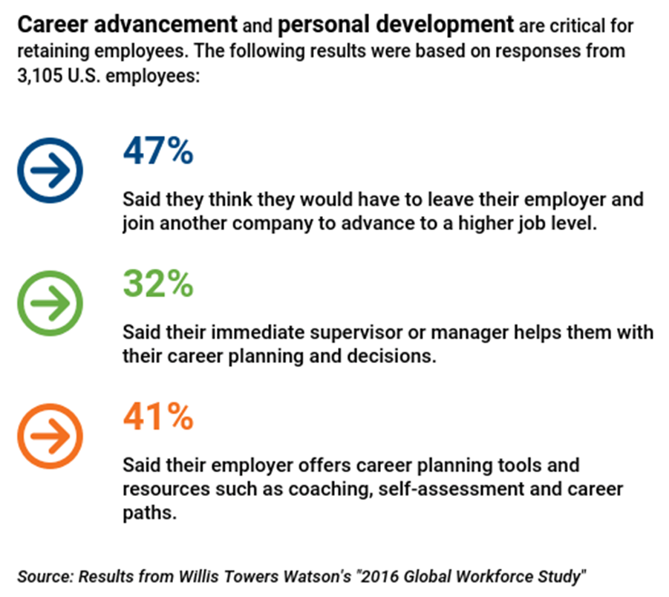
Fig. 1 Critical survey of the relevance of Personal development to employees

Personal Development is all about enhancement of our quality of Life, a proactive lifelong process of developing us, constant engagement in activities one step at a time that adds value to our ability to manage ourselves effectively whatever the circumstance. A non-stop journey, it becomes easier with each step to appreciate each activity’s value.

Training and Personal Development provides ideal opportunities for any organisations to increase the knowledge and skill base of the workforce. Although many organisations hesitate investing in the personal development of employees either due to financial pressures or the potential disruptions to workflow when an employee goes for off-site training; put simply, it the best return on investment any organization will ever get. Until Artificial Intelligence completely takeover the workplace, the most valuable assets of any organization will most probably be the employees.

CASE STUDY - INFOSYS India

* This Case Study is freely available on the Internet. It is part of the catalogue published and made available as a teaching aid by Harvard Business Publishing (Education) - https://hbsp.harvard.edu/home. Published 2005 and revision on 2006.

Introduction

Established in 1981, Infosys started from $250 capital to become a big company with a market capitalization of approximately $47.7 billion. And after several years of revenue growth, Infosys was ranked No1 in the business today Best Employer survey and is among the 20 biggest companies in the world.
Curiously in 2003, the company drop off from the Best Employer list. A meeting was held to set up new and aggressive milestone. Although the goal was reachable, The HR team knew that it was not an easy task. The fact that Infosys fell off of the best Employer has caused a huge uproar and commotion in the industry. And the HR team worked hard to prevent crisis in the future.

Background

Infosys was founded in India by seven Engineers with an initial capital of $250 borrowed by theirs spouses. At the beginning, the seven Engineers shared a vision of creating wealth in legal and ethical manner. Nandan Nilekani (the youngest) said that they wanted to build a professional and well-managed company. However, because of bureaucratic problem in India at that time, life became difficult: it could take 12 months and 15 visits to get a permission, restriction of B1 visa, foreign exchange for travel abroad, etc.). So Infosys was not able to visit its customers location in the US. The company reached a point where it was almost dissolved. Later on, one of the cofounder left the company and some other also wanted to leave. When Murphy decided to buy their shares, they changed their mind and they decided to stay.
The HR team tried to render the company to be a workplace more fun and meaningful and they introduced a number of programs despite the rise of employee discontent. Those changes (with the fact that managers were unable to understand the frustrations of the lower-level employees) led to high turnover rate despite the growth and the expansion of the company.

The Problem

In 1999 there were implementation of series of changes: building portfolio of core companies and services, reorienting the way people were measured and compensated..). These changes including the introduction of a variable pay structure made the company to remain high on the Best Employer list in 2001 and 2003. However, in 2003, Infosys dropped off the list and this shocked everyone.
In conclusion the changes that had initiated since 2001 had an unintended impact in de-emphasizing the traditional culture of Infosys. This show expectations and communication within large organisation, which led to employees to be doubtful about the changes.

A critical assessment of the potential benefits for an organisation and the individual of personally developing individuals in the workplace.

Potential benefits for the Individual

Confidence / Self esteem
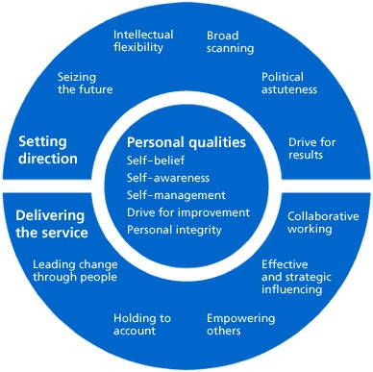
Through self-development we gain more confidence, happier which has a direct impact in both physical and mental health. The process of the growth in confidence also enables the individual to become stronger internally and externally that in turn gives the individual confidence to empower others and lead change through people. With more confidence and self-esteem, communication and interacting skills, major requirements for any successful team will ultimately improve.

Fig. 2 Essential skills for business success and self development source: Laura Harkness – Leadership

Motivation / Sense of achievement
Helps develop good working habits and positive mental attitude. “Know who you are, and be it. Know what you want, and go out and get it.” (Carol Bryant). Self-development raises self-awareness of the individual’s strengths and weaknesses and at the same time provides the motivation to turn the weakness into strength. Self-development will help focus clearly on directions and goals clear making decision-making easier, and the more the individual experience improvements in achievements and general wellbeing the more the motivation to achieve. Personal development provides the opportunity to learn new skills that will help in the personal life and also be of great benefit in the life either with new career opportunities or improvement in current job.

Productivity / Effectiveness
More focused decision making process will lead to higher efficiency which then increases effectiveness. Equipped with clearer understanding of both role and direction, the individual becomes better placed to improve their skills and in the process increase their competence, opening new opportunities or/and improving their current situation.

Potential benefits for the Organisation

Organization / Productivity
Investing in Personal Development programs strengthens the skill base of each employee and creates a highly knowledgeable staff with transferable skills, increasing their competency. This will ultimately result in greater flexibilities and efficiencies in the work process.
By investing consistently in up-skilling employees will result in a low turnover of staff. It will also create a happy work environment that will encourage creativity, innovation and more efficiencies from the employees that will improve the organisation’s turnover and market share.

Financial savings / Improved Employee Morale and retention
Personal Development equips employees to recognise and play to their strengths resulting in increase in focus and effectiveness.
An often underrated benefit of investing in Personal Development is the it demonstrates clearly to employees that they are valued, they in turn will be motivated with the knowledge that they have contributed to the turnover of the organization and are being recognized for it. An employee who feels valued is unlikely to change jobs, instead become motivated to become more efficient resulting in high staff retention rate, which will directly help to control and even reducing recruitment costs.

Positive Public Perception / Employer Brand reputation
Organisations that up-skill their employees regularly ensures that they are up to date and ahead with industry trends, changes in customer demands and changes in other environmental factors such as Government legislations, Health and Safety in the workplace.
A successful and consistent personal development strategy helps the organization develop a positive employer brand reputation that makes the company a prime consideration for talented individuals seeking employment. The organization will benefit from the employees having employees with consistent product knowledge and experience. A successful training programme will help enhance the organisation’s reputation and profile contributing to the development of the organisation’s brand.

CASE STUDY – Analysis of the Problems and potential Solutions

Infosys became a high performing organization because it started out from the beginning with a proactive strategy to foster a holistic personal development culture, expressed by the youngest co-founder and current CEO Nandan Nilekani who stated in 1981 that they wanted to build a company that “was professionally owned and professionally managed, with good corporate governance, good employee management, and good ethics.” This approach greatly helped it develop a positive Brand Employer reputation achieving the No.1 rank in the Business Today Best Employer survey.
It also contributed to Infosys ability to grow very quickly over ten years increasing its turnover 150 multiple and the number of employees by a factor of 60. This rate of growth made it difficult for
Infosys’ management to focus on employee engagement and happiness; individual employee became more remote as the organization expanded resulting in Communication breakdown. Infosys ended up in a negative self-perpetuating situation where the low staff retention rate and rapid expansion greatly contributed to the deteriorating communication internal process. The series of changes implemented in 1999 by management removing eight of it’s fifteen layers, flattening it’s organizational structure made matters worse re-focusing the Company’s objectives and de-emphasising it’s traditional culture benefiting the Infosys at the expense of the employees (Delong, Tandon & Rengaswamy, 2005). Management struggled with effective delegation as there responsibility increased resulting in employees getting confused about the expectations and procedures within the company which was making them feel that they were losing the ability to more effective and productive. An employee who after up-skilling through the company’s personal development and training programmes to achieve a specific professional goal is then given responsibilities that does not match his skill set the employee will become less motivated, lose focus and resulting in less efficient.

Critical evaluation of some of the personal development vehicles available to Organisations and the extent to which they are appropriate in meeting the development needs of an individual.

Evaluation of some of the Personal Development vehicles available to Organisations.

Job description / Individual Career Planning

The written job description details the duty and roles involved in that particular position and state the desired skills and qualifications requirements of the individual. It helps to determine the criteria and desired competences for that individual to enable the efficient and effective execution of the day-to-day tasks for that position. The job description therefore provides a baseline from which an individual Development Plan can be created when the HR Manager sits down with the employee to discuss career aims and other interests of the individual, the Plan becomes the roadmap and should include measurable goals and objectives and a realistic timeline to achieve the stated. It is vital that management takes time to sit down with the individual because everyone is unique, we do not all share the same goals or perspectives. Also the time taken for discussions will increase the return on investments for both the organization and the individual as is evident with Infosys where the HR Management were not able to allocate sufficient time for in-depth conversations with the individual due to the rapid expansion of the organisation.

Setting Performance Standards/Work place Assessments

It is vital to set quantitative standards and specific key performance objectives, this helps the individuals know the efficiency and effectiveness in the role thereby identifying their strengths and weaknesses. It will help to identify any skills or knowledge gaps that needs to be addressed and it’s urgency. Once a set of targets is met, the bar is raised higher enabling the individual to continuously feel the sense of accomplishment and motivated. Setting Performance standards also helps create a climate of accountability; Using the principle of “Behaviour must equal consequences” the manager of the individual achieving performance standards notices and should give constructive feedbacks to reinforce that achievement, likewise if the opposite is the case. The Manager must be consistent with the feedback either positive or negative; this creates a climate of accountability and increased effectiveness and efficiency. When an individual does not fell accountable, the performance and motivation is lowered resulting in lower effectiveness and expectation. This could lead to a sense of not belonging or appreciated creating confusion and doubt as was the case at Infosys where due to the challenges of managing communication within the large organization led to the employees becoming doubtful and unclear about the changes taking place in the organization.

Team observation / Self evaluation

Watching the team on a regular basis is the best way of identify skills and knowledge gaps. Observing individuals perform their duties, problem solving and interaction with team members should help the Manager identify any learning requirements.
Individuals are encouraged to regularly evaluate themselves. This means that they take ownership and responsibility of their personal and professional development.

Human Resource Department (HR).

This department manages the most vital component of any organisation – the employees. A primary role of the HR department is to ensure that the staff are treated as human assets and not as organisation cost; highly skilled skilled and motivated workforce committed strategically will add innovative, financial and brand values to the organisation. It is the role of the HR department to advise the organisation’s management on how this is achieved which includes identifying the organisation’s current and future requirements aligned with the Company’s stated strategic goals and objectives; work with the other managers to define the required skill sets and recruitment of employees with those specific skill and advise on assigning them to the right roles. HR also coordinates the Payroll and benefits which are crucial to staff retention and are commonly used as part of the incentives to encourage staff engagement and motivation to consistently perform at their highest efficiency level. It is also the role of HR to offer advise to manages regarding all issues related to the employees including their training and developments. In an organisation with flexible practise, Human Resources can rotate employees different functions based on priorities and employee skills and preference. The department also has a vital role in helping the organisation develop a competitive advantage by building up the organisation’s capacity to enable it to offer unique products and services to the customer.

Organisational structure / Company Hierarchy

Usually the hierarchical structure within an organisation is a reflection of the individual’s capacity (power) to influence others and get things done, in it’s traditional format; the higher the individual is up the ladder, the greater their influence within the organisation. The structure is rarely deliberately created to match the organisation’s defined strategy, it’s more usually a result of the environment, strategy, ambition and performance factors competing within the organisation.

Types of Organisational Structures. (Morgan J. 2014)
- The Traditional Hierarchy model
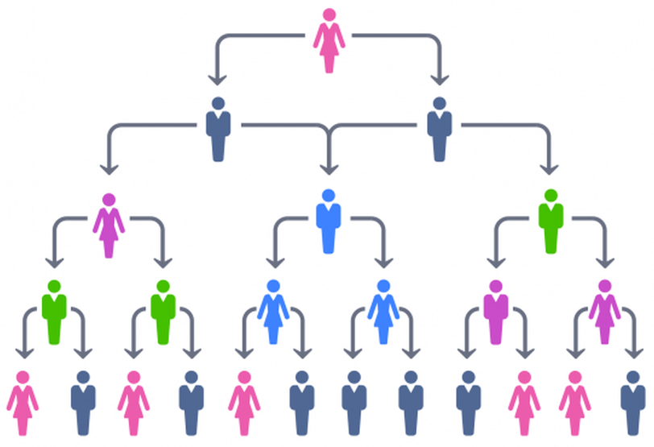
This model adopted by armed forces to illustrate the chain of command is arguably suited for the workplace place where employee initiatives and engagement is not required. The work is linear and employees are treated as organisational costs and easily dispensable and employee experience is not focused on and virtually no collaborations. Highly bureaucratic and sluggish, Communications and creativity is one way top down stagnating innovations. With a very resilient hierarchical structure, it leaves the organisation vulnerable to new entrants, competition and makes it difficult for the Company to attract and retain highly skilled and ambitious workforce. Best suited for small sized organisations, It’s greatest advantage was the reliability to maintain a resilient hierarchical management structure which will be a weakness in the modern workplace.

- The Flatter Hierarchy model
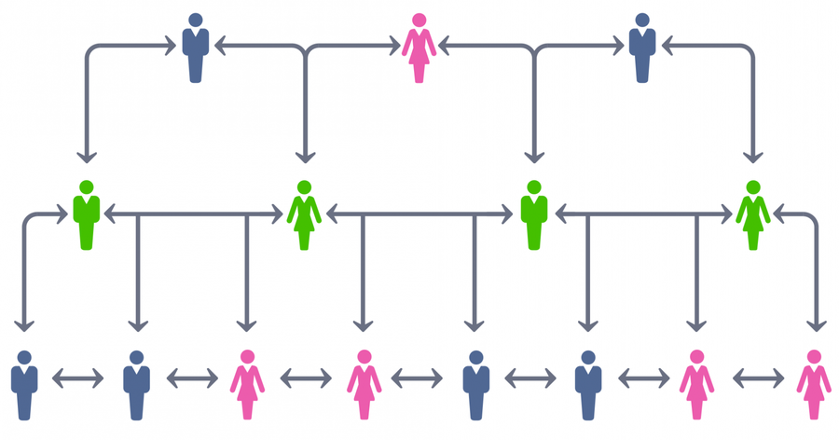
This Flatter model unlike the traditional model that concentrates Communication and influence at the top, adopts interactive collaborations and opens up the lines of Communications improving employee engagement and challenges the status quo. Though the model still involves some form of hierarchy, it is flatter (fewer layers of management) and requires far less resource allocations and efforts to achieve similar objectives in a shorter time period. To be successful implemented, this model requires robust technology that will enable staff to be able collaborate and communicate with each other as well as with the organisation at anytime from any location. This means that it’s suitable for organisations adopting modern work practices such as flexible work arrangements and are comfortable with the constantly evolving approach to work. This model is suited to large organisations although a lot of different size businesses are adopting it partly because of it’s practicality, scalability and logical approach for deployment across the whole organisation.

- The Flat Model / Self-managing Organisational structure
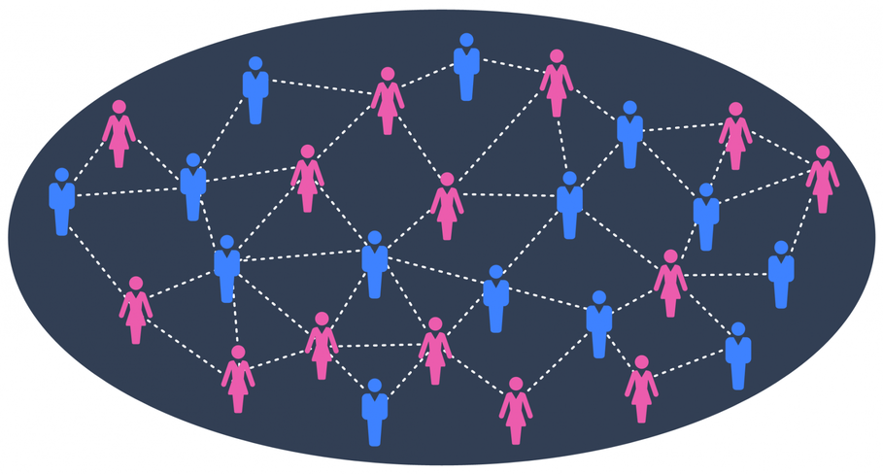
Unlike the previous two, this model has no hierarchy that is, no seniority or job titles; everyone has equal influence. Employees have knowledge of current projects and are free to participate in any one they want. Although with a lot of advantages, it is mainly suitable for small and medium size organisations, it’s impractical and challenging to implement in a large organisation with thousands of employees. As an organisation grows some structures needs to be in place; most organisations with this model have implemented it whilst a small size and expanded on it whilst expanding, not when they grew to thousands of employees. It will take a considerable time and an enormous amount of resources to implement from scratch by a large organisation, resources that may be more efficiently deplored elsewhere for a better return on investment. With no structure, accountability and efficiency could become a major challenge. Furthermore, due to human nature informal hierarchy and cliques will automatically form based on likeability and length of time in employment at the organisation (Kesler G., Kates A. 2010).

- The Flatarchies organisational structure
This is a combination of the Flat and Flatter models, with this model the organisation can be made up of adhoc teams for flat structures and have more hierarchy or the other way round with the adhoc teams more structured. Organisations with this structure are usually more dynamic and Industry disruptive in nature eg Google, Amazon etc. This model has a competitive advantage in that it enables focus on innovations; it is therefore best suited for organisations with internal innovations and incubator programmes in an environment where employees are allowed to suggest new ideas and are allowed to develop their ideas. The Flatarchies structure is suitable for any organisation large or small and is becoming more commonly adopted by organisations especially as a temporary structure to create autonomous and less bureaucratic teams for innovation programmes and developing new products and services.
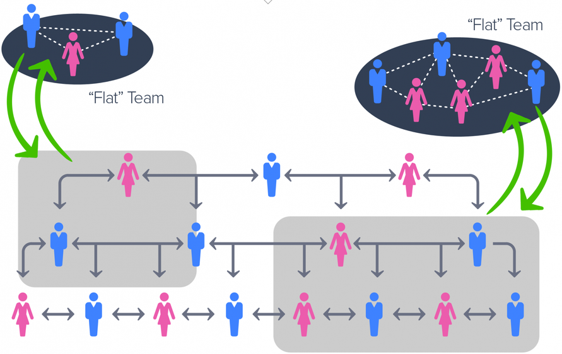

CASE STUDY – Recommended Solutions

Infosys has not been able to achieve the balance between the organisation’s needs and the needs of the employees and as a result both the company and the employees are suffering. Infosys recognises this and took steps to address the issue by implementing a series of changes in 1999 removing eight of it’s fifteen layers, flattening it’s organizational structure from fifteen to eight. Unfortunately the unintended impact of the changes was the de-emphasising the traditional culture of Infosys, which was a small company and collegial environment where processes and policies were flexible and customised to individual needs. My recommended solution for improving employee experience and retention is to focus on improving the Communications within the Organisation. Infosys should adopt the Flatarchies organisational structure instead of the Flatter model implemented in the recent changes. Currently with 15,000 staff, it will not be possible to recreate the traditional culture of Infosys when it was a small company of 250 employees and the environment collegial where processes and policies were flexible and customized to individual needs; the Flatarchies structure will make it easier to focus on improving communications and enable the managers to be able to work closely with the employess. The employees will also have a better understanding of where they fit in the rapidly growing organisation, and the values they provide to the company via their work. It will provide transparency and better understanding of the decision making process. As well as focusing on improving communications, the managers also needs to interact more closely with the all employees to gain an insight into the frustrations and issues lower level employees are facing which will help them determine the best solutions to any problems taking place.

An identified Personal Development Plan to meet the needs and expectations of an individual.
A Personal Development is all about enhancement of our quality of Life, a proactive lifelong process of developing us, constant engagement in activities one step at a time that adds value to our ability to manage ourselves effectively whatever the circumstance. A non-stop journey, it becomes easier with each step to appreciate each activity’s value.
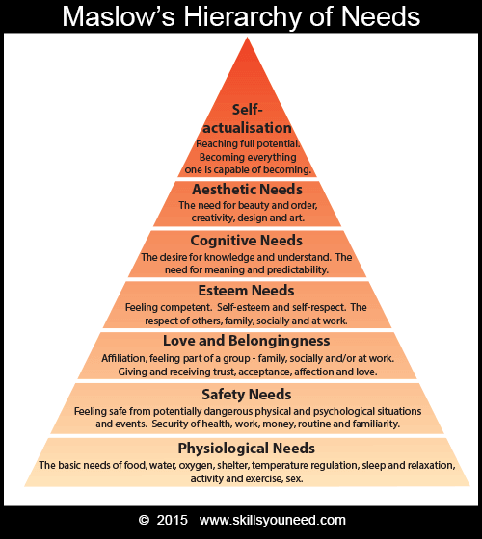
The extent an individual is able to develop depends on certain needs being met, these needs form a hierarchy where one level needs to be met before a higher one can be set (Maslow. 1970). Most professionals want to be self-sustained, competent and with limitless abilities.

Fig. 3 Hierarchy of Needs source: Maslow

According to Maslow (above illustration), right at the bottom of the Hierarchy pyramid is our Physiological (basic) needs for survival such as food, sleep etc.. This is followed by our physical and economic needs for safety and security. It is only after these needs are met can we comfortably go up to the next level of meeting our needs for love and belonging. The next step up is self-empowerment closely associated with our needs for self-esteem and worth such as the feeling of competence and the respect from and of others. The fifth level is our cognitive need to understand, desire for knowledge and the search for meaningful purpose. The next level is our need for beauty and order otherwise known as aesthetic requirements. At the top of the pyramid finally is our needs for self-actualisation that is the contentment feeling that we have accomplished our full potential.

The Personal Development Plan for the youngest cofounder and current CEO of Infosys, Nandan Nilekani.
Nandan Nilekani is the youngest cofounder and current Chief Executive Officer of Infosys. His mission statement when the Company was formed that they aim to build a company that “was professionally owned and professionally managed, with good corporate governance, good employee management, and good ethics” suggests that he believes that individual personal development training is vital to the success of Infosys.
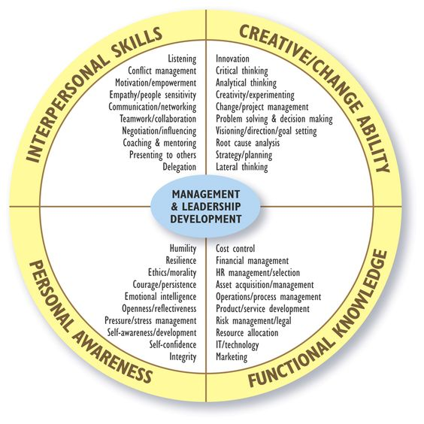
There are several ways we can categorise individual leadership development however, most leaders are not born with the natural ability to lead but develop the ability to lead effectively by focusing on acquiring core skills and competencies over time that adds value to our ability to manage ourselves and others effectively whatever the circumstance. Therefore, for the purposes of this exercise a competence based approach will be will be used to design a personal development plan for Nandan Nilekani. In the diagram (below) competencies needed for a leader to be an effective communicator and be able to cope irrespective of the circumstances are clustered into four areas namely:

Fig. 4 Essential skills for business success and self development source: Laura Harkness - Leadership

    - Interpersonal Skills
These are competencies that deal with how a leader relates and interact with others in any circumstances and includes both communication skills and listening capacity that are fundamentals requirements of effective leadership. It has been established earlier that a breakdown of communications between management is a the cause of the problems at infosys and therefore a weakness, the Personal development plan will focus on acquiring these skills.
    - Functional Knowledge.
These cluster of competencies relates to how much Nandan as leader knows about Infosys. As cofounder Nandan has in-depth knowledge of the organisation, the success and rapid expansion of Infosys is testament that this is a strength therefore, the PD plan will not include acquiring the necessary skill sets for this cluster.
    - Personal Awareness
These are competencies that are foundation skills upon which other skill sets can be developed. As a successful entrepreneur, Nandan is not lacking in these skills therefore the plan will not be focusing on improving them.
    - Creative/Change Ability
This cluster of competencies relates to the abilities of a leader to manage situations that require a creative approach. It also includes critical and strategic thinking skills sets as is the ability to identify and resolve challenges as they arise. This is an area where future development by the CEO is required and the PD plan focuses on it.
SMART APPROACH TO CREATING A PERSONAL DEVELOPMENT PLAN
TIMELINE FOR COMPLETION & REVIEW.

I expect to complete the training programme over the next 3 months before the roll-out of our new products and services. I will be reviewing my progress at the end of each of those months with my cofounders.
T
RELEVANCE & RATIONAL

There has been a lot of changes in Infosys that has lead to employee dissatisfaction and disengagement. I t is necessary for me to undertake these Courses and training so that I will be better equip to resolve these issues.
R
ACHIEVABILITY & ATTAINABILITY

I plan to achieve these skills within 3 months because most of the training will be through reading and online. For the offsite training, I will work with a cofounder to provide cover for me when I am off-site
A
MEASURABILITY & EVALUATION

Upon completion of the Courses, I will use the new skills acquired to work with my other cofounders and managers to improve communication, teamwork and the management of the changes currently taking place in the Company. I will use improvements in these areas to evaluate progress.

M
SPECIFIC OBJECTIVES & METHODOLOGY

In order to become a more effective leader, I will be attending a series of Courses to improve my Interpersonal skills and Change management abilities. These Courses will be a combination of reading, Online and Off-site training
S

Bibliography.

- Thomas J Delong, Jaya Tandon, Ganesh Rengaswamy. (2005). Infosys (A): Strategic Human Resource Management. Harvard Business Case Study.

- Jawad Syed, Robin Kramar. (2017). Human Resource Management: A Global and Critical Perspective 2nd edition. Macmillan Education UK

- David C. Thomas, Mila B. Lazarova. (2013). Essentials of International Human Resource Management: Managing People Globally. SAGE Publications

- David McGuire. (2014). Human Resource Development 2nd edition. SAGE Publications

- Steve W.J. Kozlowski, Eduardo Salas. (2009). Learning, Training, and Development in Organizations. Taylor & Francis Group

- Shaun Tyson. (2014). Essentials of Human Resource Management. Taylor & Francis.

- Gerald A. Cole. (2014). Strategic Management: Theory and Practice. Cengage Learning

- Maslow, A. H. (1970). Motivation and Personality, (2nd Edition). Harper & Row. New York.

- Weiss, M. (2007). Efficient Organizational Design: Balancing Incentives and Power [eBook]). Palgrave Macmillan UK

- Kesler G., Kates A. (2010) Leading Organization Design: How to Make Organization Design Decisions to Drive the Results You Want. Wiley

- Morgan J. (2014) The Future of Work: Attract New Talent, Build Better Leaders, and Create a Competitive Organization. John Wiley & Sons

