Student: Carl Daniels
Student Number: 97011030
Module Title: Work-based Learning Project (Major / Extended)
Module Code: BMPF7010
Submission Deadline: 12th June 2026

Assessment Component 1:

What is the True Value of Physical Activity to Actif Sport and Leisure’s Activity Participants and Wider Society?

Word count (excluding references and appendices): 13,584 words

Contents

- Introduction………………………………………………………………….. | 3
- Literature Review…………………………………………………………… | 5
- Methods ………………………………………………………………….…. | 12
- Findings ………………………………………………………………….… | 17
- Conclusions and Recommendations………………………………….… | 38
- Reference list …………………………………………………………….… | 42
- Appendices…………………………………………………………….…….  Appendix A: Ethics approval documentation  Appendix B: Survey questionnaire (English)  Appendix C: Survey questionnaire (Welsh)  Appendix D: Interview schedule  Appendix E: Qualitative coding overview  Appendix F: Survey sampling and filtering criteria | 45  45  61  63  66  68  71

- Introduction

Actif Sport and Leisure is Carmarthenshire County Council’s in-house sport and leisure service, with a mission to inspire the county’s population to be active for life through a network of facilities and community programmes. Its ten-year strategy has reached the mid-point of its implementation period, formed using empirical and secondary activity and health-related data, within a wider policy environment that emphasises prevention and community wellbeing (Carmarthenshire County Council, 2019) (Carmarthenshire County Council, 2023) (Carmarthenshire Public Services Board, 2023).
Prior to setting its 2020–2030 ten-year strategy, the service was generating an estimated £6 million of social value annually through its network of leisure centres. This figure was generated using the Datahub Software Tool developed by 4Global, in partnership with the Sheffield Hallam Research Institute, and reflects the organisation’s significant impact on health, wellbeing, and community outcomes. Recognising the importance of this contribution, Actif’s strategic intent was to double its social value over the ten-year period, underscoring a commitment to maximising the benefits of physical activity for individuals and wider society.
This aspiration aligns with industry trends that indicate a growing expectation for public-sector organisations to adopt robust frameworks for measuring and reporting social value (Lynch, 2024) (Shields, et al., 2025). In Wales, the Well‑being of Future Generations (Wales) Act 2015 places a statutory duty on public bodies to act for long‑term wellbeing, prevention and equity (Welsh Government, 2025). The Act, in particular, requires public bodies in Wales to work towards well-being goals and to demonstrate sustainable development in all decision-making. For a public leisure provider serving a largely rural county, this increases the importance of producing credible, locally relevant evidence that shows both what changes, and for whom.
At the same time, there is increasing recognition of the need to address health inequalities, promote active lifestyles, and support community resilience (Jones, et al., 2024) (Higgerson, et al., 2018) (Heckel, et al., 2024) — objectives that are central to Actif Sport and Leisure’s mission.

National evidence shows the scale of social value generated by physical activity. Sport England’s updated model estimates £107.2bn of social value in 2022/23 and £122.9bn in 2023/24, with most value arising from improvements in subjective wellbeing (Sport England, 2024) (Sport England, 2025a). These estimates now use WELLBY‑based methods and publish limitations such as cross‑sectional data and potential reverse causality (Sport England, 2025b).

Alongside England‑wide analysis, Sheffield Hallam University and Sport Wales present similar findings, highlighting the contribution of physical activity to health, cohesion and productivity across the UK (Sheffield Hallam University, 2025) (Sport Wales, 2025). These national messages reinforce the need for robust, locally grounded assessment methods.

Two methodological approaches dominate current practice. Wellbeing valuation, including the WELLBY, enables monetisation of life‑satisfaction changes and distributional analysis, though results depend heavily on assumptions in the income–wellbeing relationship (Kahneman & Deaton, 2010) (Killingsworth, et al., 2023). Operational tools such as the DataHub/4GLOBAL Social Value Calculator, currently used by Actif Sport and Leisure, convert attendance data into monetised outcomes, though the proprietary methodology limits transparency and may conflate activity exposure with actual outcome change (4Global, n.d.).

The wider academic literature highlights the risks of relying on a single monetised figure. SROI studies show variability due to subjective proxy selection and assumptions around deadweight and attribution (Arvidson & Lyon, 2014) (Maier, et al., 2015). Public-sector procurement analyses also warn that inconsistent valuation methods undermine credible comparison between bids (Shields, et al., 2025).

Locally, Actif operates in a financial climate shaped by austerity, community asset transfer and tensions between financial sustainability and social objectives (Nichols, et al., 2020) (Parker & Lloyd, 2017). This reinforces the need for a balanced approach that recognises costs but foregrounds outcomes that matter to communities.

Against this backdrop, the study aims to determine the value of participation in Actif’s programmes for individuals and the wider community, and to appraise how commonly used frameworks (calculator‑based estimates, SROI, wellbeing valuation) can be applied credibly in a Welsh local‑authority context. The contribution is threefold: (i) conceptual — clarifying what ‘value’ means across traditions; (ii) methodological — demonstrating a mixed‑methods approach that integrates calculator outputs, survey data and participant interviews; and (iii) practical — offering guidance on transparent reporting, equity‑sensitive targeting and improvement‑focused use of evidence (Arvidson & Lyon, 2014) (Sport England, 2025a).

In undertaking this project, the researcher also aims to strengthen his own practice. A key part of this is developing a clearer understanding of the different ways value can be measured — what each approach offers, where the limitations lie, and how they can be used sensibly in a local authority context. Alongside this, the project provides an opportunity to build greater confidence in mixed‑methods research: designing practical tools, analysing data in a structured way, and making sense of patterns without losing sight of the people behind them. The researcher also expects the process to sharpen his critical thinking, particularly round interpreting evidence that is often presented as definitive when, in reality, it requires careful judgement. More broadly, the study is intended to support his ongoing professional development as a senior manager by improving the way evidence is used in conversations with organisational decision-makers, colleagues and partners, and by strengthening the reflective habits expected of an insider‑researcher working within his own organisation.

The remainder of the dissertation is structured as follows: the literature review examines key theories and evidence relating to the value of physical activity and social‑value measurement; the methods section outlines the mixed‑methods design; the findings section presents results from analysis; and the conclusions and recommendations set out implications for future practice.

- Literature review

This review situates the work-based research project within the global, national and local policy context for valuing sport and physical activity. It synthesises the main theoretical lenses used to conceptualise ‘value’, and critically evaluates the approaches most often used in UK public leisure include Social Return On Investment (SROI), wellbeing valuation using wellbeing-adjusted life years (WELLBYs), and calculator‑based social value models.

For the purpose of this study, “value” is understood as the benefits generated through participation in physical activity that are meaningful to individuals, communities and public systems. These benefits include both outcomes that can be expressed in monetary terms, such as elements of social value associated with wellbeing, health and potential public service impacts, and outcomes that are less amenable to financial valuation, including lived experiences of capability, independence, routine and social connection.

Accordingly, the study adopts a broad understanding of value: financial social value is treated as a useful but partial lens, complemented by qualitative evidence to capture dimensions of value that matter to participants but are not readily monetised.

This definition reflects the realities of public leisure provision, where value must be legible to decision-makers while remaining grounded in participants’ lived experience.
The literature reviewed in the following sections is therefore considered through these different value lenses, providing a conceptual foundation for examining how physical activity is valued, measured and reported within public-sector leisure contexts.

SROI originated in social-enterprise and impact-accounting practice and was formalised in the UK through the development of standard guidance in the early 2000s (Nicholls, et al., 2012). Wellbeing valuation, operationalised through the use of WELLBYs, emerged from wellbeing economics and subjective wellbeing research, and has been incorporated into UK public appraisal through HM Treasury’s Green Book supplementary guidance (Layard, et al., 2021) (HM Treasury, 2022). Calculator-based models used in sport and leisure have a more recent policy origin, being developed to translate national evidence on participation into practical management and reporting tools, including Sport England’s Social Value Model and provider-specific tools such as the 4GLOBAL/DataHub Social Value Calculator (Sport England, 2024) (4Global, n.d.).

The goal is to identify what a credible, locally grounded approach should include for a Welsh local‑authority provider working under statutory duties and budget pressure.

International evidence consistently frames physical inactivity as a major public‑health and economic challenge, strengthening the preventive case for physical activity services. Modelling suggests meaningful long‑run economic and health gains from more active populations, while public‑health studies estimate direct healthcare costs attributable to inactivity – together, compelling reasons to evidence impact in decision‑friendly ways (Duijvestijn, et al., 2023) (Hafner, et al., 2020) (Santos, et al., 2023). In wellbeing economics, the capabilities foundation articulated in Chapters 2–3 of Dalziel, Saunders and Saunders (2018) emphasises that wellbeing depends on people’s real freedoms to lead lives they have reason to value, rather than solely on income or utility (Dalziel, et al., 2018).

However, the income–wellbeing relationship underpinning many wellbeing valuations is debated. Early work suggested that while life evaluation rises with income, emotional wellbeing may plateau at higher levels (Kahneman & Deaton, 2010); more recent adversarial collaboration indicates that emotional wellbeing often continues to increase with income for many, with different patterns among the least happy (Killingsworth, et al., 2023). Practically, WELLBY‑based monetisation requires transparency about assumptions and attention to distribution, because a single gradient is unlikely to fit all groups equally (Dalziel, et al., 2018).

Considering national (UK) context, sector partners in England have advanced national social-value estimates that illustrate the overall scale of benefit. Sport England’s latest work places annual social value above £100 billion, with most of the value arising from subjective‑wellbeing gains and additional value from reduced healthcare demand (Sport England, 2024) (Sport England, 2025a). The programme seems unusually transparent for a national model – it adopts WELLBY methods, acknowledges limitations (cross‑sectional data, potential reverse causality), and reports subgroup results – all of which improves interpretation and reduces the risk of over‑claiming when numbers are used in public decision‑making (Sport England, 2025b).

In the Welsh context, national communications similarly emphasise the combined economic, health and social value of physical activity, supporting local systems in making the case for preventive investment (Sport Wales, 2025). Yet there is a danger in national models being treated as plug‑and‑play for local allocation or for judging a single service’s contribution: parameters and averages rarely reflect nuances like rurality, transport constraints, deprivation profiles or health‑pathway adherence in a particular county, and, with the significant variation of prevalence across Wales, this presents real risk. A credible local approach has the ability to triangulate national model outputs with local administrative data and primary evidence, and report on who benefits rather than only how much (Sport Wales, 2025) (Sport England, 2025a).

Further, the Well‑being of Future Generations (Wales) Act 2015 legally binds public bodies in Wales to act for long‑term wellbeing, prevention and equity (Welsh Government, 2025). For public leisure, this reframes impact as more than income or cost control: services must show contribution to healthier communities and fairness between groups, not just throughput. In Carmarthenshire, these duties are reflected in the Public Services Board Well‑being Plan (2023) and the Council’s Leisure, Culture and Outdoor Recreation Strategy (2023), which position physical activity as a core lever for prevention and community benefit.

Sector governance since 2010 has also changed the operating landscape. Austerity and public‑service reform accelerated community asset transfer and outsourcing across the UK leisure estate, with recognised tensions between financial sustainability and social purpose (Nichols, et al., 2020) (Parker & Lloyd, 2017). Reviews note uneven capacity and risk transfer, while Parliamentary evidence has raised concerns about pseudo‑charitable structures and tax fairness in outsourcing arrangements (SPORTA, 2018). In this climate, a balanced valuation – one that integrates finance, prevention and lived community benefit – is a governance necessity.

Three complementary lenses are used in this study to organise evidence and reduce conceptual blind spots: economic or public value, wellbeing value, and social capital or community value. While no single lens is treated as sufficient on its own, wellbeing value is primary in this framework, reflecting the study’s focus on participants’ lived experience of physical activity. Economic and public value operate as an important but secondary lens, translating outcomes into forms that are legible to decision-makers, while social capital provides a contextual lens for understanding how value is shaped by relationships, access and participation.

Each lens captures a distinct aspect of “value”. Economic or public value converts outcomes into fiscal or productivity signals to support comparison and resource allocation, drawing on public-value and social-accounting traditions (Clifford, et al., 2013). Wellbeing value centres subjective experience and quality of life, aligned with wellbeing economics and capabilities-based thinking, which emphasises people’s real freedoms to live lives they have reason to value (Dalziel, et al., 2018) (Kahneman & Deaton, 2010). Social capital focuses on connection, trust and participation within communities, recognising that these relational dimensions are often central to how individuals experience value, but may be uneven or exclusionary if access and design are not addressed (Portes, 1998).

Using these lenses in combination helps avoid the limitations of any single approach. Financial valuation alone risks reducing complex social experiences to what can be monetised; wellbeing measures without context may overlook distribution and access; and social capital accounts, if used in isolation, may lack traction in public-sector decision-making. Together, the lenses provide a more complete and credible conceptual framework for examining value in public leisure, while also defining the limits of the study. The analysis does not attempt to produce a single definitive measure of “true value”, nor to capture all possible economic or societal effects of physical activity. Instead, it focuses on those dimensions of value that are most meaningful to participants and most relevant to a Welsh local-authority context operating under statutory duties and budget pressure.

For Social Return On Investment (SROI) methodological approaches in practice, a stakeholder-led theory of change is constructed, outcomes are identified, monetary proxies are assigned and for counterfactuals are accounted for (deadweight, displacement, attribution, drop‑off). Strengths include participation, explicit logic modelling and a comprehensive intent (Arvidson & Lyon, 2014). The critiques are significant for public leisure: subjectivity in proxy choice, optimism bias in assumptions, and replicability issues, where different analysts can produce materially different ratios (Maier, et al., 2015). In contexts with diffuse aims and heterogeneous users, single‑figure SROI results can over‑simplify and appear more precise than justified; SROI is safer as a scenario tool with transparent parameters and sensitivity analysis.

For WELLBY‑based methodological approaches, valuation advances comparability and enables distributional analysis aligned to Welsh duties (higher marginal value for inactive adults or people with long‑term conditions). National programmes’ explicit caveats about data limits (cross‑sectional associations, omitted variables) are a positive step and should be mirrored locally. The academic debate over the income–wellbeing relationship means local monetisation should publish assumptions and present ranges, then triangulate with survey and interview evidence to check face validity (Sport England, 2025a) (Sport England, 2025b) (Kahneman & Deaton, 2010) (Killingsworth, et al., 2023).

For calculator‑based methodological approaches, typically used by leisure providers, calculator tools convert operator data (attendances, participation type) into domain‑level valuations (health, wellbeing, education, crime) at site and programme level. This supports targeting and management and provides numbers that operators and commissioners tend to recognise (4Global, n.d.). From a research standard, however, there are transparency and inference risks: methods are often proprietary; attendance is an exposure, not an outcome; and national averages may mis‑fit local conditions where rurality, transport or pathway design differ. The safe use‑case is as indicative management intelligence, with documented settings whenever numbers are used externally, and always combined with locally collected evidence.

Public procurement debates warn that inconsistent measures and weak place‑linkage can create a form of social‑value ‘theatre’: impressive‑sounding numbers with limited relevance to local need or to delivery accountability (Shields, et al., 2025). In leisure, this risk is magnified by varied operating models (in‑house, trusts, contractors) and financial pressures on all parties. The sector therefore calls for clearer standards, place‑based targeting and credible evidence that commissioners can interrogate — in practice, explaining how values were produced, what they do and do not mean, and where the uncertainties are.

Carmarthenshire’s geography and demography influence participation and outcomes: rural travel times, variable public transport, uneven access to facilities, an ageing population and different patterns of long‑term conditions across communities (Carmarthenshire Public Services Board, 2023). Programme design (socially interactive formats, supportive progression pathways) affects whether attendance translates into improved wellbeing, a point reinforced by empirical research. These realities justify an approach that measures both the extent of participation and the quality of experience, and that uses primary data to avoid relying on national averages alone (Downward & Rasciute, 2011).

Empirical work associates sport and physical activity with higher subjective wellbeing, especially for socially interactive opportunities (Downward & Rasciute, 2011). National modelling indicates that the marginal value of shifting someone from inactive to active can be highest for certain groups (inactive adults, people with long‑term conditions) (Sport England, 2025b). This aligns with the Welsh duty to act preventively and fairly across communities and supports distributional reporting in local valuation (outcomes by inactivity status, disability, gender, age, deprivation) (Welsh Government, 2025).

In practice, the Well‑being of Future Generations framework shapes how evidence is judged in Welsh public bodies. Local leaders and Scrutiny committees typically expect to see: (i) a clear line of sight from service activity to Well‑being Objectives in the PSB plan; (ii) preventive and long‑term logic, not just short‑term utilisation; and (iii) distributional analysis that shows who benefits and where gaps remain (Welsh Government, 2025). These expectations reflect the Act’s emphasis on long‑term, prevention and fairness, and are mirrored in Carmarthenshire’s PSB (Carmarthenshire Public Services Board, 2023) and Council strategies (Carmarthenshire County Council, 2023), which position physical activity as a lever for healthier, more equal communities.

For a local authority provider, this has three evidence implications. First, headline valuations should be accompanied by transparent assumptions and ranges (WELLBY conversion choices, SROI deadweight/attribution). Second, reporting should include equity‑focused breakdowns (inactivity, disability, age, gender, deprivation) and be explicit about unmet need. Third, qualitative accounts should be used to explain how change happened and why — especially where numbers alone could be misread by committees focused on short‑term finances (Welsh Government, 2025).

To reduce the risk of social‑value ‘theatre’ and support fair comparison, a concise disclosure checklist can be used whenever values are reported externally: (1) Scope – cohort definition, time window, inclusion/exclusion rules; (2) Exposure – how attendance/participation was converted into outcomes (frequency, duration, adherence logic); (3) Assumptions – SROI‑style parameters (deadweight, attribution, displacement, drop‑off) or WELLBY conversion choices (dataset, functional form); (4) Safeguards against double counting – how overlaps across domains were handled; (5) Uncertainty – ranges or sensitivity tests for key parameters; (6) Subgroups – required distributional breakdowns; (7) Data quality – missing‑data handling and known limitations. This minimum set aligns with sector calls for clearer standards and with national programmes’ emphasis on transparent limitations and subgroup reporting (Shields, et al., 2025) (Sport England, 2025a) (Sport England, 2025b).

For a credible, local, procurement‑ready approach, five elements stand out for Actif’s context: (1) triangulate lenses – economic/public value, wellbeing and social capital – to avoid over‑reliance on a single definition; (2) publish methods and ranges (WELLBY assumptions, any counterfactuals used in SROI‑style scenarios, calculator settings) to build trust and help colleagues read numbers appropriately; (3) calibrate locally using administrative data (referral adherence, membership retention) and contextual factors (rurality, transport, deprivation); (4) report distribution (not just totals) by inactivity, disability, gender, age and deprivation, aligning with Welsh well‑being duties; and (5) use mixed methods: treat monetised values as indicative signals, then test and interpret them with survey indicators and participants’ accounts of change (Clifford, et al., 2013) (Portes, 1998) (Arvidson & Lyon, 2014) (Maier, et al., 2015) (Sport England, 2025a) (Sport England, 2025b).

The project responds to four gaps seen in practice: a local credibility gap (national averages and black‑box calculators rarely capture rurality, transport and pathway adherence); a transparency gap (results used in external settings need documented assumptions and settings to be trusted); a distribution gap (headline totals conceal who benefits); and a learning‑versus‑proving gap (valuation that only produces a big number does not help front‑line design). By integrating indicative calculator outputs (where relevant) with a bilingual survey and purposive interviews, this study aims to offer a defensible and useful account of value for a public-sector setting — procurement‑ready but also improvement‑oriented (4Global, n.d.) (Sport England, 2025a) (Sport England, 2025b).

Alongside gaps observed in practice, the academic literature also highlights a number of limitations that shape the context for this study. First, while the social value of physical activity has been widely modelled at national and sector level, there is relatively little primary research that brings together monetised social value estimates with participants’ own accounts of what they value and why. Much of the published work prioritises scale, aggregation and comparability (for example, headline values or ratios), with less attention given to how these values align with lived experience at service level (Arvidson & Lyon, 2014) (Maier, et al., 2015).

Second, there are ongoing theoretical and conceptual debates about how far wellbeing and social outcomes can, or should, be expressed in financial terms. Wellbeing valuation and SROI approaches draw on different assumptions about causality, attribution and commensuration, and their results are known to be sensitive to modelling choices and proxy selection (Kahneman & Deaton, 2010) (Arvidson & Lyon, 2014). These debates suggest that monetised figures are best understood as indicative rather than definitive, particularly in complex public-service settings.

Third, much of the available evidence has been developed within an England-focused policy and funding context. National social-value models and valuation studies are rarely tailored explicitly to the Welsh local-authority environment, where statutory duties under the Well-being of Future Generations (Wales) Act emphasise long-term wellbeing, prevention and equity. Empirical studies that ground valuation approaches within everyday Welsh public-leisure provision are comparatively limited (Welsh Government, 2025) (Sport Wales, 2025).

Finally, the literature consistently identifies methodological challenges in measuring and valuing physical activity outcomes, including reliance on cross-sectional data, the use of participation or attendance as a proxy for outcome change, and limited transparency in proprietary calculator-based models (Maier, et al., 2015) (Sport England, 2025b). These limitations do not invalidate existing approaches, but they do raise questions about how confidently headline values can be interpreted at local service level.

Taken together, the literature highlights both the importance of evidencing the value of physical activity and the limitations of existing approaches when used in isolation. While national models and monetised valuations provide useful indicators of scale and comparability, they offer only a partial account of how value is generated and experienced within local public-leisure settings. The conceptual framework set out in this chapter therefore adopts a plural lens, centred on wellbeing but informed by economic and social perspectives, and recognises the need to combine quantitative indicators with qualitative insight.

The next chapter sets out the mixed-methods approach used in this study, explaining how the research design responds to the identified gaps in both practice and the academic literature.

- Methods

This chapter explains how the study examines the value of physical activity for Actif Sport and Leisure participants and, by extension, the communities they live in. Ethical approval for the study was obtained in advance in line with the university’s research ethics requirements (see Appendix A). The design follows the approved project proposal and keeps a deliberate focus on methods that are credible but practical in an operational setting. In short: the study uses a mixed‑methods approach so that we can report what is measurable while still listening to what people say about their own experiences. This balance matters because the local debate is not only about costs and usage, but also about real gains in health, connection and day‑to‑day life.

A convergent mixed‑methods design was used. Quantitative and qualitative data were collected in the same overall period, analysed separately, then brought together to compare and combine findings. This mirrors the proposal’s intention to place numbers alongside lived experience so that the strengths of each approach are used together rather than in isolation. Mixed‑methods research is well established as a pragmatic way to study complex, real‑world topics where different kinds of evidence are needed to answer a single question (Johnson & Onwuegbuzie, 2004). At the same time, the design recognises that different research traditions exist; the approach was to work in a practical way between them so that the project remains useful for local decision‑making (Alharahsheh & Pius, 2020).

The setting is Actif Sport and Leisure, part of Carmarthenshire County Council. As described in the proposal, Actif operates facilities and outreach programmes in a non‑statutory area that has come under pressure to evidence its contribution beyond income and attendance. The study is intended to inform that local discussion by connecting user‑reported outcomes with a small number of well‑understood measures to inform balanced decisions (Carmarthenshire County Council, 2019) (Carmarthenshire County Council, 2023) (Carmarthenshire Public Services Board, 2023).

3.1 Quantitative Strand: Survey
Two samples were used. First, a survey sample of adult Actif users. The proposal outlines an intention to email surveys to around 700 members, expecting a return of approximately 100 based on historical completion rates. However, a cohort of 1,719 was returned after applying all relevant filters to the member database: 16+yrs, ‘Active’ member status, Adult member/Junior Member price level, Removed any customers without an email address, Has to have selected ‘consented to email’, Any fitness membership paid on monthly DD, and is current, Last interaction date on account – within 14 days, No linked members.

Details of the inclusion and exclusion criteria applied to derive the eligible survey cohort are summarised in Appendix F.

Given the uncertainty of return rate, it was decided to send the survey to the cohort. The survey was short (around five minutes), provided in English and Welsh, mobile friendly and made it clear that participation was voluntary and non‑judgemental (Saunders, et al., 2019).

It brought together three kinds of items: (i) brief, widely used outcome questions; (ii) a small set of perceived‑change items that reflect Actif’s theory of change; and (iii) essential demographics/usage factors to support subgroup views.

Primary outcome domains:
• Personal wellbeing: three positive items averaged to a single index (0–10) and a separate anxiety item (0–10). Reporting the positive items together and anxiety separately reflects common UK practice and helps with clear communication to non‑specialists.
• Health‑related quality of life: the five EQ‑5D‑style domains and a visual analogue rating of health today (0–100). Responses form five‑digit profiles for simple description (for example, distribution of pain/discomfort levels).
• Physical activity proxy: the number of days in the last week with 30+ minutes of activity. Using ≥5 days as a proxy for meeting adult guidelines keeps the survey simple while still offering a clear story for policy.

Secondary outcome domains:
• Social connection/loneliness (single item with three categories).
• Mental wellbeing (short three‑item subset scored 1–5 as an average index).
• Perceived outcomes of participation (four items, 1–5): managing or preventing a condition; feeling more connected; reduced use of GP/health professionals; and healthier lifestyle habits.
• Barriers (binary checklist) covering cost, travel/time, confidence, health condition, session times, accessibility and none.
• Demographics and usage: age band, facility used most, visit frequency, membership, financial situation, caring responsibilities, and presence of a long‑term condition/disability.

The choices echoed the proposal’s call for measures that are intelligible to senior managers and elected members, while still being defensible in an academic setting (Duijvestijn, et al., 2023) (Hafner, et al., 2020) (Hallal, et al., 2024) (Scott, 2022).

The full survey instrument, including consent text and question wording, is provided in Appendix B (English) and Appendix C (Welsh).

When interpreting the findings, it was important to recognise that respondents who reported a long-term health condition or disability (Question 4 of the survey) were intentionally retained within the dataset. Existing research suggests that individuals living with chronic conditions often report distinct patterns of wellbeing and health-related quality of life and may experience particularly meaningful benefits from participation in physical activity (Warburton & Bredin, 2017) (Marquez, et al., 2020). Retaining these perspectives therefore supports a more inclusive and policy-relevant understanding of value in public leisure contexts.

At the same time, the literature highlights that health-related heterogeneity can complicate comparisons across populations, particularly when general population wellbeing measures such as the ONS4 or EQ-5D are applied (Brazier & Tsuchiya, 2015) (Dolan, et al., 2019). Long-term health conditions can shape baseline wellbeing and responsiveness to change, and any differences observed in this study were therefore interpreted within this wider methodological context. The analysis was undertaken with sensitivity to these considerations, ensuring that subgroup differences were contextualised where relevant rather than over-generalised.

3.2 Qualitative Strand: Structured Interviews
The intention for the second sample was to conduct qualitative interviews from a cohort of around ten individuals who had provided historical service feedback, reporting noticeable changes – positive or negative – after engaging with Actif. This was intended to provide deeper accounts that help to interpret the survey patterns. However, reflecting on the ethical need to apply exclusion criteria (not including children or vulnerable adults) there was a higher risk of unknowingly including children and/or vulnerable adults through the use of historical feedback as the fields are not consistently captured in the database. A more secure approach was to randomly select ten of the respondents to the above survey who had completed ‘Question 29’ with appropriate content, asking for ‘the most valuable change you have experienced with Actif.’ Given that respondents had been filtered prior, this gave greater assurance of ethical compliance.

Respondents were then filtered to remove anyone not providing an answer, or entering ‘nothing’ or irrelevant text to Q29, then removing anyone who did not provide an email address, leaving eighty-seven respondents. These were further screened to identify those commenting on stronger ‘lived experience’ impacts or requiring the interview process to be conducted in Welsh, providing twenty-three respondents to be emailed an invite to participate, with a booking link provided to sixteen interview slots.

Four individuals volunteered for interviews, which was lower in number than intended. However, given that substantial survey data was obtained and the interviews gave detailed, high-quality insights to enable triangulation and deepen findings, this was deemed as sufficient.

Interviews followed a semi-structured interview schedule designed to take approximately 30 minutes, exploring participants’ perceptions of the value of physical activity, particularly aspects that are less easily captured through standardised outcome measures or financial valuation models. The schedule was developed to align with the study’s conceptual framework (economic/public value, wellbeing, and social capital), and to ensure consistency across interviews while allowing participants freedom to describe experiences in their own terms (Berkovic, et al., 2020).

Interview schedule (see Appendix D):
- Introduction and participation context
Purpose: To establish rapport and situate participants’ experiences by clarifying the type, duration and frequency of their engagement with Actif Sport and Leisure activities.
- Perceived change since becoming active
Purpose: To explore participants’ own perceptions of change associated with participation, without imposing predefined outcome categories.
- Personal value of physical activity
Purpose: To identify what participants themselves regard as most valuable about being physically active, capturing dimensions of value that are not readily represented through standard quantitative indicators.
- Social connection and community impact
Purpose: To examine whether and how participation influences feelings of social connection, belonging and engagement, aligning with the social capital lens of the study.
- Health and wellbeing in everyday life
Purpose: To understand how participants perceive the relationship between physical activity and the day-to-day management of health and wellbeing, without adopting a clinical or diagnostic framing.
- Perceived ‘worth’ of participation
Purpose: To elicit participants’ own judgements about whether participation is worthwhile and how value is articulated in practical, everyday terms.
- Limits of financial valuation
Purpose: To explore participants’ reflections on attempts to express the benefits of physical activity in monetary terms, informing analysis of the strengths and limitations of monetisation approaches.
- Open closure
Purpose: To provide participants with the opportunity to raise any additional aspects of their experience considered important, ensuring completeness and participant control.

Interviews were conducted in a quiet space in an Actif venue or via Microsoft Teams, were audio/video-recorded and transcribed with consent. The style was deliberately straightforward and approachable, encouraging participants to talk about ordinary experiences, not only ‘big’ outcomes (Berkovic, et al., 2020).

Data was pseudonymised and stored on secure Carmarthenshire County Council systems in line with the UWTSD Research Ethics & Integrity Code of Practice and GDPR. Any interview recordings were deleted after accurate transcription and quality checks. Transcripts and survey exports were retained for the period stated in the ethics submission. The public‑interest focus of the project also aligns with the Well‑being of Future Generations (Wales) Act, which places emphasis on long‑term wellbeing and fairness across communities (Welsh Government, 2025) (Carmarthenshire Public Services Board, 2023).

3.3 Analysis
Interview data were analysed using structured inductive thematic analysis. An overview of the coding process and resulting themes is provided in Appendix E.

Quantitative analysis was descriptive and exploratory, reflecting the applied purpose of the study and its focus on understanding patterns within the data rather than estimating causal effects. In line with the mixed-methods design, analysis prioritised transparent data checks and clear descriptive reporting, including summary statistics and examination of subgroup patterns (for example by facility, age band and presence of a long-term condition). A limited health-economic step was also undertaken to explore how observed wellbeing and health profiles might be expressed using conservative, UK-appropriate valuation conventions. Consistent with the cross-sectional design, these translations are presented as indicative and are interpreted alongside qualitative evidence, rather than as definitive measures of impact.

These steps are designed to keep the analysis understandable and credible for a non‑specialist audience while still following accepted research practices (Saunders, et al., 2019).

Qualitative analysis through interview saw transcripts analysed using inductive thematic analysis. In practice this means: (a) reading through each transcript more than once; (b) tagging short sections that speak to change, value, enablers or barriers; (c) grouping tags into themes such as ‘feeling part of something’, ‘managing a condition’, or ‘confidence to be active’; (d) refining theme labels and selecting short quotations to illustrate the findings. This method keeps the process transparent and helps to connect the language used by participants with the headline results seen in the survey (Berkovic, et al., 2020).

As an insider researcher, the potential for pre-understanding and expectation was recognised. To mitigate this, qualitative analysis followed a structured, question-anchored coding process and reflexive notes were kept separate from the analytic record, helping to distinguish participants’ accounts from the researcher’s own interpretations.

After separate analyses, the quantitative and qualitative strands were brought together to support integrated interpretation. Survey findings were used to identify patterns in wellbeing, perceived health and social outcomes, while interview data provided explanatory depth and context, particularly where quantitative indicators alone were limited or open to misinterpretation.

The methods adopted are proportionate to a work-based project and are intended to support credible interpretation rather than causal attribution. Quantitative findings provide an overview of patterns within a defined user population, while qualitative interviews offer explanatory depth and context. Limitations relating to cross-sectional design, self-reported data, sample scope and interview scale are acknowledged when interpreting the findings, and are considered alongside the applied purpose of the study and its organisational setting.

In summary, the chapter sets out a practical path to evidence the value of physical activity in a way that is understandable to non‑specialists and robust enough for academic scrutiny. The plan follows the proposal closely and remains grounded in the local policy context, while giving space to people’s own accounts of change. By combining concise measurement with everyday narratives, the study aims to generate findings that are both credible and usable for service planning and local decision‑making (Nichols, et al., 2020) (Parker & Lloyd, 2017) (Scott, 2022).

- Findings

This chapter brings together the results from the quantitative survey, indicative wellbeing monetisation (WELLBY-based), and qualitative interviews to present an integrated account of the value of physical activity participation within Actif Sport and Leisure. In line with the mixed-methods design set out in Chapter 3, quantitative and qualitative strands are first presented in a structured way and then considered together, allowing areas of convergence, elaboration and tension to be identified. The focus is on describing patterns observed in the data and interpreting their meaning within the organisational and policy context, rather than establishing causal effects.
Unless stated otherwise, quantitative findings refer to the eligible survey sample (n = 219). Where wellbeing-based monetisation is introduced, figures are explicitly presented as indicative or scenario-based, reflecting the cross-sectional design of the study and the absence of a measured counterfactual, consistent with the principles set out in the HM Treasury Green Book (HM Treasury, 2022).

4.1 Physical Activity Frequency within the Sample
Physical activity frequency was measured using respondents’ self-reported number of days per week in which they were active for at least 30 minutes. This measure provides a pragmatic proxy for weekly activity volume and is consistent with UK physical activity surveillance practice. Across the sample, a wide distribution of activity levels was observed, ranging from zero to seven active days per week (Figure 4.1).
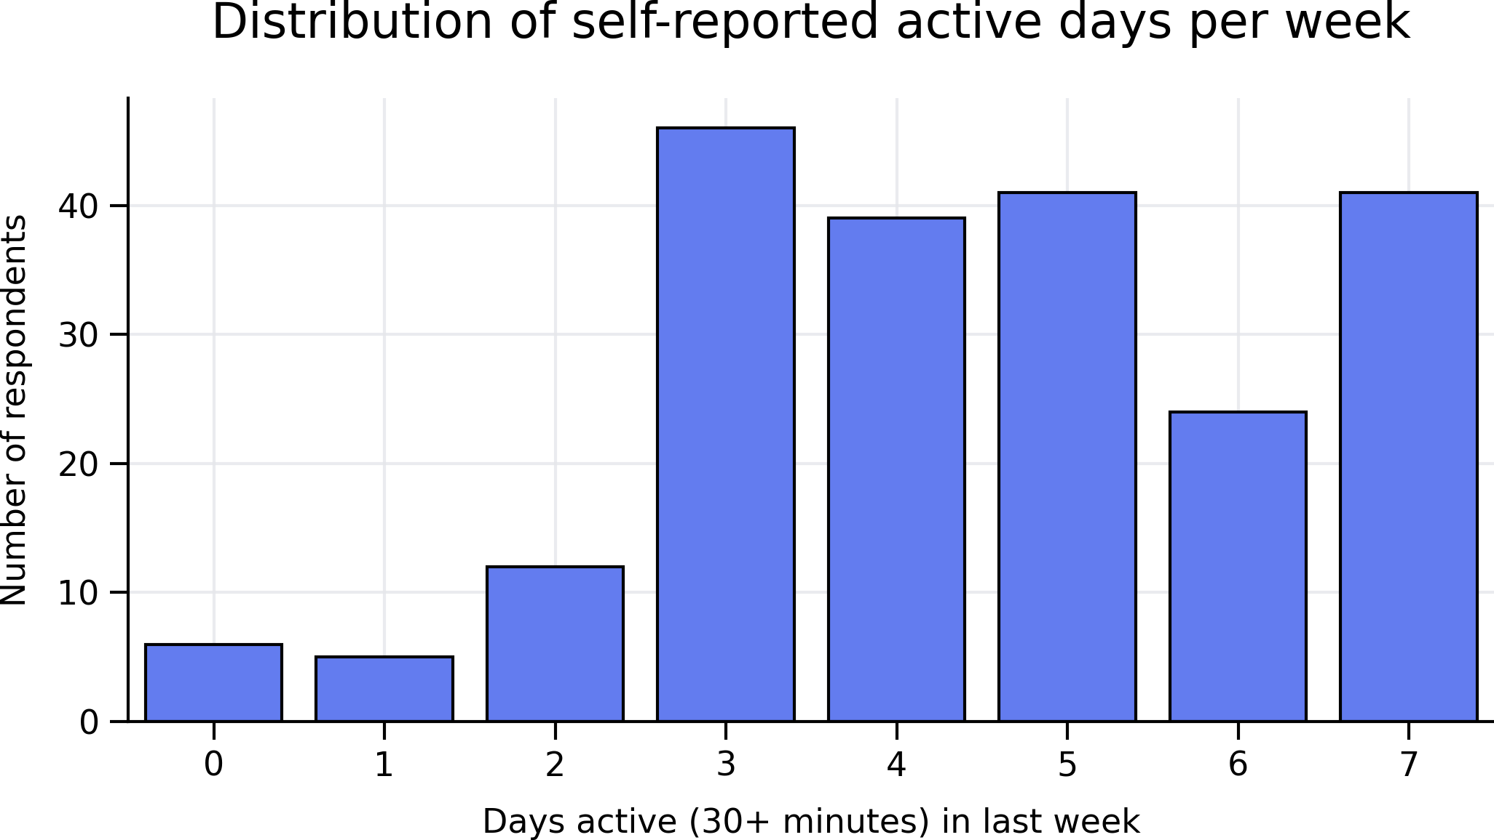
Figure 4.1: Distribution of active days per week (30+ minutes in the last week). n = 214 answered this item.

Using the UK Chief Medical Officers’ guideline of approximately 150 minutes of moderate-intensity activity per week as a reference point, respondents reporting activity on five or more days per week were classified as meeting recommended activity levels. Just under half of the sample met this threshold (Figure 3.2). Importantly, responses were spread across the full activity spectrum, supporting the use of activity frequency as a graded exposure rather than a simple binary distinction between ‘active’ and ‘inactive’ individuals.

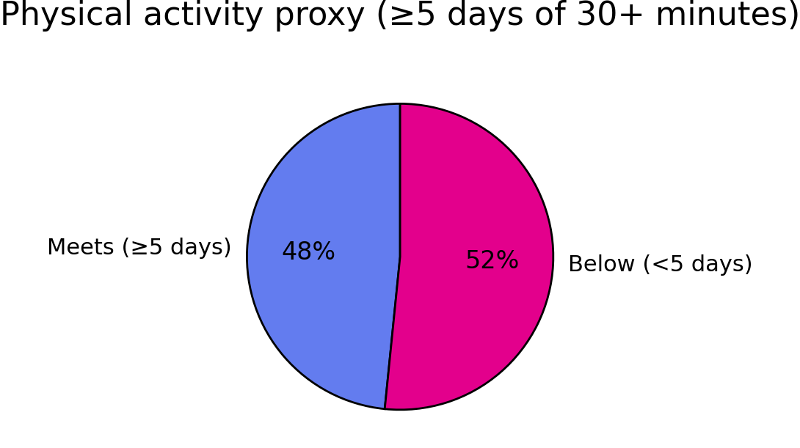
Figure 4.2: Percentage of respondents meeting the UK Chief Medical Officers’ guideline of approximately 150 minutes of moderate-intensity activity per week.

  - Physical Activity Frequency and Subjective Wellbeing

4.2.1 ONS Personal Wellbeing (ONS4)
Subjective wellbeing was assessed using the four Office for National Statistics personal wellbeing measures: life satisfaction, feeling that life is worthwhile, happiness, and anxiety. These measures are widely used in UK population wellbeing research and capture evaluative, eudemonic and affective dimensions of wellbeing, allowing comparison with national benchmarks while remaining accessible to non-specialist audiences (Office for National Statistics (ONS), n.d.).

Analysis revealed a clear graded relationship between physical activity frequency and the three positively framed ONS wellbeing measures. Mean life satisfaction increased progressively as the number of active days per week increased, with particularly pronounced differences observed between respondents reporting very low activity levels (0–1 days per week) and those reporting moderate levels of activity (2–4 days per week), as illustrated in Figure 4.3. At higher activity levels (5–7 days per week), mean life satisfaction remained elevated, with no evidence of decline or plateau within the observed range.

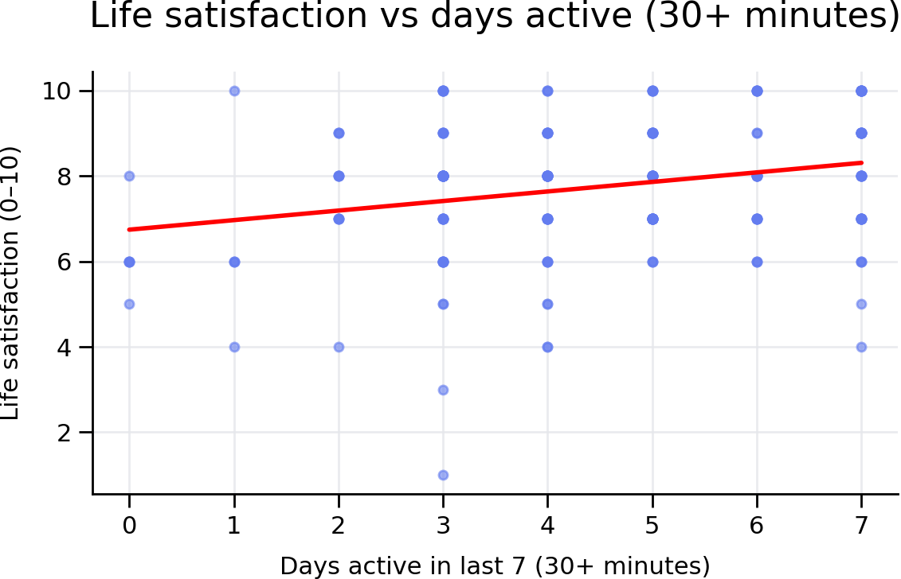
Figure 4.3: Number of days physically active versus life satisfaction.

When life satisfaction is presented using the ONS banded categories, a similar pattern is evident, with respondents reporting higher physical activity frequency more likely to be clustered in the higher life satisfaction bands (Figure 4.4).

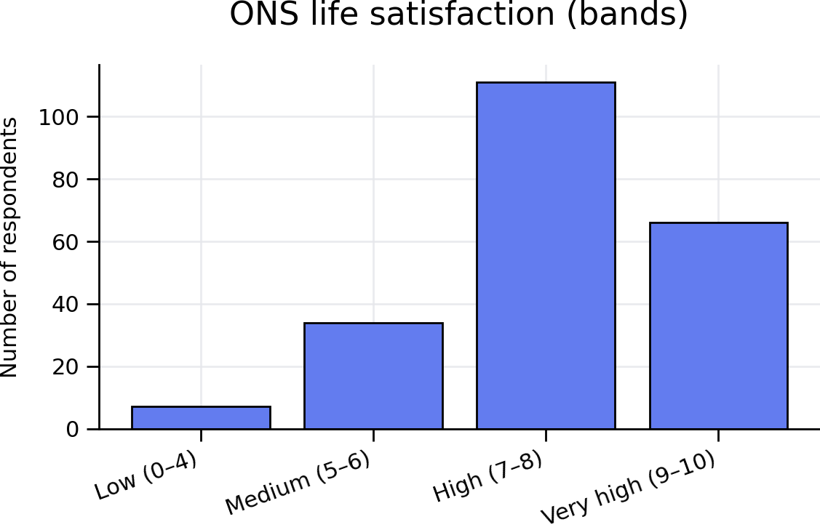
Figure 4.4: Distribution of ONS life satisfaction bands by physical activity frequency.

This convergence strengthens confidence that the observed associations reflect a broad relationship between physical activity frequency and positive subjective wellbeing rather than a single indicator.

Anxiety demonstrated an inverse relationship with activity frequency, with mean anxiety scores decreasing as reported activity increased (Figure 4.5). Given that the anxiety item asks respondents how anxious they felt “yesterday”, this suggests that higher reported activity frequency is associated not only with longer-term evaluations of wellbeing but also with day-to-day emotional experience.

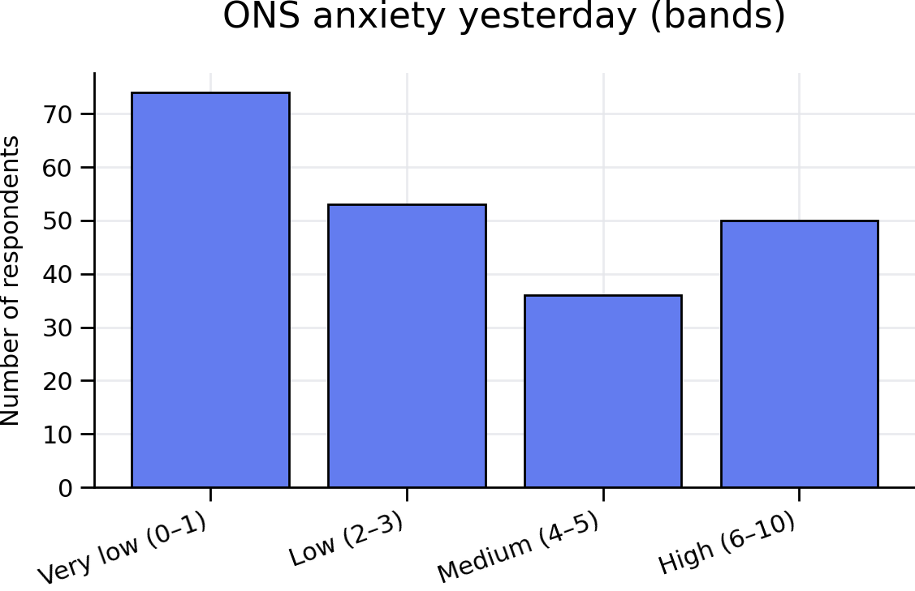
Figure 4.5: Distribution of ONS anxiety bands by physical activity frequency.

Qualitative interview findings, with themes drawn from the interview analysis process described in Appendix E, strongly reinforced these quantitative patterns. Participants often described the value of physical activity not in abstract terms, but through its impact on emotional regulation, coping, and feeling psychologically ‘level’. One participant reflected that being active had helped them manage worries they experienced following retirement, noting that they were now better able to “cope mentally” and that activity helped keep their “head straight” (Participant A). Another participant described exercise as providing emotional stability, rather than dramatic transformation, stating that it “just keeps me feeling level” and prevents a slide into low mood or anxiety (Participant C).

These accounts mirror the graded survey patterns, particularly the marked differences observed between very low and moderate activity levels. Multiple interviewees emphasised that the most meaningful change occurred once activity became regular rather than intensive, suggesting that benefits to wellbeing were accessible below guideline thresholds. As one participant explained, even modest regular activity produced a sense of emotional balance and routine that extended beyond the activity session itself, contributing to better sleep and improved mood throughout the day (Participant A). This helps to explain why the largest gains in life satisfaction observed in Figure 5.2 occur between the lowest and middle activity groups, rather than exclusively at the highest levels of activity.

Interview data also added nuance to the inverse relationship between physical activity and anxiety. While survey results showed lower mean anxiety scores among more active respondents, participants’ narratives revealed that activity functioned as a stabilising influence rather than a complete remedy. One interviewee described feeling “righteously tired” after exercise, explaining that this physical tiredness helped quieten anxious thoughts and promoted better sleep, which in turn improved next-day coping (Participant A). Another participant noted that activity did not eliminate stressors but made them feel more manageable, reinforcing the interpretation of physical activity as a tool for emotional regulation rather than avoidance of difficulty.

Across the strands of evidence, the integration of survey and interview findings suggests that physical activity frequency is associated with subjective wellbeing, with interview accounts pointing to routine, emotional balance and perceived coping capacity as plausible explanatory factors. While causality cannot be inferred from the cross-sectional design, the coherence between graded quantitative associations and lived qualitative accounts strengthens confidence in the relevance of physical activity as a correlate of wellbeing within this population. These findings are consistent with existing evidence linking regular physical activity to improved subjective wellbeing, while also highlighting the importance of modest, sustained participation rather than an exclusive focus on high-intensity or guideline-level activity.

4.2.2 Relative contributions of wellbeing domains

Although all four ONS wellbeing measures displayed broadly consistent associations with physical activity frequency, closer inspection suggests that they reflect related but distinct aspects of lived experience. Life satisfaction and feelings that life is worthwhile capture relatively stable evaluative judgements, which may be influenced by sustained patterns of behaviour, routine and perceived self-efficacy. In contrast, happiness and anxiety are more immediately emotional and likely to be sensitive to short-term fluctuations in daily experience.

The fact that activity frequency was associated not only with higher life satisfaction but also with lower reported anxiety on the previous day is therefore notable. It suggests that the relationship between regular physical activity and wellbeing operates across both longer-term evaluative domains and shorter-term emotional states. Interview narratives provide explanatory texture for this pattern, with participants describing physical activity as helping them feel calmer, sleep better, and cope more effectively with everyday stresses rather than delivering an immediate ‘high’.

Importantly, the convergence across multiple wellbeing domains strengthens confidence in the robustness of the observed associations. Were activity frequency linked to only one measure, it might raise concerns about measurement artefact or construct specificity. Instead, the alignment across life satisfaction, worthwhileness, happiness and anxiety indicates that physical activity frequency is associated with a broad spectrum of subjective wellbeing experiences within this cohort. At the same time, the differentiation between domains highlights that benefits are multifaceted, reinforcing the value of using a suite of wellbeing indicators rather than relying on a single outcome measure.

Considering the data, this pattern suggests that physical activity is not associated with wellbeing in a single, uniform way. Instead, respondents appear to experience a combination of relatively stable improvements (such as feeling more satisfied with life overall) alongside more immediate, day-to-day effects (such as feeling calmer or less anxious). In practical terms, this helps explain why participants often spoke about feeling more ‘level’, sleeping better, or coping more effectively, rather than describing dramatic or transformative changes. It also reinforces why modest, regular participation featured so strongly in interview accounts: these kinds of routines are well suited to producing steady, repeatable benefits across multiple wellbeing domains, even when activity intensity remains relatively low.

4.3 Physical Activity Frequency and Perceived Health
This section examines the relationship between physical activity frequency and perceived health status, using respondents’ self-rated health as measured by the EQ Visual Analogue Scale (EQVAS), alongside descriptive patterns from the EQ-5D-5L dimensions (with particular attention to pain/discomfort and anxiety/depression), consistent with established guidance on the interpretation of EQ-5D health-related quality of life measures (Devlin & Brooks, 2017). Collectively, these measures provide insight into how physical activity frequency relates to individuals’ own assessments of health, functioning and day-to-day capability.

4.3.1 Physical Activity Frequency and EQVAS (Self-rated Health)
Across the eligible sample, EQVAS scores demonstrated a graded positive association with physical activity frequency, increasing progressively as the number of active days per week increased, as illustrated in Figure 4.6.

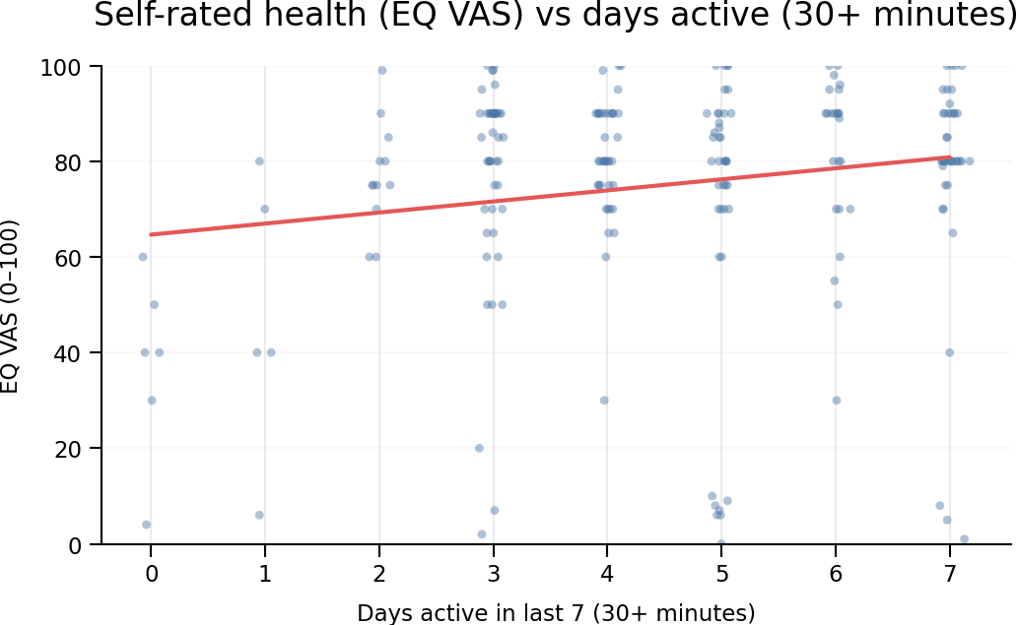
Figure 4.6: Self-rated health (EQ VAS, 0–100) plotted against number of active days in the last week.

While the largest differences were observed between very low and moderate activity levels, further gains in perceived health were still evident at higher activity frequencies. This suggests that higher reported activity levels are associated not only with avoidance of poorer perceived health, but also with progressively higher self-rated health among more active individuals.

Qualitative interview accounts strongly reinforced the interpretation of perceived health as lived functioning rather than abstract “fitness”. Participants repeatedly articulated value through concrete changes in mobility, pain and everyday capability. One participant described entering the programme with severe knee degeneration, stating that their knee was “bone on bone” and that they “could barely get upstairs and had to lock [their] leg and pull [themselves] up”. They reported that even light exercise alongside physiotherapy produced “a massive difference”, enabling them to virtually cut out painkillers and manage stairs again.

Similarly, another participant described improvements in everyday movement following participation, emphasising the practical meaning of health gains: “I can get up out of a chair easily now… going up and down stairs without struggling – I just feel lighter and fitter.” These accounts align with the graded EQVAS pattern in Figure 4.6 by illustrating how perceived health can improve through incremental changes in daily capability and confidence rather than through dramatic medical events.

4.3.2 EQ-5D-5L Descriptive Patterns (Pain/Discomfort and Anxiety/Depression)
Descriptive analysis of the EQ-5D-5L dimensions provides further context for the EQVAS gradient. Across the sample, the majority of respondents reported “no problems” or “slight problems” in domains such as mobility, self-care and usual activities. However, greater variation was observed in pain/discomfort and anxiety/depression, mirroring patterns seen in the ONS wellbeing measures. Respondents reporting higher physical activity frequency were less likely to report moderate or severe problems in these domains.

Interview narratives made clear that pain/discomfort in particular is not a marginal issue for some participants; rather, it is central to how they experience the value of being active. Participant A was explicit that exercise did not “cure” their knee but made life “much more manageable”, reducing constant pain and enabling daily tasks to require less effort and cause less discomfort. Participant D similarly described starting from a position of significant mobility limitation, noting that before engaging regularly they could not manage stairs normally and “had to go down sideways”. They reported that after sustained engagement they could “go up and down stairs normally again” and that their independence had improved to the point of needing “one walking stick now instead of two.”

These lived accounts are consistent with the survey pattern in which pain/discomfort shows greater spread than other EQ-5D-5L domains, and in which higher activity frequency is associated with fewer moderate/severe reports. The qualitative material also highlights an important nuance for interpretation: for participants managing long-term conditions, value is often framed as prevention of decline and maintenance of stability rather than total symptom removal.

4.3.3 Interpreting “Health” as Capability and Independence
A consistent feature across interviews was the framing of health value in terms of capability and independence. Participant D named “independence” as the central value, describing everyday tasks such as lifting, laundry, getting up from the floor, and avoiding injury as the outcomes that mattered most. They also linked improved bone density and reduced fracture risk to sustained weight-bearing exercise, offering a concrete example of how perceived health improvement may be experienced as long-term risk reduction rather than short-term symptom change.

Participant B’s narrative similarly points to health as capability and resilience: after experiencing an episode of sustained high heart rate while cycling, they shifted from endurance activity towards gym-based, load-bearing exercise, explicitly relating this change to ageing and the importance of “bone strength”. They described this shift as producing a different recovery profile, with gym sessions leaving them “more energised” rather than exhausted.

Collectively, the integrated findings suggest that perceived health in this cohort is closely tied to participants’ ability to function independently and manage long-term conditions. While the cross-sectional design precludes causal inference, the coherence between graded EQVAS patterns by activity frequency and participants’ detailed accounts of mobility, pain reduction and daily functioning provides a credible, internally consistent picture of how physical activity may relate to perceived health-related quality of life within this population.

4.3.4 Divergence between EQVAS and EQ-5D descriptive measures
A notable feature of the findings is the apparent divergence between respondents’ global self-rated health (EQVAS) and the persistence of specific problems captured within the EQ-5D-5L descriptive system, particularly pain/discomfort. In several cases, participants reported substantial improvements in EQVAS scores and described feeling healthier overall, despite continuing to experience chronic pain or mobility limitations. This pattern helps clarify why improvements in perceived health are evident even where complete symptom resolution has not occurred.

EQVAS invites respondents to make a holistic judgement about their current health, drawing together physical, psychological and functional considerations into a single summary score. In contrast, the EQ-5D descriptive dimensions require respondents to indicate the presence or absence of specific problems at the time of completion. For participants managing long-term conditions, these two perspectives need not align. Interview accounts suggest that feeling healthier often reflects improved coping, confidence and day-to-day capability rather than the elimination of symptoms. In this sense, EQVAS appears particularly sensitive to incremental gains in manageability and independence.

This distinction is evident in participants’ narratives. Multiple interviewees acknowledged ongoing pain but emphasised that it felt “under control” or “more manageable” as a result of regular activity. Others spoke about being better able to pace themselves, recover more effectively, or avoid flare-ups that previously disrupted daily life. These experiences are readily captured by changes in EQVAS but may not always translate into movement between EQ-5D pain/discomfort categories.

Importantly, this divergence should not be interpreted as inconsistency or measurement weakness. Instead, it highlights the value of using both global and domain-specific measures together. EQVAS captures respondents’ overall sense of health-related quality of life, while the EQ-5D dimensions provide important detail about the nature and persistence of particular problems. When considered alongside qualitative accounts, the combination offers a more complete picture of how physical activity is experienced as beneficial, even in the context of long-term or fluctuating conditions.

4.4 Psychosocial Outcomes: Anxiety and Social Isolation
This section examines the relationship between physical activity frequency and two psychosocial outcomes: anxiety and social isolation. Together, these outcomes extend the analysis beyond physical and evaluative wellbeing to consider how activity relates to day-to-day emotional experience and perceived connectedness.

4.4.1 Physical Activity Frequency and Anxiety
As reported in Section 4.2.1, anxiety scores demonstrated a consistent inverse relationship with physical activity frequency. Respondents reporting lower activity levels tended to report higher anxiety, while those reporting more frequent activity reported lower mean anxiety scores (Figure 4.5). This pattern is notable given that the anxiety item captures anxiety experienced on the previous day, making it sensitive to immediate emotional states. Despite this, habitual activity frequency remained clearly associated with anxiety levels, suggesting that regular engagement in physical activity is linked to more favourable day-to-day emotional experiences.

Interview data offered strong explanatory detail for this pattern. Participants tended not to present activity as eliminating stressors; rather, it was described as a stabilising influence that supports coping and emotional regulation. Participant A described the feeling after exercise as being “righteously tired”, implying a positive fatigue that promotes relaxation and better sleep, which in turn supports next-day coping. They also reported that becoming fitter had made “a big difference” to their ability to manage worries and anxiety following retirement.

4.4.2 Physical Activity Frequency and Social Isolation
Perceived social isolation was measured using a single item derived from the UCLA loneliness scale (how often respondents feel isolated: ‘hardly ever’, ‘some of the time’, ‘often’). Figure 4.7 shows a clear social gradient by physical activity frequency, with respondents reporting higher levels of activity more likely to report feeling isolated “hardly ever”, and those reporting very low activity more likely to report feeling isolated “often”.

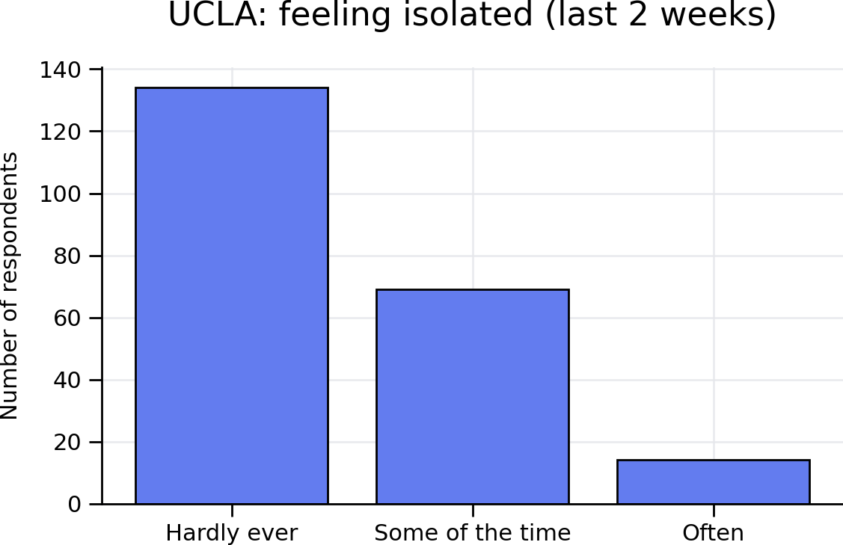
Figure 4.7: Perceived social isolation by physical activity frequency

This pattern suggests that differences in social connectedness are evident not only between those meeting guideline thresholds and those largely inactive, but also between those reporting some activity and those reporting very little. In other words, modest increases in activity frequency may be associated with meaningful differences in perceived connectedness.

4.4.3 Qualitative Elaboration: Belonging Without Social Pressure
The interviews added substantial authenticity to the survey signal by clarifying what “social connection” actually meant to participants. Importantly, social value was not always framed as developing close friendships; rather, it often operated through familiarity, routine interactions, and the confidence to be around others.

Participant A described this in understated terms: they did not report making “close friends” at the gym, but emphasised the importance of regularly seeing and chatting with the same people, interactions they would not otherwise have. In their account, this widened the range of everyday social contact following retirement and relocation.

Participant B similarly noted that at the centre you “see the same faces regularly, even if it’s just a nod or hello”, and that over time these small interactions accumulate into a sense of connection. They also observed that some people train together and then go for coffee afterwards, particularly people living on their own.

Participant C placed particular emphasis on the social dimension as part of wellbeing, describing the value of “exercising with other people, encouraging each other, having a coffee afterwards”, and noted that being active had helped them build a social group after moving to Wales.

Participant D offered a more specific account of social connection as both enabling and bounded. They noted that attending Actif had changed their social world: “If I didn’t go there, I wouldn’t see anybody.” They also described connecting with “a small group of us who are neurodivergent”, where shared understanding reduced social pressure and made connection possible on their own terms.

Taken together, the qualitative findings explain why the survey shows lower isolation among more active respondents: activity provides structured opportunities for contact and belonging, often without requiring intensive social interaction. This is particularly relevant in a public leisure context, where the centre can function as a low-barrier, routine-based social space for people who may otherwise be isolated. At the same time, the interviews also highlight that social value is uneven and conditional: it depends on routine, accessibility, and the extent to which the environment feels safe and inclusive for different individuals.

In summary, physical activity frequency was associated with both lower anxiety and lower perceived social isolation. The quantitative pattern is strongly reinforced by qualitative accounts suggesting that value is experienced through emotional regulation, improved sleep and coping, and through belonging and familiarity within a shared space. As with other findings in this chapter, these associations cannot be interpreted as causal effects; however, the coherence between survey gradients and lived accounts strengthens confidence in the relevance of these psychosocial outcomes to how participants understand the value of being active.

4.5 Threshold Effects: Meeting versus Not Meeting Activity Guidelines
This section examines whether there are observable differences in wellbeing and health outcomes between respondents who meet the UK Chief Medical Officers’ (CMO) physical activity guideline threshold and those who do not. While the earlier sections consider physical activity as a graded exposure, a threshold framing is policy-relevant because it mirrors how physical activity is commonly operationalised in public health reporting and local decision-making.

Respondents were classified into two groups: (i) meeting guidelines (active on five or more days per week, approximating at least 150 minutes of moderate-intensity activity per week), and (ii) not meeting guidelines (active on fewer than five days per week). In line with the graded findings reported earlier, respondents meeting the threshold consistently reported more favourable outcomes across subjective wellbeing, perceived health, anxiety and social isolation (Figures 4.8a–4.8d).

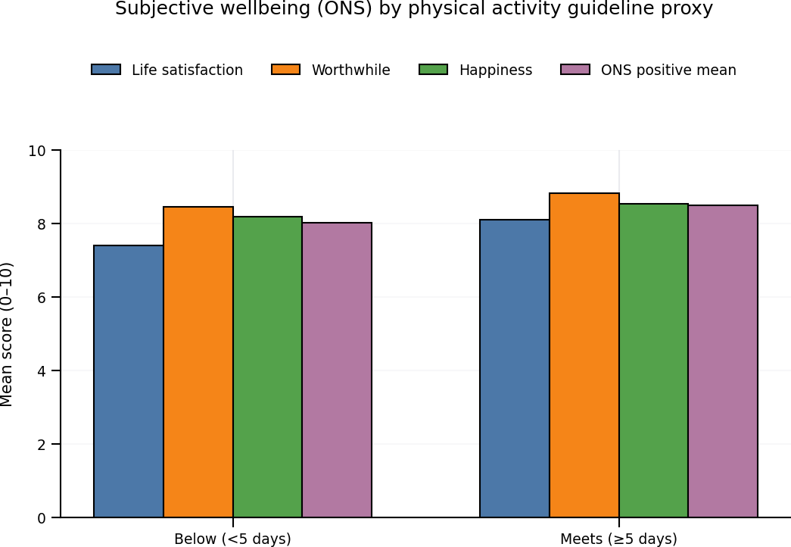
Figure 4.8a: Subjective wellbeing (ONS) by physical activity guideline proxy.

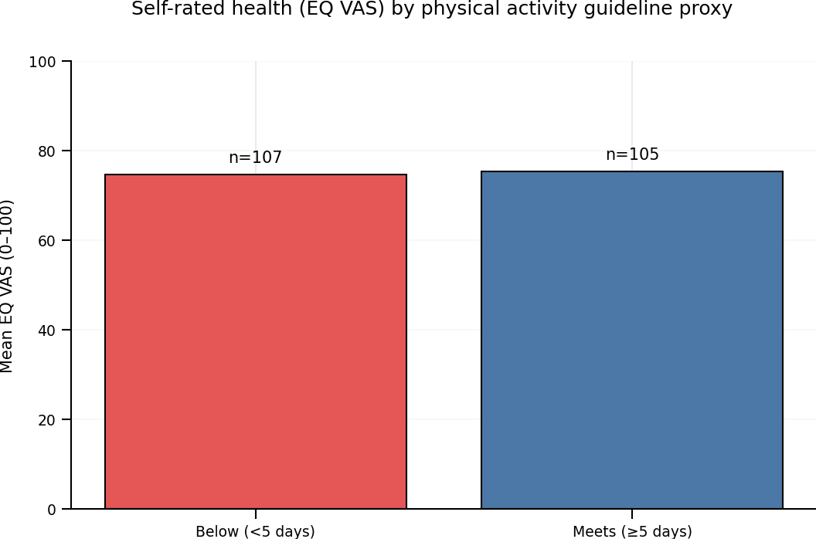
Figure 4.8b: Self-rated health (EQ VAS, 0–100) by physical activity guideline proxy (≥5 days vs <5 days).

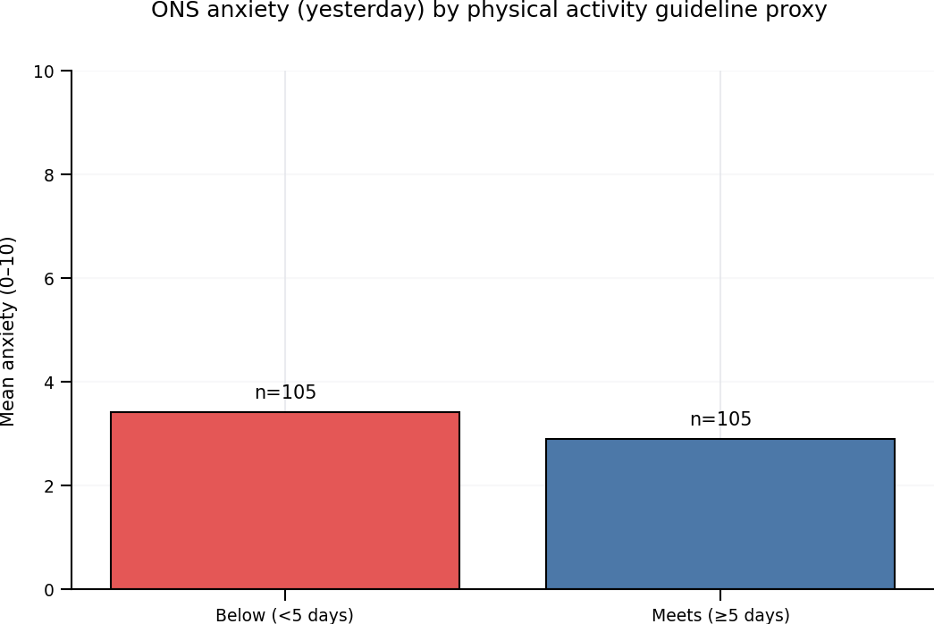
Figure 4.8c: ONS anxiety (yesterday) by physical activity guideline proxy.

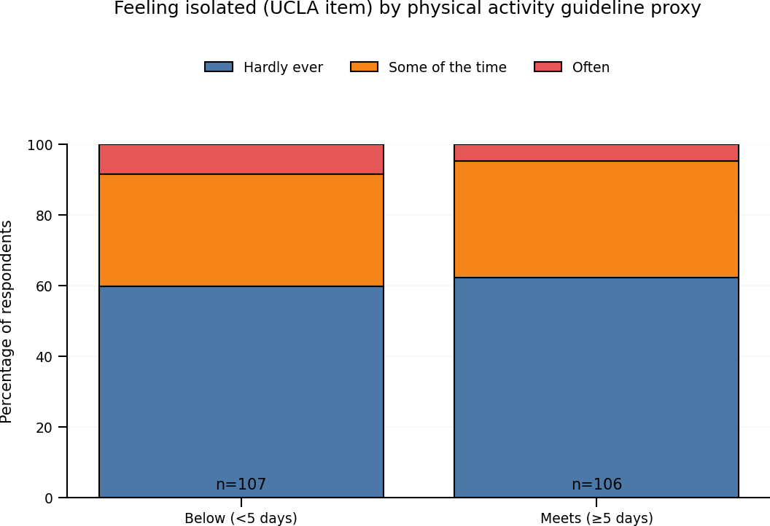
Figure 4.8d: Feeling isolated (UCLA single-item measure) by physical activity guideline proxy.

4.5.1 Quantitative threshold comparisons
Across the ONS wellbeing measures, respondents meeting guideline-level activity reported higher positive wellbeing and lower anxiety than those not meeting the threshold. Similarly, respondents meeting the threshold reported higher mean EQVAS scores and lower perceived social isolation compared with those below the threshold. While the absolute differences were modest, their consistency across domains strengthens the overall pattern observed in this chapter.

4.5.2 Qualitative elaboration: why “regular” matters
The interviews helped explain why the threshold comparison remains meaningful despite the graded nature of the data. Participants frequently framed value not in terms of intensity, but in terms of regularity, routine and the way activity becomes embedded within everyday life. Participant D described their participation pattern as stable and routine-based (“Monday, Wednesday and Friday”), emphasising that routine itself was important and that disruptions (such as school holidays) could undermine wellbeing and adherence.

Participant A similarly emphasised the role of structure, describing early-morning gym attendance as a reason to get up and a “good start to the day”, suggesting that regular participation creates benefits that extend beyond the session through improved daily rhythm and purposeful routine. Participant C’s account illustrated an even stronger embedding of activity in weekly life (12–15 classes per week), explicitly linking regular participation to sustained weight loss, improved mobility and improved sleep.

Considering the evidence, these narratives help to explain why guideline-level engagement is associated with the most consistently favourable survey outcomes: it is more likely to reflect activity that is habitual, planned and integrated into daily life, rather than occasional or sporadic activity. At the same time, the interviews also reinforce the graded finding that meaningful benefits may occur below the threshold. Multiple participants described improvements that began with relatively modest activity (e.g., water-based exercise or light-intensity sessions) and then built over time as participation became more consistent.

In summary, threshold-based analyses provide a policy-aligned perspective on the findings, while qualitative accounts indicate that the ‘threshold’ is experienced less as a binary cut-off and more as a marker of regular, routinised participation. This supports cautious interpretation: guideline-level activity is associated with the most consistently favourable outcomes in this cohort, but benefits are not restricted to this group alone.

4.5.3 Distributional and heterogeneity considerations within the sample
While earlier sections emphasise graded associations between physical activity frequency and health and wellbeing outcomes, closer inspection of both survey dispersion and interview narratives suggests that these relationships are not uniform across the sample. Respondents arrive at physical activity from highly diverse starting points, including differences in age, long-term health conditions, work or retirement status, and prior activity histories. As a result, identical levels of reported weekly activity do not necessarily represent do not necessarily represent the same lived experience.

For respondents reporting low baseline health or long-term musculoskeletal conditions, relatively modest activity levels appear to yield proportionally large perceived gains. Interviewees managing chronic pain, mobility limitation or neurological conditions consistently framed participation as a means of regaining control over daily function rather than progressing toward an external fitness ideal. In these cases, increasing from zero or one active day per week to two or three days represented a meaningful shift in independence and confidence, even where absolute activity volume remained below guideline thresholds. This helps contextualise the quantitative finding that the steepest improvements in wellbeing and EQVAS scores occur between the lowest and middle activity groups.

Conversely, for respondents already active on most days of the week, incremental increases in activity frequency were less visible in self-rated health or wellbeing measures. Interview participants with long-standing activity habits tended to frame value in terms of maintenance rather than improvement, emphasising avoiding decline, managing ageing, and sustaining routine. These narratives align with the quantitative observation that wellbeing scores plateau at higher activity levels rather than continuing to rise linearly. Together, these patterns suggest that aggregate mean scores conceal important distributional effects, where value is greatest for those furthest from where value is greatest for those starting from the lowest baseline.

This heterogeneity reinforces the analytical choice to treat physical activity frequency as a graded exposure rather than a binary indicator. It also cautions against interpreting average effects as equally applicable across the population, an issue that becomes particularly salient when considering monetised wellbeing values that implicitly average gains across individuals with very different baseline needs.

4.5.4 Boundary cases, barriers and non-linear effects
Although the overall findings indicate positive associations between activity frequency and outcomes, both quantitative and qualitative data point to boundary cases where engagement is fragile or benefits are contingent on external factors. Multiple interviewees described periods where illness, caregiving responsibilities, seasonal disruption or facility closures reduced their ability to sustain routine participation. These disruptions were frequently accompanied by declines in mood, sleep quality or perceived coping, even when participants remained motivated to be active.

Such accounts highlight that observed associations are embedded within broader social and organisational contexts. Access to facilities, consistency of timetabling, affordability, and perceived environmental safety all emerged indirectly through interviews as conditions that shape how activity is experienced and whether it is reflected in wellbeing outcomes. When these conditions are absent, frequency alone may be a poor proxy for lived experience, helping to explain some variability in survey responses within the same activity categories.

Importantly, no evidence was found of negative wellbeing effects associated with higher activity frequency within the observed range. Neither survey data nor interviews suggested overtraining, burnout or increased anxiety among the most active respondents. Instead, those reporting very high participation tended to emphasise self-regulation, enjoyment and social reinforcement as protective factors. This supports the interpretation that, within this cohort, higher activity reflects successful integration into daily life rather than coercive or externally pressured behaviour.

Together, these boundary observations add nuance to the main findings by clarifying the conditions under which activity frequency is most likely to be associated with positive outcomes, and where caution is needed in extrapolating benefits.

4.6 Indicative WELLBY-Based Monetisation of Wellbeing Outcomes
This section explores whether the observed wellbeing outcomes can be expressed in financial terms using a WELLBY-based approach. Consistent with the Green Book supplementary wellbeing guidance, all WELLBY estimates are presented as illustrative scenarios rather than estimates of impact due to the cross-sectional design and the absence of a measured baseline or control group (HM Treasury, 2022).

A WELLBY (wellbeing-adjusted life year) is typically defined as a one-point change in life satisfaction (0–10) for one person for one year, which can be aggregated and (where appropriate) monetised for appraisal purposes. This aligns with wider wellbeing-economics literature, which positions wellbeing valuation as a structured way of informing appraisal and comparison, rather than as a complete representation of lived experience (Frijters, et al., 2020). However, the Green Book guidance emphasises that credible monetisation depends on establishing a plausible counterfactual and making attribution assumptions explicit (HM Treasury, 2022).

To illustrate both the potential scale and the sensitivity to assumptions, two valuation routes were applied. Across both routes, the monetised conversion uses a unit value of £13,000 per WELLBY (2019 prices):
- Route A (Benchmark scenario): uses the difference between the sample’s observed mean life satisfaction and a national benchmark as an illustrative upper-bound WELLBY effect (explicitly not a causal estimate).
- Route B (National-model-aligned transfer values): applies published, WELLBY-derived per-person annual wellbeing values associated with physical activity status (as used in national social value modelling), treating these as transferable “policy-aligned” estimates rather than measured local effects.

4.6.1 Route A: Benchmark-based WELLBY scenario (respondent cohort)
For the eligible respondent cohort (n = 219), the mean life satisfaction score was 7.73. The benchmark scenario uses an illustrative UK mean life satisfaction of 7.45, yielding a difference of 0.284 points. This difference is treated as an upper-bound scenario because the respondent sample may differ systematically from the benchmark population (for example due to self-selection into membership and survey response).

WELLBY conversion. Under the simplifying assumption of one-year duration, the indicative WELLBYs for the cohort are:
- WELLBYs = difference in life satisfaction × people × 1 year =
0.284 × 219 = 62.18 WELLBYs.
Applying £13,000 per WELLBY produces an indicative unadjusted monetary value of £808,391 per year for the respondent cohort. Because attribution cannot be established from this dataset alone, an attribution sensitivity is shown to illustrate uncertainty:
- 25% attribution: £202,098
- 50% attribution: £404,196
- 75% attribution: £606,293
- 100% attribution (upper): £808,391

This range is not presented as the “true” value of Actif; rather it demonstrates the degree to which WELLBY monetisation depends on assumptions about counterfactual wellbeing and attribution, consistent with the Green Book emphasis on transparency. Indicative scaling of wellbeing-based values is undertaken with reference to the defined eligible membership cohort, derived using the filtering criteria set out in Appendix F.

4.6.2 Route A scaled to the filtered membership list (n = 1,719)
To illustrate potential scale, the respondent-cohort Route A results were scaled to the filtered membership list of 1,719 adult members used for survey distribution (explicitly assuming representativeness of respondents to that filtered list). The scaling factor is 1,719 / 219 = 7.8493.
Under this assumption:
- Route A: 488.1 WELLBYs (population, 1 year)
- Route A £ value (unadjusted; 2019 prices): £6,345,318 per year
- Attribution sensitivity:
  - 25%: £1,586,329
  - 50%: £3,172,659
  - 75%: £4,758,988
  - 100% (upper): £6,345,318

This scaled result is reported as indicative and is included primarily to demonstrate magnitude and sensitivity, not to claim that Actif causes an equivalent change in life satisfaction. The key empirical point is that monetised wellbeing valuations can vary by millions of pounds depending on benchmark choice and attribution framing.

4.6.3 Route B: National-model-aligned transfer values (respondent cohort)
Route B applies published, WELLBY-derived per-person annual wellbeing values associated with being “active” versus alternative comparator categories. In this study, respondents were split into two proxy activity groups based on days active (≥5 days versus <5 days): Meets n = 106 and Below n = 113. Two comparator scenarios are shown because the valuation depends materially on how the “Below” group maps onto national activity categories.
- Route B1 (conservative comparator): treat “Below” as “fairly active” and apply an incremental uplift of £1,300 per person per year for those meeting the proxy. This yields £137,800 per year for the cohort (106 x £1,300).
- Route B2 (upper comparator): treat “Below” as “inactive” and value “Meets” at £2,500 per person per year, yielding £265,000 per year for the cohort (106 x £2,500).

These are intentionally framed as transfer estimates (aligning local interpretation with national modelling practice) rather than observed local effects.

4.6.4 Route B scaled to the filtered membership list (n = 1,719)
Using the same representativeness assumption as above, Route B was also scaled to the filtered membership list. The estimated counts in the population were 832 meeting the proxy and 887 below the proxy. Under these assumptions, the annual values were:
- Route B1 scaled: £1,081,636 per year (Meets uplift vs fairly active)
- Route B2 scaled: £2,080,068 per year (Meets valued vs inactive)

As with Route B, these figures are included to demonstrate how different but defensible valuation framings produce substantially different totals, reinforcing that wellbeing-based financial values should be treated as sensemaking tools rather than definitive measures.

4.6.5 Lived value and the limits of monetisation (qualitative alignment)
The interviews provide a crucial “human validity” check on what these monetised values do and do not capture. Participants frequently expressed value in everyday terms such as independence, reduced pain, routine and belonging, but were clear that these experiences cannot be fully captured in financial terms.

First, participants framed value as capability and independence, often expressed through ordinary daily tasks rather than abstract wellbeing scores. Participant D explicitly identified “independence” as the central value and described everyday functioning outcomes such as being able to get up from the floor, lift laundry safely, and walk without injury; changes that are meaningful yet not easily summarised by a single annualised metric.

Second, participants frequently described value as prevention and self-management, rather than the narrow avoidance of health services. This helps contextualise why survey items about reduced GP/health professional use may produce weaker signals even where wellbeing and perceived health are strongly positive: the valued outcome is often “keeping things manageable”, not claiming a direct reduction in service utilisation. For example, Participant A stated that exercise does not “cure” their knee but makes life “much more manageable”.

Third, when asked directly about financial value, participants were clear that perceived worth exceeds cost and that monetary figures do not fully represent personal value. Participant C stated: “Feeling healthy is worth far more than any financial calculation.” Participant B similarly acknowledged the usefulness of tracking outcomes but noted that “the financial side doesn’t capture the full picture.”

Collectively, the qualitative findings do not render WELLBY valuation irrelevant; rather, they show why a single monetised value is insufficient as a standalone account of ‘true value’. The evidence suggests that wellbeing monetisation can help communicate scale and support strategic conversations, but it must sit alongside qualitative accounts that capture dignity, independence, routine and belonging. These are dimensions of value that participants repeatedly emphasised and that may otherwise be obscured when results are presented solely as a financial figure.

4.6.6 Behaviour of WELLBY estimates and scaling assumptions
An important empirical finding of this study relates not only to the magnitude of the WELLBY-based values produced, but to how those values behave under different assumptions about scope and scale. In particular, the contrast between cohort-level estimates, scaled estimates, and nationally aligned transfer values illustrates how sensitive wellbeing monetisation is to decisions about population definition.

In this analysis, scaled estimates were calculated using a filtered membership population of 1,719 eligible members. This figure reflects the subset of Actif Sport & Leisure memberships that met the inclusion criteria applied for survey distribution, following internal data filtering carried out by the organisation. Scaling the respondent-cohort results to this filtered population therefore represents a conservative and defensible assumption: it assumes only that wellbeing effects observed among respondents may reasonably apply across the same pool of eligible members from which the sample was drawn.

Crucially, this scaling should be understood as a minimum scope assumption, not an estimate of the total population to which wellbeing benefits might plausibly apply. In practice, Actif services are accessed by a much wider range of members and participants than those captured within the filtered dataset used for this study. However, because data for those wider groups were not extracted or cleaned to the same standard, extending monetised estimates beyond the 1,719 eligible members would require stronger assumptions than can be supported by the available evidence. The decision to scale only to this filtered population therefore reflects analytical caution rather than a claim about the upper limit of social value.

Viewed in this light, the behaviour of the WELLBY estimates is itself informative. Route A values increase rapidly when scaled, not because individual effects are assumed to be large, but because even modest per-person wellbeing differences translate into substantial aggregate values when applied across a defined population. Route B values, by contrast, remain more constrained because they rely on externally derived per-person transfer values that implicitly embed national averages and conservative modelling assumptions. The spread between these approaches demonstrates that wellbeing monetisation is highly sensitive to population boundary choices, and that transparent reporting of those choices is as important as the headline figures themselves.

Taken together, these findings reinforce the interpretation of WELLBY-based monetisation as a sensemaking tool rather than a precise measure of impact. The scaled estimates illustrate the potential order of magnitude of wellbeing value within a clearly defined membership population, while also making explicit that the true scope of social value is likely to extend beyond the bounds of what has been quantified here. This reinforces the importance of presenting monetised wellbeing values alongside qualitative and descriptive evidence, rather than treating them as exhaustive representations of value.

4.7 Qualitative Interview Findings: Lived Experience of Value
Qualitative interviews provide critical context for interpreting the quantitative patterns and monetised estimates. Across interviews, participants consistently framed the value of physical activity in terms of everyday functioning and independence, mental wellbeing, structure and routine, and social connection without pressure.

Participants emphasised ordinary but meaningful changes, such as managing stairs, getting up from chairs, sleeping better, and feeling more confident in daily life. Mentally, activity was described as helping participants feel ‘level’, cope better with worries, and maintain emotional balance. Social value was often expressed not through deep relationships but through familiarity, shared space, and reduced isolation. Importantly, participants framed value as prevention and self-management rather than avoidance of healthcare services, and consistently reported that perceived personal value exceeded financial cost.

4.8 Triangulation of Quantitative, WELLBY and Qualitative Findings
Bringing the strands together reveals strong convergence between survey patterns and interview accounts. Graded associations between activity frequency and wellbeing align with participants’ descriptions of incremental benefits, particularly at lower activity levels. Threshold-based survey results mirror participants’ accounts of routine and confidence associated with regular participation. Where monetised WELLBY values appear large or abstract, interview data help explain what those wellbeing gains consist of in lived terms and where financial valuation fails to capture aspects such as dignity, independence and belonging.

Together, the integrated findings demonstrate that while wellbeing-based monetisation can be a useful way of communicating scale, it does not fully reflect how participants themselves understand value. The findings therefore support a plural, mixed-methods approach to valuing physical activity, combining quantitative indicators, cautious financial valuation and qualitative insight to inform local decision-making.

- Conclusions & Recommendations

This dissertation set out to examine a question that is central to public leisure provision: what is the true value of physical activity, and how that value can be evidenced in a way that is both academically credible and practically useful within a local authority context? The study was designed deliberately as a mixed-methods project, recognising that value is not singular or easily reduced to one metric. Some aspects of value lend themselves to measurement and comparison; others are experienced unevenly, quietly, and over time. The challenge for public leisure is therefore not whether physical activity matters, but how its value is communicated convincingly in an environment where financial pressures often dominate decision-making.

A first conclusion is the strong internal consistency of the findings. Across the quantitative survey, wellbeing-based monetisation and qualitative interviews, physical activity frequency was consistently associated with more favourable outcomes in subjective wellbeing, perceived health, anxiety and social isolation. These associations were both graded, with improvements visible across the activity spectrum, and policy-relevant, with those meeting guideline-level activity generally reporting the most favourable profiles. Importantly, the findings do not support a narrow interpretation in which only high levels of activity are valuable. The clearest differences were observed between very low activity and modest, regular participation — a pattern that was repeatedly echoed in the interview data. Participants described value not in terms of dramatic transformation, but as feeling more level, coping better, sleeping better, and managing everyday life with greater confidence. In practical terms, the findings reinforce the importance of regularity and routine, rather than intensity alone, as a pathway to value.

A second conclusion relates to how health improvement is understood and experienced. Survey findings showed a clear association between activity frequency and self-rated health (EQ VAS), yet interview accounts rarely framed health gains in terms of cure or symptom resolution. Instead, participants consistently described value through capability and independence: being able to manage stairs, get up from a chair, rely less on pain medication, and maintain function over time. Addressing the divergence between global self-rated health and persistent pain or limitation is therefore important. Physical activity was experienced as improving overall quality of life even where long-term conditions remained. This offers a more realistic account of preventive value and aligns with wider debates in health-related quality-of-life measurement, which caution against equating impact solely with clinical change (Devlin & Brooks, 2017).

The third conclusion concerns financial social value and monetisation. The WELLBY-based scenarios illustrate that wellbeing-based valuation can communicate substantial scale, even when applied conservatively. For a local authority provider, this matters: monetised figures offer a shared language that can help balance purely cost-focused discussions and support comparison across different forms of investment (HM Treasury, 2022). At the same time, the analysis shows clearly that such valuations are highly sensitive to decisions about benchmarks, attribution and population scope. The same dataset can generate materially different totals depending on how these assumptions are set. This sensitivity is not a flaw in the approach, but an important finding in itself, reinforcing why monetised values should not be treated as definitive.

Qualitative evidence provides an essential counter-balance to this. Participants expressed value in everyday terms such as independence, reduced pain, routine and belonging, while being clear that these experiences cannot be fully captured in financial terms. Taken together, the integrated findings show that while wellbeing-based monetisation can be a useful way of communicating scale, it does not fully reflect how participants themselves understand value. This supports existing critiques of over-reliance on single monetised figures and underlines the importance of transparency and plural approaches when social value is used in public decision-making (Arvidson & Lyon, 2014) (Maier, et al., 2015).

From an applied perspective, the study highlights the importance of clear population definition and analytical restraint. Scaling monetised estimates to the filtered eligible membership population used for survey distribution represents a minimum defensible scope, grounded in available data. The decision not to extrapolate further is not a claim that value stops there, but a deliberate choice to avoid over-claiming. In a context where social value figures are increasingly scrutinised in commissioning and governance settings, this kind of restraint strengthens credibility rather than weakening the case (Shields, et al., 2025).

The findings also reinforce the value of qualitative evidence as a governance tool, rather than simply an academic addition. While qualitative methods are more resource-intensive and less standardised than survey reporting, even small amounts of carefully selected lived experience evidence help prevent abstract numbers from being misinterpreted. In this study, interviews did not seek to “prove” impact, but provided face validity, explanatory depth and balance, ensuring that the human meaning of value remains visible alongside monetised estimates.

5.1 Recommendations for Practice
Based on the findings, five practical recommendations are proposed for Actif Sport and Leisure and similar public leisure providers.

First, adopt a multi-lens approach to reporting value. Rather than relying on a single figure, reporting should routinely combine: (i) a small number of clear outcome indicators (such as ONS wellbeing, EQ VAS and social isolation); (ii) a carefully caveated, indicative range of monetised wellbeing value; and (iii) short lived-experience accounts aligned to the same themes. Together, these provide a more rounded and defensible account of value.

Second, be explicit about scope and assumptions when presenting financial social value. Population definitions, attribution assumptions and valuation choices should be clearly stated, with monetised values framed as indicative rather than definitive. This reduces the risk of social value being treated as performance theatre rather than evidence (Shields, et al., 2025).

Third, prioritise regularity and manageability in service design. The strongest wellbeing gradients were observed at the low-to-moderate end of activity frequency, suggesting that accessible entry points, consistent routines and supportive progression pathways may deliver greater value than a narrow focus on intensity or throughput.

Fourth, protect the conditions that enable routine participation. Issues such as timetabling stability, affordability and accessibility are not simply operational concerns; they shape whether participation translates into wellbeing benefit, particularly for those starting from lower baselines.

Finally, embed light-touch qualitative sense-checking. Rather than attempting large-scale qualitative programmes, simple mechanisms such as periodic “most valuable change” prompts or short, focused interviews can provide ongoing insight into lived value without creating excessive burden.

5.2 Limitations and Future Research
As with many applied, work-based studies, this research has limitations. The cross-sectional design does not allow for causal inference, and the scope of monetised valuation is constrained by data availability. Future research could strengthen attribution through longitudinal designs, pre- and post-programme measurement, or the use of referral and retention data. Extending data extraction to wider participant groups would also support cautious expansion of valuation scope while maintaining the transparency standards established here.

5.3 Final Conclusion
In conclusion, the dissertation supports a clear position: physical activity within Actif Sport and Leisure generates value that is visible, meaningful and consistent across quantitative measures and lived experience. That value can be expressed, cautiously, in financial terms, and doing so has practical utility in local authority decision-making. However, the study also shows why no single monetised figure can capture the full nature of that value. A plural, transparent approach – using monetisation as one lens while keeping everyday experience, capability and dignity in view – is therefore the most defensible way forward. This interpretation is consistent with frameworks in wellbeing economics that emphasise the role of wellbeing valuation as a guide for decision-making, rather than a definitive statement of personal value (Frijters, et al., 2020).

- Reference list

4Global, n.d. Social Value Calculator. [Online]
Available at: https://web.datahubclub.com/datahub-club/local-authorities/social-value-calculator/
[Accessed 7 March 2026].
Alharahsheh, H. & Pius, A., 2020. A review of key paradigms: Positivism vs Interpretivism. Global Academic Journal of Humanities and Social Sciences, 2(3), pp. 39-43.
Arvidson, M. & Lyon, F., 2014. Social impact measurement and non-profit organisations: compliance, resistance and promotion’. Voluntas, 25(4), pp. 869-886.
Berkovic, D., Ayton, D., Briggs, A. M. & Ackerman, I. N., 2020. The View From the Inside: Positionality and Insider Research. International Journal of Qualitative Methods, p. 19.
Brazier, J. & Tsuchiya, A., 2015. Preference-based measures of health-related quality of life. Medical Decision Making, 35(2), pp. 182-193.
Carmarthenshire County Council, 2019. Carmarthenshire County Council. [Online]
Available at: https://carmarthenshire.oc2.uk/document/6/2430
[Accessed 7 March 2026].
Carmarthenshire County Council, 2023. Carmarthenshire County Councl. [Online]
Available at: https://democracy.carmarthenshire.gov.wales/documents/s77512/
[Accessed 3 February 2026].
Carmarthenshire Public Services Board, 2023. The Carmarthenshire We Want. [Online]
Available at: https://www.thecarmarthenshirewewant.wales/media/st1hdb23/psb-well-being-plan.pdf
[Accessed 3 February 2026].
Clifford, J., Markey, K. & Malpani, N., 2013. Measuring Social Impact in Social Enterprise: The , London: E3M.
Dalziel, P., Saunders, C. & Saunders, J., 2018. Wellbeing economics: the capabilities approach to prosperity.. 1 ed. Cham: Springer.
Devlin, N. & Brooks, R., 2017. EQ-5D and the EuroQol Group: past, present and future. Applied Health Economics and Health Policy, 15(2), p. 127–137.
Dolan, P., Layard, R. & Metcalfe, R., 2019. Measuring subjective wellbeing: recommendations on measures for use by national governments. Journal of Public Economics, Volume 174, pp. 18-29.
Downward, P. & Rasciute, S., 2011. Does sport make you happy? An analysis of the well-being derived from sports participation. International Review of Applied Economics, 25(3), p. 331–348.
Duijvestijn, M., de Wit, G., van Gils, P. & Wendel-Vos, G., 2023. Impact of physical activity on healthcare costs: a systematic review. BMC Health Services Research, Volume 23, p. 572.
Frijters, P., Krekel, C. & Layard, R., 2020. A unified framework for well-being measurement and valuation. Journal of Economic Inequality, 18(2), p. 151–170..
Hafner, M. et al., 2020. Estimating the global economic benefits of physically active populations over 30 years (2020–2050). British Journal of Sports Medicine, 54(24), pp. 1482-1487.
Hallal, P., Lee, I., Sarmiento, O. & Powell, K., 2024. The future of physical activity: from sick individuals to healthy populations. International Journal of Epidemiology, 53(5), p. 129.
Heckel, L. et al., 2024. A systematic review of the wellbeing benefits of being active through leisure and fitness centres. Leisure Studies, 43(4), pp. 545-561.
Higgerson, J. et al., 2018. Impact of free access to leisure facilities and community outreach on inequalities in physical activity: a quasi-experimental study. Journal of Epidemiology & Community Health, 72(3), pp. 252-258.
HM Treasury, 2022. The Green Book: supplemenary guidance on wellbeing, London: HM Treasury (UK Government).
Johnson, R. & Onwuegbuzie, A., 2004. Mixed methods research: A research paradigm whose time has come. Educational Researcher, 33(7), pp. 14-26.
Jones, S. et al., 2024. Thinking about inequalities in physical activity as an emergent feature of complex systems. International Journal of Behavioral Nutrition and Physical Activity, Volume 21, p. 125.
Kahneman, D. & Deaton, A., 2010. High income improves evaluation of life but not emotional well-being. PNAS, 107(38), pp. 16489-16493.
Killingsworth, M. A., Kahneman, D. & Mellers, B., 2023. Income and emotional well-being: A conflict resolved. PNAS, 120(10).
Layard, R., Oparina, E. & De Neve, J.-E., 2021. Living long and living well: the WELLBY approach, World Happiness Report, New York: Sustainable Development Solutions Network.
Lynch, J., 2024. Embedding social value in procurement. [Online]
Available at: https://wcpp.org.uk/publication/embedding-social-value-in-procurement/
[Accessed 26 November 2025].
Maier, F., Schober, C., Simsa, R. & Millner, R., 2015. SROI as a method for evaluation research: understanding merits and limitations. Voluntas, 26(5), pp. 1805-1830.
Marquez, D. et al., 2020. A systematic review of physical activity and quality of life and well-being. Translational Behavioral Medicine, 10(5), p. 1098–1109.
Nicholls, J., Lawlor, E., Neitzert, E. & Goodspeed, T., 2012. A guide to social return on investtment, London: Cabinet Office (UK Government).
Nichols, G., Findlay-King, L. & Forbes, D., 2020. The Community Asset Transfer of Leisure Facilities in the UK: A Review and Research Agenda. Voluntas, Volume 31, pp. 1159-1172.
Office for National Statistics (ONS), n.d. Measuring progress, well-being and beyond GDP. [Online]
Available at: https://www.ons.gov.uk/peoplepopulationandcommunity/wellbeing
[Accessed 19 April 2026].
Parker, G. & Lloyd, G., 2017. The rise of social enterprise in UK leisure services: Managing the balance between social goals and financial viability. Managing Sport and Leisure, 22(3), pp. 165-180.
Portes, A., 1998. Social capital: its origins and applications in modern sociology. Annual Review of Sociology, 24(1), pp. 1-24.
Santos, A. et al., 2023. The cost of inaction on physical inactivity to public health-care systems: a population-attributable fraction analysis. The Lancet Global Health, 11(1), pp. 32-39.
Saunders, M., Lewis, P. & Thornhill, A., 2019. Research Methods for Business Students. 8 ed. Harlow: Pearson.
Scott, C., 2022. Providing policymakers with the evidence of the true value of physical activity to individuals and communities. European Journal of Public Health, 32(2), p. ii5.
Sheffield Hallam University, 2024. Sport and physical activity generate over £100 billion in social value. [Online]
Available at: https://www.shu.ac.uk/news/all-articles/latest-news/sport-social-value
[Accessed 03 June 2025].
Sheffield Hallam University, 2025. Health, wealth and happiness - the £123bn social value of activity. [Online]
Available at: https://www.shu.ac.uk/news/all-articles/latest-news/Health,%20wealth%20and%20happiness%20-%20the%20%C2%A3123bn%20social%20value%20of%20activity
[Accessed 7 March 2026].
Shields, P. et al., 2025. Social value—are we measuring up?. Public Money & Management, 5 August.
Sport England, 2024. Sport and physical activity generates over £100 billion in social value. [Online]
Available at: https://www.sportengland.org/news-and-inspiration/sport-and-physical-activity-generates-over-100-billion-social-value
[Accessed 7 March 2026].
Sport England, 2025a. Social value and return on investment of sport and physical activity. [Online]
Available at: https://www.sportengland.org/research-and-data/research/social-value-and-return-investment-sport-and-physical-activity
[Accessed 7 March 2026].
Sport England, 2025b. Social value of sport and physical activity 2023-24 primary report. [Online]
Available at: https://www.activelincolnshire.com/uploads/Social-value-of-sport-and-physical-activity-2023-24-primary_report.pdf
[Accessed 7 March 2026].
Sport Wales, 2025. Social Return on Investment of Sport in Wales. [Online]
Available at: https://www.sport.wales/research-and-insight/social-return-on-investment/
SPORTA, 2018. Written evidence submitted by The Sports and Recreation Trusts Association (SPORTA) to the Public Administration and Constitutional Affairs Committee. [Online]
Available at: https://committees.parliament.uk/writtenevidence/89344/html/
[Accessed 29 December 2025].
Warburton, D. & Bredin, S., 2017. Health benefits of physical activity: a systematic review of current systematic reviews. Current Opinion in Cardiology, 32(5), pp. 541-556.
Welsh Government, 2025. Well-being of Future Generations (Wales) Act 2015: the essentials. [Online]
Available at: https://www.gov.wales/well-being-future-generations-act-essentials-html
[Accessed 26 November 2025].

- Appendices

Appendix A: Ethics form
APPLICATION FOR ETHICAL APPROVAL

In order for research to result in benefit and minimise risk of harm, it must be conducted ethically. A researcher may not be covered by the University’s insurance if ethical approval has not been obtained prior to commencement.

The University follows the OECD Frascati manual definition of research activity: “creative work undertaken on a systematic basis in order to increase the stock of knowledge, including knowledge of man, culture and society, and the use of this stock of knowledge to devise new applications”. As such this covers activities undertaken by members of staff, postgraduate research students, and both taught postgraduate and undergraduate students working on dissertations/projects.

The individual undertaking the research activity is known as the “principal researcher”.

Ethical approval is not required for routine audits, performance reviews, quality assurance studies, testing within normal educational requirements, and literary or artistic criticism.

Please read the notes for guidance before completing ALL sections of the form.

This form must be completed and approved prior to undertaking any research activity. Please see Checklist for details of process for different categories of application.

SECTION A: About You (Principal Researcher)
1 | Full Name: |  | Carl Daniels
2 | Tick all boxes that apply: |  | Member of staff: | ☐ | Honorary research fellow: | ☐
 | Undergraduate Student | ☐ | Taught Postgraduate Student | ☐ | Postgraduate Research Student | ☒

3 | Institute/Academic Discipline/Centre: | Professional Practice Framework  Institute of Management and Health
4 | Campus: | Carmarthen
5 | E-mail address: | cadaniels@carmarthenshire.gov.uk (although student email is 97011030@student.uwtsd.ac.uk but I don’t tend to access)
6 | Contact Telephone Number: | 07875647078
 | For students:
7 | Student Number: | 97011030
8 | Programme of Study: | MA in Professional Practice
9 | Director of Studies/Supervisor: | Sarah Loxdale / Lowri Harris

SECTION B: Approval for Research Activity
1 | Has the research activity received approval in principle?  (please check the Guidance Notes as to the appropriate approval process for different levels of research by different categories of individual) |  | YES | ☒ | NO | ☐
 |  |  |  |  | Date
2 | If Yes, please indicate source of approval (and date where known): Approval in principle must be obtained from the relevant source prior to seeking ethical approval | Research Degrees Committee |  | ☐
2 |  | Institute Research Committee |  | ☐
2 |  | Other (write in)  Discussion with Sarah Loxdale and Lowri Harris |  | ☒ | 28/3/2025

SECTION C: Internal and External Ethical Guidance Materials
 | Please list the core ethical guidance documents that have been referred to during the completion of this form (including any discipline-specific codes of research ethics, location-specific codes of research ethics, and also any specific ethical guidance relating to the proposed methodology). Please tick to confirm that your research proposal adheres to these codes and guidelines. You may add rows to this table if needed.
1 | UWTSD Research Ethics & Integrity Code of Practice | ☒
2 | UWTSD Research Data Management Policy | ☒
3 | [List any other relevant documents here] | ☐

SECTION D: External Collaborative Research Activity
If there are external collaborators then you should gain consent from the contact persons to share their personal data with the university. If there are no external collaborators then leave this section blank and continue to section E.
1 | Institution
2 | Contact person name
3 | Contact person e-mail address
4 | Is your research externally funded? |  | YES | ☐ | NO |  | ☐
5 | Are you in receipt of a KESS scholarship? |  | YES | ☐ | NO |  | ☐
6 | Are you specifically employed to undertake this research in either a paid or voluntary capacity? | Voluntary | YES | ☐ | NO | ☐
7 |  | Employed | YES | ☐ | NO | ☐
8 | Is the research being undertaken within an existing UWTSD Athrofa Professional Learning Partnership (APLP)? | If YES then the permission question below does not need to be answered. | YES | ☐ | NO |  | ☐
9 | Has permission to undertake the research been provided by the partner organisation? | (If YES attach copy)  If NO the application cannot continue | YES | ☐ | NO |  | ☐

Where research activity is carried out in collaboration with an external organisation
10 | Does this organisation have its own ethics approval system? | YES | ☐ | NO | ☐
 | If Yes, please attach a copy of any final approval (or interim approval) from the organisation (this may be a copy of an email if appropriate).

SECTION E: Details of Research Activity
1 | Indicative title: | What is the true value of physical activity to Actif Sport and Leisure’s activity participants and wider society?
2 | Proposed start date: | 1/6/2025 | Proposed end date: | 1/2/2026A
Introduction to the Research (maximum 300 words per question within this section)
Ensure that you write for a Non-Specialist Audience when outlining your response to the points below:
- Purpose of Research Activity
- Proposed Research Question
- Aims of Research Activity
- Objectives of Research Activity
Demonstrate, briefly, how Existing Research has informed the proposed activity and explain
- What the research activity will add to the body of knowledge
- How it addresses an area of importance.
3 | Purpose of Research Activity  Background:  The researcher holds a senior managerial position in the local authority sport and leisure sector, largely non-statutory and subsidised. With continued pressure on local authority budgets, it is natural to consider services, including sport and leisure, in cost-terms as a means of prioritising. Outcomes from that linear approach may place sport and leisure at risk of reduction, cessation or model review which may in turn negatively affect provision to the wider public.  The intention of this research project is to establish the value that the sport and leisure provision and participation brings to individuals, and, in turn, any wider value delivered to society that can be identified.  Previous research:  Through recognition that policymakers should be provided with the evidence of the true value of physical activity participation, conclusive global research and findings have emerged in the past decade (Scott, 2022) returning such values as US$1900 per person in economic, health and social outcomes.  Nationally, Sheffield Hallam University (2024) were commissioned by both Wales and England to research and calculate the social value of physical activity on individuals and wider society in monetary terms. This evidenced nearly £6 billion of value in Wales (Sport Wales, 2025) and £107 billion in England (Sheffield Hallam University, 2024) derived from areas such as health, subjective wellbeing, social capital and volunteering.  A social value calculator is currently being applied to the local authority’s data, providing a social value based on leisure centre attendances. With fluctuation and significant variation when compared to studies presented by other local authorities, clarity and credibility is not yet in place. This suggests further research and alternative research methods will provide a more comprehensive view.  References:  Scott, C. (2022). Providing policymakers with the evidence of the true value of physical activity to individuals and communities. European Journal of Public Health, 32(2), ii5.  Sheffield Hallam University, (2024, October 22). Sport and physical activity generate over £100 billion in social value. Retrieved June 03, 2025, from Sheffield Hallam University: https://www.shu.ac.uk/news/all-articles/latest-news/sport-social-value  Sport Wales, (2025, June 03). Social Return on Investment of Sport in Wales. Retrieved from Sport Wales: https://www.sport.wales/research-and-insight/social-return-on-investment/  (this box should expand as you type)
4 | Research Question  What is the true value of physical activity to Actif Sport and Leisure’s activity participants and wider society? Can it be effectively calculated and expressed in financial terms, and does that do justice to the way in which participants view its value?  (this box should expand as you type)
5 | Aims of Research Activity  The aim of this research is to identify the benefits of physical activity participation to individuals and wider society, which will bring a richer view of the value of the sport and leisure section of the local authority.  This can then be combined with the costs of provision data, significantly enhancing the local authority’s ability to consider reduction, cessation or model review in a balanced way.  (this box should expand as you type)
6 | Objectives of Research Activity  - Research, analyse and critically evaluate existing models of valuing the impact of physical activity participation on individuals and wider society.  - Analyse and critically evaluate the impact of participation in Actif Sport and Leisure’s activities on individuals, based on primary and/or secondary findings.  - Reflect on the lessons learned within this work-based learning module and identify next areas of development  (this box should expand as you type)
Proposed methods (maximum 600 words)
Provide a brief summary of all the methods that may be used in the research activity, making it clear what specific techniques may be used. If methods other than those listed in this section are deemed appropriate later, additional ethical approval for those methods will be needed. You do not need to justify the methods here, but should instead describe how you intend to collect the data necessary for you to complete your project.
7 | Methodological Position:  This study adopts a pragmatic ontological position, recognising that the value of physical activity can be understood both as an objective reality that can be measured, and as a subjective experience shaped by individual perspectives (Saunders, Lewis, & Thornhill, 2019).  As an insider researcher, my positionality is shaped by professional experience within the sports and leisure sector, which provides contextual insight and facilitates rapport with participants. This insider status can enhance the depth of understanding and relevance of the research, while also requiring reflexivity to mitigate potential bias (Berkovic, Ayton, Briggs, & Ackerman, 2020)  Epistemologically, the research draws on both positivist and interpretivist traditions (Alharahsheh & Pius, 2020). Quantitative data from secondary sources and surveys will be used to identify measurable patterns and trends, while qualitative data from interviews will provide deeper insight into participants’ personal experiences and perceptions.  As such, the study follows a mixed-methods research paradigm, combining structured data analysis with thematic exploration (Johnson & Onwuegbuzie, 2004) to develop a more comprehensive understanding of the value of physical activity among Actif Sport and Leisure participants.  Summary of Research Methods:  Secondary data obtained from Actif Sport and Leisure’s internal database will be analysed. This dataset includes participation records, demographic information and indicators as to whether they have been referred via health pathways.  This data will be used to provide general context to Actif participation and how that aligns to the social value generated by the calculator currently being applied to the local authority’s data, and also to identify a suitable survey sample.  The sample will exclude children and vulnerable adults. It will also exclude individuals who have not agreed to such communications, those with insufficient activity participation data (to be established through initial research) and align with Actif Sport and Leisure’s communications approach to non-attending members.  The remaining dataset will be randomised. If the existing system does not have this function, individuals will be assigned numbers and a random number generator will be used to refine the sample size to seven hundred. Actif Sport and Leisure receives a response rate of approximately 15% to satisfaction surveys, which may therefore provide at least one hundred survey responses.  A structured survey will be administered to this random sample, designed to capture participants’ perceptions of the value of physical activity, including those which emerge from the analysis of prior research into social value, as per objective one (Section 6 above).  The survey will be distributed electronically and in a compliant system approved by the local authority, with responses collected anonymously to ensure confidentiality.  A separate cohort will be selected for interview. This group, targeting ten individuals, will be identified through analysis of existing feedback comments captured through an automated system where impactful, wellbeing-related narrative will have been submitted. The intention would be to establish meaning, not just facts, to add dimension to the more quantitative outputs predicted from the secondary data and survey research and analysis. As such, an unstructured approach is planned.  In all engagements, the main research procedures will be described to participants in advance, so that they are informed about what to expect. Participants will be told that participation is voluntary and that refusal to participate in the research will not affect their treatment.  Written consent for participation will be obtained.  Participants will be told that they may withdraw from the research at any time and for any reason and have the option of omitting questionnaire questions (where relevant) if they do not want to respond.  They will be told that their data will be treated with full confidentiality and that, if published, it will not be identifiable as theirs. Also, they will be debriefed at the end of their participation, in a way appropriate to the type of research undertaken  Analysis:  The secondary data from Actif Sport and Leisure’s database will be organised and summarised to show and describe general patterns that illustrate any findings related to geographic and demographic indicators, seasonal patterns, etc.  Survey responses will be analysed using quantitative methods.  Closed-ended questions will be summarised using descriptive statistics.  Likert-scale responses will be analysed to identify trends in perceived value.  Open-ended survey responses will be analysed using basic thematic analysis to identify common  themes and insights related to the perceived value of physical activity.  Any written comments from the survey will be reviewed and grouped into common themes to highlight shared opinions or suggestions from participants.  Where useful, the data will also be compared across different groups—for example, comparing responses from people who attend regularly versus those who attend occasionally—to see if there are any noticeable differences in how they value physical activity.  Given the unstructured nature of the interviews, careful consideration will be given to the approach and findings to ensure they can be incorporated into the research project.  (this box should expand as you type)
Location of research activity
Identify all locations where research activity will take place.
8 | This will be based within the researcher’s organisation, located in Carmarthenshire. All surveys will be carried out online and interviews will be conducted via Microsoft Teams or at one of Actif Sport and Leisure’s leisure centres.  (this box should expand as you type)
Research activity outside of the UK
If research activity will take place overseas, you are responsible for ensuring that local ethical considerations are complied with and that the relevant permissions are sought. Specify any local guidelines (e.g. from local professional associations/learned societies/universities) that exist and whether these involve any ethical stipulations beyond those usual in the UK (provide details of any licenses or permissions required). Also specify whether there are any specific ethical issues raised by the local context in which the research activity is taking place, for example, particular cultural and/or legal sensitivities or vulnerabilities of participants. If you live in the country where you will do the research then please state this.
9 | N/A  (this box should expand as you type)

10 | Use of documentation not in the public domain: Are any documents NOT publicly available? | NO | ☐
10 |  | YES | ☒
11 | If Yes, please provide details here of how you will gain access to specific documentation that is not in the public domain and that this is in accordance with the current data protection law of the country in question and that of England and Wales.  Actif Sport and Leisure’s database is not in the public domain. As an employee, the researcher can gain access to this for the purpose of this project. This has been clarified with the local authority’s Information Governance Manager.  (this box should expand as you type)

 | Does your research relate to one or more of the seven aims of the Well-being of Future Generations (Wales) Act 2015? well-being-of-future-generations-wales-act-2015-the-essentials.pdf (gov.wales) | YES | NO
12 | A prosperous Wales | ☒ | ☐
13 | A resilient Wales | ☐ | ☒
14 | A healthier Wales | ☒ | ☐
15 | A more equal Wales | ☐ | ☒
16 | A Wales of cohesive communities | ☒ | ☐
17 | A Wales of vibrant culture and thriving Welsh language | ☐ | ☒
18 | A globally responsible Wales | ☐ | ☒
19 | If YES to any of the above, please give details:
A prosperous Wales:
Existing research provides compelling evidence that that participation in physical activity increases social capital. Arguments such as productivity increases, less sickness leave from workplaces occurs, people suffer less from chronic conditions and live healthier for longer and rely less on health and social care all help create a more prosperous Wales.

A healthier Wales:
Evidence suggests that participation in physical activity enhances people’s physical and mental well-being.

A Wales of cohesive communities:
Evidence suggests that physical activity enhances community cohesion, both through volunteering and participating.

(this box should expand as you type)

SECTION F: Scope of Research Activity
 | Will the research activity include: | YES | NO
1 | Use of a questionnaire or similar research instrument? | ☒ | ☐
2 | Use of interviews? | ☒ | ☐
3 | Use of focus groups? | ☐ | ☒
4 | Use of participant diaries? | ☐ | ☒
5 | Use of video or audio recording? | ☐ | ☒
6 | Use of computer-generated log files? | ☒ | ☐
7 | Participant observation with their knowledge? | ☐ | ☒
8 | Participant observation without their knowledge? | ☐ | ☒
9 | Access to personal or confidential information without the participants’ specific consent? | ☐ | ☒
10 | Administration of any questions, test stimuli, presentation that may be experienced as physically, mentally or emotionally harmful / offensive? | ☐ | ☒
11 | Performance of any acts which may cause embarrassment or affect self-esteem? | ☐ | ☒
12 | Investigation of participants involved in illegal activities? | ☐ | ☒
13 | Use of procedures that involve deception? | ☐ | ☒
14 | Administration of any substance, agent or placebo? | ☐ | ☒
15 | Working with live vertebrate animals? | ☐ | ☒
16 | Procedures that may have a negative impact on the environment? | ☐ | ☒
17 | Other primary data collection methods. Please indicate the type of data collection method(s) below. | ☐ | ☒
 | Details of any other primary data collection method:  (this box should expand as you type) | ☐ | ☒
If NO to every question, then the research activity is (ethically) low risk and may be exempt from some of the following sections (please refer to Guidance Notes).

If YES to any question, then no research activity should be undertaken until full ethical approval has been obtained.

SECTION G: Intended Participants
If there are no participants then do not complete this section, but go directly to section H.

 | Who are the intended participants: | YES | NO
1 | Students or staff at the University? | ☐ | ☒
2 | Adults (over the age of 18 and competent to give consent)? | ☒ | ☐
3 | Vulnerable adults? | ☐ | ☒
4 | Children and Young People under the age of 18? (Consent from Parent, Carer or Guardian will be required) | ☐ | ☒
5 | Prisoners? | ☐ | ☒
6 | Young offenders? | ☐ | ☒
7 | Those who could be considered to have a particularly dependent relationship with the investigator or a gatekeeper? | ☐ | ☒
8 | People engaged in illegal activities? | ☐ | ☒
9 | Others. Please indicate the participants below, and specifically any group who may be unable to give consent. | ☐ | ☒
 | Details of any other participant groups:  N/A  (this box should expand as you type) | ☐ | ☒

Participant numbers and source
Provide an estimate of the expected number of participants. How will you identify participants and how will they be recruited?
10 | How many participants are expected? | Surveys: Estimate 100  Interviews: Estimate 10  (this box should expand as you type)
11 | Who will the participants be? | Subscribed members of Actif Sport and Leisure who have opted in to communications.  (this box should expand as you type)
12 | How will you identify the participants? | Apply exclusion criteria to database of members then, using randomised selection, send survey to 700 members with the ambition of receiving 100 responses.  Associated software is used to collect daily feedback from attendees. These will be filtered to identify 10 individuals to interview who have most recently submitted impactful, wellbeing-related narrative.  (this box should expand as you type)

 | Information for participants: | YES | NO | N/A
13 | Will you describe the main research procedures to participants in advance, so that they are informed about what to expect? | ☒ | ☐ | ☐
14 | Will you tell participants that their participation is voluntary? | ☒ | ☐ | ☐
15 | Will you obtain written consent for participation? | ☒ | ☐ | ☐
16 | Will you explain to participants that refusal to participate in the research will not affect their treatment or education (if relevant)? | ☒ | ☐ | ☐
17 | If the research is observational, will you ask participants for their consent to being observed? | ☐ | ☐ | ☒
18 | Will you tell participants that they may withdraw from the research at any time and for any reason? | ☒ | ☐ | ☐
19 | With questionnaires, will you give participants the option of omitting questions they do not want to answer? | ☒ | ☐ | ☐
20 | Will you tell participants that their data will be treated with full confidentiality and that, if published, it will not be identifiable as theirs? | ☒ | ☐ | ☐
21 | Will you debrief participants at the end of their participation, in a way appropriate to the type of research undertaken? | ☒ | ☐ | ☐
22 | If NO to any of above questions, please give an explanation
N/A was ticked for Q17 as no observations will be conducted.

(this box should expand as you type)

 | Information for participants: | YES | NO | N/A
24 | Will participants be paid? | ☐ | ☒ | ☐
25 | Is specialist electrical or other equipment to be used with participants? | ☐ | ☒ | ☐
26 | Are there any financial or other interests to the investigator or University arising from this study? | ☐ | ☒ | ☐
27 | Will the research activity involve deliberately misleading participants in any way, or the partial or full concealment of the specific study aims? | ☐ | ☒ | ☐
28 | If YES to any question, please provide full details
 | (this box should expand as you type)

SECTION H: Anticipated Risks

Outline any anticipated risks that may adversely affect any of the participants, the researchers and/or the University, and the steps that will be taken to address them.

If you have completed a full risk assessment (for example as required by a laboratory, or external research collaborator) you may append that to this form.
1 | Full risk assessment completed and appended? |  | Yes | ☐
1 |  |  | No | ☒
2 | Risks to participants  For example: sector-specific health & safety, emotional distress, financial disclosure, physical harm, transfer of personal data, sensitive organisational information
 | Risk to participants:  Potential for negative reaction to being contacted to participate in research.  Survey / Interview may cause participant to question the value of their activity more deeply than they ordinarily would, which may have unintended consequences.  The research purpose may not allow participants to provide feedback they wish to convey regarding their Actif experience.  (this box should expand as you type) | How you will mitigate the risk to participants:  Ensure members have opted into receive relevant communications and that the initial contact is positive, easy to understand and inclusive of the relevant information for participants (e.g. questions 13-27 above).  Ensure exclusion criteria is applied, ensuring those with insufficient activity participation data (to be established through initial research) are excluded and align with Actif Sport and Leisure’s communications approach to non-attending members.  Carefully consider questions and their wording to minimise risk of negative consequences, be mindful of potential emotions associated with ‘member stories’ and ensure contact details are included/available for Actif Sport and Leisure for those who wish to follow any matters up.  Ensure contact details are included/available for Actif Sport and Leisure for those who wish to follow any matters up.  (this box should expand as you type)
3 | If research activity may include sensitive, embarrassing or upsetting topics (e.g. sexual activity, drug use) or issues likely to disclose information requiring further action (e.g. criminal activity), give details of the procedures to deal with these issues, including any support/advice (e.g. helpline numbers) to be offered to participants. Note that where applicable, consent procedures should make it clear that if something potentially or actually illegal is discovered in the course of a project, it may need to be disclosed to the proper authorities
Given that the interviews are to be conducted with participants who have previously provided impactful, wellbeing-related narrative, sensitivities may arise regarding this. For example, where life changes have occurred, such as improving mobility, mental health or reducing reliance on medication, this may give rise to the need to immediate or subsequent emotional support. That said, clarifications will be sought ahead of selection for interview to screen out any vulnerable adults. Children would not be considered for this cohort.
The researcher will need to ensure preparedness for this during the interview situation, with avenues to seek support should it be required.

(this box should expand as you type)
4 | Risks to the investigator  For example: personal health & safety, physical harm, emotional distress, risk of accusation of harm/impropriety, conflict of interest
 | Risk to the investigator:  Inside researcher role exposes the senior manager of Actif Sport and Leisure to feedback that may not be relevant to the project, conflicting roles.  Dual role might also cause members to perceive an ulterior motive to the research project.  Interview locations might expose researcher to physical risk.  Stories disclosed by members, particularly the interview cohort, might be emotionally distressing.  (this box should expand as you type) | How you will mitigate the risk to the investigator:  Be sufficiently clear in all communications regarding the purpose of the research project, whilst being prepared to hear (when appropriate) and refer participants to the Actif Sport and Leisure customer service team.  Be open and honest in all communications to establish clarity and trust in the process being conducted. Include relevant clarity using questions 13-28 above (information for participants).  All surveys to be conducted electronically. Interview to be conducted via Teams wherever possible. Any ‘in-person’ interviews to be conducted at leisure centre sites, with site teams made aware of the interview and contact procedures to be in place.  Researcher to be mentally prepared for this eventuality, along with considering strategies beforehand, e.g. tissues, encouragement to take breaks with mechanisms explained and in place to do so, etc.  Additionally, avenues to seek support should it be readily available.  (this box should expand as you type)
5 | University/institutional risks  To uphold the reputation and integrity of the University, I will conduct this research with the highest standards of professionalism, organisation, and ethical responsibility. I will ensure punctuality in all scheduled research activities, maintain clear and respectful communication with participants and stakeholders, and be thoroughly prepared for all stages of the research process.  I will adhere strictly to the University’s Research Integrity and Ethics Code of Practice, as well as all relevant legal, ethical, and professional frameworks. This includes obtaining informed consent, ensuring participant confidentiality, and securely managing data in accordance with GDPR and institutional policies.  As a representative of the University, I recognise the importance of protecting its reputation. I will act with integrity and transparency throughout the research process, and will always be mindful of my responsibilities and the impact of my actions. I will also take all reasonable steps to minimise the risk of harm, misconduct, or negligence, and will seek guidance from my supervisor or the ethics committee if any uncertainties arise.
 | Risk to the University, Carmarthenshire County Council (CCC) and Actif Sport and Leisure:  .  Failure to act professionally and ethically - a  reputational risk.  Risk to Actif Sport and Leisure that ongoing memberships are negatively affected, e.g. by members more deeply considering the benefits of participating in activity with Actif and choosing not to continue – financial loss  (this box should expand as you type) | How you will mitigate the risk:  Following ethical process of the university and discussion with supervisor from University about research prior to collecting data and throughout the project, along with continued liaison with relevant CCC and Actif staff members.  Application of exclusion criteria is key, as is liaison with Acti regarding alignment with their communication approach.  (this box should expand as you type)
6 | Environmental risks  For example: accidental spillage of pollutants, damage to local ecosystems
 | Risk to the environment:  No risks are anticipated. Any issues arising will be dealt with using company policies and codes of practice  (this box should expand as you type) | How you will mitigate the risk to environment:  N/A  (this box should expand as you type)

 | Disclosure and Barring Service
 | If the research activity involves children or vulnerable adults, a Disclosure and Barring Service (DBS) certificate must be obtained before any contact with such participants. | YES | NO | N/A
7 | Does your research require you to hold a current DBS Certificate? | ☐ | ☒ | ☐
8 | If YES, please give the certificate number. If the certificate number is not available please write “Pending”; in this case any ethical approval will be subject to providing the appropriate certificate number.

SECTION I: Feedback, Consent and Confidentiality

1 | Feedback  What de-briefing and feedback will be provided to participants, how will this be done and when?
For interviews the researcher will ensure that they give a verbal thank you to the participants. Participants will be provided with contact details if they wish to contact further regarding the research or results. The researcher will also remind the participant of their right to withdraw from the research at any point. The researcher will also do this at the end of a survey, however instead of a verbal communication it will be a written page at the end giving thanks and reminding them off their right to withdraw and contact details for further information.

(this box should expand as you type)
2 | Informed consent  Describe the arrangements to inform potential participants, before providing consent, of what is involved in participating. Describe the arrangements for participants to provide full consent before data collection begins. If gaining consent in this way is inappropriate, explain how consent will be obtained and recorded in accordance with prevailing data protection legislation.
The purpose of the research will be explained to participants in the introductory page of the survey/ verbally for interview. It will also be indicated clearly that participation is voluntary, with participation implying consent.
Participation in interviews will require participants to volunteer, and informed consent would be obtained via accepting the meeting request email before interviews take place and verbally confirming the consent at the start of the meeting.

(this box should expand as you type)
3 | Confidentiality / Anonymity  Set out how anonymity of participants and confidentiality will be ensured in any outputs. If anonymity is not being offered, explain why this is the case.
Survey: An appropriate online survey tool that is compliant with Carmarthenshire County Council’s approach will be used, e.g. SNAP / Microsoft Forms which will be configured to ensure anonymity of responses
Interviews: Interviewees will be anonymised before analysis by the use of codes (e.g person A, person B). If the researcher or interviewee mentioned any specific name, the researcher will redact this information so that no one is identifiable from answers.

(this box should expand as you type)

SECTION J: Data Protection and Storage

 | Does the research activity involve personal data (as defined by the General Data Protection Regulation 2016 “GDPR” and the Data Protection Act 2018 “DPA”)? | YES | NO
1 | “Personal data” means any information relating to an identified or identifiable natural person (‘data subject’). An identifiable natural person is one who can be identified, directly or indirectly, in particular by reference to an identifier such as a name, an identification number, location data, an online identifier or to one or more factors specific to the physical, physiological, genetic, mental, economic, cultural or social identity of that natural person. Any video or audio recordings of participants is considered to be personal data. | ☒ | ☐
 | If YES, provide a description of the data and explain why this data needs to be collected:
2 | In order to contact members to invite them to participate in the survey, their contact details will be required. However, in the case of the survey, the researcher can provide the email copy to the Actif Sport and Leisure Team to distribute, negating the need to export personal data.  Contact details will have to be extracted in order to conduct interviews, as direct and personal contact will need to be made associated with the narrative feedback previously provided by the selected 10 members.  Where consent forms are required, personal details will need to be collected.  (this box should expand as you type)
 | Does it involve special category data (as defined by the GDPR)? | YES | NO
3 | “Special category data” means sensitive personal data consisting of information as to the data subjects’ –  (a) racial or ethnic origin,  (b) political opinions,  (c ) religious beliefs or other beliefs of a similar nature,  (d) membership of a trade union (within the meaning of the Trade Union and Labour Relations (Consolidation) Act 1992),  (e) physical or mental health or condition,  (f) sexual life,  (g) genetics,  (h) biometric data (as used for ID purposes), | ☒ | ☐
 | If YES, provide a description of the special category data and explain why this data needs to be collected:
4 | The narrative feedback previously submitted by those who will be invited for interview may contain details relating to (e) physical or mental health or condition. Where this is the case, the member will already have voluntarily submitted the detail and will be provided with the information for participants as outlined in questions 13-27 above, for example enabling them to opt out of participating in the research study, in which case their personal data will not be retained via the study.  (this box should expand as you type)

 | Will data from the research activity (collected data, drafts of the thesis, or materials for publication) be stored in any of the following ways? | YES | NO
5 | Manual files (i.e. in paper form)? | ☐ | ☒
6 | University computers? | ☐ | ☒
7 | Private company computers? | ☒ | ☐
8 | Home or other personal computers? | ☐ | ☒
9 | Laptop computers/ CDs/ Portable disk-drives/ memory sticks? | ☒ | ☐
10 | “Cloud” storage or websites? | ☒ | ☐
11 | Other – specify: | ☐ | ☒
12 | For all stored data, explain the measures in place to ensure the security of the data collected, data confidentiality, including details of backup procedures, password protection, encryption, anonymisation and pseudonymisation:
Actif Sport and Leisure’s customer database (Gladstone) is cloud-hosted and GDPR compliant, ensuring client confidentiality via the use of specific operator passwords or setting permissions as to who can access certain files.

Outside of the Gladstone environment, all data will be kept in password protected cloud storage on Carmarthenshire County Council’s Office 365 system which will not be shared.

All participants will be given a unique identifier to ensure confidentiality, and any lists will be kept securely in a password protected folder.

(this box should expand as you type)

 | Data Protection
 | Will the research activity involve any of the following activities: | YES | NO
13 | Electronic transfer of data in any form? | ☒ | ☐
14 | Sharing of data with others at the University outside of the immediate research team? | ☐ | ☒
15 | Sharing of data with other organisations? | ☐ | ☒
16 | Export of data outside the UK or importing of data from outside the UK? | ☐ | ☒
17 | Use of personal addresses, postcodes, faxes, emails or telephone numbers? | ☒ | ☐
18 | Publication of data that might allow identification of individuals? | ☐ | ☒
19 | Use of data management system? | ☒ | ☐
20 | Data archiving? | ☐ | ☒
21 | If YES to any question, please provide full details, explaining how this will be conducted in accordance with the GDPR and Data Protection Act (2018) (and any international equivalents, where appropriate):
All data will be encrypted and kept in password protected cloud storage on the Company’s Office 365 system which will not be shared.
Any data transfers will be encrypted and password protected.
All participants will be given a unique identifier to ensure confidentiality, and this list will be kept securely in the password protected folder.
The data will be stored until the completion of the project and then deleted.
In accordance with the DPA2018, participants will have the right to ask to see what data is held relating to them, and this data will be deleted immediately if the participant requests this, in which case the data will not be used in the project.

(this box should expand as you type)
22 | List all who will have access to the data generated by the research activity:
The principal researcher.

(this box should expand as you type)
23 | List who will have control of, and act as custodian(s) for, data generated by the research activity:
The principal researcher.

(this box should expand as you type)
24 | Give details of data storage arrangements, including security measures in place to protect the data, where data will be stored, how long for, and in what form. Will data be archived – if so how and if not why not.
All data will be encrypted and kept in password protected cloud storage on the Company’s Office 365 system which will not be shared.
The data will be stored until the completion of the project and then deleted.

(this box should expand as you type)
25 | Please indicate if your data will be stored in the UWTSD Research Data Repository (see https://researchdata.uwtsd.ac.uk/ ). If so please explain. (Most relevant to academic staff)
N/A

(this box should expand as you type)
26 | Confirm that you have read the UWTSD guidance on data management (see https://www.uwtsd.ac.uk/library/research-data-management/) | YES | ☒
27 | Confirm that you are aware that you need to keep all data until after your research has completed or the end of your funding | YES | ☒

SECTION K: Declaration
The information which I have provided is correct and complete to the best of my knowledge. I have attempted to identify any risks and issues related to the research activity and acknowledge my obligations and the rights of the participants.

In submitting this application I hereby confirm that I undertake to ensure that the above named research activity will meet the University’s Research Ethics and Integrity Code of Practice which is published on the website: https://www.uwtsd.ac.uk/research/research-ethics/
1 | Signature of applicant: | Carl Daniels | Date: 21/9/25

For STUDENT Submissions:
2 | Director of Studies/Supervisor: | Lowri Harris | Date: 30.10.25
3 | Signature: | Lowri Harris | Date: 30.10.25

For STAFF Submissions:
4 | Academic Director/ Assistant Dean: |  | Date:
5 | Signature: |  | Date:

Checklist: Please complete the checklist below to ensure that you have completed the form according to the guidelines and attached any required documentation:
☒ | I have read the guidance notes supplied before completing the form.
☒ | I have completed ALL RELEVANT sections of the form in full.
☒ | I confirm that the research activity has received approval in principle
☐ | I have attached a copy of final/interim approval from external organisation (where appropriate)
☐ | I have attached a full risk assessment (where appropriate) ONLY TICK IF YOU HAVE ATTACHED A FULL RISK ASSESSMENT
☒ | I understand that it is my responsibility to ensure that the above named research activity will meet the University’s Research Ethics and Integrity Code of Practice.
☒ | I understand that before commencing data collection all documents aimed at respondents (including information sheets, consent forms, questionnaires, interview schedules etc.) must be confirmed by the DoS/Supervisor, module tutor or Academic Director.

RESEARCH STUDENTS AND STAFF ONLY
All communications relating to this application during its processing must be in writing and emailed to pgresearch@uwtsd.ac.uk , with the title ‘Ethical Approval’ followed by your name.
You will be informed of the outcome of your claim by email; therefore it is important that you check your University and personal email accounts regularly.
STUDENTS ON UNDERGRADUATE OR TAUGHT MASTERS PROGRAMMES should submit this form (and receive the outcome) via systems explained to you by the supervisor/module leader.

This form is available electronically from the Academic Office web pages: https://www.uwtsd.ac.uk/academic-office/appendices-and-forms/

Appendix B: Survey Questionnaire (English)
Actif Sport & Leisure: Member Survey
Purpose: Understand the true value of physical activity to members and wider society, and inform local policy and service planning.
Participant Information and Consent:
You are invited to take part in a research survey run by Actif Sport & Leisure as part of a Master's project at UWTSD. Participation is voluntary; you may skip any question or exit at any time. Responses are anonymous and stored securely under UK GDPR. By continuing, you give implied consent. Your decision does not affect membership.
When you submit this form, it will not automatically collect your details like name and email address unless you provide it yourself.

1.Eligibility confirmation
I am aged 16 or over and I consent to take part.
Yes
No

2.Are you currently an Actif member paying by Direct Debit?
Yes
No

3.What is your age group?
16–24
25–44
45–64
65+

4.Do you have a long-term health condition or disability?
Yes
No
Prefer not to say

5.Which Actif facility do you use most?
Ammanford
Canolfan Pentre Awel
Carmarthen
Llandovery
Newcastle Emlyn
St Clears
Multiple sites

6.Overall, how satisfied are you with your life nowadays?
Not at all satisfied
Completely satisfied

7.Overall, to what extent do you feel the things you do are worthwhile?
Not at all worthwhile
Completely worthwhile

8.Overall, how happy did you feel yesterday?
Not at all happy
Completely happy

9.Overall, how anxious did you feel yesterday?
0 = not at all anxious, 10 = completely anxious

10.Choose the statement that best describes your mobility.
No problems
Slight
Moderate
Severe
Unable

11.Choose the statement that best describes your ability to wash/dress.
No problems
Slight
Moderate
Severe
Unable

12.Choose the statement that best describes your ability to do usual activities.
No problems
Slight
Moderate
Severe
Unable

13.Choose the statement that best describes your pain/discomfort.
None
Slight
Moderate
Severe
Extreme

14.Choose the statement that best describes your anxiety/depression.
Not anxious
Slight
Moderate
Severe
Extreme

15.On a scale 0–100, how is your health today?
0 means the worst health you can imagine, 100 means the best health you can imagine.

16.To what extent has Actif helped manage/improve a health condition?
Not at all
A great deal

17.To what extent has Actif helped you feel more connected?
Not at all
A great deal

18.To what extent has Actif reduced GP/Health Professional visits?
Not at all
A great deal

19.To what extent has Actif helped support a healthier lifestyle?
Not at all
A great deal

20.How many days in last 7 did you do 30+ mins activity?

21.Typical weekly visits to an Actif facility in the last month
0
1
2
3–4
5+

22.Over last 2 weeks I felt optimistic about the future.
Not at all
A great deal

23.Over last 2 weeks I felt useful.
Not at all
A great deal

24.Over last 2 weeks I felt close to others.
Not at all
A great deal

25.Over last 2 weeks I felt lonely.
Hardly ever
Some of the time
Often

26.Barriers to being active at Actif (tick all that apply)
Cost
Travel/time
Confidence
Health condition
Session times
Accessibility
None
Other (please specify)

27.Financial situation
Comfortable
Managing
Finding difficult
Prefer not to say

28.Caring responsibilities
None
Up to 9 hrs
10+ hrs
Prefer not to say

29.Most valuable change you have experienced with Actif?

30.Email address for potential follow-up (optional)

Appendix C: Survey Questionnaire (English)
Actif Chwaraeon a Hamdden: Arolwg Aelodau
Pwrpas: Deall gwir werth gweithgarwch corfforol i aelodau ac i’r gymdeithas ehangach, a hysbysu polisi lleol.
Gwahoddir chi i gymryd rhan mewn arolwg ymchwil gan Actif fel rhan o brosiect Meistr UWTSD. Mae cyfranogiad yn wirfoddol; gallwch hepgor cwestiynau neu adael unrhyw bryd. Mae ymatebion yn ddienw ac yn cael eu storio’n ddiogel o dan GDPR y DU. Drwy barhau, rydych yn rhoi cydsyniad ymhlyg. Nid yw’n effeithio ar aelodaeth. Gellir cysylltu â chi ar gyfer cyfweliad os byddwch yn dewis hynny. Cadarnhau cymhwystra: Rwy’n 16 oed neu’n hŷn ac yn cydsynio i gymryd rhan.
1.Cadarnhad cymhwyster
Rwy’n 16 oed neu’n hŷn ac rwy’n cydsynio i gymryd rhan.
Ydw
Nac ydw

2.Ydych chi’n aelod Actif sy’n talu drwy Ddebyd Uniongyrchol?
Ydw
Nac ydw

3.Beth yw eich grŵp oedran?
16–24
25–44
45–64
65+

4.Oes gennych gyflwr iechyd hirdymor neu anabledd?
Oes
Nac oes
Dewis peidio â dweud

5.Pa gyfleuster Actif ydych chi'n ei ddefnyddio'n bennaf?
Rhydaman
Canolfan Pentre Awel
Caerfyrddin
Llanymddyfri
Castell Newydd Emlyn
Sanclêr
Sawl safle

6.Yn gyffredinol, pa mor fodlon ydych chi ar eich bywyd y dyddiau hyn?
Ddim yn fodlon o gwbl
Yn gwbl fodlon

7.Yn gyffredinol, i ba raddau ydych chi’n teimlo bod y pethau rydych chi’n eu gwneud yn eich bywyd yn werth chweil?
Ddim yn fodlon o gwbl
Yn gwbl fodlon

8.Yn gyffredinol, pa mor hapus oeddech chi ddoe?
Ddim yn fodlon o gwbl
Yn gwbl fodlon

9.Yn gyffredinol, pa mor bryderus roeddech chi ddoe?
0 = ddim yn bryderus o gwbl, 10 = yn gwbl bryderus

10.Dewiswch y datganiad sy’n disgrifio orau eich symudedd.
Dim problemau
Ychydig
Cymedrol
Difrifol
Methu

11.Dewiswch y datganiad sy’n disgrifio orau eich gallu i ymolchi/gwisgo.
Dim problemau
Ychydig
Cymedrol
Difrifol
Methu

12.Dewiswch y datganiad sy’n disgrifio orau eich gallu i wneud gweithgareddau arferol.
Dim problemau
Ychydig
Cymedrol
Difrifol
Methu

13.Pa lefel o boen/trallod sydd gennych chi ar hyn o bryd?
Dim
Ychydig
Cymedrol
Difrifol
Eithafol

14.Pa lefel o bryder/iselder sydd gennych chi ar hyn o bryd?
Dim
Ychydig
Cymedrol
Difrifol
Eithafol

15.Rhowch rif rhwng 0 a 100 i ddangos pa mor dda neu ddrwg yw eich iechyd heddiw?
Mae 0 yn golygu’r iechyd gwaethaf y gallwch ei ddychmygu, mae 100 yn golygu’r iechyd gorau y gallwch ei ddychmygu.

16.Mae fy ngweithgarwch corfforol gydag Actif yn helpu i reoli neu atal cyflwr iechyd.
Dim o gwbl
Llawer iawn

17.Rwy’n teimlo’n fwy cysylltiedig â’m cymuned oherwydd bod yn egnïol gydag Actif.
Dim o gwbl
Llawer iawn

18.Mae bod yn egnïol gydag Actif wedi lleihau pa mor aml rwy’n gweld meddyg teulu neu weithiwr iechyd proffesiynol.
Dim o gwbl
Llawer iawn

19.Mae mynediad at gyfleusterau Actif yn gwneud hi’n haws imi arwain ffordd o fyw iach.
Dim o gwbl
Llawer iawn

20.Faint o ddiwrnodau yn ystod yr wythnos ddiwethaf wnaethoch chi wneud 30+ munud o weithgarwch corfforol?

21.Faint o ymweliadau wythnosol nodweddiadol wnaethoch chi i gyfleuster Actif yn ystod y mis diwethaf?
0
1
2
3–4
5+

22.Dros y 2 wythnos diwethaf, rwyf wedi teimlo’n optimistaidd am y dyfodol.
Dim o gwbl
Llawer iawn

23.Dros y 2 wythnos diwethaf, rwyf wedi teimlo’n ddefnyddiol.
Dim o gwbl
Llawer iawn

24.Dros y 2 wythnos diwethaf, rwyf wedi teimlo’n agos at bobl eraill.
Dim o gwbl
Llawer iawn

25.Dros y 2 wythnos diwethaf, rwyf wedi teimlo’n unig.
Anaml
Ambell waith
Yn aml

26.Pa rwystrau sydd i fod yn egnïol yn Actif? (Ticiwch bob un sy’n berthnasol)
Cost
Teithio
Hyder
Cyflwr iechyd
Amserlenni
Hygyrchedd
Dim
Arall (nodwch os gwelwch yn dda)

27.Sut fyddech chi’n disgrifio eich sefyllfa ariannol?
Cyfforddus
Rheoli
Anodd
Dewis peidio â dweud

28.A ydych chi’n ofalwr?
Dim
Hyd at 9 awr
10+ awr
Dewis peidio â dweud

29.Beth yw’r newid mwyaf gwerthfawr i chi o fod yn aelod o Actif?

30.Cyfeiriad e-bost ar gyfer dilyniant posibl (dewisol)

Appendix D: Interview Schedule
Interview documentation:

Intro text:
Before we start, I just want to quickly check a few things with you.
As you know, this interview is part of my Master’s research looking at how people experience physical activity and what they feel is valuable about it.
Taking part is completely voluntary. You don’t have to answer any question you don’t want to, you can ask to pause or stop the interview at any time, and you can withdraw later if you change your mind — you don’t need to give a reason.
Nothing you say will affect your Actif membership or access to services in any way.
The interview will be anonymised — your name won’t appear anywhere, and anything identifiable will be removed. If you’re happy for me to record the conversation, the recording will be stored securely and deleted once it’s been written up.
Do you have any questions before we begin?
Are you happy to take part in the interview?
And are you happy for the interview to be audio-recorded?
(Wait for verbal confirmation before continuing.)

Interview questions:
Section A – Introduction and Context
Q1.
Could you briefly tell me about the types of activity you do with Actif and how long you have been involved?
Optional prompts (if needed):
- How often you attend
- Whether your participation has changed over time
Purpose: orientation, rapport, contextual framing.

Section B – Perceived Change and Personal Value
Q2.
Thinking back to before you were active with Actif, what — if anything — feels different for you now?
Prompts (used selectively):
- Physical health or fitness
- Energy, mood or confidence
- Day-to-day routine
Q3.
When you think about the value of being physically active for you personally, what matters most?
Purpose: captures lived experience of “value” beyond measurable outcomes.

Section C – Social and Wider Value
Q4.
Has being active with Actif had any impact on how connected you feel to other people or to your community?
Q5.
Do you feel that being active has had any effect on how you manage your health or wellbeing day-to-day?
Purpose: aligns with wellbeing, prevention, and social capital lenses without clinical framing.

Section D – Worth, Limits and Policy Reflection
Q6.
If someone asked whether being active with Actif is “worth it” for you, how would you explain that?
Q7.
Some organisations try to put a financial value on the benefits of physical activity. How well do you think numbers capture what you’ve described today?
Purpose: directly informs your discussion on monetisation and its limits.

Section E – Closing
Q8.
Is there anything important about your experience of being active with Actif that we haven’t talked about?
Purpose: ethical closure and participant control.

Closing Script
Thank you — I really appreciate you taking the time to talk to me today.
What you’ve shared has been very helpful, and it will contribute to a wider understanding of how people experience being active, beyond just numbers or statistics.
Just to repeat, everything you’ve said will be anonymised. Your name won’t appear anywhere, and nothing will be shared in a way that identifies you.
If at any point after today you change your mind and would like to withdraw your interview, or have anything removed, you’re absolutely free to do so — just get in touch using the details I shared earlier.
Before we finish, is there anything you’d like to add, or anything you’d like me to clarify about what happens next?
Thank you again — and please take care.

If Personal or Emotional…
Thank you for sharing that — I appreciate your openness.
Some of the things you’ve talked about are very personal, and I want to emphasise again that everything you’ve said will be treated confidentially and written up anonymously.
If this conversation has brought anything up for you and you’d like to follow it up in your own time, please feel free to reach out to Actif or any support that feels right for you.
From a research point of view, what you’ve shared really helps build a fuller picture of what being active means to people in real life.
Thank you for your time, and please don’t hesitate to contact me if you have questions later or decide you’d like to withdraw.

Appendix E: Interview Coding Overview

E.1 Purpose
This appendix provides an overview of the qualitative coding and thematic analysis undertaken for the interview component of the study. It is intended to demonstrate transparency and analytical rigour by outlining how raw interview material was systematically translated into the themes presented in Chapter 4, without reproducing full transcripts or line-by-line coding.
The appendix draws directly on the working documents used during analysis:
Appendix D Interview coding and Qualitative Thematic Findings – Interviews, which formed the internal audit trail for the qualitative strand.

E.2 Overview of the Coding Process
Interview data were analysed using structured inductive thematic analysis, consistent with the approach described in Section 3.3 of the Methods chapter.
The process involved four main stages:
- First-cycle coding (question-anchored):
Each interview transcript was read multiple times and coded question-by-question using the interview schedule as an organising structure. Short segments of text were assigned initial codes that stayed close to participants’ own language (for example “feeling level”, “manageable living”, “reason to get up”), rather than service or policy terminology.
- Cross-interview comparison:
Initial codes were compared across all four interviews to identify recurring patterns, differences, and shared emphases. Codes that appeared only once were treated cautiously and were not elevated to full themes.
- Second-cycle thematic analysis:
Related initial codes were grouped into a small number of higher-order themes (six in total). Theme development was guided by three criteria:
  - Appearance across multiple participants
  - Conceptual coherence
  - Alignment with the study’s analytical lenses (wellbeing, social value, and limits of monetisation)
- Analytical reflection and integration:
Themes were interpreted alongside survey findings to support triangulation. Reflexive notes relating to insider positionality were kept separately from the analytic record to minimise interpretive bias.
This process was deliberately low-tech and proportionate, reflecting the applied, work-based nature of the study.

E.3 Final Thematic Structure
Table D.1 summarises the final qualitative themes, their meaning, indicative initial codes, and the participants contributing to each theme. Short illustrative references are provided to show grounding in the data; full quotations are presented selectively in Chapter 4.
Table E.1: Summary of Qualitative Themes from Interview Analysis
Theme | Description | Indicative initial codes | Participants contributing
Value as Everyday Functioning and Independence | Physical activity is valued primarily for enabling ordinary, day-to-day functioning and maintaining independence, rather than for fitness or performance gains. | Everyday movement; stairs and chairs; independence; manageable living; reduced pain in daily life | A, C, D (implicit in B)
Wellbeing Beyond Physical Health | Participants describe mental wellbeing, emotional regulation, and feeling “level” as central benefits, often integrated with physical outcomes rather than treated separately. | Emotional regulation; coping; mental clarity; sleep quality; feeling settled | A, B, C
Structure, Routine, and Purpose | Regular participation provides structure to daily and weekly life, particularly where other routines are fragile (e.g. post-retirement or living alone). | Routine; reason to get up; predictability; weekly structure; stability | A, C, D
Social Connection without Pressure | Social value is derived from familiarity, shared space, and low-pressure contact, rather than from forming close friendships or organised social activity. | Seeing familiar faces; belonging; nods and greetings; coffee after sessions | A, B, C, D
Value as Prevention and Self-Management | Health value is framed as maintaining stability and preventing decline, rather than curing conditions or avoiding healthcare services altogether. | Self-management; staying stable; preventing deterioration; coping with conditions | A, D
Perceived Worth Exceeds Financial Cost | Participants consistently indicate that the personal value of physical activity exceeds its financial cost and cannot be fully captured through monetary valuation. | Worth more than money; limits of numbers; value beyond metrics | B, C

E.4 Relationship to Findings Chapter
These themes informed the interpretation of quantitative and monetised wellbeing findings in Chapter 4. In particular:
- Themes relating to routine, emotional regulation, and everyday functioning helped explain graded associations between activity frequency and wellbeing outcomes.
- The theme of prevention and self-management contextualised weaker survey signals relating to reduced healthcare use.
- The theme perceived worth exceeds financial cost directly informed interpretation of WELLBY-based valuations, reinforcing their use as sense-making tools rather than definitive measures of value.
Together, the qualitative themes provided explanatory depth and face validity for the quantitative findings, while avoiding causal over-claiming.

E.5 Scope and Limits of the Qualitative Analysis
The qualitative interview component was not intended to be statistically representative or to establish causal relationships. Instead, it provides credible, grounded insight into how participants experience and articulate value, complementing the survey and wellbeing-based valuation strands.

Appendix F: Survey Sampling and Filtering Criteria
F.1 Purpose
This appendix documents the sampling and filtering criteria applied to Actif Sport and Leisure’s membership database to derive the eligible cohort used for survey distribution. The purpose is to provide transparency around population definition, inclusion and exclusion decisions, and the basis for subsequent analysis and indicative scaling presented in Chapters 3 and 4.
The criteria outlined below reflect pragmatic and ethical considerations appropriate to a work-based research project, balancing data quality, participant relevance and organisational constraints.

F.2 Data Source
The sampling frame was derived from Actif Sport and Leisure’s internal membership database. At the time of extraction, this database contained active and historic members across multiple facilities and programme types.
Filtering was applied internally by the organisation in line with data governance and communications practices.

F.3 Inclusion Criteria
The following inclusion criteria were applied sequentially to define the eligible survey cohort:
- Age:
Individuals aged 16 years or over, consistent with ethical approval and survey eligibility.
- Membership status:
Members recorded as ‘Active’ at the point of extraction.
- Membership type:
Adult membership categories only (Adult member / Junior-linked adult where applicable).
- Payment method:
Members paying via monthly Direct Debit, to ensure a consistent membership definition and current engagement.
- Consent to contact:
Members who had explicitly consented to receive email communications, in line with GDPR and organisational policy.
- Email availability:
Members with a valid email address recorded, to enable electronic survey distribution.
- Recent engagement:
Members whose most recent recorded interaction with Actif Sport and Leisure fell within the previous 14 days, ensuring respondents had recent experience on which to reflect.
- Account structure:
Members without linked accounts, to avoid duplication and ensure responses related to individual participation rather than household membership structures.

F.4 Exclusion Criteria
The following exclusions were applied to refine the cohort:
- Children and young people under 16 years of age
- Members without consent for email communication
- Members without a valid email address
- Inactive or lapsed members
- Members whose last recorded interaction fell outside the defined recency window
- Linked or dependent accounts where individual participation could not be clearly attributed
These exclusions were applied to support ethical compliance, relevance of responses, and analytical clarity.

F.5 Resulting Survey Cohort
After all inclusion and exclusion criteria were applied, the resulting eligible cohort comprised 1,719 adult members.
Given uncertainty around survey response rates, the decision was taken to distribute the survey to the full eligible cohort rather than to a smaller random subsample. This approach maximised potential responses while remaining within organisational consent and communication boundaries.

F.6 Relationship to Analysis and Interpretation
This filtered cohort forms the reference population for:
- Interpretation of survey results presented in Chapter 4
- Subgroup analysis by activity frequency and demographic characteristics
- Indicative scaling of wellbeing-based monetised values (WELLBY scenarios)
Scaling beyond this filtered cohort was deliberately avoided. While Actif Sport and Leisure serves a wider participant base, extending monetised estimates beyond the defined eligible population would require stronger assumptions than can be supported by the available data. The use of this cohort therefore represents an analytically conservative and transparent boundary choice.

F.7 Analytical Implications
The filtering approach prioritises credibility over scale. By grounding analysis in a clearly defined, recent, and contact-consented membership population, the study reduces the risk of over-claiming and strengthens the defensibility of both descriptive findings and indicative valuation outputs.
This approach aligns with the study’s broader emphasis on transparency, proportionality, and the responsible use of social value evidence in a local authority context.

