
Master of Business Administration
International Business pathway



Contemporary employability skills
Assessment 1: Individual report. Weight: 50%

Module name: Strategic Marketing

Module Code: LCMB7003

Lecturer Name: Amare Desta / Ghulam Mujtaba

Student Name: Muskhanbi Multani

Student No.: 2531718
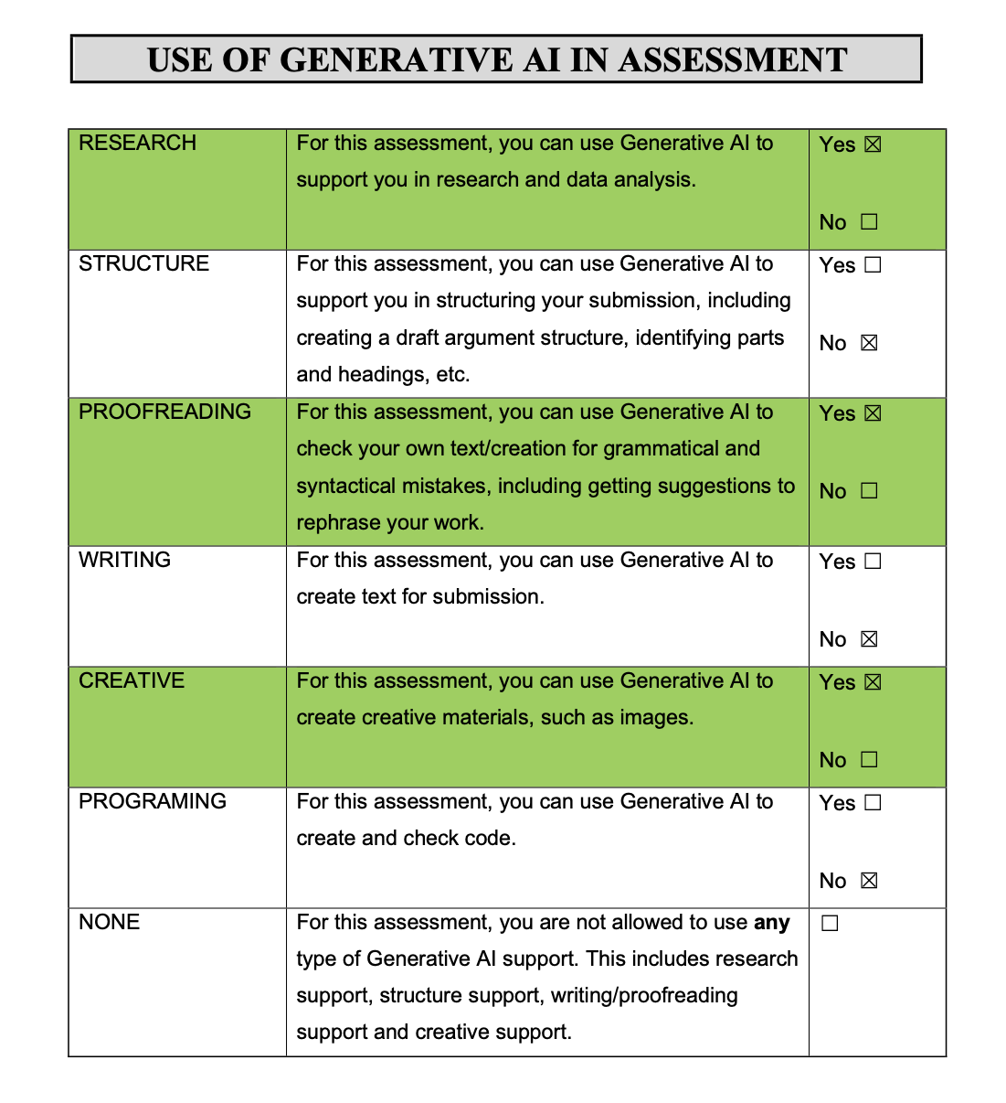
Generative AI Use Acknowledgement
I confirm that Generative AI was applied during this assessment to aid in research and data analysis, proofreading and enhancing grammar, and production of some visuals. The assignment was not developed using AI. All sources have been individually checked, and the analysis, arguments and written product are my own. I also I used for the image generation for Gemini and ChatGPT.

Table of Contents
Section 1- Strategic Management Report 1
1. Organisational Context and Overview 1
2. External and Internal Analysis 2
2.1 PESTEL Analysis 2
2.2 VRIO Analysis 4
2.3 SWOT Analysis 6
3. Comprehensive and Holistic View 8
3.1 Corporate Social Responsibility (CSR) and Strategic Alignment 8
3.2 Balanced Scorecard 9
4. Strategic Choices & Implementation 10
4.1 Business-Level Strategy 10
4.2 Porter's Five Forces 11
4.3 Ansoff Matrix 12
4.4 Recommended Strategy 13
4.5 Implementation Challenges/Solutions 13
5. Conclusion 14
Section 2: Reflective Account 15
1.1 Description 15
1.2 Feelings 15
1.3 Evaluation 15
1.4 Analysis 16
1.5 Conclusion 16
1.6 Action Plan 16
References 17

Section 1- Strategic Management Report

1. Organisational Context and Overview
Netflix is an entertainment technology company that serves subscribers worldwide through a streaming video-on-demand platform, advertising-supported streaming and a growing library of entertainment formats. Netflix has come into the UK since 2012 as an international streaming service firm and is now a major UK entertainment service player. Its business model relies on subscription fees, advertising, and the use of technology to distribute content, with personalisation and data analytics to aid content discovery and user engagement. Netflix global revenue in 2025 was $45.2 billion or 16% higher than in 2024, operating margin was 29.5% and advertising revenue was more than $1.5 billion (Netflix, 2026).
The UK is a key but more developed market. Netflix had 17.4 million UK households (59% household penetration) in 2025 compared with 46% for Amazon Prime Video and 25% for Disney+ (Ofcom, 2025). But this leadership does not necessarily mean that there is sustainable competitive advantage. Netflix's rivals are not just the SVoD offerings but also the attention of viewers that could be diverted to BBC iPlayer, ITVX, Channel 4, YouTube, gaming, and other leisure activities.
Thus, the strategic focus in Netflix UK has switched from market entry and rapid subscribers acquisition to differentiation and retention and profitable growth. Switching costs are low which enables consumers to trade up and down between platforms, content costs are limiting the power of scale to deliver better returns, regulatory pressures, affordability pressures and technological emulation are key constraints on scale alone. The key question is not whether Netflix has valuable resources, but whether it can continuously add and leverage these resources ahead of the ability of competitors to mimic them.
The report therefore examines Netflix UK and conducts an external and internal strategic analysis of the business, followed by an analysis of strategic options and implementation needs. It contends that disciplined differentiated growth is the optimal strategic fit: it leverages locally relevant content from the UK, intelligent monetisation, personalised discovery and accessibility while safeguarding long-term customer and financial value through data-driven investment controls.
Table 1: Netflix UK Strategic Context
Strategic dimension | Current position | Strategic implication
UK market position | 59% household penetration | Strong market leadership but limited room for simple subscriber-growth strategy
Competition | Amazon Prime Video, Disney+, broadcasters, YouTube and gaming | Netflix competes for consumer attention, not only subscriptions
Customer behaviour | Low switching costs and price sensitivity | Retention and perceived value are strategically important
Revenue model | Subscription + advertising | Opportunity to diversify monetisation
Content | Strong global library + UK production capability | Local relevance can support differentiation
Technology | Personalisation, data and digital infrastructure | Valuable capability but exposed to technological imitation
Regulation | Increasing UK streaming regulation | Higher compliance costs but potential legitimacy and accessibility benefits
Strategic priority | Disciplined differentiated growth | Focus on UK content, monetisation, personalisation and accessibility

2. External and Internal Analysis

2.1 PESTEL Analysis
Political
The UK political and regulatory landscape is increasingly important to Netflix, as streaming services are now held to higher public-interest standards. Media Act 2024 also provides Ofcom with increased powers relating to large video-on-demand services, such as obligations on harmful content and fairness, privacy and accessibility (UK Parliament, 2024; Ofcom, 2026). This poses extra compliance and administrative burdens for Netflix, but regulation is not just liability. Historical regulatory asymmetry between the global streaming platforms and domestic broadcasters may be diminished because of greater regulatory standardisation. Compliance, if this is integrated rather than just checked off like a number on a checklist, might then be the route to legitimacy for Netflix. Moreover, UK AV tax relief can incentivize production in the UK, giving Netflix a chance to enhance its content production skills and further develop its ties with the UK creative ecosystem (HMRC, 2023).
Economic
The strategic tension is deeper with regards to economic conditions because the cost of SVoD is still discretionary for the household. Ofcom suggests that while market expansion is expected to be important to future streaming growth in the UK, it is more likely to be reliant on retention, pricing and revenue optimisation. Netflix's financial standing is solid with worldwide revenue forecast at $45.2 billion in 2025 and an operating margin of 29.5%, but corporate profitability does not mean that the UK can afford the subscription costs of Netflix (Netflix, 2026). Price increases can boost ARPU, but can also result in downgrades or cancellation as well. The real question then is whether it is better to extract revenues in the short term or build customer lifetime value. Netflix should, therefore, consider pricing based on the impact it will have on its ARPU as well as churn, engagement and customer profitability. The quick uptake of the advertising-supported tier confirms this argument: In Q1 2025, 28% of Netflix subscribers opted into the Standard with Ads tier, whereas 13% of them did so a year ago (Ofcom, 2025). As a result, advertising is a way for Netflix to tackle affordability without compromising their access to the service.
Social
On-demand entertainment, which is convenient, flexible and personalised, is becoming increasingly popular with viewers in the UK, especially young viewers. This need is well met by Netflix' recommendation feature which streamlines the search process and allows users to navigate a vast content library. But, consumer focus is increasingly divided between SVoD, YouTube, social media and gaming. Therefore, size of the catalogue is not a differentiating factor that will be sustainable. However, the findings have shown that content preferences differ across regions which means that preparing content for the global scale must be complemented with local cultural context (Lee, Lim and Jeong, 2025). Netflix has to therefore re-evaluate UK content beyond the volume as it relates to engagement, retention, cultural relevance and international scalability. The question now is then, how much value does Netflix add to what they offer, not how many titles.
Technological
Technology is a differentiator and a potential competitive eroder. The Open Connect infrastructure enables Netflix to deliver content efficiently, and recommendation and search technologies enhance discovery (Netflix, 2022). A recent study also reveals that the use of a generative-AI designed Netflix homepage can enhance user engagement and lower serving latency (Wang et al., 2026). But the technological edge isn't going to last long, as more and more entrants can now access advanced AI and recommendation tools. The strategic value isn't really in algorithms, however, but in the use of proprietary behavioural data, experimentation, organisational learning and content. Netflix must, therefore, invest in technology further while keeping privacy and transparency in data-driven personalisation.
Environmental
Netflix's impact is felt on data infrastructure, networks, consumer devices, and content creation. Thus, environmental responsibility refers to both operational and legitimacy issues. Netflix shows improvement in emissions reductions, but the problem is how to achieve real results at a UK level. So, the environmental performance should be controlled not only as a communication tool, but also as a strategic risk. Assigning emissions targets to production decisions, supplier requirements and infrastructure efficiencies would bring the issue of sustainability to life and minimise the danger that CSR becomes symbolic.
Legal
There are close connections between legal pressures and the political environment. The proposed accessibility requirements, such as subtitling, audio description and signing, add to Netflix's obligations but also provide an opportunity to improve inclusion and customer value (Ofcom, 2026). Data protection, intellectual property rights, advertising standards, and contractual obligations are important as Netflix' business is based on creation, licensing, and distribution of valuable digital content. Therefore, achieving legal compliance should be considered a cost and an opportunity to differentiate: companies that effectively integrate accessibility, privacy and good governance will be capable of building confidence, while minimizing regulatory and reputational risk.
PESTEL synthesis
Overall, the PESTEL analysis shows that the external pressures on Netflix are not independent but instead are interconnected. Price sensitivity is enhanced by affordability, imitation barriers are lowered by technological change, relevance and discovery are key factors when society is fragmented, and accessibility and responsible governance become strategic factors in the presence of regulation. All point to a lack of interest in a scale-led approach. Netflix thus must differentiate its value to its customers, and simply renew its capabilities to do so.
Table 2: PESTEL Analysis of Netflix UK
Factor | Key evidence/issue | Strategic impact | Netflix response
Political | Media Act 2024 and stronger Ofcom oversight | Increased compliance and governance requirements | Integrate regulatory compliance into operations
Economic | Cost-of-living pressure, price sensitivity and mature SVoD market | Risk of churn/downgrading | Balance ARPU, churn and CLV; expand ad-supported tier
Social | Fragmented viewing across SVoD, YouTube, gaming and social media | Competition for attention | Increase relevance, discovery and UK content
Technological | AI and advanced recommendation technologies | Innovation opportunity but lower imitation barriers | Invest in data, AI, experimentation and responsible personalisation
Environmental | Production, infrastructure and supply-chain emissions | Operational and reputational risk | Link sustainability targets to production and suppliers
Legal | Accessibility, privacy, IP and advertising requirements | Higher compliance obligations | Use accessibility and governance as potential differentiation

2.2 VRIO Analysis
The VRIO framework measures the value of the organisational resources, rarity of the resources, cost of imitation and effective organisation of the resources as a measure of the opportunity for competitive advantage (Barney, 1991). The analysis indicates that Netflix UK doesn't gain from any single resource but from the combination of content, brand, data, technology and organisational resources.
The global distribution of its brand and vast library of content are assets that help cut the search costs for consumers and give them a familiar entertainment experience. Their scarcity is due to the fact that Amazon Prime Video and Disney+ have their own unique strong brands, and that established UK broadcasters have also established their strong brands and content. Netflix thus has an important competitive position, but not a resource monopoly. While it will take time, money and creative relationships to replicate Netflix's scale of investment in content, successful competitors can replicate individual parts of what Netflix has to offer.
Netflix's personalisation and recommendation system is a more powerful VRIO resource. By looking at behavioural data and experimenting, Netflix can adjust content discovery and ultimately enhance its engagement and retention rates. But the algorithms themselves shouldn't be at all thought to be forever uncopyable. Technological barriers are becoming increasingly low and competitors are building more advanced recommendation and discovery systems with advances in generative AI. It is not just the algorithm that is important, but the combination of data, technology, experimentation and organisational processes that are defensible.
Another potential capability will be the content and production partnerships that Netflix has in the UK. Investment in British productions can provide local salience, and popular productions can reach an international audience. This is a strategic opportunity to provide local responsiveness coupled with global scale. However, talent is mobile, and competitors can commission or license similar content, making it less special and therefore less likely that investment in the content alone will provide a sustainable edge for the UK.
Integration of resources is the most valuable resource VRIO feature, however. Netflix brings together brand awareness, behaviour analytics, tech to support delivery and discovery, content to ensure a unique service, and organisational competency to make all these resources turn into revenue. Porter (1996) states that competitive advantage comes from the synergy of interrelated activities, not the sum of the individual improvements. Netflix's system, as a whole, is thus harder to duplicate than any one resource.
But this is a potential, not a guaranteed benefit. Digital technologies are fast changing, preference will shift and competitor products can become more and more similar. A dynamic-capabilities perspective to complement VRIO focuses on how Netflix is able to 'sense', 'seize' and then 'reconfigure' its resources, to continually adapt to changes. The strategic message is that Netflix needs to continually refresh its capability system without taking it for granted that this year's technological or content advantage will continue to be unique.
In general, VRIO suggests that Netflix's major competitive advantage isn't size, it's its capacity to combine the complementary resources in a quicker and better way than others. It is good for capability renewal as continuous process, customer value as differentiation and investment as discipline, instead of just adding content.
Table 3: VRIO Assessment of Netflix UK
Resource / capability | Valuable | Rare | Difficult to imitate | Organised | Competitive implication
Global brand | ✓ | Partly | Partly | ✓ | Temporary advantage
Content library | ✓ | Partly | Partly | ✓ | Temporary advantage
Personalisation/data | ✓ | ✓ | ✓* | ✓ | Potential sustained advantage
UK production relationships | ✓ | Partly | Partly | ✓ | Temporary advantage
Technology/infrastructure | ✓ | Partly | Partly | ✓ | Temporary advantage
Organisational agility | ✓ | ✓ | ✓ | ✓ | Strong potential advantage
Integrated resource system | ✓ | ✓ | ✓ | ✓ | Strongest source of advantage

2.3 SWOT Analysis
The SWOT analysis combines the strengths of Netflix UK with the opportunities and threats of PESTEL and VRIO. The value is not just placing SWOTs on the list in isolation, but in finding out how they relate and what implications they have for strategic choice.
Strengths
Some of Netflix's key strengths are its 59% market penetration within UK households, its global brand, broad content library, ability to tailor services to individual users and its financial strength and scalable digital platform (Ofcom, 2025; Netflix, 2026). They give Netflix a lot of reach and the ability to spend more on content, technology and advertising than smaller competition companies. Its data, technology and content integration also enhances customer discovery and engagement.
Weaknesses
Notwithstanding, Netflix continues to be vulnerable to high content spend, low switch costs and the maturity of the UK market. Higher prices can lead to downgrading or cancelation, and there is pressure for enough return on every production because of the need for ongoing content investment. Netflix is also branching out into advertising, gaming and live entertainment, which poses a danger of getting involved in too many balls.
Opportunities
Key opportunities include the expansion of the advertising-supported model, UK original content, AI-enabled personalisation, accessibility and selected live entertainment initiatives. UK tax breaks for AV can also help UK production and help cement Netflix's ties with the UK creative industry (HMRC, 2023). Most importantly, these opportunities align with Netflix's existing resources, meaning they can be accomplished without the high risk of diversification.
Threats
Key challenges include growing competition, alternative entertainment offerings, saturation, regulatory pressures and rising sensitivity to price. Netflix is not only facing Disney+ and Amazon Prime Video but also broadcasters, gaming and social platforms. The levelling of SVoD penetration further limits the potential for growth based purely on acquiring additional households (Ofcom, 2025; Ofcom, 2026).
Strategic synthesis
The strategic value of the SWOT is in the relationships among these factors. The advantages in terms of financial resources, brand and technological know-how that Netflix has to exploit advertising, UK content opportunities and opportunities due to personalisation are limited by low switching costs and rising competition. Therefore, Netflix should make use of its strengths selectively instead of all growth opportunities. The analysis enables disciplined differentiated growth, with a focus on creating UK content, on intelligent monetisation and a focus on personalised customer value, with content investment and diversification kept in check through evidence-based portfolio decisions. It also controls the VRIO discovery that Netflix's durability lies in the continuous incorporation and repositioning of its resources, and not just on one single strength.
Table 4: SWOT Synthesis and Strategic Implications
SWOT element | Key issue | Strategic implication
Strengths | Brand, 59% penetration, content, data, technology and financial capacity | Use existing scale to create differentiated value
Weaknesses | High content expenditure, low switching costs, mature market | Improve content ROI and customer retention
Opportunities | Advertising, UK content, AI, accessibility, selective live formats | Develop opportunities aligned with existing capabilities
Threats | High rivalry, substitutes, regulation and price sensitivity | Reduce reliance on scale and increase customer value
SO strategy | Use brand/data/content to exploit UK content and advertising | Disciplined differentiated growth
ST strategy | Use personalisation and content to reduce switching | Improve retention and perceived value
WO strategy | Use analytics to address content-cost pressure | Portfolio-based investment
WT strategy | Limit uncontrolled diversification | Stage-gate investment decisions

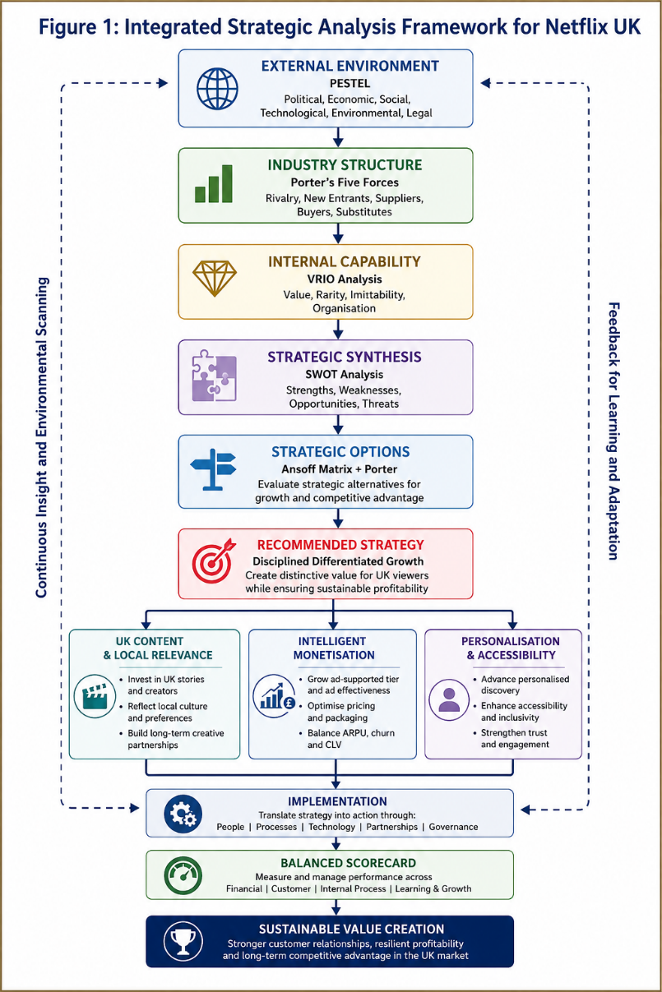
Figure 1: Integrated Strategic Analysis Framework for Netflix UK

3. Comprehensive and Holistic View

3.1 Corporate Social Responsibility (CSR) and Strategic Alignment
However, Corporate Social Responsibility (CSR) must be viewed strategically, not as a "reputational" exercise, because Netflix business is becoming more and more intertwined with regulatory, social and environmental expectations. This is especially important in the UK, where the upcoming changes to the major streaming platforms' regulations put accessibility at the center of the rules, along with media content quality and platform management. Ofcom's proposed framework imposes minimum requirements on subtitling, audio description and signing, which not only adds compliance costs, but also a chance to enhance inclusion and customer value for Netflix (Ofcom, 2026).
Accessibility can then also help drive competitive capability when it adds to the consumer experience for those who may experience accessibility barriers. But compliance doesn't automatically mean strategic CSR. If Netflix only fulfills the bare minimum of compliance, the activity can create compliance instead of differentiation. The strategic value is achieved when accessibility is embedded in product design, content creation, customer experience.
This is also the case with environmental responsibility. The environmental impacts of streaming have been established and include Scope 1 & 2 emissions, however, Netflix has commitments to reduce emissions and reported success in this area, but the environmental impact of streaming is also within production, travel, suppliers, infrastructure and consumer viewing (Netflix, 2024). What matters is then whether commitments to the environment become more than just a corporate communication but translate into concrete benefits in operations. Netflix UK needs to link sustainability goals to production, supplier, and energy efficiency requirements to make environmental sustainability a part of their resilience as well as a part of their legitimacy.
The other areas of Netflix's broader ESG goals are inclusion, belonging, governance and human rights. Strategically relevant because the global entertainment platform needs to be creative and cater for audiences with varying cultural preferences. However, there is a clash between global standardisation and local stakeholder expectations. Netflix needs to therefore implement and measure the principles of CSR on a global scale with implementation and measurement specific to the UK.
It is recommended to align CSR and commercial and operational performance, and not to have a standalone ESG programme. A CSR impact dashboard for the UK can track aspects of accessibility, emissions per production, local production spend, employee inclusion and customer trust. This would enable Netflix to determine if their CSR efforts lead to tangible operational, reputational or customer-value impacts. This would render CSR more accountable and enhance the legitimacy of stakeholders, as well as possibly playing a role in long-term differentiation.

3.2 Balanced Scorecard
The Balanced Scorecard approach created by Kaplan and Norton (1992) is an appropriate tool to translate the differentiated growth strategy of Netflix UK into measurable, financial and non-financial objectives. It is especially so in the mature streaming market where the number of subscribers is not enough to define a strategic performance. Netflix's bottom line is a challenge with four other things: keeping people subscribed to their service, making their service profitable, making it more effective, and enhancing its capabilities.
It is important to analyze the financial aspect in terms of quality and not just quantity of revenue. The advertising segment is an important opportunity, as Netflix made more than $1.5 billion in revenue from ads globally in 2025 (Netflix, 2026). But the growth of ads shouldn't destroy premium positioning or contribution margins.
Retention, engagement and perceived value should be the focus of the customer perspective. Despite low switching costs, Netflix's 59% penetration in the UK market is a testament to its strong market position and maintaining customers is as important as acquiring new ones. Churn, CLV, viewing behaviour and recommendation satisfaction should therefore be tracked in conjunction with subscribers.
The internal-process approach should assess the effectiveness of the content, the reliability of the platform, the performance of the ads, and the compliance with regulatory standards. In the meantime, the learning-and-growth view should make sure that Netflix is constantly improving its capacity in this way, such as by investing in employee development, data science knowledge, creative collaborations, and responsible use of AI.
But the four perspectives must not be dealt with separately. However, while spending less on content can enhance today's results, it can hurt engagement and retention, and over-automating can hurt creative differentiation. The Balanced Scorecard must thus be a unified strategic system, in which financial results are measured in conjunction with customer, process and organisational consequences.
In total, the Balanced Scorecard turns Netflix UK's strategic vision into measurable action and offers a way to control the growth and profitability and to ensure that the customer value and renewal of customer capabilities is balanced.
Table 5: Proposed Balanced Scorecard for Netflix UK
Perspective | Strategic objective | KPI | Proposed 3-year target | Strategic initiative
Financial | Improve revenue quality | ARPU, ad revenue/member, content ROI | +15–20% improvement from baseline | Advertising optimisation + portfolio analytics
Customer | Improve retention and perceived value | Churn, CLV, satisfaction | 10% reduction in churn from baseline | Personalised discovery + UK content
Internal Process | Improve content and operational efficiency | Content ROI, accessibility compliance, uptime | 100% applicable accessibility compliance | Data-led content selection + accessibility testing
Learning & Growth | Renew organisational capabilities | AI training, employee retention, UK partnerships | >90% priority training completion | AI/analytics training + creative partnerships

4. Strategic Choices & Implementation

4.1 Business-Level Strategy
Netflix UK has a number of choices available to it when it comes to the challenge of pursuing cost leadership, differentiation or a combination of both. Netflix is competing with other paid-for SVoD services, as well as paid and free platforms like YouTube and broadcaster platforms, making cost leadership a strategic challenge. Trying to compete mainly on price may therefore not lead to a viable margin. Moreover, Netflix's massive spending on content and technology would make it easier to simply follow a low-cost strategy, which is incompatible with its current business model.
Differentiation would be more suitable as Netflix already differentiates itself by offering exclusive content, personalisation, brand and user experience, and global distribution. But differentiation can not be interpreted as unlimited investment. Spending too heavily on emerging entertainment forms or content could result in higher expenses and lower customer value.
So, a disciplined differentiation strategy is the best strategic fit. Netflix should choose to spend money on specific features that will enhance engagement, retention and monetisation, and then de-commission low value spend based on data and portfolio analytics. This is in line with Porter's 1980 theory that differentiation may help achieve better returns if its value to customers is real and can be difficult for competitors to duplicate. It also demonstrates VRIO principle as Netflix's strength lies in the combinations of its resources rather than in any one of them.

4.2 Porter's Five Forces
Porter's Five Forces suggests a structurally tough streaming environment in the UK. The competition is fierce with Netflix challenging Amazon Prime Video, Disney+, Apple TV+, Sky/NOW, BBC iPlayer, ITVX, Channel 4 and YouTube. As UK SVoD now has a significant market share, companies are not just targeting new homes, but vying for viewers' time.
The risk of substitutes is also high. Consumers have the ability to focus on broadcasters, YouTube, gaming, social media and traditional television. The rise of TV watching on YouTube further illustrates that Netflix is part of a wider 'attention economy' (Ofcom, 2026).
There is a high degree of buyer power due to low switching costs. Netflix's perceived value and retention are important because customers can temporarily subscribe to competitors around major releases due to canceling Netflix. This pressure is backed up by Ofcom's evidence of downgrade among Netflix households.
Supplier power is moderate to strong with a preference for premium creative talent, producers, studios & rights. With the scale of Netflix, a portion of the dependence has been diminished, but not all creative resources are scarce.
Last but not least, the risk of new entrants is medium. Technology is becoming more and more available, but content rights, brand, scale and distribution are still important hurdles.
In totality, these forces imply that Netflix is not able to depend on market expansion or customer inertia. A key consideration should be its strategic priority of providing differentiated value, which boosts engagement and decreases switching behavior.
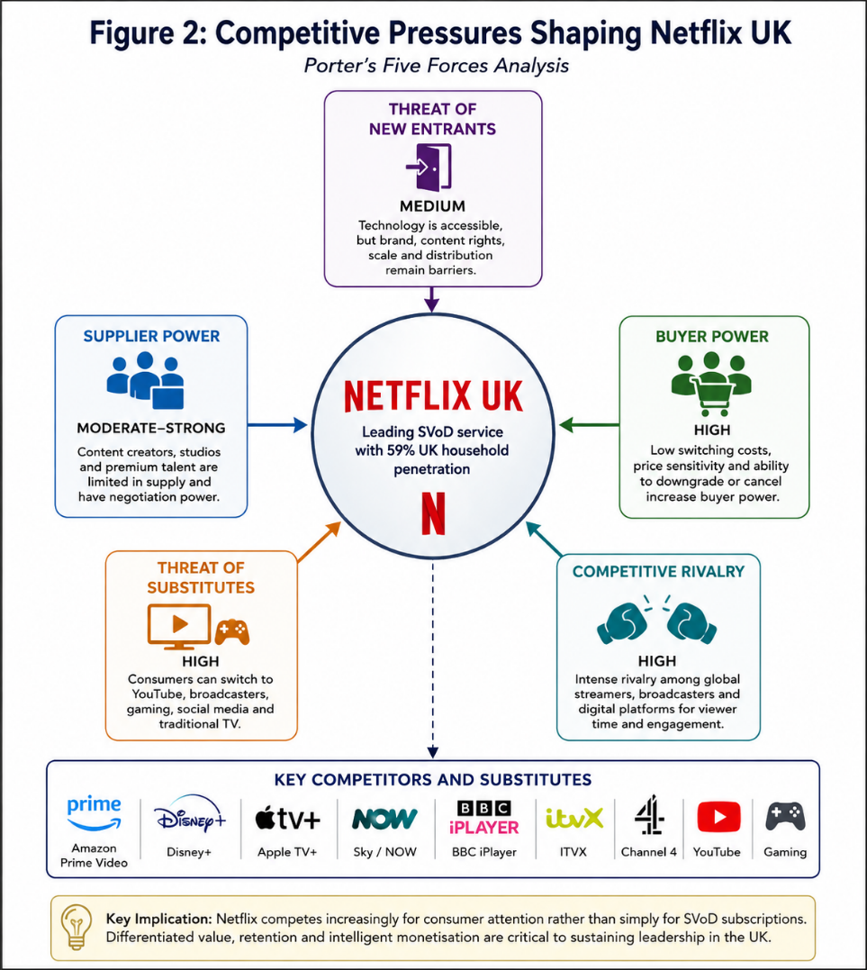
Figure 2: Competitive Pressures Shaping Netflix UK

4.3 Ansoff Matrix
From the Ansoff Matrix, it can be seen that Market Penetration and Controlled Product Development offers the best rating between opportunity and risk. Market penetration represents the opportunity for Netflix to grow usage and retention of their existing UK customer base by enhancing their recommendations, locally relevant content and customer-value propositions. Low risk: Netflix has a good brand, a good infrastructure, and a high household penetration.
New growth is possible through product development, including the advertising-supported model, making the product accessible, offering selected live programming and other entertainment models. These programs, however, should be rolled out one at a time and not all at once.
Indeed, market development is relatively low in strategic value since the focus of the report is on a highly developed UK market and diversifying into gaming or other entertainment businesses is more uncertain and requires more resources. Hence, Netflix should first maximize its value from the current customer base in the UK market and invest only a little in new markets. This will minimize strategic risk, not eliminate it, but still permit “controlled innovation.”

4.4 Recommended Strategy
The key is disciplined, differentiated growth, with three mutually reinforcing priorities: locally relevant high value content, intelligent monetisation and superior personalised access. However, to achieve the most from its investment in the UK market, Netflix needs to play a more judicious game than just adding to the catalogue. It should simultaneously grow advertising and safeguard the perceived worth of top quality memberships. The personalisation and accessibility should enhance the customer experience and aid in customer retention.
A strategy better than cost leadership is to compete primarily in terms of differentiation, meaning that Netflix would not be vulnerable to low cost substitutes. It's also better than an uncontrolled diversification for the Netflix because its biggest strategic opportunity is to get more value from an existing UK market than in a multitude of new markets.
With that in mind, the recommendation is strategic fit – Netflix can leverage its brand, data, technology and content while customizing its application to meet UK customer, regulatory and competitive requirements.

4.5 Implementation Challenges/Solutions
There are four key challenges to implementation. First, numbers must not be looked at in isolation; rising content expenditure can be better controlled using the use of portfolio analytics on the basis of audience potential, retention contribution, international scalability, and content ROI, not numbers alone. Second, regulatory requirements will be enhanced by a production/Platform compliance regulatory dashboard reporting quarterly to the Board. Third, price sensitivity needs differentiated pricing and a cost-effective advertising-supported price protection premium value. Fourthly, the opportunity for gamification and live entertainment is a risk of strategic overextension, and so investment decisions must be based on scale stage and have evidence of financial, customer or capability benefits before moving forward.
Overall, steps ought to be introduced progressively – with a focus on UK content, advertising optimisation, accessibility, and retention analytics in Year 1; and scaling up initiatives that show measurable strategic value in Years 2-3.
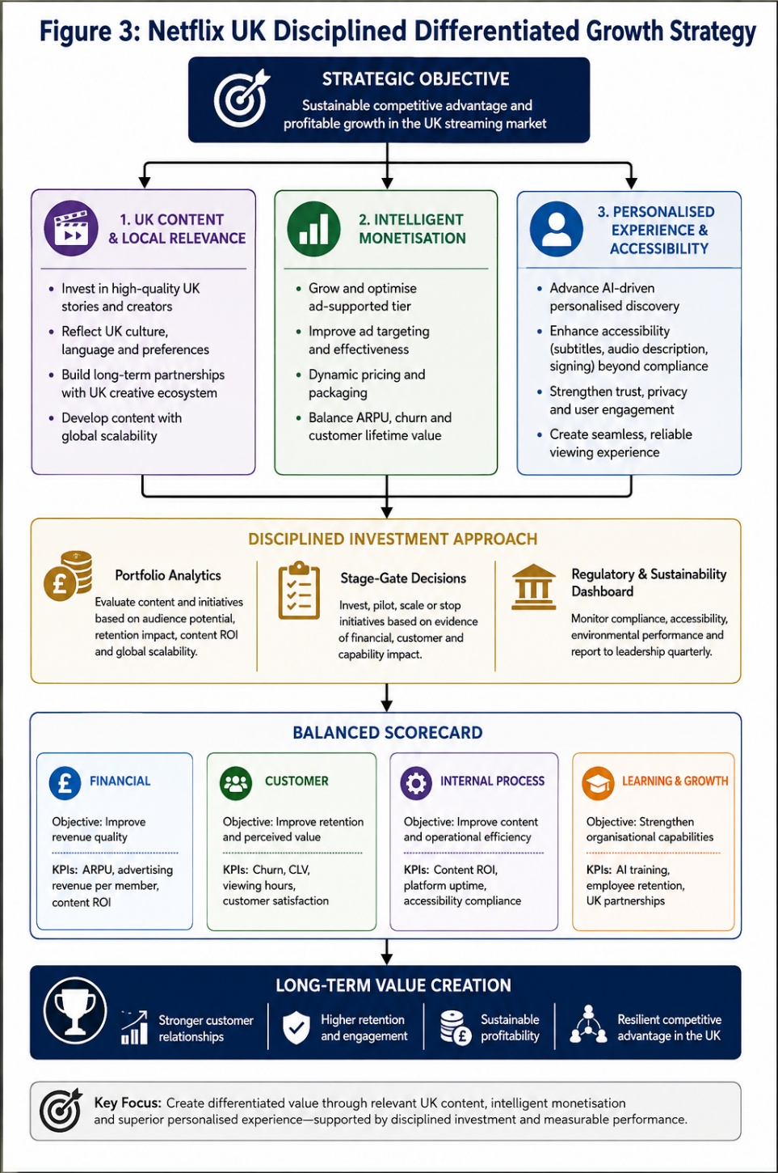
Figure 3: Netflix UK Disciplined Differentiated Growth Strategy

5. Conclusion
The company's significant strengths in terms of penetration into UK households, brand and content strength, as well as technological infrastructure, offer a solid strategic bedrock—but these are not sources of sustainable competitive advantage in a relatively mature and very competitive streaming landscape. PESTEL shows that affordability pressures, regulation, substitutes, low switching costs and high rivalry are limiting scale expansion, and VRIO suggests that Netflix's most important asset is the integration of it's resources rather than any single one. The suggested disciplined differentiated growth strategy, thus, suggests a blended approach comprising the UK content, intelligent advertising monetisation, personalised discovery and accessibility. It is only through disciplined investment, measurement of performance and ongoing capability renewal that success will be achieved.

Section 2: Reflective Account

1.1 Description
For the strategic management report, I'd be expected to assess Netflix's position in the UK streaming market and make a strategically sound recommendation. I used PESTEL, VRIO, SWOT, Corporate Social Responsibility, Balanced Scorecard, Porter's Five Forces and Ansoff's Matrix to explore the organisation. The research process was to integrate data from the companies, regulatory evidence, industry data and academics to gain insight into Netflix's internal capabilities and also the external pressures on its operations in the UK. The analysis seemed at first to be a process of taking existing frameworks and the information available and applying them to the task. The study however revealed that the primary problem was less about the identification of strategic factors, and more about the types of factors that are quite crucial to affect strategic decisions. This necessitated a shift away from description to the evaluation of the relationship between regulation, customer behaviour, technology, resources, competition and profitability.

1.2 Feelings
It was difficult to start off with as I had to keep in mind that Netflix has different functions such as content creation, technology, subscriptions, advertising, and emerging entertainment formats. I was worried about having more than one strategic framework which might make this report descriptive instead of analytical. The research continued to grow and develop, and I started to get more confident in the identification of relationships between the different strategic issues. Every session I did Netflix analysis in a mature market in the UK has really broadened my perspective on what it means to be a market leader. To me, high household penetration was correlated with good competitive advantage, but this was not the case, as evidenced, when switching costs were low and other competitors could imitate technological capabilities. I also became more aware of the need to not use information that was easy to get because it might not be true or up-to-date.

1.3 Evaluation
One of the strengths of the research process was to be able to link strategic theory to contemporary evidence. We employed PESTEL to identify external pressures and VRIO to offer an internal perspective of Netflix's resources and capabilities. The combination of both methods avoided an analysis being too external or too internal. The Balanced Scorecard helped, as it promoted thinking about Netflix's performance that went beyond subscribers, such as in terms of financial performance, retention rates, operational effectiveness and capability of the organisation.
A key shortcoming was, however, that Netflix was not able to provide much of its financial and operational data for its UK operations. Some information about market penetration, regulation and world performance is readily available in the public domain but is much less detailed than management information. This meant that, in some cases, strategic judgements had to be interpreted, not measured. This further highlighted the difference between evidence, inference and recommendation.

1.4 Analysis
The key takeaway of the exercise was that strategic frameworks are analytical tools and not one and the same. For instance, VRIO analysis can recognize beneficial resources, but it can't ensure that the resources will keep on being difficult to imitate even as technology and consumer tastes evolve. In the same way, Five Forces can indicate high competitive pressure but not necessarily the best strategic option for Netflix. The frameworks proved to be more useful when they were combined with the results of the findings.
From the PESTEL analysis, it was identified that affordability, regulation, technological development and changing consumer expectations are not independent variables but interact. Next, VRIO demonstrated that Netflix's greatest capability is the integration of brand, data, technology, content and organisational processes. Five Forces illustrated why it becomes more critical to keep customers loyal when there is little or no switching costs and few or no substitutes, and Ansoff clarified that market penetration is a less risky strategy than diversification. Collectively these insights resulted in the recommendation of disciplined differentiated growth, not cost leadership or uncontrolled diversification.
During the exercise, my definition of sustainable competitive advantage was modified too. While Netflix's size is good, size isn't necessarily scarce or sacred. The benefit of its product lies in the constant fusion and rejuvenation of resources under the influence of technology and market changes. This brought in a more dynamic concept of strategy in which competitive advantage is seen as an on-going process, not a one-time achievement.

1.5 Conclusion
In general, I found that the research process helped me to differentiate evidence, interpretation and strategic judgment. I learnt that a strategically sound report is not simply the correct use of an accepted model, but that the model has to be used to support a single argument. I also found that uncertainty, constraints of implementation, and competing alternatives should be recognised in strategic recommendations. Most importantly, I now have a better appreciation that market leadership isn't always viewed as a sustainable competitive advantage. Such strategic analysis should thus question assumptions and evaluate whether organisational capabilities will be able to continue to generate value as the external environment evolves.

1.6 Action Plan
In future strategic-management projects, I will first identify the strategic question that I would like to address in my analysis, and then choose which frameworks I want to use. I will then create an evidence hierarchy, that places peer reviewed research at the top of the list followed by government and regulatory publications, credible organisational evidence and relevant industry data. However, instead of using one framework per problem separately, I will choose frameworks based on the strategic problem and will make it clear how the results of each of these frameworks is related to the others. I will also introduce measurable implementation criteria at an early stage of the analysis and assess the alternatives in the process to a final decision. Lastly, I will spend more time examining the difference between fact and inference and strengthening student academic language skills. These changes should allow me to create future strategic reports more critically analytical, evidence-based, coherent, and defensively sound in a professional manner.

References
Ansoff, H.I. (1957) ‘Strategies for diversification’, Harvard Business Review, 35(5), pp. 113–124.
Barney, J. (1991) ‘Firm resources and sustained competitive advantage’, Journal of Management, 17(1), pp. 99–120.
HM Revenue & Customs (2023) Reform of film, TV and video games tax reliefs to expenditure credits. London: HM Revenue & Customs.
Kaplan, R.S. and Norton, D.P. (1992) ‘The balanced scorecard—Measures that drive performance’, Harvard Business Review, 70(1), pp. 71–79.
Lee, N., Lim, J. and Jeong, H.-C. (2025) ‘Patterns and dynamics of Netflix TV show popularity’, arXiv.
Netflix (2022) Netflix Open Connect. Los Gatos, CA: Netflix, Inc.
Netflix (2024) Environmental, Social and Governance Report 2024. Los Gatos, CA: Netflix, Inc.
Netflix (2026) Annual Report 2025. Los Gatos, CA: Netflix, Inc.
Ofcom (2025) Media Nations 2025: UK Report. London: Ofcom.
Ofcom (2026) Media Nations 2026: UK Report. London: Ofcom.
Ofcom (2026) Consultation: Tier 1 Standards Code. London: Ofcom.
Ofcom (2026) Stronger protections for UK audiences under new content and accessibility standards for streaming services. London: Ofcom.
Porter, M.E. (1980) Competitive Strategy: Techniques for Analysing Industries and Competitors. New York: Free Press.
Porter, M.E. (1996) ‘What is strategy?’, Harvard Business Review, 74(6), pp. 61–78.
Teece, D.J., Pisano, G. and Shuen, A. (1997) ‘Dynamic capabilities and strategic management’, Strategic Management Journal, 18(7), pp. 509–533.
UK Parliament (2024) Media Act 2024. London: UK Parliament.
Wang, L., Pan, J., Che, F. and Baltrunas, L. (2026) ‘GenPage: Towards end-to-end generative homepage construction at Netflix’, arXiv.

