Tesco in UK

Student name: Bejenari Irina
Student number: 1812797
Lecturer: Dr Gregory Cowan
Module number: LCBB4002
Module name: Community engagement

Table of Contents
Introduction 3
A clear understanding of nature and purpose of reflective practice and theoretical model of reflection 4
Detailed experience of Tesco and outcome from the activities 6
Reflection on the relationship between relevant theory and the experiences 7
Examples of key issues encountered during the role play with one successful and development area 9
Conclusion 10
References 11

Introduction
The community engagement refers to building the infrastructure of an organization for the purpose of exploration and globalization. It has mentioned several times that community engagement has been analyzed by many organizations but Tesco is a good example to explain about community engagement by setting up an example. The effective strategy and good decision-making power of managers and leaders placed this organization as a leading company in the UK. There are various aspects that are outside the control of the business such as representatives and recruiting partners of Tesco who provide business and employees to them.
By applying effective strategies and approaches Tesco has become a more productive organization which is gradually increasing the business. The employee's turnover is a very serious problem for the organizations but Tesco performs this function in a well-defined manner like fulfilling the employee retention with colours. Enhancement of interpersonal skills, good leadership, communication and self-management is very important in promotions and career advancement.

A clear understanding of nature and purpose of reflective practice and theoretical model of reflection
The brand named Tesco is a one-man organization started in 1924 in London's east. They have successfully fought for maintaining the sustainability of their business and then Soon after they had expanded their business to 57 stores in north London (Fernie and Sparks, 2018). The direction and scope of Tesco for the long term have achieved the best advantages and opportunities.
Purpose
Analysis of Tesco ensures its purposes. The main objective and purpose of Tesco are to increase the loyalty towards its employees in order to retain them (Turner, 2012). The strategies of bringing new customer have applied by managers and leaders in order to compile the entire process to focus on customer retention. The strategies include high-quality customer services and taking customer feedback on performance.
A theoretical model of reflection
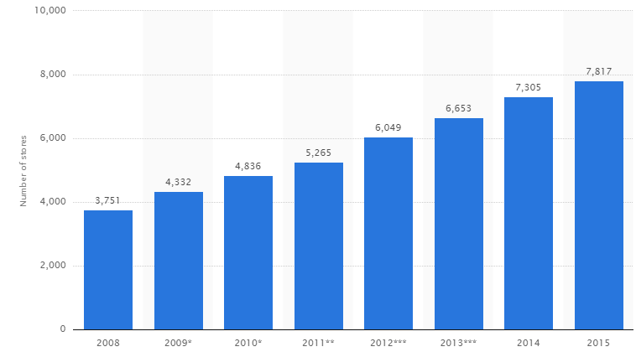
Source: (research methodology, 2015)
The term marketing can be considered as a theoretical model of reflection that influences demand in the UK for its products. Basically marketing mix has four components such as product price place and promotion.
- Product: Tesco offers a comprehensive variety of products to its customers.
- Place: It ensures the place from where the customer could get the products and services for consumption purpose and distribution for selling purpose to those locations (lal Bhardwaj, 2012).
- Price: Tesco has adopted the prices strategy is basically based on its marketing message of "Every little help"
- Promotions: Tesco has also adopted some promotional engagement programs that enable production management to showcase its quality of products to the others.

Detailed experience of Tesco and outcome from the activities
The training and development was the finest function that gives proper recognition to the employees throughout their work experience. The analysis of this study has signified how employees change their attitude. This study has accomplished various characteristics that analysis how to get succeed long run. It has been observed that other factors that control business activities also need proper determination that outlines at least one success. The success and growth of Tesco have been increased in order to transform the image and strategies. Initially, the management of Tesco has increased the strategies like pile it first and sell it cheap (Gopalia, 2011). Deployment of employment of employees in the organization is also most important activity because it has been observed that the reason behind successful delivery of work and high potential is only identification of work and strategic departmentalization of employees. Managers and leader know the effective and right use of manpower according to their specific department and functional area.

Reflection on the relationship between relevant theory and the experiences
Tesco has applied managerial theories and approaches in order to empower the overall performance. The need for identifying the scarcity of resources and allocation of resources in Tesco is identified by the managerial hierarchies and directors of Tesco (Stoddart, 2012). In order to bring new customers and the retention of a new customer is also determined by the management system. The development system of Tesco is basically depended on its entire workforce. The compilation of resources is the dynamic function performed by the organization in order to maintain sustainability in the long-run.
The theories that have been identified by expertise and management thinkers in these studies that help in increasing profitability in the long run:
- Self-determination theory: In order to the better deployment opportunities and occupation Tesco allows the enhancement of performance of its employees by applying self-determination theory and this theory is also similar to Maslow’s need hierarchy theory. If the discussion comes on determination, one factor comes in mind which is effective training & development. Training & development is a skilful function that helps the employees prevent from hectic and damages. The self-determination theory ensures both intrinsic and extrinsic motivation that support the development and prosperity of the employees.
- Bandura’s self-efficiency theory: This theory implies that the participation of employees in training and development is not the only factor but also ensures the enhancement of leadership quality within the organization (Van Zyl , 2013). The greatest thing about Tesco is they have recently opened the Tesco’s Asia academy in South Korea which gives higher education to the graduates for increasing self-efficiency and enhancement of other interpersonal skills that are essential for achieving primary organized goals.
- Leisure time: This theory indicates the use of the best reward system in Tesco that management uses. They give discounts to their employees in term of theme parks and memberships. Administration of this theory let the employees assume that the company cares about them. It proves the best motivation theory or approach followed by many organizations. Through the study of this theory is quite difficult for determination and administration.
- Privilege cards: Privilege card is the benefits or advantage for the people who are the part of Tesco in every sense like distributors, customers, employees, etc. It is a card which gives some offers and discounts to the members on acquiring services or purchase of a product.
- Adams’s equity theory: This theory is the systematic way of applying Herzberg two factor theories it ensures an equal partition of rewards and advantages between employees. The best examples are harmony shared by the company with its employees whenever they any profit. Shares in success provided by Tesco if they complete one year successfully. Tesco also saves the earning of employees according to a decided slab. These benefits are tax-free and employees can redeem these benefits any time by following systematic procedures.

Examples of key issues encountered during the role play with one successful and development area
The biggest key issue has found during the research is wastages of food in the UK produced by the Tesco society (Peeroo, et.al., 2015). Food wastages is a very serious problem increases in the UK drastically. The identification of wastage of food in Tesco was found when they producing grocery items and other recipes as bulk production. Studies have found that a regular project of bulk production on Tesco wasted around 28,500 tons of food. The distribution centres and Tesco stores are responsible for the wastages of food. Moreover, this factor ensures the overall consumption of Tesco food in the UK is estimated to 14.8 millions of tons.
Tesco has analyzed all these factors that are affecting the selling and production of Tesco and putting new processes & strategies towards minimizing the wastages of food in the UK. In order to find the main areas from where these problems are coming are their hotspots like Tesco bakeries and food producers.
Additionally, there are continuing to the good process that appreciates food surplus management in order to increase the consistency in this program. In the last few decades they have found where they are required to act and how to prioritise the work. The successful & development areas include:
- Establishment of food criteria to map the food they sell: In order to apply this function Tesco has adopted different methods of categorizing the food. On the basis of nutritional benefits, the food can be identified that which product is nutritional. All the aspects of the business are must be regulated or monitored by the managers and leaders in order to conquer the failure or weak points.
- Establishment of new health difference trackers: This method has allowed management to track the quality of the food requirements and expectations. Tesco has also measured those nutritional summary customers who use shopping trips by the permission of the government (research-methodology, 2015). It has also found by this tracker that generally customer fill the shopping basket making the difference between product qualities in healthiest and least healthy products.

Conclusion
In a few decades, Tesco has practised various strategies that helped in increasing profit and produce strong productivity. Tesco became one of the largest retail companies in the world. In addition, it also becomes so easy to address this organization because they have already explored the brand awareness and reputation of its services and products across many international boundaries. This immense success is not luck by chance, these all are the efforts of its workforce and manager. They have applied various motivational and leadership skills that prove very effective in order to enhance the popularity of the brand name.
The establishment of clear vision is possible with the help of commitment of establishments and monitoring strategies just to ensure that they are attained. Decision-making strategies are also very important in order to administrate other functions. It ensures all the areas of Tesco like customers, communities, suppliers, stakeholders, channels of distributions. Hence, they keep their workforce and customer satisfied by maintaining loyalty between them.

References
Fernie, J. and Sparks, L. eds., 2018. Logistics and retail management: emerging issues and new challenges in the retail supply chain. Kogan page publishers.
Gopalia, A., 2011. Effectiveness of online recruitment and selection process: a case of Tesco.
lal Bhardwaj, N., 2012. Consumer buying behaviour toward carbon labelling (FMCG) in Tesco supermarket. International Journal of Data and Network Security, 1(2), pp.1-11.
Peeroo, S., Samy, M. and Jones, B., 2015, December. Customer engagement manifestations on Facebook pages of Tesco and Walmart. In 2015 International conference on computing, communication and security (ICCCS) (pp. 1-8). IEEE.
research-methodology, 2015. Tesco marketing mix. [Online] research-methodology. Available at: https://research-methodology.net/tesco-marketing-mix/ [Accessed on 4th May 4, 2019]
Stoddart, K.M., 2012. Social meanings and understandings in patient-nurse interaction in the community practice setting: a grounded theory study. BMC nursing, 11(1), p.14.
Turner, J.J., 2012. Are Tesco customers exhibiting a more social type of loyalty towards Tesco and Tesco Clubcard? A critical analysis of the nature and type of Tesco customer loyalty to Tesco in Dundee.

Role Play Feedback from colleagues



