Business Plan for Long Term: Prestige Car Wash Swansea

Module: Entrepreneurial Innovation (BMBM4011)
Lecturer: Robyn Griffiths
Assignment Title: Developing a Business Plan for Long Term Success

Tanvir Ali (2205506)
University of Wales Trinity Saint Davids
Word Count: 2,713

Due: 2nd May 2025

Executive Summary

Prestige Car Wash Swansea is an eco-friendly car wash service that combines premium vehicle cleaning with sustainable practices. Located in the heart of Swansea, the business offers tailored services to individual customers, taxi drivers and corporate fleets, ensuring convenience, quality and environmental responsibility. Prestige Car Wash utilises biodegradable products, water recycling technology and energy-efficient systems to minimise its environmental footprint.

The business strategy focuses on long-term success through customer loyalty programmes, subscription services, digital engagement via a mobile app and mobile car wash offerings. By embracing innovation such as AI-driven scheduling and smart payment systems, Prestige Car Wash aims to become a market leader in sustainable car care. Financial projections estimate a steady growth rate of 15% per annum, reaching over £600,000 in revenue by year five, with a break-even point anticipated by the end of year two.

Prestige Car Wash is committed to setting a new standard for eco-friendly vehicle services in Wales, combining profitability with sustainability and building strong community relationships to ensure lasting impact.

Table of Contents
Executive Summary 2
1.0 Business Overview 4
1.1 Business Introduction 4
1.2 Industry and Market Position 4
1.3 Key Challenges and Opportunities 5
2.0 Business Strategy for Longevity 6
2.1 Sustainability Plan 6
2.2 Customer Retention 6
2.3 Market Adaptability 7
2.4 Revenue and Growth Models 8
2.5 Innovation and Technology 8
2.6 Employee Retention and Culture 9
3.0 Business Model Canvas 10
4.0 Financial Considerations 11
4.1 Financial Forecasting 11
4.2 Break-even Analysis 12
4.3 Cost-Saving Strategies and Financial Sustainability 12
5.0 Implementation Plan 14
5.1 Timeline of Key Actions 14
5.2 Monitoring Success 15
5.3 Risks and Contingency Plans 16
6.0 Conclusion 17
7.0 References 18

​ ​
​
​ ​
​
​
​
​
​
​
​
​
​ ​

1.0 Business Overview

1.1 Business Introduction
The Prestige Car Wash, which has a location in Swansea, is one of the businesses that specialise in cleaning automobiles in an environmentally responsible manner. Its objective is to provide the highest quality cleaning services possible while minimising the amount of water and energy that is wasted. The business will offer comprehensive services for washing and detailing automobiles, and it will do so by employing biodegradable components and intelligent water systems. As a result, the company will significantly cut down on waste and pollution (Prestige, 2024b).

Services Offered:
Prestige Car Wash provides a variety of packages:
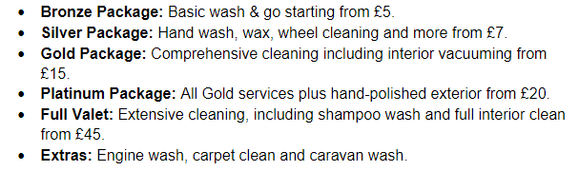(Prestige, 2024a).
1.2 Industry and Market Position
According to IBISWorld (2024), the growing demand among consumers for convenience and ownership of vehicles is the primary factor driving the car wash industry. The growing concern that consumers have for the environment has led to an increase in the popularity of vehicle washes that are favourable to the environment. Car washes are undergoing a transformation as a result of the growing number of automobiles, the rise of urban lifestyles and the growing awareness of environmental concerns among the general population. Prestige Car Wash Swansea is a company that has entered this rapidly evolving business with a commitment to excellence and sustainability. The most important markets are owners of private cars, drivers for taxis and ride-sharing services and local businesses that operate fleets. There are more than forty million automobiles that are registered in the United Kingdom (Department for Transport, 2024), which means that the potential customer base is quite substantial. For the purpose of overcoming entry barriers such as early capital investment and local competition, Prestige will employ environmentally friendly practices, reasonable pricing and first-rate service. Having achieved a satisfaction rating of 4.89, Prestige Car Wash has established itself as the most preferred option for automobile services in the Swansea area. Competitors are differentiated from them by their strategic approach that is friendly to the environment and their brilliant team (Prestige, 2024b).

1.3 Key Challenges and Opportunities
Challenges: Firmansyah et al. (2025) claim that the most important issues the company has to deal with are the costly initial investment in environmentally friendly infrastructure, the intense rivalry in the market, the fast development of technology and the always changing consumer preferences.

Opportunities: there is a growing need for businesses that are environmentally conscious and the government is giving incentives for businesses that engage in sustainable practices (Becker, 2024). Furthermore, according to Welch (2024), there are a number of chances that can be noted, including technological developments in automated automobile washing. Additional potential for the company include the expansion of mobile services, the introduction of subscriptions and the development of digital marketing strategies.

2.0 Business Strategy for Longevity

Sustainability Plan
- Water Conservation: Prestige Car Wash Swansea still considers environmental sustainability as one of its most fundamental principles. Water preservation is another. The business intends to carry out several environmentally friendly initiatives in order to meet the rising environmental standards and expectations (DEFRA, 2022). First of all, a closed-loop water recycling technology will be used to reduce water waste by as much as 70%. In a field acknowledged for excessive water usage, this is a critical indicator (Delrahim, 2024).

- Eco-Friendly Products: Prestige will commit to using biodegradable cleaning products by partnering with eco-friendly suppliers. These products will reduce chemical runoff and environmental impact, which is increasingly scrutinised by both regulatory bodies and environmentally conscious consumers (Clutterbuck, 2023).

- Energy Efficiency: Investment in solar panels and energy-efficient equipment will reduce carbon emissions and reliance on traditional power sources. This includes energy-efficient drying systems and automated washing units that consume less electricity and water per wash cycle (Eco Car Cafe, 2023).

2.2 Customer Retention
The retention of customers is the primary factor that determines whether or not a business model is effective and sustainable. Prestige has a multi-tiered approach.
- Subscription-based car wash memberships: a subscription model will provide customers monthly or annual plans at lower rates, which not only increases customer loyalty but also maintains income throughout the year (Tapuch, 2025). By participating in a loyalty program, customers who make repeat purchases will be rewarded with points that may be redeemed for free or discounted services.

- Loyalty programmes offering discounts and perks: to enhance personalisation, a Customer Relationship Management (CRM) system will be employed to analyse customer preferences and buying patterns. This data-driven approach enables more targeted marketing and service offerings, increasing customer satisfaction and retention (Faster Capital, 2025).

- Personalised customer engagement through a mobile app: social media engagement will also play a crucial role in maintaining customer interest and community presence. Engaging campaigns, referral incentives, and partnerships with local influencers will strengthen the brand image and attract a younger, environmentally aware audience (Deloitte Digital, 2024).

2.3 Market Adaptability
To remain relevant in an evolving industry, Prestige Car Wash must be agile in responding to market trends and customer needs. One of the most significant developments is the growing demand for convenience.

- Introduce mobile car wash services: the introduction of mobile car wash services will allow customers to access services from their home or workplace. This not only saves time for the customer but also reduces emissions by avoiding unnecessary travel to fixed locations (PwC, 2023).

- Expand service offerings to include detailing and interior cleaning: Prestige will offer corporate fleet cleaning services, targeting local delivery companies, taxi firms and logistics providers. These contracts provide a reliable income stream and expand the business-to-business (B2B) client base (Mintel, 2022).

- Utilise digital marketing and AI-based customer insights: to maximise profitability, dynamic pricing models will be introduced. Prices will be adjusted based on peak times, demand levels, and customer segmentation. This strategy, often used in hospitality and transport, can improve revenue without sacrificing customer satisfaction (Sahota, 2024).

Revenue and Growth Models
- Multiple revenue streams: pay-per-wash, memberships and corporate contracts. Revenue diversification is essential for financial resilience. Prestige will introduce tiered service packages, offering customers a range of services from basic exterior washes to full interior detailing. This caters to different customer budgets and needs (Business Conceptor, 2024).
- Seasonal promotions to boost sales during off-peak periods: the business will explore retail product sales, including eco-friendly car care kits. This provides an additional income stream and promotes environmentally responsible vehicle maintenance (BPlan, 2025).
- Partnership with local businesses for cross-promotions: strategic partnerships with local dealerships will be pursued. Dealerships often require vehicle preparation for new and used car displays. These partnerships provide consistent revenue and mutual brand benefits (Kotler, Keller and Chernev, 2022).

2.5 Innovation and Technology
- AI-driven appointment scheduling: innovation is critical to maintaining a competitive edge. The use of AI-driven customer insights will enable Prestige to personalise marketing strategies and predict customer behaviour. These insights can inform new service offerings, improve operational efficiency, and enhance customer experience (Harkness et al., 2023).

- Contactless payment and self-service kiosks: an automated booking and payment system will streamline the customer journey, reduce administrative workload and minimise errors. The app will include features such as real-time availability, secure payment gateways, and customer reviews (RSI Concepts, 2024).

- Automated washing tunnels for faster service: smart water usage sensors will be installed to monitor consumption and detect inefficiencies. These systems will ensure that sustainability targets are met while reducing utility costs (DEFRA, 2022).

2.6 Employee Retention and Culture
- Competitive wages and benefits: retaining skilled and motivated staff is essential to business continuity and customer satisfaction. Prestige Car Wash will offer competitive salaries, performance-based bonuses, and incentive schemes to reward excellence and commitment (Hreha, 2023).

- Career development programmes: a structured training and development programme will ensure staff are up to date with the latest eco-friendly cleaning techniques and customer service best practices. Opportunities for internal promotion will also be provided, fostering career progression and job satisfaction (Armstrong and Taylor, 2020).

- Incentives for high performance and customer satisfaction: to further support wellbeing, the business will offer health and wellness initiatives, including mental health support and flexible working arrangements. A positive workplace culture is linked to higher productivity and lower staff turnover (Oxford CBT, 2024)).

Creating a staff that is skilled, motivated and loyal to the organisation is the collective goal of these strategies. This workforce will be aligned with the key values of the company, which include quality, sustainability and innovation.

3.0 Business Model Canvas
The Business Model Canvas that can be found below provides a visual representation of the main business structure of Prestige Car Wash Swansea. This framework includes key partners, key activities, value propositions, customer relationships, channels, customer segments, cost structure and revenue streams (Athuraliya, 2022):

 | Key Partners |  | Key Activities |  | Value Propositions
- Suppliers of eco-friendly products |  | - Car washing and detailing |  | - High-quality, eco-friendly car care
- Local businesses for partnerships |  | - Mobile service operations |  | - Convenient mobile services
- Technology providers |  | - Customer service and engagement |  | - Experienced and trained staff
- Marketing agencies |  | - Marketing and promotions |  | - Competitive pricing packages
 | Customer Relationships |  | Customer Segments |  | Channels
 | - Personalised services |  | - Individual car owners |  | - Company website
 | - Loyalty programs |  | - Corporate clients |  | - Mobile app
 | - Feedback mechanisms |  | - Fleet operators |  | - Social media platforms
 | Key Resources |  | Cost Structure |  | Revenue Streams
- Skilled workforce |  | - Staff salaries |  | - Service packages
- Mobile service vehicles |  | - Equipment maintenance |  | - Subscription models
- Eco-friendly products |  | - Marketing expenses |  | - Corporate partnerships
- Technology infrastructure |  | - Utility bills |  | - Additional services and extras

4.0 Financial Considerations

4.1 Financial Forecasting
A robust financial strategy is critical for the long-term success and sustainability of Prestige Car Wash Swansea. The business projects consistent revenue growth over the next five years, driven by strategic market entry, technological adoption, and eco-conscious services (Alkaraan et al., 2023).
- Year 1: The focus is on establishing the brand, acquiring essential equipment, and implementing marketing strategies. The expected revenue is approximately £250,000, primarily from walk-in and scheduled car cleaning services.
- Year 2: With the launch of mobile car washing services and subscription-based models, revenue is projected to rise to £400,000.
- Years 3 to 5: The company expects an average annual growth rate of 15%, reaching approximately £608,350 in Year 5. This growth will be underpinned by service diversification and an expanding customer base.

The chart below illustrates the projected revenue:
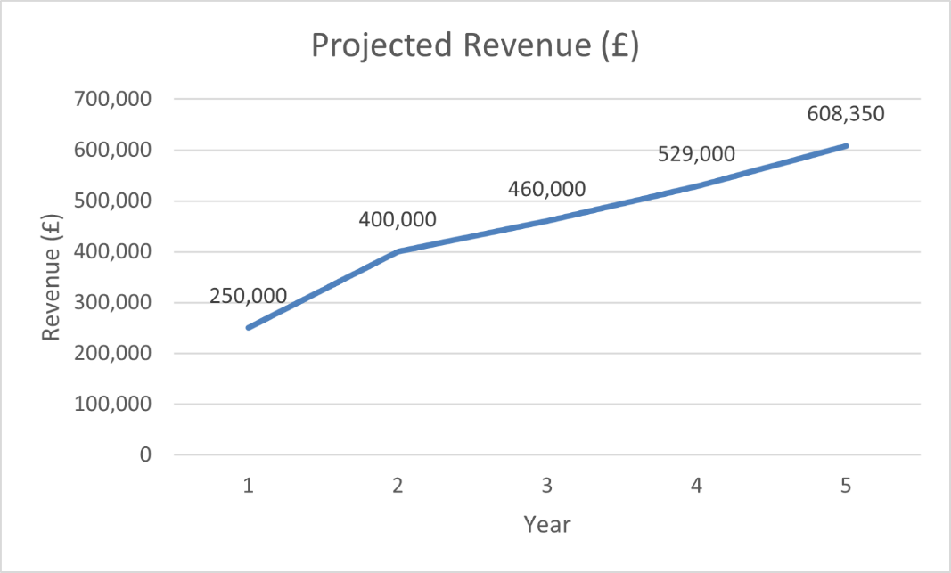

These financial projections align with current market growth trends and provide the necessary capital for reinvestment in green technologies and infrastructure (Kotler, Keller and Chernev, 2022).

4.2 Break-even Analysis
Prestige Car Wash is forecasted to achieve break-even status by the end of Year 2. This analysis is based on:
- Initial investment: £150,000 (infrastructure, eco-equipment, staff training and promotional campaigns).
- Monthly operational costs: £12,000 (wages, maintenance, consumables).
- Required monthly revenue: £20,000 to cover fixed and variable costs.

The break-even chart below shows the crossover point where revenue surpasses costs:
Break-even Point: Monthly Revenue vs Costs
Month | Revenue (£) | Costs (£)
Year 1 | 20,833 | 12,000
Year 2 | 33,333 | 12,000
Year 3+ | 38,333+ | 12,000

4.3 Cost-Saving Strategies and Financial Sustainability
Efficient cost management is essential for long-term financial sustainability. Prestige Car Wash Swansea aims to implement the following:
- Solar Energy Integration: Installation of photovoltaic systems will cut electricity usage by up to 30%, saving approximately £4,000 annually. It also reduces carbon footprint and supports brand reputation as an eco-friendly business (Carbon Trust, 2020).
- Water Efficiency Systems: Implementation of closed-loop water recycling and rainwater harvesting systems will reduce water usage by over 70%, significantly lowering water bills and meeting environmental compliance (DEFRA, 2022).
- Local Supply Chain Optimisation: Partnering with regional eco-cleaning suppliers will reduce logistics expenses, support the local economy, and enable bulk purchasing discounts.
- Smart Labour Scheduling: Using demand-based workforce planning tools to optimise staffing during peak and off-peak hours. The practice helps reduce overstaffing costs and maximises productivity.
- Waste Reduction Strategies: Introduction of biodegradable packaging and minimising plastic use in products and consumables.

Below is a visual representation of a financial sustainability roadmap:
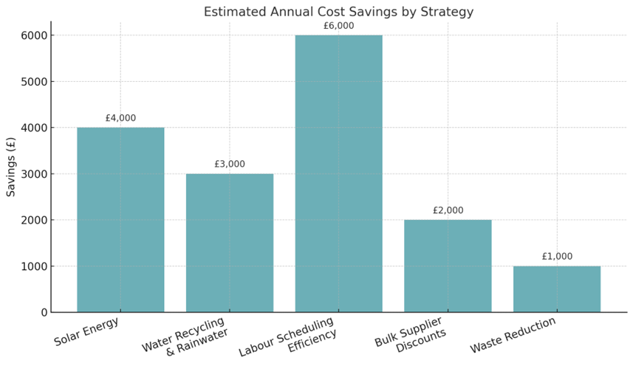

These strategies provide Prestige Car Wash with resilience to manage economic fluctuations, maintain a consistent delivery service and invest in future innovations.

5.0 Implementation Plan

5.1 Timeline of Key Actions

Prestige Car Wash Swansea Implementation Gantt Chart
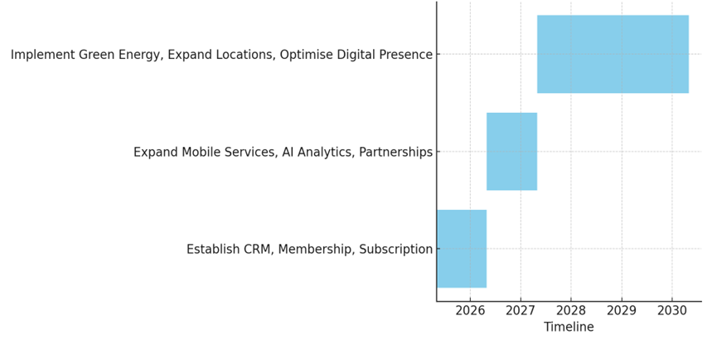

Year | Key Milestone
Year 1 | Establish CRM, launch a membership programme, introduce subscription models.
Year 2 | Expand mobile services, introduce AI-driven analytics, partner with local businesses.
Years 3-5 | Implement green energy solutions, expand service locations, optimise digital presence.

The successful execution of Prestige Car Wash Swansea’s business strategy will depend on a structured, phased implementation plan over five years. This plan will focus on launching foundational systems, expanding services, and embedding sustainability and digital innovation across the operation.

Year 1: Foundation and Customer Engagement
In the first year, the business will focus on establishing its core operational and customer engagement systems. The initial priorities include implementing a Customer Relationship Management (CRM) system to manage customer data and behaviour insights. Alongside, the launch of a membership program and subscription models will aim to drive early customer loyalty and predictable revenue streams. These systems will provide the backbone for customer-centric marketing and retention strategies (Kotler, Keller and Chernev, 2022).

Year 2: Service Expansion and Technological Integration
The second year will see the business expanding its mobile car wash services to reach a wider audience and provide convenience. The introduction of AI-driven analytics will support real-time customer insights and operational efficiencies, allowing the business to refine offerings and marketing strategies. Strategic partnerships with local businesses will also be developed to secure corporate clients, boosting revenue and brand visibility (KPMG, 2022).

Years 3–5: Sustainability and Digital Optimisation
The long-term plan focuses on embedding sustainability and digital optimisation into the business. From Year 3, the business will implement green energy solutions such as solar panels and high-efficiency machinery, contributing to its environmental targets (Carbon Trust, 2020). Service expansion to new locations will support revenue growth, and enhancements in digital presence via SEO, mobile app development, and omnichannel engagement will drive market competitiveness.
The accompanying Gantt chart visually maps out these key actions across the five-year timeframe.

5.2 Monitoring Success
To ensure effective implementation, the business will regularly monitor Key Performance Indicators (KPIs) aligned with strategic objectives:
- Customer Retention Rate: The goal is to achieve and maintain a 70% repeat customer rate. This will be tracked using the CRM and customer feedback tools.
- Revenue Growth: The business targets a 15% annual revenue increase, reflecting successful customer acquisition, retention and service diversification.
- Employee Satisfaction: Regular feedback sessions, training programmes and performance reviews will be conducted to monitor team morale and productivity (Page, 2024).
These metrics will be reviewed quarterly, with action taken promptly where gaps in performance are identified.

5.3 Risks and Contingency Plans

The implementation plan is not without risks. Three key risks have been identified, along with corresponding mitigation strategies:
- Market Saturation: With increasing competition in the car wash industry, Prestige Car Wash will differentiate itself by offering premium, eco-conscious services and personalised customer experiences, setting itself apart from low-cost competitors (IBISWorld, 2023).
- Economic Downturn: In times of economic instability, flexible pricing strategies and value-driven service bundles will be introduced to maintain customer engagement and affordability.
- Regulatory Changes: To stay compliant and agile, the company will maintain close alignment with industry regulations via memberships in trade bodies and regular consultation with legal and environmental experts (DEFRA, 2022).
Prestige Car Wash Swansea is in a position to achieve sustainable and resilient growth as a result of carefully phasing the implementation process, measuring progress through specific key performance indicators (KPIs), and preparing for any challenges.

6.0 Conclusion

Prestige Car Wash Swansea is strategically positioned to thrive in a rapidly evolving market by combining quality service with strong environmental values. By offering eco-friendly car washing solutions, adopting cutting-edge technology, and prioritising customer satisfaction through innovative loyalty programmes and personalised engagement, the business addresses both current consumer expectations and future market trends. A clear commitment to sustainability, from water recycling systems to the use of biodegradable products and renewable energy, not only enhances operational efficiency but also strengthens brand reputation. With a robust business model, diversified revenue streams, and an emphasis on employee development and retention, Prestige is set to build a loyal customer base and ensure long-term financial resilience. Through careful implementation of its phased strategy, consistent monitoring of key performance indicators, and well-prepared contingency plans, the business is well-equipped to navigate industry challenges such as competition and regulatory changes. By delivering premium, environmentally responsible car care with a customer-first approach, Prestige Car Wash Swansea aims to become the leading name in sustainable vehicle cleaning services in the region, setting a new standard for quality, innovation and corporate responsibility.

7.0 References

Alkaraan, F., Elmarzouky, M., Hussainey, K. and Venkatesh, V.G. (2023). Sustainable strategic investment decision-making practices in UK companies: The influence of governance mechanisms on synergy between industry 4.0 and circular economy. Technological Forecasting and Social Change, 187(2), p.122187. Available at: https://www.sciencedirect.com/science/article/pii/S0040162522007089.
Armstrong, M. and Taylor, S. (2020) Armstrong's Handbook of Human Resource Management Practice. 15th ed. London: Kogan Page.
Athuraliya, A. (2022). Business Model Canvas: Explained with Examples. Creately. Available at: https://creately.com/guides/business-model-canvas-explained/ [Accessed 27 Apr. 2025].
Becker, N. (2024). 7 Key Government Incentives for Sustainable Businesses (2025). ClimateSort. Available at: https://climatesort.com/government-incentives-for-sustainable-business/ [Accessed 17 Mar. 2025].
BPlan (2025). How to Boost Eco-Friendly Car Wash Service Business Success? BPlan AI. Available at: https://bplan.ai/blogs/boost-business/eco-friendly-car-wash-service-boost-business? [Accessed 26 Apr. 2025].
Business Conceptor (2024). Car Washes: Strategies for High Profitability. [online] BusinessConceptor.com - Inspires Trust. Available at: https://businessconceptor.com/blog/car-wash-profitability/ [Accessed 26 Apr. 2025].
Carbon Trust (2020) Energy Efficiency in SMEs: Best Practices Guide. Available at: https://www.carbontrust.com/
Clutterbuck, L. (2023). The Benefits of Using Eco-Friendly and Biodegradable Cleaning Products. Rainbow Life. Available at: https://rainbowlife.co.uk/blogs/rainbow-life-blog/the-benefits-of-using-eco-friendly-and-biodegradable-cleaning-products [Accessed 27 Apr. 2025].
DEFRA (2022). Consultation on Mandatory Water Efficiency Labelling. Available at: https://consult.defra.gov.uk/water-efficiency-labelling/water-efficiency-labelling/supporting_documents/Water%20efficiency%20labelling%20consultation.pdf.
Deloitte Digital (2024). The Keys to a Successful Customer Experience Personalization Strategy. Deloitte Insights. Available at: https://www.deloittedigital.com/us/en/insights/research/customer-experience-personalization-strategy.html [Accessed 27 Apr. 2025].
Delrahim, A. (2024). Sustainable Car Wash Practices And How Water Recycling Systems Factor Into Them. https://blisscarwash.com/. Available at: https://blisscarwash.com/sustainable-car-wash-practices-and-how-water-recycling-systems-factor-into-them/ [Accessed 27 Apr. 2025].
Department for Transport (2024). Vehicle licensing statistics: 2023. GOV.UK. Available at: https://www.gov.uk/government/statistics/vehicle-licensing-statistics-2023/vehicle-licensing-statistics-2023 [Accessed 26 Apr. 2025].
Eco Car Cafe (2023). Why Eco-Friendly Car Wash is the Future of Car Cleaning. Eco Car Cafe. Available at: https://ecocarcafe.com/why-car-wash-is-the-future-of-car-cleaning/ [Accessed 27 Apr. 2025].
Faster Capital (2025). Customer loyalty programs and CRM: Personalization in Loyalty Programs - FasterCapital. FasterCapital. Available at: https://fastercapital.com/content/Customer-loyalty-programs-and-CRM--Personalization-in-Loyalty-Programs.html [Accessed 27 Apr. 2025].
Firmansyah, I., Santoso, A.D., Nuha, N., Sahwan, F.L., Suryanto, F. and Wahyono, S. (2025). Environmental impact of car wash services by performing life cycle perspective. Global Journal of Environmental Science and Management, 11(1), pp.261–276. Available: https://doi.org/10.22034/gjesm.2025.01.16.
Harkness, L., Robinson, K., Stein, E. and Wu, W. (2023). How generative AI can boost consumer marketing | McKinsey. Mckinsey. Available at: https://www.mckinsey.com/capabilities/growth-marketing-and-sales/our-insights/how-generative-ai-can-boost-consumer-marketing [Accessed 27 Apr. 2025].
Hreha, J. (2023). Persona. Persona. Available at: https://www.personatalent.com/business/why-is-employee-retention-so-important/ [Accessed 27 Apr. 2025].
IBISWorld (2023) Car Wash & Auto Detailing in the UK – Market Research Report. Available at: https://www.ibisworld.com/united-kingdom/
IBISWorld (2024). Car Wash & Motor Vehicle Detailing in the UK - Market Research Report (2014-2029). Ibisworld.com. Available at: https://www.ibisworld.com/united-kingdom/industry/car-wash-motor-vehicle-detailing/5062/.
Kotler, P., Keller, K.L. and Chernev, A. (2022). Marketing Management, Global Edition. 16th ed. S.L.: Pearson Education Limited.
KPMG (2022) Operational Challenges in Service-based SMEs. London: KPMG Insights.
Mintel (2022) Car Care and Maintenance – UK – Report. Available at: https://www.mintel.com
Oxford CBT (2024). What Helps to Improve Employee Mental Health and Wellbeing. Oxford CBT. Available at: https://www.oxfordcbt.co.uk/what-helps-to-improve-employee-mental-health-and-wellbeing/ [Accessed 27 Apr. 2025].
Porter, M.E. and Kramer, M.R. (2011) ‘Creating Shared Value’, Harvard Business Review, 89(1/2), pp. 62–77.
Prestige (2024a). Affordable Car Wash Prices in Swansea | Prestige Car Wash - Prestige Car Wash Swansea: Expert Car Cleaning & Detailing. Prestige Car Wash Swansea: Expert Car Cleaning & Detailing. Available at: https://prestigecarwash.co.uk/our-prices/ [Accessed 26 Apr. 2025].
Prestige (2024b). Prestige Car Wash Swansea: Expert Car Cleaning & Detailing. Prestige Car Wash Swansea: Expert Car Cleaning & Detailing. Available at: https://prestigecarwash.co.uk/ [Accessed 26 Apr. 2025].
PwC (2023). Trends transporting the Automotive Industry report: PwC. PwC. Available at: https://www.pwc.com/gx/en/industries/automotive/publications/eascy.html [Accessed 27 Apr. 2025].
RSI Concepts (2024). The Role of Self-Service Kiosks in Enhancing Customer Experience. RSI Concepts - Top IT Solution Provider Company in Dubai, UAE. Available at: https://www.rsiconcepts.com/blog/2024/08/the-role-of-self-service-kiosks-in-enhancing-customer-experience/ [Accessed 27 Apr. 2025].
Sahota, N. (2024). Harnessing AI For Dynamic Pricing For Your Business. Forbes. Available at: https://www.forbes.com/sites/neilsahota/2024/06/24/harnessing-ai-for-dynamic-pricing-for-your-business/ [Accessed 27 Apr. 2025].
Tapuch, C. (2025). Loyalty and Rewards Programs for Car Wash Businesses. Loyaltymaster - Latest News. Available at: https://blog.loyaltymaster.com/loyalty-and-rewards-programs-for-car-wash-businesses/ [Accessed 27 Apr. 2025].
Welch, D. (2024). The Future of Sustainable Business: Trends, Challenges, and Opportunities. Green.org. Available at: https://green.org/2024/09/17/the-future-of-sustainable-business-trends-challenges-and-opportunities/ [Accessed 16 Mar. 2025].

