Student name: Olivia Green
Student number: 1906674
Lecture Name: Anita Nan
Module Name: Academic and Employability Skills
Module code: BMSW4001

Table of contents
Introduction……………………………………………………………3
Time Management…………………………………………………….3/4
Paraphrasing……………………………………………………………5
Communication ……………………………………………………….5/6
Problem Solving…………………………………………………………6/7
Summarising…………………………………………………………….7/8
Referencing……………………………………………………………….8
Conclusion…………………………………………………………………9
References…………………………………………………………………10

Introduction
The purpose of this report is to evaluate 3 employability skills and 3 academic skills, and to look at how each of these skills and what effect they have in the university and working environment. The 3 employability skills that will be evaluate and discuss are Time Management, Communication and Problem Solving, looking at what skills it takes to have good employability skills and how well it is needed in the workplace The 3 academic skills that will be evaluated are Summarising, Paraphrasing and Referencing, this report will focus on the importance of these skills in the university and how they can effected if not followed properly.

Time Management
Time management is being able to manage your time effectively and sufficiently. Good time management skill shows that you know how to prioritize, organise, set necessary goals and multitask, and do what things efficiently and effectively so that you can meet deadlines. It said that “good time management consists of priotizing, decision making, goal setting and scheduling” (Tomaszewski, 2019) all these things will help manage time efficiently.
Time management is an important employability skill to have in the workplace because it allows you to not feel pressured or under stress when your time is managed well, good time managing also shows respect and consistency to your boss and fellow colleagues. Good time management is also a good university skill to have because it shows good planning and organisation, without having good time management at university could cause serious problems in keeping up with tasks and assignments.
I think my time management is quite poor and it is something I definitely need to work on because I try to do too many things in one day which leaves me overwhelmed, and what ends up happening I either only end up doing one or more thing and everything else ends up being left until another day. Being on this course I learnt about the Pareto principle 80 20 which I have been applying to my off days which seems to work well. This principle helps to identify what is the most important things that needs to be done, and separate it with the least important, so once you’ve done the most important things that would class as having an productive day, even if you have one important thing and 10 non important things and you only done the one important task then that is still classed as having an productive day. Since learning this rule my life has become so much easier to manage, and you look at things different instead of spreading yourself too thin throughout the day and being overwhelmed.

Paraphrasing
Paraphrasing is to understand the meaning of a text or passage whether it is written or spoken and reconstruct it in your own words and still maintain the original meaning of the message, with keeping the important facts intact.
Paraphrasing is a good and an essential academic skill to have in the university because it helps students develop their own understanding skills, enough so that they can write it in their own words and change the structure of the sentence. Paraphrasing is also a good skill to have in the university because it avoids students being marked down for plagisim when writing an assignment. When you do paraphrase it’s also important to state the source of which the information was received because it is not your original idea.
Paraphrasing is a skill that I would need to work on as I am finding it extremely difficult because this is my first time in a university and learning and developing new skills at this age is becoming a challenge.

Communication
Communication skills is the ability to understand information and pass on information that is understood by others, whether it is verbal or nonverbal, which includes speaking, empathising and listening. Communication is something that is done every day by individuals, so this skill is one of the most important skills. Nonverbal communication such as facial expression, eye contact and body language contribute to more the half the percentage of communication that is interpreted based on Albert Mehrabian research.
According to Mehrabian’s (1981, p50)
- 55% of communication is non-verbal language facial expression, and eye contact and other non-verbal movements and actions
- 7% is verbal communication (words)
- 38% para verbal communication (tone and pitch of one’s voice)

Communication is a good academic skill to have because it allows others to understand you, and it shows how actively you are listening to the individuals either at university, the workplace or just everyday life, not only it shows how much you are listening, communication also shows how well you communicate with people and how you are perceived through verbal and non-verbal communication body language, eye contact and hand gestures which all come under good communication skills. Communication is a very important skill if not the most important skill that comes under a wide range of things to consider like eye contact and facial expressions, how do you look at the person talking, is your face disinterested in the conversation, meeting or classroom, body gestures and hand movements are invading personal space, does your hand gestures come across as aggressive, the tone and volume of your voice, are you loud unaware of how you speak, there are so many factors that come into play when talking about communication and the skills that need to obtained academically and in the workplace.
I think I have relatively satisfactory communication skills which still needs a bit of work, at times I am misunderstood and I say exactly what is on my mind which can come across as too outspoken, personally I like that characteristic of myself but it hasn’t gone down very well at times. I also need to work on my listening and concentration skills as I tend to drift in my own world or lose focus at times.

Problem Solving
To have a good skill like problem solving means you can solve problems that occurs in day to day life competently and promptly or finding a substitute solution, which does not always mean the problem is solved but they will be ways of dealing with it without it becoming a stress or a problem.
Problem solving is a good employability skill to have because it shows determination and resilience, problem solving also is the ability to solve problems with the ability to think quickly and that is something employers look for when employing individuals. problems will always occur in life and at the workplace, being able to solving problems would show how well one is able to work under pressure, even if the problem is not solved directly by the individual, it is the measures that were taking to solve the problem or the strategy that has been put it in place to try and resolve the problem, with clear communication, proper time management and team work
Problem solving is a skill I need to work on because it takes me some time to figure out how to sort a problem out or the best way to sort a problem. Problem solving goes hand in hand with decision making, because to solve a problem ultimately you would need to make a decision, and where I’m okay with making a decision I struggle with finding solution to a problem but when I finally do I can make a decision and stick to it.

Summarising
To summarise is the ability to turn a long piece of text and condense it, without losing the vital information of the text, it should keep the main points and facts of the texts, which should be shorter version of the main text. Summarising requires essential reading and thinking of the original text, which will show that the text is understood when it comes to writing an overview.
Summarising is a good academic skill to have when writing a text or assignment it shows that you understood the text enough to rewrite it in your own words, it also avoids plagiarism, summarising also shows good note taking skills, when taking notes only the vital parts you would take notes of. Summarising and paraphrasing go hand in hand because to know how to summarise you must know how to paraphrase. Even though you are summarising a piece of work it must be in your own words and this where paraphrasing should also be used.
Summarising is definitely a skill that I would need to work on as I do not have this skill because I have never had to use this skill before, so learning it in the university would be very essential for me so I can use it in my assignments or any academic writing. Summarising is a skill that I would struggle on because trying to condense a text into your own words for it to make sense with keeping the original text in mind is a hard skill for me to grasp and I will definitely be working on this academic skill.

Referencing
The definition of referencing is to give credit to someone who has written an piece of text, whether it is from the internet, books or articles, because the original ideas has been taken from those texts, referencing is also to give supporting evidence of written texts, then the author would need to be credited for his or her ideas.
Referencing is an essential academic skill to have because it allows you to show tutors that you have read about the information spoken or written about, and allows tutors to check information that you have stated in the referencing section that it is correct, and how long was the information created, and for every assignment that is written or spoken there needs to be evidence to support it. Without proper referencing this would be plagiarism and may cause you to fail, this why proper referencing is important.
Referencing is another academic skill that I would have to work on and improve academically because I have never used or have been taught this skill before, I would say referencing is one of the most difficult academic skills to learn because there is a specific way of referencing using the Harvard referencing technique, without using that technique in your assignment could end up being a fail.

Conclusion
The key points for this assignment were to evaluate each set of skills and to define and access each skill if they are good and why they are good in a working environment or university setting or both. The Employability skills that were assessed were Time management, communication skills and problem solving skills and the academic skills that were assessed are paraphrasing, summarising and referencing, after the defining each skill and whether these skills would be good at work or university I had to state if I had that skill or if I needed to improve those skills. Evaluating each of these skills overall, I would need to work on both academic and my employability skills to improve myself and my team building skills especially when I own my own business a lot of the employability skills will become very useful for everyday management of life. Academically those skills will help me so that I don’t struggle throughout the year of this course, so I will be working very hard to achieve all these goals for the future and become better at this university course

References
Morgan, p. (2017) The Business Student’s Guide to Study and Employability. Sage
Publications. London, Sage
Study.com (2019) “What is Paraphrasing? Definition and examples”, available from
https://study.com/academy/lessons/what-is-paraphrasing-defintion-examples-quiz.html [accessed 20th December 2019]
Zety (2019) “30+ Time Management Skills and Examples for Your Resume”, available from
https://zety.com/blog/time-management-skills [accessed 15 December 2019]
Study skills city college (2011) “English for Academic Purpose Blended Learning Course”, available from
https://studyskillscitycollege.wordpress.com/?s=Summarising+&submit=Serach
Griffiths, B.A. and Dunham, E.B (2015) “Communication” Certificate in Higher Education: Skills for the Workplace Student Yearbook, Sage Publications, London, Sage.


Academic and Employability Skills (ACE) — term 1
BMSW4001
In-class exercise 2: Summarising (Oct 2019)
Student Name: Student ID/Group:
Time allocated: 1 hour. Please return your paper to the lecturer upon completion. It will be returned to you at the next session. You will need to include a scanned copy of this exercise in the form of an appendix together with your Task 1 (part of the Assignment for this module).

Ex.l
Read the following text and make notes on the main ideas. You can do this on a separate piece of paper which you do not have to hand in.
To be a great leader, you need to start by leading yourself
Most people go into top positions with good intentions, but those often crumble due to the demands — and perks — of the job. If you want to succeed, devote some time and energy to self-leadership, says consultant Lars Sudmann. Being a leader is a little like being a parent; beforehand, we have all these rosy visions of how we're going to do it, how incredible we're going to be, and how we'll sidestep the mistakes that we see other people make. But when it's our turn to assume the role, we find that reality doesn't match our expectations or imaginations. Sudmann, for example, believed that he would ace his first leadership role. Then, he held his first major staff meeting, an employee asked a question about the company's email signature, and the proceedings — and his command of them — completely fell apart.
After some months, Sudmann realized he was fighting against certain entrenched factors that keep all leaders from improving. Like many in the working world, leaders have too much to do and not enough time to do it; they don't clearly think through their priorities and strategies; and being in a position of power causes them to assume that the people beneath them will take care of a lot of problems.
Sudmann found a potential solution to these "classic leadership problems" in Marcus Aurelius, the Roman emperor and Stoic philosopher. Rather than spending his time trying to learn to rally and guide others, Marcus Aurelius focused a surprising amount of his energy on mastering self-leadership. Sudmann has found this orientation tremendously helpful. Below he breaks down three actions that go into self-leadership.
First of all, you need to be aware of your shortcomings; leaders need to know all of their biases, predilections and weaknesses. Another idea is to take 5-10 minutes every day to think about the challenges you've recently handled and the ones you'll soon face. While Marcus Aurelius was fond of reflecting in the evening, Sudmann likes doing this over morning coffee. Questions to pose include: "How did my leadership go yesterday? How would the leader I'd like to be have faced the challenges I faced? What about my challenges today? What could I do differently?" Write down your thoughts so you can refer back to them and learn from them.
Also, regulate your feelings; no matter how much preparation and reflection you put in, there will be employees, colleagues, clients and associates who anger, frustrate or annoy you. That's where the practice of "reframing" comes in; stopping and asking yourself ... on a scale from 1 to 10, how important is this issue right now? Then, give yourself a momentto think: "How would the leader I aspire to be handle this situation?" The answer will come to you.
Lecturer's signature: Date: 

Academic and Employability Skills (ACE) — term 1
BMSW4001
In-class exercise 2: Summarising (Oct 2019)
Ex.2
Re-read the text 'To be a great leader, you need to start by leading yourself' on the previous page Summarise main ideas from the text in your own words. Write about 175 words.
 |  |  |  |  |  |  |  |  |  | 
 |  |  |  |  |  |  |  |  |  | 
 |  |  |  |  | e |  |  |  | 
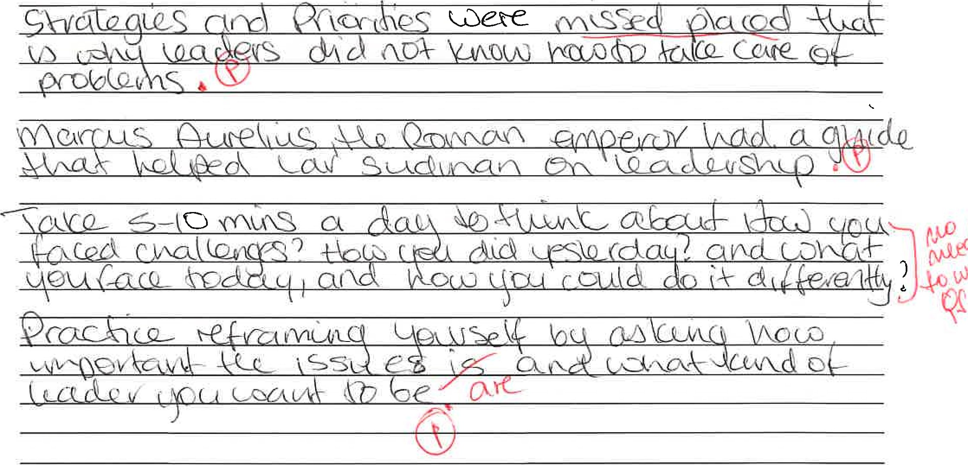

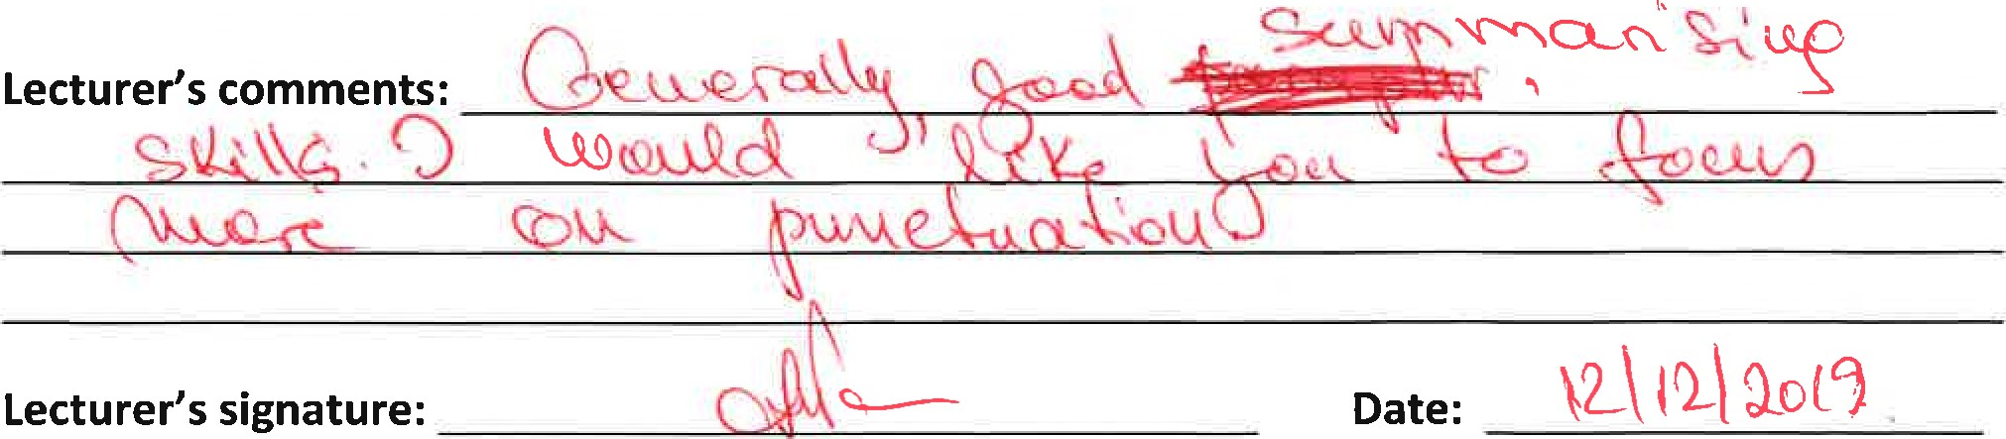

Appendix
Academic and Employability Skills (ACE) — term 1
BMSW4001
In-class exercise 2: Summarising (Oct 2019)
Student Name: Student ID/Group:
Time allocated: 1 hour. Please return your paper to the lecturer upon completion. It will be returned to you at the next session. You will need to include a scanned copy of this exercise in the form of an appendix together with your Task 1 (part of the Assignment for this module).

Ex.l
Read the following text and make notes on the main ideas. You can do this on a separate piece of paper which you do not have to hand in.
To be a great leader, you need to start by leading yourself
Most people go into top positions with good intentions, but those often crumble due to the demands — and perks — of the job. If you want to succeed, devote some time and energy to self-leadership, says consultant Lars Sudmann. Being a leader is a little like being a parent; beforehand, we have all these rosy visions of how we're going to do it, how incredible we're going to be, and how we'll sidestep the mistakes that we see other people make. But when it's our turn to assume the role, we find that reality doesn't match our expectations or imaginations. Sudmann, for example, believed that he would ace his first leadership role. Then, he held his first major staff meeting, an employee asked a question about the company's email signature, and the proceedings — and his command of them — completely fell apart.
After some months, Sudmann realized he was fighting against certain entrenched factors that keep all leaders from improving. Like many in the working world, leaders have too much to do and not enough time to do it; they don't clearly think through their priorities and strategies; and being in a position of power causes them to assume that the people beneath them will take care of a lot of problems.
Sudmann found a potential solution to these "classic leadership problems" in Marcus Aurelius, the Roman emperor and Stoic philosopher. Rather than spending his time trying to learn to rally and guide others, Marcus Aurelius focused a surprising amount of his energy on mastering self-leadership. Sudmann has found this orientation tremendously helpful. Below he breaks down three actions that go into self-leadership.
First of all, you need to be aware of your shortcomings; leaders need to know all of their biases, predilections and weaknesses. Another idea is to take 5-10 minutes every day to think about the challenges you've recently handled and the ones you'll soon face. While Marcus Aurelius was fond of reflecting in the evening, Sudmann likes doing this over morning coffee. Questions to pose include: "How did my leadership go yesterday? How would the leader I'd like to be have faced the challenges I faced? What about my challenges today? What could I do differently?" Write down your thoughts so you can refer back to them and learn from them.
Also, regulate your feelings; no matter how much preparation and reflection you put in, there will be employees, colleagues, clients and associates who anger, frustrate or annoy you. That's where the practice of "reframing" comes in; stopping and asking yourself ... on a scale from 1 to 10, how important is this issue right now? Then, give yourself a momentto think: "How would the leader I aspire to be handle this situation?" The answer will come to you.
Lecturer's signature: Date:
Academic and Employability Skills (ACE) — term 1
BMSW4001
In-class exercise 2: Summarising (Oct 2019)
Ex.2
Re-read the text 'To be a great leader, you need to start by leading yourself' on the previous page Summarise main ideas from the text in your own words. Write about 175 words.
e

In class exercises

