2015755@student.uwtsd.ac.uk
Development & Application of manufacturing operation
- Will Holmes
- 2015755
- ACMA5001
- Development and application of manufacturing operations
Table of Contents
0.0 List of figures and tables 2
1.0 Introduction 3
2.0 History of automation 1940-2020 3
2.1 1940s-1950s 3
2.2 1960s 4
2.3 1970s-80s 5
2.4 1990s 5
2.5 2000s-2010s 6
3.0 Types of automated manufacturing 8
3.1 Origins of Automation sectors 8
3.2 Fixed automation 8
3.3 Programmable automation 9
3.4 Flexible automation 10
4.0 References 12

0.0 List of figures and tables

Figure 1 – Ford Motor Company first production line.…………………………….……………………….……3
Figure 2 – Manufacturing automation process….…….……………………………………………………………3
Chart 1 – Jobs lost v jobs gained 1960s …………….…………………………………………………………………4
Figure 3 – First robotic arm designed for manufacturing use…….……………………………………….…5
Figure 4 - Automated manufacturing 1…………….…………………………………………………………….…….6
Figure 5 Automated manufacturing 2……………………………………………………………………………………6
Figure 6– lean manufacturing process ………………………………………………………………………………...6
Figure 7 – Six Sigma process….………………………………….……………………………………………….…………7
Figure 8 – Total productive maintenance ……….………….…………………………………………………………7
Figure 9 – DFMA process….…………………………………….……………………………………………………………7
Figure 10 – Fixed automation production line………………………………………………………………………8
Figure 11 – Fixed automation block diagram….………….…………………………………………………………8
Table 1 – Fixed automation advantages & disadvantages ……….……………………………………………9
Figure 12 – Programmable automation production line….……………………………………………………9
Figure 13 – Programmable automation block diagram….………………………………………………………9
Table 2 – Programmable automation advantages & disadvantages ……….………….………….……10
Figure 14 – Flexible automation production line ……….………………………………………………….……10
Figure 15 – Flexible automation block diagram. ……….……………………………….……………………….10
Table 3– Flexible automation advantages & disadvantages. ……….……………………….……….…….10
Figure 16 – 3 types of manufacturing automation methodologies. ………….……….……………….11

.

1.0 Introduction
This report will explore the history of automated manufacturing and applying technologies to achieve goals throughout process plants. It will investigate fixed, flexible, and programmable automated manufacturing and what roles they play within the automated industry, discussing how these different systems are implemented in the industry and the sectors in which they’re originated and employed within.
The report will cover control systems in place and processes variables applied to each of the three types of manufacturing automation, and how each increased output and efficiency within their optimal sectors. It will unveil the advantages and disadvantages of these processes, and how these processes progress, along with developing and new technology from the origins of automation in the 1950s following its history to the 2010s when current methodologies and processes are used.

2.0 History of automation 1940-2020

2.1 1940s-1950s
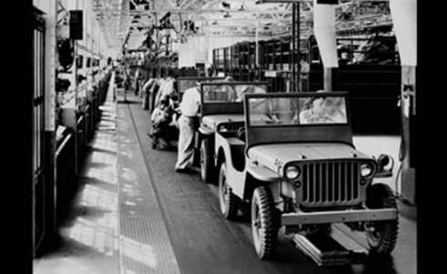
Automated manufacturing made its stamp in history post second world war within the automobile industry at Ford Motor Company 1946. where the first automated processes were set into place to “describe the increased use of automatic devices and controls in mechanized production lines. The origin of the word is attributed to D.S. Harder, an engineering manager at the Ford Motor Company at the time” Groover (2023)
The initial objective was to achieve an automated carousel primarily featuring five stages, handling, making, inspecting, assembling, testing, and packaging. This is what is now known as automated manufacturing and what was the groundwork of so many other improvement processes. Such as lean, Six sigma, and Muda.
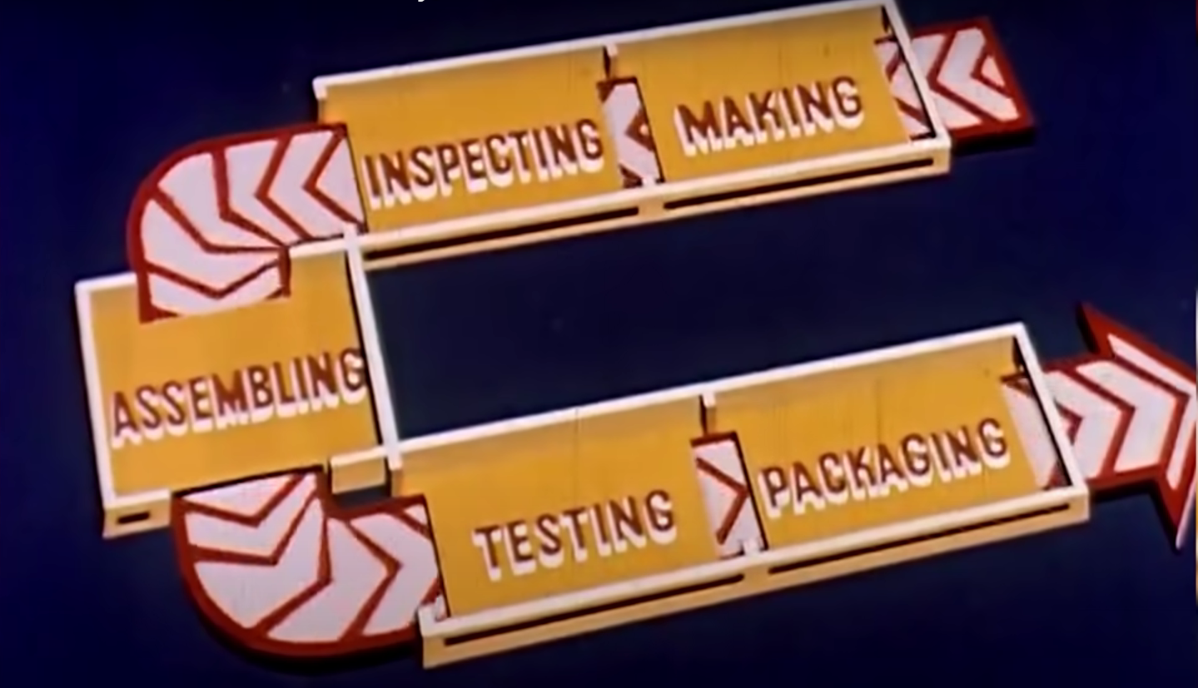
This era of automation was in very much an experimental phase, trialling combinations and pushing the limit with the machinery available at the time. Most large companies were analysing main issue areas and inspecting sections to automate. The manufacturing process could be broken down into three broad groups, manual, mechanisation, and automation. Within these areas sections could be further broken down, the manual sector is where physical tasks could be carried out with the use of your hands or the aid of hand tools. Mechanisation is where manually operated, power-driven machines with varying degrees of control to achieve one or more operations. It’s broken down to a machine, semi-automatic, and automatic. Last is continuous automatic production, this is where automated machines are integrated using transfers with controllers to achieve an automated production line. These three phases of manufacturing automation are the steppingstones of modern automated production lines.

2.2 1960s
During the 1950s and 60s, the progression of automated system processes was growing at a substantial rate and was causing major concern in the United States. Throughout the late 50s and 60s, it was estimated that 1.8 million jobs per year were being replaced by automated processes. At that going rate 25,000 jobs would need to be made per week to ensure no one person was out of work. This era was known as the “automation depression” and an article stated, “We are stumbling blindly into the automation era with no concept or plan to reconcile the need of workers for income and the need of business for cost-cutting and worker-displacing innovations.” Leetaru (2019).

The chart above shows the vast growth in automation, and the job losses it caused over a twelve-month period in the early 1960s which is stated along the blue line, the orange line is the processes implemented to combat the problem by John. F. Kennedy. The number of jobs being created for displaced automation jobs is never on target to stop the issue, as it persisted to be an issue throughout the industry to this current age of automated manufacturing.

2.3 1970s-80s
The 1970s was a huge turning point in the automated manufacturing industry. General Motors prototyping industrial robots performing various tasks such as welding, and machining. The success of these processes was quickly recognised and utilised by other car manufacturers.
The 1970s also saw staggering robotic advancements in the automotive industry. A robotic arm that was developed by Stanford University made it possible for robot arms to complete multiple complex tasks, as it was able to move more freely on multiple axes than older generation models.
Later into the 60s, the arm was improved and re-designed at MIT. The arm model was embedded with sensors and a microprocessor, making the arm more versatile. The redevelopment of the arm design saw a 30% sales growth, which primarily came from the automotive industry. This trend continued into the 80s as the industry saw consistent growth in the automotive industry using automation tooling. Which in turn meant more money was being pushed towards automating as many processes as possible.

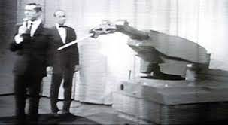

2.4 1990s
Throughout the 1990s automation saw significant advancements, primarily in the manufacturing, and technology sectors. The continuous growth and use of the internet-enabled numerous businesses large or small to make significant growth in their fields, many previously manual tasks were now automated eliminating the need for human interference, which increased efficiency and productivity.
During this time the manufacturing industry saw an extensive overhaul with the use of newly founded automated technology, and the use of computer numerically controlled (CNC) machines became at the heart of every operation. These machines would allow for greater precision in the production of low or high-volume goods, enabling companies to be more repeatable, and reproducible, with fewer mitigating factors hindering the quality. Robotics became more prevalent with robots being used for tasks such as assembly, welding, and painting.
The 1990s was also a turning point for automated information technology used throughout industries but became a more common thing throughout smaller businesses and households. These tasks would enable data entry, report generation, and system monitoring to be completed systematically without any manual input.
Although automation in the 1990s led to significant improvements in the field, also heavily increasing productivity, and efficiency in many industries, the concern which originated in the early 1960s the “automation depression” still posed a threat with automated factory lines displacing jobs that they had now replaced.
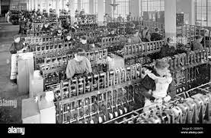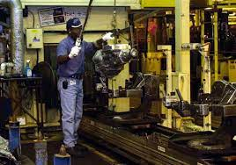

2.5 2000s-2010s
Carrying on from the growth in the 90s manufacturing automation saw significant technological advancements, robotics as the designs became sophisticated and cost-effective, and artificial intelligence (AI) this system enabled companies to create manufacturing systems with the capability of learning and diagnosing issues without any manual data input (MDI), information technology was further developed with the use of cloud computing making previously time and resource consuming tasks to be completely automated, and supply chain automation with its advancements in logistics, and supply chain management improving efficiency and reducing costs. With the widespread adoption of these automated processes in various sectors and industries, the manufacturing industry has propelled forward showing signs of AI ran operations soon eliminating the need for manual input altogether.
Additionally, there were some key developments within manufacturing automation because of the adopted methodologies. Here are some of the key methodologies:
Lean manufacturing is a methodology that aims to eliminate waste and increase efficiency throughout manufacturing processes. Lean utilises techniques used throughout the industry such as continuous improvement, just-in-time production, and value stream mapping (VSM), to reduce lead times, and costs, whilst increasing output and improving quality.
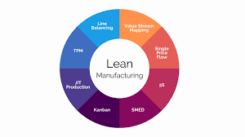

Six-sigma is a heavily data-driven methodology aiming to improve quality whilst reducing defective components during the manufacturing process. With the use of statistical analysis and process controls, it can identify root causes and eliminate sources of variation within the manufacturing production line.
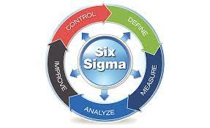
Total productive maintenance (TPM) is a methodology designed to optimise the efficiency of all manufacturing equipment; this is achieved by involving all parties in the maintenance process. This methodology utilises techniques such as planned maintenance, quality maintenance, and autonomous maintenance.
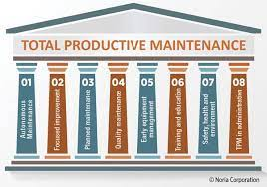
Design for manufacturing and assembly (DFMA) is a widely used methodology within the engineering sector, as it focuses on reducing the steps taken during the manufacturing phase, this enables ease of assembly as fewer components are used and less complex parts if applicable. Further reducing production costs, improving quality, and optimising time to the consumer.
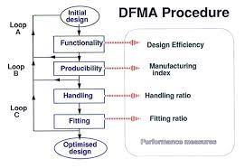

3.0 Types of automated manufacturing

The types of automated manufacturing include Fixed automation, fixed automation refers to a system designed to produce a single product type. Fixed (complex) automation typically involves a set of repetitive or fixed sequences, for instance, assemblies or product processing. This type of automated manufacturing is reinforced with specialist hardware to automate assembly or fixed sequential processing operations.
Programmable automation describes the process of mass production of a product in which production equipment is reprogrammed to accommodate production environments and the new specification of components.
Within fixed automation, the machining or assembly system is fixed in position by the equipment configuration, while programmable automation has the flexibility to alter the sequence of operations to correctly establish product configurations.
Flexible automation systems are highly adaptable systems with high computer input and controls. Commands are input by operators using code or through Human Machine Interfaces (HMIs). These instructions are high-level, and low-level changes automatically identify various automation processes within their allocated locations. Within flexible automation systems, multiple machine tools can be bridged to a sophisticated handling system typically through robotic automation.

3.1 Origins of Automation sectors

3.2 Fixed automation
Fixed automation is a manufacturing process involving specialised tools to repeatedly complete and specific task. The process was originally exploited back in the early 20th century with the development of assembly lines by Henry Ford.
This use of the process revolutionised the industry by increasing manufacturing speed and efficiency. This was achieved by reducing the size of tasks and utilising specialised tooling for each process. This use of fixed automation continued its growth with advancing technology more complex and precise machines can be produced allowing more systems to be easily automated.
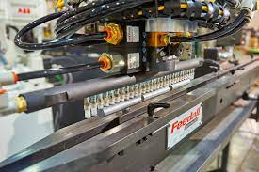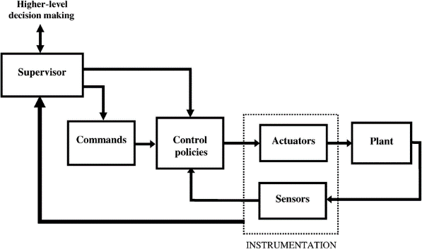

Fixed (Hard) Automation
Advantages | Disadvantages
Consistent quality | Large initial investment
Unmanned operation | Failures leading to unplanned downtime
Reduced human error | Require some manual labour, for observation and programming
24/7 Run-time | Additional costs for specialised technicians
Assorted component manufacturing | Extensive planning for running schedules

3.3 Programmable automation
Programmable automation, also known as soft automation, is a manufacturing process primarily derived from computer-controlled machines, capable of performing a multitude of tasks. The origins of this processing method can be traced back to the 1950s and 1960s when the initial idea and machines known as (CNC) machines were made.
Originally, CNC machines were developed for the aerospace industry, where they played a key part in controlling complex components of jet engines. These early developing CNC machines used “tapes” for the programming of the CNC operation, as a result, the movements available were limited in their capabilities. Throughout the following decades, the development of CNC capability became more advanced with the assistance of computer-aided design (CAD) thus pushing the capability of automated manufacturing.
During the 1980s, the manufacturing industry was introduced to programmable logic controllers (PLCs), which provide a flexible option for controlling automated processes. These PLCs allow operators to write custom instructions allowing the process to achieve a wide range of manufacturing processes.
Nowadays, programmable automation is essential in almost every aspect of manufacturing, advancing the technology is a current focus by introducing sensors, and self-learning algorithms by the way of AI, enabling the industry to push its limits whilst still hitting targets.

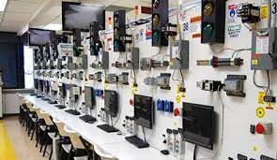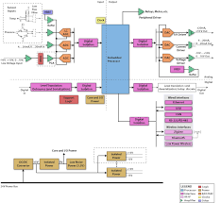

Programmable Automation
Advantages | Disadvantages
New technology allows for, relay switching, counting, timing, calculating, and processing analogue signals | PLC control systems require specialised training
Upload and download via PLC controllers are simple | Logic functions are set and not easily modified
New or varying PLCs can be made without full re-wiring | Regular maintenance is scheduled to keep all systems running correctly
Troubleshooting is simple using software or hardware as a computer would to trace the defective coding and solve it effectively | Large initial investment
Less power, reducing costs

3.4 Flexible automation
Flexible automation was first established in automated manufacturing in the 1950s when numerical control (NC) and computer numerical control (CNC) were introduced allowing companies to produce large quantities of goods whilst increasing quality for a reduced cost. Being introduced around the same time as fixed automation both methodologies use similar technology and processes.
The variance between the two is design purpose, one being utilised as a single operational tool whereas the other Is designed to have multiple purposes, configuring, and adapting the specification of the components being manufactured.
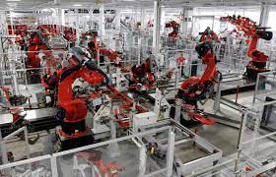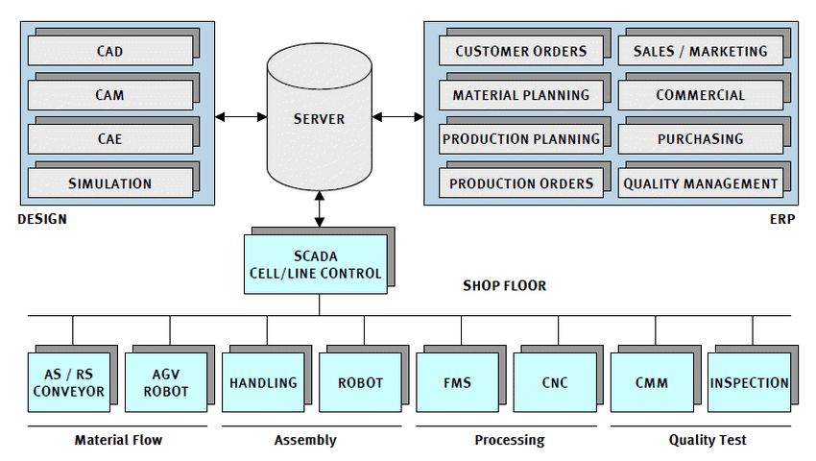
Flexible (Soft) Automation
Advantages | Disadvantages
Assured quality | Large initial investment
Unmanned operation | Mechanical & electrical issues hard to diagnose over a large production line
Simple tooling to suit most jobs | extensive time is required to specify design needs for a variety of future needs
Non-stop run-time | Additional costs for specialised technicians
Assorted component manufacturing | Extensive planning for running schedules

As stated above, flexible automation is a tool companies use to produce a multitude of components using the same production line. A design change can be made in many sectors of the production line ranging from programming, tooling, and material adapting to the current specification of components.
An example employing flexible automation in recent years would be the manufacturing of flat-pack furniture. This industry has taken a once bulky high-cost process into a mainstream business capable of producing quality products at a fraction of the cost.
The use of flexible automation within this industry would be highly beneficial from a manufacturing point of view if the correct tools are implemented. The main attributes of flat-pack furniture include ease of installation, low-cost/ lightweight materials, and ease of adaptation to its design. All the attributes listed above contribute towards the success of flat pack furniture and can be made progressively stronger with the implementation of flexible automation.
As communicated above, flat-pack furniture can be adapted to suit many variations and designs with ease. Thus, flexible automation is the strongest applicant for success.
Although output numbers would be greater with use of a fixed automation system, if a fixed operating system was used throughout the industry for every design, size, and specification, a revised production line would be needed for each one. This operation would supersede any budget, and space available for most companies and would result in losses.
A flexible automated production line would have a larger initial investment but allow for near to all variations to be produced along one production line. This could be achieved by a change in programming, alternate directives given to the robots, and self-medicating/teaching software allowing for a production line to make systematic changes for the specifications required.
In turn this would have the following effects:
- Lower operating space required.
- Reduce manual labour.
- Increase reproducibility.
- Lower operating costs.
- Hardware has applicability in multiple automation processes.
- Minimal tool changeovers between tasks.

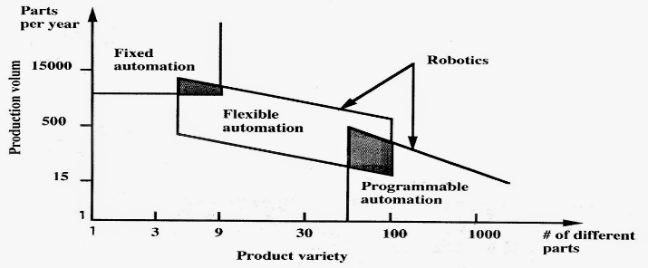

4.0 References

Meyer (2004) post war automation movement retrieved April 2023.
http://www.autolife.umd.umich.edu/Labor/L_Overview/L_Overview7.htm

Midwest engineering (2023) Flexible automation systems retrieved April 2023 from Midwest engineering.
https://www.mwes.com/capabilities/assembly-and-automation/flexible-automation-systems/

Empowered automation (2022) Fixed automation systems retrieved March 2023 from Empowered Automation.
https://www.empoweredautomation.com/what-is-fixed-automation

Groover (2023) historical developments of automation retrieved March 2023 from Britannica https://www.britannica.com/technology/automation

Leetaru (2019) 1960s automation reshape retrieved April 2023 from Forbes https://www.forbes.com/sites/kalevleetaru/2019/07/18/automation-reshaped-the-workplace-in-the-1960s-but-will-the-deep-learning-revolution-be-different/?sh=7c98cb3c702f

Porter (2021) industrial automation history retrieved April 2023 from Warbleton council https://warbletoncouncil.org/automatizacion-industrial-4369

Peterson (2022) origin story of the PLC retrieved April 2023 from control automation.
https://control.com/technical-articles/the-origin-story-of-the-plc/

Wake industrial (2021) Hard v soft automation retrieved April 2023 from Wake industrial
https://www.wakeindustrial.com/blog/2021/02/15/flexible-vs-hard-automation-what-are-the-differences-and-benefits-to-each-one/

Cross (2023) efficiency with flexible automation retrieved April 2023 from Cross
https://www.crossco.com/resources/technical/fixed-versus-flexible-automation/

Midwest engineering (2023) Flexible automation systems retrieved April 2023 from Midwest engineering.
https://www.mwes.com/capabilities/assembly-and-automation/fixed-automation-systems/

