Kristian Crawford

1919795

Digital Degree Apprenticeship

Introduction to Web and Database Concepts

ACCA4023

16th April 2021

Table of Contents

Title Page Page 1
Table of Contents Page 2
Abstract Page 3
Requirements Page 4
Implementation Page 4 – 8
Evaluation Page 8 – 12
References Page 13 – 14

Appendices
Appendix I Page 15 – 17
Appendix ii Page 18 – 49

Abstract

This report details the steps taken to plan, produce, develop, and evaluate a photography-based website, which is designed to plot my journey through learning the art of photography, in the hope of inspiring others with a similar taste for the art. Allowing them to become more adept at producing those rare shots that they will be happy to share with others, whilst feeling a sense of pride at their achievement. This is not intended as a one stop shop, just a road sign that will point the beginner in one possible direction, and set them on a path of self-discovery, whilst hopefully having fun along the way as I have.

Requirements
This website is designed to enable me to share with others some of the things I have learnt about photography over the years. This site is designed as an introduction to the topic and is thus best suited to those who are at the beginner level, offering to help with the aid of a few pointers on how I first learnt to develop from taking basic family snapshots, to thinking about composition of photographs. This is highlighted in the gallery page where I have displayed a sample of the images I have captured over the years.
The relevance of the site is displayed through the journey I have undertaken, providing some information to those wishing to embark on a similar journey. This site is not intended as a one stop answer just a reference point for those wishing to make use of it.

Implementation
During the early design process I produced the following rough outlines of what each page would look like, and what information would be contained on each page. First is the home page.
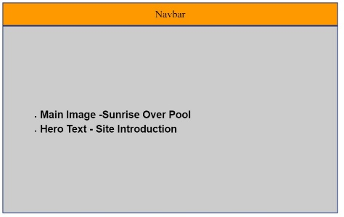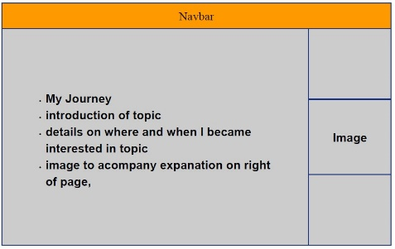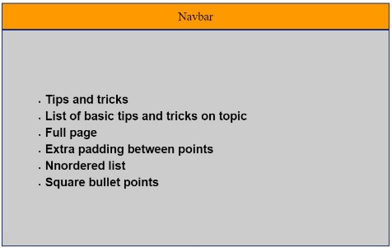
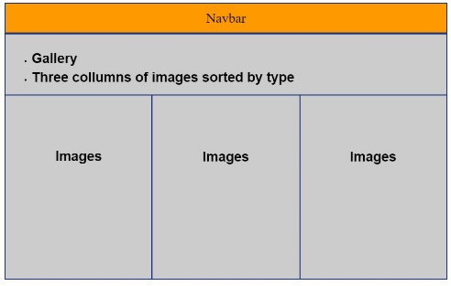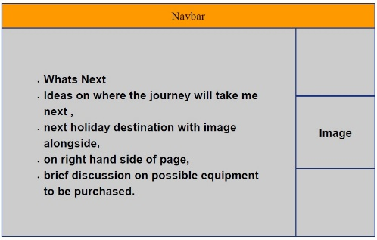
Each of these five images represent the basic outline of the website I built. With the intent of the order of the pages being to take the reader on a journey, similar to, but much shorter than my own.
The following screenshots are the five pages of my website in the order they are intended to be viewed, although the user is free to examine them in any order, and doing so should not in any way lessen their impact. It is worth noting that all images with the exception of the image on the “What’s Next” are my own and have been taken over a number of years using a number of different cameras.
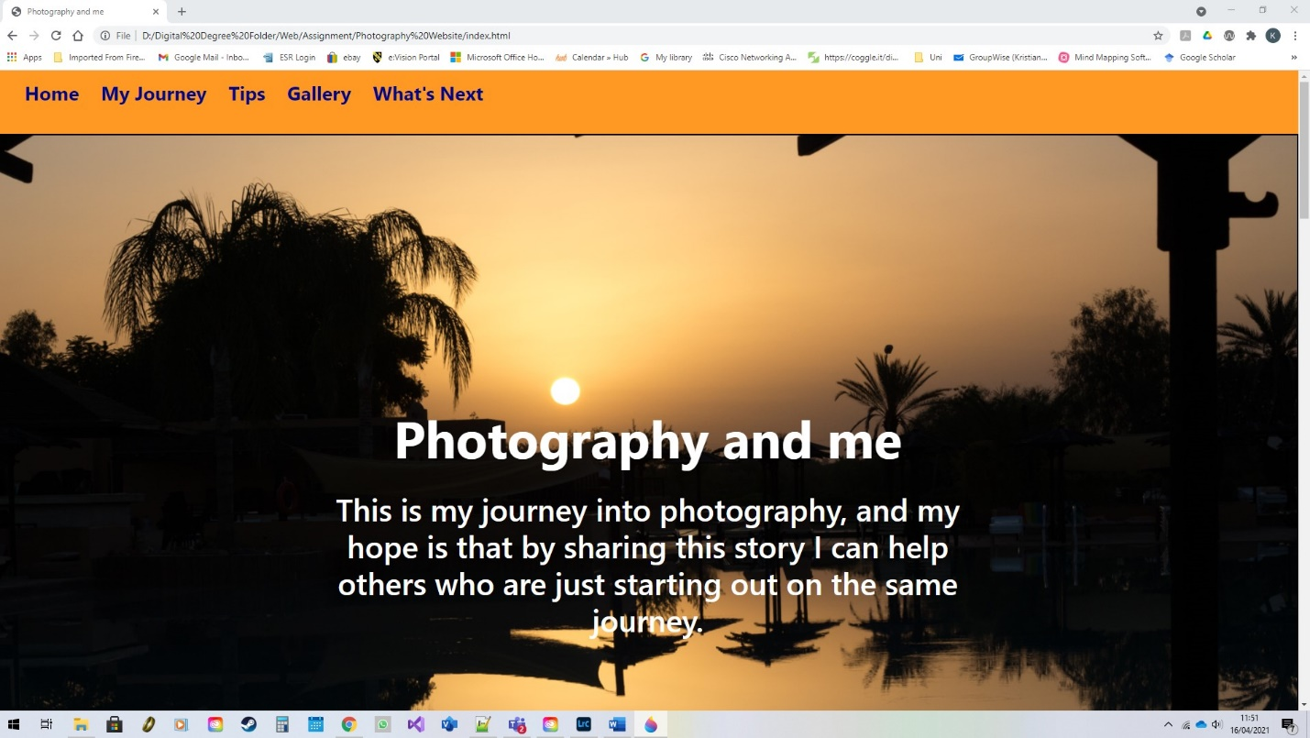
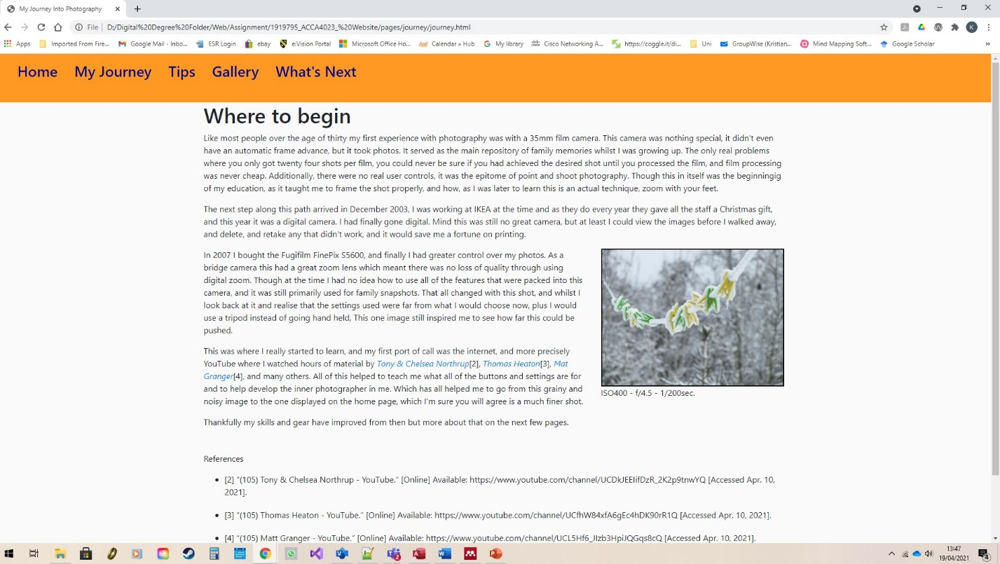
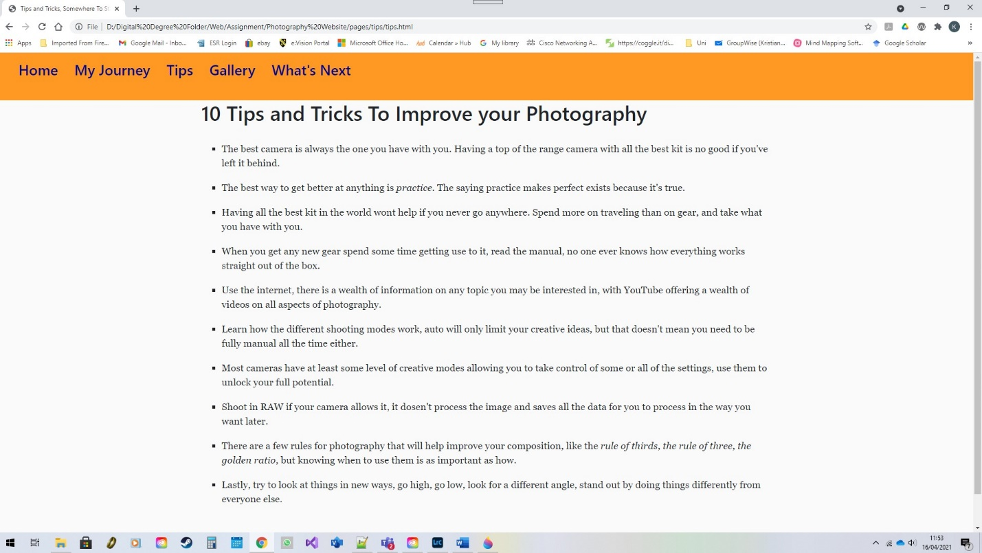
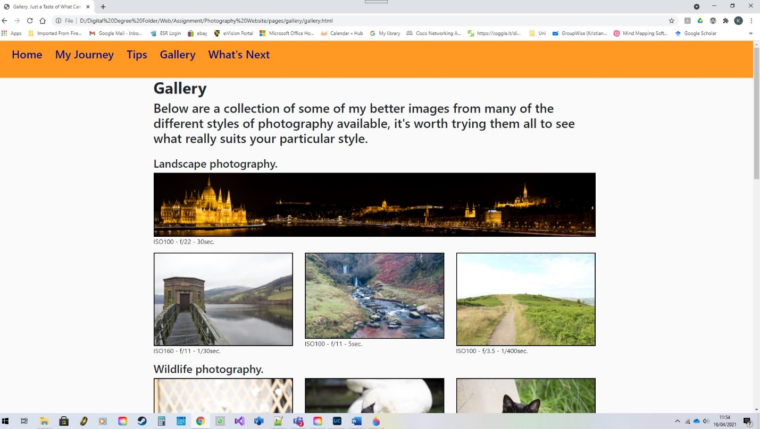
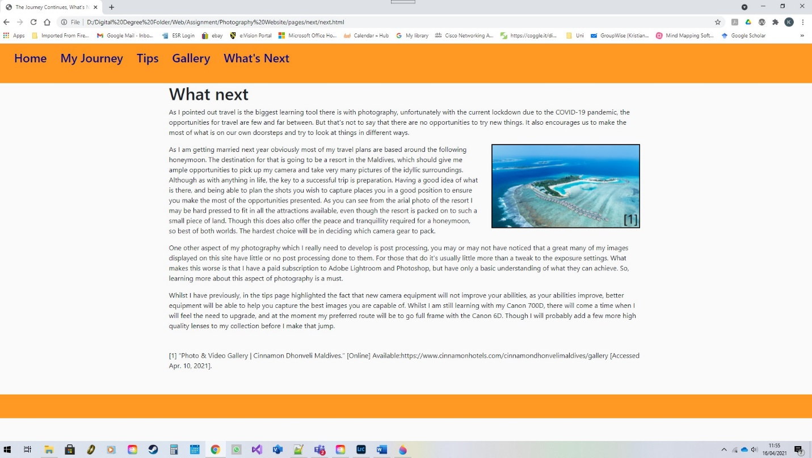

For validation of the code contained within the website I used the [1]W3C organisation html validator, and the [2]W3C css validator. The html validator only pulled up two different errors although they each appeared more than once, they were
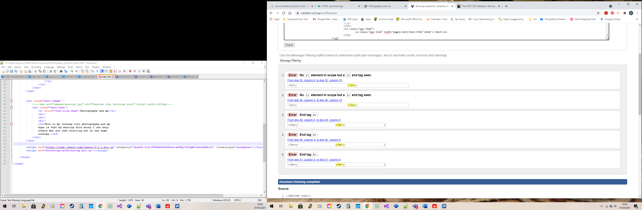 and
.
Both of these errors were easily resolved, firstly by removing the additional </li> element end tags, which had been created by not ensuring that only the required elements were selected when copying and pasting, to create extra nav bar links. This issue also appeared on all of the other pages. So remedial work was also required there. The second issue was corrected by changing the </br> tags to <br/> tags. There were originally three of these on the main page, but to tidy things up I removed two of them and repositioned the text using css.
There was one other issue that the validators did not pick up and that was concerned with adding a hero image. I attempted three different methods of achieving this with no effect, and can only conclude that the issue must lie within the use of Bootstrap [3], and a conflict caused by this, as manually inserting the three main images worked it had other drawbacks, including the prevention of a footer being displayed on the main screen where it worked on all other screens.

Evaluation

When evaluating any website we must look at three main factors to assess its impact, the usability, accessibility, and the methods of search engine optimisation used within the site.
The most commonly used definition of usability is that provided by the International Standards Organisation [3], which defines usability as “the effectiveness, efficiency, and satisfaction with which specified users can achieve goals in a particular environment”. Mohammad H. Alshira’H [4] in his report on the effects of Usability and accessibility on end-user satisfaction. The paper defines the level of usability in line with past experiences of similar environments and the ability to use past experience to enable free interaction with new systems. Conversely the need to learn new skills before being able to freely use the new environment to meet goals can render the environment less accessible, which grows with the depth of the learning required. The overall conclusion of this paper is that usable systems are shown to produce huge savings and raised satisfaction, which increases the chances of improved feedback, and return custom.
Building on this N. Wagner, K. Hassanein, and M. Head [5], in their journal on the impact of age on website usability, which uses the outcome of a test carried out using a test website and users of varying ages to show that age related deterioration of spatial and cognitive abilities, in an ever aging population can have a very negative affect on website usability. For the study the examined the performance and satisfaction of the system used to create an overall picture of the effects of aging, as the performance levels should remain constant. One of the indicators of how age can affect satisfaction can be found in the way that we understand how each part of a website interacts with all of the other parts, this is key to being able to successfully navigate the entirety of the site in an effective manner. However, this study found that due to the fact that younger web users preferred more image based material and older users more text based material, the decline in spatial ability did not have the expected effect on the feelings of disorientation and thus satisfaction expected. The conclusion of this report emphasises the importance of designing websites for the expected target audience to improve usability and satisfaction, but also the need to where possible cater to the needs of all audiences, by keeping website design simple and straight forward, and providing navigational cues, to enable easy navigation for all.
When assessing the usability of a website we must consider the intended target audience to ensure that the layout, and content match the expectations of the user, whilst enabling them to make full, and easy use of the entire site.
The Internet Standards Organisation [5] has produced a set of guidelines to ensure website accessibility, which is defined by the guidelines as ensuring that website content is available and accessible to people with a wide range of disabilities, also that following the Web Content Accessibility Guidelines 2.0 will ensure greater accessibility to users in general. This is further supported by S. Dongaonkar, R. Vadali, and C. Dhutadmal [6], with their content accessibility evaluation using the Web Content Accessibility Guidelines. In this paper they outline the importance of accessibility, and the removal of barriers for people of all abilities to interact with the content of websites. During this study they looked at a number of tools for evaluating web pages to evaluate the current levels of accessibility in certain groups of websites. Their findings show that the majority of sites tested show little concern for accessibility, possibly due to the developers lack of understanding of the requirements.
As these papers have shown the importance of producing a website that is both usable and accessible is beneficial both to the producer of the website, whether that be an individual or an organisation, is of key importance to ensure that the information contained in the site is disseminated appropriately to the required audience. For organisations and public bodies, the ability to reach the wides possible audience and allow them unhindered access to the information in their websites can be even more important as not only will their audience be much larger but they are also governed by legal requirements. The “Equality Act 2010” [7], chapter 2, subsection 20, requires that all service providers must make “reasonable adjustments” to ensure that their services are available to disabled people. Public sector bodies also have to adhere to the “Public Sector Bodies(Website and Mobile Applications)(No.2) Accessibility Regulations 2018” [8], which require all websites and mobile applications produced by public sector bodies to be perceivable, operable, understandable, and robust to ensure their accessibility. Additionally, all public sector bodies are required are required to provide a clear and comprehensive statement of their compliance with the regulations.
It is worth noting that A. Hambley’s Newsletter [9] it is stated that the current automated evaluation tools are not totally effective when assessing the needs of blind web users, as they are unable to empirically evaluate websites, but that through the use effective sampling of webpages and the use of a larger number of interoperable evaluation tools it is possible to gain a more empirical view of the accessibility of websites to blind users.
When looking at accessibility it is important to consider all aspects of website design including the effective use of tags, for both bodies of text and images, as well as the choice of appropriate colours and suitable layouts to ensure that you maximise the potential for the site to reach as wide an audience as possible.
This all goes to show that with a well crafted website usability and accessibility go hand in hand, so as to ensure that the user satisfaction is at its highest possible level. Though to ensure that the method of information transmission is as effective as possible we also need to examine how the end user will approach the information, for this we turn to the Nielsen Norman Group [10], [11], [12], who have produced a number of reports detailing how we as individuals interact with data on websites. The initial report detailed how we as users view information on websites in an F shaped pattern with the upper part of the website getting the most attention which then gets progressively less until we end up scanning just the left hand side of the page. They later identified three other patterns of reading. The spotted pattern, where the user fixates on certain words or groups of words, either because they stand out due to different styling, or because they resemble a word that the user is searching for. The layer-Cake scanning pattern, where users scan headings and sub headings until they find what they are looking for before settling on any accompanying text. The commitment pattern is more akin to traditional reading styles and is normally reserved for readers who either very interested or very motivated by the content.

But when it comes to getting your website read, the best designed most accessible and usable website in the world is of no use if no one can find you. For this task you require good search engine optimisation techniques to be built in to your design. Linchpin [13], and Google [14], offer some great advice on how to optimise your website to produce better search engine results, and make you more visible on the web. Some of these involve selecting the right keywords to incorporate in your website, the correct use of tags, including alt tags for your images, and creating a simple and easy to follow site structure with good internal links. All of these properly implemented can help to improve your chances of being found amongst the billions of other websites out there.
When the above criteria are applied to my own website, we first must assess the usability of the website. To this end I decided from the outset that I would keep the layout simple. Having only five pages this was fairly easy to achieve, also allowing me to set up a easily understood file structure, which further ensured that any future adaptations could be done in an organised way, either by myself or someone else who may wish to take this on. The site itself provides clear links at the top of the page for each page of the site with a clear and concise name for each page, indicating the purpose of the page, with each page laying out the information within in a clear way with any images presented clearly connected to the appropriate passages of text. As this is a site about photography, I have also provided some of the basic camera settings used for each of the photographs I have taken with the exception of the image on the main page, as a guide on how I managed to achieve each of the shots. Only one of the images used was not my own, which appears on the “What’s Next” page which I have referenced at the base of the page in the IEEE format, as is in keeping with this report, if this were to be a live page then I would have linked the image to the original website not just a full screen version in a new page without the in-page citation number. Again, all images with the exception of the home page image open in new tabs when clicked. For future improvements I would consider as a first step the introduction of additional hints and tips on the “Tips” page including the potential for the introduction of an advanced tips section to include topics such as back button focusing and the appropriate use of flash. Additionally, the “Gallery” page has only small selection of photographs, and only covers five different types of photography, in future there would probably be cause to extend both the number of images per category and the number of categories, which could include topics such as still life, action photography, motor photography, and many others. Such an expansion would lead to the need for a better way of navigating such a long page, or possibly the need to split the page into various sub pages dedicated to each subject. Another change that would be worth making is when preparing the images used in the site, removal of the meta data would reduce the involved file sizes and improve load times. One final change could be the option of adding an email, or feedback button to the footer to get user feedback on issues or improvements for the site.
To ensure appropriate search engine optimisation I ensure that in line with the advice provided by Linchpin [13], and Google [14], I made appropriate use of all of the tags used in my website, and insured that each topic discussed had its own class or id tag. All images are provided with appropriate alternate text to ensure that the search engine is able to assess the images, where appropriate the location of the image is also provided to yield greater search engine results. I have at this time not named any of the individuals, which again would help with search engine optimisation, as they have not expressed a wish to be identified by name. Again, the design of the website and its file structure, which is laid out in a simple but organised manner with each of the sub pages, and accompanying page specific items being contained within a suitably named sub folder as shown below.
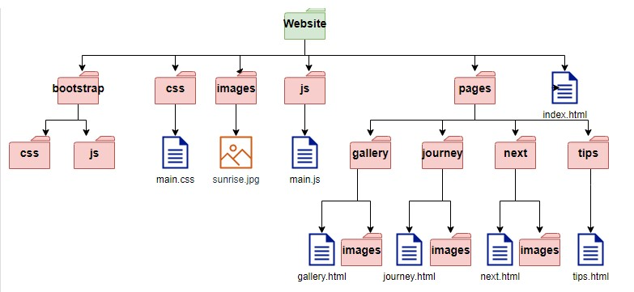
This is with enabling easy navigation of the site in mind for both users and the search engine crawlers, to ensure that both are able to understand and navigate the site in order to maximise the experience of the user and their ability to discover the site to enjoy its content. Although it is recommended that Images, videos, lists and text are used to heighten the experience I currently have no videos that would be suitable, but have sought to remedy this by linking into three suitable YouTube [19] channels.
For accessibility I have acted where possible with the WCAG 2.1 Guidelines [15], with the specific guidelines that have been met listed in Appendix 1. To check adherence with these guidelines I have used a variety of methods from adjusting the size of the screen manually to simulate using a variety of different devices, and resizing the contents of the pages in those different screens to check scalability, as well as altering screen ratios to assure that the content is viewable in both landscape and portrait-oriented screens. Checking the contrast ratio to assure that the text is clearly viewable was done through WCEG – contrast checker [16], this was carried out on both the navbar and the main text areas to ensure the required levels of contrast were achieved. Choosing the correct colour scheme for the site in order to achieve this goal was done with the W3scools Complementary colour tool [17], which helped me to select the colours required based on my existing plan. Further refinement was undertaken using the WCAG – contrast checker [16] to ensure that the required ratios were met, and to fine tune the colour choices. Once I had the site built to my satisfaction, I then proceeded to run each page of the finished site through the WAVE [18] evaluation tool, by using the Chrome plugin, which returned only one error, which was connected to the navbar, and was connected to the burger button, which appeared when the navbar collapsed, and has no value or text. As I am unsure how to resolve this issue, I have left it as it is, as the function works perfectly. In conclusion taking all of this into account this website is as accessible, and as useful as it can be and has many steps taken to ensure that it has been optimised for search engines and general use.

References
[1] “The W3C Markup Validation Service.” [Online] Available: https://validator.w3.org/ [Accessed Apr. 07, 2021].
[2] “The W3C CSS Validation Service.” [Online] Available: http://jigsaw.w3.org/css-validator/ [Accessed Apr. 07, 2021].
[3] “Bootstrap Tutorial - How to Set Up and Use Bootstrap (Beginners).” [Online] Available: https://websitesetup.org/bootstrap-tutorial-for-beginners/ [Accessed Mar. 29, 2021].
[4] “ISO 9241-11:2018(en), Ergonomics of human-system interaction — Part 11: Usability: Definitions and concepts.” [Online] Available: https://www.iso.org/obp/ui/#iso:std:iso:9241:-11:ed-2:v1:en [Accessed Apr. 10, 2021].
[5] M. H. Alshira’h, “Paper-The Effects of Usability and Accessibility for E-Government Services on the End-User… The Effects of Usability and Accessibility for E-Government Services on the End-User Satisfaction,” Int. J. Interact. Mob. Technol., vol. 14, no. 13, pp. 78–90, Aug. 2020, doi: 10.3991/ijim.v14i13.14659, .” [Online] Available: https://online-journals.org/index.php/i-jim/article/view/14659/7659 [Accessed Apr. 07, 2021].
[6] “ISO - ISO/IEC 40500:2012 - Information technology — W3C Web Content Accessibility Guidelines (WCAG) 2.0.” [Online] Available: https://www.iso.org/standard/58625.html [Accessed Apr. 10, 2021].
[7] S. Dongaonkar, R. Vadali, and C. Dhutadmal, “Content Accessibility Evaluation of Government Website using WCAG (Web Content Accessibility Guidelines),” in Proceedings of the Second International Conference on Research in Intelligent and Computing in Engineering, Jun. 2017, vol. 10, pp. 27–31, doi: 10.15439/2017r79, [Online] Available: https://annals-csis.org/Volume_10/drp/79.html [Accessed Apr. 07, 2021].
[8] “Equality Act 2010.” [Online] Available: https://www.legislation.gov.uk/ukpga/2010/15/contents [Accessed Apr. 10, 2021].
[9] “The Public Sector Bodies (Websites and Mobile Applications) Accessibility Regulations 2018.” [Online] Available: https://www.legislation.gov.uk/uksi/2018/852/contents/made [Accessed Apr. 10, 2021].
[10] A. Hambley, “Empirical web accessibility evaluation for blind web users,” ACM SIGACCESS Access. Comput., no. 129, pp. 1–5, Jan. 2021, [Online] Available: https://dl.acm.org/doi/10.1145/3458055.3458057 [Accessed Apr. 07, 2021].
[11] “F-Shaped Pattern For Reading Web Content (original eyetracking research).” [Online] Available: https://www.nngroup.com/articles/f-shaped-pattern-reading-web-content-discovered/ [Accessed Apr. 10, 2021].
[12] “F-Shaped Pattern of Reading on the Web: Misunderstood, But Still Relevant (Even on Mobile).” [Online] Available: https://www.nngroup.com/articles/f-shaped-pattern-reading-web-content/ [Accessed Apr. 10, 2021].
[13] “Text Scanning Patterns: Eyetracking Evidence.” [Online] Available: https://www.nngroup.com/articles/text-scanning-patterns-eyetracking/ [Accessed Apr. 10, 2021].
[14] “How To Design An SEO Friendly Website That Ranks Well In Google.” [Online] Available: https://linchpinseo.com/how-to-design-an-seo-friendly-website/ [Accessed Apr. 10, 2021].
[15] “Documentation to Improve SEO | Google Search Central.” [Online] Available: https://developers.google.com/search/docs [Accessed Apr. 10, 2021].
[16] “How to Meet WCAG (Quickref Reference).” [Online] Available: https://www.w3.org/WAI/WCAG21/quickref/?showtechniques=136%2C316%2C335%2C413%2C148#text-alternatives [Accessed Apr. 10, 2021].
[17] “WCAG - Contrast Checker.” [Online] Available: https://contrastchecker.com/ [Accessed Apr. 13, 2021].
[18] “Color Scheme - Complementary.” [Online] Available: https://www.w3schools.com/colors/colors_complementary.asp [Accessed Apr. 3, 2021].
[19] “WAVE Web Accessibility Evaluation Tool.” [Online] Available: https://wave.webaim.org/ [Accessed Apr. 13, 2021].
[20]“(105) YouTube.” [Online] Available: https://www.youtube.com/ [Accessed Apr. 10, 2021].
Website References
Images
[1] “Photo & Video Gallery | Cinnamon Dhonveli Maldives.” [Online] Available: https://www.cinnamonhotels.com/cinnamondhonvelimaldives/gallery [Accessed Apr. 10, 2021].
Websites
[2] “(105) Tony & Chelsea Northrup - YouTube.” [Online] Available: https://www.youtube.com/channel/UCDkJEEIifDzR_2K2p9tnwYQ [Accessed Apr. 10, 2021].
[3] “(105) Thomas Heaton - YouTube.” [Online] Available:
https://www.youtube.com/channel/UCfhW84xfA6gEc4hDK90rR1Q [Accessed Apr. 10, 2021].
[4] “(105) Matt Granger - YouTube.” [Online] Available: https://www.youtube.com/channel/UCL5Hf6_JIzb3HpiJQGqs8cQ [Accessed Apr. 10, 2021].
Appendices
Appendix i
Guideline 1.1 – all images are provided with text alternatives.
Guideline 1.2.1-1.2.9 – not applicable.
Guideline 1.3.1 – semantic text used where appropriate, otherwise standard text formatting conventions used.
Guideline 1.3.2 – ensuring that the correct reading sequence can be programmatically determined.
Guideline 1.3.4 – all items provided with textual identification.
Guideline 1.3.4 – display orientation is not limited by the content.
Guideline 1.3.5 – not applicable as no inputs available.
Guideline 1.4.1 – colour is not used as the only means of conveying information.
Guideline 1.4.2 – not applicable, no audio.
Guideline 1.4.3 – the contrast ratio for the main elements on the site has a contrast ration of 7.02:1 as identified by WCAG - contrast checker [15]
Guideline 1.4.4 – text can be resized up to 200% without loss of content or functionality.
Guideline 1.4.5 – text is used to convey information rather than images of text.
Guideline 1.4.6 – large scale text has a contrast ratio of 4.5:1, with main text having a contrast ratio of 20.12:1.
Guideline 1.4.7 – no background audio was used on the website.
Guideline 1.4.8 – text is not justified, text spacing is appropriate, and text can be resized to 200% without requiring horizontal scroll.
Guideline 1.4.9 – images of text are only used as an integral part of a larger image, and for referencing purposes.
Guideline 1.4.10 – content can be presented without loss of information without requiring scrolling in two dimensions.
Guideline 1.4.11 – non text contrast ratio of at least 3:1.
Guideline 1.4.12 – no loss of content or functionality caused by adopting correct text spacings.
Guideline 1.4.13 – no additional content provided by hover over.
Guideline 2.1.1 – all functions operate through a keyboard interface.
Guideline 2.1.2 – no keyboard traps.
Guideline 2.2.1 – no time limits.
Guideline 2.2.2 – no auto moving, blinking, or scrolling elements, no auto updating elements.
Guideline 2.2.3 – no timing elements present.
Guideline 2.2.4 – no interruptions involved.
Guideline 2.2.5 – no reauthentication required.
Guideline 2.2.6 – no timeouts set.
Guideline 2.3.1 – no flashing elements present.
Guideline 2.3.2 – no flashing elements present.
Guideline 2.3.3 – no animations triggered by interactions.
Guideline 2.4.1 – clear navigation system and no repeated blocks of content.
Guideline 2.4.2 – all pages clearly titled, with pertinent titling applied.
Guideline 2.4.3 – all pages are displayed in the intended order in the navigation bar, but reading pages out of order will not affect the meaning of each page.
Guideline 2.4.4 – all links either point to described page, or expanded image as described on screen, no hidden, or mislabelled links.
Guideline 2.4.5 – all pages can be linked to from all other pages including the home page.
Guideline 2.4.6 – all headings and labels describe topic or purpose.
Guideline 2.4.7 – keyboard operable user interface has visible keyboard focus indicator.
Guideline 2.4.8 – users’ location within pages displayed in navigation bar.
Guideline 2.4.9 – all link text describes the purpose of the link.
Guideline 2.5.1 – no use of multipoint or path-based gestures.
Guideline 2.5.2 – all touch events are only triggered when touch is removed from a control.
Guideline 2.5.3 – all user interface components with text labels contain label as part of the name.
Guideline 2.5.4 – no device motion activated functions present.
Guideline 2.5.5 – target size of all pointer inputs larger than 44x44 pixels, except where the target is in a sentence or block of text.
Guideline 2.5.6 – no input mechanisms available on site.
Guideline 3.1.1 – language of each page defined in initial html tag.
Guideline 3.1.2 – all language used is in accordance with original language declaration.
Guideline 3.1.3 – all language used on all pages is clearly understandable and used appropriately in line with the context of the topic.
Guideline 3.1.4 – no abbreviations used on site.
Guideline 3.1.5 – all text as at appropriate reading level.
Guideline 3.1.6 – no text with ambiguous meaning or pronunciation used.
Guideline 3.2.1 – all focus elements either change to content highlighted in the link name, or a larger representation of the focus element.
Guideline 3.2.2 – no input elements available.
Guideline 3.2.3 – all navigation elements are consistently displayed.
Guideline 3.2.4 – all repeated components are identified consistently.
Guideline 3.2.5 – all changes of context are initiated by user request.
Guideline 3.3.1-3.3.6 – no input options available.
Guideline 4.1.1 – all element tags opened and closed appropriately, all elements are nested appropriately, and do not contain duplicate attributes, all ID’s used are unique and describe the element they are attached to, unless multiple elements are similar enough to share an ID.
Guideline 4.1.2-4.1.3 – not applicable.

Appendix ii
The following is the code for each page of the website
index.html
<!DOCTYPE html>
<html lang="en">
<head>
<title>Photography and me</title>
<meta charset="utf-8">
<meta name="viewport" content="width=device-width, initial-scale=1">
<link rel="stylesheet" href="bootstrap/css/bootstrap.min.css">
<link rel="stylesheet" type="text/css" href="css/main.css">
</head>
<body>
<nav class="navbar navbar-expand-md">
<a class="navbar-brand" ></a>

<button class="navbar-toggler navbar-dark" type="button" data-toggle="collapse" data-target="#main-navigation">
<span class="navbar-toggler-icon"></span>
</button>
<div class="collapse navbar-collapse" id="main-navigation">
<ul class="navbar-nav">
<li class="nav-item">
<a class="nav-link" href="index.html"><h3><b>Home</b></h3></a>
</li>
<li class="nav-item">
<a class="nav-link" href="pages/journey/journey.html"><h3><b>My Journey</b></h3></a>
</li>
<li class="nav-item">
<a class="nav-link" href="pages/tips/tips.html"><h3><b>Tips</b></h3></a>
</li>
<li class="nav-item">
<a class="nav-link" href="pages/gallery/gallery.html"><h3><b>Gallery</b></h3></a>
</li>
<li class="nav-item">
<a class="nav-link" href="pages/next/next.html"><h3><b>What's Next</b></h3></a>
</li>
</ul>
</div>
</nav>

<div class="main-page-image">
<img src="images/sunrise.jpg" alt="Sunrise over Moroccan pool just outside Marrakech" style= width:100%>
<img src="images/bakery.jpg" alt="Traditional Moroccan bakery in Marrakech" style= width:100%>
<img src="images/market.jpg" alt="Man selling teeth and dentures in Marrakech market" style= width:100%>
<div class="introduction">
<h1 style="font-size:75px"><b>Photography and me</h1>
<br/>
<h2 style="font-size:45px">This is my journey into photography, and my
hope is that by sharing this story I can help
others who are just starting out on the same
journey.<b></h2>
</div>
</div>

<script src="https://code.jquery.com/jquery-3.5.1.min.js" integrity="sha256-9/aliU8dGd2tb6OSsuzixeV4y/faTqgFtohetphbbj0=" crossorigin="anonymous"></script>
<script src="bootstrap/js/bootstrap.min.js"></script>

</body>

</html>

journey.html
<!DOCTYPE html>

<html lang="en">

<head>

<title>My Journey Into Photography</title>
<meta charset="utf-8">
<meta name="viewport" content="width=device-width, initial-scale=1">
<link rel="stylesheet" href="../../bootstrap/css/bootstrap.min.css">
<link rel="stylesheet" type="text/css" href="../../css/main.css">
</head>

<body>
<nav class="navbar navbar-expand-md">
<a class="navbar-brand" ></a>

<button class="navbar-toggler navbar-dark" type="button" data-toggle="collapse" data-target="#main-navigation">
<span class="navbar-toggler-icon"></span>
</button>
<div class="collapse navbar-collapse" id="main-navigation">
<ul class="navbar-nav">
<li class="nav-item">
<a class="nav-link" href="../../index.html"><h3>Home</h3></a>
</li>
<li class="nav-item">
<a class="nav-link" href="journey.html"><h3>My Journey</h3></a>
</li>
<li class="nav-item">
<a class="nav-link" href="../tips/tips.html"><h3>Tips</h3></a>
</li>
<li class="nav-item">
<a class="nav-link" href="../gallery/gallery.html"><h3>Gallery</h3></a>
</li>
<li class="nav-item">
<a class="nav-link" href="../next/next.html"><h3>What's Next</h3></a>
</li>
</ul>
</div>
</nav>
<div class="container features">
<div class="row">

<div class="col-lg-12 col-md-12 col-sm-12">
<h1 class="feature-title">Where to begin</h1>
<p id="beginning">Like most people over the age of thirty my first experience
with photography was with a 35mm film camera. This camera was nothing
special, it didn’t even have an automatic frame advance, but it took
photos. It served as the main repository of family memories whilst
I was growing up. The only real problems where you only got twenty
four shots per film, you could never be sure if you had achieved the
desired shot until you processed the film, and film processing was
never cheap. Additionally, there were no real user controls, it was
the epitome of point and shoot photography. Though this in itself was
the beginning of my education, as it taught me to frame the shot properly,
and how, as I was later to learn this is an actual technique, zoom
with your feet.
</p>
<p id="going-digital">The next step along this path arrived in December 2003, I was
working at IKEA at the time and as they do every year they gave all
the staff a Christmas gift, and this year it was a digital camera. I
had finally gone digital. Mind this was still no great camera, but at
least I could view the images before I walked away, and delete, and
retake any that didn't work, and it would save me a fortune on printing.
</p>
</div>

<div class="col-lg-8 col-md-8 col-sm-12">
<p id="learning-control">In 2007 I bought the Fugifilm FinePix S5600, and finally I had
greater control over my photos. As a bridge camera this had a great
zoom lens which meant there was no loss of quality through using
digital zoom. Though at the time I had no idea how to use all of the
features that were packed into this camera, and it was still primarily
used for family snapshots. That all changed with this shot, and whilst
I look back at it and realise that the settings used were far from what
I would choose now, plus I would use a tripod instead of going hand held,
This one image still inspired me to see how far this could be pushed.
</p>
<p>This was where I really started to learn, and my first port of call was
the internet, and more precisely YouTube where I watched hours of material
by <cite><a href="https://www.youtube.com/channel/UCDkJEEIifDzR_2K2p9tnwYQ"
target="_blank">Tony & Chelsea Northrup</a></cite>[2], <cite><a href="
https://www.youtube.com/channel/UCfhW84xfA6gEc4hDK90rR1Q" target="_blank">Thomas Heaton</a></cite>[3],
<cite><a href="https://www.youtube.com/channel/UCL5Hf6_JIzb3HpiJQGqs8cQ" target="_blank">
Mat Granger</a></cite>[4], and many others. All of this helped to teach me what all
of the buttons and settings are for and to help develop the inner
photographer in me. Which has all helped me to go from this grainy and noisy
image to the one displayed on the home page, which I'm sure you will agree
is a much finer shot.
</p>
</div>

<div class="col-lg-4 col-md-4 col-sm-12">
<figure>
<a href="images/pegs.jpg" target="_blank"><img src="images/pegs.jpg" alt="pegs frozen to a line" class="img-fluid"></a>
<br/>
<figcaption>ISO400 - f/4.5 - 1/200sec.<figcaption/>
<figure/>
</div>

<div class="col-lg-12 col-md-12 col-sm-12">
<p id="closing">Thankfully my skills and gear have improved from then but more about that on the next few pages.
</p>
</div>
</div>
</div>
<div class="col-lg-12 col-md-12 col-sm-12">
<p id="references">
References
<ul>
<li>[2] “(105) Tony & Chelsea Northrup - YouTube.” [Online] Available:
https://www.youtube.com/channel/UCDkJEEIifDzR_2K2p9tnwYQ [Accessed Apr. 10, 2021].
</li>
<li>[3] “(105) Thomas Heaton - YouTube.” [Online] Available:
https://www.youtube.com/channel/UCfhW84xfA6gEc4hDK90rR1Q [Accessed Apr. 10, 2021].
<li>[4] “(105) Matt Granger - YouTube.” [Online] Available:
https://www.youtube.com/channel/UCL5Hf6_JIzb3HpiJQGqs8cQ [Accessed Apr. 10, 2021].
</li>
</ul>
</p>
</div>
<footer id="main-footer">
<p> </p>
</footer>

<script src="https://code.jquery.com/jquery-3.5.1.min.js" integrity="sha256-9/aliU8dGd2tb6OSsuzixeV4y/faTqgFtohetphbbj0=" crossorigin="anonymous"></script>
<script src="../../bootstrap/js/bootstrap.min.js"></script>

</body>

</html>

tips.html

<!DOCTYPE html>

<html lang="en">

<head>

<title>Tips and Tricks, Somewhere To Start</title>
<meta charset="utf-8">
<meta name="viewport" content="width=device-width, initial-scale=1">
<link rel="stylesheet" href="../../bootstrap/css/bootstrap.min.css">
<link rel="stylesheet" type="text/css" href="../../css/main.css">
</head>

<body>
<nav class="navbar navbar-expand-md">
<a class="navbar-brand" ></a>

<button class="navbar-toggler navbar-dark" type="button" data-toggle="collapse" data-target="#main-navigation">
<span class="navbar-toggler-icon"></span>
</button>
<div class="collapse navbar-collapse" id="main-navigation">
<ul class="navbar-nav">
<li class="nav-item">
<a class="nav-link" href="../../index.html"><h3>Home</h3></a>
</li>
<li class="nav-item">
<a class="nav-link" href="../journey/journey.html"><h3>My Journey</h3></a>
</li>
<li class="nav-item">
<a class="nav-link" href="tips.html"><h3>Tips</h3></a>
</li>
<li class="nav-item">
<a class="nav-link" href="../gallery/gallery.html"><h3>Gallery</h3></a>
</li>
<li class="nav-item">
<a class="nav-link" href="../next/next.html"><h3>What's Next</h3></a>
</li>
</ul>
</div>
</nav>

<div class="container features">
<div class="row">

<div class="col-lg-12 col-md-12 col-sm-12">
<h1 class="feature-title">10 Tips and Tricks To Improve your Photography</h1>
</br>
<ul id="hint-list">
<li>The best camera is always the one you have with you.
Having a top of the range camera with all the best kit is no good if you've
left it behind.</li>
<li>The best way to get better at anything is <em>practice</em>. The saying practice
makes perfect exists because it's true.</li>
<li> Having all the best kit in the world wont help if you never go anywhere.
Spend more on traveling than on gear, and take what you have with you.</li>
<li>When you get any new gear spend some time getting use to it, read the
manual, no one ever knows how everything works straight out of the box.</li>
<li>Use the internet, there is a wealth of information on any topic you may
be interested in, with YouTube offering a wealth of videos on all aspects of
photography.</li>
<li>Learn how the different shooting modes work, auto will only limit your
creative ideas, but that doesn't mean you need to be fully manual all the
time either.</li>
<li>Most cameras have at least some level of creative modes allowing you
to take control of some or all of the settings,
use them to unlock your full potential.</li>
<li>Shoot in RAW if your camera allows it, it doesn’t process the image and saves
all the data for you to process in the way you want later.</li>
<li>There are a few rules for photography that will help improve your composition,
like the <i>rule of thirds</i>, <i>the rule of three</i>, <i>the golden ratio</i>,
but knowing when to use them is as important as how.
<li>Lastly, try to look at things in new ways, go high, go low, look for a
different angle, stand out by doing things differently from everyone else.</li>
</ul>
</div>
</div>
</div>

<footer id="main-footer">

</footer>
<script src="https://code.jquery.com/jquery-3.5.1.min.js" integrity="sha256-9/aliU8dGd2tb6OSsuzixeV4y/faTqgFtohetphbbj0=" crossorigin="anonymous"></script>
<script src="../../bootstrap/js/bootstrap.min.js"></script>

</body>

</html>

Gallery.html

<!DOCTYPE html>

<html lang="en">

<head>

<title>Gallery, Just a Taste of What Can Be Done</title>
<meta charset="utf-8">
<meta name="viewport" content="width=device-width, initial-scale=1">
<link rel="stylesheet" href="../../bootstrap/css/bootstrap.min.css">
<link rel="stylesheet" type="text/css" href="../../css/main.css">
</head>

<body>
<nav class="navbar navbar-expand-md">
<a class="navbar-brand" ></a>

<button class="navbar-toggler navbar-dark" type="button" data-toggle="collapse" data-target="#main-navigation">
<span class="navbar-toggler-icon"></span>
</button>
<div class="collapse navbar-collapse" id="main-navigation">
<ul class="navbar-nav">
<li class="nav-item">
<a class="nav-link" href="../../index.html"><h3>Home</h3></a>
</li>
<li class="nav-item">
<a class="nav-link" href="../journey/journey.html"><h3>My Journey</h3></a>
</li>
<li class="nav-item">
<a class="nav-link" href="../tips/tips.html"><h3>Tips</h3></a>
</li>
<li class="nav-item">
<a class="nav-link" href="gallery.html"><h3>Gallery</h3></a>
</li>
<li class="nav-item">
<a class="nav-link" href="../next/next.html"><h3>What's Next</h3></a>
</li>
</ul>
</div>
</nav>

<div class="container features">
<div class="row">

<div class="col-lg-12 col-md-12 col-sm-12">
<h1 class="feature-title"><b>Gallery</b></h1>

</div>

<div class="col-lg-12 col-md-12 col-sm-12">
<h2 class="page-description">Below are a collection of some
of my better images from many of the different styles of
photography available, it's worth trying them all to see
what really suits your particular style.</h2>
<h3 class="landscape">Landscape photography.</h3>
</div>

<div class="col-lg-12 col-md-12 col-sm-12">
<figure>
<a href="images/panorama.jpg" target="_blank"><img src="images/panorama.jpg" alt="Night
time panorama of Budapest from the Margaret Bridge." class="img-fluid"></a>
<figcaption>ISO100 - f/22 - 30sec.<figcaption/>
<figure/>
</div>

<div class="col-lg-4 col-md-4 col-sm-12">
<figure>
<a href="images/reservoir.jpg" target="_blank"><img src="images/reservoir.jpg" alt="Talybont
reservoir on an overcast day." class="img-fluid"></a>
<br/>
<figcaption>ISO160 - f/11 - 1/30sec.<figcaption/>
<figure/>
</div>

<div class="col-lg-4 col-md-4 col-sm-12">
<figure>
<a href="images/waterfall.jpg" target="_blank"><img src="images/waterfall.jpg" alt="Waterfall
above Talybont reservoir on an overcast day." class="img-fluid"></a>
<figcaption>ISO100 - f/11 - 5sec.<figcaption/>
<figure/>
</div>

<div class="col-lg-4 col-md-4 col-sm-12">
<figure>
<a href="images/hilltop-path.jpg" target="_blank"><img src="images/hilltop-path.jpg" alt="Path
leading top top of Caerphilly Mountain." class="img-fluid"></a>
<br/>
<figcaption>ISO100 - f/3.5 - 1/400sec.<figcaption/>
<figure/>
</div>

<div class="col-lg-12 col-md-12 col-sm-12">
<h3 class="wildlife">Wildlife photography.</h3>
</div>

<div class="col-lg-4 col-md-4 col-sm-12">
<figure>
<a href="images/magpie.jpg" target="_blank"><img src="images/magpie.jpg" alt="Magpie on a
fence." class="img-fluid"></a>
<br/>
<figcaption>ISO100 - f/5.6 - 1/80sec.<figcaption/>
<figure/>
</div>

<div class="col-lg-4 col-md-4 col-sm-12">
<figure>
<a href="images/swan.jpg" target="_blank"><img src="images/swan.jpg" alt="Swan at Roath
Park." class="img-fluid"></a>
<br/>
<figcaption>ISO100 - f/5.6 - 1/500sec.<figcaption/>
<figure/>
</div>

<div class="col-lg-4 col-md-4 col-sm-12">
<figure>
<a href="images/cat.jpg" target="_blank"><img src="images/cat.jpg" alt="Beast of bodmin
wannabe, just kidding, it’s my cat." class="img-fluid"></a>
<br/>
<figcaption>ISO100 - f/5.6 - 1/80sec.<figcaption/>
<figure/>
</div>

<div class="col-lg-12 col-md-12 col-sm-12">
<h3 class="night-time">Night time photography.</h3>
</div>

<div class="col-lg-4 col-md-4 col-sm-12">
<figure>
<a href="images/fireworks.jpg" target="_blank"><img src="images/fireworks.jpg" alt="Fireworks
in Pontypridd." class="img-fluid"></a>
<br/>
<figcaption>ISO100 - f/8 - 2sec.<figcaption/>
<figure/>
</div>

<div class="col-lg-4 col-md-4 col-sm-12">
<figure>
<a href="images/light-trails.jpg" target="_blank"><img src="images/light-trails.jpg" alt="Light
trails from passing car on the A470 to Brecon." class="img-fluid"></a>
<br/>
<figcaption>ISO100 - f/11 - 41sec.<figcaption/>
<figure/>
</div>

<div class="col-lg-4 col-md-4 col-sm-12">
<figure>
<a href="images/sunset-light-trails.jpg" target="_blank"><img src="images/sunset-light-trails.jpg"
alt="Light trails on the M4 at sunset." class="img-fluid"></a>
<br/>
<figcaption>ISO100 - f/5.6 - 1/80sec.<figcaption/>
<figure/>
</div>

<div class="col-lg-12 col-md-12 col-sm-12">
<h3 class="people">Portrait photography.</h3>
</div>

<div class="col-lg-4 col-md-4 col-sm-12">
<figure>
<a href="images/future-wife.jpg" target="_blank"><img src="images/future-wife.jpg"
alt="Photo of my future wife." class="img-fluid"></a>
<br/>
<figcaption>ISO100 - f/4.5 - 1/50sec.<figcaption/>
<figure/>
</div>

<div class="col-lg-4 col-md-4 col-sm-12">
<figure>
<a href="images/kids.jpg" target="_blank"><img src="images/kids.jpg" alt="Photo
of my children at a family gathering." class="img-fluid"></a>
<br/>
<figcaption>ISO200 - f/3.2 - 1/180sec.<figcaption/>
<figure/>
</div>

<div class="col-lg-4 col-md-4 col-sm-12">
<figure>
<a href="images/brother.jpg" target="_blank"><img src="images/brother.jpg"
alt="Photo of my brother." class="img-fluid"></a>
<br/>
<figcaption>ISO400 - f/5.6 - 1/125sec.<figcaption/>
<figure/>
</div>

<div class="col-lg-12 col-md-12 col-sm-12">
<h3 class="up-close">Macro photography.</h3>
</div>

<div class="col-lg-4 col-md-4 col-sm-12">
<figure>
<a href="images/flowers.jpg" target="_blank"><img src="images/flowers.jpg"
alt="Flowers from my mother’s back garden." class="img-fluid"></a>
<br/>
<figcaption>ISO100 - f/5 - 1/125sec.<figcaption/>
<figure/>
</div>

<div class="col-lg-4 col-md-4 col-sm-12">
<figure>
<a href="images/cactus.jpg" target="_blank"><img src="images/cactus.jpg" alt=" close up photo
of a succulent cactus ." class="img-fluid"></a>
<br/>
<figcaption>ISO200 - f/29 - 1/8sec.<figcaption/>
<figure/>
</div>

<div class="col-lg-4 col-md-4 col-sm-12">
<figure>
<a href="images/caterpillar.jpg" target="_blank"><img src="images/caterpillar.jpg"
alt="Caterpillar on a leaf." class="img-fluid"></a>
<br/>
<figcaption>ISO100 - f/5.6 - 1/80sec.<figcaption/>
<figure/>
</div>

<div class="col-lg-12 col-md-12 col-sm-12">
<h3 class="footnote"><p>Whilst there are many more styles of photography these are just a
smple of some of the photographs I have taken myself.</p>
<p>Clicking on the images will produce a full screen version in a new tab, and for reference I have provided some of the camera settings used for each shot.</p></h3>

</div>

</div>
</div>

<footer id="main-footer">
<p> </p>
</footer>
<script src="https://code.jquery.com/jquery-3.5.1.min.js" integrity="sha256-9/aliU8dGd2tb6OSsuzixeV4y/faTqgFtohetphbbj0=" crossorigin="anonymous"></script>
<script src="../../bootstrap/js/bootstrap.min.js"></script>

</body>

</html>

next.html

<!DOCTYPE html>

<html lang="en">

<head>

<title>The Journey Continues, What's Next</title>
<meta charset="utf-8">
<meta name="viewport" content="width=device-width, initial-scale=1">
<link rel="stylesheet" href="../../bootstrap/css/bootstrap.min.css">
<link rel="stylesheet" type="text/css" href="../../css/main.css">
</head>

<body>
<nav class="navbar navbar-expand-md">
<a class="navbar-brand" ></a>

<button class="navbar-toggler navbar-dark" type="button" data-toggle="collapse" data-target="#main-navigation">
<span class="navbar-toggler-icon"></span>
</button>
<div class="collapse navbar-collapse" id="main-navigation">
<ul class="navbar-nav">
<li class="nav-item">
<a class="nav-link" href="../../index.html"><h3>Home</h3></a>
</li>
<li class="nav-item">
<a class="nav-link" href="../journey/journey.html"><h3>My Journey</h3></a>
</li>
<li class="nav-item">
<a class="nav-link" href="../tips/tips.html"><h3>Tips</h3></a>
</li>
<li class="nav-item">
<a class="nav-link" href="../gallery/gallery.html"><h3>Gallery</h3></a>
</li>
<li class="nav-item">
<a class="nav-link" href="next.html"><h3>What's Next</h3></a>
</li>
</ul>
</div>
</nav>

<div class="container features">
<div class="row">

<div class="col-lg-12 col-md-12 col-sm-12">
<h1 class="feature-title">What next</h1>
<p id="next step">As I pointed out travel is the biggest learning tool there is with
photography, unfortunately with the current lockdown due to the COVID-19 pandemic,
the opportunities for travel are few and far between. But that's not to say that there
are no opportunities to try new things. It also encourages us to make the most of what
is on our own doorsteps and try to look at things in different ways.
</p>
</div>

<div class="col-lg-8 col-md-8 col-sm-12">
<p id="getting-away">As I am getting married next year obviously most of my travel
plans are based around the following honeymoon. The destination for that is going
to be a resort in the Maldives, which should give me ample opportunities to pick up
my camera and take very many pictures of the idyllic surroundings. Although as with
anything in life, the key to a successful trip is preparation. Having a good idea of
what is there, and being able to plan the shots you wish to capture places you in a
good position to ensure you make the most of the opportunities presented. As you can
see from the arial photo of the resort I may be hard pressed to fit in all the
attractions available, even though the resort is packed on to such a small piece of
land. Though this does also offer the peace and tranquillity required for a honeymoon,
so best of both worlds. The hardest choice will be in deciding which camera gear to pack.
</p>
</div>

<div class="col-lg-4 col-md-4 col-sm-12">
<a href="images/Dhonveli-Aerial-Exterior-Aerial-view-1.jpg" target="_blank"><img
src="images/Dhonveli-Aerial-Exterior-Aerial-view.jpg" alt="Arial view of Cinnamon
Dhonveli resort in the Maldives" class="img-fluid"></a>
</div>
<div class="col-lg-12 col-md-12 col-sm-12">
<p id="editing">One other aspect of my photography which I really need to develop is
post processing, you may or may not have noticed that a great many of my images displayed
on this site have little or no post processing done to them. For those that do it's usually
little more than a tweak to the exposure settings. What makes this worse is that I have a
paid subscription to Adobe Lightroom and Photoshop, but have only a basic understanding of
what they can achieve. So, learning more about this aspect of photography is a must.
</p>
</div>
<div class="col-lg-12 col-md-12 col-sm-12">
<p id="closing">Whilst I have previously, in the tips page highlighted the fact that
new camera equipment will not improve your abilities, as your abilities improve, better
equipment will be able to help you capture the best images you are capable of. Whilst
I am still learning with my Canon 700D, there will come a time when I will feel the need
to upgrade, and at the moment my preferred route will be to go full frame with the Canon 6D.
Though I will probably add a few more high quality lenses to my collection before I make
that jump.
</p>
</div>
<div class="col-lg-12 col-md-12 col-sm-12">
<p id="image-reference">[1] “Photo & Video Gallery | Cinnamon Dhonveli Maldives.”
[Online] Available:https://www.cinnamonhotels.com/cinnamondhonvelimaldives/gallery [Accessed Apr. 10, 2021].
</p>
</div>

</div>
</div>

<footer id="main-footer">
<p> </p>
</footer>
<script src="https://code.jquery.com/jquery-3.5.1.min.js" integrity="sha256-9/aliU8dGd2tb6OSsuzixeV4y/faTqgFtohetphbbj0=" crossorigin="anonymous"></script>
<script src="../../bootstrap/js/bootstrap.min.js"></script>
</body>

</html>
main.css

body {
padding: 0;
margin: 0;
background: #fafafa;
}

.navbar {
background:#ff9924;
}

.nav-link,
.navbar-brand {
color: #00088a;
cursor: pointer;
}

.nav-link {
margin-right: 1em !important;
}

.nav-link:hover {
color: #000;
}

.navbar-collapse {
justify-content: flex-start;
}

.introduction {
text-align: center;
position: absolute;
top: 71%;
left: 50%;
transform: translate(-50%, -50%);
color: #ffffff;
}

#hint-list {
list-style-type: square
}

#hint-list {
font-family: Georgia, Times, serif;
font-size: 1.2em
}

li {
padding-bottom: 20px
}

#main-footer {
background:#ff9924;
color:#fff;
text-align:center;
padding:20px;
margin-top:40px;
}

#closing {
padding-bottom: 30px
}

.page-description {
padding-bottom: 20px
}

img {
border: 2px solid #000000;
}

